BigBlueBam
The Complete Manual
Sixteen apps that behave like one. A field guide.
Open source. Self-hosted. Built for humans and AI agents.

Table of Contents

CHAPTER 1

Bam
Plan it, drag it, ship it.

Bam is where the work lives. Every project is a board you shape yourself, with your own phases, task states, and fields, run in time-boxed sprints that carry unfinished work forward instead of dropping it. This chapter takes you from your first project to closing a sprint and reading the reports, and it shows where an AI agent can pick up the same board your team uses. By the end you will be able to set up a project, run a sprint start to finish, and find any task fast.
At a glance
- Configurable boards: phases, task states, labels, and fields, set per project
- Time-boxed sprints with carry-forward that never quietly loses work
- Rich task cards: subtasks, time tracking, start and due dates, custom fields
- Board, List, Timeline, and Calendar views of the very same work
- Full MCP access, so an agent can run the board with nearly a person's authority
In this chapter
Overview . Key concepts . Where to find it . Feature reference . Project dashboard and project list . Kanban board . Task detail drawer . Creating and editing tasks . Subtasks and parent tasks . Sprints
Bam is the BigBlueBam flagship: a multi-user Kanban planner where teams run
projects on configurable boards, plan and close sprints, track tasks with rich
detail, and report on delivery. Reach for it when a team needs to organize work
into phases and time-boxed iterations.

Overview
Bam is where work gets planned and tracked. Each project is a board with its own
phases (columns), task states, labels, epics, sprints, custom fields, and
templates. You move tasks across the board by dragging cards, group them into
time-boxed sprints, and carry unfinished work forward when a sprint closes. Cards
carry a full task record: assignee, priority, story points, start and due dates,
subtasks, comments, attachments, time entries, and custom fields.
TIP
Card positions are stored as floating-point values, so reordering a long column never renumbers its neighbors. Drag freely.
Carry-forward is a first-class concept, so unfinished work follows you instead of falling through the cracks.
Bam is built for small-to-medium teams. It supports many concurrent projects, and
every project can be shaped differently because phases, states, and custom fields
are all configurable per project (and priorities per org). The same data is
reachable through MCP tools, so an AI agent can create tasks, run reports, or plan
a sprint with nearly the same authority a human has in the UI.
Every board action is also an MCP tool, so an agent can plan a sprint with nearly the authority a person has.
Bam connects to the rest of the suite. Helpdesk tickets can spawn Bam tasks (a
Helpdesk tab then appears on the task), GitHub commits and pull requests can link
back to a task, Slack receives sprint and task notifications, and Banter messages
can reference a task by its human id so a deep link opens the right board with the
task drawer open.
The core objects you work with are projects, phases, task states, tasks, sprints,
epics, labels, custom fields, and saved views.

Key concepts
- Organization (org) - The top-level tenant. Org roles are owner, admin, and
member, plus a guest role. Priorities are configured at the org level.
- Project - A board with its own phases, states, labels, epics, sprints,
custom fields, and templates. Every project has a task id prefix (2 to 6
uppercase letters, for example MAGE or FRND) that prefixes every task id.
Project roles are admin, member, and viewer.
- Phase - A board column. A phase can carry a WIP limit, a color, start and
terminal flags, and an auto-state that is applied when a task enters the phase.
- Task state - The status of a task, orthogonal to its phase. Each state
belongs to a category (todo, active, blocked, review, done, or cancelled) and
may be a closed state. Tasks in a closed state count toward velocity.
- Task - The unit of work. Each task has a human id in the form PREFIX-N (for
example MAGE-38). A task holds a title, rich-text description, phase, state,
sprint, epic, assignee, reporter, priority, story points, time estimate and
logged time, start and due dates, labels, custom fields, links, parents and
subtasks, comments, and attachments.
- Priority - A per-org configurable value. The default set is Critical, High,
Medium, Low, and None. New tasks default to Medium.
- Sprint - A time-boxed iteration with a status of planned, active, completed,
or cancelled. Only one sprint can be active per project at a time. The default
sprint length is 14 days. A sprint carries a goal, start and end dates, velocity,
and retrospective notes.
- Carry-forward - When you complete an active sprint, each incomplete task can
be carried forward to a target sprint, moved to the backlog, or cancelled.
Carried tasks show a carry-forward badge and remember their original sprint for
reporting.
- Epic - A grouping of tasks across sprints, with a status of open, in
progress, or closed. Epics roll up task counts and story points.
- Label - A project-scoped tag with a name and color.
- Custom field - A project-scoped field stored on each task. The seven field
types are text, number, date, select, multi-select, checkbox, and url. A field
can be required and can be shown on the card.
- Saved view - A saved filter, sort, swimlane, and view-type preset. It can be
private to you or shared with the project. Saved views persist the Board, List,
Timeline, and Calendar view types.
- Swimlane - A horizontal grouping of the board. The options are No Swimlanes,
By Assignee, By Priority, and By Epic.
- Start and due dates - Each task can carry a start date and a due date. These
drive the Timeline (Gantt) and Calendar views and feed the overdue and My Work
groupings.
- Watcher - A user subscribed to a task's notifications. Watchers are populated
by the system as people get involved with a task. There is no manual
add-watcher or remove-watcher control in the Bam UI.
- Done-gate - A task cannot move into a closed state while it still has open
subtasks. The board surfaces this as an alert and the API returns an
INCOMPLETE_SUBTASKS error.
NOTE
Only one sprint can be active per project at a time. Plan the next one while the current sprint runs, then start it the moment this one closes.
WARNING
The done-gate is strict. Close or cancel the open subtasks first, or the API returns INCOMPLETE_SUBTASKS and the card stays exactly where it was.

Where to find it
Bam is served at /b3/. From the left sidebar you reach Dashboard (the
project list), My Work (your personal task queue), and the Projects list
with a plus button to create a project. Opening a project lands you on its board
at /projects/:id/board.
TRY IT
Open /b3/, click Projects, and create a project with a two-to-six-letter prefix like DOCS. Your very first task will be DOCS-1.
To use Bam you need an authenticated session (a login cookie or a bbam_ API key)
and membership in at least one project. Some actions require a project admin role
or an org owner or admin role. On a brand-new install, Bam routes you to
/b3/bootstrap to create the first account until a SuperUser exists.
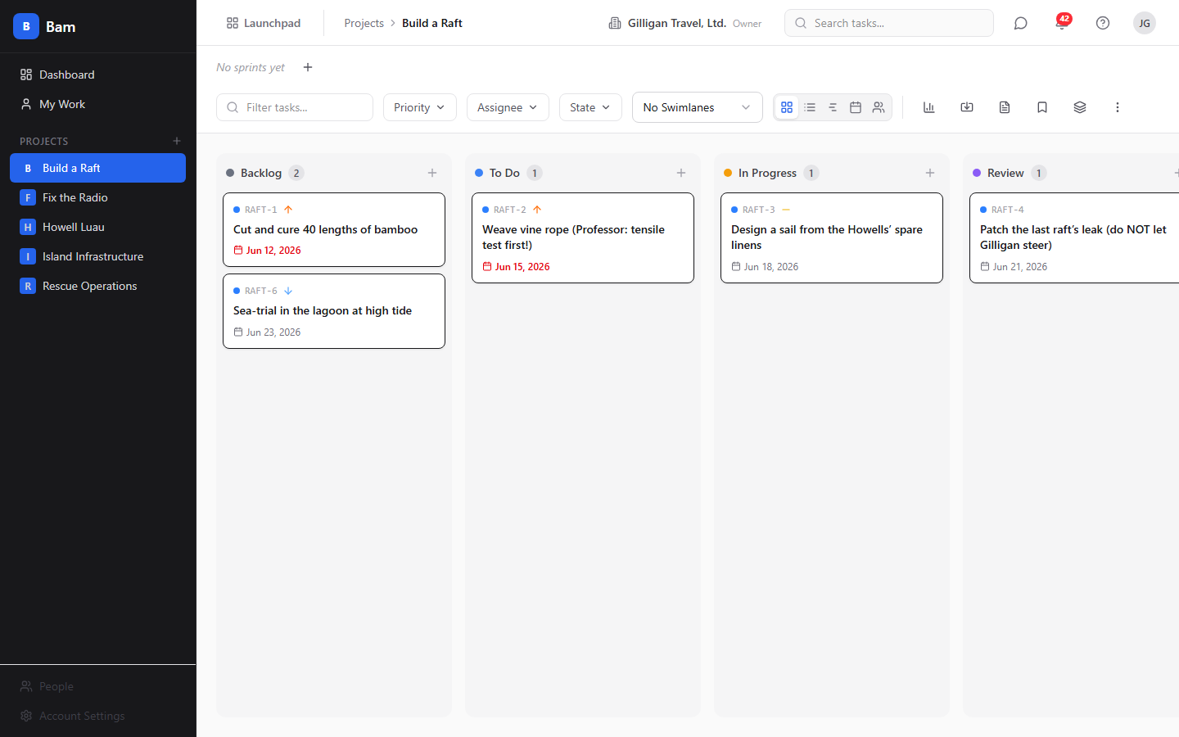
Figure 1.1 Kanban board

Feature reference

Project dashboard and project list
The dashboard is your home page in Bam. It lists every project you can see.
To create a project:
1. From the sidebar, click Dashboard, or click the plus button next to
Projects.
2. Click New Project (the empty state reads No projects yet with a
Create Project button).
3. Enter a project name and a task id prefix of 2 to 6 uppercase letters.
4. Optionally set a description, icon, color, project template, and default sprint
duration.
5. Submit. You land on the new project's board with its phases and states seeded
from the template you chose.
To open a project, click its card on the dashboard or its entry in the sidebar.
Project changes require an admin role; deleting (archiving) a project requires
admin plus the relevant org permission.

Kanban board
The board is the primary view. Phases are columns and tasks are cards you drag
between them.
The board header carries the sprint selector, a filter bar, the swimlane selector
(No Swimlanes, By Assignee, By Priority, By Epic), a lane-sort
control (used with the epic swimlane), the view switcher (Board, List, Timeline,
Calendar, Workload), and action icons for the dashboard, Import tasks, Task
templates, Saved views, Manage epics, and a Project options
three-dot menu.
To add a task to a column, use the column's add control to open the create dialog,
or type into the inline add input under a column.
To move a task, drag its card to another column or to a new position. The board
persists the new position immediately. If you drag a task with open subtasks into a
closed state, the move is blocked and you see an alert.
To act on a single card, right-click it. The context menu offers Open detail,
Add subtask..., Duplicate, Priority (Critical, High, Medium, Low,
None), Move to phase, Set state, Assign to... (Unassigned plus org
members), Change parent task (searchable), and Delete task (which warns
that deletion is irreversible).
The Project options menu holds Manage Phases, Custom Fields,
Export, and Delete Project.

Task detail drawer
Opening a task slides in a detail drawer with everything about that task.
To open a task, click its card or choose Open detail from the card's context
menu. The drawer header shows the task's human id (click it to copy), a state
selector, and a priority selector, plus controls to Share to Banter,
Duplicate task, and close.
The drawer body has tabs: Details, Comments, Activity, and a
Helpdesk tab that appears only when the task was created from a Helpdesk
ticket. On the Details tab you can edit the title and rich-text description,
manage parent tasks and subtasks, add labels, upload attachments, and add task
links. The right sidebar holds Assignee, Reporter, Sprint, Phase,
Epic, Story Points, Time Logged, Start Date, Due Date,
Labels, and Custom Fields, and a Delete Task action at the bottom.
The Assignee picker lists all members of the org, not just members of the
current project, so you can assign work to anyone in the org. To edit any field,
change its control in the sidebar; the drawer saves the change as you go. The
description auto-saves shortly after you stop typing.
A task's watchers are maintained automatically as people get involved (for
example, being assigned or commenting). There is no watcher list or
add-watcher control in the drawer.
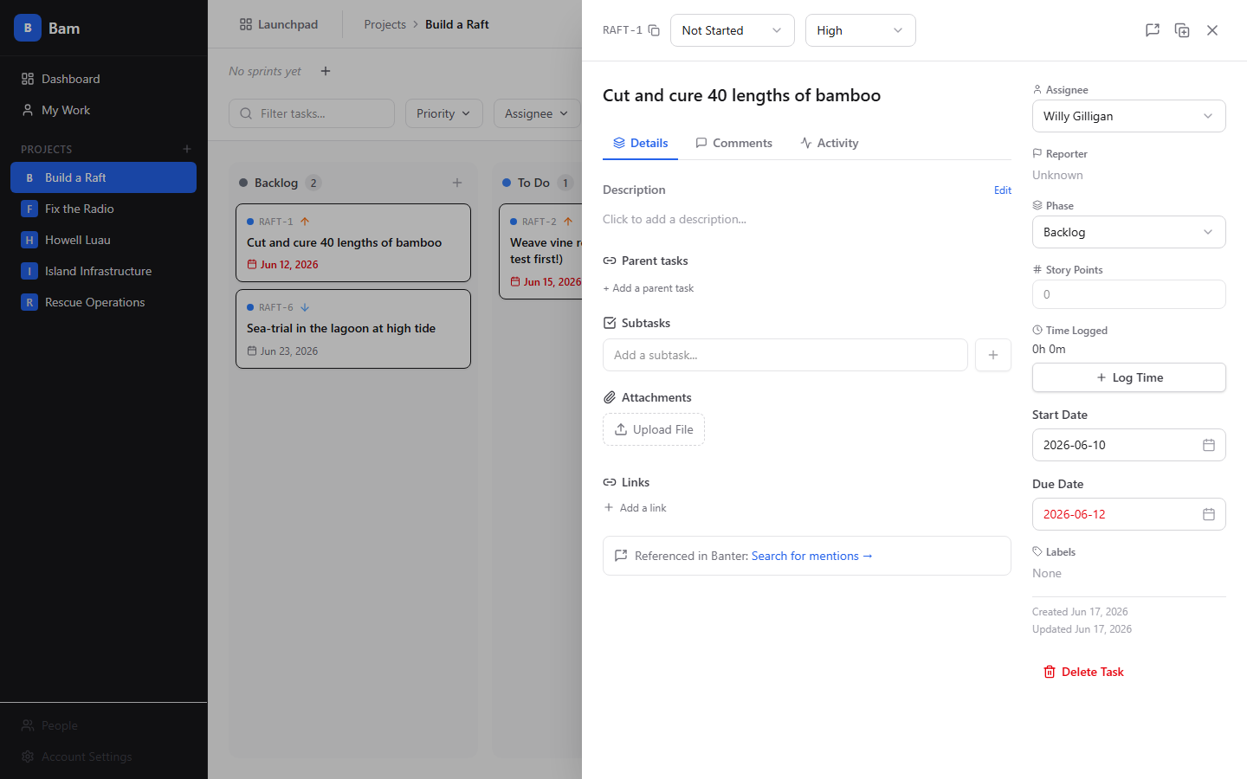
Figure 1.2 Task detail

Creating and editing tasks
To create a task from the create dialog:
1. Trigger the dialog from a column's add control or press the N shortcut.
2. Fill in Title (placeholder "What needs to be done?"), and optionally
Phase, Priority, Story Points, Assignee, Due Date,
Labels, and a description. The Assignee picker lists every org member.
3. Click Create Task.
To edit a task, open its drawer and change fields inline, or use the card context
menu for quick priority, phase, state, and assignee changes.
To duplicate a task, use Duplicate task in the drawer header or Duplicate
in the card context menu. You can include subtasks when duplicating.
Bam blocks moving or updating a task into a closed state while it has open
subtasks. Parent-child links are guarded against self-parenting and cycles.

Subtasks and parent tasks
A task can have multiple parents and multiple subtasks.
To add a subtask, open the task, and on the Details tab type a title into the
Add a subtask... input and confirm. The subtask progress bar tracks how many
subtasks are done.
To mark a subtask done, click its checkbox. Click the row body to open the subtask
in the drawer.
To add a parent, in the Parent tasks section click + Add a parent task (or
+ Add another parent), search by title or id, and pick a task. Remove a parent
with the X on its chip.

Sprints
Sprints are time-boxed iterations you run from the board's sprint selector.
To create a sprint, open the sprint selector and choose Create sprint, then set
a name (placeholder "Sprint 1"), start and end dates, and an optional goal.
To start a sprint, select it and choose Start this sprint. Only one sprint can
be active per project, so starting a sprint while another is active is rejected.
Starting a sprint sends a Slack notification and fires a sprint-started event.
To complete a sprint, choose Complete Sprint. The complete dialog is titled
Complete Sprint: NAME and lists every incomplete task with a per-task dropdown:
Carry forward, Move to backlog, or Cancel task. Add optional
Retrospective Notes (optional) and click Complete Sprint. Velocity is
computed from closed tasks.
To delete a planned sprint, choose Delete this sprint from the selector. To
cancel an active or planned sprint, the Cancel action moves its tasks back to the
backlog and sets the sprint status to cancelled.
To review a finished sprint, choose View sprint report.
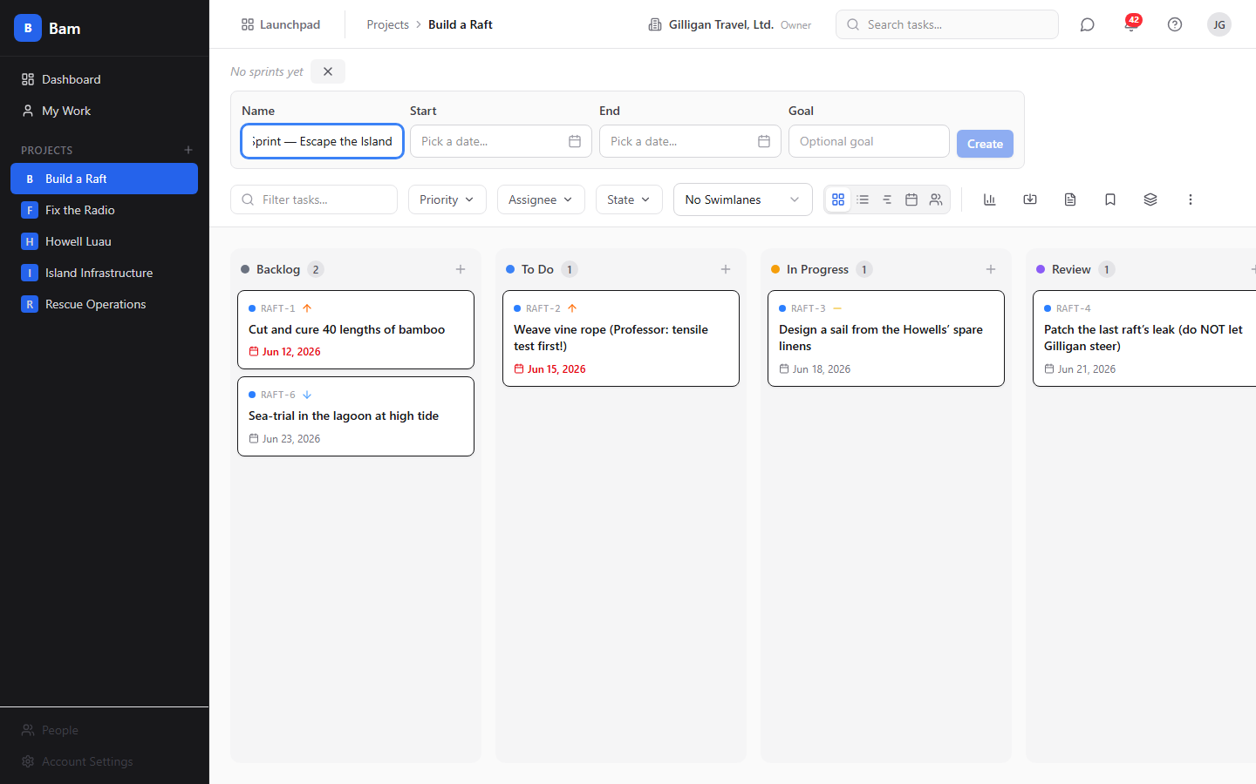
Figure 1.3 Sprint planning

Carry-forward
When you complete a sprint, carry-forward decides what happens to unfinished work.
In the Complete Sprint dialog, set each incomplete task's dropdown:
- Carry forward moves the task to the target sprint, increments its
carry-forward count, and stamps its original sprint.
- Move to backlog removes the task from the sprint (descoped).
- Cancel task leaves the task in the completed sprint.
Carried-forward cards show a carry-forward badge on the board, and the original
sprint is preserved so reports stay accurate.

Epics
Epics group tasks across sprints.
To manage epics, click Manage epics in the board header to open the epic
manager, then create an epic with a name, description, color, and optional start
and target dates.
To assign a task to an epic, open the task and set its Epic in the drawer
sidebar.
To view epic progress, open an epic's detail page (click its chip) for a
group-by-sprint task list and a burnup chart, with rollups of task and story-point
counts.

Phases (columns)
Phases are the board's columns and define your workflow.
To manage phases, open the Project options menu and choose Manage Phases.
From the phase manager you can add, edit, reorder, and delete phases, and set a
WIP limit, color, start and terminal flags, and an auto-state applied on entry.
When you delete a phase you can re-home its tasks to another phase.

Task states
Task states are the per-project status values, seeded from the project template.
Each state has a category (todo, active, blocked, review, done, or cancelled) and a
closed flag. You set a task's state from the drawer header, the card context menu's
Set state, or by dragging into a phase with an auto-state.

Labels
Labels are project-scoped tags.
To add a label to a task, open the create dialog or the task drawer and pick from
the project's labels. Labels are managed per project and are also visible
org-wide to the cross-app resolver.

Custom fields
Custom fields add project-specific data to every task.
To manage custom fields, open the Project options menu and choose Custom
Fields. Create a field of one of the seven types: text, number, date, select,
multi-select, checkbox, or url. A field can be marked required and can be shown on
the card. Custom-field values appear in the Custom Fields section of the task
drawer sidebar.

Saved views
Saved views remember a filter, sort, swimlane, and view-type combination.
To save a view, set your filters, swimlane, and view, then click Saved views
in the board header and save the current configuration. A saved view can be
private to you or shared with the project; only the owner can edit or delete it.
Saved views persist the Board, List, Timeline, and Calendar view types. Workload is
a view mode you can switch to, but it is not a persistable saved-view type.

Alternate views (List, Timeline, Calendar, Workload)
The view switcher in the board header toggles between five views: Board,
List, Timeline, Calendar, and Workload.
To change view, click the matching icon in the view switcher.
- List is a flat, sortable table of the project's tasks.
- Timeline lays tasks out by date as a Gantt chart, using each task's start and
due dates.
- Calendar places tasks on their due dates.
- Workload shows load per user; clicking a user there filters the board to that
user.
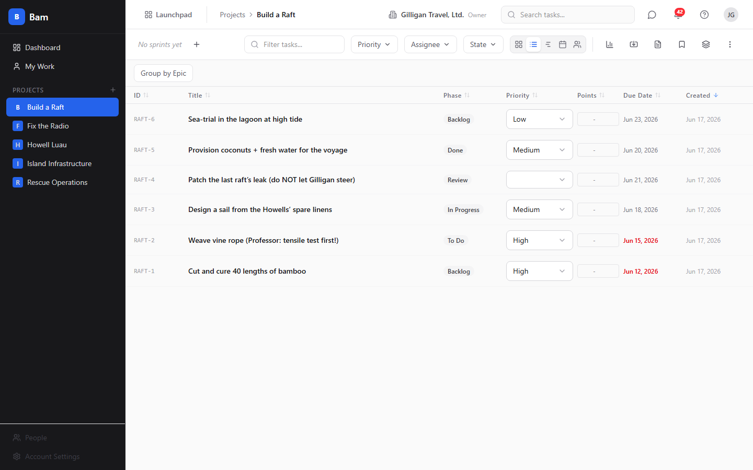
Figure 1.4 List view

Task templates
Templates are reusable task blueprints.
To manage templates, click Task templates in the board header. A template can
carry a name, title pattern, description, priority, labels, phase, story points,
and a list of subtask titles.
To create a task from a template, apply the template; Bam creates the task and its
subtasks, and you can override fields at apply time.

Import
Import brings an existing backlog into a project.
To import, click Import tasks in the board header to open the import dialog.
You can import from CSV, Trello, Jira, or GitHub Issues. For CSV you map columns,
preview a dry run before committing, and configure value maps, link mappings,
custom-field mapping, a duplicate strategy (create, skip, or update), and a date
locale (us or iso). Unmatched phases and labels are created automatically.

Export
Export downloads a project's tasks.
To export, open the Project options menu and choose Export. Pick a
Format of JSON or CSV, optionally scope to a specific sprint (or All sprints),
and click Export. Export is rate-limited.

iCal feed
Bam can publish tasks with due dates as a calendar feed.
To subscribe, generate a calendar token for the project (or use your personal
feed), then add the feed URL to an external calendar app. Project feeds are served
at /projects/:id/calendar.ics and your personal feed at /me/calendar.ics, each
authenticated by a token in the query string. You can create and revoke calendar
tokens per project.

Comments, reactions, and revisions
Discuss work directly on the task.
To comment, open a task, go to the Comments tab, write in the editor, and
click Comment. To react, click a reaction on a comment; the five reactions are
thumbs-up, heart, rocket, eyes, and party. You can edit and delete your own
comments. Editing snapshots the previous version, and an "(edited)" badge opens the
full revision history.

Time tracking
Log time against a task as separate entries.
To log time, open a task and in the Time Logged section of the sidebar click
Log Time, enter minutes, a date, and an optional description, then save. Each
entry is its own row and the total rolls up into the task's logged time. Your
personal time entries are also available across a date range.

Attachments
Attach files to a task.
To add an attachment, open a task and in the Attachments section click
Upload File and choose a file. Each attachment shows its size and date with
download and delete controls.

Task links
Attach external URLs to a task.
To add a link, open a task and use the Links section on the Details tab to
add an http(s) URL with a title. A task can hold up to 50 links.

Reports and project dashboard
Bam reports on delivery at the project level.
To view reports, open a project's dashboard at /projects/:id/dashboard or its
reports at /projects/:id/reports. Available reports include velocity, burndown,
cumulative flow, cycle time (average and median lead time), overdue tasks,
workload, time tracking over a date range, and status distribution. Burndown can
target a specific sprint or the active sprint.

Audit log
Every project keeps an append-only activity record.
To view it, open the project audit log at /projects/:id/audit-log. Entries are
written to the append-only, monthly-partitioned activity log.

People and members
Manage the people in your org and projects.
To manage people, open /people (org admins and owners) for the people list and
each person's detail page at /people/:userId. The detail page has tabs
Overview, Projects, Access, and Activity. From Overview you
edit identity (display name, timezone) and membership (role, default org). From
Projects you add the user to projects with a role. From Access you manage
API keys, sessions, and password resets. Platform SuperUsers use
/superuser/people.
To add a member to a project, use the project's member controls (project admin
only) or add the user to projects from their Projects tab. Note that
assignment is not gated on project membership: the task Assignee picker lists
every org member, so you can assign a task to someone who is not yet a project
member.

My Work
My Work is your personal queue across every project. It lists only the tasks
assigned to you (it queries each project's task list filtered to your user id), so
it never shows another person's work.
To open it, click My Work in the sidebar. The page groups your open tasks into
Overdue, Due This Week, In Progress, and All My Tasks. Tasks land
in Overdue or Due This Week based on their due date, in In Progress if
they have a start date, and in All My Tasks otherwise. Completed tasks are
hidden, and when nothing is assigned you see "All caught up!".
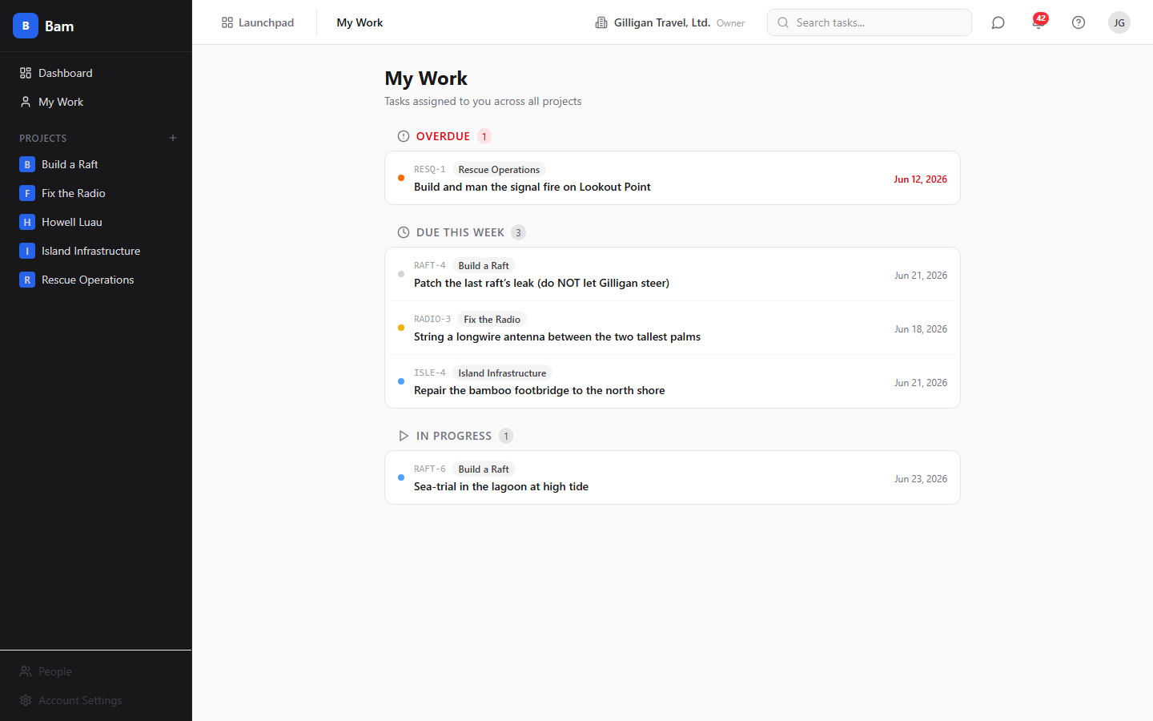
Figure 1.5 My Work

Settings
Settings control your profile and the org's configuration.
To open settings, go to /settings. The ten tabs are Profile, Appearance
(System, Light, Dark), Notifications, Members, Tasks (which includes
Manage Priorities), Permissions, Launchpad, Integrations (API
keys, agents and service accounts, webhooks, Slack, and the per-org SMTP
override), AI Providers, and Helpdesk. Use the Tasks tab's Manage
Priorities to configure the org's priority set. The per-org email relay lives
on the Integrations tab; the platform-wide relay it falls back to is set in
the SuperUser Console (see Email delivery (SMTP) below).
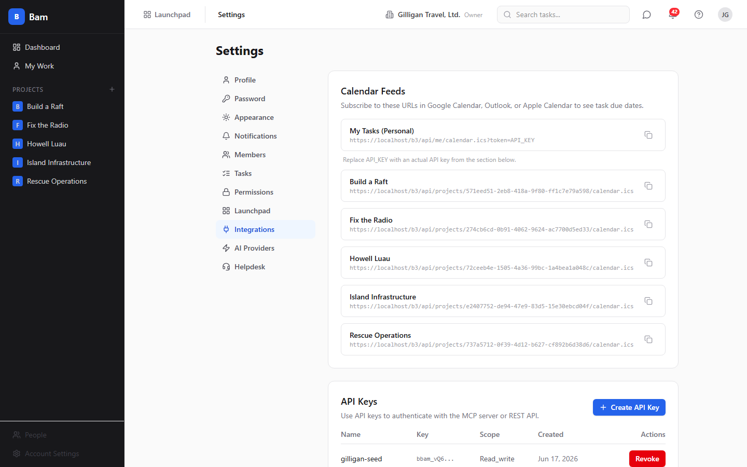
Figure 1.6 Integrations and API keys

Email delivery (SMTP)
BigBlueBam sends outbound mail (org invitations, password resets, system and
reporting alerts, and Blast campaigns) through an SMTP relay. There are two
levels of configuration, and the system always picks the most specific one that
is set.
The resolution order is: the org override first, then the platform
relay, then the server's environment default. In plain terms: if your
organization has set its own relay, your org's mail goes through it; if it has
not, your org's mail falls back to the platform relay a SuperUser configured;
and if neither is set, the system uses the SMTP values baked into the server's
environment variables. This used to live under Account Settings >
Integrations; the platform relay has since moved to the SuperUser Console, and
the per-org override now sits in its own card on the Integrations tab.
Platform email (SMTP). The platform relay is the system-wide, fallback
sender. It is what the platform uses for new-org-setup invitations, the
password-reset fallback, and system and reporting alerts, and it is the relay
any organization falls back to when it has not configured its own. Only a
platform SuperUser can set it.
To configure the platform relay, open the SuperUser Console at
/superuser, click the Platform tab, and scroll to the Platform SMTP
relay card. Fill in SMTP Host, SMTP Port (587 for STARTTLS, 465 for
TLS-only), SMTP Username, SMTP Password, and From Address, set Use
TLS (secure) for port 465, and save. Any field you leave blank falls back to
the matching server environment variable (SMTP_HOST, SMTP_PORT, SMTP_USER,
SMTP_PASS, EMAIL_FROM). Use Test connection to verify login and TLS, or
enter an address and click Send test email to confirm end-to-end delivery.
Changes take effect within 30 seconds.
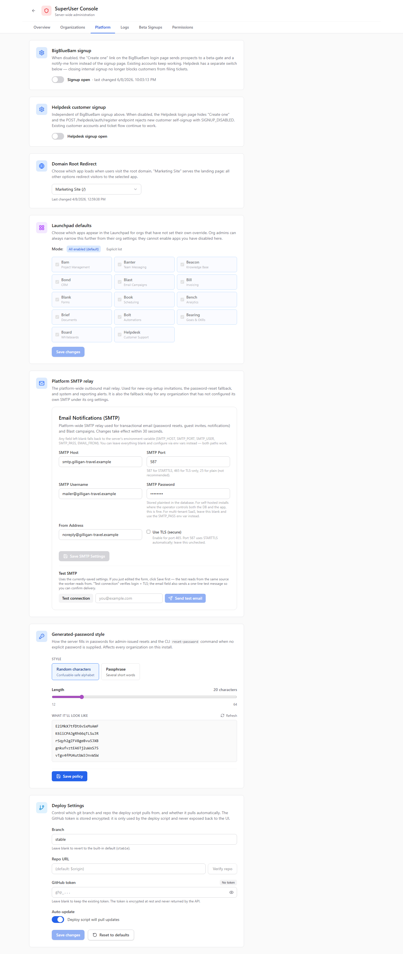
Figure 1.7 Platform email (SMTP)
Organization email (SMTP). An org admin or owner can give their organization
its own relay, which overrides the platform relay for that org's outbound mail
(Blast campaigns and member or guest invitations). Leaving it blank keeps the
org on the platform relay.
To configure the org override, open /settings, select the Integrations
tab, and scroll to the Organization Email (SMTP) card. Fill in the same
fields and save; the card confirms whether the org is using its own relay or
falling back to the platform relay. The relay password is masked on read, so
leaving the dots in place keeps the stored password unchanged. Test relay
checks whichever relay will actually send (your org override if set, otherwise
the platform fallback). To stop using the org relay, click Use platform
relay, which clears the override. Changes take effect within 30 seconds.
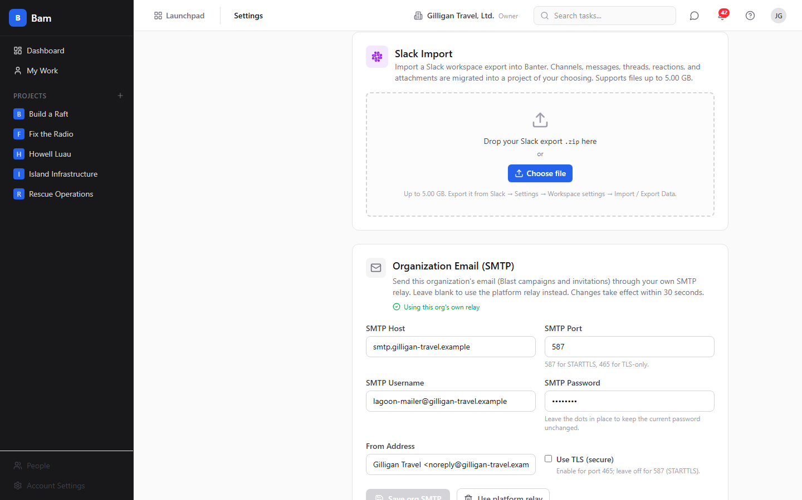
Figure 1.8 Organization email (SMTP)

Command palette and keyboard shortcuts
Bam has power-user navigation built in.
Press Ctrl/Cmd+K to open the command palette. Other shortcuts: N creates a
task, S or / focuses search, F toggles the filter, Esc closes the
current overlay, and ? opens the Keyboard Shortcuts overlay and Help.

Notifications
Bam delivers in-app notifications.
To review notifications, open your notifications list; you can mark a single
notification read, or mark all read.

Cross-app integrations
Bam connects to other apps in the suite:
- Helpdesk - Tasks created from a Helpdesk ticket show a Helpdesk tab in
the drawer linked to the source ticket.
- GitHub - Commits and pull requests can link to a task and appear in the
drawer's linked section.
- Slack - Starting and completing a sprint, and task events, can post to
Slack.
- Banter - Use Share to Banter from the task drawer to post a task into a
channel. Banter messages that reference a task's human id deep-link back into
Bam.
- Bolt - Task, sprint, epic, and comment changes emit events to Bolt.
- Launchpad - Cross-app navigation links Bam to the rest of the suite.

Working with AI agents
Agents drive Bam through its MCP tools, which accept natural identifiers (project,
phase, sprint, and label names, a user's email, or a human id like FRND-42) as
well as UUIDs. The catalog spans nine Bam tool files and lets an agent do nearly
everything a human can on the board:
- Tasks - search_tasks, get_task, bam_get_task_by_human_id,
create_task, update_task, move_task, delete_task, bulk_update_tasks,
log_time, duplicate_task, import_csv, task_upsert_by_external_id,
bam_add_task_parent, bam_remove_task_parent, bam_list_task_parents,
bam_list_task_subtasks.
- Sprints - list_sprints, create_sprint, start_sprint,
complete_sprint, get_sprint_report.
- Projects - list_projects, get_project, create_project,
test_slack_webhook, disconnect_github_integration.
- Epics - bam_create_epic, bam_update_epic, bam_get_epic,
bam_list_epics.
- Members and users - list_members, get_my_tasks,
bam_find_user_by_email, bam_find_user, bam_invite_member,
bam_admin_reset_password, bam_send_password_reset_link.
- Reports - get_velocity_report, get_burndown, get_cumulative_flow,
get_overdue_tasks, get_workload, get_status_distribution,
get_cycle_time_report, get_time_tracking_report.
- Templates - list_templates, create_from_template.
- Comments - list_comments, add_comment.
- Import - import_github_issues, suggest_branch_name, bam_import_csv.
Resolver helpers (bam_list_labels, bam_list_phases, bam_list_states) and
identity tools (get_me, update_me, list_my_orgs, switch_active_org) round
out the Bam-specific catalog.
On top of the Bam tools, agents reach Bam through the cross-cutting agentic
platform that every app shares:
- Identity, audit, heartbeat - An agent identifies itself and reports liveness
with agent_heartbeat, reviews its own recent actions with agent_audit, and
describes its capabilities with agent_self_report. Every write an agent makes
is recorded with an agent actor type in the activity log.
- Approval queues - For work that needs a human sign-off, an agent files a
proposal with proposal_create, a human or another agent lists pending items
with proposal_list, and a decision is recorded with proposal_decide.
- Cross-app read plane - search_everything fans a query out across apps
(Bam tasks included) with normalized scoring, resolve_references turns mentions
like FRND-42 into resolved entities, and activity_query reads the unified
cross-app activity view. Composite views project_view and account_view
assemble a rounded picture of a project or account spanning multiple apps.
- Idempotent upserts - task_upsert_by_external_id keys on the project plus an
external id and emits a task.upserted event with a created flag, so an agent
can sync tasks from an external system without creating duplicates.
- Visibility preflight - Before an agent posts a Bam task into a shared
surface, it calls can_access(asker_user_id, entity_type, entity_id) and drops
anything the asker is not allowed to see.
- Agent policies and webhooks - A per-agent kill switch and tool allowlist
(bam.*, task.*, and so on) gate every service-account call, and subscribed
Bolt events are pushed to agent runners via signed outbound webhooks.
Destructive tools require human review. delete_task and
disconnect_github_integration use the two-step confirm_action token flow: the
tool stages the action and returns a time-limited token, and a second call confirms
it. When reviewing agent work, watch the project audit log and the task Activity
tab; both record the agent actor. See docs/apps/bam/mcp-tools.md for the full
tool catalog.

User Stories

Story: Spin up a project from a template
Who: A team lead or org admin starting a new effort.
Goal: Create a project that arrives with phases and states already set up.
Before you start: A session with permission to create projects.
Steps
1. In the sidebar, click Dashboard, or click the plus next to Projects.
2. Click New Project (or Create Project in the empty state).
3. Enter a project name and a task id prefix of 2 to 6 uppercase letters.
4. Choose a project template (for example kanban_standard, scrum, bug_tracking, or
minimal) and submit.
Result: You land on the new project's board. Its phases and task states are
seeded from the template (for example kanban_standard gives Backlog, To Do, In
Progress, Review, Done).
Related: Manage Phases and Custom Fields to shape the board further. Agents use
create_project.

Story: Create and work a task end to end
Who: A team member doing the day-to-day work.
Goal: Take a task from creation to done with full detail along the way.
Before you start: Membership in a project.
Steps
1. Press N or use a column's add control to open the create dialog.
2. Fill in Title, then optionally Phase, Priority, Story Points,
Assignee (any org member), Due Date, and Labels, and click Create
Task.
3. Drag the card across phases as work progresses.
4. Open the task, log time in Time Logged with Log Time, write a note on
the Comments tab, react to a teammate's comment, and upload a file under
Attachments.
5. When finished, set a closed state. If the task still has open subtasks, the
move is blocked until you finish them.
Result: The task moves to a closed state and counts toward sprint velocity, with
its time, discussion, and files attached.
Related: Subtasks, the done-gate, and create_task / update_task /
log_time for agents.

Story: Track your personal load
Who: Anyone with assigned tasks.
Goal: See what you owe and what is overdue across all projects.
Before you start: Tasks assigned to you.
Steps
1. Click My Work in the sidebar.
2. Scan the Overdue, Due This Week, In Progress, and All My Tasks
groups. Only tasks assigned to you appear here.
3. Click any task to jump to its project board and act on it.
Result: You have a single, cross-project view of your own work, with completed
tasks hidden.
Related: Agents use get_my_tasks.

Story: Plan and run a sprint
Who: A team lead running iterations.
Goal: Plan a sprint, work it, and close it cleanly.
Before you start: A project with tasks; no other active sprint.
Steps
1. In the board's sprint selector, choose Create sprint and set a name, start
and end dates, and an optional goal.
2. Add tasks to the sprint (set each task's Sprint in its drawer, or filter to
the sprint).
3. Choose Start this sprint to make it active.
4. Work the board through the sprint.
5. Choose Complete Sprint, decide each leftover task's fate, add
Retrospective Notes (optional), and click Complete Sprint.
6. Review velocity with View sprint report.
Result: The sprint is completed, leftover tasks are routed, and velocity is
recorded.
Related: Carry-forward; create_sprint, start_sprint, complete_sprint,
get_sprint_report.

Story: Carry forward unfinished work
Who: A team lead closing a sprint with leftover tasks.
Goal: Move unfinished tasks to the next sprint without losing history.
Before you start: An active sprint with incomplete tasks.
Steps
1. Choose Complete Sprint on the active sprint.
2. For each incomplete task, set the dropdown to Carry forward.
3. Pick the target sprint and click Complete Sprint.
Result: The carried tasks move to the target sprint with a carry-forward badge,
and each task's original sprint is preserved for reporting.
Related: The Plan and run a sprint story; complete_sprint.

Story: Group work under an epic
Who: A planner organizing a larger initiative.
Goal: Track related tasks across sprints under one epic.
Before you start: A project with tasks.
Steps
1. Click Manage epics in the board header and create an epic with a name and
color.
2. Open each task and set its Epic in the drawer sidebar.
3. Open the epic's detail page to see its tasks grouped by sprint and a burnup
chart.
Result: Tasks are grouped under the epic, and the epic page shows progress
rollups.
Related: Agents use bam_create_epic, bam_update_epic, bam_get_epic.

Story: Customize the board
Who: A project admin tailoring the workflow.
Goal: Shape phases, fields, and labels to fit how the team works.
Before you start: Project admin role.
Steps
1. Open Project options and choose Manage Phases to add, reorder, and
configure phases (WIP limits, colors, auto-state on entry).
2. Open Project options and choose Custom Fields to add a field (for
example a select or url field) and mark it shown on the card.
3. Add and color the labels the team needs.
Result: The board reflects the team's workflow, with the right columns, fields,
and labels.
Related: Phases, Custom fields, Labels.

Story: Slice the board with views
Who: Anyone who wants a focused cut of the board.
Goal: Filter and group the board, then save the cut for reuse.
Before you start: A project with tasks.
Steps
1. In the view switcher, pick Board, List, Timeline, Calendar, or
Workload.
2. Apply swimlanes (By Assignee, By Priority, or By Epic) and set
filters.
3. Click Saved views and save the configuration, optionally sharing it with
the project.
Result: Your filtered, grouped view is saved and reusable. (Workload is a view
mode you can switch to but cannot save as a view type.)
Related: Saved views, Alternate views. Tasks need start and due dates for the
Timeline and Calendar views to place them.

Story: Import an existing backlog
Who: Someone migrating work into Bam.
Goal: Bring tasks from a CSV or another tool into a project.
Before you start: Project membership and a source file or connected tool.
Steps
1. Click Import tasks in the board header.
2. Choose CSV, Trello, Jira, or GitHub Issues.
3. For CSV, map columns, set value, link, and custom-field maps, choose a duplicate
strategy (create, skip, or update), and run the preview.
4. Confirm the import.
Result: Tasks land in the project, with unmatched phases and labels created
automatically.
Related: Agents use import_csv / bam_import_csv / import_github_issues.

Story: Report on delivery
Who: A lead or stakeholder checking progress.
Goal: Read the delivery metrics for a project.
Before you start: A project with sprint and task history.
Steps
1. Open the project dashboard at /projects/:id/dashboard, or its reports at
/projects/:id/reports.
2. Review velocity, burndown, cumulative flow, cycle time, overdue tasks,
workload, time tracking, and status distribution.
3. Scope burndown to a specific sprint or the active sprint as needed.
Result: You have the metrics to judge pace and risk.
Related: Agents use get_velocity_report, get_burndown,
get_cumulative_flow, get_overdue_tasks, get_workload,
get_status_distribution, get_cycle_time_report, get_time_tracking_report.

Story: Subscribe to a project calendar
Who: Anyone who wants due dates in their calendar app.
Goal: See task due dates in an external calendar.
Before you start: Access to the project and a calendar token.
Steps
1. Generate a calendar token for the project (or use your personal feed).
2. Copy the feed URL (/projects/:id/calendar.ics or /me/calendar.ics) with the
token in the query string.
3. Add the feed to your external calendar app as a subscribed calendar.
Result: Tasks with due dates appear in your calendar and refresh on the app's
schedule. Revoke the token any time to cut access.
Related: iCal feed.

Story: Deep-link a task across apps
Who: Anyone who shares a task reference in another app.
Goal: Open a task directly from a reference like MAGE-38.
Before you start: Access to the project that owns the task.
Steps
1. From a Banter message or email that references a task (for example MAGE-38),
open /b3/tasks/ref/MAGE-38.
2. Bam resolves the reference to the task.
Result: The project board opens with that task's drawer open.
Related: Share to Banter; the bam_get_task_by_human_id and resolve_references
tools.

Story: Sync tasks from an external system with an agent
Who: An AI agent keeping a Bam project in step with an external tracker.
Goal: Create or update tasks idempotently without making duplicates.
Before you start: A service-account API key whose agent policy allows the Bam
task tools, and an external id per source record.
Steps
1. The agent resolves the project by name or id and confirms write access.
2. For each external record, the agent calls task_upsert_by_external_id with the
project, the external id, and the task fields.
3. Bam creates the task on first sight and updates it on subsequent calls, emitting
a task.upserted event with a created flag each time.
4. For any task the agent intends to surface in a shared channel, it first calls
can_access and drops entities the asker may not see.
Result: The project stays mirrored to the external system with no duplicate
tasks, and every change is recorded under the agent actor in the audit log.
Related: The Working with AI agents section; task_upsert_by_external_id,
can_access, agent_audit.

Related
- Helpdesk (/helpdesk/) - Tickets can create Bam tasks; a created task shows
a Helpdesk tab linking to its source ticket.
- Banter (/banter/) - Share tasks to channels and deep-link back via human
ids.
- Bolt (/bolt/) - Receives task, sprint, epic, and comment events from Bam.
- Bench (/bench/) and the project reports - Delivery metrics and dashboards.
- Bam MCP-tools reference and guide in docs/apps/bam/ (mcp-tools.md,
guide.md). Treat the code as the source of truth where the reference lags.

Check yourself
Every answer is findable in this chapter. Check your work against the Answer Key appendix at the back of the book.
1. What is the maximum length of a project's task id prefix?
a) 2 letters
b) 6 letters
c) 8 letters
d) There is no limit
2. How many sprints can be active in a single project at the same time?
a) Unlimited
b) One
c) Two
d) One per member
3. When you close an active sprint with unfinished tasks, what three things can happen to each incomplete task?
4. What prevents a task from moving into a closed state?
a) A WIP limit on the phase
b) Open subtasks
c) A missing assignee
d) An active sprint
5. What priority does a new task get by default, and how many custom field types does Bam support?
6. Which of these is NOT one of Bam's saved view types?
a) Board
b) List
c) Timeline
d) Mind map
7. Which roles exist at the organization level?
a) owner, admin, and member, plus a guest role
b) admin and member only
c) owner and viewer only
d) There are no roles at the org level
8. A task state is orthogonal to its phase and belongs to one of six categories. Name them.
9. What are the three project roles?
a) admin, member, and viewer
b) owner, admin, and member
c) lead, contributor, and guest
d) admin and member
10. What are the four swimlane options for grouping the board?
11. How do you manually add a watcher to a task in the Bam UI?
a) From the task detail drawer
b) Through the command palette
c) You cannot; watchers are populated by the system as people get involved with the task
d) By assigning the task to them
12. An epic can hold one of three statuses, and it rolls up two metrics across its tasks. What are they?

CHAPTER 2

Banter
Where the conversation lives.

Banter is the chat layer of BigBlueBam: channels, direct messages, threads, reactions, pins, and bookmarks, all sitting right next to the rest of the suite. It shares your Bam identity and your org's people, so there is no second login and no second roster to manage. This chapter walks you from your first visit to #general through posting, threading, searching, and the admin policies that govern who can do what, and it shows where an AI agent can post, schedule, and listen on the same channels your team uses. By the end you will be able to set up channels, run a conversation, and find any message fast.
At a glance
- Channels, DMs, and threads that keep side conversations out of the main timeline
- Rich messages up to 40,000 characters with mentions, reactions, pins, and bookmarks
- Full-text search across every channel you can see, with author, date, and attachment filters
- Org-level policy for who can create channels, retention, file size, and @mention groups
- MCP access, so an agent can post, schedule, DM, and listen for patterns on a channel
In this chapter
Overview . Key concepts . Where to find it . Feature reference . Send a message . Reply in a thread . React to a message . Pin a message . Bookmark a message . Edit or delete your message
Banter is the chat layer of BigBlueBam. It gives your team channels, direct messages, threads, reactions, pins, and bookmarks so conversations live alongside the rest of the suite. Reach for it when work needs a back-and-forth instead of a ticket or a task.

Overview
Banter is a real-time messaging app shared by everyone in your organization. You talk in channels (open rooms anyone can join, or private rooms by invitation), in direct messages (one-to-one or small groups), and in threads that hang off a single message so a side conversation does not flood the main timeline.
Threads hang off a single message, so a side conversation stays focused instead of drowning the channel.
Banter does not have its own login or its own user list. You sign in to BigBlueBam (Bam) first, and Banter uses that same identity and the same people. Everyone you can message is already a member of your org. If you open Banter while signed out, you see "Please log in to BigBlueBam first to access Banter" with a link back to the main app.
NOTE
Banter rides on your BigBlueBam identity. Everyone you can message is already a member of your org, and signing out of Bam signs you out of Banter too.
Banter is in BETA. A "beta" pill appears next to the Banter wordmark in the sidebar. Posting, threading, reacting, pinning, bookmarking, mentions, DMs, search, attachments, and scheduled posts driven by automation or AI agents are all working.
Live audio is not started from inside Banter. The voice and video write actions were retired; every call write endpoint returns HTTP 410 Gone, and live audio for a channel now happens in the suite-wide Bureau docked box (which joins a shared room derived from the channel). Banter keeps a read-only view of past calls and their transcripts, but you do not start or join a call from inside Banter. See "Past calls and audio" below.

Key concepts
- Channel - a named conversation space. Channels are public (anyone in the org can find and join), private (invite only), or a DM type (dm / group_dm). Each channel has a name, an optional topic and description, members with roles, and a slug that is unique within your org.
- #general - the default channel. The first time anyone opens Banter in an org that has no channels, Banter creates #general, marks it the default, and auto-joins every active member (the creator becomes owner). You cannot delete or leave the default channel.
- Channel role - your standing inside one channel: owner, admin, member, or viewer. A viewer is read-only and cannot post. Channel admins manage pins, members, and settings.
- Direct message (DM) - a private conversation with one other person. A group DM is a private conversation with 3 to 8 people total.
- Message - a single post. Messages support rich text (bold, italic, code, links), @mentions, and emoji, up to 40,000 characters. You can edit or delete your own messages.
- Thread - replies attached to a parent message. A reply stays in the thread unless you tick Also send to channel, which also mirrors it into the main timeline.
- Reaction - an emoji you toggle on a message. Click once to add, click again to remove.
- Pin - a channel-wide marker that any member can see in the channel's pinned list. Only channel admins can pin or unpin.
- Bookmark - your own private save of a message, with an optional note. Bookmarks are visible only to you and live on the Bookmarks page.
- Mention - typing @ plus a name notifies that person. Org admins can also define @mention user groups (for example @engineering) that notify everyone in the group.
- Presence - your live status: online, idle, in a call, do not disturb, or offline.
- Scheduled message - a message queued to post later at a set time, or deferred automatically when a channel is inside its quiet hours.
- Quiet hours - a per-channel policy that holds non-urgent posts until the channel's allowed hours. Used mostly by automated and agent posts.
- Agent pattern subscription - a rule that lets an agent or service account listen to a channel and react when messages match a pattern.

Where to find it
Banter is served at /banter/. Reach it from the Launchpad app switcher in the top-left of any BigBlueBam app. The default landing channel is #general (/banter/channels/general); a bare /banter/ visit redirects there.
TRY IT
Open the Launchpad app switcher in the top-left, choose Banter, and land in #general; type a message and press Enter to post your first line.
Prerequisites:
- You must be signed in to BigBlueBam. Banter has no separate login.
- You must belong to an organization. Everyone you can message is a member of that org.
- To create channels, your org's policy must allow it for your role (set under Banter Administration).
- To manage org settings, channel groups, @mention groups, or a Slack import, you need org admin or owner access.
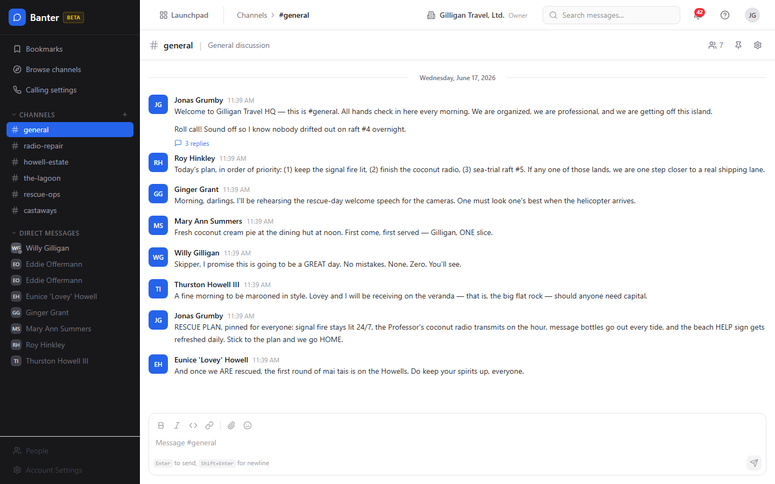
Figure 2.1 Channels & sidebar

Feature reference

Send a message
The compose box sits at the bottom of every channel and DM.
To post a message:
1. Open a channel from the sidebar or a DM from the Direct Messages section.
2. Click the text box that reads Message #<channel> and type.
3. Use the toolbar above the box for formatting: Bold, Italic, Code, Link, Attach file, and Emoji. The emoji picker offers a palette of 24 common emoji.
4. Type @ to mention someone; pick a name from the autocomplete list.
5. Press Enter to send. Use Shift+Enter for a new line. The hint under the box reads "Enter to send, Shift+Enter for newline".
Your draft is saved per channel, so switching channels does not lose what you were typing.
TIP
Because drafts are kept per channel, you can start a reply in one room, jump to another to grab a detail, and come back to find your half-written message still waiting.
To attach a file: click Attach file, pick one or more files, and they upload to storage. While the upload runs you see "Uploading...". Once a file is selected, the box shows "N files attached" with each filename and a Remove all link. The file is linked to the message when you send it, so the recipients see the attachment in the channel. You can send a message that is only an attachment with no text.
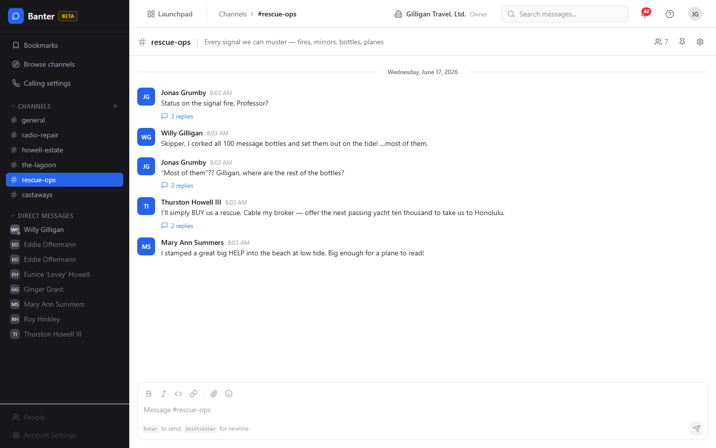
Figure 2.2 Channel conversation

Reply in a thread
Threads keep a focused discussion attached to one message.
To reply in a thread:
1. Hover over the message you want to reply to.
2. In the hover bar, click Reply in thread. The right-hand Thread panel opens.
3. Type your reply in the box labeled "Reply...".
4. To also post your reply into the main channel timeline, tick Also send to channel before sending.
5. Press Enter or click the send button.
The parent message shows a "N reply" / "N replies" link that reopens the thread. Replying notifies the parent author and prior repliers.
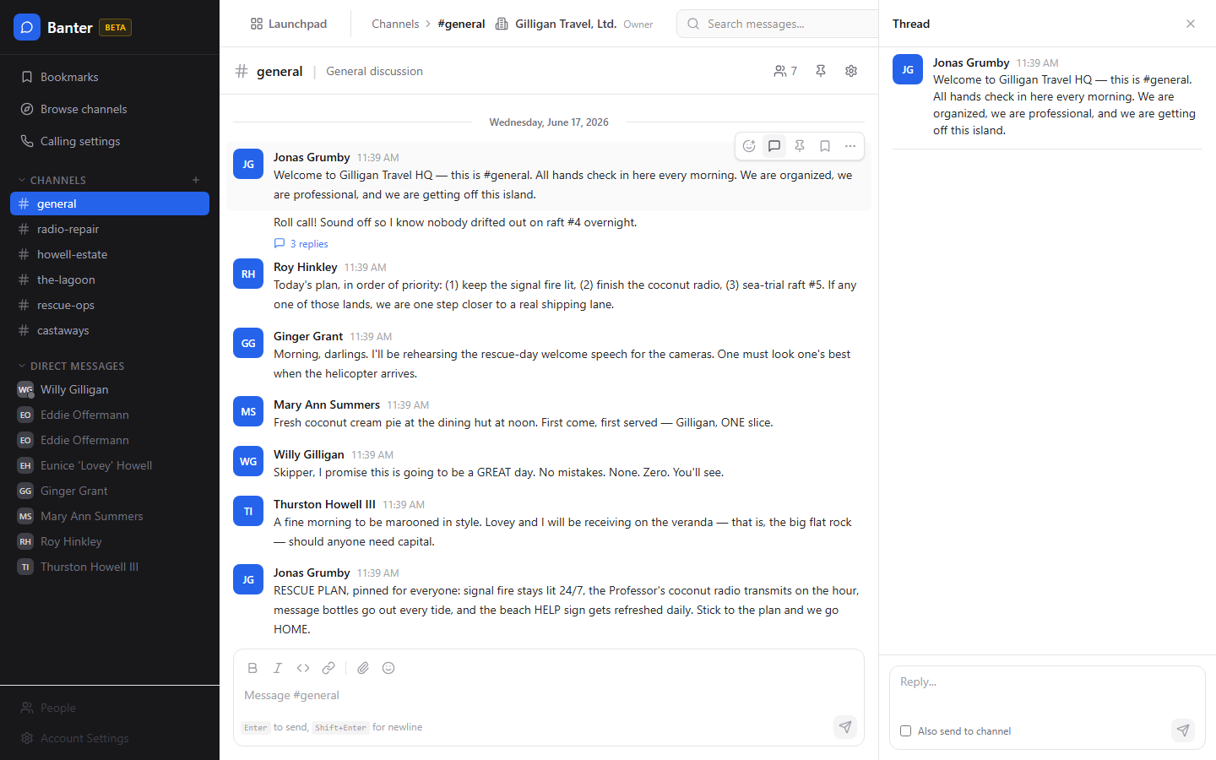
Figure 2.3 Threaded replies

React to a message
To add or remove a reaction:
1. Hover over a message and click Add reaction.
2. Choose an emoji. The quick reactions are thumbs up, heart, laughing, party, eyes, and rocket.
3. Click the same emoji badge again to remove your reaction.
Reaction badges under a message show the emoji and a running count.

Pin a message
Pins are channel-wide and visible to every member. Only channel admins can pin.
To pin or unpin:
1. Hover over the message and click Pin message (or open the more menu and choose Pin to channel).
2. To remove it, hover and click Unpin message (or Unpin from channel in the more menu).
3. View the channel's pins with the Pinned messages button in the channel header.
If you are not a channel admin, pinning fails with "Couldn't pin - channel admins only".

Bookmark a message
Bookmarks are private to you, with an optional note.
To bookmark:
1. Hover over a message and click Bookmark (or choose Bookmark in the more menu).
2. To remove it, click Remove bookmark.
3. Open all your saved messages from the Bookmarks quick action in the sidebar.
On the Bookmarks page each row links to the channel and shows the author and a preview. Use Go to message to jump there or Remove bookmark to clear it. When empty, the page reads "No bookmarks yet".

Edit or delete your message
To edit:
1. Hover over your own message and open the more menu.
2. Click Edit message, change the text, and click Save (or press Enter). Click Cancel or press Esc to discard.
Edited messages show "(edited)". A message may be locked by its author or thread starter; a lock icon and the note "This message is locked - nobody may edit it." indicate you cannot edit it. Org admins and owners can always edit.
To delete:
1. Open the more menu on your own message.
2. Click Delete message.
Deletes are soft (the message is removed from view). Channel and org admins can delete others' messages.

Create a channel
To create a single channel:
1. In the sidebar, find the Channels section and click the + button.
2. In the inline New Channel box, type a name in the channel-name field (lowercase letters, numbers, and hyphens, up to 80 characters).
3. Click Create. You are taken to the new channel.
Whether you can create channels depends on your org policy ("Who can create channels"). The server enforces that policy on every create: with Everyone any member can create, with Admins only only org admins and owners can, and with Organization owners only only owners can. Channel creation is rate-limited to 5 per hour.
To add many channels at once (org admins):
1. Right-click the + button. The tooltip reads "Create channel - right-click to add many".
2. In the Add many channels dialog, paste one channel name per line. The dialog notes "Paste one channel name per line. Up to 50 at a time." and summarizes how many are valid, duplicate, or invalid.
3. Choose Public or Private.
4. Click Create N channels. Each row reports back as created, duplicate, invalid, or error. If any rows are left, Create remaining continues.
Note: the Add many channels dialog uses a coarser permission gate than the single + create. It admits any org admin or owner (and any member when your org's policy allows members to create channels) but does not apply the Organization owners only distinction. If your org is set to owners-only, create those channels one at a time with the + button to be sure the policy is honored, or have an owner run the bulk dialog.

Browse and join channels
To find and join open channels:
1. Click Browse channels in the sidebar. The Browse Channels page opens.
2. Type in the Search channels... box to filter.
3. Each result shows the channel name, a Private pill if applicable, the topic, the member count ("N members"), and when it was last active ("Last active ...").
4. Click Join on a channel you want. Channels you already belong to show Joined.
When nothing matches you see "No channels found" and "Try a different search term". Joining is only allowed on public channels; private channels require an invitation.

Start a direct message or group DM
To start a one-to-one DM:
1. In the sidebar, open the Direct Messages section.
2. Click a team member listed there. A DM opens (or reuses an existing one).
A group DM holds 3 to 8 people total and must be allowed by your org's group-DM setting. If the people list fails to load, the sidebar shows "Couldn't load people - tap to retry"; with no teammates it shows "No team members found".
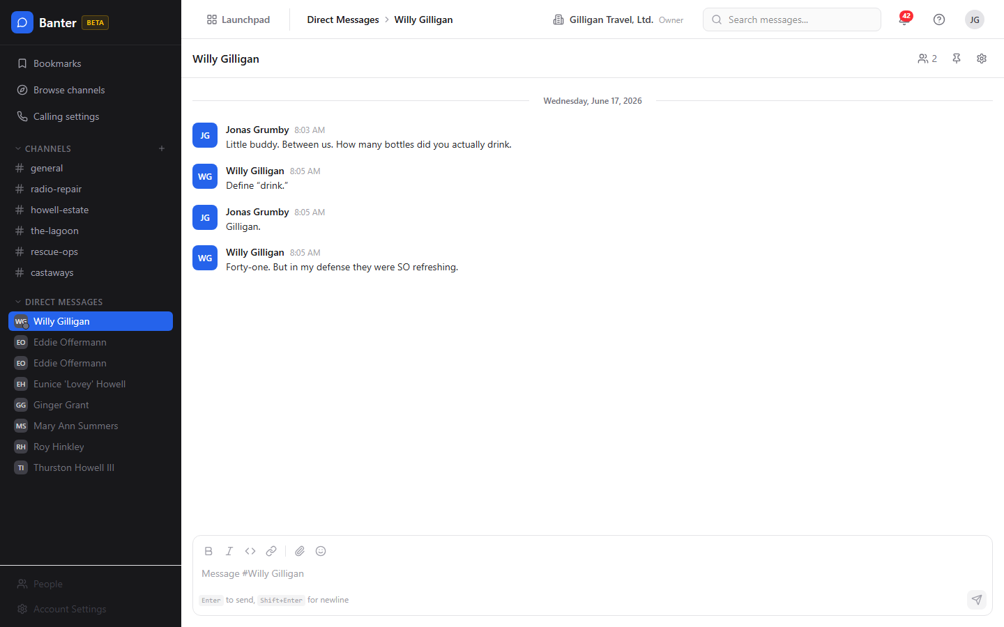
Figure 2.4 Direct messages

Configure a channel
Channel admins manage a channel from its settings.
To change channel settings:
1. In the channel header, click the Channel settings button (gear icon). The Channel Settings modal opens.
2. Edit Channel name, Topic, or Description.
3. Toggle Allow bots and Allow huddles as needed.
4. Click Save Changes. A "Saved!" confirmation appears.
5. Under Members (N), review the member list.
To add a member from this modal, type an email or username into the Email or username field and click Add. The server resolves the identifier to a person in your org (exact email first, then a handle built from the display name) and adds them. If no active member matches, you get a "No active user in this organization matches ..." error.
To archive (delete) a channel:
1. Open the channel's Channel Settings modal, or use the per-channel hover menu in the sidebar.
2. In the Danger Zone (shown only for non-default channels), click Delete Channel.
3. Confirm at the prompt "Are you sure you want to delete #<name>? This will archive the channel and all its messages. This action cannot be undone." by clicking Yes, delete channel.
WARNING
Deleting a channel archives it along with every message in it, and there is no undo. The default channel is the exception: it cannot be deleted or left.
Deleting a channel archives it; it disappears from the active list. The default channel cannot be deleted or left.

Rename, leave, or delete from the sidebar
Hover a channel in the sidebar to reveal its menu:
- Rename - rename in place.
- Channel settings - open the settings modal.
- Leave channel - leave (hidden for the default channel). The last remaining owner cannot leave while other members stay; you see "LAST_OWNER_CANNOT_LEAVE" if you try.
- Delete channel - archive it; click again at "Click again to confirm".

Mark a channel read
Banter tracks your read position automatically. Opening a channel clears its unread badge, and your read cursor syncs across devices, so a channel you read on your laptop is not flagged unread on your phone. Unread channels show a dot, and channels with unread mentions show a count badge. The read cursor is also broadcast (channel.read_cursor_synced) so open tabs update live.

Search messages
The Search page (reached from the header search box or the sidebar) has a query box (Search messages...) and Filters for Channel (All channels), Author (Anyone), From date, To date, and Has attachments. Use Clear all filters to reset.
To search:
1. Open Search from the header search box or the sidebar.
2. Type at least two characters in the Search messages... box and press Enter.
3. Optionally click Filters and narrow by Channel, Author, From date, To date, or Has attachments.
4. Read the result rows; each shows the channel, author, time, and a snippet with the matched terms highlighted. Click a row to jump to that channel.
When nothing matches you see "No results found" and "Try different keywords". Search runs Postgres full-text search over message text and is scoped to channels you can see.
The same search is available to AI agents through the MCP tool banter_search_messages, and there are companion endpoints for channel search (GET /v1/search/channels) and call-transcript search (GET /v1/search/transcripts).
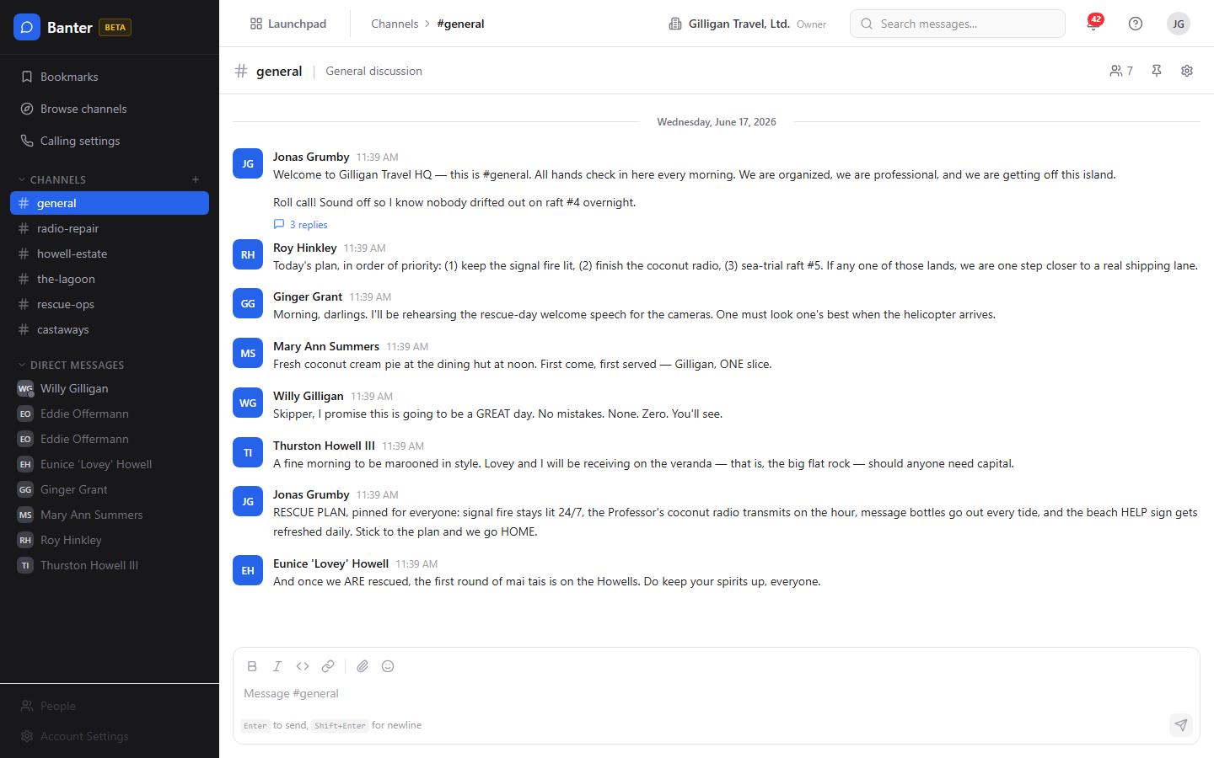
Figure 2.5 Message search

Past calls and audio
Banter no longer hosts the live call experience. Live audio for a channel happens in the suite-wide Bureau docked box, which joins a shared room derived from the channel (huddle-banter-<channel_id>), not inside Banter. There is no "start call" button in a Banter channel, and every call write endpoint in the API returns HTTP 410 Gone with X-Deprecated-Replacement: bureau-docked-box. The matching MCP write call tools target those retired endpoints and will fail if invoked.
What remains in Banter is read-only history:
1. Open a past call's playback page at /banter/calls/:id.
2. Review its type (voice, video, or huddle), duration, participants, and transcript.
Do not expect to start, join, or end a call from Banter. For live audio, use the Bureau docked box.

Keyboard shortcuts
- Ctrl/Cmd+K - quick channel switcher.
- Ctrl/Cmd+Shift+M - toggle mute on the current channel.
- Esc - close the open thread or the channel switcher.
- ? - open Help.
- Up arrow in an empty compose box - edit your last message.

Preferences
Open the Preferences page from the user menu. Sections include Profile, Theme (Light, Dark, System), Notifications (Desktop notifications, Notification sound), and Messaging (Enter to send, Show typing indicators, Compact mode). Click Save Preferences to apply.
Your theme choice (Light, Dark, System) is saved locally in your browser (bbam-theme). The five other toggles - Notification sound, Desktop notifications, Enter to send, Show typing indicators, and Compact mode - are stored on the server, so they round-trip and follow you across devices.
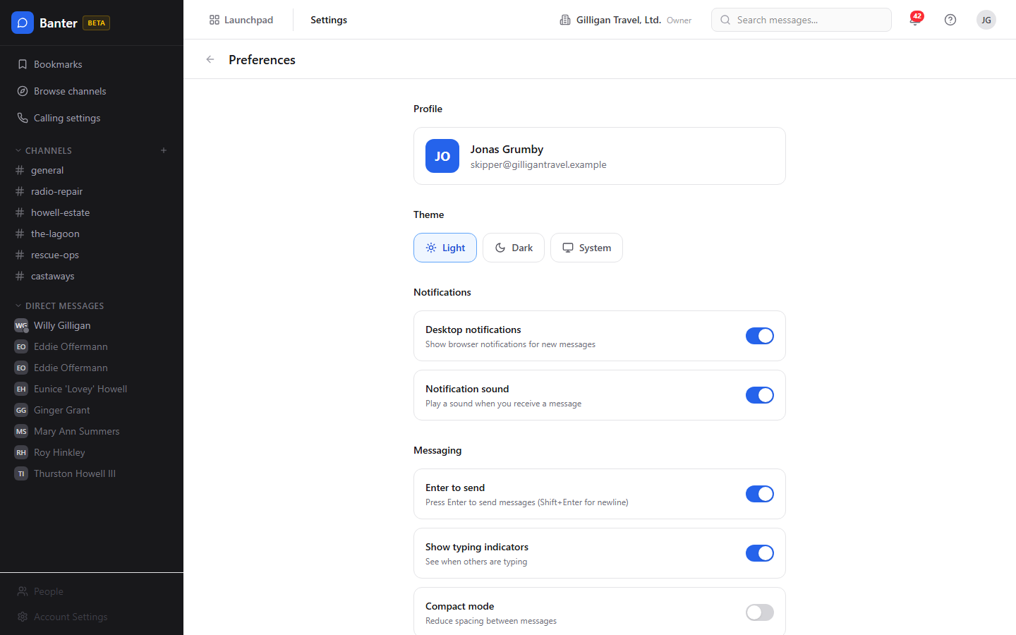
Figure 2.6 Preferences

Admin: organization policy
Org admins open Banter Administration from the Admin link.
To set org-wide policy:
1. Go to Banter Administration.
2. Under Channel Settings, set Who can create channels (Everyone, Admins only, or Organization owners only) and the Default Channel.
3. Under Message Settings, set message retention days and the maximum file size.
4. The Voice & Video section and the Voice Agent / STT / TTS / LLM block configure the external audio integration used by the Bureau audio layer (LiveKit host/key/secret, plus STT, TTS, and LLM providers). Set these only if you run that integration. Test Connection validates LiveKit credentials.
5. Save your changes.
All three Who can create channels options take effect: Everyone lets any member create channels, Admins only limits it to org admins and owners, and Organization owners only limits it to owners. The single + create in the sidebar enforces whichever you choose. (The bulk Add many channels dialog applies a coarser admin-or-owner gate; see "Create a channel".)

Admin: organize the sidebar with channel groups
Channel groups are sidebar buckets that group related channels.
To manage groups:
1. As an org admin, open the channel-groups admin area.
2. Create a group with a name, reorder groups, edit, or delete them.
Channel groups carry a name, a position, and a default collapsed state, and can optionally be tied to a project.

Admin: define @mention groups
User groups let you mention a whole team at once, for example @engineering.
To create one:
1. As an org admin, open the user-groups admin area.
2. Create a group with a name, a handle (the @mention text), and an optional description.
3. Add members to the group.
Mentioning the group's handle in a message notifies every member.

Admin: import from Slack
Org admins can migrate a Slack workspace export.
To run an import:
1. Open the Slack import area under admin.
2. Upload your Slack export .zip. Banter parses it and shows a preview of users and channels.
3. Map each user (auto_match, send_invite, create a stub, map_existing to an existing user, or skip) and each channel (import_new, merge_existing, or skip).
4. Choose options such as preserving timestamps and whether to bring over attachments, reactions, pins, and DMs. A dry-run option is available.
5. Start the import and poll its status until it completes.
6. You can abort an in-progress import and optionally clean up any stub users it created.

Working with AI agents
Agents and service accounts drive a large share of Banter activity through the MCP tool set: over 50 core Banter tools (54 as of this writing) plus 3 subscription tools. The full catalog is in the Banter MCP-tools reference; the most common flows are below. Channel and user arguments accept a UUID, a bare name or #name, or an email or @handle, resolved server-side.
- Post, schedule, DM, react, pin. Agents post with banter_post_message (a channel can be given by #name), reply with banter_reply_to_thread, react with banter_react, pin with banter_pin_message and unpin with banter_unpin_message, and DM with banter_send_dm or banter_send_group_dm (each creates-or-reuses the conversation and posts in one call). Edits use banter_edit_message. Destructive tools (banter_delete_channel, banter_delete_message) require an explicit confirm step via the confirm_action flow.
- Scheduled posts and quiet hours. Use banter_schedule_post with a required scheduled_at to queue a message for later. If a channel has a quiet-hours policy, a normal post inside the quiet window is held and delivered later (when defer_if_quiet is set) or rejected with QUIET_HOURS. A worker delivers scheduled and deferred messages at the right time. List pending ones with banter_list_scheduled_messages and cancel one with banter_cancel_scheduled_message. Banter emits message.scheduled and message.quiet_hours_deferred events so automations can react.
- Passive listening (pattern subscriptions). An agent can subscribe a channel to a pattern with banter_subscribe_pattern (kinds: interrogative, keyword, regex which is admin only, and mention). Matches fire a message.matched event (on source banter) that the agent can act on. Manage subscriptions with banter_unsubscribe_pattern and banter_list_subscriptions. Subscriptions are gated by the channel's agent_subscription_policy and by org-level agent policies; a blocked subscription is recorded but marked not effective (effective:false) with a reason.
- Share suite entities. Agents can drop a Bam task or sprint, or a Helpdesk ticket, into a channel with banter_share_task, banter_share_sprint, and banter_share_ticket.
- Read and resolve. banter_list_messages, banter_search_messages, banter_search_channels, banter_browse_channels, banter_list_channel_members, banter_get_unread, banter_mark_read, banter_find_user_by_email, and banter_find_user_by_handle let an agent read context before acting.
Scheduled posts and quiet hours mean an agent can queue a message and trust it lands at the right moment.
These per-app tools sit on top of the cross-cutting agentic platform. Agents identify themselves and prove liveness with agent_heartbeat; high-impact actions can be routed through an approval queue with proposal_create / proposal_list / proposal_decide. Cross-app discovery uses search_everything and resolve_references (canonical mention syntax) rather than per-app search alone, and the unified activity view stitches Banter posts in with the rest of the suite. Every service-account tool call is checked against the org's agent_policies (per-agent kill switch plus glob allowlist, for example banter.*), and subscribed Bolt events can be pushed to agent runners via signed outbound webhooks.
What a human should know when reviewing agent work: agents posting into shared Banter surfaces honor per-entity visibility (they call can_access for each cited entity and drop anything the asker is not allowed to see), and replies route human-in-the-loop follow-ups to the thread author. Scheduled and deferred posts will appear later than the moment the agent ran, which is expected. Banter emits Bolt events on the banter source (channel.created, message.posted, message.mentioned, message.edited, reaction.added, message.scheduled, message.quiet_hours_deferred, and message.matched) that you can wire into automations or audit.

User Stories

Story: Get into Banter and read #general
Who: A new team member opening Banter for the first time.
Goal: Reach the team's main channel and start reading.
Before you start: You are signed in to BigBlueBam and belong to an org.
Steps
1. Open the Launchpad app switcher in the top-left and choose Banter.
2. Banter loads at #general. If this is the very first visit for your whole org, #general is created automatically and everyone is added.
3. Read the timeline. Unread channels in the sidebar show a dot; mentions show a count badge.
4. Open the Direct Messages section in the sidebar to see who you can message.
Result: You are in #general, can see your channels and teammates, and your read position is tracked from here on.
Related: Create a channel; Start a direct message.

Story: Send your first message
Who: Any member.
Goal: Post a formatted message with a mention to a channel.
Before you start: You are a member (not a viewer) of the channel.
Steps
1. Open the channel from the sidebar.
2. Click the box that reads Message #<channel> and type your text.
3. Select a word and click Bold or Italic in the toolbar to format it; click Code for inline code or Link to add a URL.
4. Type @ and pick a teammate from the autocomplete to mention them.
5. Click Emoji to add an emoji from the palette.
6. Press Enter to send (use Shift+Enter for a new line).
Result: Your message appears in the timeline, the mentioned person is notified, and your draft is cleared.
Related: React to a message; Reply in a thread; Attach a file. An agent can post the same way with banter_post_message.

Story: Attach a file to a message
Who: Any member of the channel.
Goal: Share a file alongside a message.
Before you start: The file is within your org's maximum file size.
Steps
1. Open the channel and click Attach file in the compose toolbar.
2. Pick one or more files. While they upload, the box shows "Uploading...".
3. Confirm the "N files attached" preview lists your files. Use Remove all to clear them and start over.
4. Type a message if you want one, then press Enter to send. An attachment-only message with no text is allowed.
Result: The message posts with its attachments, and everyone in the channel can see and open them.
Related: Search supports a Has attachments filter to find messages with files later.

Story: Create a channel for a new topic
Who: A member whose org allows channel creation, or an org admin.
Goal: Stand up a new channel and start posting in it.
Before you start: Your org's "Who can create channels" policy permits your role.
Steps
1. In the sidebar, click the + next to Channels.
2. In the New Channel box, type a name in the channel-name field using lowercase letters, numbers, and hyphens.
3. Click Create.
4. You land in the new channel; post your first message to seed the conversation.
Result: The channel exists, you own it, and it shows in your sidebar.
Related: To create several at once, an org admin can right-click the + for Add many channels (which uses a coarser admin-or-owner gate). Agents create channels with banter_create_channel.

Story: Find and join an existing channel
Who: Any member looking for the right room.
Goal: Discover a public channel and join it.
Before you start: None.
Steps
1. Click Browse channels in the sidebar.
2. On the Browse Channels page, type in the Search channels... box.
3. Scan the results for the right topic and member count.
4. Click Join on the channel you want.
Result: You are a member; the channel appears in your sidebar and shows Joined in the browser.
Related: Agents can list public channels with banter_browse_channels and join with banter_join_channel.

Story: Start a direct message
Who: Any member.
Goal: Have a private one-to-one conversation.
Before you start: The other person is an active member of your org.
Steps
1. Open the Direct Messages section in the sidebar.
2. Click the person you want to message.
3. Type in the compose box and press Enter.
Result: A private DM opens (or an existing one is reused) and your message is delivered.
Related: For a small group, an org that allows group DMs can start one with 3 to 8 people. Agents use banter_send_dm and banter_send_group_dm.

Story: Hold a side conversation in a thread
Who: Any member.
Goal: Reply to a specific message without cluttering the channel.
Before you start: There is a message you want to respond to.
Steps
1. Hover the message and click Reply in thread.
2. In the Thread panel, type your reply in the "Reply..." box.
3. If the whole channel should see it too, tick Also send to channel.
4. Press Enter to send.
Result: Your reply is attached to the thread, the parent shows an updated reply count, and the parent author and prior repliers are notified.
Related: Agents reply with banter_reply_to_thread.

Story: React, pin, and bookmark a message
Who: Any member (pinning requires channel admin).
Goal: Acknowledge a message, surface it for the channel, and save it for yourself.
Before you start: None for reacting or bookmarking; channel admin for pinning.
Steps
1. Hover the message and click Add reaction, then pick an emoji.
2. If you are a channel admin, click Pin message to add it to the channel's pinned list. Open Pinned messages in the header to review pins.
3. Click Bookmark to save the message privately. Find it later under Bookmarks in the sidebar.
Result: Your reaction shows under the message, the pin (if you added one) is visible to all members, and the bookmark is saved to your Bookmarks page.
Related: Edit or delete your message. Agents use banter_react, banter_pin_message, banter_unpin_message, and banter_create_bookmark.

Story: Edit or delete something you posted
Who: The message author (or a channel/org admin for deletion).
Goal: Fix a typo or remove a message.
Before you start: The message is yours and is not locked.
Steps
1. Hover your message and open the more menu.
2. Click Edit message, change the text, and click Save (or press Enter; press Esc to cancel).
3. To remove it instead, open the more menu and click Delete message.
Result: Edited messages show "(edited)"; deleted messages disappear from the timeline.
Related: Agents use banter_edit_message and banter_delete_message (delete requires confirmation).

Story: Find an old message with search
Who: Any member.
Goal: Locate a past message across the channels you can see.
Before you start: You are in Banter.
Steps
1. Click the header search box or open Search from the sidebar.
2. Type at least two characters of what you remember and press Enter.
3. Click Filters and narrow by Channel, Author, From date, To date, or Has attachments if the results are broad.
4. Click a result row to jump to that message's channel.
Result: You see matching messages with the search terms highlighted, scoped to channels you belong to.
Related: An agent can run the same search with banter_search_messages.

Story: Configure and tidy a channel
Who: A channel admin.
Goal: Set a channel's name, topic, and behavior, add a member, and manage its lifecycle.
Before you start: You are an admin or owner of the channel.
Steps
1. In the channel header, click Channel settings.
2. Edit Channel name, Topic, and Description.
3. Toggle Allow bots and Allow huddles as needed.
4. Click Save Changes and confirm the "Saved!" message.
5. To add a member, type an email or username into the Email or username field and click Add.
6. To archive the channel, open the Danger Zone, click Delete Channel, and confirm with Yes, delete channel.
Result: The channel reflects your changes, the new member is added, or the channel is archived and removed from the active list.
Related: Agents update channels with banter_update_channel, add members with banter_add_channel_members, and archive with banter_archive_channel.

Story: Schedule a message for later (automation and agents)
Who: A workflow or an AI agent.
Goal: Post a message at a specific future time, or respect a channel's quiet hours.
Before you start: An agent or automation with permission to post to the channel. There is no in-app scheduler in the SPA today.
Steps
1. The agent calls banter_schedule_post with the channel, the content, and a future scheduled_at.
2. If the channel has a quiet-hours policy and the post lands inside the quiet window, it is deferred automatically when defer_if_quiet is set, or rejected with QUIET_HOURS otherwise.
3. A worker delivers the message at the scheduled time.
4. Pending scheduled messages for a channel can be listed with banter_list_scheduled_messages and cancelled with banter_cancel_scheduled_message before they send.
Result: The message posts at the right time. Banter emits message.scheduled (and message.quiet_hours_deferred when deferred) for downstream automations.
Related: Pattern subscriptions let an agent listen for matching messages and react.

Story: Have an agent listen for a pattern and respond
Who: An AI agent or service account, plus a channel admin to allow it.
Goal: Trigger agent action whenever messages in a channel match a pattern.
Before you start: The channel's agent_subscription_policy and the org's agent policies allow the agent.
Steps
1. The agent subscribes with banter_subscribe_pattern, choosing a kind: interrogative, keyword, mention, or regex (regex is admin only).
2. When a message matches, Banter fires a message.matched event (on source banter).
3. The agent acts on the match (for example, replies in the thread, routes to a human, or shares a suite entity), honoring can_access on anything it cites.
4. Remove the subscription with banter_unsubscribe_pattern; review active ones with banter_list_subscriptions.
Result: The agent reacts automatically to matching traffic. Blocked subscriptions are recorded as not effective (effective:false) with a reason, so you can see why an agent is not listening.
Related: Share a suite entity into the channel after a match.

Story: Share a task, sprint, or ticket into a channel
Who: A member or an agent.
Goal: Bring a Bam task or sprint, or a Helpdesk ticket, into a conversation.
Before you start: You can see the entity you want to share.
Steps
1. From an automation or agent, call banter_share_task, banter_share_sprint, or banter_share_ticket with the channel and the entity.
2. The shared entity is posted into the channel for everyone to discuss.
Result: The channel shows a reference to the entity, keeping the discussion next to the work.
Related: Reply in a thread to discuss the shared item without flooding the channel.

Story: Set up Banter for the whole org
Who: An org admin or owner.
Goal: Decide who can create channels, set retention and file limits, and organize the sidebar.
Before you start: You have org admin or owner access.
Steps
1. Open Banter Administration.
2. Under Channel Settings, set Who can create channels and the Default Channel.
3. Under Message Settings, set retention days and maximum file size.
4. Create channel groups to bucket channels in the sidebar.
5. Define @mention user groups (for example @engineering) and add members.
Result: New channels follow your policy, the sidebar is organized, and teams can be mentioned as a group.
Related: Migrate an existing Slack workspace with the Slack import. All three "Who can create channels" options are enforced on the single + create; the bulk Add many channels dialog uses a coarser admin-or-owner gate.

Story: Migrate a Slack workspace
Who: An org admin.
Goal: Bring channels, history, and people over from Slack.
Before you start: You have a Slack export .zip and admin access.
Steps
1. Open the Slack import area under admin and upload the .zip.
2. Review the preview of users and channels.
3. Map each user (auto_match, send_invite, stub, map_existing, or skip) and each channel (import_new, merge_existing, or skip).
4. Choose options such as preserving timestamps and importing attachments, reactions, pins, and DMs. Run a dry run first if you want to validate.
5. Start the import and poll its status to completion.
Result: Your Slack content is imported into Banter according to your mapping; you can abort and clean up stubs if needed.
Related: Channel groups and @mention groups help organize the imported channels and teams.

Story: Review a past call
Who: Any member with access to the channel where the call happened.
Goal: Look back at a finished call and read its transcript.
Before you start: A call took place; live audio is handled by the Bureau docked box, not Banter.
Steps
1. Open the call's playback page at /banter/calls/:id.
2. Review the call type (voice, video, or huddle), duration, and participants.
3. Read the transcript.
Result: You have a read-only record of the call. You cannot start, join, or end a call from Banter; use the Bureau docked box for live audio.
Related: None.

Related
- BigBlueBam (Bam) at /b3/ - the host app that owns your identity, organizations, and people. You sign in there before using Banter, and tasks and sprints shared into Banter come from Bam.
- Helpdesk at /helpdesk/ - tickets shared into a Banter channel come from here.
- Bureau docked box - the suite-wide live-audio layer that replaced Banter calls. Use it for voice and video; Banter keeps only the read-only call history.
- Bolt at /bolt/ - the automation engine that consumes Banter events (channel.created, message.posted, message.mentioned, message.edited, reaction.added, message.scheduled, message.quiet_hours_deferred, and message.matched, all on source banter) and can drive Banter actions.
- Banter MCP-tools reference in docs/apps/banter/ - the full catalog of the Banter tools (over 50 core tools plus the 3 subscription tools) used by AI agents.
- Banter guide in docs/apps/banter/ - product-level overview. Where it advertises live voice calls, follow this help doc instead: those calls are retired in Banter, and live audio is handled by the Bureau docked box.

Check yourself
Every answer is findable in this chapter. Check your work against the Answer Key appendix at the back of the book.
1. What is the maximum length of a single Banter message?
a) 4,000 characters
b) 10,000 characters
c) 40,000 characters
d) There is no limit
2. What are the three channel types besides DMs?
a) public, private, and a DM type
b) open, closed, and hidden
c) team, project, and personal
d) default, custom, and archived
3. What are the four channel roles, and which one is read-only?
4. How many people total can a group DM hold?
a) 2 people
b) 3 to 8 people
c) Up to 10 people
d) Up to 50 people
5. Who can pin a message in a channel, and who can everyone see the pin?
6. Who can see your bookmarks?
a) Everyone in the channel
b) Only channel admins
c) Only you
d) Anyone in your org
7. Which of these is one of the live presence statuses in Banter?
a) away on vacation
b) do not disturb
c) in a meeting
d) snoozed
8. What happens the first time anyone opens Banter in an org that has no channels?
9. What are the three options for the 'Who can create channels' org policy?
a) Everyone, Admins only, Organization owners only
b) Members, Managers, Owners
c) Open, Restricted, Locked
d) Everyone, Verified, Owners
10. How is channel creation from the single + button rate-limited?
11. What happens to a reply in a thread unless you tick 'Also send to channel'?
a) It is discarded
b) It stays in the thread only
c) It posts only to the parent author
d) It is queued for later
12. What does Banter now do about live audio calls, and where does live audio happen instead?
13. What is a quiet hours policy, and which posts does it mostly affect?
14. What keyboard shortcut opens the quick channel switcher?
a) Ctrl/Cmd+K
b) Ctrl/Cmd+Shift+M
c) Esc
d) Up arrow

CHAPTER 3

Beacon
Knowledge that stays true, not just written once.

Beacon is your team's knowledge base, built so articles stay accurate over time instead of rotting quietly after the day they were written. You write in Markdown, find answers by meaning with hybrid search, walk a knowledge graph of typed links, and lean on a freshness dashboard that surfaces stale knowledge before it misleads anyone. This chapter takes you from your first published article through search, linking, the governance sweep, and expiry policy, and it shows where an agent can ingest and verify knowledge through the same tools. By the end you will be able to publish an article, find it by meaning, and keep the whole library verified.
At a glance
- Knowledge articles with a full lifecycle: Draft, Active, Pending Review, Archived, Retired
- A freshness signal that flags stale, expiring, or unverified knowledge before it bites
- Hybrid search: semantic plus tags plus link traversal plus keyword fallback
- A Knowledge Graph of typed links and implicit Tag Affinity edges
- Per-scope expiry policy and a Fridge Cleanout dashboard for keeping the library verified
In this chapter
Overview . Key concepts . Where to find it . Feature reference . Knowledge Home . Browse the article list . Read an article (detail page) . Create and edit an article . Lifecycle actions . Search
Beacon is your team's knowledge base: a place to write, search, link, and keep
articles current. It is the app you reach for when knowledge needs to stay
accurate over time, not just get written once and forgotten.

Overview
Beacon stores your team's knowledge as Beacons (knowledge articles). Each
Beacon has a title, a short summary, a Markdown body, an owner, a visibility
level, and an expiry date. Beacons move through a lifecycle (Draft, Active,
Pending Review, Archived, Retired) and carry a freshness signal so stale
knowledge surfaces before it misleads anyone.
Freshness is the whole point: Beacon shows you when knowledge is going stale before anyone acts on it.
Beyond plain storage, Beacon connects articles into a Knowledge Graph of
typed links and shared tags, runs hybrid search (semantic plus tags plus
link traversal plus keyword fallback), and gives governance owners a
freshness-focused dashboard for keeping the library verified. Expiry policies
let an org set how long knowledge stays trusted before it needs re-verification.
Beacon is part of the BigBlueBam suite. It shares your platform login with Bam
and the other apps, pulls its project list from Bam, and publishes lifecycle
events to Bolt so automations can react when knowledge is created, updated,
verified, or retired.
Beacon is currently in BETA. The sidebar logo shows a beta badge.

Key concepts
- Beacon - A single knowledge article. Has a globally unique slug, a title,
a summary (up to 500 characters), a Markdown body, a version number, a status,
a visibility, an owner, an optional project, and an expiry date.
- Status - The article's place in its lifecycle. The five statuses you will
see in the UI are Draft, Active, Pending Review, Archived, and
Retired. New articles start as Draft; publishing makes them Active.
- Visibility - Who can see the article: Public, Organization,
Project, or Private. Public and Organization are visible to all org
members; Private is visible only to the owner or creator; Project is visible
to the owner, creator, or members of that project.
- Freshness - A computed signal based on when the article was last verified
and when it expires. The detail page and cards show one of four states:
Verified recently, Content is stale, Expiring soon, or Needs
verification.
- Verification - A recorded review confirming an article is still accurate.
Verifying resets the expiry date and raises the verification count.
- Challenge - A flag that an Active article may be wrong. Challenging moves
it to Pending Review.
- Tags - Free-form labels on an article. Tags drive filtering, search tag
expansion, and implicit graph edges. They are a search and filter facet: you
add and remove tags as chips on the Search screen to widen or narrow results.
Note: the editor shows a "Tags (comma-separated)" field, but tags typed there
are not saved today (a known limitation; see Create and edit an article). Tags
that appear on articles come from agent or API writes, not from the editor
field.
- Link - A typed connection between two articles: Related To,
Supersedes, Depends On, Conflicts With, or See Also. Links are
read-only in the UI today (created through MCP tools or the API; see Links
between articles).
- Knowledge Graph - The network of Beacons. Nodes are articles; edges are
either explicit typed links or implicit "Tag Affinity" edges between articles
that share enough tags.
- Saved query - A named, reusable search configuration you can reopen later.
Scope can be Private, Project, or Organization.
- Expiry policy - Per-scope rules (System, Organization, Project) that set
the minimum, maximum, and default number of days before an article expires,
plus a grace period.

Where to find it
Beacon lives at /beacon/. You must be logged in to BigBlueBam first; Beacon
has no login of its own and uses the shared platform session. If you are not
signed in, Beacon shows "Please log in to BigBlueBam first to access Beacon."
with a "Go to BigBlueBam Login" link to /b3/.
The left sidebar has six navigation items: Home (/), Browse
(/list), Search (/search), Graph (/graph), Dashboard
(/dashboard), and Beacon Settings (/settings). At the top of the sidebar
is a project scope selector; it shows the active project name or "All
Projects" by default, and it filters most views to that scope.
What you can do depends on your role. Editing access works like this: a
SuperUser can edit any Beacon; an org Admin or Owner can edit any Beacon in the
org; a Member can edit only Beacons they own or created. Editing System-level
expiry policy requires SuperUser.
Press the ? key (when your cursor is not in a text field) to open the in-app
help from any Beacon screen.
TRY IT
Open any Beacon screen and press the ? key while your cursor is outside a text field to pop the in-app help.
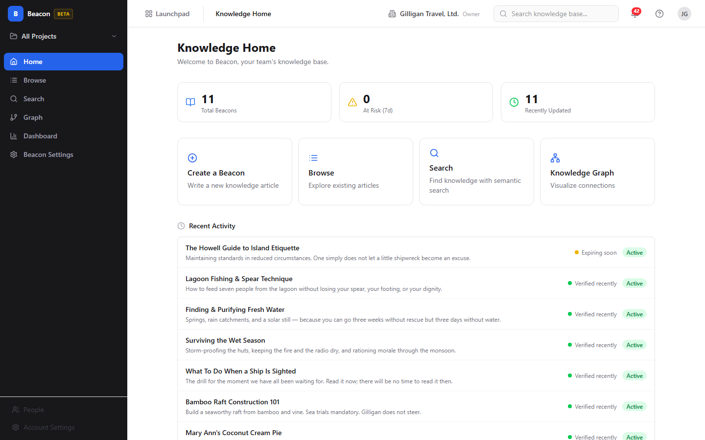
Figure 3.1 Knowledge home

Feature reference

Knowledge Home
The home screen is your starting point. Its heading is "Knowledge Home" with
the subtitle "Welcome to Beacon, your team's knowledge base."
To use Knowledge Home:
1. Open Beacon at /beacon/ or click Home in the sidebar.
2. Read the three stat cards at the top: "Total Beacons", "At Risk (7d)",
and "Recently Updated". Clicking "Total Beacons" or "At Risk (7d)" takes
you to Browse; clicking "Recently Updated" takes you to the Graph.
3. Use a quick-action card to jump into a task: "Create a Beacon",
"Browse", "Search", or "Knowledge Graph".
4. Scroll to "Recent Activity" to see up to 8 recently touched articles;
click one to open its detail page.

Browse the article list
Browse lists the Beacons you can see, with filtering. The screen is titled
"Article list" in docs and rendered at /list.
To browse and filter:
1. Click Browse in the sidebar.
2. Type into the search input (placeholder "Search beacons...") to filter by
text.
3. Click a status chip to filter by lifecycle state: All, Active,
Pending Review, Draft, or Archived.
4. Read the project indicator near the toolbar: it shows "Showing beacons for:
<name>" when scoped to a project, or "Showing all org beacons" otherwise.
5. Click a card to open that article's detail page.
6. Click "Load more" at the bottom to fetch the next page of results.
To start a new article from here, click "New Beacon" (or, if the list is
empty, "Create Beacon" in the "No beacons yet. Create your first one." empty
state).
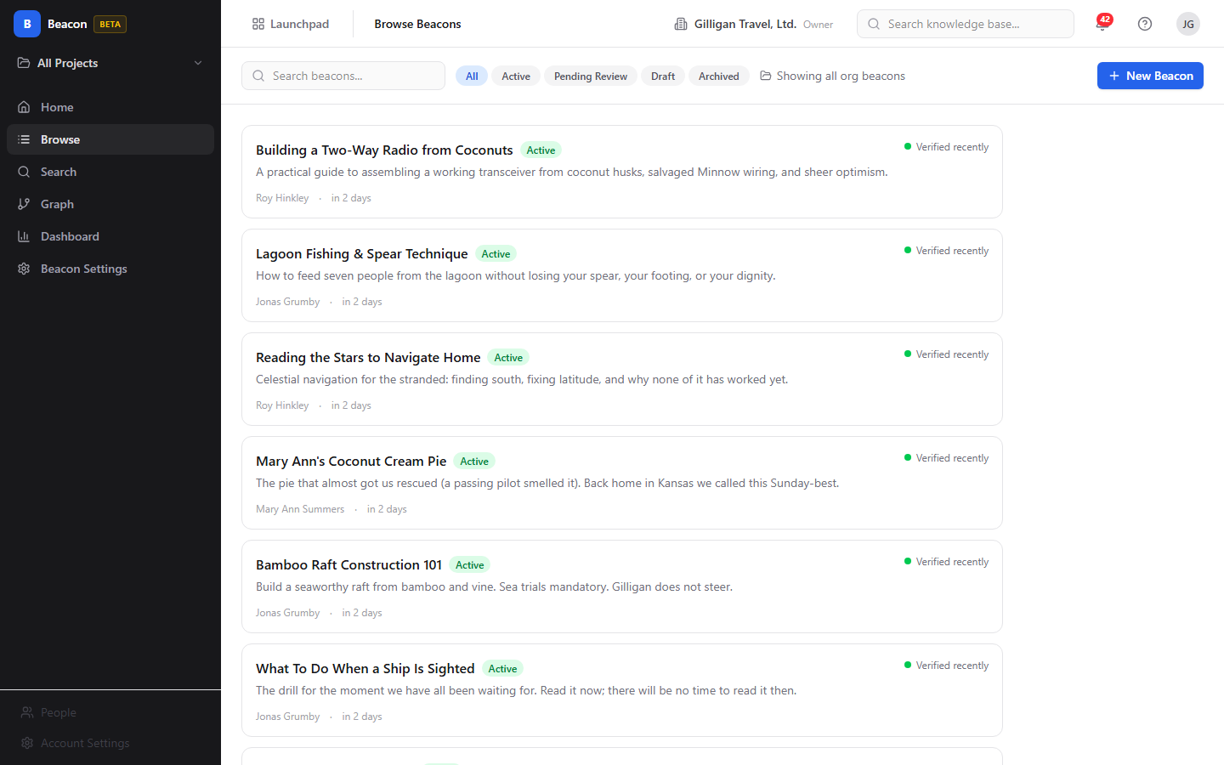
Figure 3.2 Browse articles

Read an article (detail page)
The detail page shows one article in full, with its lifecycle actions and
metadata.
What you see:
- The title, a StatusBadge, a LifecycleActions row, presence chips, and
an "Edit" button.
- The summary, the rendered Markdown body, and the Tags row.
- An Attachments panel and a Comments section.
- A right sidebar with Status, Owner, Project ("Organization-wide"
if the article has no project), Freshness, Expires (a date), Last
Verified ("Never" if it has never been verified), Verifications (a
count), Tags, Linked Beacons (each links to its target), and
Version (vN, with an expandable history). A "View in Graph" link opens
the article in the Graph.
To open an article, click any card in Browse, Search, the Graph, or the Recent
Activity list, then read or act on it from the detail page.
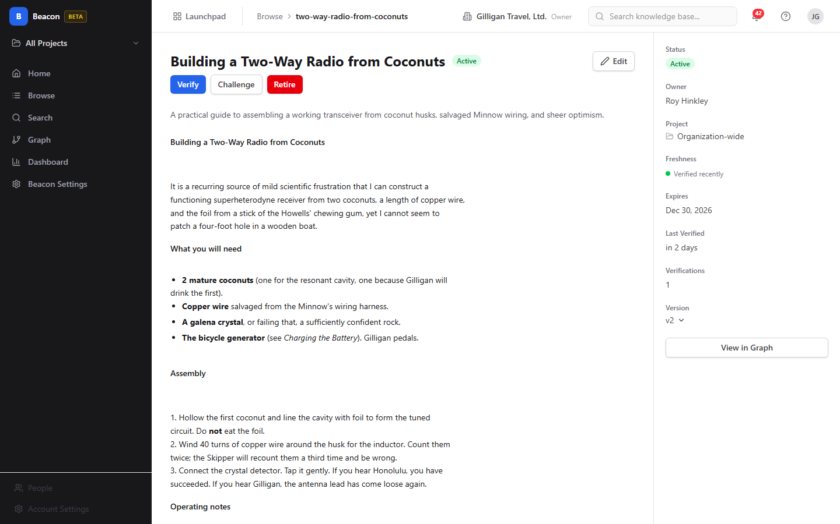
Figure 3.3 Article detail

Create and edit an article
The editor is reached at /create (from the "Create a Beacon" card on Home or
"New Beacon" in Browse) and at /<idOrSlug>/edit (the "Edit" button on a detail
page). The header reads "Create Beacon" or "Edit Beacon".
The body field is a plain Markdown text area, labeled "Body (Markdown)".
You write Markdown directly; there is no rich-text formatting toolbar.
To write a new article:
1. Open the editor with "New Beacon" or the "Create a Beacon" card.
2. Type a title in the title field (placeholder "Beacon title...").
3. Optionally add a Summary (up to 500 characters; a live "N characters
remaining" counter shows your budget).
4. Write the article in Body (Markdown) (placeholder "Write your knowledge
article in Markdown...").
5. Choose Project (optional) from the select. The default option is
"Organization-wide (no project)". This selector is shown only when creating;
when editing, the project is read-only.
6. Choose a Visibility: Public, Organization, Project, or Private. The
editor defaults to Organization.
7. Click "Save as Draft" to keep it as a Draft, or "Publish" to create
it and immediately make it Active. Both buttons are disabled until the title
is non-empty.
Known limitation: the editor includes a "Tags (comma-separated)" field
(placeholder "e.g. onboarding, deployment, api"), but anything you type there is
currently not saved on either create or edit. Do not rely on the editor to set
tags. Tags on an article today come from agent or API writes
(beacon_upsert_by_slug and the tag write endpoints), and you filter by them
on the Search screen.
NOTE
The editor's tag field does not save today. Tags you see on articles were written by an agent or the API, and you filter by them on the Search screen rather than setting them on the editor.
Editing an existing article works the same way, except the Project field is
read-only and your changes bump the article's version and write a version
snapshot.
There is no screenshot of the editor in this set.

Lifecycle actions
Lifecycle actions live in the row under the title on the detail page. Which
buttons appear depends on the article's current status. Each button opens a
confirmation dialog titled "<Action> Beacon".
- Draft shows Publish. Publishing moves the article to Active and
recomputes its expiry. Dialog text: "This will make the beacon visible to
others based on its visibility setting."
- Active shows Verify, Challenge, and Retire.
- Pending Review shows Publish and Retire.
- Archived shows Restore and Retire. Restore returns an Archived
article to Active and resets its expiry. Dialog text: "Restore this beacon to
Active status."
WARNING
Retired is a terminal state. The Restore button still appears on a Retired article, but the server only restores Archived ones, so Restore returns an error and the status will not change. To bring back retired knowledge, recreate or re-author it.
To run a lifecycle action:
1. Open the article's detail page.
2. Click the action button in the lifecycle row.
3. Read the confirmation dialog and click the matching button to confirm, or
Cancel to back out.
Known limitation: a Retired article also shows a Restore button, but the
server only restores articles that are currently Archived. Retired is a terminal
state, so clicking Restore on a Retired article returns an error and the
status does not change. To bring a Retired article back, recreate or re-author
it rather than relying on Restore.
Known limitation: a Pending Review article shows a Publish button, but
the server only publishes articles that are currently Draft. Clicking
Publish on a Pending Review article returns an error ("Cannot publish a
beacon with status 'PendingReview'; must be Draft") and the status does not
change. To return a Pending Review article to Active, verify it instead, which
records a verification and resets its expiry.

Search
Search runs a hybrid query across every Beacon you can access. The heading is
"Search" with the subtitle "Find knowledge across all accessible Beacons."
To search:
1. Click Search in the sidebar.
2. Type a natural-language query in the primary input (placeholder "Search
Beacons...").
3. Optionally narrow with the QueryBuilder controls:
4. Watch the footer's live "~N Beacons match" count update as you adjust
filters.
5. Click a result card to open the article.
Each ResultCard shows the title, a StatusBadge, the summary, a highlighted
matching passage, clickable tag chips ("Add '<tag>' to filters"), match-source
badges ("Semantic match", "Tag expansion", "Link traversal",
"Keyword match"), the freshness state, a verification count, the owner, and
up to two linked beacons with their link type.
Your search configuration is reflected in the URL, so you can copy the link and
share an exact search with a teammate.
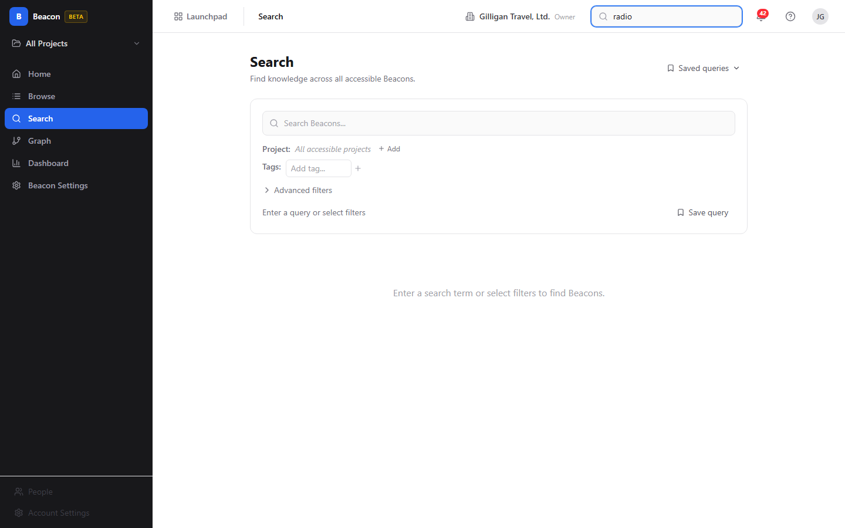
Figure 3.4 Hybrid search

Saved queries
You can name and reuse a search configuration.
To save a query:
1. Build the search you want in Search.
2. Click "Save query" in the footer to open the "Save Search Query" dialog.
3. Enter a Name and pick a Scope: "Private (only me)", Project, or
Organization.
4. Confirm to save.
To reuse a saved query, open the "Saved queries" dropdown at the top right of
the Search screen, then click a saved entry to load it. In the
SavedQueriesPanel you can click an entry to load it, or click its trash icon
to delete it.

Knowledge Graph
The Graph visualizes how articles connect. The heading is "Knowledge Graph".
When no article is focused, the Graph shows a Knowledge Home layout: a "Hub
Beacons" canvas of the most-connected articles on the left, and on the right an
"At Risk" list (expiring within 7 days) and a "Recently Updated" list.
When you focus an article, the Graph draws a force-directed canvas of that
article's neighbors, with a breadcrumb trail, node and edge counts, and an
EdgeLegend explaining the colors.
To explore the graph:
1. Click Graph in the sidebar, or click "View in Graph" on a detail
page to start from a specific article.
2. With an article focused, set Hops: to 1, 2, or 3 to widen or narrow how
many steps out the graph reaches.
3. Use the implicit-edges eye toggle ("Show/Hide implicit edges") to show or
hide Tag Affinity edges.
4. Use the "Filter by Status" dropdown (Active, Pending Review, Draft,
Archived) to dim non-matching nodes; "Filtered nodes are dimmed, not hidden."
Click "Clear" to reset.
5. Click a node to open its NodePopover, which shows the title, status,
summary, tags, freshness, verification count, and owner, plus actions
"View Beacon" (open detail) and "Explore from here" (re-center the
graph on that node).
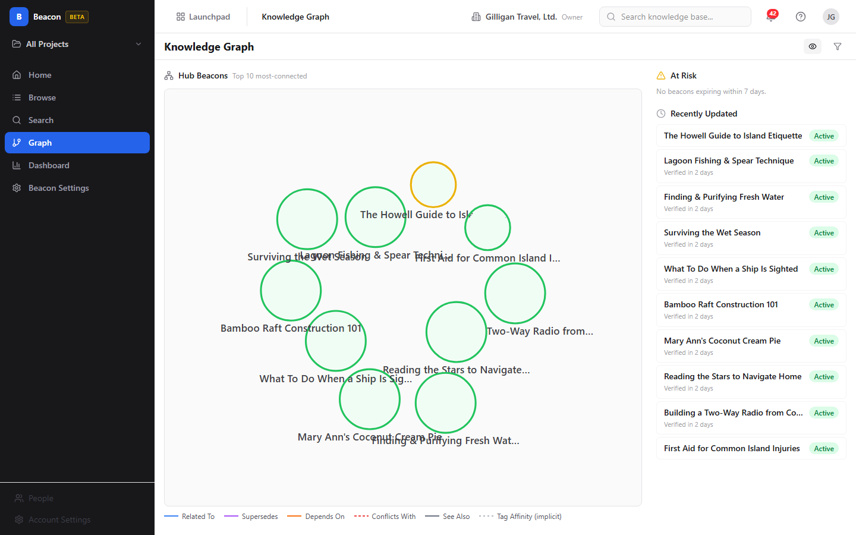
Figure 3.5 Knowledge graph

Tags
Tags label articles for filtering, search expansion, and implicit graph edges.
In the UI today, tags are a search and filter facet rather than something you
add or remove on an individual article.
To work with tags:
1. Open the Search screen and find the Tags: control in the QueryBuilder.
2. Type into the "Add tag..." typeahead and pick a tag to add it as a filter
chip; click a chip's remove control to drop it from the filter.
3. On a ResultCard, click a tag chip ("Add '<tag>' to filters") to add that
tag to your search.
These tag chips add and remove tags from your search filter only; they do not
change the tags stored on an article. The article detail page and graph node
popovers display an article's tags read-only. The editor's "Tags
(comma-separated)" field does not persist (see Create and edit an article), so
the tags you see on articles today are written by agents or the API, not from
the UI. Writing tags goes through the tag endpoints (or beacon_tag_add /
beacon_tag_remove): you may add 1 to 20 tags at a time, each 1 to 128
characters, and removing a tag that is not present returns an error. Article
tags also drive the implicit "Tag Affinity" edges in the Graph.

Links between articles
Links create typed connections between two articles. The available types are
Related To, Supersedes, Depends On, Conflicts With, and See Also.
In the UI today, links are read-only: the detail page lists an article's
existing links under Linked Beacons (each row opens its target), and the
Graph draws them as typed edges. There is no human "create a link" or "remove a
link" control in the Beacon SPA. Links are created and removed through the MCP
tools beacon_link_create and beacon_link_remove (or the equivalent API), so
an agent or integration sets up the connections that you then read and navigate.
To follow an existing link:
1. Open the source article's detail page.
2. Under Linked Beacons, click a target to jump to it.
3. Open the Graph (or click "View in Graph") to see the link as a typed
edge in context.
Creating a duplicate link (same source, target, and type) is rejected at the
tool/API layer.

Comments
Each article has a threaded discussion. The heading is "Comments (n)".
To comment:
1. On the detail page, scroll to the Comments section.
2. Type into the box labeled "Add a comment. Markdown supported." Markdown is
supported in comments.
3. Click "Post Comment".
4. To reply, click Reply on a comment (threads nest up to 4 levels deep).
5. To remove your own comment, click Delete. The confirm reads "Delete this
comment? Replies will also be removed." Admins, owners, and SuperUsers can
delete others' comments.

Attachments
You can attach files to an article. The heading is "Attachments (n)".
To attach a file:
1. On the detail page, find the Attachments panel.
2. Drop a file on the drop zone ("Drop a file here or") or click "Choose
File". The limit is "Max 10 MB. Images, PDF, text, office docs."
3. Each attached file row shows a thumbnail or icon, the filename, the size, the
uploader, and the time, with Download and Delete actions.
4. To remove an attachment, click Delete and confirm "Delete attachment
'<name>'?". The uploader, or an admin, can delete an attachment.
Uploading requires edit access to the article.

Fridge Cleanout (governance dashboard)
The Dashboard is a freshness and governance console. Its header is "Fridge
Cleanout" with the subtitle "Knowledge governance dashboard". It has four
tabs: Overview, At-Risk, Archived, and Agent Activity.
This dashboard is freshness-only. It does not show article-view counts or
search-pattern analytics; those metrics do not exist in Beacon. Everything here
is about keeping knowledge verified and cleaning out stale articles.
To use each tab:
- Overview: read four cards - "Freshness Score" (a percentage),
"At-Risk (7 days)", "Archived Backlog" (articles archived more than 30
days), and "Total Active" - plus a "Freshness Breakdown" bar that reads "X
of Y active beacons verified within 30 days".
- At-Risk: a table of articles expiring within 7 days (Title, Expires,
Owner, Status, Actions). Click a row's Verify or Challenge button to
act on one article. To act in bulk, tick the checkboxes and click "Verify
Selected (n)".
- Archived: articles archived for 30 or more days (Title, Archived Since,
Owner, Actions). Each row offers Restore and Retire. Tick checkboxes
and click "Retire Selected (n)" to retire several at once.
- Agent Activity: recent verification events, each reading "Verified by
<owner> <time>" with the article's verification count (shown as v<count>) and
current status.
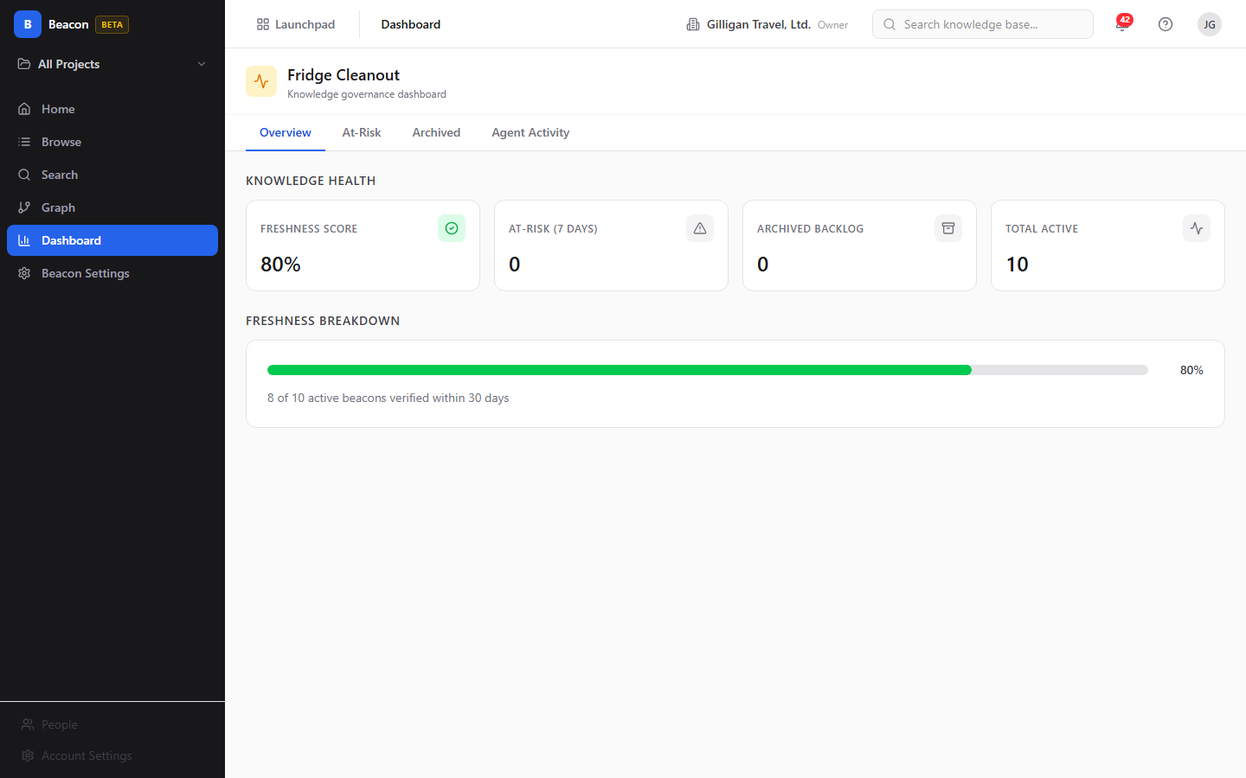
Figure 3.6 Freshness dashboard

Expiry Policy Settings
Beacon Settings is where you set how long knowledge stays trusted. The header is
"Expiry Policy Settings" with the subtitle "Manage knowledge freshness
policies across the hierarchy".
To view and set policy:
1. Click Beacon Settings in the sidebar.
2. Read the "Effective Policy (Your Context)" card, which shows the resolved
Min, Max, Default Expiry, and Grace Period that apply to you right now.
Policies resolve in order: Project, then Organization, then System.
3. Edit a policy in the appropriate editor:
4. In an editor, set Min, Max, and Default expiry (in days) plus the Grace
period. Client validation enforces min <= default <= max and keeps values
within the parent scope's bounds.
5. Click "Save Policy". Success or warning text appears; editors you lack
permission to change show "Read-only - requires higher permissions to edit".
There is no screenshot of Beacon Settings in this set.
A few notes on freshness mechanics that policy controls:
- A daily expiry sweep moves Active articles to Pending Review when they expire,
moves Pending Review articles to Archived after the grace period, and deletes
very old Drafts.
- The lifecycle includes an internal "Expired" value, but the live sweep never
sets it and the UI has no badge for it, so you will not see an "Expired" status
on any article in normal use. The states you encounter are Draft, Active,
Pending Review, Archived, and Retired.

Working with AI agents
Agents drive Beacon through its MCP tools (30 of them). They can author and
update knowledge, run retrieval to ground answers, verify articles, and build or
query the graph and policy. Comments and attachments have no MCP tools, so
agents cannot post comments or upload files; those stay human-only.
Beacon ships 30 MCP tools, so an agent can author, verify, and graph knowledge with the same reach a person has.
Common agent flows and the Beacon-specific tools behind them:
- Idempotent ingestion. Agents write or refresh knowledge with
beacon_upsert_by_slug (the POST /entries/upsert write plane). The tool is
keyed on the article's slug and returns a created flag so the agent can tell
an insert from an update. Re-running it with the same slug updates in place
rather than creating duplicates. This is the recommended path for bulk or
repeated imports; there is no human button for it. Because the editor's tag
field does not persist, agent and API writes are how tags get set on articles.
- Authoring and lifecycle. Beyond upsert, agents have the full set:
beacon_create, beacon_update, beacon_get, beacon_list,
beacon_publish, beacon_verify, beacon_challenge, beacon_retire,
beacon_restore, beacon_versions, and beacon_version_get. Each tool
resolves an article by UUID, slug, or title.
- Grounding and retrieval (RAG). Agents pull knowledge with beacon_search
or beacon_search_context. The context variant always turns on graph and tag
expansion and pre-fetches linked articles, so an agent gets a richer slice of
the graph in one call. beacon_suggest powers typeahead.
- Automated verification. beacon_verify accepts verification types
AgentAutomatic, AgentAssisted, and ScheduledReview, plus an optional
confidence score. Agent verifications show up under the dashboard's Agent
Activity tab, so a human can review what the agent confirmed. The daily
expiry sweep also enqueues Pending Review articles for an agent verification
pass.
- Graph and governance. Agents can build and read the graph with
beacon_link_create, beacon_link_remove, beacon_graph_neighbors,
beacon_graph_hubs, and beacon_graph_recent, and read or set expiry policy
with beacon_policy_get, beacon_policy_set, and beacon_policy_resolve.
Treat policy as the four expiry and grace fields (min, max, default expiry
days, grace period days). Link creation and removal are agent/API only; the
Beacon SPA has no human link-management control.
- Tags and saved queries. beacon_tags_list reads tags in scope;
beacon_tag_add and beacon_tag_remove write them. beacon_query_save,
beacon_query_list, beacon_query_get, and beacon_query_delete manage
saved searches.
TIP
When an agent needs context, beacon_search_context beats plain beacon_search: it always turns on graph and tag expansion and pre-fetches linked articles, so it pulls a richer slice of the graph in a single call.
Platform agent rails. Beacon's tools run inside the suite-wide agentic
platform, so the same guardrails apply here as everywhere:
- Visibility preflight. Before an agent cites a Beacon in a shared surface,
it must confirm the asker can see it by calling can_access (entity type
beacon.entry). Beacons are visibility-gated; refusal reasons include
beacon_private_not_owner and beacon_project_not_member. Anything the asker
cannot see is dropped from the agent's answer.
- Cross-app retrieval. search_everything fans out across the suite and
includes Beacon results with normalized scoring, and resolve_references
turns canonical mentions into Beacon links. Both honor the same visibility
rules.
- Identity, heartbeat, and audit. Agent and service accounts are tagged with
a kind and emit heartbeats (agent_heartbeat); their Beacon writes are
attributed in the unified activity view alongside Bam, Bond, and Helpdesk
events, so you can audit what an agent created, verified, or retired.
- Approvals and policy. High-impact agent work can be routed through the
proposal queue (proposal_create / proposal_list / proposal_decide) for a
human to approve. Per-agent kill switches and tool allowlists (the beacon.*
prefix) gate which agents may touch Beacon at all, and subscribed Bolt events
can be pushed to agent runners over signed outbound webhooks.
For the full tool catalog, see docs/apps/beacon/mcp-tools.md.

User Stories

Story: Write and publish your first article
Who: A new team member who has knowledge to capture.
Goal: Get an article published and visible to the team.
Before you start: Be logged in to BigBlueBam and have create access (any
Member can create).
Steps
1. Open Beacon at /beacon/. On Knowledge Home, click the "Create a
Beacon" card (or click Browse then "New Beacon").
2. In the editor, type a clear title in the field (placeholder "Beacon
title...").
3. Add a short Summary (up to 500 characters).
4. Write the article in Body (Markdown) using Markdown syntax.
5. Leave Project (optional) as "Organization-wide (no project)" or pick a
project.
6. Choose a Visibility. The default is Organization. (The editor also shows a
"Tags (comma-separated)" field, but tags typed there are not saved today, so
skip it; have an agent or the API set tags instead.)
7. Click "Publish" to create and activate the article in one step. (To keep
working on it privately first, click "Save as Draft", then later open the
article and click Publish in the lifecycle row.)
Result: The article is Active and visible according to its visibility
setting. It appears in Browse, Search, and the Graph, and it has an expiry date
computed from the effective policy.
Related: Lifecycle actions; Create and edit an article. An agent does the
same with beacon_create then beacon_publish, or in one idempotent call with
beacon_upsert_by_slug.

Story: Find an answer by meaning
Who: Anyone looking for knowledge without knowing exact keywords.
Goal: Locate the right article using a natural-language question.
Before you start: Be logged in. Articles must already exist and be visible
to you.
Steps
1. Click Search in the sidebar.
2. Type your question in the primary input (placeholder "Search Beacons...").
3. If results are too broad, open "Advanced filters" and narrow by
Status, Tags, Project:, or Freshness.
4. Watch the "~N Beacons match" count to confirm you have narrowed sensibly.
5. Read the match-source badges on each result ("Semantic match", "Tag
expansion", "Link traversal", "Keyword match") to judge why it matched.
6. Click the best result to open the article.
Result: You land on the article's detail page with the relevant passage
highlighted.
Related: Saved queries; the agent equivalents are beacon_search and
beacon_search_context.

Story: Save and reuse a search
Who: Anyone who runs the same lookup repeatedly.
Goal: Keep a search configuration to reopen later.
Before you start: Have a useful search built in Search.
Steps
1. In Search, configure your query and filters as you want them.
2. Click "Save query" in the footer.
3. In the "Save Search Query" dialog, enter a Name and pick a Scope:
"Private (only me)", Project, or Organization.
4. Confirm to save.
5. Later, open the "Saved queries" dropdown at the top right and click your
saved entry to load it.
Result: The saved query reloads its full configuration with one click.
Organization-scoped queries are reusable by teammates.
Related: Search. Agents use beacon_query_save, beacon_query_list,
beacon_query_get, and beacon_query_delete.

Story: Link related articles
Who: A knowledge owner organizing related content.
Goal: Connect two articles with a typed relationship.
Before you start: Links are created through MCP tools or the API; there is no
link-creation control in the Beacon SPA, so this story runs through an agent or
integration with edit access to the source article.
Steps
1. An agent (or API caller) invokes beacon_link_create with the source
article, the target article, and a link type: Related To, Supersedes, Depends
On, Conflicts With, or See Also.
2. Open the source article's detail page and confirm the new link appears under
Linked Beacons.
3. Open the Graph or click "View in Graph" to see the new edge in
context.
Result: The two articles are connected. The edge shows in the Graph with its
type label, and readers can navigate between them from Linked Beacons.
Related: Knowledge Graph; Links between articles. Agents use
beacon_link_create and beacon_link_remove.

Story: Explore how knowledge connects
Who: Someone trying to understand a topic and its dependencies.
Goal: Walk the graph outward from a starting article.
Before you start: Have at least a few linked or tagged articles.
Steps
1. Click Graph in the sidebar, or click "View in Graph" from an
article's detail page.
2. If you started without a focal node, click a hub in "Hub Beacons" to
focus it.
3. Set Hops: to 2 or 3 to widen the view.
4. Toggle the implicit-edges eye control to show or hide Tag Affinity edges.
5. Click a node to open its NodePopover, then click "Explore from here"
to re-center on a neighbor, or "View Beacon" to open it.
Result: You see the network around your topic and can move through related
articles without losing your place.
Related: Link related articles. Agents use beacon_graph_neighbors,
beacon_graph_hubs, and beacon_graph_recent.

Story: Challenge an article that looks wrong
Who: Any reader who spots an inaccuracy.
Goal: Flag an Active article so an owner reviews it.
Before you start: Be able to read the article (challenging needs read access
plus challenge permission).
Steps
1. Open the article's detail page (or find it in the dashboard's At-Risk
tab).
2. Click Challenge in the lifecycle row, or Challenge on the At-Risk row.
3. Read the confirmation ("Flag this beacon for review. It will move to Pending
Review status.") and confirm.
Result: The article moves to Pending Review and surfaces for an owner to
verify, update, or retire.
Related: Keep knowledge fresh; lifecycle actions. The agent tool is
beacon_challenge.

Story: Keep knowledge fresh (governance sweep)
Who: A knowledge owner, admin, or governance lead.
Goal: Verify what is about to expire and clear out old archived articles.
Before you start: Have edit access to the articles you will act on.
Steps
1. Click Dashboard in the sidebar to open Fridge Cleanout.
2. On Overview, check the "Freshness Score" and "At-Risk (7 days)"
cards.
3. Open the At-Risk tab. For an article that is still correct, click
Verify; for one that is wrong, click Challenge. To verify several,
tick their checkboxes and click "Verify Selected (n)".
4. Open the Archived tab. For each old article, click Restore to bring
it back to Active or Retire to remove it. To retire several, tick their
checkboxes and click "Retire Selected (n)".
Result: At-risk articles are verified (their expiry reset) and stale
archived articles are retired or restored. The Freshness Score improves.
Related: Expiry Policy Settings; lifecycle actions. Agents use
beacon_verify and beacon_retire; agent verifications appear under the
Agent Activity tab as "Verified by <owner>" rows with the verification count
(v<count>) and status.

Story: Set the freshness policy for a team
Who: An org Admin, Owner, or SuperUser.
Goal: Control how long knowledge stays trusted before it needs
re-verification.
Before you start: Have policy-edit permission for the scope you want to
change (System policy requires SuperUser).
Steps
1. Click Beacon Settings in the sidebar.
2. Review the "Effective Policy (Your Context)" card to see what currently
applies.
3. In the Organization Policy editor (or Project Policy after picking a
project), set Min, Max, and Default expiry (in days) and the Grace period.
4. Confirm the values satisfy min <= default <= max and stay within the parent
scope's bounds.
5. Click "Save Policy" and read the success or warning text.
Result: New and republished articles in that scope compute their expiry from
the updated policy, and the daily sweep enforces the grace period.
Related: Fridge Cleanout. Agents use beacon_policy_get,
beacon_policy_set, and beacon_policy_resolve.

Story: Discuss and attach evidence to an article
Who: A reviewer or contributor adding context.
Goal: Leave a comment and attach supporting evidence.
Before you start: Be able to read the article; uploading needs edit access.
Steps
1. Open the article's detail page.
2. In the Comments section, type in the box labeled "Add a comment. Markdown
supported." and click "Post Comment". Use Reply to respond in a
thread.
3. In the Attachments panel, drop a file or click "Choose File" (max 10 MB:
images, PDF, text, office docs).
4. Confirm the file appears in the list, with Download and Delete
actions.
Result: The discussion and evidence are recorded on the article for the next
reader or reviewer.
Related: Read an article. Comments and attachments have no MCP tools, so
this story is human-only.

Story: Ingest knowledge as an agent (idempotent import)
Who: An AI agent or an integration importing knowledge.
Goal: Create or update articles repeatably without making duplicates.
Before you start: The agent runs through the MCP server with a service
account and the right permissions (the beacon.* tool prefix must be allowed by
its agent policy).
Steps
1. The agent calls beacon_upsert_by_slug with a stable slug, plus title,
body_markdown, and any of summary, visibility, project_id,
metadata, or change_note.
2. The tool returns data, a created flag, and an idempotency_key.
3. The agent reads the created flag: true means a new article was inserted,
false means an existing one was updated in place.
4. On the next run with the same slug, the agent calls the tool again; the
existing article is updated rather than duplicated.
Result: Knowledge stays in sync with the source system across repeated runs.
Each upsert emits an entry.upserted Bolt event carrying the created flag, so
automations can react to inserts and updates differently. The write is
attributed to the agent in the unified activity view for later audit.
Related: Working with AI agents. A human can review the result on the
article's detail page.

Related
- Bam (/b3/) - Beacon shares Bam's login and pulls its project list from
Bam. Sign in to Bam before using Beacon.
- Bolt (/bolt/) - Beacon publishes lifecycle events (source beacon):
entry.upserted, beacon.created, beacon.updated, beacon.published,
beacon.verified, beacon.challenged, comment.created,
attachment.uploaded, and beacon.expired (emitted when an article is
retired). Use Bolt to automate reactions to knowledge changes.
- Cross-app search - Beacon articles surface in the platform-wide
search_everything and resolve_references retrieval, so other apps and
agents can find and cite knowledge subject to the same visibility rules.
- docs/apps/beacon/mcp-tools.md - the full Beacon MCP tool reference.
- docs/apps/beacon/guide.md - the Beacon product guide.

Check yourself
Every answer is findable in this chapter. Check your work against the Answer Key appendix at the back of the book.
1. What are the five statuses a Beacon moves through in its lifecycle?
a) Draft, Active, Pending Review, Archived, Retired
b) New, Open, Reviewed, Closed, Deleted
c) Draft, Published, Stale, Expired, Removed
d) Pending, Active, Verified, Archived, Locked
2. A Beacon's summary is limited to how many characters?
a) 140 characters
b) 280 characters
c) 500 characters
d) There is no limit
3. What are the four freshness states a Beacon can show?
4. Which visibility level is visible only to the owner or creator?
a) Public
b) Organization
c) Project
d) Private
5. What does challenging an Active article do to its status?
6. Which of these is NOT one of Beacon's typed link types?
a) Related To
b) Supersedes
c) Blocks
d) Conflicts With
7. What does verifying an article do besides recording a review?
8. What is the editor's default visibility when you create a new Beacon?
a) Public
b) Organization
c) Project
d) Private
9. What is the attachment size limit on an article?
a) 2 MB
b) 5 MB
c) 10 MB
d) 25 MB
10. In what order do expiry policies resolve when computing your effective policy?
11. How many tags can you add at a time through the tag write endpoints?
a) 1 to 5
b) 1 to 10
c) 1 to 20
d) Up to 50
12. What does the daily expiry sweep do to Active articles when they expire, and to Pending Review articles after the grace period?
13. What does the beacon_upsert_by_slug tool return so an agent can tell an insert from an update?
a) A status code
b) A created flag
c) A version number
d) A diff
14. Comments and attachments have no MCP tools. What does that mean for agents?

CHAPTER 4

Bearing
Set the objective, watch the drift, act in time.

Bearing is where your team's objectives get measurable. You set a Period, add Goals inside it, and break each goal into Key Results with a start value, a target, and a current value. As you check in, Bearing rolls those numbers into one progress percentage and compares it against where you should be by now, so a goal that is slipping shows up while there is still time to fix it. By the end of this chapter you will be able to stand up a quarter, run weekly check-ins, triage what is behind, and close the period out.
At a glance
- Periods that scope the whole UI to one quarter, half, year, or custom span
- Goals scoped to Organization, Team, Project, or Individual
- Key Results in Number, Percentage, Currency, or Yes/No, clamped 0 to 100 percent
- Automatic status from actual progress against expected, with an At Risk triage view
- Agent and REST reach for linking key results to Bam work, reports, and status overrides the UI does not surface
In this chapter
Overview . Key concepts . Where to find it . Feature reference . Goals Dashboard . My Goals . At Risk . Periods . Goal Detail . Create a Goal
Bearing is the goals and OKR tracker for BigBlueBam. Teams use it to set objectives for a time period, attach measurable key results, check in on progress, and surface the goals that are falling behind before the period ends.

Overview
Bearing organizes work around objectives. You create a Period (a named time box such as a quarter), add Goals inside it, and break each goal into Key Results that carry a start value, a target value, and a current value. As you record progress on the key results, Bearing rolls those numbers up into a single goal progress percentage and compares it against where you should be by now, so a goal that is drifting becomes visible while there is still time to act.
Bearing compares actual progress against where you should be by now, so a drifting goal becomes visible while there is still time to act.
The product is built for small to medium teams running a regular OKR cadence: set goals at the start of a period, check in weekly with status updates, triage the goals that are at risk, and close the period out at the end. Goals can be scoped to the whole organization, a team, a project, or an individual, so the same period can hold company objectives next to team objectives.
Bearing can read progress from your real work when an agent or API caller links a key result to a Bam epic, project, or sprint. As linked Bam tasks reach a done state, a background job recomputes the key result and its goal automatically. That linking is available through the MCP tools and REST, not through a human screen in this build.
Bearing is in beta. It signs you in with your existing BigBlueBam (Bam) session, so you reach it the same way you reach the other apps in the suite.

Key concepts
- Period - A named time box that goals live inside, for example "Q2 2026". A period has a type, a start date, an end date, and a status. The whole Bearing UI is scoped to one selected period at a time.
- Period status - The lifecycle of a period. The Bearing UI shows these as draft, active, completed, and archived. You activate a period to make it the working scope and complete it when the period is over.
- Goal - An objective owned by one user inside a period. A goal has a title, an optional description, a scope, a status, and a cached progress percentage that is the average of its key results.
- Scope - Who a goal is for: Organization, Team, Project, or Individual. The dashboard can filter and group goals by scope.
- Goal status - Where a goal stands: draft, on_track, at_risk, behind, achieved, missed, or cancelled. Bearing derives status automatically from how actual progress compares to expected progress, unless someone overrides it.
- Key Result (KR) - A measurable outcome under a goal. Each KR has a metric type (Number, Percentage, Currency, or Yes/No), a start value, a target value, a current value, and an optional unit. KR progress is clamped between 0 and 100 percent.
- Check-in - Recording a new current value for a key result. Each check-in updates the KR's progress, rolls up to the goal's progress, and writes a point-in-time snapshot for the sparkline and history chart.
- Status update - A status post against a goal. It records a status tag, an optional body, and a snapshot of the goal's status and progress at the time it was posted.
- Watcher - A user subscribed to a goal who is emailed when the goal's status changes.
- Expected progress - Where a goal should be based on how much of the period has elapsed. Bearing compares actual against expected to decide whether a goal is on track, at risk, or behind.
- At Risk - The view that lists goals whose status is at_risk or behind, sorted by how far they have fallen behind expected progress.
NOTE
A goal's overall progress is the average of its key results, and each key result's progress is clamped between 0 and 100 percent. A current value past the target does not push a key result above 100.

Where to find it
Bearing is served at /bearing/. Reach it from the BigBlueBam app switcher the same way you reach the other apps.
Before Bearing is usable:
- You must be logged in to BigBlueBam. If you are not, Bearing shows a "Please log in to BigBlueBam first" screen with a link to /b3/.
- You work inside your active organization. Bearing scopes everything to that org.
- At least one Period must exist and be selected. The dashboard and the at-risk view are gated on a selected period. A fresh org has no periods, so the first thing to do is create one on the Periods page and select it in the sidebar.
TIP
The Dashboard and the At Risk view are both gated on a selected period. In a fresh org with no periods, create one on the Periods page and select it in the sidebar first, or those views will only show a prompt.
Press ? anywhere outside a text field to open the in-app help viewer.

Feature reference
The Bearing sidebar carries a brand mark with a beta pill, a period scope selector dropdown, and four navigation items with these exact labels: Dashboard, My Goals, At Risk, and Periods. The period scope selector sets the one period that the whole UI is scoped to; your choice is remembered between visits, and Bearing auto-selects the first active period if you have not chosen one.

Goals Dashboard
The Dashboard is the home view at /. It shows the goals in the selected period, with filters and a search box.
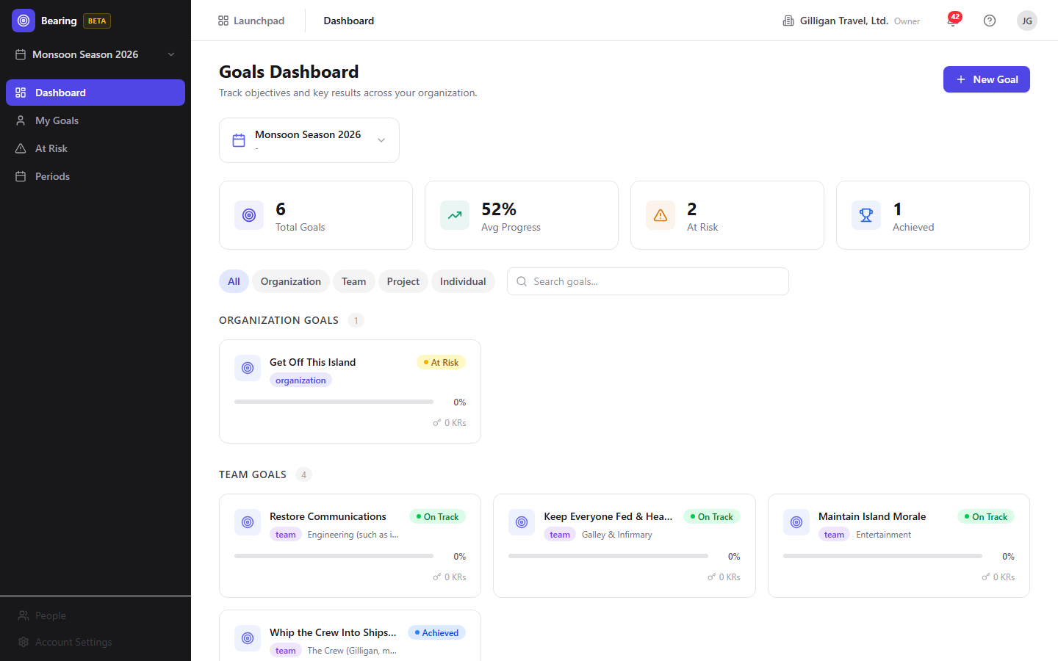
Figure 4.1 Goal dashboard
What you see, top to bottom:
- The header "Goals Dashboard" with the subtitle "Track objectives and key results across your organization." and a New Goal button.
- A period selector card showing the selected period's name, date range, and time remaining.
- A stats row with four cards: Total Goals, Avg Progress, At Risk, and Achieved. These read from the selected period's report and populate with the period's real totals.
- Scope tabs: All, Organization, Team, Project, Individual.
- A search box with placeholder "Search goals...".
- A grid of goal cards. With the All tab selected, cards are grouped by scope. Each card shows the goal's title, scope badge, project or team, a progress bar (actual against expected), the owner avatar, and the key result count.
To open a goal, click its card. To browse a different period, change the selection in the sidebar period selector.
If no period is selected you see a "Select a period" prompt. If the period has no goals you see "No goals found" with a Create First Goal button.

My Goals
My Goals at /my-goals lists every goal you own across all periods, not just the selected one.
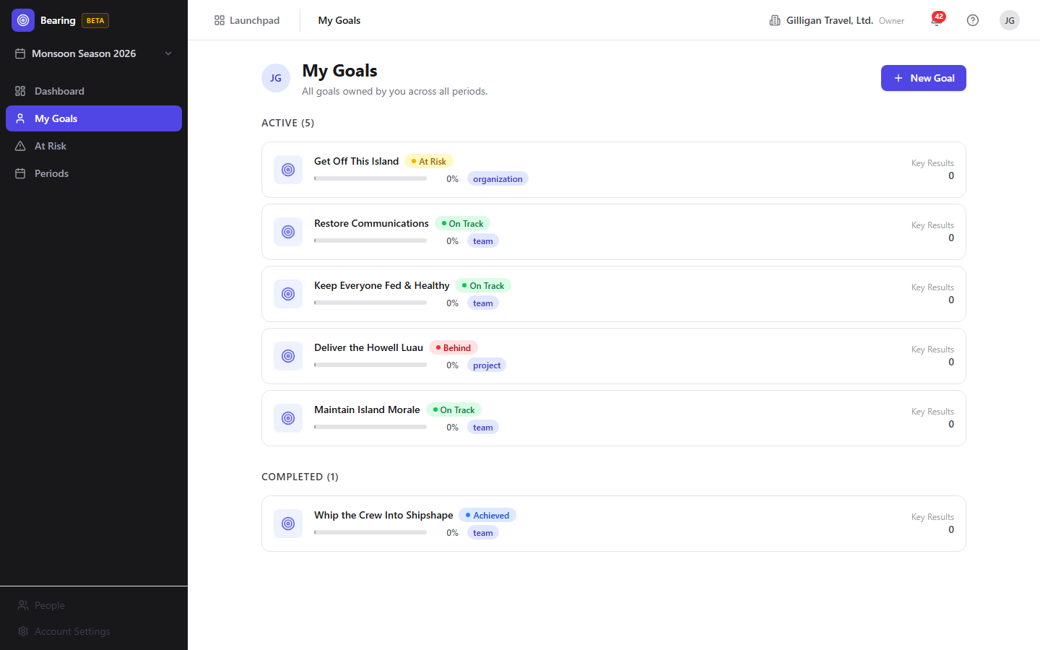
Figure 4.2 My goals
- The header reads "My Goals" with the subtitle "All goals owned by you across all periods." and a New Goal button that takes you to the Dashboard to create one.
- Goals are split into Active and Completed sections, where completed means a goal that is achieved or missed.
- Each row shows the goal icon, title, status badge, progress bar, period and scope badges, and the key result count. Click a row to open the goal.
If you own no goals you see "No goals assigned to you" with a Go to Dashboard button.

At Risk
At Risk at /at-risk is the triage view. It lists the goals in the selected period whose status is at_risk or behind, sorted so the goals that have fallen furthest behind appear first.
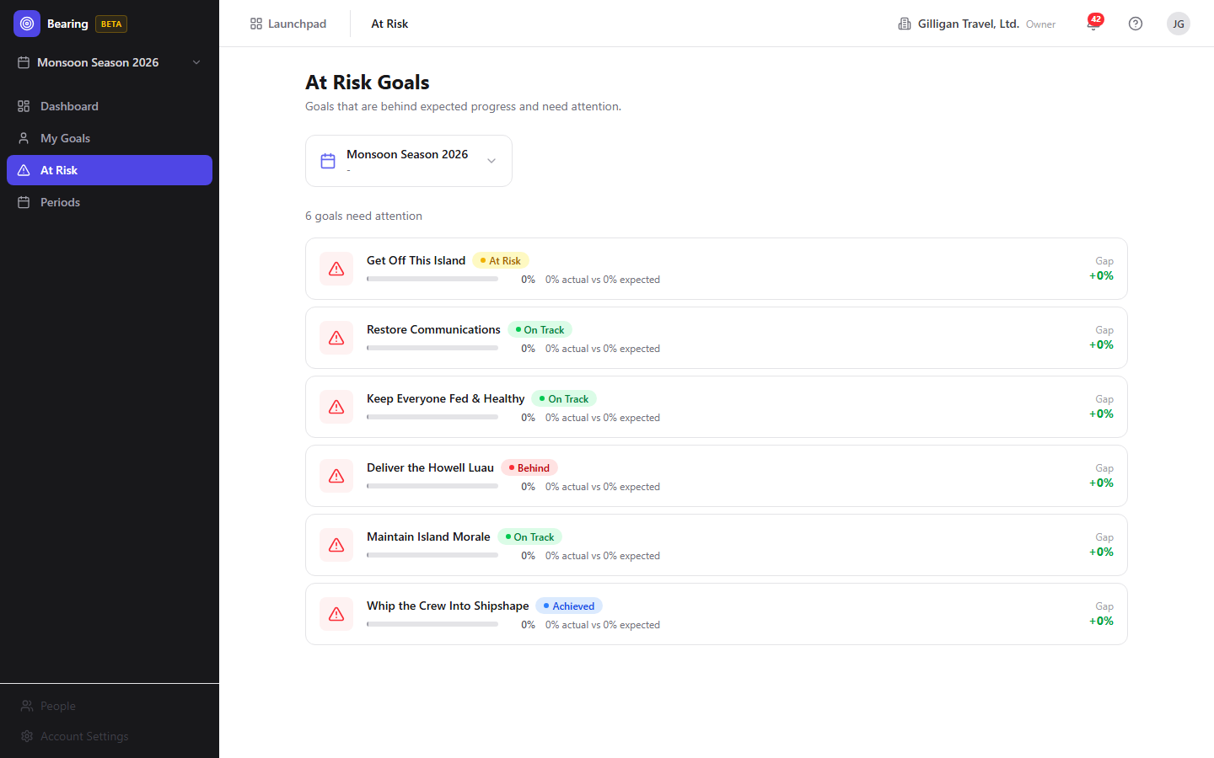
Figure 4.3 At-risk goals
- The header reads "At Risk Goals" with the subtitle "Goals that are behind expected progress and need attention.".
- Each row shows a red alert badge, the goal title, its status badge, a progress bar, an "actual vs expected" readout, a color-coded Gap, and the owner avatar. Click a row to open the goal.
If nothing is behind you see "All goals are on track".

Periods
The Periods page at /periods is where you create and manage the time boxes that hold goals.
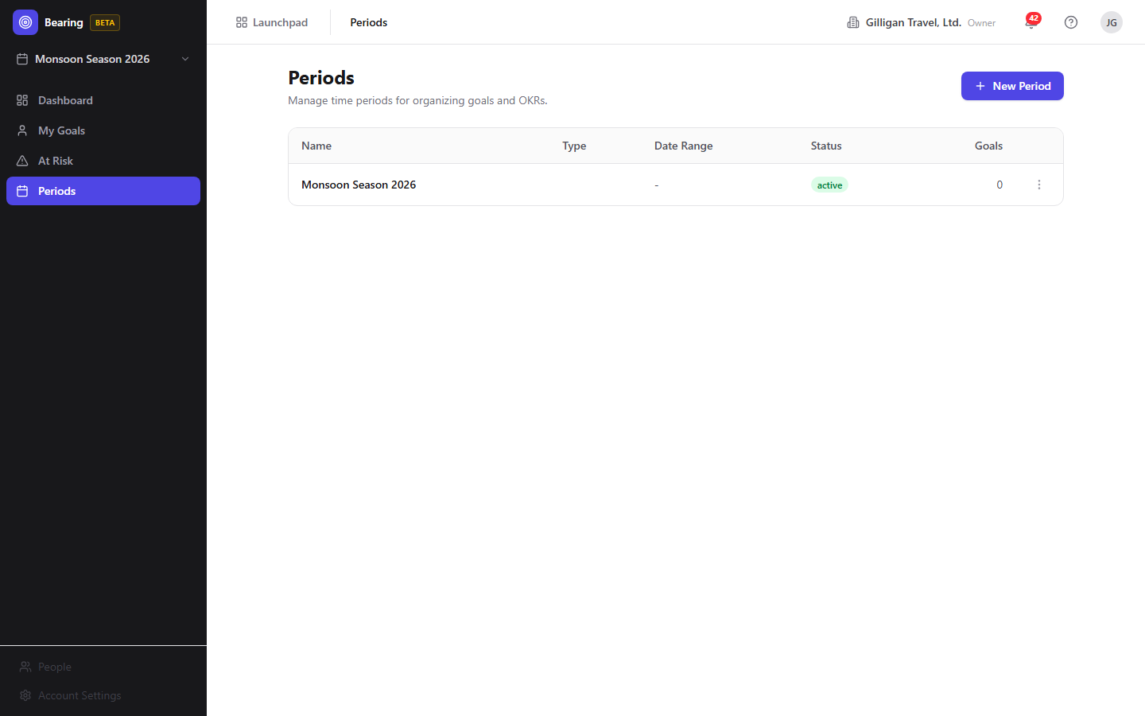
Figure 4.4 Periods
- The header reads "Periods" with the subtitle "Manage time periods for organizing goals and OKRs." and a New Period button.
- A table with columns Name, Type, Date Range, Status, and Goals, plus a row menu.
- Each row has a "..." menu with Edit, an Activate item (shown only while the period's status is planning), a Complete item (shown only when the period is active), and Delete.
To create a period:
1. Click New Period. The Period Form dialog opens.
2. Type a Name, for example "Q2 2026".
3. Choose a Type: Quarter, Half Year, Year, or Custom.
4. Set the Start Date and End Date. The start date must be before the end date.
5. Click Create Period.
To edit a period, choose Edit from the row menu. The same dialog opens with a Save Changes button.
To activate a newly created period so it becomes the working scope, choose Activate from the row menu (shown while the period is in planning). To complete a period when it is over, choose Complete from the row menu (available only while the period is active). To delete a period, choose Delete and confirm. Deleting is blocked with a conflict error if the period still has goals.
WARNING
Deleting a period that still holds goals fails with a conflict error. Move or delete the goals inside it first, then delete the period.

Goal Detail
Open a goal from any list to reach its detail page at /goals/:id. This is where most day-to-day work happens.
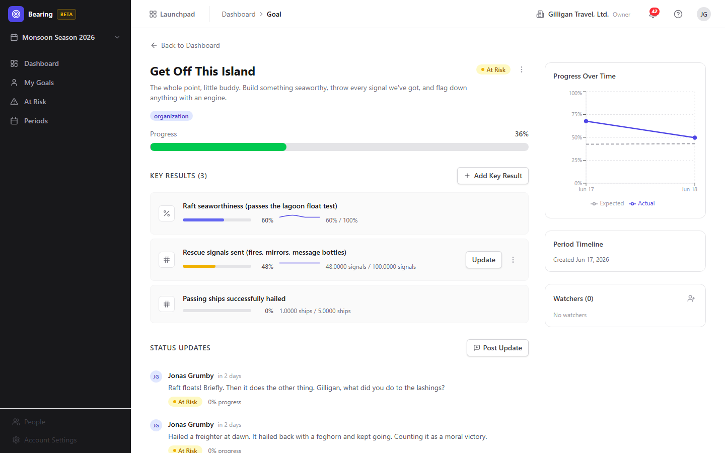
Figure 4.5 Goal detail
The page has a Back to Dashboard link, the goal title and description, a status badge, and a "..." menu with Edit and Delete Goal.
To edit a goal's title or description:
1. Open the "..." menu and choose Edit.
2. Change the Title input and the description box.
3. Click Save, or Cancel to discard.
Below the header is a meta row with the owner avatar and name, the scope badge, the period-name badge, and the project-name badge, followed by a progress bar reading "{n}% (expected: {m}%)".
The right sidebar holds a Progress Over Time chart that plots the goal's actual progress against expected over the period, a Period Timeline card showing the goal's creation date, and the Watchers card.
Note: the Period Timeline card's time-remaining badge is inert in this build (it is fed an empty end date), so it does not count down. The progress chart, the progress-bar values, and the Watchers card all work as described.

Create a Goal
Goals are created from the Dashboard.
1. On the Dashboard, click New Goal. The dialog opens with the title "Create Goal" and the description "Set a new objective for this period.".
2. Type a Title, for example "Increase customer retention by 15%".
3. Optionally fill in Description (optional) with why the goal matters.
4. Choose a Scope: Organization, Team, or Project (the dialog defaults to Team).
5. Click Create Goal.
Bearing creates the goal in the selected period, assigns you as the owner, and opens the new goal's detail page.
Note that the Create Goal dialog does not offer an Individual scope or an owner field; new goals are owned by you. Reassigning a goal to another owner is done through the AI agent tool bearing_goal_update or REST, not the human UI.

Add and edit Key Results
Key Results live in the Key Results (n) section of the goal detail page.
To add a key result:
1. On the goal detail page, click Add Key Result (or Add First Key Result if there are none yet). The dialog opens with the title "Add Key Result" and the description "Define a measurable outcome for this goal.".
2. Type a Title, for example "Increase monthly active users".
3. Choose a Metric Type: Number, Percentage, Currency, or Yes/No.
4. Set the Start Value and the Target Value.
5. For Number or Currency metrics, optionally set a Unit (optional), for example "users", "$", or "EUR".
6. Click Add Key Result.
To edit a key result, hover its row, open the "..." menu, and choose Edit. The same dialog opens with a Save Changes button. To delete one, open the "..." menu and choose Delete, then confirm.
Each key result row shows a metric icon, the title, a progress bar, a sparkline of recent values, and a "current / target" readout. The goal's overall progress is the average of its key results' progress, and that progress renders correctly throughout Bearing (see the note under Record progress below).

Record progress on a Key Result
You record progress (a check-in) by setting a key result's current value.
1. On the goal detail page, hover the key result's row.
2. Click Update.
3. Type the new current value in the inline number field.
4. Click Save, or Cancel to back out. Pressing Enter saves and Escape cancels.
A check-in records the new value, updates the key result's progress, recomputes the goal's overall progress as the average of its key results, re-derives the goal's status, and writes a snapshot row that feeds the KR sparkline and the goal history chart.
Goal and key-result progress display the real percentage. Earlier builds capped the stored progress value at a precision that overflowed for any figure of 10 percent or more, which left progress bars stuck at 0 percent; that storage limit has been widened, so bars and percentages reflect the actual numbers.

Post a status update
Status updates are the weekly check-in narrative on a goal.
1. On the goal detail page, in the Status Updates section, click Post Update. The dialog opens with the title "Post Status Update" and the description "Share progress with your team.".
2. Choose a status chip: On Track, At Risk, Behind, or Achieved.
3. Type your note in the Update box, for example what changed and any blockers.
4. Click Post Update.
Your update appears in the feed with your name, a relative timestamp, the body, a status badge for the status you chose, and the goal's progress at the time you posted. Posting an update snapshots the goal's status and progress.

Watch a goal
The Watchers card on the goal detail page subscribes people to status-change emails.
1. On the goal detail page, find the Watchers (n) card in the right sidebar.
2. Click the add (person-plus) icon to reveal the input.
3. Type a user ID or email into the User ID or email field.
4. Click the + button, or press Enter, to subscribe that person.
5. To stop watching, hover a watcher chip and click the X.
The form subscribes whoever you enter, resolving the value to an active member of your org by user ID first, then by email. To remove a watcher who is not you, you must be the goal's owner or an org admin or owner.
TRY IT
On any goal's detail page, open the Watchers card, click the person-plus icon, type a teammate's email, and press Enter to subscribe them to that goal's status-change emails.
When a watched goal's status changes, a background job emails the watchers (using real email when SMTP is configured for the deployment), with an unsubscribe link per recipient.

Reports and CSV export
Bearing can produce period, at-risk, and owner reports, plus CSV exports of goals and key results. These are available through the API and the MCP tools, not through a screen in the Bearing SPA.
- A period report is a markdown summary table with per-goal and per-key-result detail for one period.
- An at-risk report is a markdown list of every at_risk and behind goal across the org.
- An owner report is a markdown rollup of one user's goals grouped by period.
- CSV exports dump all goals (goals-export.csv) or all key results (key-results-export.csv).
To produce any of these, use the AI agent tools bearing_report and bearing_at_risk described next, or call the REST routes directly.

Working with AI agents
Bearing exposes a set of MCP tools so AI agents can drive the same goals and key results you manage in the UI, and reach a few capabilities the human UI does not surface (linking, reports, status override, and CSV-style detail). Agents forward your bearer token and org context, and many tools accept human labels (a period name, a goal or key result title, an owner's email) in place of UUIDs. When a key result title is shared across multiple goals, the resolver fails closed and asks the agent to disambiguate with a UUID.
Period tools:
- bearing_periods - list periods, optionally filtered by status or year.
- bearing_period_get - one period plus its stats (goal count, average progress, at-risk count).
- bearing_period_create - create a period (cadence quarter, half, year, month, or custom) with start and end dates.
- bearing_period_update - change a period's name, type, dates, or status (set status to archived to archive it).
- bearing_period_delete - delete a period.
- bearing_period_activate - make a period the live planning window.
- bearing_period_complete - close a period out at the end of the cadence.
Goal tools:
- bearing_goals - list goals filtered by period, scope, owner, or status.
- bearing_goal_get - one goal with its key results and progress detail.
- bearing_goal_create - create a goal, naming the period by label and the owner by email.
- bearing_goal_update - update a goal, including reassigning the owner. This is the only way to change a goal's owner, since the UI has no owner picker.
- bearing_goal_delete - delete a goal and its key results.
- bearing_goal_status_override - force a goal's status (for example to at_risk or achieved), bypassing the automatic progress-derived status. There is no human screen for this; it is agent and REST only.
- bearing_goal_updates - list the status updates posted on a goal.
- bearing_goal_history - get a goal's point-in-time progress snapshots.
- bearing_goal_watchers - list a goal's watchers.
- bearing_goal_watch - add a watcher to a goal.
- bearing_goal_unwatch - remove a watcher (yourself, or anyone if you are the owner or an org admin or owner).
Key result tools:
- bearing_kr_list - list the key results under a goal.
- bearing_kr_get - get one key result.
- bearing_kr_create - add a key result to a goal.
- bearing_kr_update - update a key result's definition and, when a current value is supplied, record a value check-in.
- bearing_kr_delete - delete a key result.
- bearing_kr_link - link a key result to a Bam epic, project, sprint, or task so its progress tracks real delivery. There is no human screen for this in the current build; it is agent and REST only.
- bearing_kr_links - list the Bam-entity links on a key result.
- bearing_kr_unlink - remove a link from a key result.
- bearing_kr_history - get a key result's value and progress snapshot history.
Update and report tools:
- bearing_update_post - post a goal status update, the same as the Post Update dialog.
- bearing_report - generate a period, at-risk, or owner report as markdown or JSON. There is no human reports screen; this is how reports are produced.
- bearing_at_risk - return the org-wide list of at-risk and behind goals.
When an agent links a key result to Bam work with bearing_kr_link, a background recompute job keeps that key result and its goal current as the linked Bam tasks reach a done state. Bearing also emits events (goal created, updated, status changed, achieved, deleted, watcher added or removed; key result created, updated, value updated, linked, deleted; period activated, completed, archived) that Bolt automations can react to.
Link a key result to Bam delivery and it moves on its own as the work lands, no manual check-in required.
Beyond the Bearing-specific tools, agents working here also use the cross-cutting platform surface that every BigBlueBam app shares:
- Identity and heartbeat. Agent and service callers are first-class identities (users.kind is human, agent, or service), and runners report liveness and capabilities through agent_heartbeat, agent_self_report, and agent_audit. Goals, key results, and updates created by an agent are attributed to that agent in the same feeds humans read.
- Approval queues. A risky or far-reaching change (for example bulk-creating a quarter of goals, or overriding statuses) can be staged for a human through proposal_create / proposal_list / proposal_decide instead of applied directly.
- Unified activity and cross-app search. search_everything fans out across apps so a Bearing goal turns up alongside related Bam tasks, Bond deals, and Beacon docs, and the unified activity view threads Bearing changes into one timeline.
- Visibility preflight. Before an agent cites a Bearing goal in a shared surface such as a Banter post or a Brief doc, it calls can_access for each entity and drops anything the asker is not allowed to see.
- Policies and webhooks. Every service-account tool call passes the platform agent_policies allowlist and kill switch before it runs, so an agent only reaches the Bearing tools its policy permits, and outbound webhooks can push subscribed Bearing events to an agent runner.
For reviewers: agent-created goals and updates show up in the same lists and feeds as human ones, attributed to the agent. See the Bearing MCP-tools reference under docs/apps/bearing/ for the full catalog and parameters.

User Stories

Story: Set up your first quarter
Who: A team lead standing up OKRs in a fresh org.
Goal: Have an active period selected so goals can be created.
Before you start: You are logged in to BigBlueBam and Bearing is open. No period exists yet.
Steps
1. In the sidebar, click Periods.
2. Click New Period.
3. In the Name field type your period name, for example "Q2 2026".
4. Choose a Type of Quarter.
5. Set the Start Date and End Date to cover the quarter.
6. Click Create Period.
7. In the period's "..." menu, choose Activate.
8. In the sidebar period scope selector at the top, select the period you just created.
Result: The period is active and selected, and scopes the whole UI. The Dashboard now shows this period and is ready for goals.
Related: You can also start working in a period just by selecting it in the sidebar selector. See "Provision a quarter with an agent" below for the agent counterpart.

Story: Create your first objective
Who: A goal owner setting an objective for the quarter.
Goal: Create a goal in the current period and open it.
Before you start: A period exists and is selected in the sidebar.
Steps
1. In the sidebar, click Dashboard.
2. Click New Goal.
3. Type a Title, for example "Increase customer retention by 15%".
4. Optionally fill in Description (optional).
5. Choose a Scope of Organization, Team, or Project.
6. Click Create Goal.
Result: The goal is created in the selected period with you as the owner, and Bearing opens its detail page.
Related: Add Key Results next. To set a different owner, use the agent tool bearing_goal_create with an owner email, or bearing_goal_update afterward.

Story: Break a goal into key results
Who: A goal owner who wants measurable outcomes.
Goal: Add the key results that define what success means for the goal.
Before you start: You are on the goal's detail page.
Steps
1. In the Key Results section, click Add Key Result (or Add First Key Result).
2. Type a Title, for example "Increase monthly active users".
3. Choose a Metric Type: Number, Percentage, Currency, or Yes/No.
4. Set the Start Value and Target Value.
5. For a Number or Currency metric, optionally set a Unit (optional).
6. Click Add Key Result.
7. Repeat for each measurable outcome.
Result: Each key result appears as a row with a progress bar and a "current / target" readout. The goal's progress is the average of its key results and renders the real percentage.
Related: Record progress on a key result next. To wire a key result to real Bam delivery, an agent can use bearing_kr_link.

Story: Record weekly progress
Who: A goal owner doing a weekly check-in.
Goal: Update a key result's current value so the goal's progress and status recompute.
Before you start: The goal has at least one key result.
Steps
1. Open the goal's detail page.
2. Hover the key result row and click Update.
3. Type the new current value in the inline field.
4. Click Save.
Result: The key result's value and progress update, the goal's overall progress and status recompute from the average, and a snapshot is written for the sparkline. Progress shows the true percentage.
Related: Post a status update to add narrative for the team. An agent can record the same check-in with bearing_kr_update.

Story: Post a status update for the team
Who: A goal owner sharing progress.
Goal: Leave a check-in note and a status on the goal.
Before you start: You are on the goal's detail page.
Steps
1. In the Status Updates section, click Post Update.
2. Choose a status chip: On Track, At Risk, Behind, or Achieved.
3. Type your note in the Update box.
4. Click Post Update.
Result: The update appears in the feed with your name, the time, the status badge, and the goal's progress at the time you posted. Watchers are notified when the status changes.
Related: Watch a goal to receive its status-change emails. An agent can post the same update with bearing_update_post.

Story: Triage the goals that are behind
Who: A team lead reviewing where the quarter is slipping.
Goal: Find the goals that are at risk or behind and act on the worst ones.
Before you start: A period is selected and has goals with recorded progress.
Steps
1. In the sidebar, click At Risk.
2. Review the list, which is sorted by how far each goal has fallen behind expected progress, with the worst at the top.
3. Read each row's "actual vs expected" readout and Gap.
4. Click the goal that needs the most attention to open it.
5. On the goal, record updated key result values and post a status update explaining the plan.
Result: You have identified the goals that need attention and refreshed their progress and narrative.
Related: An agent can pull the same list anytime with bearing_at_risk, or generate a markdown at-risk report with bearing_report.

Story: Review your own goals across periods
Who: Any individual contributor or lead who owns goals.
Goal: See every goal you own, current and finished, in one place.
Before you start: You own at least one goal in any period.
Steps
1. In the sidebar, click My Goals.
2. Read the Active section for goals still in flight.
3. Read the Completed section for goals that are achieved or missed.
4. Click any row to open that goal.
Result: You see all of your goals across every period, grouped by whether they are still active.

Story: Watch a goal you care about
Who: A stakeholder who wants to be told when a goal's status changes.
Goal: Subscribe someone to a goal's status-change emails.
Before you start: You are on the goal's detail page.
Steps
1. In the right sidebar, find the Watchers card.
2. Click the add (person-plus) icon.
3. Type a user ID or email into the User ID or email field.
4. Click the + button, or press Enter, to subscribe that person.
Result: The watcher's avatar appears on the card. When the goal's status changes, a background job emails them.
Related: The form subscribes whoever you enter, resolving the value by user ID first, then by email. An agent can do the same with bearing_goal_watch.

Story: Close out the quarter
Who: A team lead wrapping up a period.
Goal: Mark the period complete and produce a retrospective report.
Before you start: The period is active and its goals are up to date.
Steps
1. In the sidebar, click Periods.
2. Find the period's row and open its "..." menu.
3. Choose Complete.
Result: The period is marked completed and a period.completed event fires for any Bolt automations watching it.
Related: For a retrospective, an agent can run bearing_report with the period type to produce a markdown summary table with per-goal and per-key-result detail.

Story: Provision a quarter with an agent
Who: An AI agent provisioning OKRs from a brief.
Goal: Create a period, goals, and key results in one pass without manual UI work.
Before you start: The agent has a Bearing-scoped policy and the org context.
Steps
1. The agent creates or activates the period with bearing_period_create and bearing_period_activate (or fetches an existing one with bearing_periods or bearing_period_get).
2. For each objective, the agent calls bearing_goal_create, naming the period by label and the owner by email.
3. For each measurable outcome, the agent calls bearing_kr_create against the goal title.
4. The agent records starting values with bearing_kr_update.
Result: A fully populated period with owned goals and key results, ready for the team. The same goals appear in the human Dashboard and My Goals views, with progress rendering correctly.
Related: This is the agent counterpart to the first four human stories above. For a far-reaching batch, the agent can stage the plan with proposal_create for a human to approve first.

Story: Wire key results to real delivery (agent)
Who: An AI agent connecting OKRs to Bam work.
Goal: Make a key result's progress track actual task completion automatically.
Before you start: The goal and key result exist, and the Bam epic, project, or sprint to track is known.
Steps
1. The agent calls bearing_kr_link to bind the key result to a Bam epic, project, sprint, or task.
2. As linked Bam tasks reach a done state, the recompute background job updates the key result's progress and rolls it up to the goal.
Result: The key result and its goal move on their own as delivery progresses, with no manual check-ins. This linking is available only through agents or REST in the current build.
Related: There is no human linking screen, so this story has no UI equivalent. The agent can review the current links with bearing_kr_links and remove one with bearing_kr_unlink.

Story: Run a weekly status sweep (agent)
Who: An AI agent producing a weekly OKR digest.
Goal: Summarize at-risk goals and period progress for the team.
Before you start: Periods and goals exist with recorded progress.
Steps
1. The agent calls bearing_at_risk for the org-wide list of at-risk and behind goals.
2. The agent calls bearing_report with the period or owner type for a markdown summary.
3. Before quoting any goal in a shared channel, the agent calls can_access for each cited goal and drops anything the audience cannot see.
4. The agent relays the summary into the channel the team reads, for example a Banter post or a Brief document.
Result: The team gets a current OKR status summary without anyone opening the Bearing UI.
Related: Humans can read the same at-risk list on the At Risk page.

Related
- Bam (/b3/) - the project planning tool whose epics, projects, sprints, and tasks a key result can be linked to so its progress tracks real delivery. Bearing requires a Bam session to sign in.
- Bolt (/bolt/) - the automation engine. Bearing emits goal, key result, and period events (goal created, status changed, achieved, key result value updated, period activated and completed, and more) that Bolt rules can react to.
- Banter (/banter/) and Brief (/brief/) - common destinations for agent-generated OKR digests produced by bearing_report and bearing_at_risk.
- Bench (/bench/) - analytics dashboards that can surface goal progress alongside other org metrics.
- See the Bearing MCP-tools reference and guide under docs/apps/bearing/ for the full tool catalog and parameter details.

Check yourself
Every answer is findable in this chapter. Check your work against the Answer Key appendix at the back of the book.
1. What must exist and be selected before the Dashboard and At Risk views will show goals?
a) At least one Goal
b) At least one Period
c) At least one Key Result
d) An active Bolt automation
2. Which four metric types can a Key Result use?
a) Number, Percentage, Currency, Yes/No
b) Integer, Float, Money, Boolean
c) Count, Ratio, Dollars, Flag
d) Number, Date, Text, Select
3. How is a goal's overall progress calculated from its key results, and what range is each key result's progress clamped to?
4. What are the four scopes a goal can have?
a) Company, Squad, Repo, Person
b) Organization, Team, Project, Individual
c) Global, Department, Sprint, User
d) Org, Group, Board, Owner
5. How does Bearing decide whether a goal is on track, at risk, or behind?
6. What happens if you try to delete a period that still has goals?
a) The goals are deleted with it
b) The goals move to the next period
c) Deletion is blocked with a conflict error
d) The period is archived instead
7. The Periods row menu only shows Activate while the period is in which status?
a) active
b) planning
c) completed
d) archived
8. Which goal scope is not offered in the Create Goal dialog, and how can a goal be reassigned to a different owner?
9. What does a check-in do when you set a key result's new current value?
a) Only updates that one key result's bar
b) Updates the KR, rolls up the goal's progress, re-derives the goal's status, and writes a snapshot
c) Emails all watchers a digest
d) Marks the goal achieved
10. What does linking a key result to Bam work do, and where is that linking available?
11. How does the Watchers form resolve the value you type into the User ID or email field?
a) By display name only
b) By user ID first, then by email
c) By email first, then by handle
d) It always requires a UUID
12. What two sections does the My Goals page split goals into, and what does the Completed section contain?

CHAPTER 5

Bench
Chart the whole suite in one place.

Bench is the read-and-visualize layer over the rest of BigBlueBam. You assemble dashboards out of widgets, where each widget queries an approved data source like Bond deals or Blast campaigns and renders a chart, KPI card, or table. Bench never stores your business data; it reads other products' tables through an allowlisted registry and scopes every query to your active organization. By the end of this chapter you will be able to build a dashboard, explore a source ad hoc, save and schedule queries, and see where an agent can summarize a dashboard and flag anomalies for you.
At a glance
- Shared dashboards built from widgets, each charting one registered data source
- Eleven chart types, from bar and line to KPI card, gauge, and progress bar
- Ad-Hoc Explorer for a quick aggregate without building a whole dashboard
- Saved queries and cron-driven scheduled reports to Email, Banter, or Brief
- Full MCP surface, so an agent can read dashboards, run queries, and compare periods
In this chapter
Overview . Key concepts . Where to find it . Feature reference . Dashboards list . Dashboard view . Dashboard edit . Widget Templates gallery . Widget Wizard . Widget Edit (live preview)
Bench builds shared analytics dashboards and ad-hoc queries across the other BigBlueBam apps. Reach for it when you want one place to chart deals, campaigns, goals, knowledge-base activity, and other suite data, then share or schedule those views for your team.

Overview
Bench is a read-and-visualize layer on top of the rest of the suite. You assemble dashboards out of widgets, where each widget runs a query against an approved data source (a product plus an entity, such as Bond deals or Blast campaigns) and renders the result as a chart, KPI card, or table. You can also explore a source interactively in the Ad-Hoc Explorer, save query definitions, and schedule recurring report deliveries.
Bench does not store your business data. It queries other products' tables through a compile-time data source registry that allowlists exactly which tables and columns Bench is allowed to read, and always scopes every query to your active organization. Because the registry is an allowlist, you can only chart sources and fields that have been registered.
Bench reads other apps but never writes them, and every query is org-scoped through an allowlisted registry.
Bench sits between the operational apps (Bam, Bond, Blast, Beacon, Bearing, and others) and the people who need a roll-up view of them. Operators and leads build dashboards in the UI. AI agents can do the same work through MCP tools: they read and summarize dashboards, run ad-hoc queries, build dashboards and widgets, manage saved queries and scheduled reports, and run anomaly and period-comparison checks.
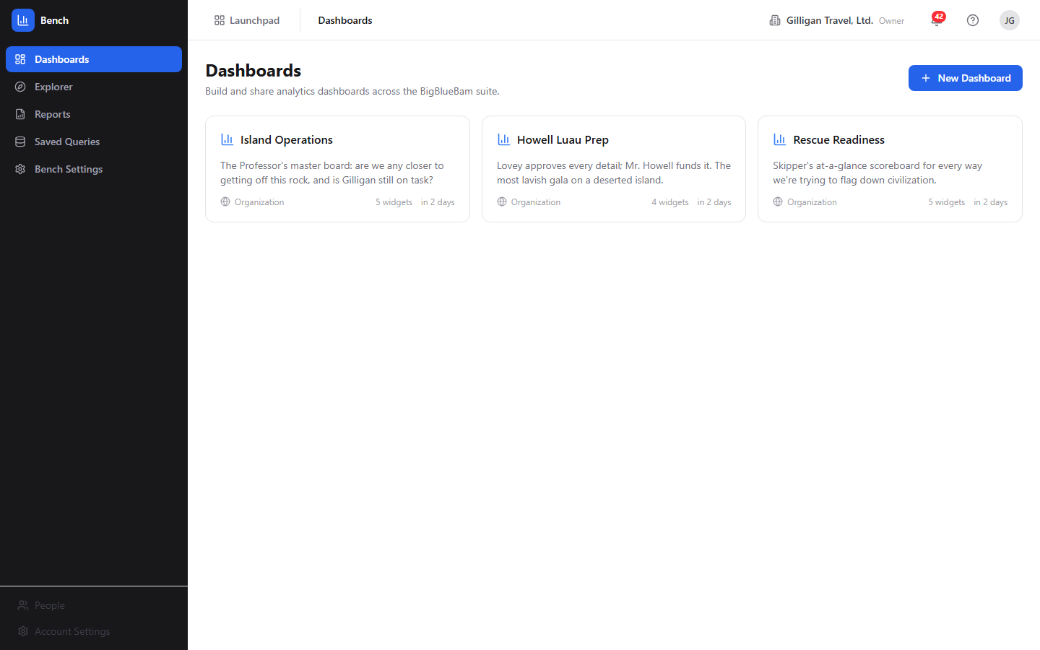
Figure 5.1 Dashboard list

Key concepts
- Dashboard - A named container of widgets with a saved layout. Each dashboard has a visibility of Private, Project, or Organization, an optional linked project, and an optional auto-refresh interval. One dashboard per org can be the default.
- Widget - One visualization on a dashboard. A widget has a name, a chart type, a data source and entity, and a query configuration. The renderer draws bar, line, area, pie, donut, KPI card, counter, and table widgets distinctly; any other type falls back to a table.
- Data source - A registered (product, entity) pair that maps to one underlying table with declared measures, dimensions, and filters. Bench can only query registered sources and columns, and every query is automatically scoped to your organization.
- Measure - A numeric aggregation in a query: count, sum, avg, min, or max of a field. A query needs at least one measure.
- Dimension - A field to group by (for example, deal stage or campaign).
- Filter - A condition on a field. Operators include equals, not equals, greater/less than (and -or-equal), in, is null, is not null, between, and like.
- Saved query - A reusable query definition (data source, entity, and query config) you can keep and re-run later.
- Scheduled report - A cron-driven dashboard snapshot delivered to a target on a schedule. Delivery methods are Email, Banter Channel, and Brief Document; export formats are PDF, PNG, and CSV.
- Materialized view - A pre-computed rollup that the worker refreshes automatically. Three are exposed to you as queryable bench: data sources: Daily Task Throughput, Pipeline Snapshot, and Campaign Engagement.
NOTE
A materialized view is a pre-computed rollup the worker refreshes for you. Bench surfaces three as bench: data sources: Daily Task Throughput, Pipeline Snapshot, and Campaign Engagement.

Where to find it
Bench lives at /bench/. You must be logged in to BigBlueBam first. If you open Bench while signed out, you will see a "Bench Analytics" screen with the message "Please log in to BigBlueBam first to access Bench." and a "Go to BigBlueBam Login" button that sends you to /b3/.
Once you are in, the left sidebar has five destinations: Dashboards, Explorer, Reports, Saved Queries, and Bench Settings. The header carries the Launchpad app switcher, breadcrumbs, an organization switcher, a notifications bell, and your user menu. Bench reads your active organization from the auth store; use the organization switcher in the header to change which org's data you are charting. Pressing the ? key anywhere outside a text input opens the in-app Help.
Some write actions require a higher API-key scope. Creating dashboards and widgets needs read_write; creating, sending, and deleting scheduled reports needs admin scope plus the matching report permission.

Feature reference

Dashboards list
The landing view at /bench/. It shows every dashboard you can see as a grid of cards.
Each card shows the dashboard name, an optional description, a visibility pill (Private with a lock icon, Project with a people icon, or Organization with a globe icon), the widget count ("N widgets"), and the relative time it was last updated. A kebab menu (the horizontal dots that appear on hover) holds View, Duplicate, and Delete (Delete is destructive).
To create a dashboard:
1. Click New Dashboard (the button with the plus icon, top right).
2. Bench creates a dashboard named "Untitled Dashboard" with Private visibility and immediately opens it in the edit view.
3. Set its name, description, and visibility there, then add widgets.
To open, duplicate, or delete a dashboard:
1. Click a card (or its kebab menu View) to open the read view.
2. Choose Duplicate from the kebab menu to clone the dashboard and its widgets into a new copy. The copy is forced to Private visibility.
3. Choose Delete from the kebab menu to remove the dashboard and its widgets. This is permanent.
If you have no dashboards yet, the page shows "No dashboards yet" with the hint "Create your first dashboard to start visualizing data."

Dashboard view
The read-only view of one dashboard at /dashboards/:id. Each widget renders its chart along with the query's execution time in milliseconds.
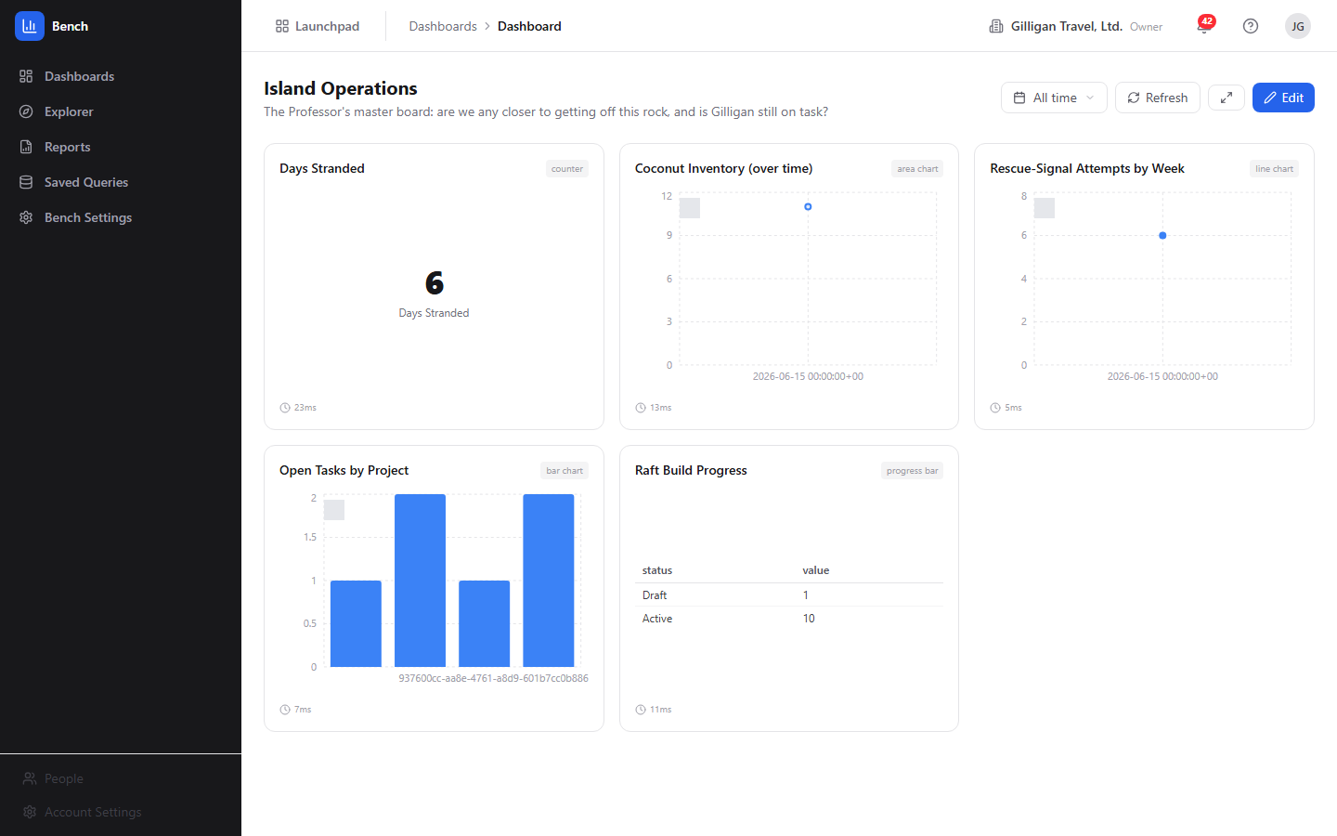
Figure 5.2 Dashboard view
The toolbar (top right) has:
- A date-range picker. You can pick a preset (Today, Last 7 days, Last 30 days, Last 90 days, This month, This quarter, This year) or a custom From/To range and click Apply.
- Refresh (circular-arrow icon), which re-runs every widget query.
- A fullscreen toggle (the expand icon, no text label), which fills the screen for a wall-board display.
- Edit, which opens the edit view.
To view a dashboard:
1. Open it from the Dashboards list.
2. Read each widget; the small clock and number under a widget is how long that widget's query took.
3. Pick a date range from the picker to scope the time-based widgets, or click Refresh to re-pull the data, or the fullscreen toggle for a kiosk display.
If the dashboard has a saved auto-refresh interval, the view re-fetches on that schedule on its own.
If a dashboard has no widgets, the view shows "This dashboard has no widgets yet." with an Add widgets link to the edit view.
The date-range picker scopes the dashboard's widgets: the selected preset or custom From/To range is passed into each widget's query, so changing the range re-filters the widgets that have a time field. Widgets with no time dimension run their own stored query unchanged.

Dashboard edit
The edit view at /dashboards/:id/edit, titled Edit Dashboard. Use it to rename a dashboard, set its visibility, and manage its widgets.
The metadata block has three fields: Name, Description, and a Visibility select (Private, Project, Organization). Click Save (the disk icon, top right) to persist them.
The Widgets section has two buttons:
- Templates (sparkles icon) toggles the Widget Templates gallery inline.
- Custom Widget (plus icon) opens the Widget Wizard.
Each existing widget appears as a row with a drag handle, its name, a "data_source / entity - type" subline, an Edit link to the Widget Edit page, and a trash icon that deletes the widget.
To edit a dashboard:
1. Open the dashboard and click Edit.
2. Change Name, Description, or Visibility and click Save.
3. Add widgets with Templates or Custom Widget, edit a widget with its Edit link, or remove one with its trash icon.
4. To reorder widgets, drag a widget row by its drag handle and drop it where you want it. The new order is saved to the dashboard layout and survives a reload.

Widget Templates gallery
A gallery of prebuilt widget presets, shown inline in the Dashboard edit view when you click Templates. It is titled Widget Templates and has a Close action.
Category filter pills across the top (All, Project Management, CRM, Email Marketing, Support, Cross-Product) narrow the grid. Each preset card shows a type icon, a type pill, the preset name, a short description, and its category.
To add a preset widget:
1. In the Dashboard edit view, click Templates.
2. Optionally click a category pill to filter.
3. Click a preset card. Bench instantiates it as a working widget on the dashboard (carrying a full query config that maps to registered sources and fields) and closes the gallery.
The presets in the Project Management, CRM, Email Marketing, and Cross-Product categories build widgets against registered sources that return data. The Support presets (Open Tickets, Tickets by Priority) build cleanly but query the Tickets source, which does not return data in this release (see "Sources that do not return data"), so those widgets show "No data".

Widget Wizard
A four-step builder for a custom widget, reached from a dashboard's edit view via Custom Widget, at /dashboards/:id/widgets/new. Titled New Widget.

Figure 5.3 Widget wizard
The step indicator names the four steps: Data Source, Measures & Dimensions, Chart Type, Name & Style.
To build a widget with the wizard:
1. Step 1 (Data Source): pick a registered source from the list. Each entry shows the product pill, the source label, and its description.
2. Step 2 (Measures & Dimensions): check the measures to aggregate and the dimensions to group by. Each measure lists its allowed aggregations; each dimension lists its type.
3. Step 3 (Chart Type): pick one of the eleven types: Bar Chart, Line Chart, Area Chart, Pie Chart, Donut Chart, KPI Card, Counter, Table, Funnel, Gauge, Progress Bar.
4. Step 4 (Name & Style): type a Widget Name, then confirm the summary panel (Source, Measures, Dimensions, Type).
5. Click Create Widget. Bench builds the query config (using the first allowed aggregation for each chosen measure and your dimensions as group-bys) and returns you to the Dashboard edit view.
TIP
The Widget Wizard and the Widget Edit page offer the same eleven chart types, but Widget Edit adds a live preview that re-runs the query as you change the source, measures, and dimensions. Tune there when you want to see the result before you save.
Use Back to revisit a step, or Cancel on the first step to leave without creating.

Widget Edit (live preview)
The full widget editor at /widgets/:id/edit, titled Edit Widget. It has two columns: configuration on the left, a live preview on the right.
On the left you can change Widget Name, the Data Source select, the Chart Type grid (the same eleven types as the wizard), the Measures and Dimensions checkboxes, and the Display Options checkboxes (Show legend and Stacked).
On the right, the Preview panel renders live query results. A Refresh button re-runs the preview query, and a line below it reads "Query took Nms" with the row count.
To edit a widget:
1. From the Dashboard edit view, click a widget's Edit link.
2. Adjust the name, data source, chart type, measures, dimensions, or display options.
3. Watch the Preview update; click its Refresh to re-pull.
4. Click Save. Bench writes the change and returns you to the Dashboard edit view.

Ad-Hoc Explorer
An interactive query view at /explorer, titled Ad-Hoc Explorer, with the subtitle "Query any data source interactively."
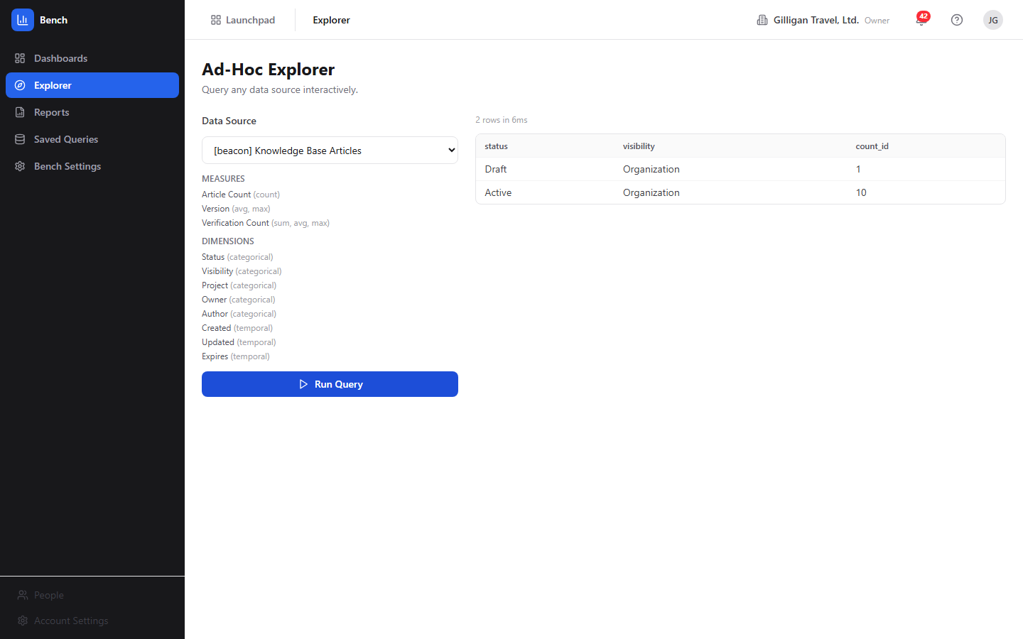
Figure 5.4 Ad-hoc explorer
The left panel has a Data Source dropdown (each option is shown as "[product] Label"), read-only Measures and Dimensions lists for the selected source, and a Run Query button. The right panel shows an error banner when a query fails, the generated SQL (in non-production builds only), a "N rows in Xms" line, and the results table.
To explore a source:
1. Choose a source from the Data Source dropdown.
2. Review its Measures and Dimensions.
3. Click Run Query.
4. Read the results table, plus the row count and timing.
When you open the Explorer from a saved query's Run button, it loads that saved query's source and full configuration and runs it for you (a "Loaded saved query: <name>" note appears). When you open the Explorer directly and pick a source yourself, Run Query runs one fixed shape per source: the first measure with its first aggregation, plus the first two dimensions, limited to 50 rows.
TRY IT
Open the Explorer, pick Knowledge Base Articles from the Data Source dropdown, and click Run Query to see the fixed shape: the first measure, the first two dimensions, and up to fifty rows.
Known limitation: when you pick a source manually in the Explorer there are no measure, dimension, or filter controls; it runs the fixed shape described above. For arbitrary measures, dimensions, and filters without going through a saved query, an agent can use the bench_query_ad_hoc MCP tool.

Scheduled Reports
The reports list at /reports, titled Scheduled Reports, with the subtitle "Automated dashboard snapshots delivered on a schedule."
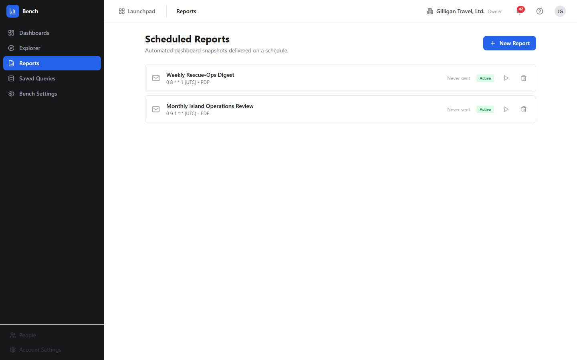
Figure 5.5 Scheduled reports
Each row has a delivery-method icon (envelope for Email, speech bubble for Banter Channel, document for Brief Document), the report name, a "cron (timezone) - FORMAT" subline, a last-sent line ("Last sent X" or "Never sent"), an optional delivery-status pill, an Active/Paused pill, a Send now play button, and a delete trash icon.
To create a scheduled report:
1. Click New Report. A dialog titled New Scheduled Report opens.
2. Fill in Report Name.
3. Choose a Dashboard to render.
4. Choose a Schedule preset (Every day at 9 AM, Every Monday at 9 AM, First of every month at 9 AM, Every Friday at 5 PM, or Custom). For Custom, type a cron expression. The detected timezone is shown below.
5. Choose a Delivery Method (Email, Banter Channel, or Brief Document). The target field relabels to Email Address, Channel, or Document accordingly, and you enter the destination.
6. Choose an Export Format (PDF, PNG, or CSV).
7. Leave Enable immediately checked to activate the schedule now, or uncheck it to create it paused.
8. Click Create Report.
To run a report immediately, click its Send now play button. To remove one, click its trash icon. Creating a report needs admin API-key scope plus the report-create permission; Send now and Delete need their matching permissions.
Known limitation: report delivery is a stub in this release. The worker logs "simulating delivery (stub)" and stamps the row's status; it does not produce or send an actual PDF, email, Banter post, or Brief document. On success the worker writes a delivered status, but the row's status pill only colors sent, queued, and failed, so a delivered report shows the neutral gray pill rather than a green one. Treat Send now and the schedule as wiring that updates status, not as confirmed delivery.
WARNING
Send now and the schedule only stamp the row's status; they do not produce or send an actual PDF, email, Banter post, or Brief document. A successful run even shows the neutral gray pill rather than a green one, so treat this as wiring, not confirmed delivery.

Saved Queries
The saved-query list at /saved-queries, titled Saved Queries, with the subtitle "Reusable query definitions you can run from the ad-hoc explorer."
Each row has the query name, an optional description, a "data_source/entity - Created DATE" subline, a Run button, an Edit pencil, and a Delete trash icon.
To save a query:
1. Click New Query. A dialog titled New Saved Query opens.
2. Fill in Name, an optional Description, and choose a Data Source.
3. Check the Measures to aggregate and the Dimensions to group by (at least one measure is required).
4. Click Create. Bench saves the query with a real configuration built from your measures and dimensions.
To edit or run a saved query:
1. Click the Edit pencil to change the name, description, data source, measures, or dimensions (dialog titled Edit Saved Query), then click Update. Editing reloads the saved configuration so you keep its definition.
2. Click Run to open the Explorer with that saved query loaded and executed.
If you have none yet, the page shows "No saved queries" with the hint "Create a query to save and re-run later from the explorer."

Bench Settings
A read-only settings view at /settings, titled Settings, with the subtitle "Configure Bench data sources and preferences."
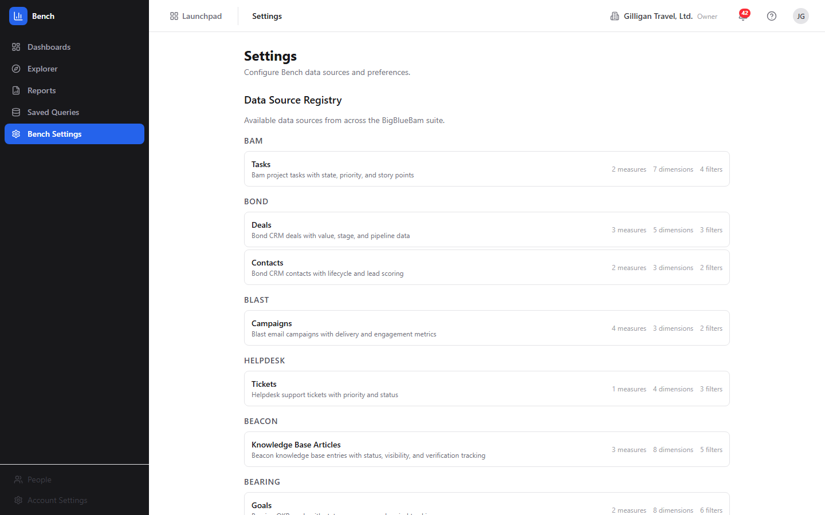
Figure 5.6 Bench settings
It has three sections, none of them editable:
- Data Source Registry - every registered source grouped by product, each showing its label, description, and counts of measures, dimensions, and filters.
- Cache - the Default Cache TTL (60 seconds).
- Query Execution - the Statement Timeout (10,000 ms).
To review what Bench can query:
1. Open Bench Settings from the sidebar.
2. Scroll the Data Source Registry to see which products and entities are available and how many measures, dimensions, and filters each exposes.

Registered data sources
These are the sources Bench can query, from the data source registry. Each query is automatically scoped to your organization.
Product | Entity | Label | Backing table
bam | tasks | Tasks | tasks
bond | deals | Deals | bond_deals
bond | contacts | Contacts | bond_contacts
blast | campaigns | Campaigns | blast_campaigns
helpdesk | tickets | Tickets | tickets
beacon | articles | Knowledge Base Articles | beacon_entries
bearing | goals | Goals | bearing_goals
bureau | floor_analytics | Bureau Floor Analytics (Daily) | bureau_floor_analytics
bench | daily_task_throughput | Daily Task Throughput | bench_mv_daily_task_throughput
bench | pipeline_snapshot | Pipeline Snapshot | bench_mv_pipeline_snapshot
bench | campaign_engagement | Campaign Engagement | bench_mv_campaign_engagement
Notes on specific sources:
- The Bam tasks source, the Bond, Blast, Beacon, and Bearing sources, and the Pipeline Snapshot and Campaign Engagement materialized views all return data and back the working dashboard widgets and Explorer queries. The Bam tasks source is org-scoped by its org_id column.
- The Bureau Floor Analytics source is a nightly rollup, not a live feed. Its rows are written once per floor per day for the previous day, so a one-day window is usually empty during the day. Use a Last 7 days window for Bureau widgets. The agent anomaly and period-comparison tools do not work against this source, because it has no created_at column.

Sources that do not return data
Two registered sources do not return data in this release, because their backing tables have no organization column and the query builder scopes every query by organization_id:
- helpdesk:tickets (Tickets) - the tickets table is scoped by project_id with no org column, so the org filter fails and the query returns nothing. The Support gallery presets (Open Tickets, Tickets by Priority) are affected. Fixing this needs a schema change to give the table an org column (or an org-scoping join), not a registry tweak.
- bench:daily_task_throughput (Daily Task Throughput) - this materialized view is grouped by project and day with no organization column, unlike the Pipeline Snapshot and Campaign Engagement views, so the org filter fails and it returns nothing. The Daily Task Throughput gallery preset works around this by charting the org-scoped Bam tasks source with a daily time bucket instead.
If you need task analytics today, use the bam: Tasks source (now org-scoped) or build a daily-throughput widget from the Bam tasks source with a day time bucket, as the gallery preset does.

Working with AI agents
Agents drive Bench through the Model Context Protocol. The Bench MCP tools call the same bench-api routes the UI uses, with the caller's bearer token, so an agent sees only data its token is allowed to see and every query is org-scoped. The full Bench tool surface lives in apps/mcp-server/src/tools/bench-tools.ts and is summarized in this app's MCP-tools reference.
What agents commonly do in Bench:
- Discover what can be queried - bench_list_data_sources lists every source with its schema. Agents should call this first to learn valid field names.
- Run ad-hoc queries - bench_query_ad_hoc runs a structured query (measures, dimensions, filters, limit) against any registered source. This is the freeform query path the Explorer UI does not expose for manually-picked sources.
- Read dashboards and widgets - bench_list_dashboards, bench_get_dashboard, bench_list_widgets, and bench_query_widget read a dashboard and run its widget queries. bench_summarize_dashboard is the canonical "read this dashboard for me" entry point: it fetches the dashboard and runs every widget query, returning the bundle for summarization. Widgets backed by a non-returning source come back as a per-widget error rather than failing the whole call.
- Manage and trigger reports - bench_list_scheduled_reports lists schedules; bench_generate_report triggers an immediate delivery (the same Send now path, still a delivery stub).
- Detect anomalies and compare periods - bench_detect_anomalies compares the most recent period against the previous one and flags a change over 30% with a severity of high, medium, or low. bench_compare_periods compares two arbitrary date ranges and returns both values, the percent change, and the direction. There is no UI for either; both are agent-only. Both filter on a created_at column, so they work only for sources that have one with a valid org column (Bond, Blast, Beacon, Bearing) and not for the helpdesk:tickets, Bureau, or materialized-view sources.
An agent can flag a metric that moved sharply, marking any change over thirty percent as high, medium, or low severity.
When you review agent work in Bench, the things to confirm are that the agent queried a source that actually returns data, that visibility on any dashboard it created matches your intent (the default is Private), and that a report it created or triggered points at the right delivery target. Note again that triggering a report does not yet send anything.
Bench also participates in the cross-cutting agentic platform. Every agent action carries an agent or service identity that is recorded in the unified activity log, and agents send periodic agent_heartbeat calls so operators can see which runners are live. High-impact or cross-app steps an agent is unsure about can be routed to a human approval queue with the platform proposal_create and proposal_decide tools. Per-agent kill switches and tool allowlists in agent_policies gate which tools a service account may call, and outbound webhooks can push Bench Bolt events (such as report.delivered, source bench) to subscribed agent runners. Before an agent reposts Bench results into another app's shared surface, it should run the platform can_access visibility check for each cited entity and drop anything the asking user is not allowed to see. Cross-app reads (search_everything, activity_query) let an agent pull context from other apps to frame a Bench summary.

User Stories

Story: Open and read a dashboard
Who: Anyone with access to Bench.
Goal: See the current numbers on an existing dashboard.
Before you start: You are logged in to BigBlueBam and at least one dashboard exists in your organization.
Steps
1. Go to /bench/. The Dashboards list shows the dashboards you can see.
2. Click a dashboard card.
3. Read each widget's chart or KPI; the clock and number under a widget is its query time.
4. Pick a date range from the picker to scope the time-based widgets, or click Refresh (circular-arrow icon) to re-pull the data.
5. Click the fullscreen toggle (the expand icon) if you want a kiosk display.
Result: You are on the dashboard read view with current data for your active organization, scoped to the range you chose.
Related: The bench_get_dashboard and bench_summarize_dashboard tools let an agent read the same dashboard.

Story: Build a dashboard from scratch
Who: An operator or lead with read_write API-key scope.
Goal: Create a new dashboard and add widgets to it.
Before you start: You are logged in and know which sources you want to chart.
Steps
1. On the Dashboards list, click New Dashboard.
2. Bench creates "Untitled Dashboard" and opens it in the Edit Dashboard view.
3. Set Name, Description, and Visibility, then click Save.
4. Click Templates to add a prebuilt widget, or Custom Widget to open the Widget Wizard.
5. Add the widgets you want, drag their rows to order them, then click the back arrow to return to the read view.
Result: A new dashboard with your widgets in the order you set, visible according to the visibility you chose.
Related: An agent can do this with bench_create_dashboard plus bench_add_widget.

Story: Add a custom widget with the wizard
Who: An operator or lead with read_write scope.
Goal: Add a widget that charts a specific measure grouped by a dimension.
Before you start: You are in a dashboard's Edit Dashboard view.
Steps
1. Click Custom Widget to open the New Widget wizard.
2. Step 1: pick a Data Source that returns data (for example Bond Deals or Bam Tasks).
3. Step 2: check one or more Measures and the Dimensions to group by.
4. Step 3: pick a Chart Type.
5. Step 4: type a Widget Name and confirm the summary.
6. Click Create Widget.
Result: The widget is added to the dashboard and you are back in the Edit Dashboard view.
Related: bench_add_widget does the same from an agent, with full control over the query config.

Story: Drop in a prebuilt widget from Templates
Who: An operator or lead with read_write scope.
Goal: Add a common widget quickly without building a query.
Before you start: You are in a dashboard's Edit Dashboard view.
Steps
1. Click Templates to open the Widget Templates gallery.
2. Optionally click a category pill (for example CRM or Email Marketing) to filter.
3. Click a preset card.
Result: Bench instantiates the preset as a working widget and closes the gallery. Presets in the Project Management, CRM, Email Marketing, and Cross-Product categories return data; the Support presets build cleanly but show "No data" because the Tickets source is not org-scoped in this release.

Story: Reorder a dashboard's widgets
Who: An operator or lead with read_write scope.
Goal: Change the order widgets appear in.
Before you start: The dashboard has at least two widgets.
Steps
1. Open the dashboard and click Edit.
2. Grab a widget row by its drag handle (the grip icon at the left of the row).
3. Drag it above or below another widget and drop it.
Result: The widgets reorder, and the new order is saved to the dashboard layout, so it survives a reload and shows the same way in the read view.

Story: Tune a widget with the live preview
Who: An operator or lead with read_write scope.
Goal: Adjust a widget's source, chart type, or fields and confirm the result before saving.
Before you start: The dashboard already has the widget you want to change.
Steps
1. In the Edit Dashboard view, click the widget's Edit link.
2. Change the Data Source, Chart Type, Measures, Dimensions, or Display Options (Show legend, Stacked).
3. Watch the Preview panel; click its Refresh to re-pull.
4. Click Save.
Result: The widget is updated and you are back in the Edit Dashboard view.
Related: bench_update_widget makes the same change from an agent.

Story: Explore a source ad hoc
Who: Anyone with access to Bench.
Goal: Pull a quick aggregate from a source without building a dashboard.
Before you start: You are logged in.
Steps
1. Open Explorer from the sidebar.
2. Choose a source from the Data Source dropdown (pick one that returns data, such as Knowledge Base Articles).
3. Review the Measures and Dimensions for the source.
4. Click Run Query.
5. Read the results table and the row count and timing.
Result: A table of the fixed query shape (first measure, first two dimensions, up to 50 rows) for that source.
Related: For arbitrary measures, dimensions, and filters, save a query with the configuration you want and run it here, or use the bench_query_ad_hoc tool from an agent.

Story: Save a query and run it later
Who: Anyone with read_write scope.
Goal: Keep a reusable query definition and re-run it.
Before you start: You are logged in.
Steps
1. Open Saved Queries from the sidebar.
2. Click New Query.
3. Enter a Name, an optional Description, and pick a Data Source.
4. Check the Measures and Dimensions you want, then click Create.
5. Later, click Run on the saved row to open the Explorer with the query loaded and executed, or the Edit pencil to change it.
Result: The query appears in the Saved Queries list with a real configuration, and Run opens the Explorer showing its results.
Related: An agent can save a query with bench_create_saved_query.

Story: Schedule a recurring report
Who: An admin (admin API-key scope plus the report-create permission).
Goal: Have a dashboard snapshot delivered on a schedule.
Before you start: The dashboard you want to send already exists.
Steps
1. Open Reports from the sidebar and click New Report.
2. Enter a Report Name and pick a Dashboard.
3. Choose a Schedule preset, or pick Custom and type a cron expression.
4. Choose a Delivery Method (Email, Banter Channel, or Brief Document) and enter the target.
5. Choose an Export Format (PDF, PNG, or CSV).
6. Leave Enable immediately checked, then click Create Report.
7. Optionally click the report's Send now play button.
Result: The report appears in the list with an Active pill and its schedule. Note that delivery is a stub in this release: status is stamped but no artifact is actually sent, and a successful run shows the neutral status pill rather than a colored one.
Related: bench_generate_report triggers the same Send now path from an agent.

Story: Duplicate a dashboard as a starting template
Who: An operator or lead with read_write scope.
Goal: Reuse an existing dashboard's layout and widgets as the basis for a new one.
Before you start: A dashboard you want to copy exists.
Steps
1. On the Dashboards list, open the source dashboard's kebab menu.
2. Click Duplicate. Bench clones the dashboard and its widgets; the copy is Private.
3. Open the copy and click Edit to rename it and adjust its widgets and visibility.
Result: A new Private dashboard that mirrors the original's widgets.
Related: bench_duplicate_dashboard clones a dashboard from an agent.

Story: Have an agent summarize a dashboard and flag anomalies
Who: An AI agent acting for a user, plus the user reviewing the result.
Goal: Get a written summary of a dashboard and a heads-up on metrics that moved sharply.
Before you start: The agent has a token scoped to the org and the dashboard ID (it can find it with bench_list_dashboards).
Steps
1. The agent calls bench_summarize_dashboard with the dashboard ID to fetch the dashboard and run every widget query.
2. The agent calls bench_detect_anomalies for the metrics it cares about, on a source that has a created_at column and a valid org column (for example Bond Deals or Blast Campaigns).
3. The agent composes a summary, noting any metric flagged as an anomaly and its severity.
4. Before reposting the summary into another app's shared surface, the agent runs the platform can_access check for each cited entity and drops anything the asking user cannot see.
5. You review the summary and confirm the cited dashboard and metrics.
Result: A summary of the dashboard with anomalies flagged, safe to share.
Related: bench_compare_periods for an explicit before/after comparison; the platform proposal_create tool to route an uncertain action to a human queue.

Related
- Bam, Bond, Blast, Beacon, Bearing, Bureau, Helpdesk - the products whose data Bench charts. Bench reads their tables through the registry; it does not write to them.
- Banter - a report delivery method (Banter Channel) and a target for cross-app agent posts.
- Brief - a report delivery method (Brief Document).
- Bolt - Bench emits the report.delivered event (source bench) that Bolt automations and outbound webhooks can subscribe to.
- See this app's MCP-tools reference in docs/apps/bench/ for the full Bench tool catalog, and docs/apps/bench/guide.md for the narrative guide.

Check yourself
Every answer is findable in this chapter. Check your work against the Answer Key appendix at the back of the book.
1. What does Bench store about your business data?
a) A full copy of every source table
b) Only the dashboards and widgets you build
c) Nothing; it queries other products' tables through a registry
d) A nightly snapshot of all org data
2. How many chart types does the Widget Wizard offer at the Chart Type step?
a) Five
b) Eight
c) Eleven
d) Fourteen
3. What are the three visibility options a dashboard can have?
4. What is the minimum number of measures a query needs?
a) Zero
b) At least one
c) At least two
d) Exactly one per dimension
5. Name the five numeric aggregations a measure can use.
6. When you duplicate a dashboard, what visibility does the copy get?
a) It keeps the original's visibility
b) Organization
c) Project
d) It is forced to Private
7. What query shape runs when you pick a source manually in the Explorer?
a) Every measure and dimension for the source
b) The first measure with its first aggregation, plus the first two dimensions, limited to 50 rows
c) Only a row count
d) A custom query you type in
8. What are the three delivery methods for a scheduled report?
9. What are the three export formats for a scheduled report?
a) PDF, PNG, and CSV
b) PDF, DOCX, and XLSX
c) HTML, CSV, and JSON
d) PNG, SVG, and PDF
10. Why do the helpdesk:tickets and Daily Task Throughput sources return no data in this release?
11. At what change does bench_detect_anomalies flag a metric, and with what severities?
a) Over 10%, with pass or fail
b) Over 30%, with high, medium, or low severity
c) Over 50%, with a single alert flag
d) Any change, ranked one through five
12. What are the read-only values shown in Bench Settings for Cache TTL and the statement timeout?

CHAPTER 6

Bill
Bill it, send it, get paid.

Bill turns the work your team already tracked into invoices a client can read and pay. You build a draft, fill it with line items, finalize it to lock a permanent number, send it, and record payments until the balance hits zero. Along the way it captures expenses with an approval step, resolves billing rates so tracked time prices itself, and reports on revenue, aging, and profitability. By the end of this chapter you can stand up your billing identity, send a finalized invoice, and read the numbers at the close of a period.
At a glance
- Draft-to-paid invoice lifecycle: finalize locks the number, payments close the balance
- Money in integer cents everywhere, so the inputs never round or guess
- Recurring schedules that bill a client on a cadence without re-drafting
- Time-based billing that resolves the most specific rate that applies
- Full MCP coverage, so an agent can draft and collect while a human approves and sends
In this chapter
Overview . Key concepts . Where to find it . Feature reference . Dashboard . Invoice list . Create an invoice . Invoice from time entries . Invoice detail . Edit an invoice
Bill turns the work your team does into invoices, tracks who has paid and who is overdue, captures project expenses, and reports on revenue and profitability. Reach for it when you need to bill a client, record a payment, or close out a billing period.

Overview
Bill is the invoicing and billing app in the BigBlueBam suite. You create an invoice for a client, fill it with line items, finalize it to assign a permanent number, send it, and record payments until it is fully paid. Alongside invoices, Bill tracks expenses (with an approval step), rates that drive time-based billing, and a set of financial reports.
Bill is org-scoped: every client, invoice, expense, rate, and setting belongs to your active organization. It connects to the rest of the suite in several places. It can pull billable time from Bam projects and tasks, generate an invoice from a won Bond deal, route an invoice for approval through Bam's approval queue, and emit events that Bolt automation rules can react to.
A few conventions to know up front. All money in Bill is stored and entered in integer cents, not dollars. The amount, rate, and payment inputs in the UI are labeled "(cents)" and take whole numbers, so typing 150 means one dollar and fifty cents. Invoices are only editable while they are in draft; once you finalize an invoice, its number and line items are locked.
TIP
Every amount, rate, and payment field is in whole cents, not dollars. Typing 150 means one dollar and fifty cents, so multiply your dollar figure by 100 before you enter it and nothing rounds.
Roles matter for the money-sensitive steps. Any member who can write to Bill can build a draft invoice, add line items, manage clients, log expenses, record payments, and configure rates and settings. But the steps that commit money or sign off on it - Finalize, Re-send / Send, Approve or Reject an expense, and Mark reimbursed - require an admin or owner role. A member can prepare the work; an admin or owner approves and sends it.

Key concepts
- Invoice - A billable document addressed to one client. It snapshots your company details (the "from" side) and the client details (the "to" side) when it is created, and carries an invoice date, due date, line items, tax, totals, and payment history. Its number is literally DRAFT until you finalize it.
- Invoice status - The lifecycle of an invoice. The values that the app actually sets are draft (editable, no number yet), sent (finalized, number assigned, edits locked), viewed (a client opened the public link), partially_paid (some payment recorded, balance remains), paid (paid in full), and void (cancelled). Overdue is not a stored status: it is computed from the due date as any unpaid, finalized invoice that is past due. The Invoices list Overdue filter pill and the Dashboard Overdue tile both draw from that computed set, so they populate correctly.
- Line item - One row on an invoice: a description, quantity, unit (default hours), and unit price in cents. The amount is quantity times unit price. Line items can only be added, edited, or removed while the invoice is a draft.
- Client - The recipient of an invoice. Carries name, email, phone, address, tax ID, default payment terms (in days), default payment instructions, and notes. A Bill client is separate from a Bond contact or company, though it can be linked to a Bond company.
- Payment - A recorded receipt against an invoice: an amount in cents, a method (Bank Transfer, Credit Card, Check, Cash, Stripe, PayPal, or Other), an optional reference, and a date.
- Expense - A project cost: description, amount in cents, category, vendor, date, and a billable flag. Expenses start as pending, a reviewer moves them to approved or rejected, and an approved expense can be moved on to reimbursed.
- Rate - A billing rate scoped to your org, a project, a user, or a user-on-a-project, with an amount in cents and a type (hourly, daily, or fixed). When Bill bills tracked time, it resolves the most specific rate that applies.
- Settings - Your company identity and the defaults new invoices inherit: invoice prefix, default tax rate, payment terms, payment instructions, footer text, and terms text.
- Recurring schedule - A subscription that bills one client on a cadence (weekly, monthly, quarterly, or annually) from a saved line-item template. It carries a status (active, paused, or cancelled), a next-run date, a count of invoices generated so far, and a mode: auto-finalize (each generated invoice gets a number and is marked sent) or draft (each generated invoice is left as a draft to review). A daily worker sweep materializes invoices from schedules whose next-run date has arrived, and you can also generate one on demand.
- Public view token - A long opaque token on each invoice that grants read-only access (and a PDF) without logging in. It is how a sent invoice can be viewed by someone outside your org.
NOTE
Overdue is not a stored status. It is computed live from the due date as any unpaid, finalized invoice that is past due, which is why the Dashboard Overdue tile, the Invoices list Overdue pill, and the Reports overdue table all agree.
Point Bill at a project and a date range and tracked time prices itself, resolving the most specific rate that applies.

Where to find it
Bill is served at /bill/. You must be logged in to BigBlueBam first; if you are not, Bill shows a "Please log in to BigBlueBam first to access Bill." screen with a "Go to BigBlueBam Login" link to /b3/. Everything is scoped to your active organization, and mutating actions require the matching Bill permission on your account.
TRY IT
Open /bill/, click Bill Settings, fill in your Company Name and an Invoice Prefix, and click Save Settings. Watch for the Saved! confirmation, then your next invoice carries those details on its from side.
The left sidebar carries a fixed New Invoice quick-action button, then the nav items Dashboard, Invoices, Recurring, Clients, Expenses, Rates, and Reports, and under a Bill Settings subheading the Bill Settings item. Press ? anywhere in Bill to open the embedded Help viewer.
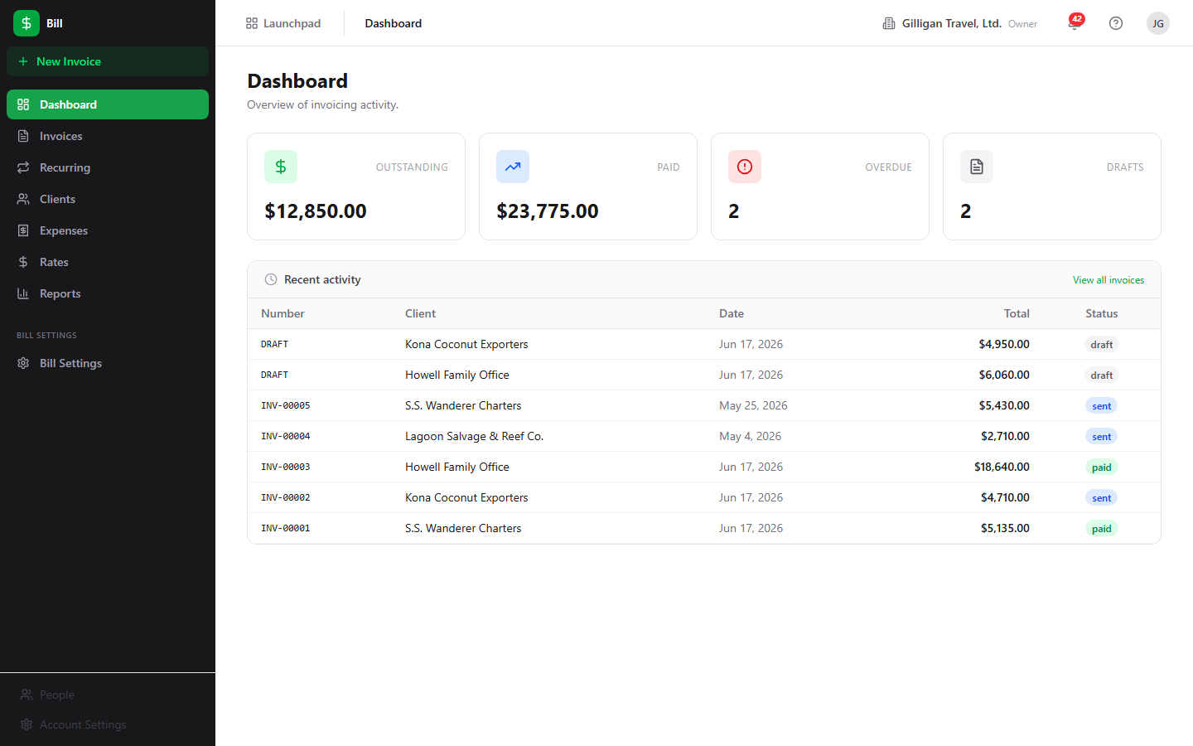
Figure 6.1 Billing dashboard

Feature reference

Dashboard
The Dashboard is the default view at /bill/, titled Dashboard with the subtitle "Overview of invoicing activity." It shows four stat tiles - Outstanding, Paid, Overdue, and Drafts - and a Recent activity table listing recent invoices (Number, Client, Date, Total, Status) with a View all invoices link.
The Outstanding, Paid, and Drafts numbers are computed in the browser from your full invoice list. The Overdue tile is different: it counts the invoices returned by the overdue report (unpaid, finalized invoices whose due date has passed), so it reflects what is actually past due. Clicking the Overdue tile opens the Invoices list pre-filtered to overdue. Clicking the other tiles or View all invoices returns you to the Dashboard.
To open an invoice from the Dashboard:
1. Go to /bill/ from the sidebar Dashboard item.
2. In the Recent activity table, click any row.
3. You land on that invoice's detail page.
To jump straight to overdue invoices:
1. Click the Overdue tile.
2. The Invoices list opens with the Overdue filter applied, showing every past-due unpaid invoice.

Invoice list
The Invoices list at /bill/invoices is titled Invoices with the subtitle "Manage and track all your invoices." It is the main place to scan, filter, and act on invoices.
The columns are Number, Client, Date, Due (the due date), Total, Due (the remaining balance, which is total minus amount paid), Status, and Actions. The two "Due" columns are a date and a balance respectively. Above the table is a row of status filter pills; the empty pill is labeled All. Per-row actions include PDF, Finalize (drafts only), and Request approval.
To filter the list:
1. Open Invoices in the sidebar.
2. Click a status pill (All, or a specific status such as Draft, Sent, or Paid).
3. The table reloads with only invoices in that status.
The Overdue pill shows every invoice that is unpaid, finalized, and past its due date. Unlike the other pills, which match a stored status, the Overdue pill draws from the overdue report, so it computes past-due invoices from each invoice's due date. The Dashboard's Overdue tile deep-links here.
To finalize a draft from the list:
1. Find a draft row.
2. Click Finalize in its Actions cell. Finalize requires an admin or owner role.
3. The invoice is assigned a number and moves to sent; it can no longer be edited.
To download a PDF from the list:
1. Click PDF on any row.
2. The invoice PDF opens inline.
To request approval from the list:
1. Click Request approval on a row.
2. In the Request approval for {number} modal, choose an Approver from the select (the list is active Bam users), optionally type a Message (optional), and click Send request.
3. The helper text reads "Sends a Banter DM to the approver via Bolt." The request is posted to Bam's approval queue with subject type bill.invoice; the approver acts on it inside Bam.
The two entry points for creating invoices live at the top of this view: From Time Entries (see "Invoice from time entries") and New Invoice (see "Create an invoice").
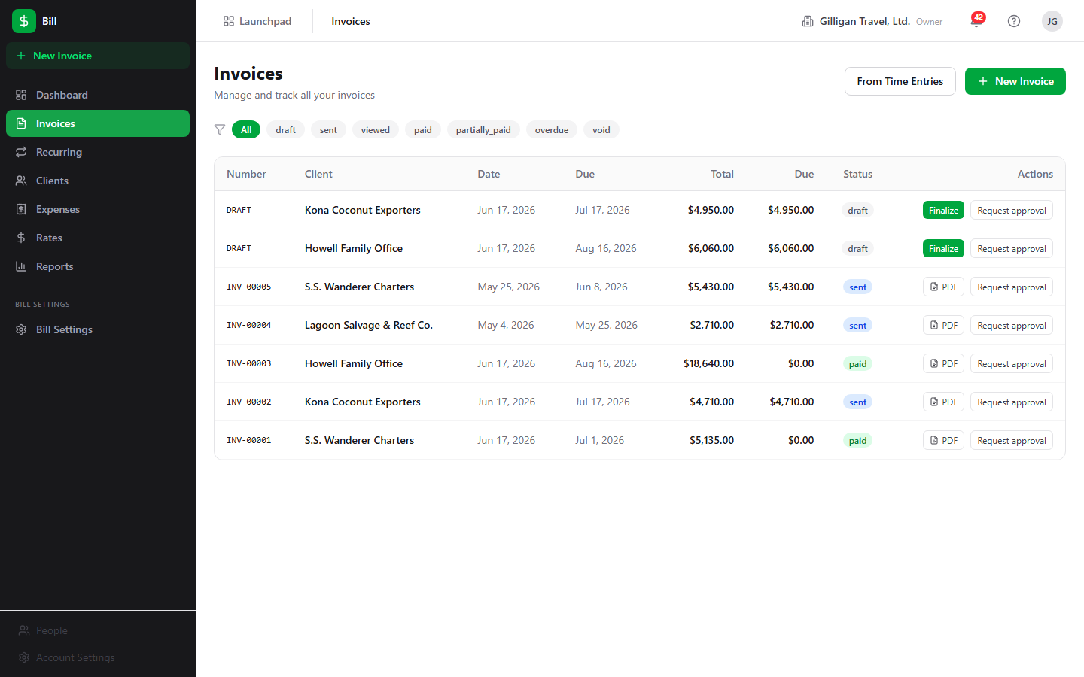
Figure 6.2 Invoice list

Create an invoice
The New Invoice form at /bill/invoices/new (titled New Invoice) builds a draft invoice manually. Reach it from the sidebar New Invoice button, the Invoices list New Invoice button, or a client's + New Invoice link. Any member with write access can create a draft.
To create an invoice:
1. Click New Invoice.
2. Choose a Client from the select. The Create Draft Invoice button stays disabled until a client is chosen.
3. In the Line Items table, fill in Description, Qty, and Unit Price (in cents) for each row. The Amount column is computed. Click + Add line item to add another row, or the X at the end of a row to remove it.
4. In the totals box, review the Subtotal, edit the Tax Rate if needed (the Tax and Total update automatically).
5. Optionally add Notes (internal).
6. Click Create Draft Invoice. Bill creates the draft, adds each line item, and opens the new invoice's detail page. Use Cancel to return to the Dashboard instead.
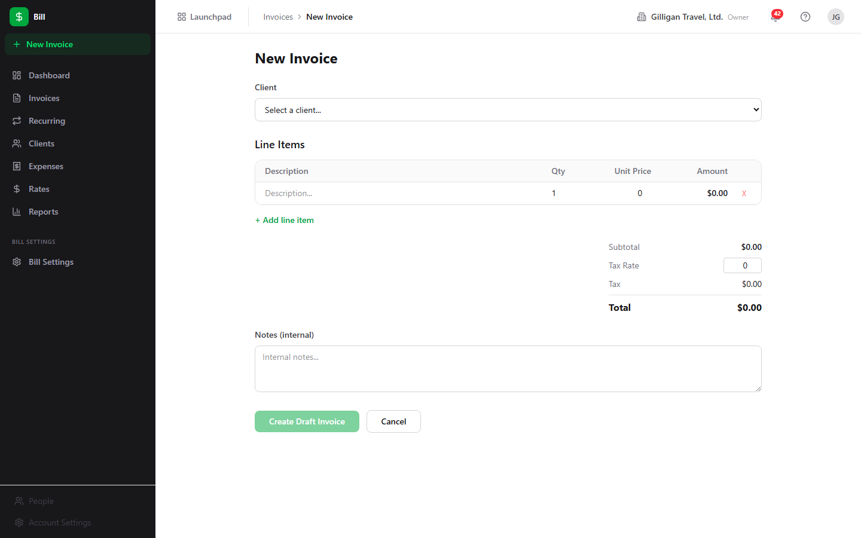
Figure 6.3 New invoice form

Invoice from time entries
The page at /bill/invoices/from-time is titled Invoice from Time Entries with the subtitle "Generate an invoice from Bam time tracking data." It turns billable hours logged in Bam into a draft invoice in one pass.
To generate an invoice from tracked time:
1. From the Invoices list, click From Time Entries (or go to /bill/invoices/from-time).
2. Pick a Bam project in the Project select.
3. Pick the recipient in the Bill to client select.
4. Set the Date From and Date To range.
5. Click Generate Invoice.
Every billable time entry on that project between the two dates is grouped by team member and task, priced with the configured billing rate, and added as a line item on a new draft invoice. Each contributing user needs a billing rate configured for the project (set one under Rates or through the API), or generation fails with an error explaining which rate is missing. When generation succeeds you land on the new draft's detail page, where you can review the line items, then Finalize and send. Use Create Manually Instead to switch to the blank New Invoice form.
This flow is backed by POST /bill/api/v1/invoices/from-time-entries, which accepts either a date_from/date_to range (what the wizard sends) or an explicit list of time_entry_ids. The bill_create_invoice_from_time MCP tool drives the same range form for agents; see "Working with AI agents."

Invoice detail
The detail page at /bill/invoices/:id shows everything about one invoice: header with number, client, and a status badge; From and To panels; Invoice Date, Due Date, Total, and Amount Due tiles; the read-only line items with a Subtotal / Tax / Discount / Total footer; the payments section; and an inline PDF preview iframe once a PDF exists.
The header actions vary by status:
- Edit appears on drafts and opens the edit form.
- Finalize appears on drafts; it assigns the number and locks the invoice. Admin or owner only.
- Re-send appears on sent or viewed invoices; it marks the invoice sent again and queues an email if email is configured. Admin or owner only.
- Void appears on any non-draft, non-void invoice; it cancels the invoice.
- Duplicate is always available; it clones the invoice (and its line items) into a new draft and opens that draft.
- Request approval opens an inline form that posts to Bam's approval queue, the same flow as the list view.
- PDF opens the invoice PDF.
To record a payment from the detail page:
1. Open the invoice. The Record Payment control appears when the status is not draft, void, or paid.
2. Enter the Amount (cents).
3. Choose a Method (Bank Transfer, Credit Card, Check, Cash, Stripe, PayPal, or Other).
4. Click Save Payment.
5. The payment appears in the list (Date, Method, Amount). When recorded payments reach the total, the invoice flips to paid; a partial payment shows partially_paid. Bill rejects a payment that would exceed the remaining balance.
WARNING
A payment cannot push an invoice past paid. Bill rejects any receipt larger than the remaining balance, so record the actual amount received rather than rounding up to the total.
To void an invoice:
1. Open a sent, viewed, or paid invoice (void is blocked on drafts; delete a draft instead).
2. Click Void in the header.
3. The invoice moves to void and drops out of revenue reports.
To duplicate an invoice:
1. Click Duplicate in the header.
2. Bill creates a new draft with the same line items and opens it for editing.
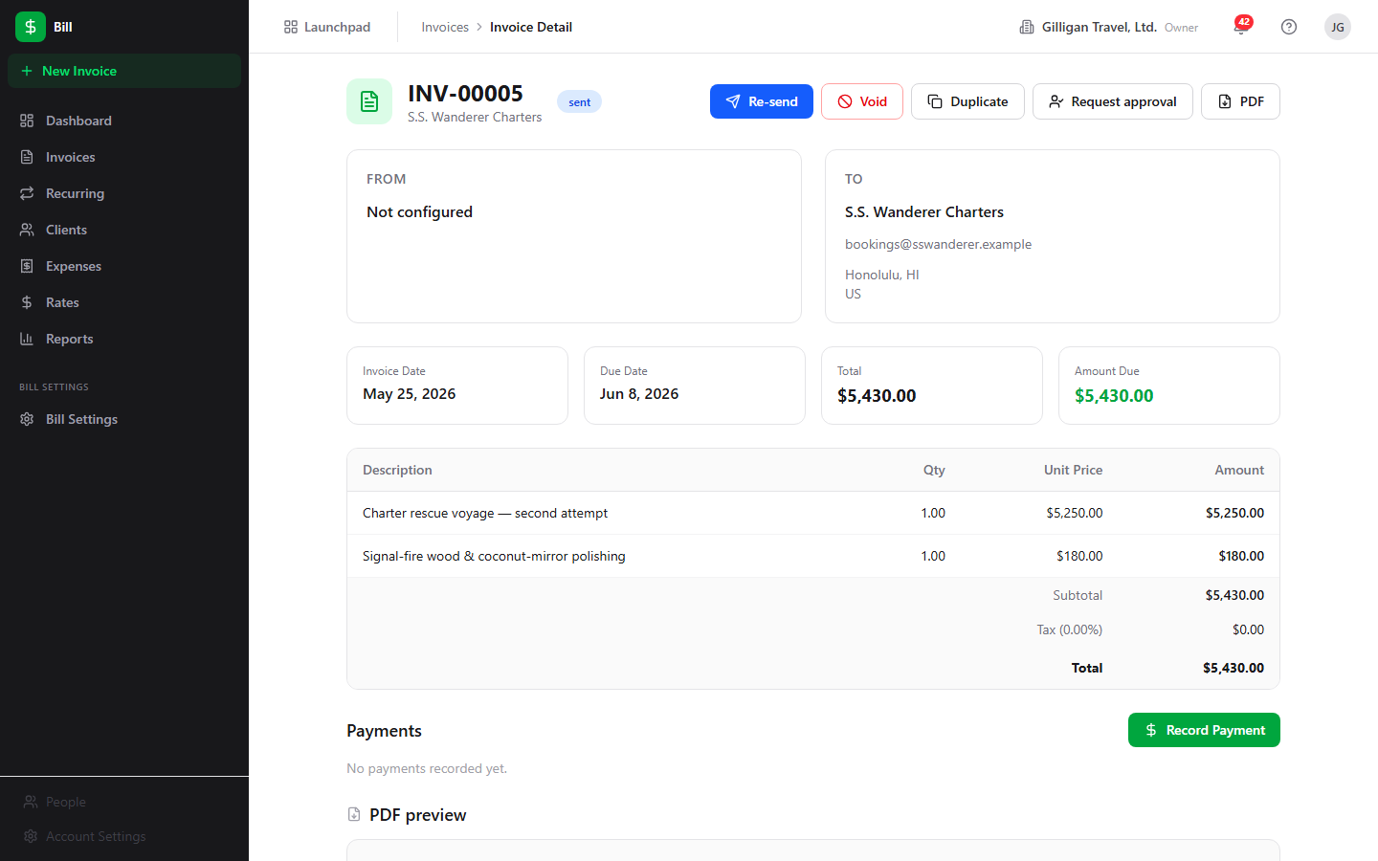
Figure 6.4 Invoice detail

Edit an invoice
The edit form at /bill/invoices/:id/edit is titled Edit Invoice {number} and is available only for drafts. A non-draft shows "Only draft invoices can be edited." with a "Back to Invoice" link.
The editable fields are Tax Rate (%), Internal Notes, Footer Text (on invoice), and Terms & Conditions (on invoice). The edit form cannot add or remove line items and cannot change the client. To change line items, do it on the New Invoice form before creating, or duplicate the invoice and rebuild it.
To edit a draft:
1. On the invoice detail page, click Edit.
2. Adjust Tax Rate (%), Internal Notes, Footer Text (on invoice), or Terms & Conditions (on invoice).
3. Click Save Changes (or Cancel to discard).

Clients
The Clients list at /bill/clients is titled Clients with the subtitle "Manage billing clients." Columns are Name, Email, Phone, and Terms (shown as "{n} days").
To add a client:
1. Open Clients in the sidebar.
2. Click New Client to reveal the inline form.
3. Enter Name and Email.
4. Click Create Client.
To open and edit a client:
1. Click a client row to open /bill/clients/:id.
2. Click Edit to enable inline editing of Contact Information (Name, Email, Phone) and Address & Tax (Address Line 1, Address Line 2, City, State, ZIP, Tax ID) plus Notes.
3. Click Save (or Cancel).
The client detail page also shows Total Billed, Total Paid, and Outstanding Balance summary cards computed from this client's invoices, the read-only address, tax ID, payment terms, and notes, and an Invoices table (Invoice #, Date, Status, Total, Paid, Due). The + New Invoice link opens the New Invoice form; note that it does not pre-select this client, so choose the client again on the form.

Expenses
The Expenses list at /bill/expenses is titled Expenses with the subtitle "Track project expenses and receipts." Columns are Description, Category, Vendor, Date, Amount, Status, and Actions. A row of status pills filters the list: All (empty), pending, approved, rejected, and reimbursed. The reimbursed pill shows expenses you have paid back to the submitter.
To log an expense:
1. Open Expenses and click New Expense to go to /bill/expenses/new (titled New Expense).
2. Fill in Description, Amount (cents), and Date.
3. Choose a Category (Software, Travel, Hardware, Contractor, Office, Meals, or Other) and optionally a Vendor.
4. Tick Billable to client if the cost should be invoiceable.
5. Click Submit Expense. The expense is created as pending.
To approve or reject an expense:
1. On the Expenses list, find a pending row.
2. Click Approve or Reject in its Actions cell. Approving and rejecting require an admin or owner role.
3. The status changes to approved or rejected. Only pending expenses can be approved or rejected; once approved, an expense is locked from edits.
To mark an approved expense reimbursed:
1. On the Expenses list, find an approved row.
2. Click Mark reimbursed in its Actions cell. This is an admin or owner action.
3. The status changes to reimbursed, the terminal step of the expense lifecycle (pending to approved to reimbursed). Only approved expenses can be marked reimbursed.
Editing an expense, deleting one, and attaching a receipt are supported by the API but have no button in the current UI. To attach a receipt or edit an expense, use the API (POST /bill/api/v1/expenses/:id/receipt, PATCH /bill/api/v1/expenses/:id) or the matching MCP tools.
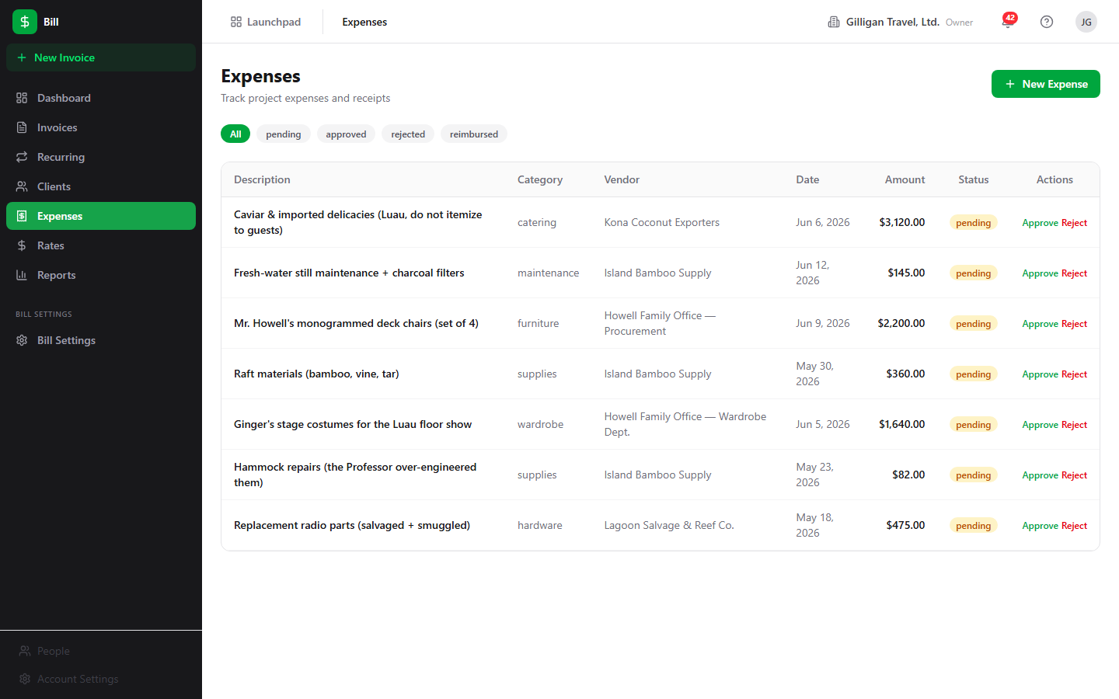
Figure 6.5 Expense list

Rates
The Rates list at /bill/rates is titled Billing Rates with the subtitle "Configure hourly, daily, or fixed rates per org/project/user." Columns are Rate, Type, Scope (derived as User + Project, User, Project, or Organization), Effective From, and Actions.
To add a rate:
1. Open Rates and click New Rate to reveal the inline form.
2. Enter Rate (cents) (the form defaults to 15000) and choose a Type (Hourly, Daily, or Fixed).
3. Click Create Rate.
To delete a rate, click Delete in its Actions cell.
The inline form only sets amount and type, so rates created in the UI are organization-scoped. Project-specific, user-specific, and date-bounded rates are supported by the data model and the resolver but must be created through the API (POST /bill/api/v1/rates with project_id, user_id, effective_from, or effective_to) or the bill_create_rate MCP tool, which accepts those scopes. When Bill bills time, it resolves the most specific rate that applies, preferring a user-and-project rate, then a user rate, then a project rate, then the organization rate, restricted to rates whose date range covers the work date.

Reports
The Reports view at /bill/reports is titled Financial Reports. It renders four tables:
- Revenue by Month (Month, Invoiced, Collected, Count).
- Outstanding Aging (Client, with 0-30, 31-60, 61-90, and 90+ day buckets).
- Project Profitability (Project, Revenue, Expenses, Profit, Margin). Only approved expenses count against profit.
- Overdue Invoices (Invoice, Client, Amount Due, Days Overdue). Each row links to the invoice. It computes overdue from each invoice's due date; the Dashboard tile and the Invoices list Overdue filter draw from the same set.
Revenue and profitability exclude draft, void, and written-off invoices. Outstanding and overdue also exclude paid invoices. Report views require Bill report permissions.
To read your reports:
1. Open Reports in the sidebar.
2. Review the four tables in place.
3. Click any Overdue Invoices row to jump to that invoice.
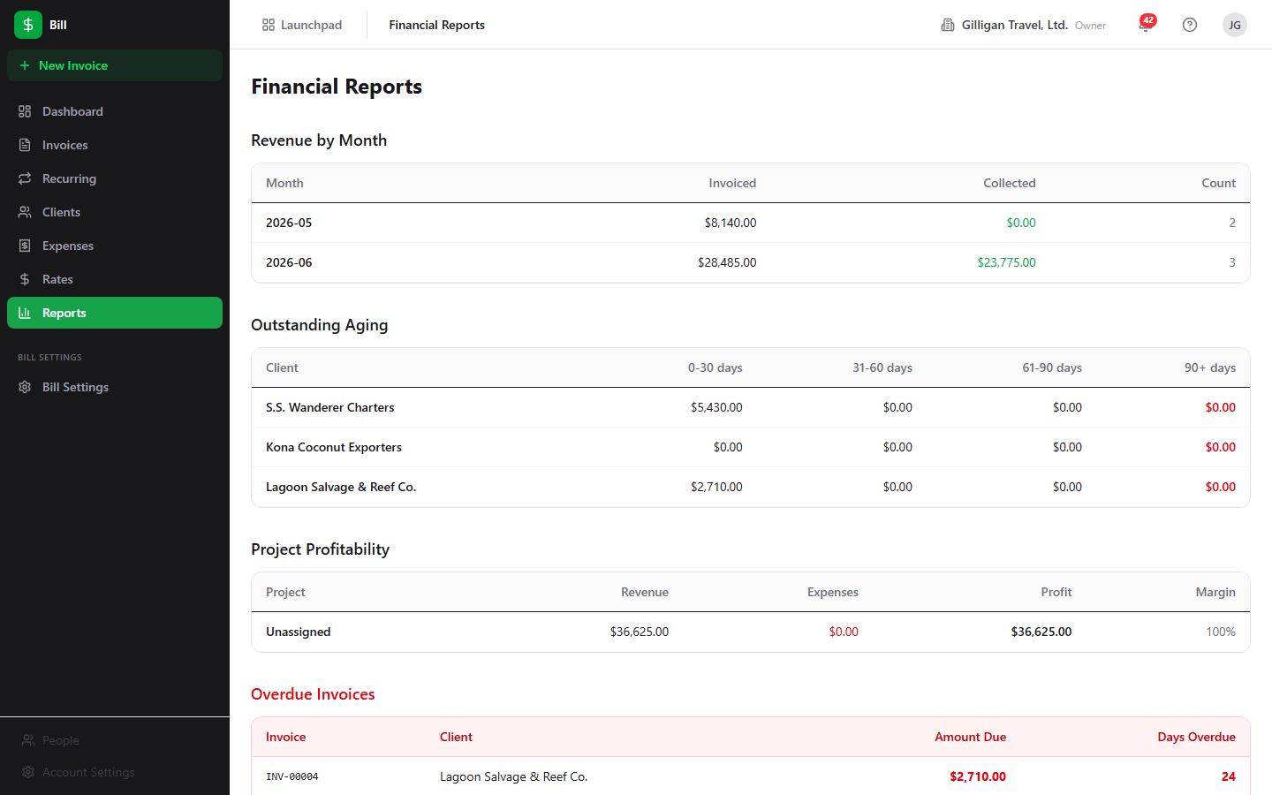
Figure 6.6 Financial reports

Settings
The Settings view at /bill/settings is titled Billing Settings. It has two sections.
Company Information holds Company Name, Email, Phone, Tax ID, and Address. These are snapshotted onto each invoice's "from" side at creation time.
Invoice Defaults holds Invoice Prefix, Default Tax Rate (%), Payment Terms (days), Default Payment Instructions, Default Footer Text, and Default Terms & Conditions. New invoices inherit these defaults.
To update your billing identity and defaults:
1. Open Bill Settings in the sidebar.
2. Edit any field under Company Information or Invoice Defaults.
3. Click Save Settings. The button shows "Saved!" on success.
The settings record also stores a company logo URL and a default currency, both reachable through the API and the bill_update_settings MCP tool, but neither has a field in the current Settings form.

Recurring billing
The Recurring page at /bill/recurring is titled Recurring with the subtitle "Subscription schedules that generate invoices automatically." It is where you set up standing fees that bill a client on a cadence without re-drafting the invoice each cycle.
The table columns are Name, Cadence, Next run, Generated (the count of invoices produced so far), Mode (Auto-finalize or Draft), Status, and Actions. A row of filter pills above it filters by status: All (empty), active, paused, and cancelled. Each schedule carries a client, a cadence (weekly, monthly, quarterly, or annually), a saved line-item template, an optional tax rate, a start date, an optional end date, and a mode.
The Mode determines what each run produces. With Auto-finalize on, every generated invoice is assigned a number and marked sent automatically. With it off (Draft), each run produces a draft for you to review, finalize, and send by hand. Schedules generate on their own through a daily worker sweep that materializes invoices from every active schedule whose next-run date has arrived; you can also force one immediately with Generate now.
Set a recurring schedule to Auto-finalize and every cycle's invoice numbers, finalizes, and sends itself.
To create a recurring schedule:
1. Open Recurring in the sidebar and click New Recurring Schedule.
2. Give the schedule a Schedule name and pick a Client.
3. Choose a Cadence (weekly, monthly, quarterly, or annually) and a Start date; optionally set an End date and a Tax rate (%).
4. Tick Auto-finalize generated invoices to bill automatically, or leave it unchecked to generate drafts for review.
5. In the Line items (template) table, add a Description, Qty, and Unit price (cents) for each row. The Subtotal updates as you type.
6. Optionally add Notes (internal), then click Create schedule. The schedule starts active.
The per-row actions depend on status:
- Generate now materializes an invoice immediately from the template (available on active and paused schedules). A banner reports the generated invoice number, or "draft" when the schedule is in draft mode.
- Pause stops generation on an active schedule; Resume restarts a paused one.
- Cancel stops all future generation permanently. It is an admin or owner action; existing invoices the schedule already produced are kept. Cancelling prompts for confirmation and cannot be undone.
Creating, updating, pausing, resuming, and generating-now follow the same write permission as drafting an invoice, so any member who can create invoices can run these. Cancelling a schedule is restricted to an admin or owner, mirroring invoice deletion. When a run produces an invoice, Bill emits a recurring.invoice_generated event on the bill source for Bolt rules to consume.
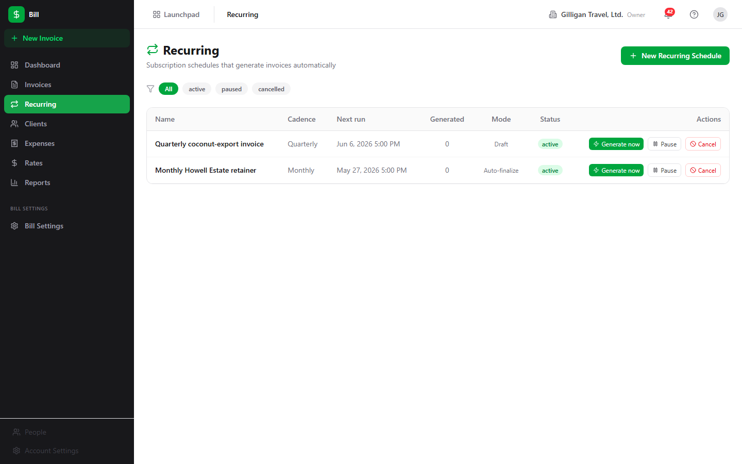
Figure 6.7 Recurring billing

PDF generation
Every invoice can be downloaded as a PDF. The PDF action on the list, the PDF action in the detail header, and the inline PDF preview iframe all render the invoice through Bill's PDF service (GET /bill/api/v1/invoices/:id/pdf). A draft's PDF is named DRAFT.pdf; a finalized invoice's PDF is named after its number.
When you finalize an invoice, Bill enqueues a background PDF job; when you send one, it enqueues an email job. While those run, the detail page can show a "PDF generating..." state. You do not need to trigger PDF generation manually; the PDF action always renders on demand.

Public invoice view
Each invoice carries a public view token. Anyone with the token URL can read a safe subset of the invoice and fetch its PDF without logging in, through GET /bill/api/v1/invoice/:token and GET /bill/api/v1/invoice/:token/pdf. The first open of the token URL marks a sent invoice as viewed. The public response omits internal fields such as the organization ID, the creator, the linked Bond deal, and tax IDs.
There is no Bill SPA page for the public view and no client-facing payment action on it. The public page is view-and-PDF only: the client cannot pay through it, so you record payments yourself from the invoice detail page. The token URL is intended to be shared with a client, typically from a sent-invoice email.

Working with AI agents
Bill exposes 47 MCP tools (catalogued in apps/mcp-server/src/tools/bill-tools.ts), which together cover the full invoicing and recurring-billing lifecycle from chat or a Bolt automation rule. Many tools resolve fuzzy identifiers: a client can be named by name or email, and a Bam project by name, and the tool resolves it to an ID. Mutating tools run under the same per-action permissions as the UI, so an agent acting as a member can build drafts but cannot finalize, send, or approve expenses unless its account has the admin or owner grant.
What agents commonly do:
- List and inspect: bill_list_invoices, bill_get_invoice, bill_get_invoice_jobs, bill_list_clients, bill_get_client, bill_list_expenses, bill_list_rates, bill_get_settings.
- Build a draft: bill_create_invoice (blank draft for a client), then bill_add_line_item, bill_update_line_item, and bill_delete_line_item per line. bill_update_invoice adjusts a draft's dates, tax, discount, terms, notes, and footer. For a Bond-deal handoff, bill_create_invoice_from_deal pulls the deal value into one line item; in a Bolt rule the deal ID is passed as {{ event.deal.id }} from a deal.* event, and it must be a UUID.
- Bill tracked time: bill_create_invoice_from_time takes a project, a billing client, and a date_from/date_to range, and the Bill API resolves the matching time entries, groups them by user and task, prices each group with the resolved rate, and builds one line item per group. This is the same range form the in-app wizard uses.
- Finish and collect: bill_finalize_invoice to assign the number and lock the invoice, bill_send_invoice to mark it sent, bill_record_payment to log receipts, and bill_delete_payment to reverse one. bill_void_invoice, bill_duplicate_invoice, and bill_delete_invoice cover the rest of the invoice lifecycle.
- Clients: bill_create_client, bill_update_client, and bill_delete_client manage the recipient records.
- Expenses and rates: bill_create_expense, bill_update_expense, bill_delete_expense, bill_approve_expense, and bill_reject_expense for costs; bill_create_rate, bill_update_rate, bill_delete_rate, and bill_resolve_rate for billing rates (the create tool accepts project, user, and effective-date scoping that the UI form does not). Marking an approved expense reimbursed is a UI and REST action (POST /bill/api/v1/expenses/:id/reimburse) with no dedicated MCP tool.
- Recurring schedules: bill_list_recurring_invoices and bill_get_recurring_invoice to read schedules and their line-item template; bill_create_recurring_invoice to stand one up (client, cadence, mode, and template line items); bill_update_recurring_invoice to adjust it; bill_pause_recurring_invoice, bill_resume_recurring_invoice, and bill_cancel_recurring_invoice to control its lifecycle (cancel is admin or owner); and bill_generate_recurring_invoice_now to materialize an invoice on demand.
- Reporting: bill_get_overdue, bill_get_revenue_summary, bill_get_profitability, and bill_get_outstanding back the Reports view's data.
- Settings: bill_get_settings and bill_update_settings read and write the org billing identity and invoice defaults, including the logo URL and default currency the UI form omits.
A typical agent flow is: an agent drafts an invoice from a deal or from logged time, fills line items, and records a payment when one lands, while leaving the Finalize and Send steps for an admin or owner to approve. For high-stakes actions, route the work through the platform approval queue (the proposal_create / proposal_list / proposal_decide tools) so a human signs off before money moves.
One caution for agent-driven invoicing: the invoice number format the live finalizer produces is {prefix}-{number:05d} (for example INV-00001). Year-based forms like INV-2026-0042 that appear in some seed data and examples are not what finalize generates.
Bill participates in the cross-cutting agentic platform that every BigBlueBam app shares:
- Identity and heartbeat. Agent and service accounts carry users.kind (agent or service), which is mirrored onto each activity row's actor_type, so Bill writes made by an agent are attributable. Agent runners report liveness with agent_heartbeat.
- Approvals. Beyond the in-app Request approval flow (which posts to Bam's queue), agents can stage any decision in the durable proposal queue with proposal_create and let a human resolve it with proposal_decide.
- Unified activity. Bill invoice and payment activity is queryable across apps through activity_query and activity_by_actor, and surfaces in the unified activity view alongside the other apps.
- Policies and webhooks. Per-agent kill switches and tool allowlists (the bill.* glob) gate which Bill tools a given agent may call. Subscribed Bill events can be pushed to agent runners over HMAC-signed outbound webhooks.
- Visibility. Before an agent surfaces Bill data (an invoice total, a client balance) into a shared surface in another app, it should run the platform can_access check for each cited bill.invoice entity and drop anything the asker is not allowed to see, per docs/reference/agent-conventions.md.
For the full tool catalog, see the MCP-tools reference in docs/apps/bill/.

User Stories

Story: Set up your billing identity
Who: An org admin or owner setting up Bill for the first time.
Goal: Make new invoices carry your company details and sensible defaults.
Before you start: You are logged in to BigBlueBam and have Bill settings permission.
Steps
1. Open Bill at /bill/ and click Bill Settings in the sidebar.
2. Under Company Information, fill in Company Name, Email, Phone, Tax ID, and Address.
3. Under Invoice Defaults, set the Invoice Prefix, Default Tax Rate (%), Payment Terms (days), Default Payment Instructions, Default Footer Text, and Default Terms & Conditions.
4. Click Save Settings and wait for the "Saved!" confirmation.
Result: Your company identity is stored. Every new invoice snapshots these details onto its "from" side and inherits the defaults you set.
Related: Add your first client next (Story: Add a client and send your first invoice). An agent can set the same fields, including the logo URL and default currency, with bill_update_settings.

Story: Add a client and send your first invoice
Who: Anyone who bills clients. (A member can build the draft; an admin or owner finalizes and sends.)
Goal: Create a client, invoice them, and send it.
Before you start: Billing identity is set in Bill Settings. You have permission to create clients and invoices.
Steps
1. Click Clients in the sidebar, then New Client.
2. Enter the client Name and Email and click Create Client.
3. Click New Invoice (sidebar or Invoices list).
4. Choose your new client in the Client select.
5. In Line Items, enter a Description, Qty, and Unit Price (in cents) for each row, using + Add line item for more rows.
6. Set the Tax Rate if needed and review Subtotal, Tax, and Total.
7. Click Create Draft Invoice. You land on the draft's detail page.
8. Click Finalize in the header (admin or owner). The invoice gets its number and locks.
9. Click Re-send to dispatch it (this queues an email if email is configured).
Result: The client has a finalized, sent invoice with a permanent number. It appears in the Invoices list as sent.
Related: Record the payment when it arrives (Story: Record a payment to close out). An agent can do the same with bill_create_client, bill_create_invoice, bill_add_line_item, bill_finalize_invoice, and bill_send_invoice.

Story: Record a payment to close out
Who: Anyone tracking receivables.
Goal: Log payments against an invoice and watch it reach paid.
Before you start: The invoice is finalized (status is sent, viewed, or partially_paid).
Steps
1. Open Invoices and click the invoice row.
2. In the payments section, find Record Payment.
3. Enter the Amount (cents) received.
4. Choose a Method (for example, Bank Transfer).
5. Click Save Payment.
6. Repeat for additional payments until the recorded total reaches the invoice total.
Result: A partial payment shows the invoice as partially_paid; when payments reach the total it becomes paid. The Dashboard Paid and Outstanding tiles reflect the change.
Related: Bill rejects a payment larger than the remaining balance. An agent can record payments with bill_record_payment and reverse one with bill_delete_payment.

Story: Capture, approve, and reimburse an expense
Who: A team member logging a project cost, and an admin or owner reviewing it.
Goal: Record an expense and move it through approval and reimbursement.
Before you start: You have permission to create expenses; the reviewer has the admin or owner role needed to approve and reimburse.
Steps
1. Click Expenses in the sidebar, then New Expense.
2. Fill in Description, Amount (cents), and Date.
3. Choose a Category and optionally a Vendor.
4. Tick Billable to client if it should be invoiceable, then click Submit Expense. The expense is pending.
5. The reviewer opens the Expenses list, finds the pending row, and clicks Approve (or Reject).
6. After paying the submitter back, the reviewer clicks Mark reimbursed on the approved row.
Result: The expense moves to approved (or rejected), and an approved expense can be moved on to reimbursed. Approved expenses count against project profit in the Project Profitability report and can no longer be edited.
Related: Receipt upload and expense edits are available through the API and the bill_update_expense tool. An agent can log expenses with bill_create_expense, list them with bill_list_expenses, and decide them with bill_approve_expense / bill_reject_expense. Marking reimbursed is a UI and REST action with no dedicated MCP tool.

Story: Send an invoice for approval before billing
Who: Someone who needs sign-off before an invoice goes out.
Goal: Route an invoice to a colleague for approval.
Before you start: The invoice exists. You know which Bam user should approve it.
Steps
1. On the Invoices list, click Request approval on the invoice row (or use Request approval on the invoice detail page).
2. In the Request approval for {number} dialog, pick an Approver from the select.
3. Optionally type a Message (optional).
4. Click Send request.
Result: A request is posted to Bam's approval queue (subject type bill.invoice) and a Banter DM goes to the approver via Bolt. The approver reviews and decides inside Bam.
Related: After approval, finalize and send the invoice (Story: Add a client and send your first invoice). An agent can stage a comparable sign-off in the platform proposal queue with proposal_create.

Story: Turn a won Bond deal into an invoice
Who: An account owner, or a Bolt rule, converting closed-won revenue into a bill.
Goal: Generate a draft invoice from a Bond deal with the deal value as a line item.
Before you start: The deal exists in Bond and you have its UUID. A matching Bill client exists (or you know its name/email).
Steps
1. Have an agent call bill_create_invoice_from_deal with the deal's UUID and the billing client. In a Bolt rule, pass {{ event.deal.id }} from the triggering deal.* event.
2. The tool creates a draft invoice with the deal value as one line item and emits invoice.created.
3. In Bill, open the new draft, adjust line items or tax if needed, and click Finalize (admin or owner).
4. Click Re-send to send it.
Result: A draft invoice tied to the deal becomes a finalized, sent invoice. A human stays in control of finalize and send.
Related: This is the canonical Bond-to-Bill handoff. See "Working with AI agents" for the tool details.

Story: Bill tracked time from a project
Who: Anyone billing logged hours.
Goal: Generate an invoice from Bam time entries over a date range.
Before you start: A rate exists that covers the work (set one under Rates, via the API, or with bill_create_rate for project/user scope). You know the project, the client, and the date range to bill.
Steps
1. Confirm a rate applies by checking Rates, or have an agent call bill_resolve_rate for the project, user, and date.
2. From the Invoices list, click From Time Entries.
3. Pick the Project, the Bill to client, and the Date From / Date To range.
4. Click Generate Invoice. Bill groups every billable entry on that project in the range by user and task, prices each group with the resolved rate, and builds one line item per group on a new draft.
5. Review the generated line items on the draft, click Finalize, then Re-send.
Result: A draft invoice built from real tracked time, ready to finalize and send.
Related: Configure rates first (the Rates feature). An agent can do the same with bill_create_invoice_from_time (project, client, and a date_from/date_to range), and resolve a rate with bill_resolve_rate.

Story: Put a standing fee on a recurring schedule
Who: Anyone who bills the same client the same amount on a regular cadence (a retainer, a subscription, a quarterly standing order).
Goal: Bill a client automatically on a cadence without re-drafting the invoice each cycle.
Before you start: The client exists in Bill. You have permission to create invoices (creating a schedule uses the same write permission).
Steps
1. Click Recurring in the sidebar, then New Recurring Schedule.
2. Enter a Schedule name and pick the Client.
3. Choose a Cadence (weekly, monthly, quarterly, or annually) and a Start date; set an End date and a Tax rate (%) if needed.
4. Decide the mode: tick Auto-finalize generated invoices to bill and send automatically, or leave it unchecked to generate drafts you review first.
5. Fill in the Line items (template) table with the descriptions, quantities, and unit prices (cents) to bill each cycle.
6. Click Create schedule. It starts active with a next-run date on the start date.
Result: The schedule appears in the Recurring list as active. A daily worker sweep generates an invoice from the template whenever the next-run date arrives, advancing the next run by the cadence. Auto-finalize schedules send each invoice automatically; draft schedules leave each one for you to finalize and send.
Related: Use Generate now to produce an invoice immediately, Pause / Resume to stop and restart generation, and Cancel (admin or owner) to end the schedule while keeping the invoices it already produced. An agent can do all of this with bill_create_recurring_invoice, bill_pause_recurring_invoice, bill_resume_recurring_invoice, bill_cancel_recurring_invoice, and bill_generate_recurring_invoice_now. Build a Bolt rule on the recurring.invoice_generated event to react when a schedule bills.

Story: Close out a billing period
Who: A finance owner reviewing the month.
Goal: See revenue, aging, profitability, and what is overdue.
Before you start: You have Bill report permissions.
Steps
1. Click Reports in the sidebar.
2. Read Revenue by Month for invoiced and collected totals.
3. Read Outstanding Aging to see balances by client and age bucket.
4. Read Project Profitability to compare revenue against approved expenses per project.
5. Read Overdue Invoices, and click any row to open and chase that invoice.
Result: A complete financial snapshot for the period, with overdue invoices computed from due dates.
Related: An agent can pull the same data with bill_get_revenue_summary, bill_get_profitability, bill_get_outstanding, and bill_get_overdue. The Dashboard's Overdue tile and the Invoices list Overdue filter draw from the same overdue set.

Story: Chase overdue invoices automatically
Who: A finance owner who wants overdue reminders to send themselves.
Goal: Have Bill email clients whose invoices are past due, and let automation escalate.
Before you start: Invoices have due dates; SMTP is configured for real email (otherwise reminders are logged).
Steps
1. Finalize and send invoices as usual so they have due dates.
2. Each day at 09:00 UTC, Bill's reminder sweep finds invoices past their due date that are not paid or void, and that were not reminded in the last 7 days.
3. The sweep emails the client (or logs the reminder if SMTP is not set), records the reminder timestamp and count, and emits an invoice.overdue event on the bill source.
4. Build a Bolt rule on invoice.overdue to escalate or notify the account owner.
Result: Overdue clients get periodic reminders without manual effort, and downstream automation can react to the invoice.overdue event.
Related: Bill also emits invoice.created, invoice.finalized, invoice.sent, invoice.paid, and payment.recorded, all on the bill source, for Bolt rules to consume.

Related
- Bam (/b3/) - Projects, tasks, and time entries feed time-based invoicing and rate resolution; invoice approvals route through Bam's approval queue.
- Bond (/bond/) - Won deals convert into draft invoices via bill_create_invoice_from_deal; a Bill client can link to a Bond company.
- Bolt (/bolt/) - Automation rules consume Bill events such as invoice.paid, invoice.overdue, payment.recorded, and recurring.invoice_generated, and can trigger bill_create_invoice_from_deal.
- Banter (/banter/) - Approval requests reach the approver as a Banter DM.
- Bill's own docs in docs/apps/bill/: the MCP-tools reference (the full 47-tool catalog) and guide.md.

Check yourself
Every answer is findable in this chapter. Check your work against the Answer Key appendix at the back of the book.
1. How is money stored and entered throughout Bill?
a) In dollars and cents
b) In integer cents
c) In the org's default currency only
d) As a free-text string
2. Which invoice action requires an admin or owner role rather than plain write access?
a) Adding a line item to a draft
b) Creating a draft invoice
c) Finalizing an invoice
d) Managing clients
3. Once you finalize an invoice, what two things become locked?
4. Is 'overdue' a stored invoice status?
a) Yes, the app sets it like draft or paid
b) No, it is computed from the due date
c) Only on recurring invoices
d) Only after a reminder email sends
5. Name the six invoice status values that the app actually sets.
6. What three states make up the expense lifecycle from submission to terminal step?
7. When Bill bills tracked time, which rate does it use?
a) The organization rate always
b) The most specific rate that applies
c) The highest rate available
d) The rate on the first time entry
8. What happens when you record a payment larger than the remaining balance?
a) The invoice flips to paid and the extra is credited
b) Bill rejects the payment
c) The overage becomes a new draft invoice
d) The client is refunded automatically
9. What is the difference between a recurring schedule's Auto-finalize mode and its Draft mode?
10. Can a client pay through the public invoice view that the view token opens?
a) Yes, it has a Pay Now button
b) No, it is view-and-PDF only and you record payments yourself
c) Only with Stripe configured
d) Only for partially_paid invoices
11. What invoice number format does the live finalizer produce, and what form should you not expect?
12. Which expenses count against profit in the Project Profitability report?
a) All logged expenses
b) Only approved expenses
c) Only billable expenses
d) Only reimbursed expenses
13. Marking an approved expense reimbursed has no dedicated MCP tool. How does an agent or user do it?

CHAPTER 7

Blank
Build it, publish it, collect it.

Blank is the intake layer for the whole suite. You build a form by dragging fields from a palette, decide who can reach it, and publish to a public URL that anyone with the link can fill out, no code required. Responses land in a Responses table and an Analytics view, and they can route into Bond or Helpdesk when that wiring is configured. By the end of this chapter you will be able to design a form, gate who can submit it, and read the numbers that come back.
At a glance
- Drag-and-drop builder with 21 field types, from Short Text to NPS to File Upload
- A public, login-free form at /forms/<slug> once you publish
- Layered access: visibility, sign-in requirement, and allowed email domains
- Real file uploads validated by a background worker, with status pills per submission
- Full MCP coverage, so an agent can draft, publish, and report on a form
In this chapter
Overview . Key concepts . Where to find it . Feature reference . Forms list . Form Builder . Field Settings . Form Settings dialog . Access control and notifications . Publish dialog
Blank is the forms and surveys app in BigBlueBam. Build a form with drag-and-drop fields, publish it to a public URL, and collect and review responses without writing any code.

Overview
Blank lets you build forms and surveys, publish them, and gather responses from anyone with the link. You start from the Forms list, design the form in a visual builder by adding fields from a palette, set who can see it, then publish to get a shareable public URL. Responses flow back into a Responses table and an Analytics view.
Design in a visual builder, then publish to a public URL anyone with the link can fill out, no code required.
The core objects are forms and submissions. A form holds a set of ordered fields and a collection of behavior settings (visibility, confirmation, theming, response limits). A submission is one filled-in response, stored against the form. Forms move through a lifecycle from draft to published, and an author can later close a form to stop accepting responses.
Blank fits alongside the rest of the suite as the intake layer. Forms can be scoped to your organization or to a specific Bam project, and submitted responses can be routed into Bond (as a contact) or Helpdesk (as a ticket) when that routing is configured at the API level.
Authoring happens in the Blank SPA, which requires a BigBlueBam login. Filling out and submitting a published form does not require a login when the form is set to public visibility.

Key concepts
- Form - the top-level object you build and share. It has a name, a slug (used in its public URL), a description, fields, and behavior settings.
- Field - a single input or element on the form. Fields are ordered, can be marked required, and each has a stable field key (letters, digits, and underscores; must start with a letter or underscore) used as the storage key for answers.
- Field type - what kind of input a field is, for example Short Text, Email, Rating, NPS, or Dropdown. You pick the type from the builder palette when you add a field. A few layout-only types (Section Header, Paragraph, Hidden Field, and Page Break) carry no submitted answer.
- Form status - the lifecycle state of a form: draft (still being built), published (live and accepting responses), or closed (no longer accepting responses). New forms start as draft.
- Form type - a label on the form (Public, Internal, or Embedded) found on the per-form Settings page.
- Visibility - who can reach the form through its URL: Public (anyone with the link), Organization (members of your org), or Project members (members of a chosen Bam project).
- Logic (conditional display) - a field can be configured to show only when another field meets a condition (for example, equals or contains a value). This is stored on the field and is available to agents through the MCP field tools; the visual builder does not yet expose a conditional editor.
- Submission - one response to a form. Submissions are listed in the Responses view and aggregated in Analytics.
- Confirmation - what a respondent sees after submitting: a message, a redirect, or a custom page.
- Public form URL - the shareable link to your published form, in the form https://YOUR-DOMAIN/forms/<slug>. This is the server-rendered page the Publish dialog hands you.
NOTE
Conditional display is stored on the field and reachable through the MCP field tools, but the visual builder has no conditional editor yet. To show a field only when another answer matches, set it up through an agent or the API for now.

Where to find it
Blank is served at /blank/. Reach it from the Launchpad app switcher in the top-left of the layout chrome, or go directly to /blank/.
The left sidebar has two items: Forms (the Forms list at /blank/) and Blank Settings (a read-only app information page at /blank/settings). Pressing the question-mark key opens this Help.
Prerequisites:
- A BigBlueBam session or a bbam_ / bbam_svc_ API key. Unauthenticated visitors to the authoring SPA see a "Please log in to BigBlueBam first" screen with a link to /b3/.
- Membership in an organization. All forms and submissions are scoped to your org.
- Publishing a form requires the blank.form.publish permission. Closing a form requires blank.form.close, and deleting a submission requires blank.submission.delete.

Feature reference

Forms list
The Forms list at /blank/ is the home screen. It is headed Forms with the subtitle "Build forms and surveys to capture responses from anyone." Each form appears as a card showing its name, description, a status pill (draft, published, or closed), the field count, the submission count, and a relative "updated" time.
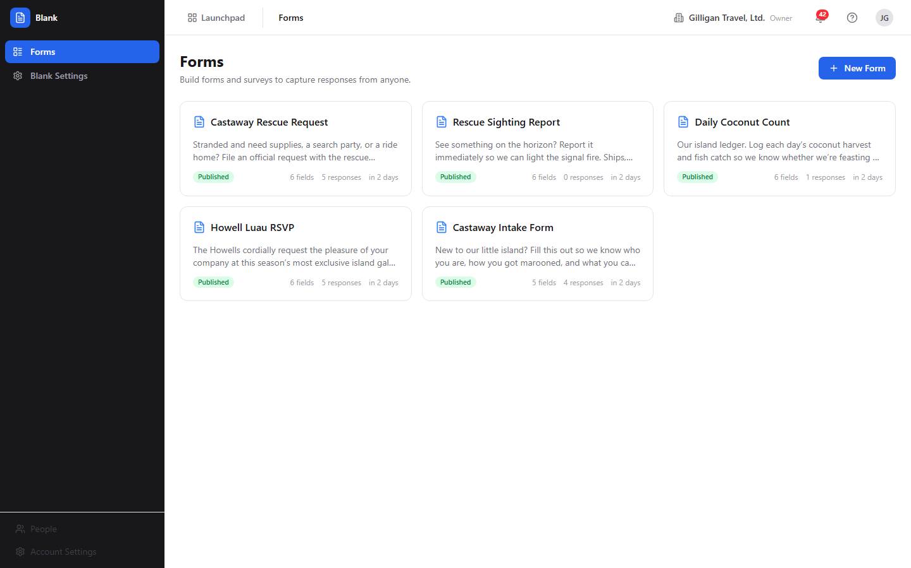
Figure 7.1 Forms list
To create a form:
1. Click New Form (the button with the plus icon, top-right).
2. Blank creates a draft named "Untitled Form" with a generated slug and opens it in the builder.
3. Continue in the builder to rename it and add fields.
To open an existing form:
1. Click the form's card. The builder opens at /blank/forms/<id>/edit.
Each card has an overflow menu (the three-dot icon that appears on hover). It contains:
- Preview - opens the full-page Form Preview.
- Responses - opens the Responses table for the form.
- Duplicate - clones the form and its fields into a new draft. The copy's name gets "(Copy)" appended and it starts as a draft.
- Delete - permanently removes the form. This also removes its fields and submissions. This action is destructive and cannot be undone.
WARNING
Deleting a form removes its fields and every submission with it, permanently and with no undo. If you only want to stop new responses, close the form or turn off Accept Responses instead, which leaves the data intact.
If you have no forms yet, the list shows an empty state: "No forms yet" with "Create your first form to start collecting responses."

Form Builder
The builder at /blank/forms/<id>/edit is where you design a form. It has a left field palette, a center canvas, an optional right field-config panel, and an optional live-preview panel.
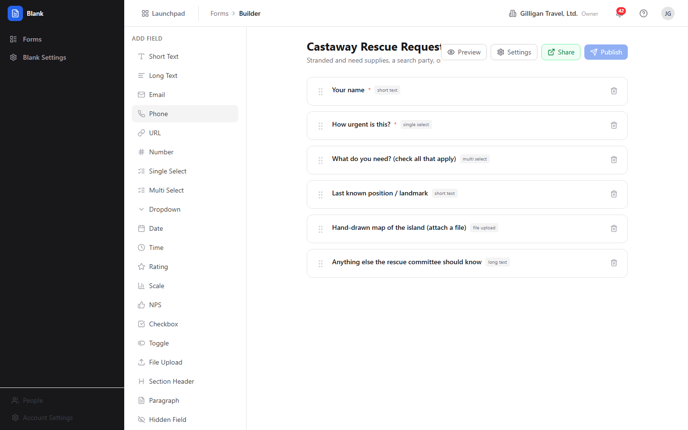
Figure 7.2 Form builder
The left palette is headed Add Field. Click any type to append a field of that type to the canvas. The available types are:
Short Text, Long Text, Email, Phone, URL, Number, Single Select, Multi Select, Dropdown, Date, Time, Rating, Scale, NPS, Checkbox, Toggle, File Upload, Section Header, Paragraph, Hidden Field, and Page Break.
To name the form:
1. In the center canvas, edit the form Title input at the top.
2. Edit the Description input below it. Both save automatically as you type.
To add a field:
1. Click a type in the Add Field palette on the left.
2. The new field appears at the bottom of the canvas. Click it to configure it in the Field Settings panel on the right.
To reorder fields:
1. Drag a field row by its grip handle and drop it in the new position. The order is saved automatically.
To delete a field:
1. Click the trash icon on the field row in the canvas.
The top-right action bar of the builder has these controls:
- Preview (eye icon) - toggles the live-preview panel on the right.
- Settings (gear icon) - opens the Form Settings dialog (visibility, expiration, and project).
- Share (external-link icon) - appears only after the form is published. It reopens the "Your form is live" dialog with the public URL.
- Publish (send icon) - publishes the form. It is disabled once the form is already published.
If the form has no fields, the canvas shows "Click a field type on the left to add it".
The palette's Page Break item splits a form into pages. Adding one inserts a layout-only divider in the builder rather than a stray input, and the public form pages at that boundary. See "Multi-page forms" below. You can also page a form by setting the Page Number on individual fields in Field Settings.

Field Settings
When you select a field in the canvas, the right panel is headed Field Settings. The controls available depend on the field's type. Every control saves to the field when you change it or leave the input.
Common controls:
- Label - the visible question text.
- Key - the field key (shown in a monospace font). This is the storage key for the answer.
- Description - helper text shown under the label.
- Placeholder - placeholder text inside the input.
- Required - a checkbox that makes the field mandatory.
- Page Number - which page the field belongs to in a multi-page form.
Type-specific controls:
- Options editor - for Single Select, Multi Select, and Dropdown. Use "+ Add option" to add choices.
- Min Length and Max Length - for text fields.
- Min Value and Max Value - for numeric fields.
- Scale Min and Scale Max - for Scale fields.
- Regex Pattern - an optional validation pattern applied to string answers.
Layout-only fields (Section Header, Paragraph, Hidden Field, and Page Break) do not show validation controls like the regex pattern, because they collect no answer.

Form Settings dialog
The Settings button in the builder action bar opens the Form Settings dialog, titled Form Settings. It covers visibility, expiration, project scoping, who may submit (sign-in and allowed email domains), and submission notifications (email and Banter).
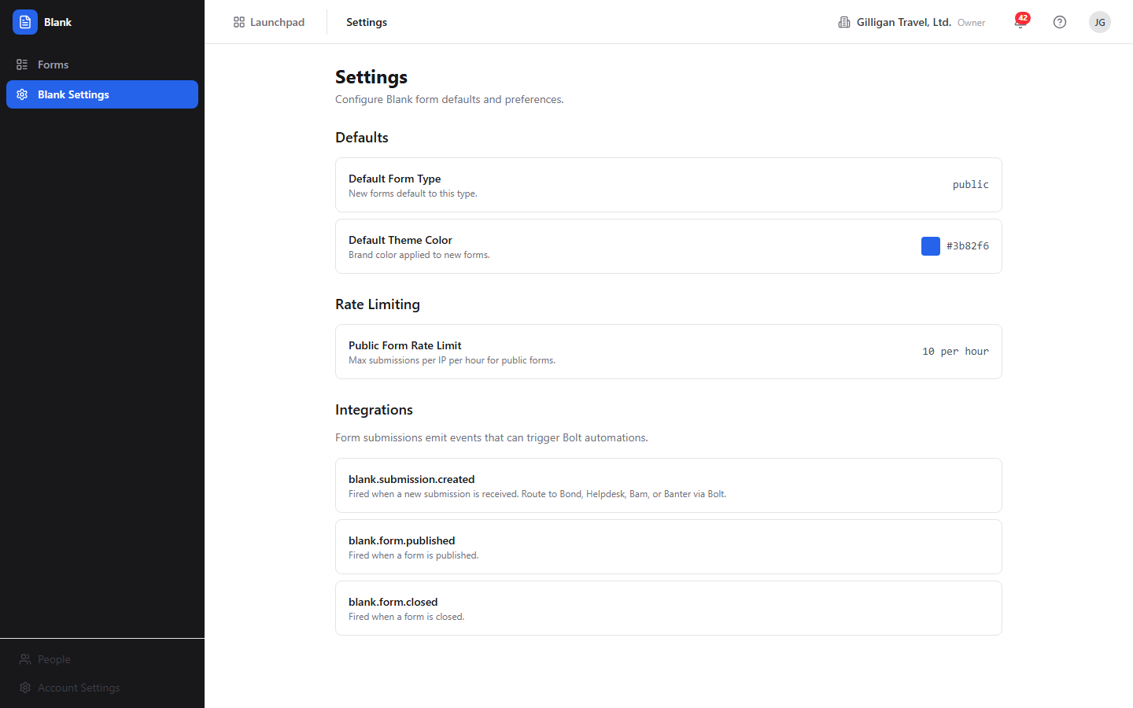
Figure 7.3 Form settings
To set visibility:
1. Click Settings in the builder.
2. Under Visibility, choose one of the radio options:
3. If you choose Project members, a Project picker appears. Select a Bam project.
4. Click Save. Save is disabled if you chose Project members without picking a project.
To set an expiration:
1. In the Form Settings dialog, use the Expires at datetime field to set when the form stops accepting responses.
2. Use the Clear button next to it to remove an expiration.
3. Click Save.
Use Cancel to close the dialog without saving.

Access control and notifications
Below visibility and expiration, the Form Settings dialog has controls for who may submit and what happens when they do. These are enforced and delivered for real.

Figure 7.4 Access control and notifications
- Require sign-in to submit - a checkbox. When on, a visitor must be signed in to a BigBlueBam account before they can submit (or upload a file). An anonymous attempt is rejected with a "You must be signed in to submit this form" error.
- Allowed email domains - a comma-separated list, for example acme.com, example.org. When set, only a submitter whose email is on one of these domains may submit; everyone else is rejected with a "Submissions from ... are not allowed" error. The submitter's email is taken from their signed-in account, the form's email field, or an explicit email in the response, in that order. Leave the field blank to allow any domain. A leading @ is tolerated and stripped.
- Email me on new submissions - a checkbox that turns on notification emails for this form.
- Notification recipients - a comma-separated list of email addresses to notify on each new submission. Used together with Email me on new submissions.
- Post to Banter channel - an optional picker. When a channel is chosen, each new submission also posts a short message to that Banter channel.
To gate who can submit:
1. Click Settings in the builder.
2. Check Require sign-in to submit to force authentication, and/or enter one or more domains under Allowed email domains.
3. Click Save.
To get notified of submissions:
1. Click Settings in the builder.
2. Check Email me on new submissions and enter one or more addresses under Notification recipients.
3. (Optional) Pick a Post to Banter channel target.
4. Click Save.
Note: the sign-in and allowed-domain gates are enforced on the public submit and file-upload paths. Combine them with Visibility (org or project membership) for layered access control. Notification and confirmation emails are dispatched through your deployment's SMTP transport; where SMTP is not configured, the worker logs the message instead of delivering it.

Publish dialog
When you click Publish in the builder, Blank publishes the form (it must have at least one field) and opens the publish-result dialog, titled Your form is live.
TRY IT
Open /blank/, click New Form, drop a single Rating field on the canvas, then click Publish and copy the URL from the Your form is live dialog.
The dialog shows:
- A read-only public URL of the shape https://YOUR-DOMAIN/forms/<slug>.
- A Copy button that copies the URL (the button text changes to "Copied").
- An Open in new tab link.
- The form's current visibility label.
- A Done button to close the dialog.
To share a published form:
1. Click Publish (or Share, if the form is already published) in the builder.
2. In the Your form is live dialog, click Copy to copy the public URL, or Open in new tab to view it.
3. Click Done.
Note: the URL handed out here is the server-rendered page at /forms/<slug>. That is the canonical public form. This is the link to share with respondents.

Preview
Preview shows the form exactly as a respondent would see it, without accepting input.
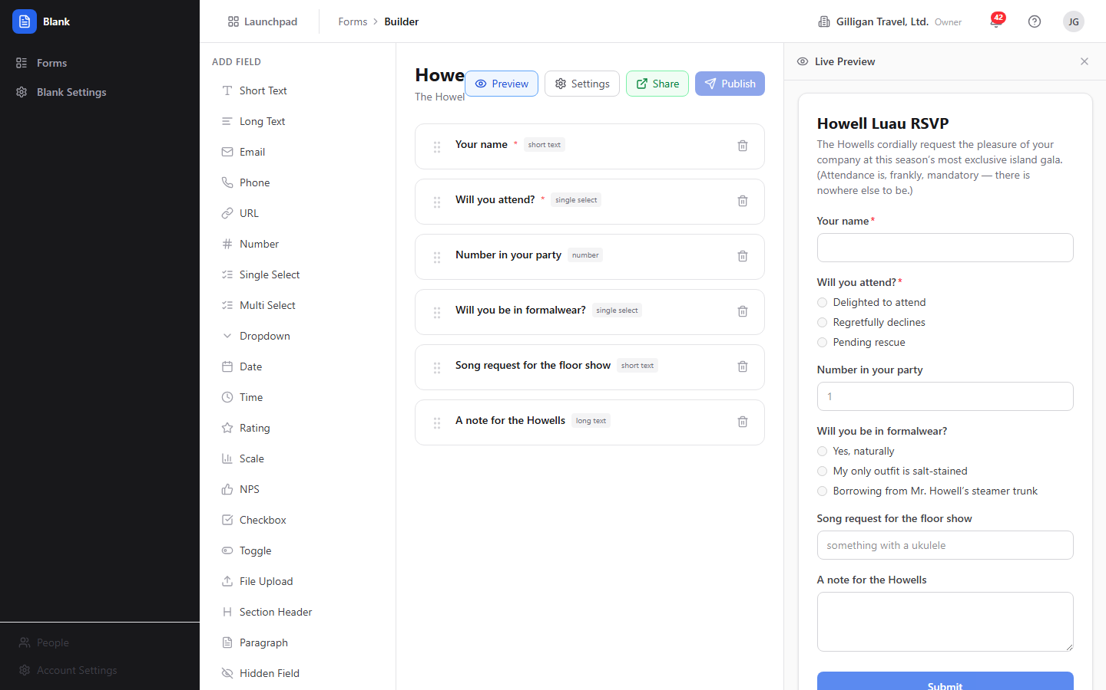
Figure 7.5 Live preview
There are two ways to preview:
- In the builder, click Preview (eye icon) to toggle the live-preview panel on the right. The panel renders the form as you edit and splits a multi-page form at page boundaries with Previous and Next controls and a progress bar.
- From the Forms list overflow menu, click Preview, or go to /blank/forms/<id>/preview, for the full-page Form Preview. The header has a "Back to Builder" link and a "PREVIEW MODE" label, and all inputs are disabled.

Responses
The Responses view lists every submission for a form. Open it from a form card's overflow menu (Responses) or at /blank/forms/<id>/responses. The page is titled "<form name> - Responses" and shows the submission count. The back chevron returns you to the builder.
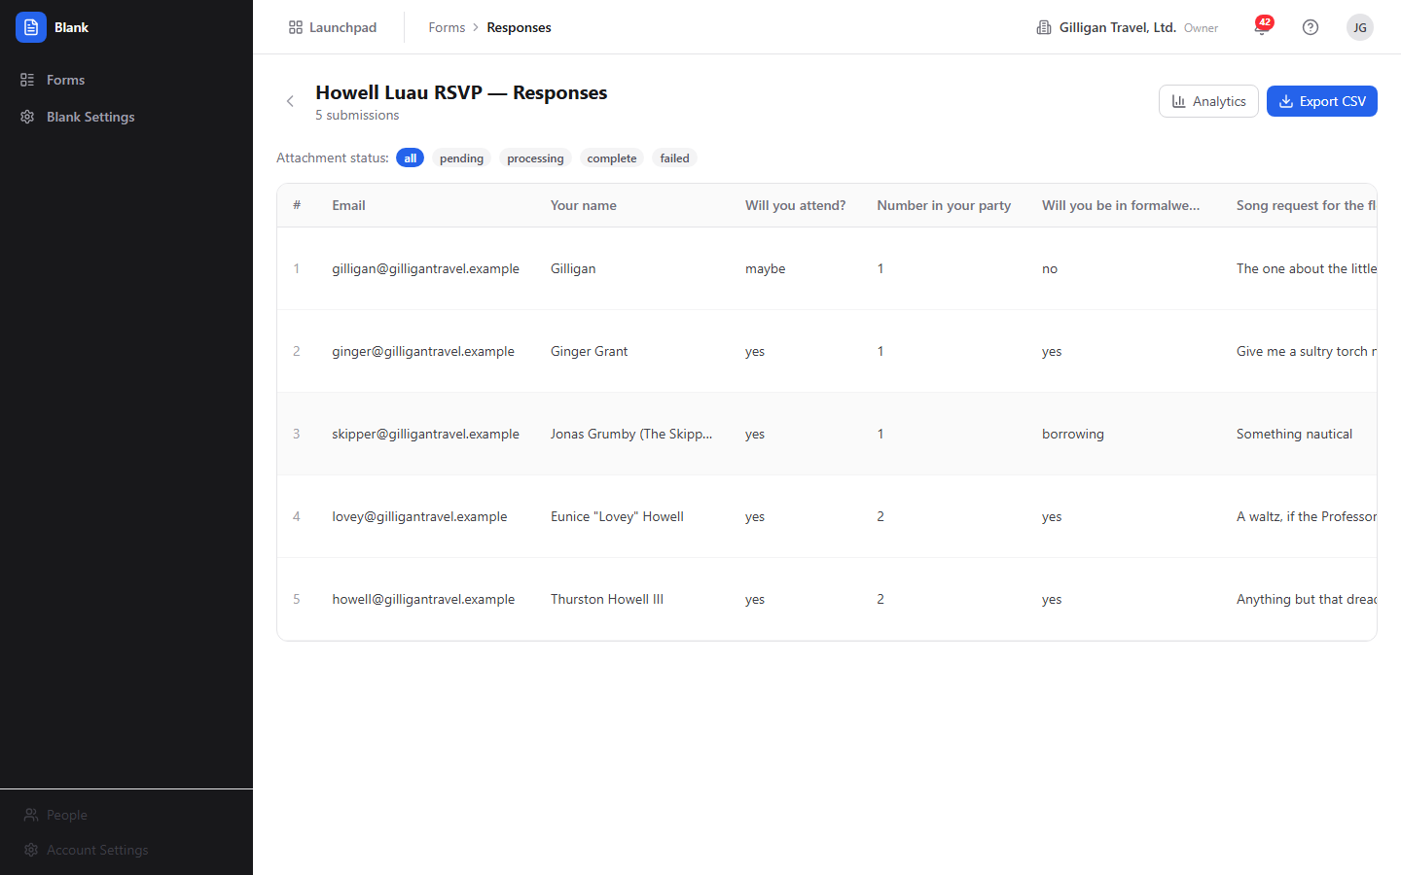
Figure 7.6 Responses table
Actions on the Responses page:
- Analytics - opens the Analytics view for this form.
- Export CSV - downloads all submissions for the form as a CSV file named submissions.csv.
To filter by attachment processing state:
1. Use the Attachment status: filter pills above the table: all, pending, processing, complete, or failed. This filters the visible rows.
The table columns are: a row number (#), Email, the first five display fields' answers, Files (a processing-status pill), and Date. If there are no submissions, the table shows "No responses yet."
File uploads are real. When a respondent attaches a file to a File Upload field, the bytes are uploaded to object storage (MinIO/S3) before the form is submitted, and the submission carries a stored-object reference. A background worker then validates each stored file (extension and MIME allowlist, confirming the object actually landed in storage), records the verified file on the submission, and mints a short-lived download link. The Files pill reflects that real outcome: pending (awaiting the worker), processing, complete (every file validated and stored), or failed (a file was rejected, for example a disallowed type or a missing object). Uploads are constrained to a size cap and an allowlist of image, document, spreadsheet, CSV, plain-text, and zip types; SVG is always blocked.
To export responses:
1. Open the Responses view for the form.
2. Click Export CSV. The browser downloads submissions.csv with every submission.

Analytics
The Analytics view aggregates the responses to a form. Open it with the Analytics button on the Responses page or at /blank/forms/<id>/analytics. The page is titled "<form name> - Analytics" and shows the total submission count.
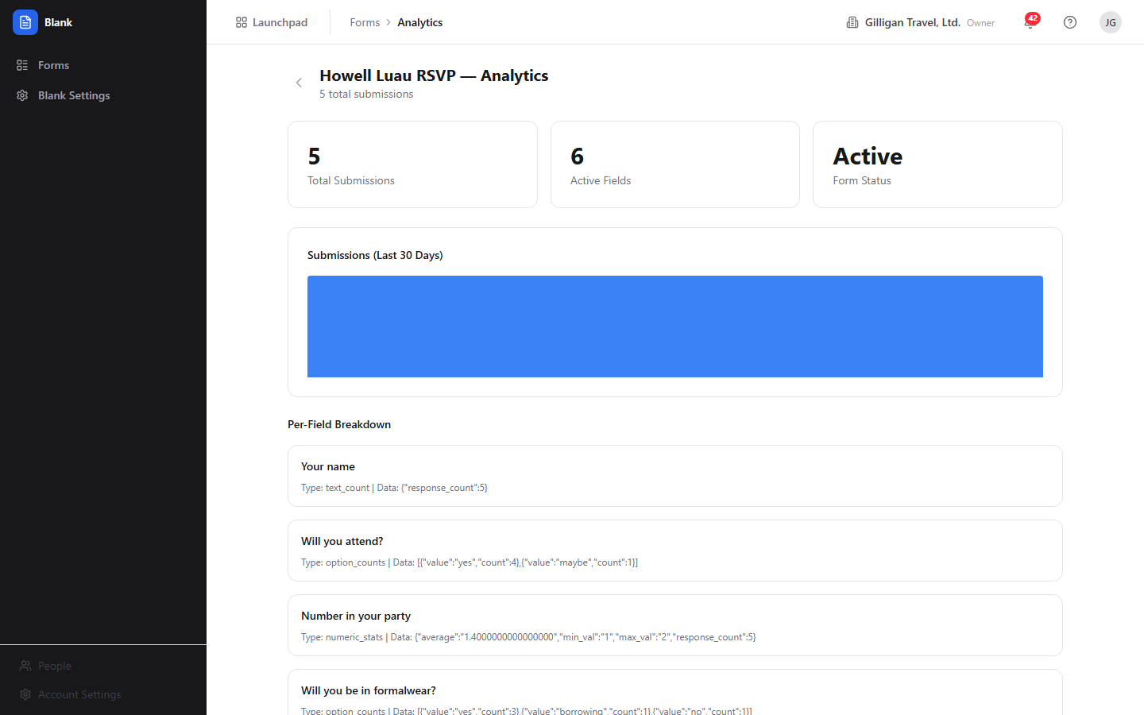
Figure 7.7 Form analytics
It contains:
- Summary cards: Total Submissions, Active Fields, and Form Status.
- A Submissions (Last 30 Days) bar chart driven by the daily submission trend.
- A Per-Field Breakdown section. For each non-decorative field, this shows aggregated values: option counts for select, multi-select, and dropdown fields; numeric statistics (average, minimum, maximum, and count) for rating, scale, NPS, and number fields; and a text count for other fields.

Per-form Settings page
Each form has a settings page at /blank/forms/<id>/settings with additional toggles. Reach it by entering the URL directly. The builder's Settings button opens the in-builder Form Settings dialog instead, which covers only visibility, expiration, and project.
The per-form Settings page has these sections:
- Access - Form Type (Public, Internal, Embedded), Accept Responses (whether new submissions are accepted), and One per Email (limit to one submission per email address).
- Confirmation - Type (Show Message, Redirect, or Custom Page) and a Confirmation Message textarea.
- Branding - a Theme Color picker and a Show Progress Bar checkbox for multi-page forms.
- Notifications - an Email on Submit checkbox to be notified when someone submits.
Each control saves immediately when you change it.
Email on submit is real. When a form has Email on Submit turned on (with recipients configured) or a respondent supplies their email, a background worker sends two kinds of message: a confirmation email to the respondent (using the form's confirmation message) and a notification email to each configured recipient summarizing the new submission. Delivery goes out through the configured SMTP transport; if SMTP is not configured in your deployment, the worker logs the message it would have sent instead of dropping it silently, so the wiring is the same whether or not mail is delivered. The richer access and notification controls (recipient list, Banter channel, sign-in requirement, allowed domains) live in the in-builder Form Settings dialog described above; this page exposes the single Email on Submit toggle.

Multi-page forms
A longer form can be split across pages so respondents work through it a section at a time.
There are two ways to page a form:
- Page Break field. In the builder, click Page Break in the Add Field palette wherever you want a page boundary. It appears as a divider in the builder (it collects no answer) and the public form starts a new page there.
- Page Number. Select a field in the canvas and set its Page Number in Field Settings, assigning each field to the page you want it on.
To show a progress bar across the pages, open the per-form Settings page at /blank/forms/<id>/settings and enable Show Progress Bar under Branding. Use Preview to confirm the pages before you publish.

Blank Settings (app-level)
The Blank Settings item in the sidebar opens a read-only information page at /blank/settings, headed Settings. It displays the app defaults (default form type Public, default theme color #3b82f6), the rate-limiting policy (10 submissions per hour), and the events Blank emits. Nothing on this page is editable.

Public form
A published form is served as a self-contained HTML page at https://YOUR-DOMAIN/forms/<slug>. This is the page the Publish dialog gives you and the one respondents fill out. It renders the form's fields, splits a multi-page form across pages with Back and Next controls and a progress bar, optionally collects the respondent's email, and shows the confirmation (message, redirect, or page) after a successful submission.
Public submission is anonymous for forms set to Public visibility. Forms set to Organization or Project members visibility check that the caller belongs to the org or the chosen project before rendering or accepting a submission. The public submit endpoint is rate-limited to 10 submissions per hour per IP, and a form can also enforce a per-email limit, a maximum response count, and an expiration date.
A form can additionally require sign-in and restrict submitters to an allowed set of email domains, both enforced on the public submit and file-upload paths (see "Access control and notifications" under Form Settings dialog). With Require sign-in to submit on, an unauthenticated submit or upload is rejected. With Allowed email domains set, a submitter whose email is not on an allowed domain is rejected. These gates stack with visibility, the per-email limit, the maximum response count, and the expiration date.
File Upload fields are accepted on the public form: the respondent's file is uploaded to object storage before the form is submitted, the submission references the stored object, and a background worker validates the file (type allowlist, and confirming the object landed) and records it with a download link. The Files pill on the Responses table reflects that real outcome.

Working with AI agents
Agents drive Blank through MCP tools that proxy to the same API the SPA uses. The tools share your permissions, so an agent can only do what you could do. There are 20 Blank MCP tools, and together they cover the full authoring lifecycle: generate, create, edit fields, publish, close, duplicate, delete, and read or export responses.
TIP
Several MCP tools have no matching screen in the SPA, including blank_close_form, blank_get_embed_code, and per-field edits. When you need to close a form or grab its embed snippet, reach for an agent or the API rather than hunting for a button that is not there.
The MCP tools share your permissions, so an agent can drive the full authoring lifecycle but only ever do what you could.
Generate and create:
- Draft a form from a description with blank_generate_form, which returns a suggested form specification (it does not save anything). Its heuristics seed fields when the description mentions name, email, phone, NPS, rating or satisfaction, feedback or comment, and bug or issue.
- Create the draft with blank_create_form, which accepts inline field definitions.
Edit structure:
- Add a field with blank_add_field (it accepts the conditional-display arguments conditional_on_field_id, conditional_operator, and conditional_value).
- Change a field with blank_update_field, remove one with blank_delete_field, and reorder them with blank_reorder_fields.
Inspect, publish, and manage lifecycle:
- List and read forms with blank_list_forms and blank_get_form.
- Update form metadata with blank_update_form.
- Publish a draft with blank_publish_form and stop new responses with blank_close_form.
- Clone a form with blank_duplicate_form, get its iframe snippet with blank_get_embed_code, and remove a form with blank_delete_form (destructive).
Read and report on responses:
- List and read submissions with blank_list_submissions and blank_get_submission.
- Summarize and report on results with blank_summarize_responses and blank_get_form_analytics (both return the same analytics payload the Analytics view uses).
- Export raw responses with blank_export_submissions (returns CSV text), and remove a single response with blank_delete_submission (destructive).
Some tools have no matching screen in the SPA: blank_generate_form (the builder has no AI-draft entry point), blank_get_submission (the Responses table has no per-submission detail view), blank_add_field / blank_update_field / blank_delete_field / blank_reorder_fields (an agent can edit fields directly, whereas a person does the same work in the builder canvas), blank_close_form, blank_get_embed_code, and blank_delete_submission. When reviewing agent work, check the form's fields and visibility in the builder before publishing, and confirm the public URL from the Your form is live dialog.
Blank also participates in the suite-wide agent platform. Agent activity is attributed to an agent identity and surfaced in the unified activity feed; long-running agents send heartbeats. Destructive or sensitive steps (publishing, closing, or deleting) can be routed through the approval-queue tools so a human decides before the action lands. Per-agent policies (kill switch plus a blank.* tool allowlist) gate which Blank tools a service account may call, and subscribed Blank events can be pushed to agent runners through signed outbound webhooks. Before an agent quotes a submission's contents into a shared surface it should call the visibility preflight (can_access) for that entity and drop anything the asker is not allowed to see.
For the full tool catalog and argument shapes, see the MCP-tools reference in docs/apps/blank/mcp-tools.md.

User Stories

Story: Build and publish your first form
Who: A team member collecting feedback or intake.
Goal: Create a form, add a few fields, and get a shareable public URL.
Before you start: You are logged in to BigBlueBam and have the blank.form.publish permission.
Steps
1. Go to /blank/. On the Forms list, click New Form.
2. The builder opens with an "Untitled Form" draft. Click the form Title input in the center canvas and type a name. Add a Description below it.
3. In the Add Field palette on the left, click the field types you want, for example Rating, NPS, and Long Text. Each appears in the canvas.
4. Click a field in the canvas to open the Field Settings panel on the right. Set its Label, mark it Required if needed, and adjust type-specific options.
5. Reorder fields by dragging their grip handles. Remove a field with its trash icon.
6. Click Settings in the top-right action bar. Choose a Visibility option, set an Expires at date if you want one, and click Save.
7. Click Publish. In the Your form is live dialog, click Copy to copy the public URL.
Result: The form's status pill reads "published" on the Forms list, and you have a https://YOUR-DOMAIN/forms/<slug> URL to share.
Related: "Collect and review responses." An agent can do the same with blank_create_form then blank_publish_form.

Story: Collect and review responses
Who: The form author after sharing the link.
Goal: Let people submit the form and review what came in.
Before you start: The form is published and set to a visibility that lets your respondents reach it.
Steps
1. Share the public URL (from the Your form is live dialog) with respondents. They open /forms/<slug>, fill out the fields, and submit. After submitting they see the confirmation you configured.
2. Back in Blank, go to the Forms list and open the form's overflow menu (three-dot icon).
3. Click Responses.
4. Review the table. Each row shows the row number, Email, the first five fields' answers, the Files status, and the Date.
5. To narrow the list by attachment processing state, click a pill under Attachment status: (all, pending, processing, complete, or failed).
6. Click Export CSV to download every submission as submissions.csv.
Result: You have reviewed the responses in the table and, if you exported, a CSV file of all submissions.
Related: "Analyze results." An agent can pull the same data with blank_list_submissions and blank_export_submissions.

Story: Analyze results
Who: The form author wanting aggregate numbers.
Goal: See totals, the recent trend, and per-field breakdowns.
Before you start: The form has at least one submission.
Steps
1. Open the form's Responses view.
2. Click Analytics.
3. Read the summary cards: Total Submissions, Active Fields, and Form Status.
4. Review the Submissions (Last 30 Days) bar chart for the recent trend.
5. Scroll to Per-Field Breakdown to see option counts for choice fields and numeric statistics (average, minimum, maximum, count) for rating, scale, NPS, and number fields.
Result: You understand how many responses arrived, when, and how each field was answered.
Related: An agent can request the same payload with blank_summarize_responses or blank_get_form_analytics and write a summary.

Story: Duplicate a form as a template
Who: Someone who reuses a form structure for a new round.
Goal: Start a new form from an existing one without rebuilding it.
Before you start: You have an existing form to copy.
Steps
1. On the Forms list, open the source form's overflow menu (three-dot icon).
2. Click Duplicate.
3. A new draft appears in the list with "(Copy)" in its name and the same fields.
4. Open the copy, adjust its title, fields, and settings, then click Publish when ready.
Result: A new draft form with the same fields, ready to edit and publish independently of the original.
Related: An agent can clone a form with blank_duplicate_form.

Story: Restrict a form to your organization or a project
Who: An author who wants the form limited to internal people.
Goal: Stop people outside your org or project from viewing or submitting the form.
Before you start: You are editing the form in the builder.
Steps
1. Click Settings in the builder action bar.
2. Under Visibility, choose Organization to limit to your org, or Project members to limit to a Bam project.
3. If you chose Project members, select a project in the Project picker that appears.
4. Click Save.
Result: People who are not in the org (or not members of the chosen project) get a forbidden response when they open the public URL. Members can view and submit as normal.
Related: "Gate a public form by sign-in and email domain" covers the complementary requires_login and allowed_domains gates, which are enforced on the public submit and file-upload paths and stack with visibility.

Story: Gate a public form by sign-in and email domain, and get notified
Who: An author who wants only known people to submit and wants to hear about each response.
Goal: Require sign-in and an allowed email domain to submit, and email the right people when a submission arrives.
Before you start: You are editing the form in the builder.
Steps
1. Click Settings in the builder action bar.
2. Check Require sign-in to submit to force authentication (optional but recommended for internal forms).
3. Under Allowed email domains, enter the domains you accept, comma separated, for example acme.com, example.org. Leave it blank to allow any domain.
4. Check Email me on new submissions and, under Notification recipients, enter the addresses to notify, comma separated.
5. (Optional) Pick a Post to Banter channel target to also post each submission to a channel.
6. Click Save, then Publish.
Result: An unauthenticated visitor is turned away with a sign-in error, a submitter on a disallowed domain is rejected, and every accepted submission triggers a confirmation email to the submitter plus a notification email to your recipients (and a Banter post if configured). Where SMTP is not configured, the worker logs the messages instead of delivering them.
Related: "Restrict a form to your organization or a project" covers the visibility gate that stacks with these. An agent can set the same fields with blank_update_form (requires_login, allowed_domains, notify_on_submit, notify_emails).

Story: Collect file uploads on a form
Who: An author who needs respondents to attach a document or image.
Goal: Add a file-upload field and review the stored files that come in.
Before you start: You are editing the form in the builder.
Steps
1. In the Add Field palette, click File Upload. The field appears in the canvas; set its Label and mark it Required if needed.
2. Publish the form and share the public URL.
3. A respondent attaches a file; it is uploaded to object storage before they submit, and the submission references the stored object.
4. Open the form's Responses view. Watch the Files pill move from pending to complete as the background worker validates and stores each file (or to failed if a file is rejected).
5. Use the Attachment status: filter pills to find submissions whose files are still pending or that failed validation.
Result: Respondents can attach files, the files are stored for real, and the Responses table tells you which submissions have validated attachments.
Related: Uploads are limited to a size cap and an allowlist of image, document, spreadsheet, CSV, plain-text, and zip types (SVG is always blocked).

Story: Build a multi-page survey
Who: An author with a longer survey to split across pages.
Goal: Group fields onto separate pages so respondents page through them.
Before you start: The form has several fields.
Steps
1. In the builder, click Page Break in the Add Field palette wherever you want a page boundary. It appears as a divider in the canvas.
2. Add or arrange the fields for each page around the page breaks. (Alternatively, select a field, open Field Settings, and set its Page Number.)
3. (Optional) Open the per-form Settings page at /blank/forms/<id>/settings and enable Show Progress Bar under Branding.
4. Click Preview to confirm the pages, then Publish.
Result: The public form shows fields grouped by page with Back and Next controls and, if enabled, a progress bar.
Related: Page breaks and per-field Page Number both page a form; use whichever fits how you build.

Story: Close a form to stop accepting responses
Who: An author or agent wrapping up a collection.
Goal: Stop new submissions on a published form.
Before you start: You have the blank.form.close permission. There is no Close button in the SPA; closing is done through the API or an agent.
Steps
1. Call POST /blank/api/v1/forms/<id>/close with your session cookie or API key, or have an agent call blank_close_form.
2. Blank sets the form's status to closed, turns off Accept Responses, and emits a form.closed event (source blank).
Result: The form's public page no longer accepts submissions, and its status pill reads "closed" on the Forms list. There is no in-app control to reopen or un-publish a form.
Related: To pause without closing, an author can turn off Accept Responses on the per-form Settings page instead.

Story: Have an agent draft, create, and publish a form
Who: A user delegating form creation to an AI agent.
Goal: Go from a plain-language description to a published, shareable form.
Before you start: The agent runs with your credentials and your publish permission. Its blank.* policy allowlist must permit the tools below.
Steps
1. Ask the agent to draft the form. It calls blank_generate_form with your description and returns a suggested specification of fields. Nothing is saved yet.
2. Review the suggested fields with the agent and adjust.
3. The agent calls blank_create_form with the field definitions inline to create the draft. It can refine the structure further with blank_add_field, blank_update_field, blank_delete_field, and blank_reorder_fields.
4. The agent calls blank_publish_form to publish it. If publishing is routed through the approval queue, you approve the proposal first.
5. Open the form in the builder to confirm the fields and visibility, then copy the public URL from the Your form is live dialog (open it with the Share button).
6. Later, ask the agent to report on results with blank_summarize_responses.
Result: A published form created from a description, with a public URL you can share and an agent that can summarize responses on demand.
Related: "Build and publish your first form" covers the same flow by hand.

Related
- Bond - submissions can be routed to create a Bond contact when routing is configured for the form at the API level.
- Helpdesk - submissions can be routed to create a Helpdesk ticket when routing is configured for the form at the API level.
- Bam - forms can be scoped to a Bam project through Project members visibility, and the Form Settings dialog loads your Bam projects to choose from.
- Bolt - Blank emits form.published, form.closed, and submission.created events (source blank) that Bolt automations can react to.
- MCP tools reference: docs/apps/blank/mcp-tools.md.
- App guide: docs/apps/blank/guide.md.

Check yourself
Every answer is findable in this chapter. Check your work against the Answer Key appendix at the back of the book.
1. What status does a brand-new form start in?
a) published
b) draft
c) closed
d) active
2. How many submissions per hour per IP does the public submit endpoint allow?
a) 5
b) 10
c) 50
d) There is no limit
3. What are the three visibility options that control who can reach a form through its URL?
4. Which file type does Blank always block on uploads, regardless of the size cap?
a) PDF
b) CSV
c) SVG
d) ZIP
5. Before Blank will publish a form, what minimum does the form need?
6. What does deleting a form remove besides the form itself?
a) Nothing else
b) Its fields and submissions
c) Only its submissions
d) Only its fields
7. Which four field types are layout-only and carry no submitted answer?
a) Short Text, Email, Number, Date
b) Section Header, Paragraph, Hidden Field, Page Break
c) Rating, Scale, NPS, Checkbox
d) Single Select, Multi Select, Dropdown, Toggle
8. What is the shape of the public form URL that the Publish dialog hands you?
9. Where in the SPA can an author close a published form?
a) The builder action bar
b) The Forms list overflow menu
c) The per-form Settings page
d) Nowhere; there is no Close button in the SPA, so closing is done through the API or an agent
10. When 'Allowed email domains' is set, in what order is the submitter's email determined?
11. What does the 'complete' Files pill on the Responses table mean?
a) The submission was deleted
b) Every file was validated and stored
c) The form is closed
d) The worker has not run yet
12. What two requirements gate getting to the Blank authoring SPA in the first place?

CHAPTER 8

Blast
Write it once, send it everywhere, watch what lands.

Blast turns your Bond CRM contacts into an audience for bulk email. You compose a message once, in a visual block editor, raw HTML, or from a saved template, pick who should receive it, and send. After every send, Blast records what happened to each recipient and rolls the results into per-campaign and org-wide analytics. This chapter walks you from a first draft through Send Now to reading opens, clicks, bounces, and unsubscribes, and it shows where an agent can assemble a campaign for your approval.
At a glance
- Three ways to build an email body: visual block editor, raw HTML, or a saved template
- Segments that filter your Bond contacts and cache a contact count
- Per-recipient delivery tracking plus per-campaign and org-wide analytics
- Automatic open, click, bounce, complaint, and unsubscribe handling with no UI to wire
- A CAN-SPAM gate that blocks any send missing an unsubscribe link or a physical address
In this chapter
Overview . Key concepts . Where to find it . Feature reference . Campaigns list . Create a campaign . Campaign detail and Send Now . Visual builder . Templates . Template gallery
Blast is the email campaign tool in the BigBlueBam suite. Marketers and operators use it to design HTML emails, target groups of Bond CRM contacts, send to those contacts, and track opens, clicks, bounces, and unsubscribes.

Overview
Blast turns your Bond CRM contacts into an audience for bulk email. You write a message once (in a visual block editor, raw HTML, or from a saved template), pick who should receive it, and send. After a send, Blast records what happened to each recipient and rolls the results up into per-campaign and org-wide analytics.
The core objects you work with are campaigns (a single bulk send), templates (reusable email designs), segments (saved filters over Bond contacts), and sender domains (the domains you verify so mailbox providers trust your mail). Each campaign tracks counters for sent, delivered, opened, clicked, bounced, unsubscribed, and complained, and exposes a per-recipient delivery table.
Blast fits into the suite in two directions. It pulls its audience from Bond (contacts are the recipient pool, and segments filter on Bond contact fields), and it pushes activity into Bolt (every send and engagement event is published so automation rules can react). It shares its login and SMTP relay with the rest of the platform: there is no separate Blast account, and there is no Blast-specific email server.
Blast pulls its audience from Bond and pushes every send and engagement event into Bolt, so your automation can react the moment an email lands.
Two things are worth knowing before you rely on Blast for production sending. First, outbound email goes through one platform-wide SMTP relay that a SuperUser configures in the Bam app, not in Blast. Second, the in-app campaign detail page only exposes Send Now; scheduling, pausing, cancelling, editing, and deleting a campaign are available through the API and MCP tools but are not wired into the campaign detail UI today.

Key concepts
- Campaign - A single bulk email send. Has a name, subject, body (HTML), optional plain-text body, an optional template, an optional segment, From name/email, reply-to, and rollup counters.
- Campaign status - One of six states: draft, scheduled, sending, paused, sent, cancelled. A draft is editable, deletable, and sendable. A scheduled campaign can be sent or cancelled. A sending campaign can be paused or cancelled. sent is the terminal success state and the only one analytics counts. There is no "archived" state.
- Template - A reusable email design: name, subject template, HTML body, an optional visual block layout, and a description. Templates carry a version number that bumps automatically each time you save an edit.
- Segment - A saved filter over Bond contacts, built from one or more conditions joined by ALL conditions (AND) or ANY condition (OR). Each segment caches a contact count so you can see roughly how many people match.
- Recipient / send log - One row per person per campaign. It tracks the status of that one email (queued, sent, delivered, bounced, complained, or failed) and drives the Recipients table on the campaign detail page.
- Engagement event - An append-only record of an open, click, unsubscribe, bounce, or complaint. These feed the analytics counters and are published to Bolt.
- Unsubscribe - An org-wide suppression keyed on email. Once an address unsubscribes (or files a spam complaint), it is excluded from future sends across the whole org.
- Sender domain - A domain you add and verify (SPF, DKIM, DMARC) so mailbox providers accept your mail.
- Merge fields - Placeholders the sender fills in per recipient: {{first_name}}, {{last_name}}, {{email}}, {{company}}, and {{unsubscribe_url}}.
- CAN-SPAM gate - A compliance check that runs when you send or schedule. The HTML body must contain both an unsubscribe mechanism and a physical mailing address, or the send is rejected.
WARNING
Unsubscribes are org-wide and keyed on the email address. Once an address unsubscribes or files a spam complaint, it is suppressed across the whole org and excluded from every future send. There is no per-campaign opt back in.

Where to find it
Blast is served at /blast/. It is a separate SPA but shares its login with the Bam app: there is no separate Blast sign-in. If you are not signed in to BigBlueBam, Blast shows a "Please log in to BigBlueBam first" screen that links to /b3/. Sign in there once and return to /blast/.
The left sidebar has two groups. The primary group is Campaigns, Templates, Segments, and Analytics. Below it, a Blast Settings group holds Domains and SMTP. The header carries the Launchpad trigger, breadcrumbs, the org switcher, the notifications bell, and the user menu. Press ? anywhere to open in-app help.
Prerequisites:
- A BigBlueBam account and membership in an org (shared with Bam).
- Bond contacts in your org, since segments and sends draw from the contact pool.
- A configured platform SMTP relay for any real delivery (see the SMTP feature below).
- For sender-domain changes you need admin scope; most other write actions need read_write scope.

Feature reference

Campaigns list
The campaigns list is the home view of Blast, at /blast/. It shows every campaign in a table and is where you start a new one.
To browse and filter campaigns:
1. Open Blast at /blast/. The header reads Campaigns with the subtitle "Create and manage email campaigns".
2. Use the Search campaigns... box to filter the table by campaign name. This filter is applied in your browser to the names already loaded.
3. Click a status button to filter by state. The buttons are All, draft, scheduled, sending, sent, paused, and cancelled. Click the active status again to clear it.
4. Read each row: Campaign (name plus subject), Status, Sent, Open Rate, Click Rate, and Date. Open Rate and Click Rate show a dash until the campaign has sent.
5. Click any row to open that campaign's detail page.
To start a new campaign, click New Campaign at the top right. This opens the create form.
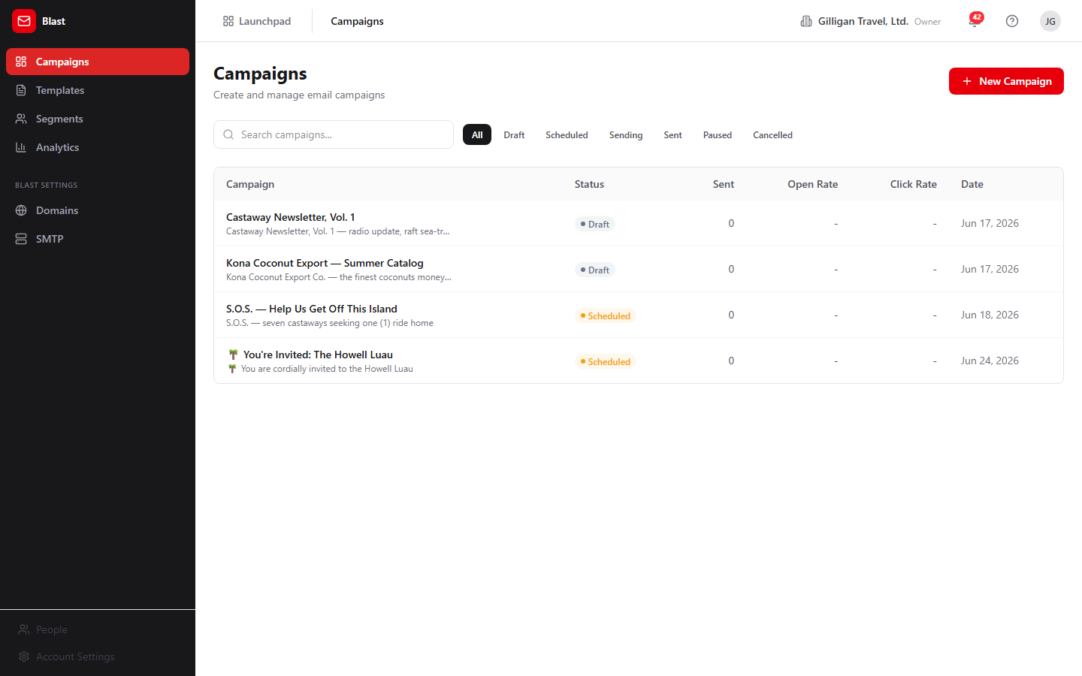
Figure 8.1 Campaign list

Create a campaign
The create form is at /blast/campaigns/new. It collects the campaign settings and lets you build the email body in one of three ways. Creating a campaign always produces a draft; nothing is sent from this page.
To create a campaign:
1. From the campaigns list, click New Campaign. The header reads New Campaign.
2. Fill in **Campaign Name *** (for example, "April Product Launch") and **Subject Line ***. Both are required; the Create Campaign button stays disabled until they have values.
3. Under From, optionally enter a sender Name and Email.
4. Choose a Segment. The default is All contacts; the dropdown also lists your saved segments with their cached counts in parentheses.
5. Choose a content mode with the Content: toggle: Visual Builder, HTML, or From Template.
6. Make sure the body includes an unsubscribe link and a physical mailing address (the new-template footer already includes an {{unsubscribe_url}} link). Without both, the campaign cannot be sent or scheduled later.
7. Click Create Campaign. The button reads "Creating..." while it saves, then returns you to the campaigns list with the new draft.
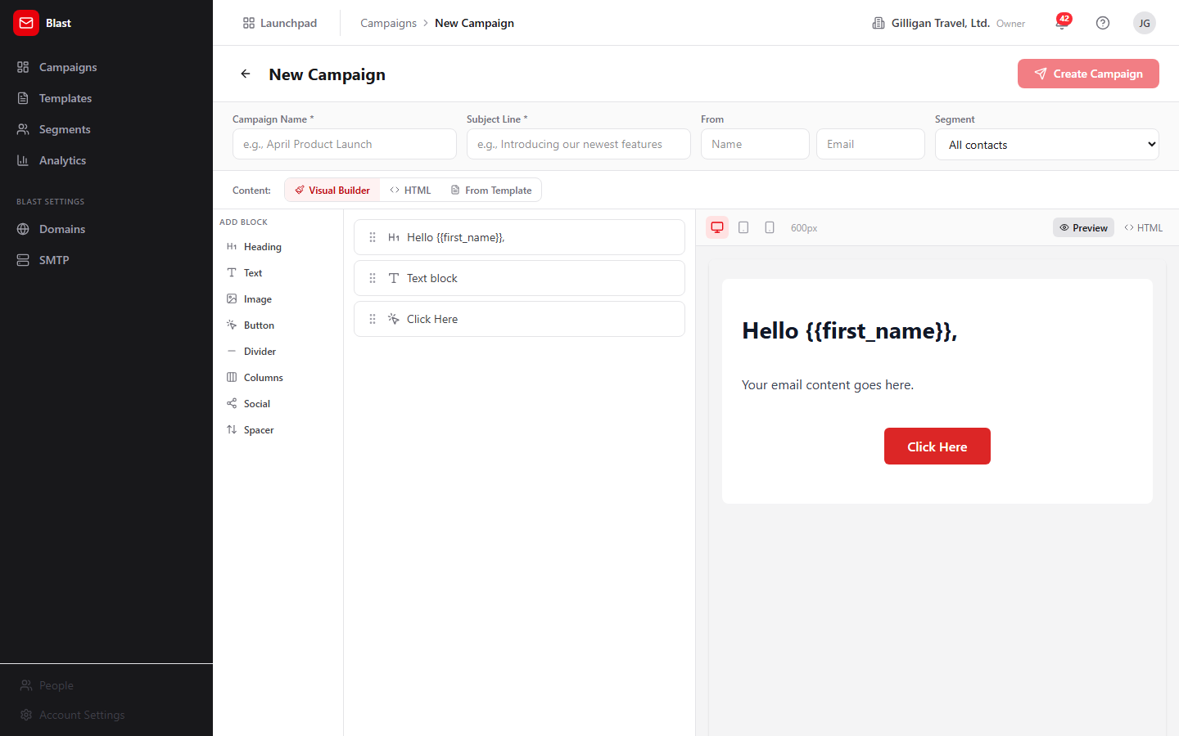
Figure 8.2 New campaign form
Segment caveat: choosing a segment here records which segment the campaign is associated with, but the sender does not yet filter recipients by segment. See "Send a campaign (Send Now)" for what actually happens at send time.

Campaign detail and Send Now
The detail page is at /blast/campaigns/:id. It is where you send a draft and where you review results after a send.
To open and read a campaign:
1. From the campaigns list, click the campaign row. The page shows the back arrow, the campaign name and subject, and a status badge.
2. Read the primary metrics: Total Sent, Delivered, Opened (with open rate), and Clicked (with click rate).
3. Read the secondary metrics: Bounced, Unsubscribed, and Complaints.
4. If the campaign has click data, read the Top Clicked Links table.
5. Under Campaign Details, read From, Sent Date, Scheduled, Recipients, and Created.
6. Scroll to the Recipients table for per-recipient delivery. It pages 25 rows at a time with Prev and Next. Each row shows Email, a Status icon (Delivered, Sent, Bounced, Failed, or Pending), and the Sent, Delivered, and Bounced times.
To send a campaign immediately:
1. Open a campaign whose status is draft or scheduled. The Send Now button appears at the top right only for these two states.
2. Click Send Now. The button reads "Sending..." while it submits.
3. The CAN-SPAM check runs first. If the HTML body is missing an unsubscribe mechanism or a physical address, the send is rejected with a validation error (see "Why a send was rejected" below).
4. If the check passes, the status flips to sending, the send job is queued in the background worker, and the campaign begins delivering.
No screenshot exists for the campaign detail page or the Send Now button yet.
What Send Now does not expose: scheduling, pausing, cancelling, editing, and deleting a campaign all exist in the API and MCP tools, but the detail page only renders Send Now. To schedule, pause, cancel, edit, or delete a campaign today you must use the API or an MCP tool (blast_update_campaign, blast_pause_campaign, blast_cancel_campaign, and the schedule path inside blast_send_campaign).
NOTE
The campaign detail page only renders Send Now today. Scheduling, pausing, cancelling, editing, and deleting a campaign all exist in the API and MCP tools, but you reach them through the API or a tool, not the detail UI.

Visual builder
The visual builder is the drag-and-drop email designer shared by the campaign create form and the template editor. It produces email-safe inline HTML so your message renders consistently across mail clients.
To build an email body visually:
1. In the campaign create form choose the Visual Builder content mode, or open the template editor and select the Visual mode.
2. From the left palette, click a block to add it. The blocks are Heading, Text, Image, Button, Divider, Columns, Social, and Spacer.
3. In the center list, reorder blocks by dragging the handle, and use each block's Duplicate and Remove controls.
4. Select a block to edit its properties in the right-hand editor.
5. Use the preview at the bottom to check the layout. Switch widths with the desktop, tablet, and mobile toggles (600, 480, and 320 pixels), and toggle between the rendered view and the source with the Code/Eye control.
6. Insert merge fields in text where you want them personalized, for example Hello {{first_name}},.
The block layout is saved alongside the email so you can reopen and keep editing it later.

Templates

Template gallery
The gallery lists your reusable templates at /blast/templates.
To manage templates:
1. Open Templates from the sidebar. The header reads Templates with the subtitle "Reusable email templates for your campaigns".
2. Use the Search templates... box to find a template by name.
3. Each card shows the template name, the subject template, a version badge such as v2, the description, and the relative time it was last updated.
4. Hover a card to reveal Duplicate (copy) and Delete (trash). Delete asks "Delete this template?" before removing it.
5. Click a card to open it in the editor.
To start a new template, click New Template at the top right.
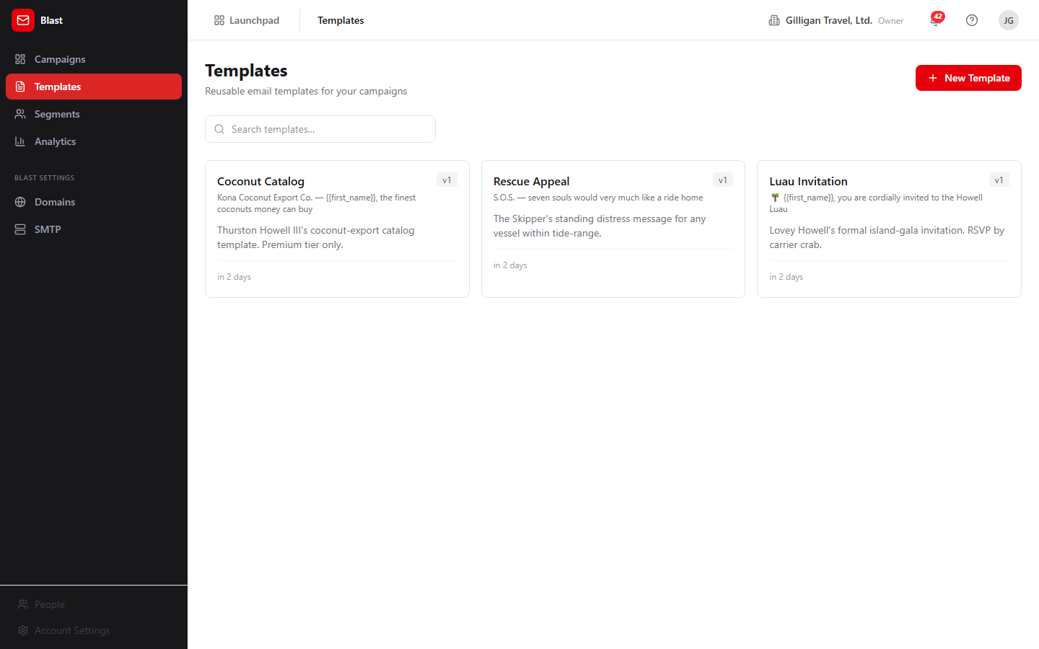
Figure 8.3 Template gallery

Template editor
The editor is at /blast/templates/new for a new template and /blast/templates/:id/edit for an existing one. Saving an edit bumps the template's version automatically.
To author a template:
1. Click New Template from the gallery, or click an existing template to edit it.
2. Fill in **Template Name *** and **Subject Line *** (the subject shows a live merge preview). Both are required; Save Template stays disabled until they have values. Optionally add a Description.
3. Build the body using the Visual / HTML toggle. Visual opens the block builder; HTML gives you a raw editor with a live iframe preview.
4. Click Save Template. The button reads "Saving..." while it saves.
New templates start with a default block layout that includes a footer with an {{unsubscribe_url}} link, which helps satisfy the CAN-SPAM check when a campaign uses the template.
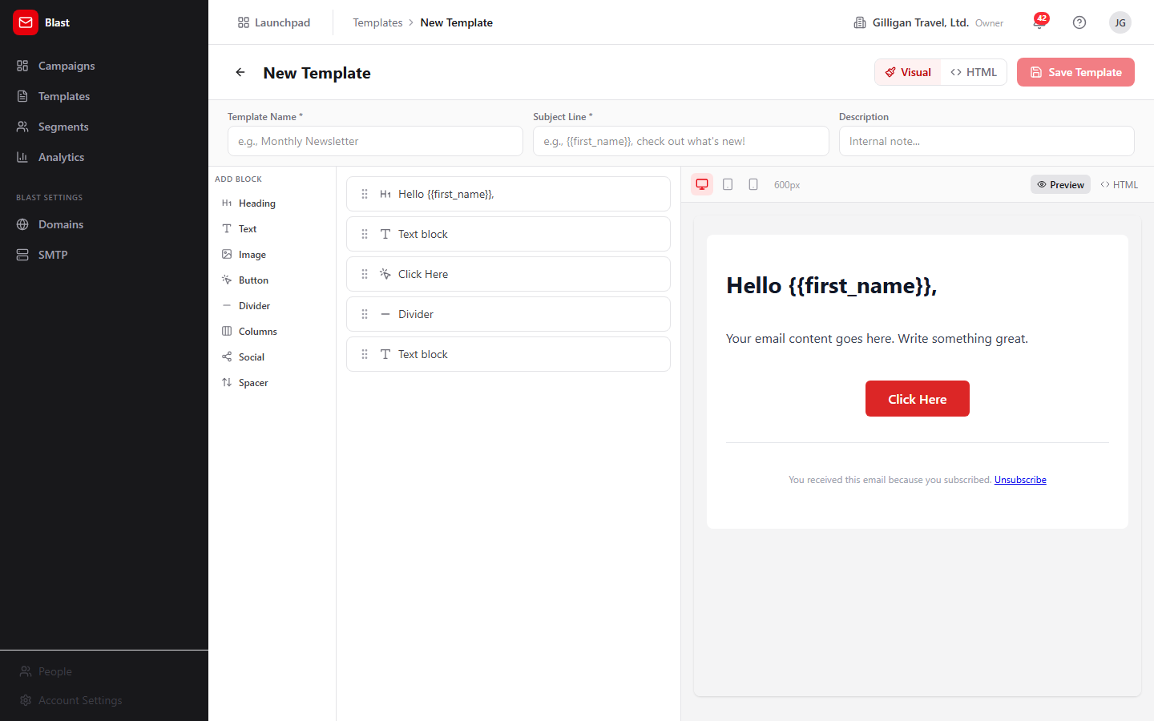
Figure 8.4 Template editor

Segments

Segment list
The segment list is at /blast/segments. Segments are saved filters over your Bond contacts.
To manage segments:
1. Open Segments from the sidebar. The header reads Segments with the subtitle "Target specific groups of contacts for your campaigns".
2. Use the Search segments... box to find a segment by name.
3. Read each row: Segment (name plus description), Contacts (the cached count), Conditions (for example, "2 condition(s), match all"), and Last Updated.
4. Under Actions, click Recalculate count (refresh icon) to recompute how many contacts currently match. Click Delete (trash icon) to remove the segment; it asks "Delete this segment?" first.
To start a new segment, click New Segment at the top right.
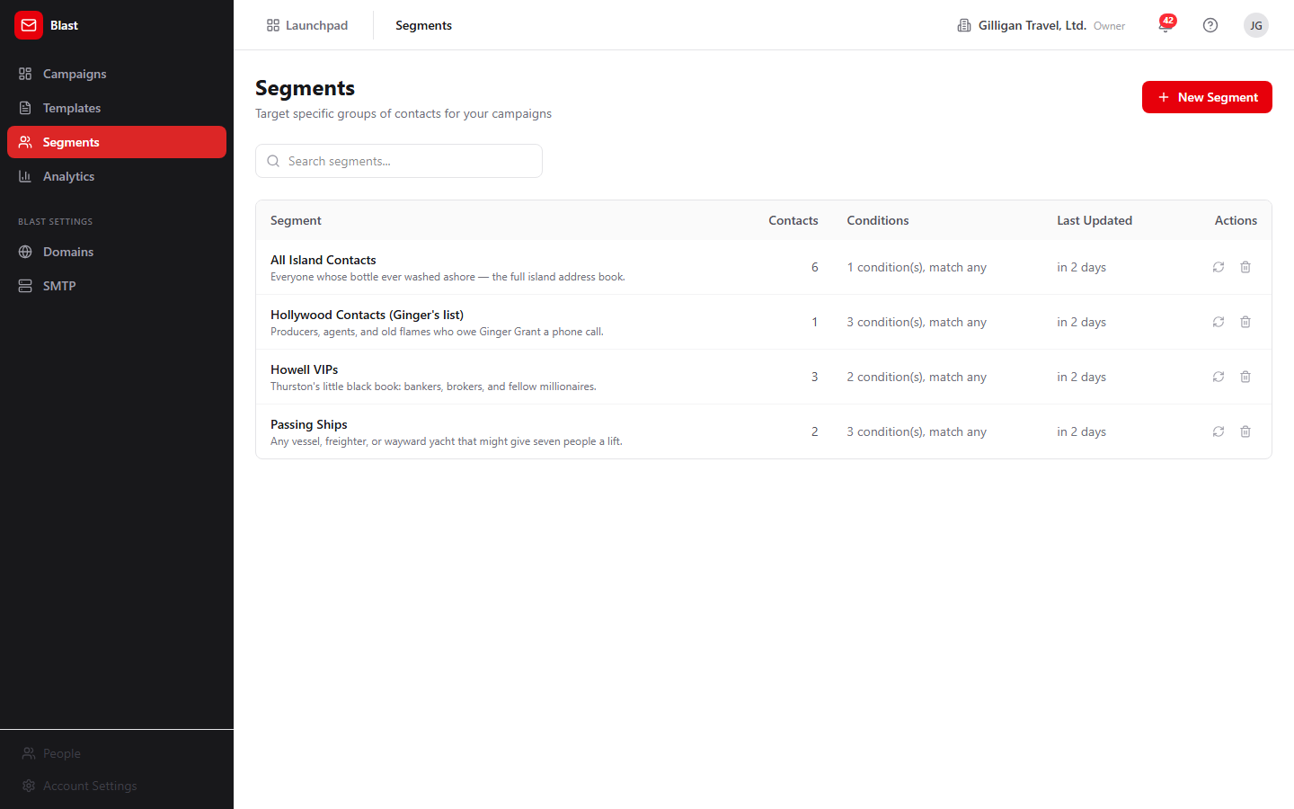
Figure 8.5 Segment list

Segment builder and preview
The builder is at /blast/segments/new. It is a create-only form; there is no edit page in the UI.
To build a segment:
1. Click New Segment from the segment list. The header reads New Segment.
2. Enter a Segment Name and an optional Description.
3. Choose a Match mode: ALL conditions (AND) to require every condition, or ANY condition (OR) to match any one.
4. Add one or more conditions. Each condition has a field, an operator, and a value:
5. Click Add Condition to add another row, or the trash icon to remove a row.
6. Click Create Segment (it reads "Saving..." while it saves), or Cancel to discard.
After creating, return to the segment list and click Recalculate count to see how many Bond contacts match.
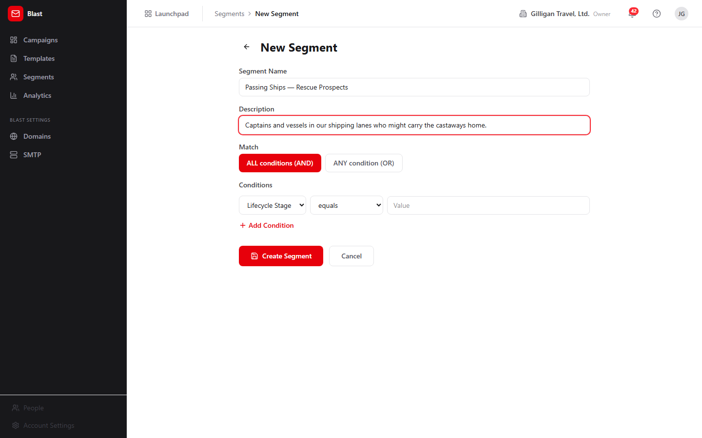
Figure 8.6 Segment builder
The builder UI exposes six fields and seven operators. The backend supports more (it can also filter on email, first_name, last_name, and use the is_set and is_not_set operators), but those are reachable only through the API or the blast_create_segment / blast_update_segment MCP tools, not through the builder UI.
Segments filter only on Bond contact columns. There is no targeting by tags, activity history, or custom fields.

Analytics
The analytics dashboard is at /blast/analytics, titled Email Analytics with the subtitle "Overview of your email campaign performance". It rolls up performance across all sent campaigns in your org. Only campaigns in the sent state are counted.
To review org-wide email performance:
1. Open Analytics from the sidebar.
2. Read the stat cards: Total Sent, Delivered, Avg Open Rate (with total opens), Avg Click Rate (with total clicks), and Bounce Rate (with total bounced).
3. Read the tiles Campaigns Sent and Unsubscribes.
4. Read the Weekly Engagement Trend table for Period, Campaigns, Sent, Open Rate, and Click Rate by week.
For a single campaign's analytics, open its detail page instead (see "Campaign detail and Send Now").
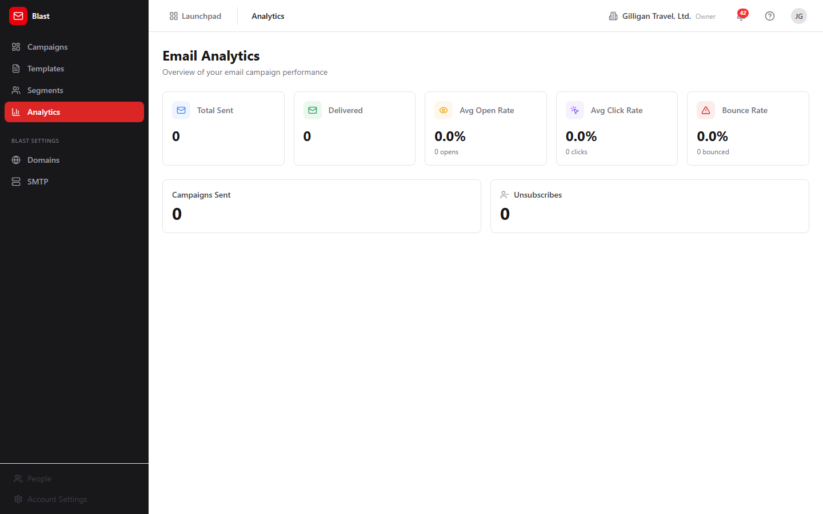
Figure 8.7 Analytics dashboard

Sender Domains
The Sender Domains page is at /blast/settings/domains, under Blast Settings. Verifying a domain improves deliverability by proving to mailbox providers that you are authorized to send from it. Adding and removing domains needs admin scope.
To add and verify a sending domain:
1. Open Domains under Blast Settings. The header reads Sender Domains with the subtitle "Verify your sending domains for better deliverability".
2. In the add row, type your domain (for example, "company.com") and click Add Domain.
3. On the new domain's card, read the Required DNS Records list (each row shows a record type, name, and value) and add those records at your DNS host.
4. Click Verify DNS (refresh icon) to run live lookups. The SPF, DKIM, and DMARC indicators turn to a green check when each record is found.
5. To remove a domain, click Remove (trash icon) and confirm "Remove this domain?".
No screenshot exists for the Sender Domains page yet.

SMTP (platform relay)
The SMTP page is at /blast/settings/smtp, titled SMTP Settings. It is an information card, not a form. Blast keeps no SMTP credentials of its own. Every Blast campaign is sent through a single platform-wide relay stored in the platform settings and configured once in the Bam app under Account Settings -> Integrations. The same relay sends transactional email and Blast campaigns.
What you see depends on your role:
- Platform SuperUser: a blue info box and an Open Account Settings button that opens /b3/settings, where you open the Integrations tab to edit the relay.
- Org owner or admin: an amber box and a View in Account Settings button that opens /b3/settings. You can view the configuration there, but only a SuperUser can change it.
- Other roles: a neutral box telling you to contact your platform SuperUser or org admin.
To configure outbound email, a SuperUser opens SMTP under Blast Settings, clicks Open Account Settings, then opens the Integrations tab in the Bam app and enters the relay details. This is a prerequisite for any real send.
No screenshot exists for the SMTP Settings page yet.

Tracking and unsubscribe (automatic, no UI)
Blast handles opens, clicks, and unsubscribes through endpoints that run without any operator action and without a signed-in user. You do not configure these; they are described here so you understand the metrics.
- Open tracking: a 1x1 pixel embedded in each email records an open and increments the campaign's opened counter.
- Click tracking: links are rewritten so a click is recorded (with the destination URL) and then redirects to the real target. Only http/https links are allowed.
- Unsubscribe: the unsubscribe link in each email opens a confirmation page with a Confirm Unsubscribe button. Confirming suppresses that address across the whole org and increments the unsubscribed counter.

Provider webhooks (automatic, no UI)
Your email provider can notify Blast of bounces and complaints. When a bounce arrives, Blast marks the recipient bounced and increments the bounced counter. When a spam complaint arrives, Blast marks the recipient complained, increments the complaints counter, and automatically unsubscribes that address org-wide. There is no UI for this; the results show up in your campaign and analytics counters.

Why a send was rejected
When you click Send Now (or schedule a campaign through the API), Blast runs a CAN-SPAM compliance check before sending. The campaign is rejected with a validation error unless its HTML body contains both:
1. An unsubscribe mechanism (for example, an {{unsubscribe_url}} merge field, or text containing "unsubscribe" or "opt-out").
2. A physical mailing address (a recognizable street address, a P.O. box, or a {{physical_address}} merge field).
There is no warning before you click Send Now; the error surfaces from the send request. The simplest fix is to use the default template footer, which already includes an {{unsubscribe_url}} link, and to add your mailing address to the body.
TIP
The default template footer already includes an unsubscribe link, so the fastest way to clear the CAN-SPAM gate is to build on a template and just add your mailing address to the body.

Working with AI agents
Agents drive Blast through 28 MCP tools backed by the same Blast API the UI uses. Most action tools resolve campaigns, templates, and segments by human-readable name as well as by UUID, so an agent can say "send the April Product Launch campaign" without knowing the ID. Name resolution prefers an exact match, accepts a single fuzzy match, and returns a clean error when a name is ambiguous.
Most agent tools resolve campaigns, templates, and segments by name, so an agent can act on the April Product Launch campaign without ever knowing its ID.
Common agent actions and their tools:
- Draft and reuse content: blast_create_template, blast_get_template, blast_list_templates, blast_update_template, blast_duplicate_template, and blast_preview_template (renders a template with sample merge data without sending).
- Create and edit a campaign draft: blast_draft_campaign (resolves a template or segment by name or UUID and creates a draft), blast_update_campaign, blast_list_campaigns, and blast_get_campaign.
- Build and check audiences: blast_create_segment and blast_update_segment (full field and operator set, including the ones the builder UI hides), blast_list_segments, blast_get_segment, blast_preview_segment (first 50 matching contacts), blast_evaluate_segment (the full resolved send list, read-only), blast_recalculate_segment_count, and blast_check_unsubscribed (confirm an address is not suppressed before targeting it).
- Send and control a send: blast_send_campaign, blast_pause_campaign, and blast_cancel_campaign.
- Review results: blast_get_campaign_analytics, blast_get_campaign_device_analytics, blast_list_campaign_recipients, blast_get_engagement_summary, and blast_get_engagement_trend.
The key human-in-the-loop control is on sending. blast_send_campaign takes require_human_approval, which defaults to true. With the default, the tool does not send immediately; it schedules the campaign about an hour out and returns a note that a human must confirm before it goes. Only require_human_approval: false triggers an immediate send. When you review agent work, expect agent-initiated sends to land as scheduled campaigns awaiting a person, and treat any immediate send as an explicit override.
TRY IT
Have an agent call blast_send_campaign with the default require_human_approval set to true, then open the campaigns list and watch it land as a scheduled campaign about an hour out, awaiting your confirmation before any mail leaves.
Two tools named like AI features are not wired to a model. blast_draft_email_content and blast_suggest_subject_lines return hard-coded templated strings, not model-generated copy. Use them as scaffolding, not as a writing assistant.
Blast agents also run on the platform-wide agentic surface that spans every app:
- Identity and heartbeat: every agent action is tagged with the actor's kind (human, agent, or service) on the activity log, and agent runners post agent_heartbeat so operators can see which agents are live.
- Proposals (approval queues): an agent can stage a campaign send or a segment change as a durable proposal with proposal_create, and a human clears it with proposal_decide. This is the recommended pattern for sends beyond the per-tool require_human_approval gate.
- Unified activity and search: activity_query, activity_by_actor, and search_everything let an agent (or a reviewer) trace what an agent did across Blast, Bond, and the rest of the suite.
- Visibility preflight: before an agent posts campaign results into a shared surface, it calls can_access for each cited entity and drops anything the asking user is not allowed to see.
- Agent policies and webhooks: a per-agent kill switch and tool allowlist (the blast.* prefix) gate which Blast tools a given service account may call, and outbound webhooks push subscribed Blast Bolt events to agent runners.
For the full tool catalog and schemas, see mcp-tools.md.

User Stories

Story: Set up outbound email before your first send
Who: A platform SuperUser (or an org admin verifying the setup).
Goal: Make sure Blast can actually deliver mail before anyone sends a campaign.
Before you start: You are signed in to BigBlueBam. SMTP relay credentials are configured by a SuperUser; org admins can only view them.
Steps
1. Open Blast at /blast/ and click SMTP under Blast Settings in the sidebar.
2. Read the SMTP Settings card. It explains that Blast uses one platform-wide relay, not its own credentials.
3. As a SuperUser, click Open Account Settings. (As an org admin, click View in Account Settings to confirm the relay is set, then ask a SuperUser if it is not.)
4. In the Bam app at /b3/settings, open the Integrations tab and enter or confirm the SMTP relay details.
5. Return to Blast.
Result: The platform relay is configured, so future Send Now actions can actually deliver email.
Related: "Verify a sending domain for deliverability" below, which improves deliverability once SMTP works.

Story: Send a one-off campaign from scratch
Who: A marketer or operator.
Goal: Compose and send a single email to your contacts.
Before you start: You are signed in, the platform SMTP relay is configured, and your org has Bond contacts. You need read_write scope.
Steps
1. From the campaigns list at /blast/, click New Campaign.
2. Enter a **Campaign Name *** and a **Subject Line ***.
3. Optionally set the From Name and Email, and choose a Segment (or leave it on All contacts).
4. With the Content: toggle on Visual Builder, add blocks from the palette and edit them. Make sure the body has an unsubscribe link and your physical mailing address; the default template footer covers the unsubscribe link.
5. Click Create Campaign. You return to the campaigns list with a new draft.
6. Click the new campaign's row to open it, then click Send Now.
7. If the CAN-SPAM check passes, the status moves to sending and delivery begins. If it fails, add the missing unsubscribe link or address and try again.
Result: The campaign is sending, and its detail page begins filling in delivery and engagement metrics.
Related: "Review campaign performance" below. Agents do the same with blast_draft_campaign then blast_send_campaign.
Recipient scope caveat: the sender currently delivers to your whole org's eligible contacts (excluding unsubscribed and empty-email contacts) regardless of which segment you chose. Segment-targeted sending is not yet honored by the sender.

Story: Reuse a saved template for a campaign
Who: A marketer who has a house style.
Goal: Build a campaign from an existing template instead of starting blank.
Before you start: At least one template exists in Templates.
Steps
1. From the campaigns list, click New Campaign.
2. Enter a **Campaign Name *** (the subject prefills from the template, but you can edit it).
3. Set the Content: toggle to From Template and pick a template from Choose a template.... The subject and body load from the template.
4. Adjust the content as needed.
5. Click Create Campaign, open the new draft, and click Send Now.
Result: A campaign built on your template is sending.
Related: "Author and version a reusable template" below.

Story: Author and version a reusable template
Who: A designer or marketer maintaining brand templates.
Goal: Create a reusable email design and keep it updated over time.
Before you start: You are signed in with read_write scope.
Steps
1. Open Templates and click New Template.
2. Enter a **Template Name *** and **Subject Line ***, and optionally a Description.
3. Build the body in Visual mode (or switch to HTML). Keep the footer's {{unsubscribe_url}} link so campaigns using this template pass the CAN-SPAM check.
4. Click Save Template.
5. To update later, open the template, edit it, and click Save Template again; the version badge bumps (for example, v1 to v2).
6. To fork a template, hover its card in the gallery and click Duplicate.
Result: A versioned, reusable template is available in the gallery and selectable in From Template when creating a campaign.
Related: Agents do this with blast_create_template, blast_update_template, and blast_duplicate_template.

Story: Build a targeted segment from CRM data
Who: A marketer who wants to target a subset of contacts.
Goal: Save a reusable filter over Bond contacts and see how many match.
Before you start: Your org has Bond contacts with the relevant fields populated.
Steps
1. Open Segments and click New Segment.
2. Enter a Segment Name and an optional Description.
3. Choose ALL conditions (AND) or ANY condition (OR).
4. Add conditions, for example field Lifecycle Stage, operator equals, value customer. Use Add Condition for more rows.
5. Click Create Segment.
6. Back on the segment list, click Recalculate count on the new segment to see how many Bond contacts match.
Result: A saved segment with a contact count, selectable in the Segment dropdown on the campaign create form.
Related: Agents do this with blast_create_segment (which also exposes the email, first_name, last_name fields and the is_set/is_not_set operators) and can preview matches with blast_preview_segment or resolve the full send list with blast_evaluate_segment. Remember the sender does not yet honor the chosen segment at send time.

Story: Review campaign performance
Who: A marketer or manager.
Goal: Understand how a send performed, both per campaign and across the org.
Before you start: At least one campaign has reached the sent state.
Steps
1. For a single campaign, open it from the campaigns list and read Total Sent, Delivered, Opened (with open rate), and Clicked (with click rate), plus the secondary Bounced, Unsubscribed, and Complaints.
2. Read the Top Clicked Links table to see which links drew clicks.
3. Page through the Recipients table with Prev and Next to inspect per-recipient delivery status.
4. For an org-wide view, open Analytics and read Total Sent, Delivered, Avg Open Rate, Avg Click Rate, and Bounce Rate, plus the Weekly Engagement Trend table.
Result: You can see open, click, bounce, and unsubscribe performance for one campaign and for the org as a whole.
Related: Agents read the same data with blast_get_campaign_analytics, blast_get_campaign_device_analytics, blast_get_engagement_summary, and blast_get_engagement_trend.

Story: Verify a sending domain for deliverability
Who: An org admin.
Goal: Prove your sending domain is authorized so more mail reaches inboxes.
Before you start: You have admin scope and access to your domain's DNS settings.
Steps
1. Open Domains under Blast Settings.
2. Type your domain (for example, "company.com") and click Add Domain.
3. On the domain card, copy each row from Required DNS Records into your DNS host.
4. Click Verify DNS (refresh icon). The SPF, DKIM, and DMARC indicators turn green when verification succeeds.
Result: A verified sender domain that improves deliverability for your campaigns.
Related: "Set up outbound email before your first send" (SMTP must work first).

Story: A recipient unsubscribes or a message bounces (automatic)
Who: No operator; the system handles this.
Goal: Honor unsubscribes and record bounces and complaints without manual work.
Before you start: A campaign has sent and your provider can post bounce/complaint notifications.
Steps
1. A recipient clicks the unsubscribe link, lands on the confirmation page, and clicks Confirm Unsubscribe. Their address is suppressed org-wide.
2. When your provider reports a bounce, Blast marks the recipient bounced and increments the bounced counter.
3. When your provider reports a spam complaint, Blast marks the recipient complained, increments the complaints counter, and auto-unsubscribes the address.
Result: Suppressions and bounce/complaint counts update automatically and appear in the campaign and analytics metrics. Suppressed addresses are excluded from future sends.
Related: "Review campaign performance" to see the resulting counters. An agent can confirm an address is not suppressed before targeting it with blast_check_unsubscribed.

Story: Let an agent draft a campaign for your approval
Who: An operator working with an AI agent.
Goal: Have an agent assemble a campaign draft and a target audience, then approve the send yourself.
Before you start: The agent's service account has the blast.* tool allowlist enabled, the SMTP relay works, and your org has Bond contacts.
Steps
1. Ask the agent to build the audience. It calls blast_create_segment over Bond contact fields and can sanity-check the size with blast_preview_segment or blast_evaluate_segment.
2. Ask the agent to draft the campaign. It calls blast_draft_campaign, resolving your template and segment by name, and the campaign lands as a draft.
3. The agent calls blast_send_campaign with the default require_human_approval: true. The campaign is scheduled about an hour out and the tool returns a note that a human must confirm.
4. You review the draft in Blast (open it from the campaigns list), check the body for the unsubscribe link and physical address, then either click Send Now to send it now or let the scheduled time pass after confirming.
Result: The agent did the assembly work, but no mail left the system without your review. The audit log shows the agent as the actor on the draft and you as the actor on the send.
Related: "Send a one-off campaign from scratch". Agents can also stage the send as a proposal_create for an explicit approval queue, and you clear it with proposal_decide.

Story: Nurture a Bond contact group, then react in Bolt
Who: An operator (or an agent) wiring email into cross-app automation.
Goal: Email a group of Bond contacts and have Bolt automation react to the engagement.
Before you start: You have Bond contacts, a Blast segment over them, a working SMTP relay, and at least one Bolt rule listening for Blast events.
Steps
1. In Blast, build a segment over your Bond contacts (see "Build a targeted segment from CRM data").
2. Create a campaign and send it (see "Send a one-off campaign from scratch").
3. As the campaign sends and recipients open, click, unsubscribe, or bounce, Blast publishes events from source blast: campaign.created, campaign.sent, campaign.completed, and the engagement.opened, engagement.clicked, engagement.unsubscribed, and engagement.bounced events.
4. In Bolt, a rule that listens for one of these events runs its action, for example creating a Bam task to follow up or updating the contact's record. Bond contact activity timelines also reflect the campaign engagement.
Result: Email activity in Blast drives downstream automation in Bolt and shows up against contacts in Bond, closing the loop from CRM data to email to follow-up.
Related: See the Bond and Bolt help docs. An agent can drive the Blast side end to end with blast_create_segment, blast_draft_campaign, and blast_send_campaign, gating the actual send behind a human via require_human_approval.

Related
- Bond - The CRM that owns the contacts Blast sends to. Segments filter on Bond contact fields, and campaign engagement flows back to Bond contact activity timelines.
- Bolt - The automation engine that reacts to Blast events (campaign.sent, engagement.opened, and the rest) to create tasks or update records.
- Bam (the core app) - Hosts your login and the platform SMTP relay. Configure outbound email at /b3/settings under Account Settings -> Integrations.
- Blast MCP tools reference - The full catalog of the 28 Blast MCP tools agents use.
- Blast guide - Additional product context. Note: the guide mentions an "archived" campaign state and "A/B testing" that the current build does not implement; treat this help doc's feature list as authoritative.

Check yourself
Every answer is findable in this chapter. Check your work against the Answer Key appendix at the back of the book.
1. How many states can a campaign be in?
a) Four
b) Five
c) Six
d) Seven
2. Which campaign status is the terminal success state and the only one analytics counts?
a) delivered
b) sending
c) sent
d) scheduled
3. What two things must a campaign's HTML body contain to pass the CAN-SPAM gate?
4. Which two campaign statuses make the Send Now button appear on the detail page?
a) draft and scheduled
b) draft and sending
c) scheduled and paused
d) sent and draft
5. Where does Blast pull its audience from, and where does it push its send and engagement events?
6. Where is the platform SMTP relay actually configured?
a) In Blast under SMTP settings
b) In the Bam app under Account Settings then Integrations
c) Per campaign on the create form
d) In the Sender Domains page
7. What does blast_send_campaign do by default when require_human_approval is true?
8. How many rows does the Recipients table show per page on the campaign detail page?
a) 10
b) 25
c) 50
d) 100
9. What are the two match modes for joining a segment's conditions?
10. What scope do you need to add or remove a sender domain?
a) read
b) read_write
c) admin
d) No scope is required
11. When a spam complaint arrives, what three things does Blast do automatically?
12. What do the blast_draft_email_content and blast_suggest_subject_lines tools return?
a) Model-generated copy
b) Hard-coded templated strings
c) An error until a model is configured
d) The contents of a saved template

CHAPTER 9

Blueprint
Diagrams your team and your agents can both read.

Blueprint draws flowcharts, graphs, org charts, and mind maps, but stores each one as a typed graph of nodes and edges rather than a flat picture. Because every box and every line is a real database row, every change is an auditable action, and the same actions are open to AI agents as named tools. This chapter walks you from a blank canvas to a laid-out diagram, then into the round-trip with Bam where a node and its task stay in sync. By the end you will be able to build a diagram, arrange it with one click, and turn it into a project plan.
At a glance
- Typed node and edge graph, so every change is an ordinary auditable action
- Five shapes, five edge kinds, and server-side ELK auto-layout in four flavors
- Two-way Bam sync: a linked node and its task share a title and description
- Generate a diagram from a Bam project, or promote a whole graph into tasks
- Full MCP surface, so an agent can emit a fully wired diagram in one call
In this chapter
Overview . Key concepts . Where to find it . Feature reference . Browse and filter diagrams . Create a diagram . The editor canvas . Add nodes . Edit a node . Move and pin nodes
Blueprint is a diagram editor whose diagrams are a typed relational graph of nodes and edges, not an opaque drawing. Reach for it when you want a flowchart, graph, org chart, mind map, or system map that every teammate, and every AI agent, can read, edit, version, and turn into Bam tasks with a full audit trail.

Overview
Blueprint stores every diagram as a set of database rows: a diagram record, one row per node, and one row per edge. Because the graph is structured rather than a flat image, every change you make is an ordinary, auditable action, and the same actions are exposed to AI agents as MCP tools. That is the core idea: a node is a first-class object that can be styled, nested, linked to a task in Bam, promoted into a new task, or generated from an existing one.
You work with three kinds of object. A diagram is the top-level artifact (a flowchart, a graph, an org chart). A node is a box on the canvas with a shape, label, description, size, and position. An edge is a connection between two nodes with a direction, a kind, and arrow markers. Diagrams live in your organization and can optionally belong to a project, which controls who can see them.
Blueprint is wired into Bam, the Kanban and sprint tool. You can generate a diagram from an existing Bam project (one node per task, edges drawn from parent/child links), and you can promote a diagram into Bam (one task per node, parent links from the edges). A node linked to a Bam task stays in two-way sync: rename the node and the task title updates, rename the task and the node updates.
Link a node to a Bam task once and the two stay in lockstep, both directions, nothing to configure.
Several capabilities in Blueprint are agent-driven or API-driven rather than point-and-click. Anything an agent can do to a diagram, it does through a named tool, so an agent can read a process description and emit a fully wired diagram in a single call, with the same permissions and the same audit trail as a person. A few backend capabilities still have no rendered screen (Mermaid import, image export, template seeding); where that is the case this document says so plainly rather than promising a button that does not exist.
One call in, a complete laid-out diagram out, audited exactly like a person's edit.

Key concepts
- Diagram - the top-level artifact. Has a name, a type, a layout algorithm, a visibility level, an optional project, and an archived flag.
- Diagram type - a tag that picks the type icon and the sidebar grouping. The New diagram dialog offers Flowchart, Graph, Sequence, Class, and Mind map. Generate from Bam writes the type org_chart.
- Node - a vertex on the canvas. Carries a shape, label, markdown description, position, width and height, a pinned flag, fill color, an optional parent (for nesting), and an optional cross-product link.
- Shape - the visual form of a node. The palette offers Rounded, Rectangle, Diamond, Ellipse, and Hexagon.
- Edge - a connection between two nodes. Carries a kind (Default, Dependency, Flow, Reference, Inherits) and an end marker (Filled arrow, Open arrow, No arrow / None).
- Pinned - a node excluded from auto-layout. A pinned node keeps the position you set by hand when you run a layout pass.
- Layout algorithm - the auto-arrange engine, run server-side by ELK. The layout dropdown offers Layered, Force-directed, Tree, and Grid, and all four apply a layout. Tree maps to ELK's mrtree and Grid maps to ELK's rectpacking. The radial algorithm is reachable only through the API or an agent.
- Linked entity - a cross-product reference from a node to an object in another app, such as a Bam task, a Beacon entry, a Bond deal, or a Bearing goal. Only Bam tasks have live two-way sync.
- Visibility - who can see the diagram. Private (you, plus collaborators), Project (project members, or the org if there is no project), or Organization (everyone in your org).
- Collaborator - a user granted explicit access to one diagram at a role of owner, editor, commenter, or viewer, on top of any project- or org-level visibility. Managed in the editor's People panel, or by an agent through the API.
- Snapshot (version) - a saved, immutable copy of the whole graph that you can restore later. Browsed and restored from the editor's History panel.
- Comment - a note attached to the whole diagram or anchored to a single node, with a resolved flag for review threads. Read, written, and resolved in the editor's Comments panel, or by an agent through the API.
- Star - your personal favorite flag on a diagram, used to filter the list.
TIP
The layout dropdown gives you Layered, Force-directed, Tree, and Grid, but the radial arrangement never shows up there. If you want a radial layout, an agent can apply it through blueprint_apply_layout.

Where to find it
Blueprint is served at /blueprint/. Reach it from the platform Launchpad in the top header of any BigBlueBam app.
You need a signed-in BigBlueBam account; the app refuses to load when you are not authenticated and links you to /b3/ to log in with the message "Please log in to BigBlueBam first to access Blueprint." To use the Bam-integration features (generate from Bam, promote to tasks, two-way sync), you also need a Bam project with tasks, because those flows talk to Bam directly using your shared session.
Press the ? key from the diagram list or the editor (when no field is focused) to open the in-app help viewer at /blueprint/help.
TRY IT
Open /blueprint/, press N to drop a node, type a Label in the Inspector, then set the layout dropdown to Layered and click Apply layout to watch ELK arrange it server-side.

Feature reference

Browse and filter diagrams
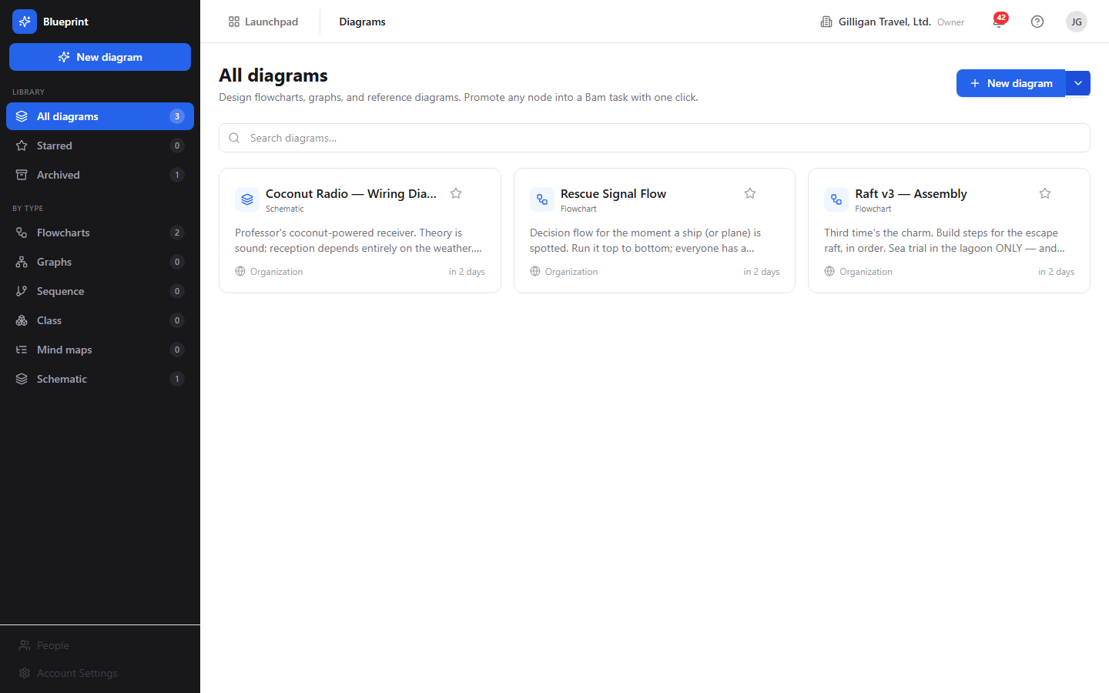
Figure 9.1 Diagram list
The diagram list at /blueprint/ shows every diagram you can see, as a grid of cards. Each card shows the type icon, the diagram name, the lowercase type label, a Star toggle, and a More menu. The card footer shows the visibility (Private, Project, or Organization, each with its own icon) and the relative time the diagram was last updated.
To find a diagram:
1. Use the left sidebar to filter. Under Library, click All diagrams, Starred, or Archived. Under By type, click Flowcharts, Graphs, Sequence, Class, or Mind maps. Each pill shows a count.
2. Type in the Search diagrams... box to filter the visible cards by name or description.
3. Click a card to open it in the editor, or open the card's More menu and choose Open editor.
The page heading reflects the active filter (for example All diagrams, Starred diagrams, or Flowchart diagrams). When nothing matches, an empty state appears with a New diagram button.

Create a diagram
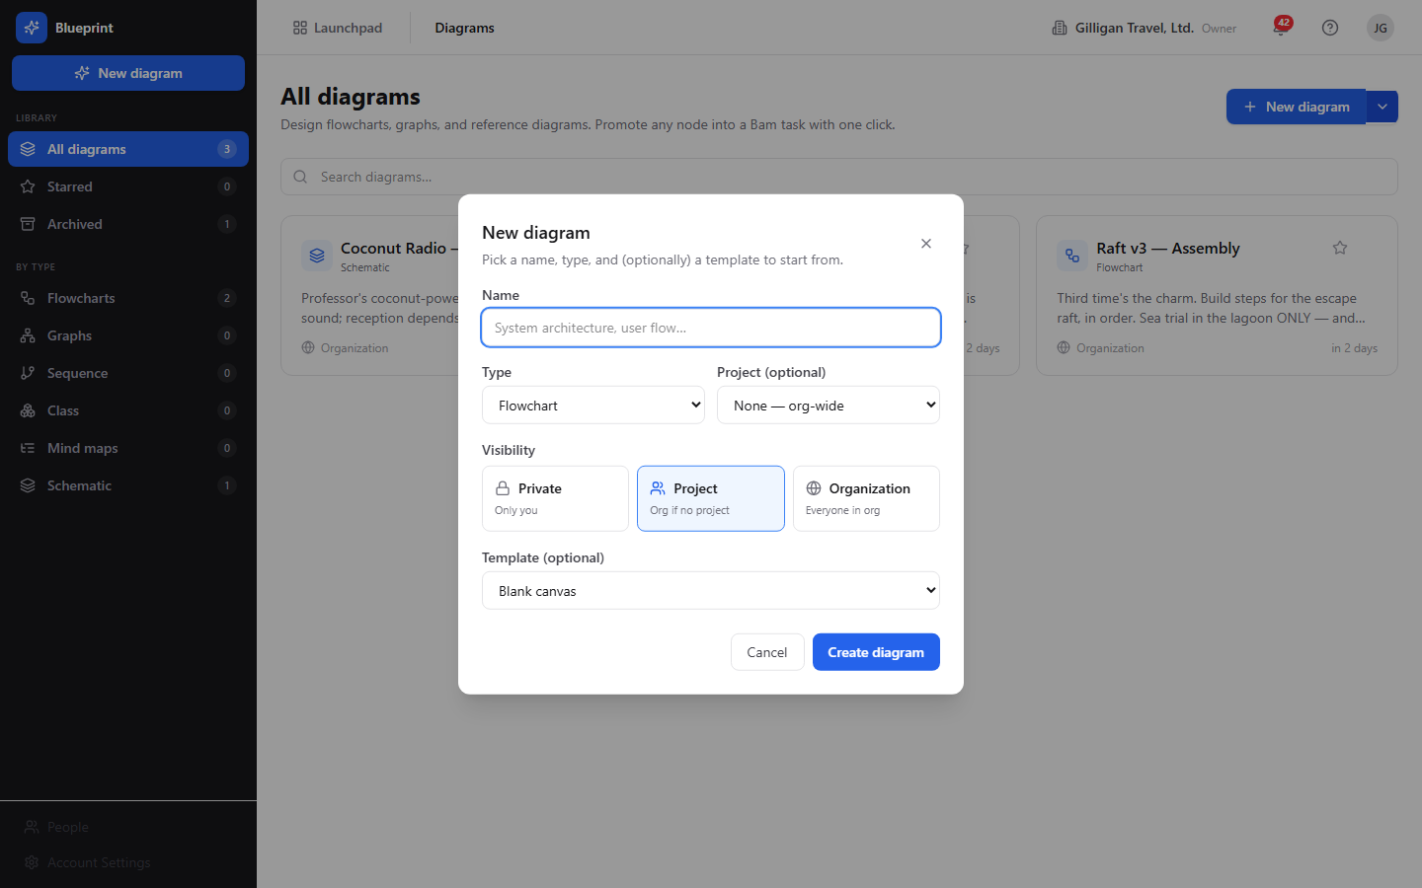
Figure 9.2 New diagram dialog
To create a blank diagram:
1. Click New diagram at the top right of the list, or New diagram in the sidebar.
2. In the New diagram dialog, enter a Name (required, up to 200 characters). The placeholder suggests "System architecture, user flow...".
3. Choose a Type: Flowchart, Graph, Sequence, Class, or Mind map.
4. Optionally choose a Project (optional). Leave it on None - org-wide for a diagram that is not tied to a project.
5. Pick a Visibility: Private (Only you), Project (Project members, or Org if no project), or Organization (Everyone in org). The dialog defaults to Project; if you choose Project without a project, the diagram is created Private.
6. Optionally pick a Template (optional). The empty option is labeled Blank canvas, and system templates show a "system" suffix. See the note below before relying on this.
7. Click Create diagram. The new diagram opens in the editor.
The split button next to New diagram has a chevron menu with two entries: Blank diagram or template (opens the same dialog) and From Bam project tasks... (opens the Generate from Bam dialog, described later).
Note on templates: the Template select is present, but a chosen template does not seed any nodes or edges into the new diagram. The backend accepts a template id and ignores its content, and there is no UI to create templates today, so the list is effectively empty unless rows were inserted directly into the database. Treat every new diagram as a blank canvas regardless of the template you pick.
NOTE
The Template select in the New diagram dialog is wired but inert today: the backend accepts a template id and ignores its content. Treat every new diagram as a blank canvas no matter which template you pick.

The editor canvas
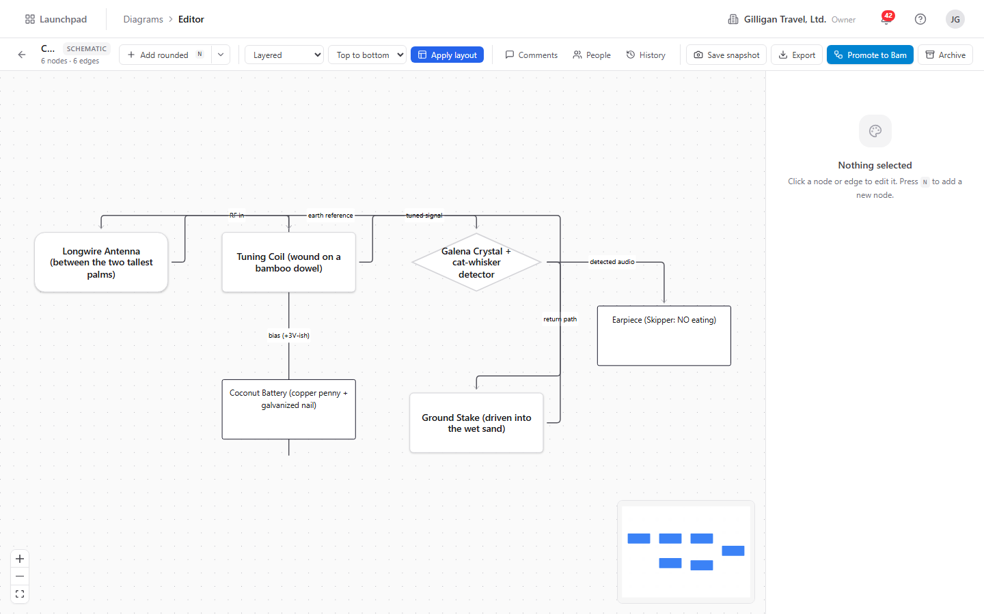
Figure 9.3 Diagram editor
Opening a diagram shows the editor at /blueprint/d/<id>. The canvas is an infinite, pannable React Flow surface with a dotted background, zoom and fit controls at the bottom left, and a minimap at the bottom right. The top bar shows a Back arrow (titled Back to diagrams), the diagram name, an uppercase type chip, and a count line reading N nodes · M edges.
The right side of the screen is the Inspector, which shows the properties of whatever node or edge you have selected. When nothing is selected it reads Nothing selected with the hint "Click a node or edge to edit it. Press N to add a new node."

Add nodes
You can add a node four ways:
- Click the Add <shape> split button in the top bar. The body adds the last shape you used; the chevron opens a menu listing Rounded, Rectangle, Diamond, Ellipse, and Hexagon, with a Last badge on the most recent.
- Press the N key to add a node with the last-used shape.
- Right-click empty canvas and pick a shape under Add node in the pane menu.
- Drag a connection out of a node handle and release it on empty canvas. An Add connected node palette opens at the drop point; pick a shape and the new node is created already wired to the origin node, with the arrow following the direction you dragged.
Every new node starts with the label New node and is selected immediately so the Inspector is open and ready for you to type. The last-used shape is remembered per browser.

Edit a node
Select a node to edit it in the Inspector on the right. The node panel header shows Node and a short id, a Pin toggle, and a Delete button.
To edit a node:
1. Select the node on the canvas.
2. Edit the Label field; the change saves when you leave the field or press Enter.
3. Edit the Description using the rich-text editor (it supports bold, italic, code, and links). The placeholder reads "Describe this node... bold, italic, code, links all work."
4. Change the Shape with the dropdown.
5. Set Width (40 to 2000) and Height (30 to 2000).
6. Pick a Fill color swatch, or click Clear to remove the fill.
You can also resize a node directly on the canvas: select it and drag the resize handles that appear around it. The new size is saved when you finish dragging.
The node right-click menu offers the same actions plus a few extras: Duplicate (with the keyboard hint), Pin position or Unpin (allow auto-layout), a Change shape list, the Fill color swatches (White, Red, Amber, Green, Blue, Violet, Pink, Zinc, and Clear), Link to entity..., Promote to Bam task, and Delete node.

Move and pin nodes
Drag a node to reposition it. The new position is saved when you release the drag.
To keep a node where you put it during an auto-layout pass, pin it: select the node and click the Pin toggle in the Inspector, or right-click the node and choose Pin position. A pinned node is excluded from layout and cannot be dragged until you unpin it. To release it, click the Pin toggle again or choose Unpin (allow auto-layout).

Duplicate a node
To copy a node, select it and press Cmd/Ctrl+D, or right-click it and choose Duplicate. The clone appears offset down and to the right and copies the label, shape, size, style, and any linked entity. Edges connected to the original are not copied; wire the clone in yourself if you need it connected.

Delete a node
To delete a node, select it and press Delete, or right-click it and choose Delete node, or click the trash button in the Inspector. A confirmation appears asking "Delete this node and its connected edges?"; deleting a node removes every edge attached to it.
If the node is linked to a Bam task, a richer dialog appears titled Delete "<label>"?. It explains that the node is linked to a Bam task and offers three buttons: Cancel, Delete node only, and Delete node + task. The last option also deletes the linked Bam task, including its subtasks, comments, time entries, and activity.

Connect nodes with edges
To draw an edge, hover a node to reveal its connection handles (top, left, right, bottom), then drag from a handle to a handle on another node. Releasing on a valid handle creates the edge. Releasing on empty canvas opens the Add connected node palette so you can create the target node and the edge in one gesture.
New edges use a smooth line with a closed (filled) arrowhead by default.

Edit an edge
Select an edge to edit it in the Inspector. The edge panel header shows Edge and a short id and a Delete button.
To edit an edge:
1. Select the edge.
2. Edit the Label field.
3. Choose a Kind: Default, Dependency, Flow, Reference, or Inherits.
4. Choose an End marker: Filled arrow, Open arrow, or None.
The edge right-click menu offers the same Edge kind and End marker choices, plus Delete edge.

Delete an edge
To delete an edge, select it and press Delete, right-click it and choose Delete edge, or click the trash button in the Inspector.

Snap to grid
To line nodes up on a grid, right-click empty canvas and choose Snap to grid under Align; a checkmark shows it is on. While it is on, dragging a node quantizes its position to the grid. To clean up an existing diagram in one pass, choose Snap nodes to grid now, which rounds every node onto the grid and saves the moves. The snap-on setting is remembered per browser.

Auto-layout
Auto-layout arranges the graph automatically using the ELK engine, server-side. Pinned nodes keep their hand-set positions.
To run a layout:
1. In the top bar, choose an algorithm from the layout dropdown: Layered, Force-directed, Tree, or Grid.
2. Choose a direction: Top to bottom, Left to right, Bottom to top, or Right to left. Direction applies to layered layouts.
3. Click Apply layout.
You can also right-click empty canvas and pick an algorithm under Reorganize, where the current algorithm carries a Current badge.
All four dropdown choices apply a layout. Layered and Force-directed map to ELK's layered and force algorithms. Tree maps to ELK's mrtree (a tree layout) and Grid maps to ELK's rectpacking (a compact grid-like packing). The radial algorithm is not in the dropdown and is reachable only through the API or an agent using blueprint_apply_layout.

Export a diagram
To export, click the Export dropdown in the top bar. It offers Mermaid (.mmd) and JSON, a separator, and Reload from server. Pick a format and the file downloads, named after the diagram.
You can also export from the pane right-click menu via Export as Mermaid and Export as JSON.
Only Mermaid and JSON export are offered in the editor. The underlying tool advertises SVG and PNG, but those are deferred to a worker render job and the in-process export service rejects them with "Format ... is not supported in-process", so image export is not available from the editor today.

Mermaid import
The backend can import a Mermaid source string and turn it into a Blueprint graph, materializing its nodes and edges into the typed tables. There is no rendered screen for pasting Mermaid into the editor yet, so this is currently an API or agent capability rather than a button. Import can replace the existing graph or append to it, and you can run a layout pass afterward to position the new nodes.

Snapshots (versions)
A snapshot saves the entire graph so you can return to it later.
To save a snapshot, click Save snapshot (the camera button) in the top bar, choose Save snapshot from the pane right-click menu, or use the Save snapshot button at the top of the History panel. You can enter an optional label when prompted ("Snapshot label (optional)"). Each snapshot is numbered automatically, one higher than the latest.
To browse and restore versions, open the History panel from the top bar (the clock icon). Each entry shows its version number (for example v2), its label or "Unlabeled", who saved it, and how long ago. Click Restore on a version, then Confirm the prompt ("Replace the current graph with v<n>?") to roll the diagram back to that snapshot. See the Comments, People, and version History panels section for the full panel walkthrough.

Star and archive
To star a diagram, click the Star toggle on its card in the list (the title reads Star or Unstar). Starred diagrams show under the Starred sidebar filter.
To archive a diagram, use the card's More menu and choose Archive, or in the editor click Archive in the top bar, or choose Archive diagram from the pane right-click menu. Archiving is a soft delete: the diagram is hidden from the default list but its nodes, edges, comments, and snapshots are preserved. You confirm before it archives ("Archive this diagram? It will be hidden from the default list."). Archived diagrams show under the Archived sidebar filter. Archiving requires admin scope on your API key when done by an agent.
WARNING
Deleting a node removes every edge attached to it, and if the node is linked to a Bam task, choosing Delete node + task also deletes that task along with its subtasks, comments, time entries, and activity. Archiving only hides a diagram; node and task deletion is the destructive one to watch.
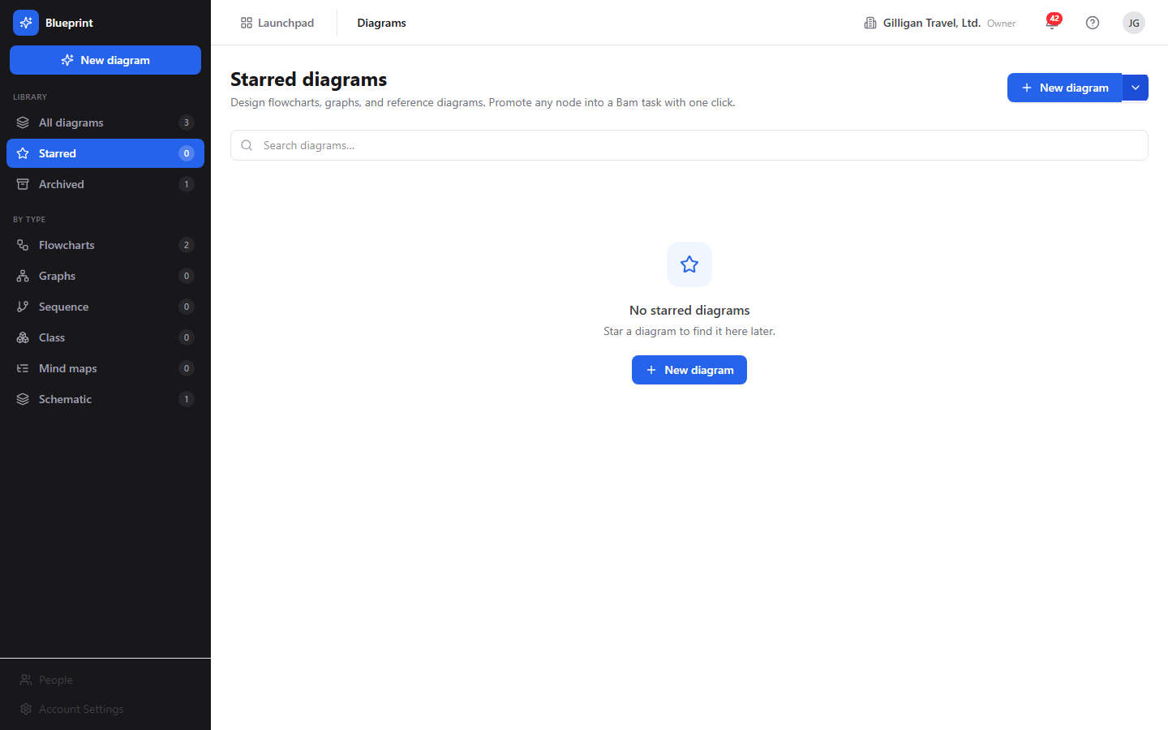
Figure 9.4 Starred diagrams
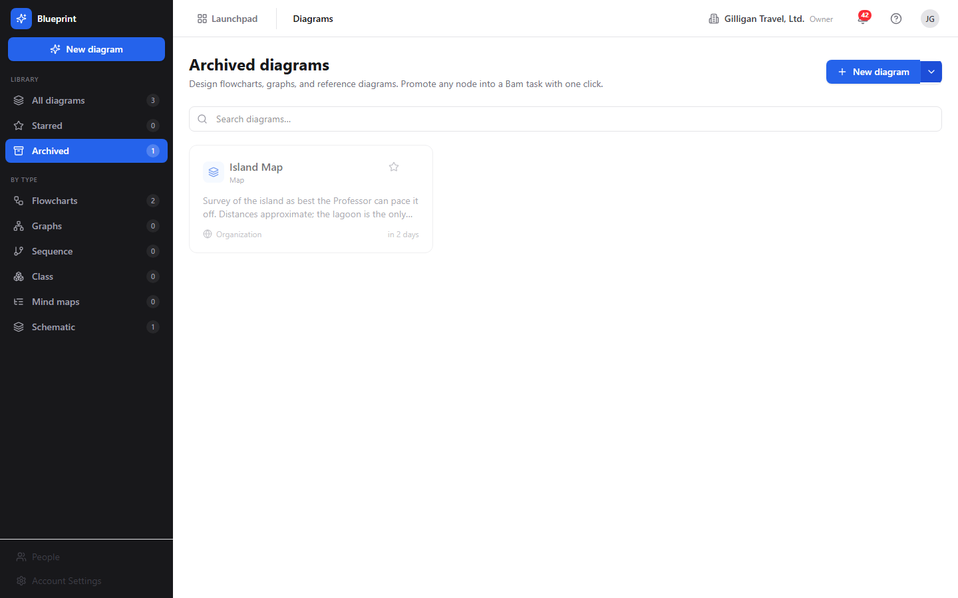
Figure 9.5 Archived diagrams

Link a node to another app's entity
A node can carry a cross-product link to an object in another app, so the diagram references entities across the suite. The canonical link types are bam.task, beacon.entry, bearing.goal, bond.deal, bond.contact, and helpdesk.ticket. Only bam.task links stay in live two-way sync.
To link a node:
1. Select the node.
2. In the Inspector, under Linked entity, type the link type into the type field (for example bam.task) and the entity id (a UUID) into the entity id (uuid) field.
3. Click Link.
Alternatively, right-click the node, choose Link to entity..., and enter the reference type and UUID when prompted. A linked node shows a small badge on the canvas.

Promote a single node to a Bam task
To turn one node into a Bam task:
1. Select the node.
2. Click Promote to task in the Inspector, or right-click the node and choose Promote to Bam task.
3. If the diagram is not tied to a project, enter the Bam project id (a UUID) when prompted.
4. The app creates the task in Bam, then links the node back to it so future title and description edits sync both ways.
Under the hood the Blueprint backend returns a task payload; the app posts that payload to Bam itself using your session, then links the node to the new task. The backend does not create the task on its own.

Promote a whole graph to Bam tasks
To turn an entire diagram into a Bam project plan:
1. Click Promote to Bam (the sky-blue button) in the top bar.
2. If the diagram has no project, enter a Bam project id (a UUID) when prompted.
3. Choose an edge direction when prompted: source-parent (default; an edge A to B means A is the parent of B), target-parent (A to B means B is the parent of A), or none (skip parent links).
4. Watch the progress overlay. It creates one task per node, reuses any task a node is already linked to, then wires parent and child links from the edges.
5. When it finishes, the summary reads "Created N task(s)", plus "reused M existing" and "wired K parent link(s)" where applicable. Any failures are listed.
As with single-node promotion, the backend returns a plan and the app executes it against Bam; the diagram itself does not create tasks server-side. After promotion, each node is linked to its new task, so the badges appear and two-way sync is active.

Generate a diagram from a Bam project
To build a diagram automatically from an existing project:
1. In the list, click the chevron next to New diagram and choose From Bam project tasks....
2. In the Generate from Bam project dialog, choose a Project.
3. Optionally check Include completed tasks.
4. Optionally check Run auto-layout (layered, top-to-bottom) (on by default).
5. Click Generate.
The result is a new diagram with one node per task and edges drawn from existing parent/child links, opened already laid out. Each node is linked to its task, so renaming a node updates the task and renaming the task updates the node. Generated diagrams are written with the type org_chart.

Two-way sync with Bam
Once a node is linked to a Bam task (through generation, promotion, or a manual link), the two stay in sync. Editing the node's label or description in Blueprint updates the linked task in Bam. Changing the task's title or description in Bam updates every node linked to it. This happens automatically; there is nothing to configure.

Live collaboration refresh
When more than one person has a diagram open, Blueprint keeps everyone's canvas current. When anyone adds, moves, edits, or deletes a node or edge, every other open editor refetches the graph and updates. Your own zoom and pan position are not affected by other people's edits. The presence strip in the top bar shows who else is on the diagram, and the selected node is URL-addressable (?node=<id>) so a follower can be brought to the same node.

Comments, People, and version History panels
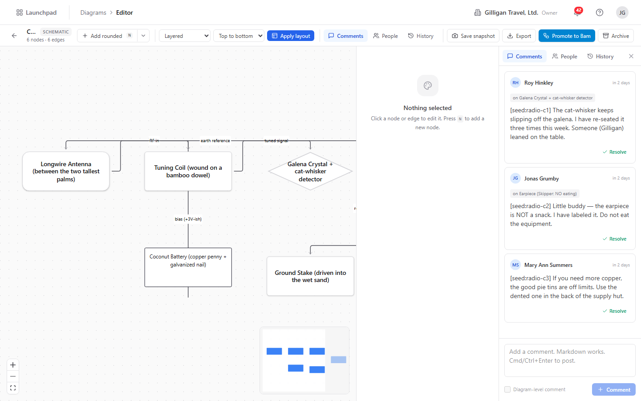
Figure 9.6 Comments & collaboration
The editor's top bar carries three toggle buttons, just left of the snapshot and export controls, that open a panel on the right side of the canvas: Comments, People, and History. Each button opens its panel and highlights while active; click it again, or the panel's close (X) button, to dismiss it. The three tabs share one panel, so you can switch between them without losing your place. Comments, collaborators, and snapshots are all preserved when a diagram is archived.
Comments. Open the Comments panel (the speech-bubble icon) to read, write, and resolve notes on the diagram. Each comment shows its author, the relative time it was posted, and the rendered markdown body; a comment anchored to a node shows an "on <node label>" chip. To add one, type in the composer at the bottom (markdown works) and click Comment or press Cmd/Ctrl+Enter. The composer's checkbox controls anchoring: with a node selected on the canvas it reads Pin to <node> and attaches the comment to that node; with nothing selected it posts a diagram-level comment. Click Resolve to close a review thread (or Reopen to undo); resolved comments are hidden until you click Show N resolved.
People (collaborators). Open the People panel (the people icon) to grant explicit per-diagram access on top of project- or org-level visibility. Search by name or email in the Add by name or email box and pick a person to add them (as an editor by default). Each collaborator row shows their name, a role dropdown (Owner, Editor, Commenter, or Viewer), and a trash button to remove them. Change a role from the dropdown. When a diagram has no direct collaborators the panel explains that people with project or org access can still see it.
History (versions). Open the History panel (the clock icon) to browse and restore snapshots. The Save snapshot button at the top captures the current graph as a new version. Each entry shows its version number, its label or "Unlabeled", who saved it, and how long ago. Click Restore then Confirm to roll the graph back to that version. See Snapshots (versions) for how snapshots are numbered and what they capture.
All three panels are also fully agent- and API-driven, so an agent manages comments, collaborators, and versions through the same MCP tools described under Working with AI agents.

Working with AI agents
Blueprint is built to be driven by AI agents. Every structural change is exposed as an MCP tool, so an agent acts on a diagram with the same permissions and the same audit trail as a person. There are 36 Blueprint MCP tools, covering the full surface: diagram read and write, nodes, edges, layout and generation, the Bam round-trip, versions, comments, collaborators, stars, Mermaid import, and templates.
Common agent flows:
- Author a whole diagram in one call. An agent reads a process description, org roster, or task list and calls blueprint_create to make the diagram, then blueprint_generate with a list of node specs and edge specs. The server materializes the ids, wires up parent containers, and runs auto-layout. This is the headline path; blueprint_generate accepts 1 to 500 node specs and up to 2000 edge specs, with replace: true to wipe the existing graph first or auto_layout: false to skip the post-generate pass.
- Turn a Mermaid block into an editable graph. blueprint_import_mermaid parses a Mermaid source string (for example from a Brief, a Beacon entry, or an LLM draft) into the typed node/edge graph, then blueprint_apply_layout positions it.
- Edit incrementally. blueprint_add_node, blueprint_update_node, blueprint_move_node, blueprint_duplicate_node, and blueprint_delete_node cover nodes; blueprint_add_edge, blueprint_update_edge, and blueprint_delete_edge cover edges; blueprint_apply_layout re-arranges. Through blueprint_apply_layout an agent can use the radial algorithm that the UI dropdown does not reach.
- Read the graph. blueprint_list, blueprint_get, blueprint_read_nodes, blueprint_read_edges, blueprint_search, and blueprint_export. Note blueprint_search matches only on name and description and filters the visible list client-side; it does not search node labels yet.
- Round-trip with Bam. blueprint_generate_from_bam turns a project's tasks into a diagram; blueprint_promote_graph_to_tasks and blueprint_promote_node_to_task return a plan the caller executes against Bam; blueprint_link_entity attaches a cross-product reference so the two-way sync hook fires.
- Version, review, and share. blueprint_snapshot_version / blueprint_list_versions / blueprint_restore_version manage restore points; blueprint_list_comments / blueprint_add_comment / blueprint_update_comment (set resolved: true to resolve a thread) drive review; blueprint_list_collaborators / blueprint_add_collaborator / blueprint_remove_collaborator manage explicit access; blueprint_star / blueprint_unstar set the caller's personal favorite; blueprint_list_templates lists templates.
Destructive tools follow a preview-then-commit pattern: blueprint_archive, blueprint_delete_node, blueprint_delete_edge, blueprint_restore_version, and blueprint_remove_collaborator first return a confirmation prompt and act only when called again with confirm_action: true. blueprint_archive also requires admin scope. Service-account calls are checked against the platform agent policy kill switch and the blueprint.* allowlist before they run, and an agent posting cited entities into shared surfaces should call the platform can_access tool first. Agent runs are recorded in the unified activity feed under the agent identity, surface a heartbeat, and can route work through the platform proposal queue for human approval.
A few tool descriptions describe roadmap behavior that the running app does not yet deliver. blueprint_create claims a template seeds the diagram, but template content is never applied. blueprint_export advertises svg and png, which the in-process export service rejects. blueprint_promote_node_to_task and blueprint_promote_graph_to_tasks return a payload or plan only; the caller performs the actual task creation in Bam and then back-links the node with blueprint_link_entity. Plan for these gaps when reviewing agent work.
For the full tool catalog and schemas, see the Blueprint MCP-tools reference in docs/apps/blueprint/.

User Stories

Story: Create your first flowchart
Who: Anyone with a BigBlueBam account who wants to sketch a process.
Goal: Build a small flowchart, connect and label the steps, tidy the layout, and save a copy.
Before you start: Be signed in. No project is required.
Steps
1. Go to /blueprint/ from the Launchpad.
2. Click New diagram. Enter a Name, leave Type on Flowchart, choose a Visibility, and click Create diagram.
3. In the editor, press N (or click Add <shape>) to add a node. With the node selected, type a Label in the Inspector.
4. Add two or three more nodes the same way.
5. Drag from one node's handle to another node's handle to connect them. Repeat until the steps are linked.
6. Select an edge and set its Label and Kind in the Inspector if you want to annotate the flow.
7. Set the layout dropdown to Layered, pick a direction such as Top to bottom, and click Apply layout.
8. Click Save snapshot and enter an optional label.
Result: A laid-out flowchart with labeled steps and a saved snapshot you can return to.
Related: Export the diagram as Mermaid or JSON from the Export menu. An agent would build the same diagram with blueprint_create plus blueprint_generate.

Story: Visualize an existing Bam project
Who: A project lead who wants a picture of a project's task structure.
Goal: Generate a diagram from a Bam project, with each node tied to its task.
Before you start: Have a Bam project that contains tasks, in the same org and session.
Steps
1. Go to /blueprint/.
2. Click the chevron next to New diagram and choose From Bam project tasks....
3. In the Generate from Bam project dialog, choose your Project.
4. Check Include completed tasks if you want finished work in the diagram.
5. Leave Run auto-layout (layered, top-to-bottom) checked.
6. Click Generate.
Result: A new diagram opens, laid out, with one node per task and edges drawn from the project's parent/child links. Each node is linked to its task, so the two stay in sync.
Related: This is the reverse of promoting a graph to tasks. An agent uses blueprint_generate_from_bam.

Story: Turn a mind map into a project plan
Who: A planner who brainstormed work as a mind map and now wants real tasks.
Goal: Promote the diagram into a Bam project, one task per node, with parent links from the edges.
Before you start: Have a diagram of the work and a target Bam project id.
Steps
1. Open the diagram in the editor.
2. Make sure the structure reads parent-to-child along the edges (an edge from the parent idea to the child idea).
3. Click Promote to Bam in the top bar.
4. If prompted, enter the Bam project id (a UUID).
5. When prompted for edge direction, choose source-parent so each edge makes the source node the parent.
6. Watch the progress overlay until it reports the created tasks and wired parent links.
Result: One Bam task per node, with parent and child relationships matching the edges. Each node is now linked to its task, and the badges appear on the canvas.
Related: Promote a single node instead with Promote to task in the Inspector. An agent uses blueprint_promote_graph_to_tasks and then creates the tasks with Bam tools.

Story: Keep a diagram and its tasks in sync
Who: Anyone maintaining a diagram that mirrors live work in Bam.
Goal: Confirm that edits flow both directions between a node and its linked task.
Before you start: Have a diagram whose nodes are linked to Bam tasks (from generation or promotion).
Steps
1. Open the diagram in the editor.
2. Select a linked node (it shows a link badge) and change its Label in the Inspector.
3. Open the linked task in Bam and confirm its title now matches.
4. In Bam, rename the task.
5. Back in Blueprint, reload the diagram (or wait for the live refresh) and confirm the node label updated.
Result: The node and the task hold the same title and description, kept in sync automatically.
Related: Link more nodes with the Inspector Link button or the node menu's Link to entity.... An agent uses blueprint_link_entity and blueprint_update_node.

Story: Reorganize a messy graph
Who: Anyone whose diagram has drifted into a tangle.
Goal: Auto-arrange the graph while keeping a few key nodes fixed.
Before you start: Have a diagram open in the editor.
Steps
1. Pin the nodes you want to keep in place: select each one and click the Pin toggle in the Inspector, or right-click and choose Pin position.
2. In the layout dropdown, choose an algorithm: Layered or Force-directed for edge-aware arrangements, Tree for a hierarchy, or Grid for a compact packing.
3. Pick a direction and click Apply layout.
4. If you want everything aligned to a grid afterward, right-click empty canvas and choose Snap nodes to grid now.
Result: The unpinned nodes are arranged by the chosen algorithm; the pinned nodes stay where you put them.
Related: For a radial layout, use an agent with blueprint_apply_layout, since the UI dropdown does not offer it.

Story: Have an agent draft a diagram from a document
Who: A user working with an AI agent that has MCP access.
Goal: Produce a complete, laid-out diagram from a written process description without drawing it by hand.
Before you start: Have an agent connected to the MCP server with a key allowed to use blueprint.* tools.
Steps
1. Give the agent the source text (a process description, a roster, or a task list) and ask it to build a Blueprint diagram.
2. The agent calls blueprint_create to make the diagram.
3. The agent calls blueprint_generate with node specs and edge specs extracted from your text. The server creates the nodes, wires the edges and any parent containers, and runs auto-layout. (If the source is already a Mermaid block, the agent can use blueprint_import_mermaid instead, then blueprint_apply_layout.)
4. Open the diagram from /blueprint/ to review it.
5. Adjust labels, shapes, and layout in the editor as needed.
Result: A fully wired, laid-out diagram you can refine by hand, created in a single agent call.
Related: The agent can then call blueprint_promote_graph_to_tasks to turn the diagram into a Bam plan. Every agent mutation is audited like a human edit.

Story: Review and snapshot before an agent rewrite
Who: A diagram owner who wants a safe restore point before an agent reworks the graph.
Goal: Capture the current graph, let the agent rewrite it, and roll back if needed.
Before you start: Have a diagram open, and an agent with blueprint.* access.
Steps
1. In the editor, click Save snapshot and label it (for example "before agent rewrite").
2. Ask the agent to make its changes. It can read the graph with blueprint_read_nodes and blueprint_read_edges, and rewrite with blueprint_generate (replace: true) or incremental node/edge tools.
3. Have the agent add a comment summarizing what it changed with blueprint_add_comment, and read review feedback with blueprint_list_comments.
4. If the result is wrong, ask the agent to restore the labeled snapshot with blueprint_restore_version (it lists versions with blueprint_list_versions first).
Result: The diagram is either the agent's improved version or rolled back to your snapshot, with the review thread recorded.
Related: Listing and restoring versions, and reading comments, are also in the editor's History and Comments panels; an agent does the same with blueprint_list_versions, blueprint_restore_version, and blueprint_list_comments.

Story: Curate your diagram library
Who: Anyone keeping a tidy set of diagrams.
Goal: Star the diagrams you use most and archive the ones you no longer need.
Before you start: Have several diagrams in your org.
Steps
1. Go to /blueprint/.
2. Click the Star toggle on the cards you want to keep handy.
3. Click Starred in the sidebar to see only those.
4. For a stale diagram, open its More menu and choose Archive, then confirm.
5. Click Archived in the sidebar to review or find archived diagrams later.
Result: Your most-used diagrams are one filter click away, and stale ones are hidden from the default list without being destroyed.
Related: Archiving is reversible at the data level since nodes, edges, comments, and snapshots are preserved. An agent archives with blueprint_archive (which requires admin scope and a confirmation step).

Related
- Bam (/b3/) - the Kanban and sprint tool Blueprint exchanges work with. Generate a diagram from a Bam project, promote a diagram or node into Bam tasks, and rely on two-way sync between a node and its linked task.
- Beacon, Bearing, Bond, Helpdesk - nodes can carry cross-product links to a Beacon entry, a Bearing goal, a Bond deal or contact, or a Helpdesk ticket via the Inspector's Linked entity section or the node menu's Link to entity....
- Brief - Mermaid export from Blueprint produces a source string you can embed elsewhere, and blueprint_import_mermaid turns a Mermaid block back into an editable graph.
- Blueprint MCP-tools reference and guide in docs/apps/blueprint/ for the full catalog of the 36 agent tools.

Check yourself
Every answer is findable in this chapter. Check your work against the Answer Key appendix at the back of the book.
1. How does Blueprint store a diagram?
a) As a single flat image file
b) As an opaque collaborative drawing blob
c) As a typed relational graph of node and edge rows
d) As a Mermaid source string only
2. Which shapes does the node palette offer?
a) Rounded, Rectangle, Diamond, Ellipse, and Hexagon
b) Circle, Square, Triangle, and Star
c) Box, Pill, and Cloud
d) Only Rectangle and Ellipse
3. Which cross-product link type stays in live two-way sync?
a) beacon.entry
b) bond.deal
c) bam.task
d) bearing.goal
4. What are the five edge kinds you can choose?
a) Default, Dependency, Flow, Reference, and Inherits
b) Solid, Dashed, Dotted, Curved, and Straight
c) Parent, Child, Sibling, Peer, and Root
d) Up, Down, Left, Right, and None
5. What type does Generate from Bam write onto the new diagram?
a) flowchart
b) graph
c) mind_map
d) org_chart
6. Which export formats are actually offered in the editor?
a) SVG and PNG
b) Mermaid (.mmd) and JSON
c) PDF and DOCX
d) CSV and XML
7. What does it mean to pin a node, and what effect does pinning have during auto-layout?
8. Name Blueprint's three visibility levels and who can see a diagram at each.
9. When you promote a whole graph to Bam tasks, what does the source-parent edge direction mean?
10. What are the four collaborator roles available in the People panel?
11. How is each snapshot numbered, and what does a snapshot capture?
12. When an agent calls blueprint_generate, how many node specs and edge specs can it pass?

CHAPTER 10

Board
An infinite canvas your whole team can draw on.

Board is where you think in space instead of in lists. It gives you an infinite Excalidraw canvas for sketches, retros, architecture maps, and brainstorms, with sticky notes, shapes, arrows, and frames that auto-save and sync live as your team draws together. This chapter walks you from your first template through real-time collaboration, version snapshots, and locking, and it shows the marquee handoff where stickies become tracked Bam tasks. By the end you will be able to spin up a board, run a live session on it, and turn the ideas into work.
At a glance
- Infinite Excalidraw canvas: stickies, text, shapes, arrows, frames, and images
- Live collaboration with shared cursors and auto-save as you draw
- Named version snapshots you can restore at any time
- Promote brainstorm stickies into real Bam tasks in a named project and phase
- 40 MCP tools, so an agent can read, build, and tidy a board with your permissions
In this chapter
Overview . Key concepts . Where to find it . Feature reference . Board list (All Boards) . Creating a board from a template . Creating a blank board . The infinite canvas . Adding sticky notes . Adding text
Board gives your team an infinite canvas for sketching ideas, running retros, mapping architecture, and brainstorming together. Reach for it when a list or a document is not enough and you need to draw, group, and arrange thoughts in space.

Overview
Board is BigBlueBam's whiteboarding app. Each board is one infinite canvas powered by Excalidraw, where you place sticky notes, text, shapes, arrows, freehand drawings, frames, and images. Boards auto-save as you work and sync in real time, so several people can edit the same canvas at once and see each other's cursors.
One infinite canvas, many cursors. The whole team draws together and sees each other move in real time.
Board is in beta. The sidebar shows a yellow beta chip next to the Board logo.
Boards live inside your BigBlueBam organization and can optionally be scoped to a Bam project. Because projects, project members, phases, and tasks all live in Bam, Board can hand work back to Bam: sticky notes from a brainstorm can be promoted into Bam tasks in a named project and phase. You organize boards with stars, archive, templates, and named version snapshots.
Board does not have its own login. It reads your shared BigBlueBam session, and your permissions come from Bam. If you are not signed in, Board shows a "Please log in to BigBlueBam first" screen with a link to the main app.
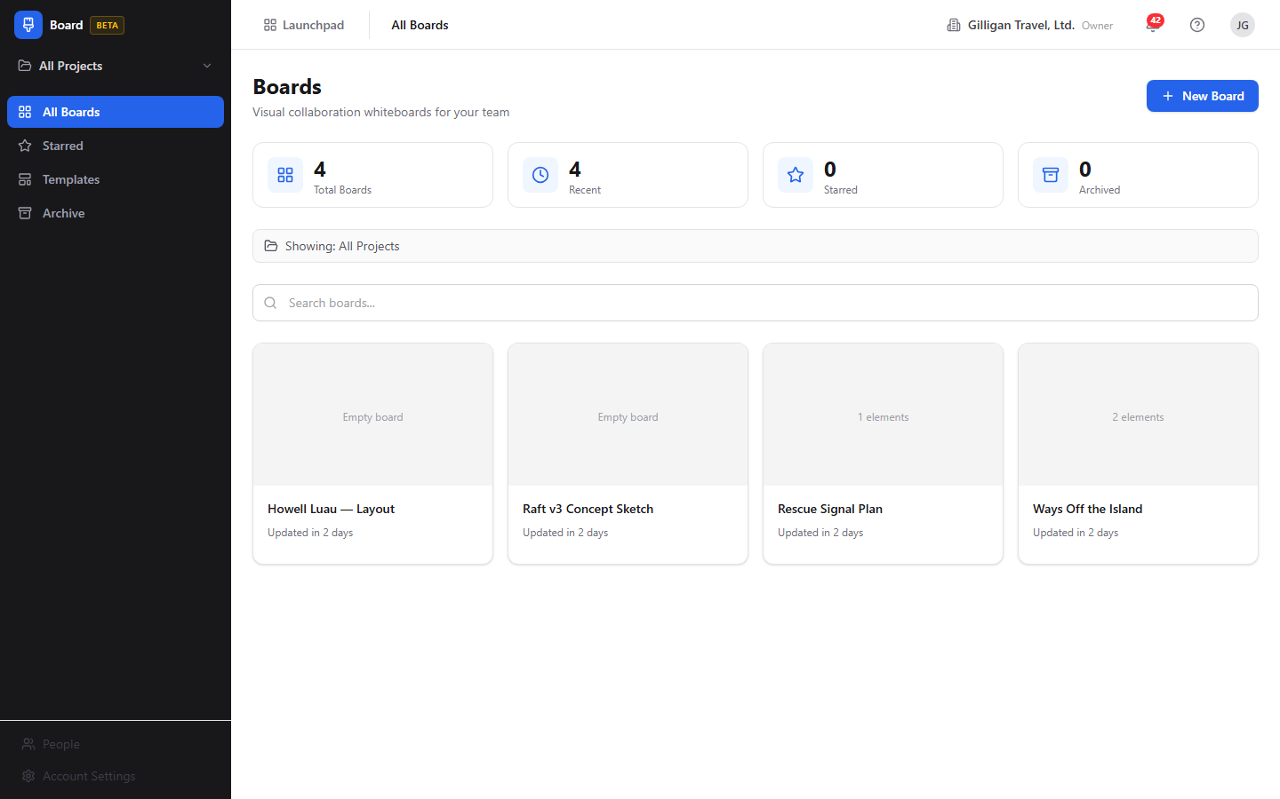
Figure 10.1 All boards

Key concepts
- Board - one infinite-canvas whiteboard. It has a name, a description, an emoji icon, a background pattern, a visibility setting, an optional project association, and a locked flag.
- Element - anything on the canvas: a sticky note, text, a shape, a connector (arrow or line), an image, or a frame. The canvas scene is stored whole, and a per-element copy is kept so the board can be searched, read, and promoted.
- Sticky note - a colored note. The default color is yellow. (Excalidraw has no native sticky; Board builds one from a rectangle with bound text.)
- Shape - a rectangle, diamond, ellipse, or freehand drawing from Excalidraw's toolbar.
- Frame - a labeled region on the canvas that groups the elements inside it. Frames are used when reading or summarizing a board by section.
- Background - the canvas backdrop pattern. One of dots (default), grid, lines, or plain.
- Visibility - who can see a board. private (creator plus explicitly added collaborators), project (project members plus collaborators plus creator), or organization (every member of your org). The default is project.
- Collaborator - a person granted access to a single board with either view or edit permission. There is no in-app screen to manage collaborators today; manage them through the visibility setting or have an agent or API client do it (see Feature reference).
- Lock - a board-level read-only switch. When a board is locked, only the board creator or an org admin or owner can edit it.
- Star - your personal favorite marker on a board.
- Version - a named snapshot of a board's canvas that you can restore later.
- Template - a reusable board blueprint you start new boards from. System templates ship with the platform; your org can also create its own.
- Integrity issue - a flag on a board whose project link is broken (cross-org, missing, or auto-detached). You resolve it by detaching the board from the project or reassigning it to a valid one.
- Roles - org roles resolve as viewer, member, admin, owner. Admins and owners get full access to any board in the org.

Where to find it
Board is served at /board/. A single board's canvas is at /board/<boardId>, and its version history is at /board/<boardId>/versions.
TRY IT
Open /board/, click New Board, pick a Retro template, and click Use. You will land on a pre-filled canvas with no layout work.
Prerequisites:
- A signed-in BigBlueBam session. Board uses the shared Bam session cookie.
- An organization. To scope a board to a project, that project must exist in Bam and belong to your org.
- Edit access to a board to change it. Locked boards are editable only by the creator or an org admin or owner.
The left sidebar has four nav items: All Boards, Starred, Templates, and Archive. A project scope selector at the top of the sidebar lets you switch between "All Projects" and a single project to filter the list and stats. Press ? anywhere outside a text field to open the in-app help.

Feature reference

Board list (All Boards)
The home view lists your boards as cards. It shows a heading "Boards" and the subtitle "Visual collaboration whiteboards for your team".
The page has four stat cards across the top: Total Boards, Recent, Starred, and Archived. Below them is a search box and a grid of board cards.
To browse and open a board:
1. Open Board at /board/. All Boards is the default view.
2. To narrow the list to one project, use the project scope selector at the top of the sidebar. A banner shows "Showing: All Projects" or "Showing: <Project>", with a Show All Projects reset.
3. Type in the Search boards... box to filter by board name or description.
4. Click a board card to open its canvas.
Each board card shows the board's thumbnail or icon, an element-count caption ("N elements" or "Empty board"), a project badge, and a collaborator-count chip ("N collaborator(s)"). A lock icon appears on locked boards. An amber warning icon appears when a board has an integrity issue, with the tooltip "N integrity issue(s). Open the board to fix."
If there are no boards, the empty state reads "No boards yet" (or "No boards match your search"), with a Create Board button that takes you to the Templates browser.
The ... menu on each card holds Version history, Duplicate, Archive, and Delete. See the lifecycle and version sections below.

Figure 10.2 All boards

Creating a board from a template
Templates give you a pre-built canvas (a retro layout, a brainstorm board, an architecture template, and so on).
To create a board from a template:
1. From All Boards, click New Board (top-right), or click Templates in the sidebar. Both lead to the Templates browser.
2. The browser shows a heading "Templates" and the subtitle "Start from a pre-built template, or create a blank board".
3. Use the category tabs to filter: General, Retro, Brainstorm, Planning, Architecture, Strategy, or All.
4. On the template you want, click Use.
5. A new board is created from that template and its canvas opens.
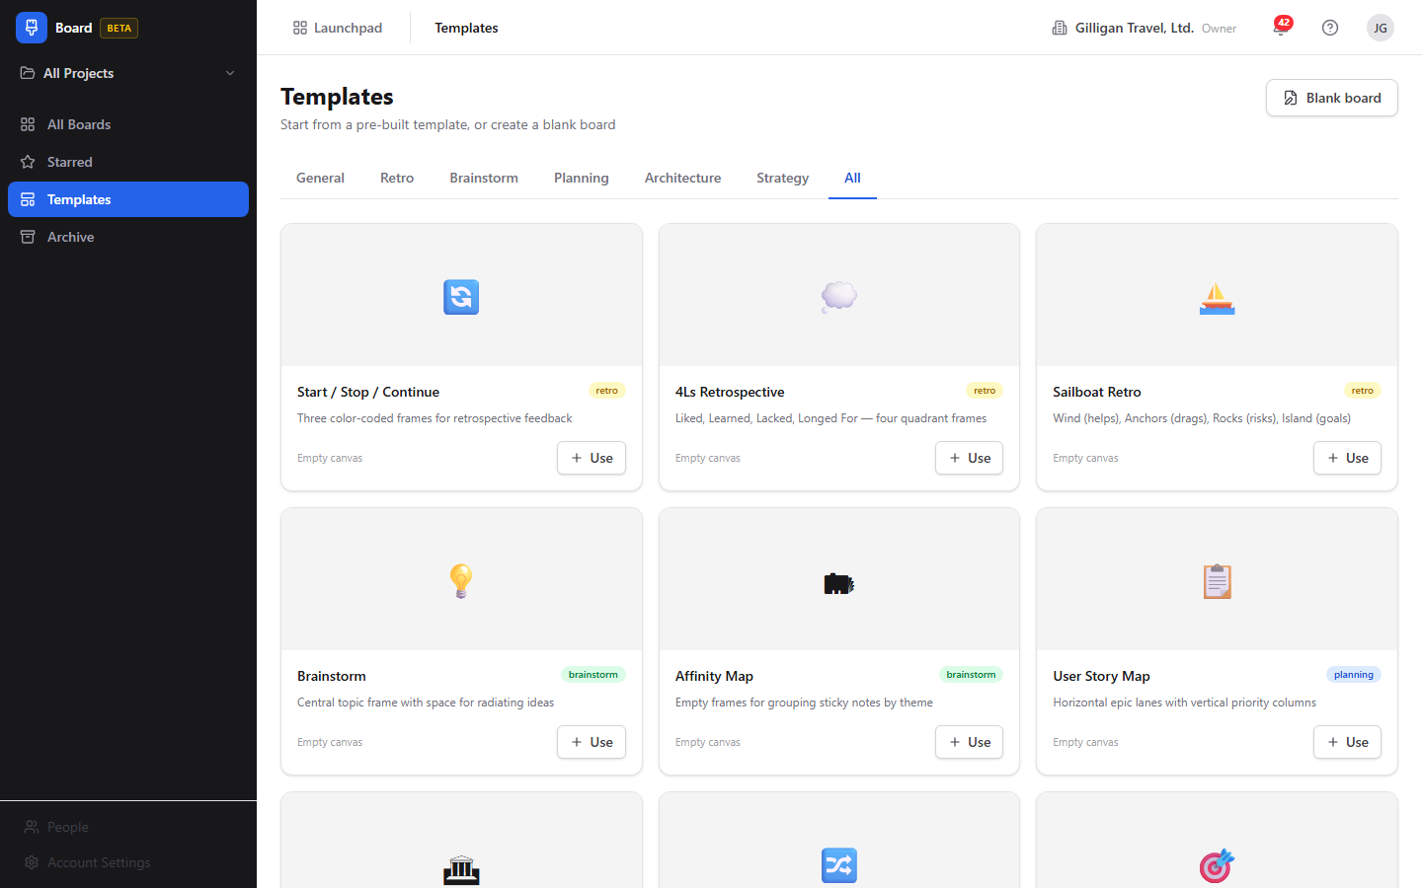
Figure 10.3 Board templates

Creating a blank board
To start from an empty canvas:
1. In the Templates browser, click Blank board (top-right), which opens the "Create New Board" page. (You can also pick the Blank Board card, captioned "Start with an empty canvas", on that page.)
2. The page shows a heading "Create New Board".
3. Pick an emoji with the Icon picker.
4. Type a name in the Board name field (placeholder "Untitled Board").
5. Click Create Board. To abandon, click Cancel.
6. The new board's canvas opens.

The infinite canvas
The canvas is a full-screen Excalidraw editor. It opens when you click a board card or finish creating a board.
The drawing tools are Excalidraw's own native toolbar, not Board's. From that toolbar you can add and edit shapes (rectangle, diamond, ellipse), arrows and lines, text, freehand drawings, frames, and images, plus zoom, pan, and multi-select. Use Excalidraw's toolbar for everything you draw.
Board overlays a few of its own controls on top of the canvas:
- A floating board toolbar at the top (covered below).
- A connection status badge at the top-right.
- An integrity banner at the top when the board's project link is broken.
- A chat panel that slides in from the right.
Your work saves automatically. The canvas persists locally as you draw and writes to the server a few seconds after you stop, and it saves once more when you close the tab. You do not need a Save button for canvas content.
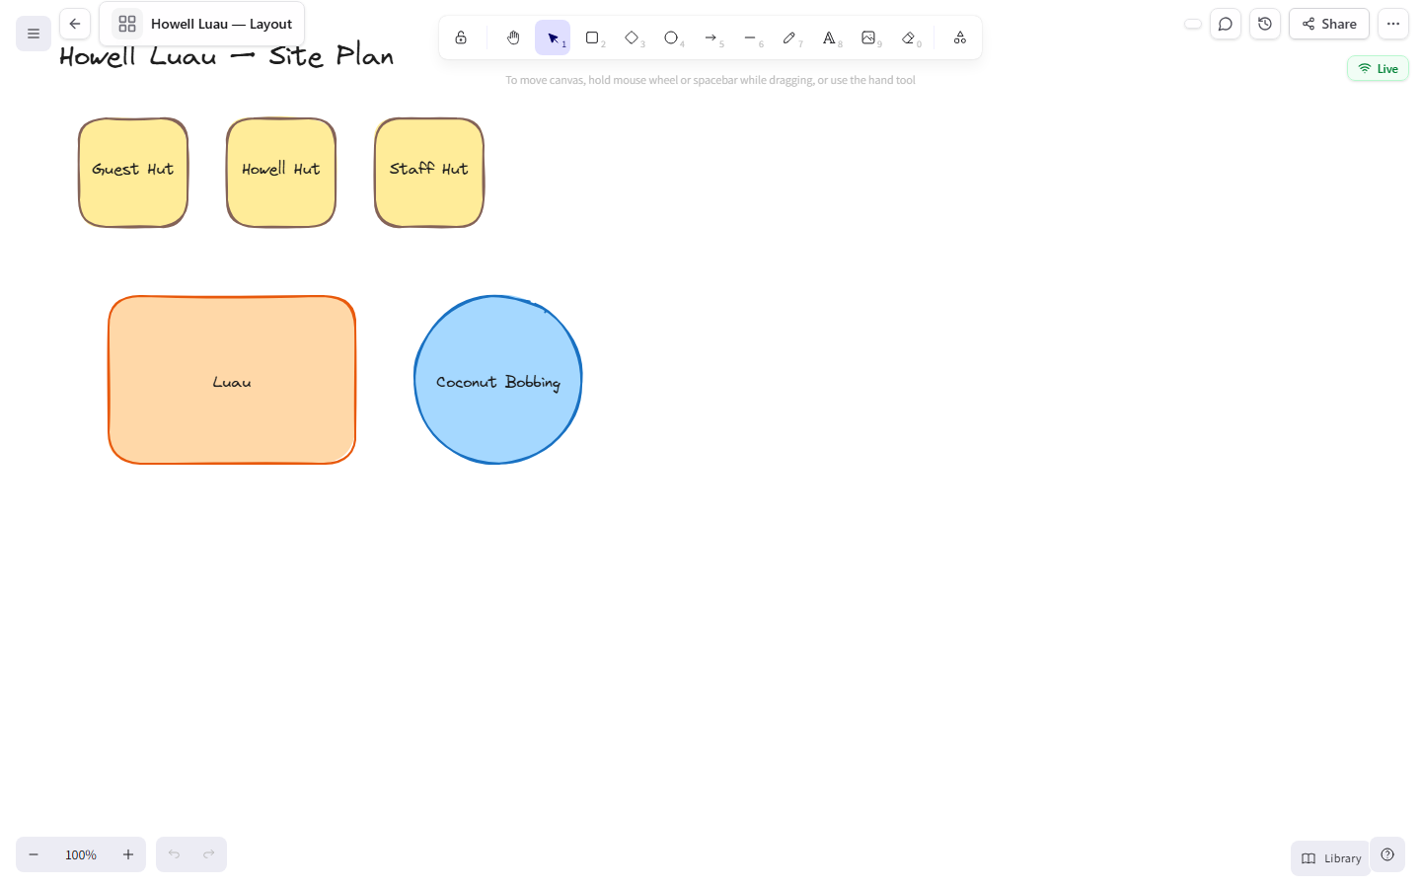
Figure 10.4 Board canvas

Adding sticky notes
Sticky notes are colored notes for capturing ideas. The default color is yellow.
Add stickies from Excalidraw's tools on the canvas (a rectangle with text). An AI agent can also add a sticky directly with one of six colors (yellow, green, blue, red, purple, orange) and a position; see Working with AI agents.

Adding text
Add free text from Excalidraw's text tool on the canvas. An agent can add a text element with a position; see Working with AI agents.

Shapes, arrows, and frames
Rectangles, diamonds, ellipses, arrows, lines, freehand strokes, images, and frames all come from Excalidraw's native toolbar. Group related elements inside a frame so the board can later be read or summarized by section.

The board toolbar
The floating toolbar at the top of the canvas holds board-level controls (it is separate from Excalidraw's drawing toolbar):
- A back arrow (tooltip "Back to boards") that returns to All Boards.
- An icon picker and the board name. Click the name to rename the board inline; press Enter to save or Escape to cancel.
- A lock icon, shown when the board is locked.
- The presence strip, which shows who else is present on the board and is the entry point to a voice huddle (see Real-time presence and audio).
- A Toggle chat button that opens the chat panel.
- A Version history button that opens the board's versions.
- A Share button that copies a shareable link to the board to your clipboard. The button briefly reads "Link copied" after a successful copy.
- A ... menu containing Lock board / Unlock board, and Export as PNG and Export as SVG. Each export item renders the board on the server and downloads a real image file.
To rename a board from the toolbar:
1. Open the board's canvas.
2. Click the board name in the floating toolbar.
3. Type the new name.
4. Press Enter to save (or Escape to cancel).
To copy a shareable link:
1. Open the board's canvas.
2. Click the Share button in the floating toolbar.
3. The board's link is copied to your clipboard and the button shows "Link copied".
4. Paste the link to anyone who has access to the board. Access is still governed by the board's visibility and collaborators, so the link opens for people who are already allowed to see it.

Locking a board
Locking makes a board read-only for everyone except its creator and org admins and owners. Use it to freeze a finished board.
To lock or unlock a board:
1. Open the board's canvas.
2. In the floating toolbar, open the ... menu.
3. Click Lock board (or Unlock board if it is already locked).
4. A locked board shows a lock icon in the toolbar and on its card in the list.

Chat
Each board has a side chat panel for discussion while you whiteboard.
To chat:
1. Open the board's canvas.
2. Click the Toggle chat button in the floating toolbar to open the chat panel (header "Chat").
3. Type in the Type a message... box and send.
4. Your messages appear right-aligned; others' messages appear on the left.
Note: chat is not pushed live over the realtime connection. The panel refreshes by polling, so new messages from others appear after the next refresh rather than the instant they are sent. The chat shows up to the last 100 messages.
NOTE
Board chat is the one part of a board that is not real time. The panel refreshes by polling, so a teammate's message shows up on the next refresh rather than the instant it is sent, and the panel keeps the last 100 messages.

Version history (snapshots)
A version is a named snapshot of the whole canvas. Save a version before a big change so you can roll back.
To save a version:
1. Open the board's canvas and click the Version history button in the floating toolbar (or open the ... menu on the board card and choose Version history). This opens the "Version History" page.
2. Click Save Version.
3. In the dialog, type a Version name.
4. Confirm to create the snapshot.
The version list shows each version's name, a "Latest" chip on the newest one, the creator, and a relative time. The newest snapshot is at the top.
To restore a version:
1. Open the "Version History" page for the board.
2. Find the version you want and click Restore.
3. Confirm at the "Restore this version?" prompt.
4. The board's canvas is replaced with that snapshot.
Note: the Save Version dialog has a Description (optional) field, and the list is laid out to show a description, an element count, and the creator's name. The backend does not store the description and does not return an element count or creator name on versions today, so those fields render blank. Only the version name, the creator reference, and the timestamp are saved and shown reliably.
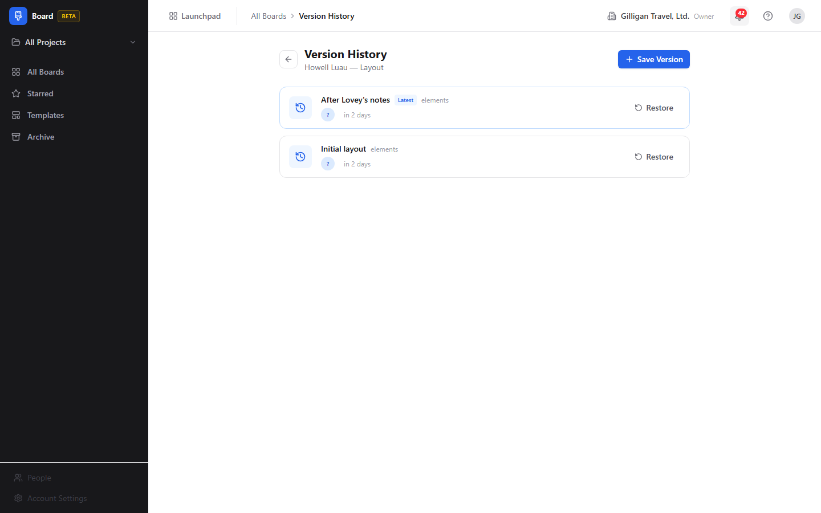
Figure 10.5 Version history

Archive, restore, and delete
Archiving hides a board without destroying it. Deleting is permanent.
To archive a board:
1. On All Boards, open the ... menu on the board's card.
2. Click Archive. The board moves to the Archive view.
To view and restore archived boards:
1. Click Archive in the sidebar. The heading reads "Archive".
2. On an archived board's card, click Restore to bring it back, or Delete permanently to remove it for good.
3. If the archive is empty, you see "Archive is empty".
To delete a board permanently from the list:
1. On a board's ... menu, click Delete.
2. Confirm in the "Delete board?" dialog. This permanently removes the board and its elements, collaborators, stars, versions, and links. This cannot be undone.

Duplicating a board
Duplicate copies a board and all its elements into a new board.
To duplicate:
1. On All Boards, open the ... menu on the board's card.
2. Click Duplicate.
3. A copy is created, named "<original name> (copy)".

Starring a board
Stars are your personal favorites.
To star a board:
1. On a board card in All Boards, click the star overlay on the card to toggle it.
2. Open Starred in the sidebar to see all your starred boards (heading "Starred Boards"). If you have none, the view reads "No starred boards".

Templates browser
Beyond creating boards, the Templates browser is where org templates are surfaced. Each template card shows a thumbnail or icon, a name, a description, a category badge, an element count, and a Use button. Categories shown as tabs are General, Retro, Brainstorm, Planning, Architecture, Strategy, and All. If there are none, the view reads "No templates available". System templates are read-only; your org can create and manage its own (through the API or an agent today; see Working with AI agents).

Fixing a board with an integrity issue
A board can end up with a broken project link (the project is in another org, was deleted, or was auto-detached). When that happens, an amber banner appears at the top of the canvas.
To fix it:
1. Open the affected board (its card shows an amber warning icon in All Boards).
2. Read the message in the amber integrity banner at the top of the canvas.
3. To remove the broken link, click Detach from project (also labeled Leave unattached).
4. To point the board at a valid project, click Reassign to a project, pick a project from the radio list in the "Reassign to a project" dialog, and confirm.

Export
A board's canvas can be exported as JSON, SVG, or PNG.
To export an image from the canvas:
1. Open the board's canvas.
2. In the floating toolbar, open the ... menu.
3. Click Export as PNG or Export as SVG. The menu item briefly reads "Exporting…" while the server renders the board.
4. A real image file downloads, named after the board.
Export is also available to AI agents: an agent renders SVG or PNG with the board_export tool, and the same server endpoint (GET /boards/:id/export/:format) can be called directly through the API.

Collaborators (no in-app management today)
A board's visibility (private, project, organization) controls who can reach it, and a board can also have explicit per-person collaborators with view or edit permission. There is a complete backend for adding, listing, changing, and removing collaborators, but there is no screen in the Board app to manage them today. The toolbar's Share button copies the board's link rather than opening a collaborator manager. Until a sharing screen ships, control who can see a board through its visibility setting, or have an agent or API client manage collaborators directly (the board_add_collaborator, board_list_collaborators, board_update_collaborator, and board_remove_collaborator tools, covered under Working with AI agents).

Real-time presence and audio
When more than one person is on a board, you see each other's live cursors on the canvas and presence indicators in the toolbar. The connection status badge at the top-right shows Live (green), Connecting (amber), or Offline (red), plus an "N editors" chip when other people are present. If your connection drops and reconnects, recent changes are replayed so the canvas catches up.
Audio for a board comes from the platform-wide presence system that the toolbar surfaces through its presence strip, not from a board-api capability. The strip reports the open canvas as a shared surface, and the platform call manager derives a per-board voice room from it, so a teammate can join a voice huddle on the same canvas. Audio conferencing is therefore a platform feature layered on top of Board, not something the Board service hosts itself.

Element limits
A board can hold a large number of elements, with a soft limit at 500 and a hard limit at 2000 live elements. Past the soft limit you get a warning; at the hard limit further additions are rejected. Deleted elements do not count.

Working with AI agents
Agents reach Board through 40 MCP tools backed by board-api. Every tool forwards your bearer token, so an agent acts with your permissions and a locked board stays locked. Most tools accept a board name or UUID; templates, projects, and phases also resolve by name. For the full catalog and arguments, see the Board MCP-tools reference in docs/apps/board/.
TIP
Tools resolve a board by name or UUID, and templates, projects, and phases resolve by name too. So an agent can act on "Q3 Retro" without you ever copying an id, and every tool forwards your bearer token so a locked board stays locked.
What agents commonly do:
- Read and observe a canvas. board_read_elements reads every element with its position, text, and type. board_read_stickies returns only sticky notes; board_read_frames returns frames with their child elements; board_summarize produces a frame-grouped summary. board_search searches element text across boards. board_list, board_get, board_list_recent, board_list_starred, board_stats, and board_org_stats cover discovery and metadata.
- Build a board. board_create makes a board (optionally from a template by name). board_add_sticky drops a sticky in one of six colors at a position; board_add_text adds a text element. board_update patches name, description, background, visibility, and icon.
- Promote to Bam tasks (the marquee cross-app flow). board_promote_to_tasks turns selected brainstorm stickies into Bam tasks in a named project and phase, and records a link from each sticky back to its task. There is no human button for this today; it is an agent-and-API flow. board_list_links shows the resulting links and board_delete_link removes one without touching the task or sticky.
- Manage what humans cannot reach in the UI yet. Collaborators (board_add_collaborator, board_list_collaborators, board_update_collaborator, board_remove_collaborator), templates (board_list_templates, board_create_template, board_update_template, board_delete_template, board_instantiate_template), versions (board_list_versions, board_create_version, board_restore_version), chat (board_read_chat, board_post_chat), stars (board_star_toggle), and integrity (board_check_integrity, board_remediate_integrity) all have tools even where Board has no screen.
- Run lifecycle and export. board_duplicate, board_archive (soft delete), board_restore, and board_delete_permanent (hard, irreversible delete) cover lifecycle. board_export exports SVG or PNG, the same render the canvas export menu downloads.
Promote-to-tasks is the marquee handoff: a sticky from a brainstorm becomes a tracked Bam task, linked back to where it started.
Things for a human reviewer to know:
- Promote-to-tasks creates real Bam tasks. Review the resulting tasks in the target project after an agent runs it.
- board_delete_permanent cascades through elements, collaborators, stars, versions, and links and cannot be undone. Prefer board_archive unless removal is final.
- Two MCP behaviors are known to drift from the backend and may not do what their description implies: board_update cannot toggle the lock state (its PATCH does not accept a locked field, so locking stays a separate action with no MCP tool of its own), and a few tool descriptions and return shapes do not exactly match the live API (for example board_create lists different background and visibility defaults than the server applies, which are dots and project). Prefer the dedicated paths and verify results.
- Right after a fresh board is drawn, the per-element copy that powers search and promote may lag the canvas by a few seconds. If board_search or a promote finds nothing on a brand-new board, give the snapshot a moment.
WARNING
Deleting a board permanently removes its elements, collaborators, stars, versions, and links, and it cannot be undone. Archive instead unless the removal is truly final, since an archived board can always be restored.
Agent actions emit Bolt events you can automate on: board.created, board.updated, board.locked, and board.elements_promoted.

Cross-cutting agentic platform
Board's tools sit on the same platform surface every app shares, so agent work is identifiable, reviewable, and governed:
- Identity and heartbeat. Agent and service accounts are distinct from human users, and their actions are tagged as such in the activity log. Long-running agents report liveness with agent_heartbeat.
- Approvals. An agent can route a board action it should not take unilaterally (for example a permanent delete or a large promote-to-tasks run) into an approval queue with proposal_create; a human reviews and resolves it with proposal_list and proposal_decide.
- Unified activity. Board activity is queryable alongside every other app through the unified activity view and activity_query / activity_by_actor.
- Visibility preflight. Before an agent posts a board's contents into another shared surface, it calls can_access for each cited entity and drops anything the asking user is not allowed to see.
- Policies and webhooks. Per-agent kill switches and tool allowlists (a board.* glob covers Board's tools) gate every service-account call, and subscribed Bolt events can be pushed to an agent runner over a signed outbound webhook.

User Stories

Story: Create your first board from a template
Who: A team member new to Board.
Goal: Get a working whiteboard started without setting up a layout by hand.
Before you start: Be signed in to BigBlueBam.
Steps
1. Go to /board/. You land on All Boards.
2. Click New Board at the top-right. The Templates browser opens.
3. Use the category tabs (General, Retro, Brainstorm, Planning, Architecture, Strategy, All) to find a fitting layout.
4. On the template you want, click Use.
5. The new board opens on the canvas.
Result: A new board exists, pre-filled from the template, and you are looking at its canvas. It appears in All Boards.
Related: To start empty instead, see "Create a blank board". An agent can do the same with board_create (template by name) or board_instantiate_template.

Story: Create a blank board
Who: Anyone who wants an empty canvas.
Goal: Start a whiteboard from scratch with a name and icon.
Before you start: Be signed in.
Steps
1. Go to /board/ and click Templates in the sidebar (or New Board from the list).
2. Click Blank board at the top-right of the Templates browser.
3. On the "Create New Board" page, pick an emoji with the Icon picker.
4. Type a name in Board name (placeholder "Untitled Board").
5. Click Create Board.
Result: An empty board opens on the canvas, ready to draw on.
Related: board_create does this for an agent.

Story: Brainstorm on the canvas
Who: A facilitator or contributor running an ideation session.
Goal: Capture ideas as sticky notes, text, shapes, and arrows on one canvas.
Before you start: Have a board open and edit access to it.
Steps
1. Open the board's canvas.
2. Use Excalidraw's native toolbar to add sticky notes, text, shapes, arrows, freehand drawings, and frames.
3. Drag elements to arrange them; group related ideas inside a frame.
4. Keep working. The canvas auto-saves as you go and again when you close the tab.
Result: Your ideas are captured on the board and saved automatically.
Related: An agent can seed a board with board_add_sticky and board_add_text, then group thinking with frames for board_summarize.

Story: Collaborate live with teammates
Who: Two or more people working a board at the same time.
Goal: Edit together and see each other's changes and cursors.
Before you start: Each person needs access to the same board.
Steps
1. Each person opens the same board's canvas.
2. Watch the connection status badge at the top-right for Live, and the "N editors" chip for who is present.
3. Add and move elements. Changes from others appear on your canvas in real time, and you see their cursors.
4. If your connection drops, wait for it to reconnect; recent changes are replayed automatically.
Result: Everyone is editing one shared canvas and stays in sync.
Related: To bring people in, copy the board link with the Share button (see "Share a board link"). To talk while you work, use the presence strip in the toolbar to start a voice huddle on the canvas. To type instead, see "Chat while you whiteboard".

Story: Share a board link
Who: Anyone who wants a teammate on a board.
Goal: Hand someone a direct link to the board.
Before you start: Have the board open. The recipient must already be allowed to see the board (through its visibility or as a collaborator).
Steps
1. Open the board's canvas.
2. Click the Share button in the floating toolbar.
3. The board's link is copied to your clipboard and the button shows "Link copied".
4. Paste the link into chat, email, or wherever your teammate will find it.
Result: Your teammate has a direct link that opens the board's canvas, subject to the board's visibility and collaborator rules.
Related: There is no in-app collaborator manager yet; widen who can open the link through the board's visibility setting, or have an agent add explicit collaborators with board_add_collaborator.

Story: Chat while you whiteboard
Who: Collaborators on a board.
Goal: Discuss the board without leaving it.
Before you start: Have the board open and edit access.
Steps
1. Open the board's canvas.
2. Click Toggle chat in the floating toolbar to open the chat panel.
3. Type in Type a message... and send.
4. Read the thread in the panel; your messages are right-aligned.
Result: The team has a running discussion attached to the board.
Related: Chat refreshes by polling, so messages from others appear on the next refresh rather than instantly. An agent can read or post with board_read_chat and board_post_chat.

Story: Star and find your boards
Who: A regular Board user with many boards.
Goal: Keep important boards one click away and filter the list.
Before you start: Have at least one board.
Steps
1. On All Boards, click the star overlay on a board card to favorite it.
2. Click Starred in the sidebar to see only starred boards.
3. Back on All Boards, use the project scope selector to filter by project.
4. Use the Search boards... box to find a board by name or description.
Result: Your favorites are grouped in Starred, and you can filter and search the full list.
Related: An agent can list boards with board_list, list starred with board_list_starred, toggle a star with board_star_toggle, and search element text with board_search.

Story: Snapshot and restore a board
Who: Anyone about to make a big change.
Goal: Save a restore point and roll back if needed.
Before you start: Have edit access to the board.
Steps
1. Open the board and click the Version history button in the floating toolbar.
2. On the "Version History" page, click Save Version.
3. Type a Version name and confirm.
4. Later, to roll back, return to "Version History", click Restore on the version you want, and confirm at "Restore this version?".
Result: A named snapshot is saved, and you can restore the canvas to it at any time.
Related: The dialog's Description field and the list's element-count and creator-name fields are not stored or returned by the backend today and render blank. An agent can snapshot and restore with board_create_version, board_list_versions, and board_restore_version.

Story: Promote brainstorm stickies into Bam tasks
Who: A facilitator (with an agent's help) turning ideas into tracked work.
Goal: Convert selected sticky notes into Bam tasks in a project and phase.
Before you start: Stickies exist on the board, and you know the target Bam project (and optionally phase). There is no human button for this; it runs through an agent or the API.
Steps
1. Identify the sticky notes you want to turn into tasks.
2. Ask an agent to promote them, naming the target project and phase. The agent uses board_promote_to_tasks.
3. The agent creates one Bam task per sticky and records a link from each sticky to its task.
4. Open the target project in Bam to review the new tasks.
Result: Each promoted sticky has a matching Bam task, linked back to the source element.
Related: This emits a board.elements_promoted Bolt event you can automate on. An agent can review the links with board_list_links. See the Bam help doc for task management.

Story: Lock a finished board
Who: The board creator or an org admin or owner.
Goal: Freeze a board so others cannot change it.
Before you start: Be the creator or an org admin or owner.
Steps
1. Open the board's canvas.
2. Open the ... menu in the floating toolbar.
3. Click Lock board.
4. To allow edits again, repeat and click Unlock board.
Result: The board is read-only for everyone except its creator and org admins and owners, and shows a lock icon in the toolbar and on its card.
Related: An agent cannot toggle the lock through board_update; locking is a separate action with no MCP tool of its own today.

Story: Fix a board flagged with an integrity issue
Who: Anyone who opens a board with a broken project link.
Goal: Clear the integrity warning by detaching or reassigning the project.
Before you start: Have edit access to the board.
Steps
1. Open the board; its card in All Boards shows an amber warning icon.
2. Read the amber integrity banner at the top of the canvas.
3. To drop the broken link, click Detach from project (or Leave unattached).
4. To repoint it, click Reassign to a project, choose a project in the "Reassign to a project" dialog, and confirm.
Result: The integrity warning clears and the board is either unattached or attached to a valid project.
Related: An agent can do the same with board_check_integrity and board_remediate_integrity (action detach or reassign).

Story: Archive, restore, or delete a board
Who: A board owner cleaning up.
Goal: Remove a board from the active list, recover it, or delete it for good.
Before you start: Have edit access to the board.
Steps
1. On All Boards, open the board card's ... menu and click Archive.
2. To recover it, click Archive in the sidebar, find the board, and click Restore.
3. To remove it permanently, click Delete permanently on the archived card, or use Delete on the ... menu in the list and confirm "Delete board?".
Result: The board is archived (recoverable) or permanently deleted, depending on your choice.
Related: Use Duplicate on the ... menu first if you want a copy before removing the original. An agent uses board_archive, board_restore, and board_delete_permanent.

Story: Export a board image
Who: Anyone who needs a picture of the board for a doc or deck.
Goal: Get an SVG or PNG of the board.
Before you start: Have access to the board.
Steps
1. Open the board's canvas.
2. Open the ... menu in the floating toolbar.
3. Click Export as PNG or Export as SVG. The item shows "Exporting…" while the server renders the board.
4. The image file downloads, named after the board.
Result: You have an SVG or PNG rendering of the board saved to your downloads.
Related: An agent can export the same render with board_export, and the export endpoint is also reachable directly through the board-api.

Story: Have an agent set up and seed a board
Who: Someone who wants a board built and pre-populated without doing it by hand.
Goal: Get a named board, scoped to a project, with starter stickies on it.
Before you start: Be signed in. Know the project name (if you want it scoped) and the rough content you want seeded.
Steps
1. Ask an agent to create the board, naming it and the project. The agent uses board_create (optionally from a template by name).
2. Ask the agent to drop your starter ideas as stickies. It uses board_add_sticky once per note, choosing colors.
3. Open /board/ and the new board appears in All Boards; open it to see the seeded canvas.
Result: A ready-to-use board exists with your starting content, and you can keep editing it live.
Related: The agent can also group the stickies into frames so a later board_summarize reads cleanly, and can promote them to Bam tasks with board_promote_to_tasks.

Related
- Bam - the core project and task app. Board scopes boards to Bam projects, and promote-to-tasks creates Bam tasks in a project and phase. See docs/apps/api/ or the Bam help doc.
- Bolt - workflow automation. Board emits board.created, board.updated, board.locked, and board.elements_promoted events you can build rules on.
- Platform presence and audio - provides the toolbar presence strip and any voice huddle on a board. Audio is a platform feature, not part of the Board service.
- Board MCP-tools reference - the full list and arguments for the 40 Board MCP tools, in docs/apps/board/.
- Board guide - the product guide in docs/apps/board/, for narrative and background.

Check yourself
Every answer is findable in this chapter. Check your work against the Answer Key appendix at the back of the book.
1. What is a board's default visibility setting?
a) private
b) project
c) organization
d) public
2. What is the default background pattern for a new board's canvas?
a) grid
b) lines
c) dots
d) plain
3. What are the soft and hard element limits on a single board, and what happens at each?
4. What is the default color of a sticky note?
a) yellow
b) blue
c) green
d) white
5. Board has no login of its own. How does it know who you are and what you can do?
6. When a board is locked, who can still edit it?
a) Anyone with the link
b) Only the board creator
c) The board creator or an org admin or owner
d) No one until it is unlocked
7. Which native toolbar do you draw with on the canvas, and which controls does Board overlay on top of it?
8. What does the Share button in the floating toolbar actually do?
a) Opens a collaborator manager
b) Copies a shareable link to the board to your clipboard
c) Emails the board to a teammate
d) Publishes the board publicly
9. Why is there no in-app way to manage collaborators today, and what controls who can reach a board instead?
10. Which three formats can a board's canvas be exported as?
a) PDF, SVG, and PNG
b) JSON, SVG, and PNG
c) JSON, PDF, and PNG
d) DOCX, SVG, and PNG
11. On the Save Version dialog, which fields render blank, and why?
12. What is a frame used for on a board?
a) Locking a region of the canvas
b) A labeled region that groups the elements inside it
c) Setting the background pattern
d) Marking a board as a favorite
13. What does the connection status badge at the top-right report, and what are its three states?

CHAPTER 11

Bolt
When this happens, do that.

Bolt is the suite's wiring closet. Other apps emit events as people work, and Bolt watches for them and reacts, running the actions you defined without anyone clicking a button. You build a rule as WHEN this happens, IF these conditions hold, THEN run these steps, and every firing is recorded as an execution you can open and read line by line. By the end of this chapter you will be able to build a rule from a template or by hand, watch it run, and see where an AI agent can author and audit the same automations you do.
At a glance
- The suite's event hub: every app reports its activity to one place
- Trigger-condition-action rules with 13 condition operators and AND or OR logic
- Templates: 16 pre-built blueprints you instantiate and customize
- Schedule triggers that fire on a cron clock, not just on app events
- Full execution log with per-step detail, retries, and single-event tracing
In this chapter
Overview . Key concepts . Where to find it . Feature reference . Automations home . Enabling and disabling an automation . Creating and editing an automation . Simple mode . Visual mode . Settings sidebar
Bolt watches for events across the BigBlueBam apps and reacts to them automatically. When something happens in one app (a task is created, a deal goes stale, a ticket breaches its SLA), Bolt runs a rule you defined and carries out one or more actions. Reach for it when you want work to happen without a person clicking a button.

Overview
Bolt is the suite's event-driven automation engine, and its event hub. You build an automation (also called a rule) out of three parts: a trigger (the event to watch for), optional conditions (extra tests the event must pass), and an ordered list of actions (what to do when it fires). The shape is "WHEN this happens, IF these conditions hold, THEN run these steps."
Other BigBlueBam apps publish events as people work: Bam emits task and sprint events, Bond emits deal events, Helpdesk emits ticket events, and so on. Every one of those apps reports its events to Bolt through a shared helper, so Bolt is the single place where the suite's activity converges. Bolt matches each event against your enabled automations and runs the matching rules. Each action is an MCP tool call (for example "create a task in Bam" or "send a webhook"), so Bolt can act inside any app in the suite without you wiring up integrations by hand.
Bam tasks, Bond deals, Helpdesk tickets: Bolt is the one place the whole suite's activity converges.
Every run is recorded as an execution with per-action steps, so you can see exactly what fired, what passed, what failed, and why. You can browse runs for a single automation or across the whole organization in the Execution Log, and you can trace one ingested event through every rule it touched.
Every run is recorded as an execution with per-action steps, so nothing fires in the dark.
Bolt is currently marked BETA (a yellow "beta" pill sits next to the brand in the sidebar). This document describes what the Bolt web app actually does today. Where a capability exists only through the API or an MCP tool and is not wired into the in-app UI, that is called out so you do not go looking for a button that is not there.

Key concepts
- Automation (rule) - the top-level object: a trigger, optional conditions, an ordered list of actions, and limit settings. The UI calls these "Automations".
- Trigger - what starts an automation. It has a Trigger Source (the app that emits the event, such as Bam or Bond) and an Event Type (the bare event name, such as task.created). A trigger can also carry an optional filter.
- Event source - the emitting app, stored alongside the bare event name. Bolt uses bare-name-plus-explicit-source naming, so the event is deal.rotting with bond as a separate source field, not bond.deal.rotting. The trigger dropdowns offer 14 sources: Bam, Banter, Beacon, Brief, Helpdesk, Schedule, Bond, Blast, Board, Bench, Bearing, Bill, Book, and Blank.
- Trigger filter - an optional set of equality rules (key matches value) checked against the raw event payload before the automation fires.
- Condition - an extra test on the event: a field, an operator, and a value, grouped with AND or OR logic. Conditions gate the whole automation; if they are not met, the run is skipped. There are 13 operators (equals, not_equals, contains, not_contains, starts_with, ends_with, greater_than, less_than, is_empty, is_not_empty, in, not_in, matches_regex). Fields that read the event body must be prefixed event. (for example event.task.priority).
- Action - one step Bolt runs when the automation fires. Each action calls an allowlisted MCP tool with parameters you supply. Actions run in order; this is a linear list, not a branching flow (see the note under Actions).
- On Error - per-action behavior when a step fails: Stop (halt the run), Continue (run the rest anyway), or Retry (retry up to the Retry Count).
- Templating - action parameters can interpolate values from the event with {{ event.* }}, the actor with {{ actor.id }} / {{ actor.type }}, automation metadata with {{ automation.* }}, the current time with {{ now }}, and a prior step's result with {{ step[N].result.* }}. There is no {{ actor.name }} and no top-level {{ org.* }}.
- Execution - one run of one automation against one event. Its status is one of: Running, Success, Partial (some steps failed but all ran), Failed (halted early), or Skipped (a guard or condition prevented it). A skipped run records a reason such as cooldown active, rate limited, or conditions not met.
- Execution step - one action attempt inside an execution, with its own status: success, failed, or skipped.
- Template - a pre-built automation blueprint you can instantiate and customize. Bolt ships 16 templates.
- Schedule trigger - the Schedule source fires automations on a cron schedule (cron.fired) rather than off another app's event.
- Limits - per-automation guards: Max Executions / Hour (1 to 1000 in the UI, default 60) and Cooldown (seconds) (0 to 3600, default 0). There is also an internal max chain depth that prevents automations from triggering each other in an endless loop.

Where to find it
Bolt lives at /bolt/. Open it from the suite app switcher, or go straight to the URL.
Prerequisites:
- You must be signed in to BigBlueBam. Bolt has no login of its own. If you are not signed in, it shows "Please log in to BigBlueBam first to access Bolt." with a "Go to BigBlueBam Login" link that sends you to /b3/.
- Bolt is org-scoped. The automations, templates, and executions you see belong to your active organization.
- For an automation to actually fire, the originating app must publish its events, and the background worker and MCP server must be running. Building and saving rules works on its own, but live execution depends on those services.
The sidebar nav has three items: Automations (the home list), Executions (the org-wide Execution Log), and Templates (the template gallery). A project scope selector sits in the chrome and defaults to All Projects; it scopes the automation list and the stat cards. Press the ? key anywhere in Bolt to open the in-app Help viewer.

Feature reference

Automations home
The home page (/) lists your automations and summarizes them. The heading reads "Automations" with the subtitle "Create trigger-condition-action workflows to automate your work."
To browse and filter automations:
1. Open Automations from the sidebar (the lightning / Zap icon).
2. Read the three stat cards at the top: Total Automations, Enabled, and Disabled.
3. Use the "Search automations..." box to filter by name.
4. Click a source chip ("All", then Bam, Banter, Beacon, Brief, Helpdesk, Schedule, Bond, Blast, Board, Bench, Bearing, Bill, Book, Blank) to show only automations on that trigger source.
5. Use the Enabled and Disabled toggles to filter by state.
6. Each automation card shows its name, a source badge, the trigger event, the description, "Last run", and an "Actions" count. If you have none yet, the list reads "No automations found".
The home list, stats, and filters are shown in the screenshot below.
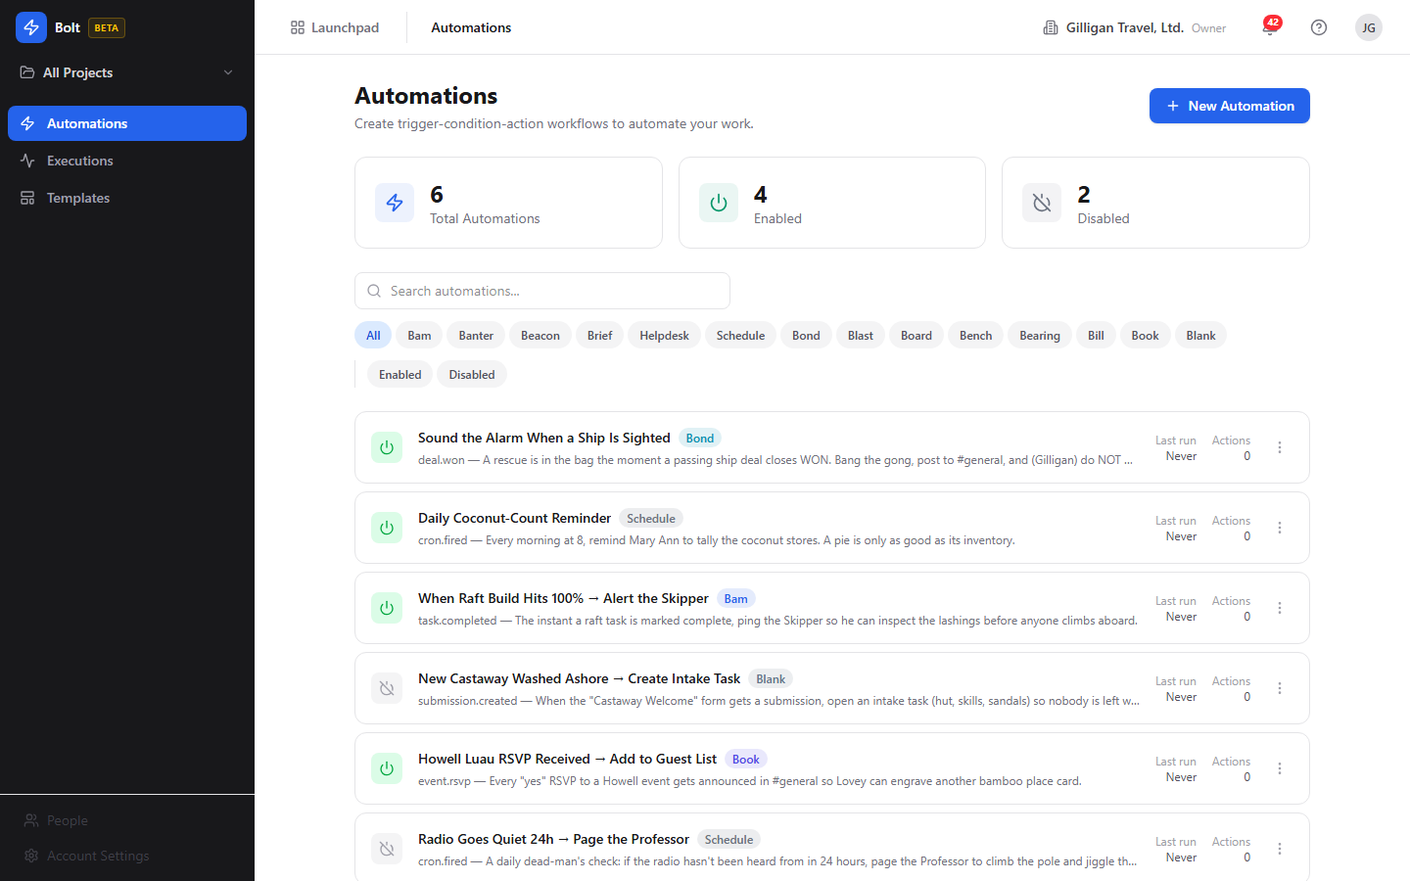
Figure 11.1 Automations home - stat cards, source filter chips, and the automation list

Enabling and disabling an automation
Each card carries a power toggle so you can turn a rule on or off without opening it. Disabled automations never fire.
To toggle an automation from the home list:
1. On the automation's card, click the power toggle (its tooltip reads "Enable" when off and "Disable" when on).
2. The card updates in place and the Enabled / Disabled stat cards adjust.
You can also set the state from inside the editor with the Enabled toggle in the Settings sidebar, or save directly to enabled with Save & Enable (see the editor below).

Creating and editing an automation
The editor (/new for a new rule, /automations/:id for an existing one) is where you define the trigger, conditions, actions, and limits. It has two modes, Simple and Visual, switched with the toggle near the top. There is no separate automation-detail page; opening a card from the home list takes you into the editor, which doubles as the detail view.
To start a new automation:
1. On the Automations home page, click New Automation (the Plus button). You land in the editor in Simple mode.
2. Type a name into the "Automation name..." field at the top, and optionally a description in "Add a description...".
The editor with its WHEN / IF / THEN sections and the Settings sidebar is shown below.
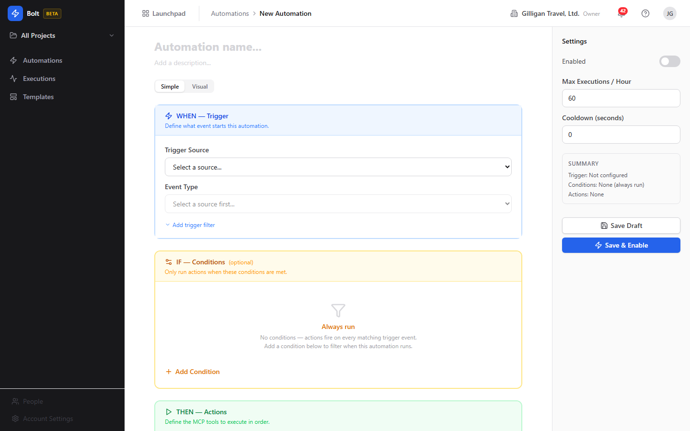
Figure 11.2 Automation editor - the WHEN, IF, and THEN sections and the Settings sidebar
Opening an existing automation from a home-list card lands you in the same editor, pre-filled with that rule's trigger, conditions, and actions.
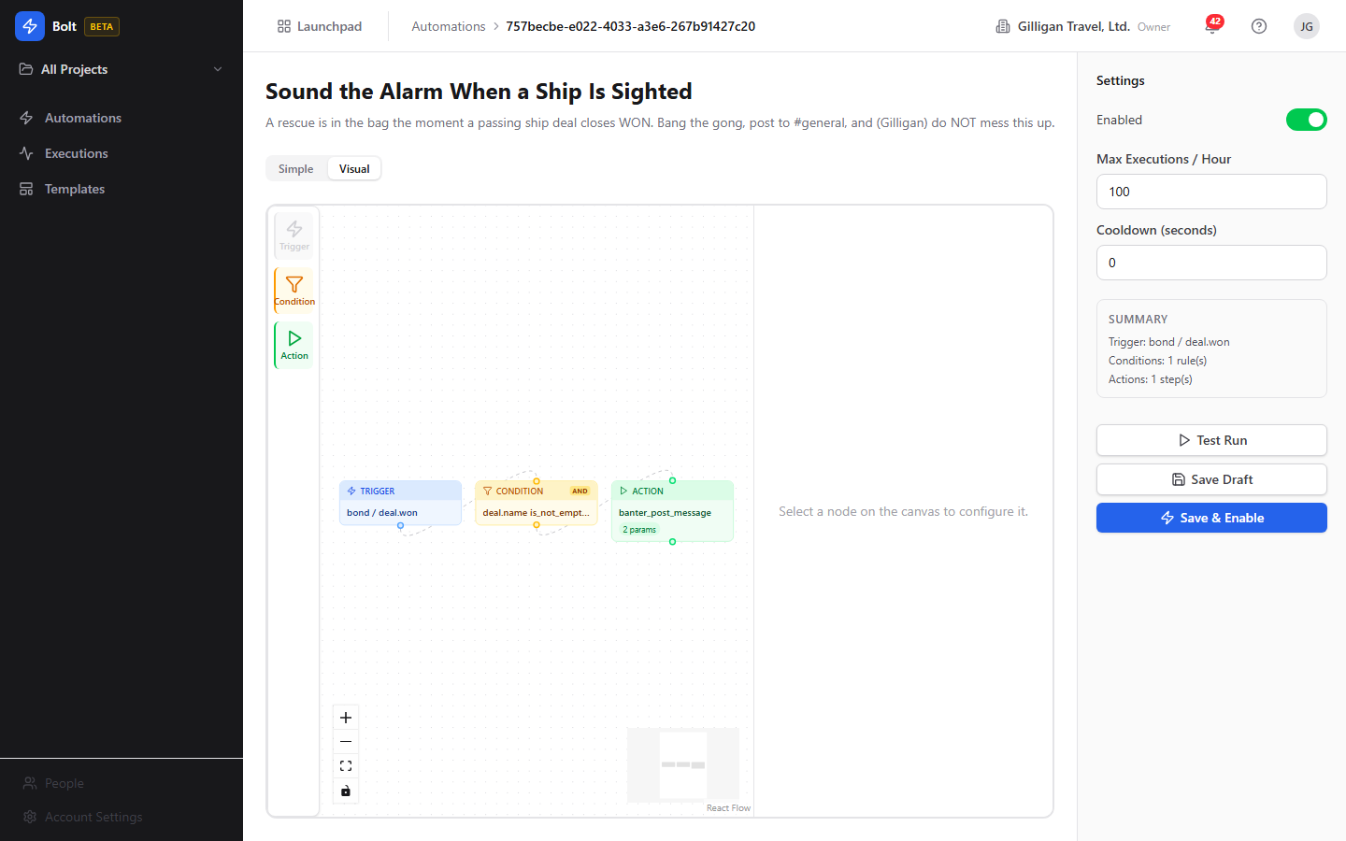
Figure 11.3 Automation detail - an existing rule opened in the editor from a home-list card

Simple mode
Simple mode lays the rule out as three stacked sections: WHEN - Trigger (blue), IF - Conditions (amber, optional), and THEN - Actions (green).
To set the trigger:
1. In the WHEN - Trigger section, choose a Trigger Source from the dropdown.
2. Choose an Event Type. Each option shows the event name and a short description.
3. If you picked the Schedule source, a Schedule editor appears. Use its Presets, Custom, or Advanced tabs (11 presets, a day-of-week picker, and a timezone) to build the cron schedule; the editor shows a plain-English description of when it will run.
4. To narrow which events match, click "Add trigger filter" and add equality rules. The link then reads "Filter (N rules)".
To add conditions (optional):
1. In the IF - Conditions section, click Add Condition. With no conditions the section reads "Always run".
2. For each row, set the logic toggle (the first reads "Where", later rows toggle AND / OR), pick a field, choose an operator (the operator list is filtered to the field's type and uses friendly labels), and enter a value.
3. Remove a condition with its remove control. Conditions gate the whole automation: if they fail, the run is skipped.
To add actions:
1. In the THEN - Actions section, click Add Action. You must add at least one ("Add at least one action to define what happens.").
2. For each action (numbered #N), pick a tool from the action select. Tools are grouped by source and each option shows the tool's description.
3. Fill in the Parameters. Required parameters are marked with "*". Some are enum or boolean selects; text parameters accept {{ }} templates. Click "Add optional parameter (N available)" to expose optional ones.
4. To control failure handling, click "Show advanced" and set On Error (Stop, Continue, or Retry) and a Retry Count.
5. Actions run top to bottom in the order listed.
Note on flow: Bolt runs actions as a single linear ordered list. Conditions decide whether the whole automation runs; they do not branch to different actions. Despite any "branching" language in older marketing, there are no per-edge branches. Variable interpolation between steps is real: a later action can reference an earlier one with {{ step[N].result.* }}.

Visual mode
Visual mode shows the same automation as a node graph on a canvas. Switching from Simple to Visual builds a graph from your current form state (or loads the saved graph if one exists).
To use Visual mode:
1. Click Visual on the mode toggle.
2. Add nodes from the palette: Trigger, Condition, and Action. Only one trigger is allowed.
3. Select a node to configure it in the Node inspector on the side. With nothing selected it reads "Select a node on the canvas to configure it."
4. Press ? on the canvas to see the shortcuts: Delete or Backspace to remove, Escape to deselect, Ctrl+A to select all, scroll to zoom, and drag to pan.
5. Switch back to Simple at any time. If you have unsaved graph changes, Bolt warns "Unsaved graph changes may be lost. Switch to Simple mode?" before discarding them.
Note: Bolt compiles the graph down to the same linear ordered action list as Simple mode when it saves, so non-linear arrangements are flattened.

Settings sidebar
The right sidebar holds the rule's limits and the save controls.
1. Enabled - toggle whether the automation is active.
2. Max Executions / Hour - cap how many times this rule may run per hour (default 60; 1 to 1000).
3. Cooldown (seconds) - minimum gap between runs (default 0; 0 to 3600).
4. The Summary card restates the configured trigger, condition count, and action count.
5. Save Draft saves without enabling. Save & Enable saves and turns the rule on.
If the form has problems, a banner reads "Please fix the following errors before saving:" and lists each issue; fix them and save again.

Test Run
The editor shows a Test Run button in the Settings sidebar for an already-saved automation (it does not appear while creating a new one). It evaluates the automation's conditions against a sample event without running any actions.
To use it:
1. Open a saved automation in the editor.
2. Click Test Run in the Settings sidebar. Bolt sends a simulated event, seeded from the trigger filter when you have one, to the test endpoint.
3. Read the result box that appears under the button. A green box means the conditions passed (the actions would run on a real event); an amber box means they did not. The box shows a human-readable summary message.
The test only evaluates conditions; it never executes actions. To confirm an automation's actions actually run, enable it and inspect the resulting runs in the Execution Log. Agents can run the same conditions-only dry run with the bolt_test MCP tool, passing an explicit simulated event (see Working with AI agents).
NOTE
Test Run is a conditions-only dry check: a green box means the actions would run on a real event, an amber box means they would not. To confirm the actions themselves fire, enable the rule and read the resulting runs in the Execution Log.

Duplicating an automation
Duplicating clones a rule so you can adapt it without touching the original.
To duplicate from the home list:
1. On the automation's card, open the more-menu (the three-dot menu).
2. Click Duplicate. Bolt creates a copy named "<name> (copy)" that starts disabled, so it cannot fire until you review and enable it.
TIP
Duplicate a working rule before you experiment on it. The copy starts disabled and carries no execution history, so you can adapt it freely and only flip the toggle once it looks right.

Deleting an automation
To delete a rule:
1. On its card, open the more-menu and click Delete.
2. Confirm in the browser prompt. Deleting removes the automation and its conditions, actions, executions, and version history.
WARNING
Delete is irreversible and takes everything with it: the rule plus all of its conditions, actions, executions, and version history. Disable a rule instead when you only need to pause it.

Per-automation executions
Each automation has its own run history.
To view one automation's runs:
1. On its card, open the more-menu and click View Executions (or open it from the editor).
2. The page heading reads "<name> - Executions" with a "Back to <name>" link and the subtitle "Execution history for this automation."
3. Filter with the status chips: All, Success, Failed, Partial, Running, Skipped.
4. The table lists Status, Duration, Conditions Met, Error, and Started. Click a row to open the execution detail.

Execution Log (organization-wide)
The Execution Log (/executions) shows every automation run across your organization.
To monitor all runs:
1. Open Executions from the sidebar (the Activity icon). The heading reads "Execution Log" with the subtitle "History of all automation runs across your organization."
2. Filter with the status chips. When more than one automation has run, an "All automations" dropdown lets you narrow to a single rule.
3. The table lists Automation, Status, Duration, Conditions Met, and Started. Click a row to open the execution detail.
The org-wide log is shown below.
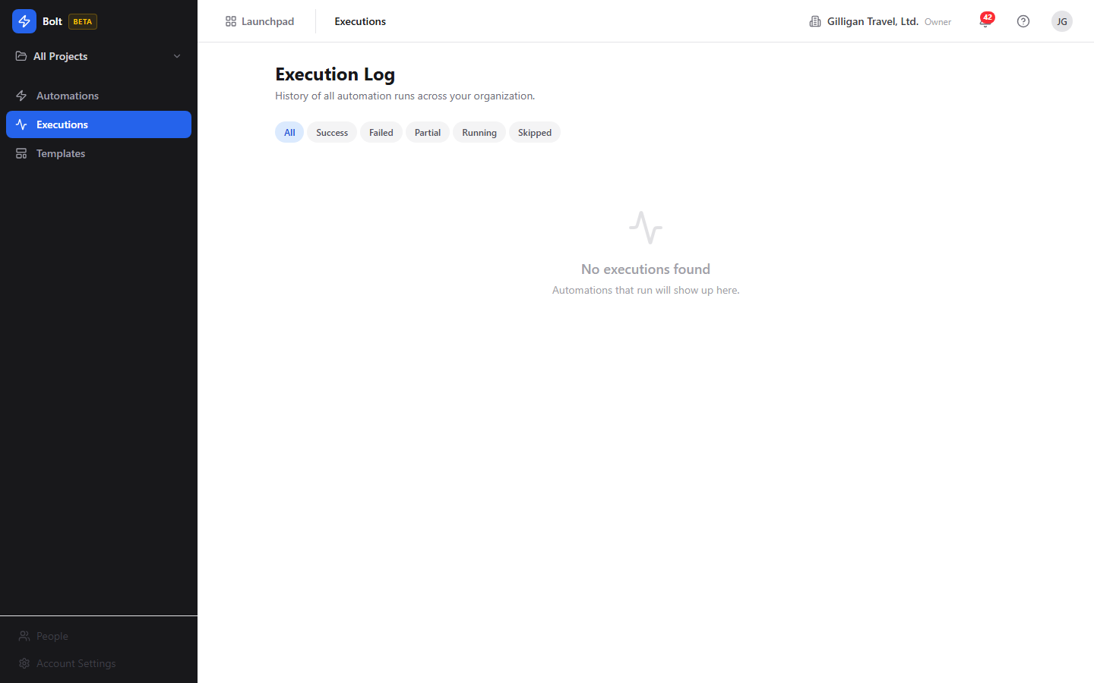
Figure 11.4 Execution log - the organization-wide table of automation runs

Execution detail
The execution detail page (/executions/:id) shows everything about a single run: what triggered it, whether its conditions passed, and what each step did.
To inspect a run:
1. Click any row in the Execution Log or a per-automation execution list.
2. The page heading is the automation's name, with a "Back to Executions" link and a status badge.
3. The summary cards show Duration, Conditions Met, Steps, and Completed.
4. If the run failed, an Error block explains why.
5. The "Trigger Event" panel shows the raw event JSON, and "Condition Evaluation" shows how each condition was scored.
6. The "Execution Steps" timeline lists each action attempt in order with its result.

Retrying a failed run
A failed or partial run can be re-queued from its detail page.
To retry:
1. Open the run's execution detail.
2. Click Retry (it appears only for runs whose status is Failed or Partial).
3. Bolt queues a fresh run. Retries count against the automation's hourly limit, so if you are over the cap the retry is rejected as rate limited.

Templates
Templates are pre-built automations you can instantiate and then customize. Bolt ships 16 of them.
To start from a template:
1. Open Templates from the sidebar (the LayoutTemplate icon). The heading reads "Templates" with the subtitle "Start with a pre-built automation template and customize it."
2. Each card shows a source badge, the template name, a description, and the trigger event.
3. Click Use Template. Bolt instantiates the template and drops you into the editor to adjust and save it.
The template gallery is shown below.
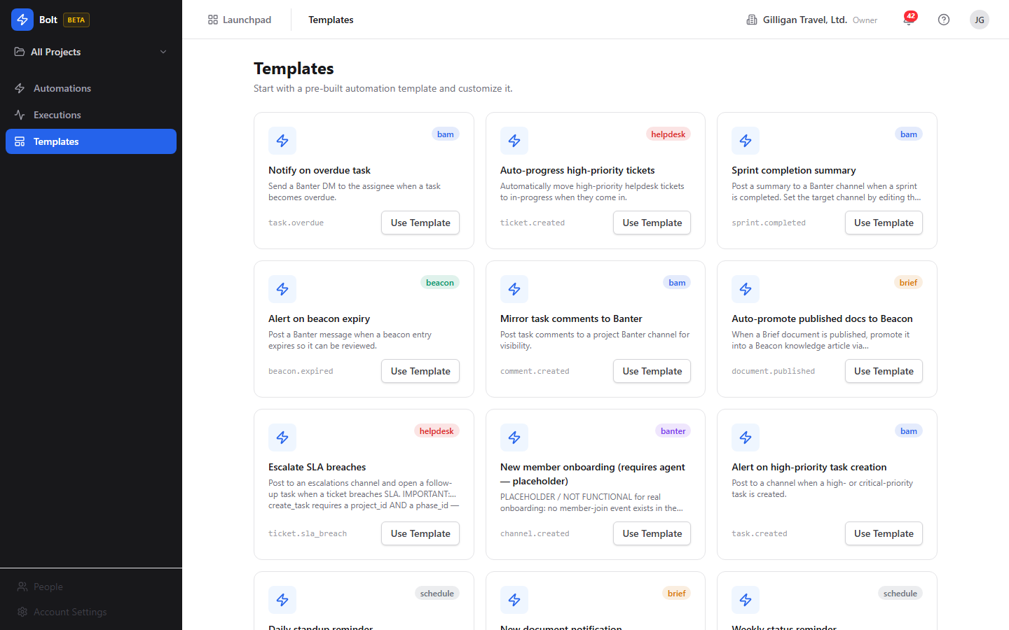
Figure 11.5 Template gallery - the grid of pre-built templates, each with a source badge and Use Template button
Note that some templates are starting points rather than turnkey rules. A few are labeled "(requires agent)" and wire a working notify step but leave the cross-app part (for example creating an invoice from a closed deal) for an AI agent to complete. Others need a value only you can supply (a cron schedule, a project and phase for a created task). Read each template's actions after instantiating and fill in anything marked required before you enable it.
TRY IT
Open Templates, click Use Template on "Alert on high-priority task creation", fill in any required parameter, then click Save & Enable and watch it appear on the Automations home as Enabled.

Working with AI agents
Bolt is built so an AI agent can author and operate automations the same way a person does, and so agents can serve as the execution substrate for the rules themselves. Bolt is also the suite's event hub: every app reports its activity here, which makes Bolt the natural place for an agent to observe what is happening across BigBlueBam.
Bolt exposes 26 MCP tools: 24 in the core Bolt tool module plus 2 observability tools.
- Authoring and operating: bolt_create, bolt_update, bolt_patch (metadata-only: name, description, enabled), bolt_get, bolt_get_automation_by_name, bolt_list, bolt_stats, bolt_enable, bolt_disable, bolt_duplicate, and bolt_delete. Mutating tools accept a name as well as a UUID and resolve it through bolt_get_automation_by_name, returning a clean "Automation not found" on a miss. This lets an agent run meta-automation tasks like "disable the Nightly Deploys rule" by name.
- Templates: bolt_list_templates and bolt_instantiate_template (with optional name, description, project, and cron overrides) let an agent stand up a rule from a built-in blueprint.
- Versions: bolt_list_versions and bolt_restore_version read and roll back the snapshots that every save records. This history has no in-app UI; agents and the REST API are the only way to use it (see below).
- Inspecting and testing: bolt_executions (runs for an automation), bolt_list_executions (org-wide runs), bolt_execution_detail (one run with its steps), bolt_retry_execution (re-queue a failed or partial run), and bolt_test (evaluate an automation's conditions against a simulated event). As in the UI, bolt_test only evaluates conditions; it does not execute actions. It returns passed (whether the actions would run), a per-condition log, and a human-readable message. The tool requires an explicit simulated event payload, so an agent can dry-check a rule against any payload it wants to imagine.
- Catalogs: bolt_events (the trigger event catalog, optionally filtered by source) and bolt_actions (the action allowlist with parameter schemas). An agent discovers valid triggers and actions here before building a rule.
- AI drafting: bolt_generate turns a natural-language prompt into a draft automation (it does not save; pass the result to bolt_create), and bolt_explain renders an automation definition in plain English. Both require an LLM provider configured in Bam Settings and return AI_NOT_CONFIGURED otherwise. This drafting has no in-app UI; it is agent and API only.
- Observability: bolt_event_trace returns the full evaluation trail for one ingested event id (every automation it matched, each condition outcome, and each action outcome), and bolt_recent_events lists recent ingested events that matched at least one automation, filtered by source, event, since, and limit.
Agents are also the execution substrate. Every action Bolt runs is an MCP tool call the background worker makes on the automation's behalf, so the same authority that lets an agent build a rule also powers the rule's steps.
Two capabilities exist in the backend and through MCP tools but have no in-app UI today, so do not look for them in the web app or present them to users as in-app buttons:
- AI drafting - the API and the bolt_generate / bolt_explain tools can draft an automation from a prompt and explain one in plain English, but no screen in the Bolt web app calls them.
- Versioning - every save snapshots a restorable version, and the API and the bolt_list_versions / bolt_restore_version tools can list and restore them, but the web app does not surface version history or a restore button.
Agent runs ride the suite's shared agentic platform, which sits alongside the Bolt-specific tools:
- Identity and heartbeat. Agents are first-class actors (users.kind of agent or service), so their writes are attributed in the activity log, and they report liveness with agent_heartbeat. Service-account tool calls fail closed against per-agent kill switches and glob allowlists (bolt.*), so an operator can revoke an agent's Bolt access centrally without editing any rule.
- Approvals. When a flow needs a human in the loop, an agent files a proposal with proposal_create, which a reviewer resolves with proposal_list and proposal_decide. Those decisions themselves emit proposal.created and proposal.decided platform events, which Bolt can trigger on.
- Visibility. Before an agent surfaces a cited entity into a shared place, it calls can_access to confirm the asker is allowed to see it, and drops anything that is not. Bolt automations that post cross-app results should respect the same gate.
- Cross-app read plane. search_everything and activity_query let an agent pull context from across the suite, including the unified activity view, before deciding how to build or change a Bolt rule.
- Outbound webhooks. Bolt fans subscribed events to agent runners over HMAC-signed webhooks with retry-and-backoff and auto-disable on repeated failure, and it emits a platform catalog.drift_detected event when an unknown event name is ingested, so an agent can notice and react to drift.
For the full tool catalog and parameter schemas, see the MCP-tools reference and guide in docs/apps/bolt/.

User Stories

Story: Create your first automation from a template
Who: A new Bolt user who wants automation running quickly without building from scratch.
Goal: Stand up a working rule and turn it on.
Before you start: Be signed in to BigBlueBam with your target organization active. Pick a template whose action does not need values you cannot supply yet.
Steps
1. Open Bolt at /bolt/ and click Templates in the sidebar.
2. Browse the gallery. Each card shows the source, name, description, and trigger event. Click Use Template on one you want, for example "Alert on high-priority task creation".
3. You land in the editor with the trigger, conditions, and actions pre-filled. Review each action's Parameters and fill in anything marked required (some templates need a project and phase, a cron schedule, or a notification target).
4. Open the Settings sidebar and check Max Executions / Hour and Cooldown (seconds); adjust if needed.
5. Click Save & Enable.
Result: The rule appears on the Automations home page as Enabled and will run the next time a matching event is published.
Related: Build a rule by hand with "Create an automation by hand". An agent can do the same with bolt_instantiate_template then bolt_enable, or bolt_create then bolt_enable.

Story: Create an automation by hand
Who: A team lead who wants a specific rule the templates do not cover.
Goal: Define a trigger, optional conditions, and actions, then enable the rule.
Before you start: Be signed in with the right organization active. Know which event should start the rule and what you want it to do.
Steps
1. On the Automations home page, click New Automation.
2. Type a name into "Automation name...", and optionally a description.
3. In WHEN - Trigger, pick a Trigger Source and an Event Type. For a scheduled rule, pick Schedule and build the cron schedule in the Schedule editor.
4. In IF - Conditions (optional), click Add Condition and build each row: a field, an operator, and a value. Remember that fields reading the event body start with event. (for example event.task.priority).
5. In THEN - Actions, click Add Action, pick a tool, and fill in its Parameters. Use {{ event.* }} and {{ step[N].result.* }} templates where you need values from the event or a previous step. Use "Show advanced" to set On Error and Retry Count.
6. In the Settings sidebar, set Max Executions / Hour and Cooldown (seconds).
7. Save the rule, then click Test Run to dry-check its conditions against a sample event. When you are satisfied, click Save & Enable to turn it on (or Save Draft to keep it off for now).
Result: The automation is saved. If you used Save & Enable, it will fire on the next matching event; if you saved a draft, enable it later from the home list power toggle.
Related: Confirm runs with "Watch a run and read its detail". An agent can author the same rule with bolt_create and ask bolt_explain to describe it in plain English.

Story: Auto-create a Bam task when a Bond deal goes stale
Who: A sales operations owner who wants neglected deals to become follow-up tasks automatically.
Goal: When Bond flags a deal as rotting, Bolt creates a Bam task so someone follows up.
Before you start: Be signed in with the organization that owns the Bond pipeline active. Bond's stale-deal detection runs as a daily background job that emits a deal.rotting event for deals past their stage's rotting threshold. Know the Bam project and phase the new task should land in.
Steps
1. On the Automations home page, click New Automation and name it, for example, "Follow up on rotting deals".
2. In WHEN - Trigger, set Trigger Source to Bond and Event Type to deal.rotting.
3. Leave IF - Conditions empty to act on every rotting deal, or add a condition such as event.deal.value greater_than a threshold to only chase larger deals.
4. In THEN - Actions, click Add Action and choose the Bam "create task" action. Fill in the required project and phase, and template the task title and body from the event, for example a title using {{ event.deal.name }}.
5. In the Settings sidebar, leave a sensible Cooldown (seconds) so the same deal does not generate repeated tasks within a short window.
6. Click Save & Enable.
Result: The next time the daily stale-deal job emits deal.rotting, Bolt creates a Bam task for that deal. Each run shows up in the Execution Log; open one to see the trigger event and the created-task step.
Related: This is the canonical cross-app chain (Bond to Bolt to Bam). To verify it, see "Watch a run and read its detail". An agent can build the same rule with bolt_create and audit firings with bolt_event_trace and bolt_recent_events.

Story: Turn an automation off and back on
Who: Anyone who needs to pause a rule temporarily (during a migration, a noisy period, or maintenance).
Goal: Stop a rule from firing without deleting it, then resume it later.
Before you start: The automation already exists.
Steps
1. Open the Automations home page.
2. Find the automation's card and click its power toggle. The tooltip reads "Disable" when the rule is on.
3. The card switches to Disabled and the Disabled stat card increments. The rule no longer fires.
4. When you are ready, click the toggle again (now reading "Enable") to resume it.
Result: The automation is paused or resumed immediately. While disabled, no events match it.
Related: An agent can do the same with bolt_disable and bolt_enable, addressing the rule by name.

Story: Watch a run and read its detail
Who: A user who wants to confirm an automation behaved correctly, or diagnose why it did not.
Goal: Find a specific run and understand what triggered it, whether conditions passed, and what each step did.
Before you start: The automation has fired at least once (or you have just enabled it and triggered the event).
Steps
1. Open Executions from the sidebar to see the org-wide Execution Log.
2. Narrow the list with the status chips (All, Success, Failed, Partial, Running, Skipped) and, if more than one rule has run, the "All automations" dropdown.
3. Click the run you want. The detail page opens with the automation name, a status badge, and summary cards for Duration, Conditions Met, Steps, and Completed.
4. Read the "Trigger Event" panel for the raw event, "Condition Evaluation" for how conditions scored, and the "Execution Steps" timeline for each action's result. If it failed, read the Error block.
Result: You can see exactly why a run succeeded, ran partially, failed, or was skipped.
Related: For one automation only, use View Executions from its card. An agent can pull the same data with bolt_executions, bolt_execution_detail, and bolt_event_trace.

Story: Retry a failed run
Who: A user whose automation failed because of a transient problem (a downstream app was briefly unavailable).
Goal: Re-run the failed execution without rebuilding anything.
Before you start: Open the run's execution detail; its status must be Failed or Partial.
Steps
1. On the execution detail page, confirm the status badge reads Failed or Partial.
2. Click Retry.
3. Bolt queues a fresh run. If the automation is already at its hourly cap, the retry is rejected as rate limited; wait for the window to reset or raise Max Executions / Hour on the rule.
Result: A new run is queued and appears in the Execution Log. Open it to confirm it succeeded this time.
Related: Adjust the rule's limits in the editor's Settings sidebar if retries are being throttled. An agent can re-queue the same run with bolt_retry_execution.

Story: Schedule a recurring automation
Who: Someone who wants a rule to run on a clock (a daily standup reminder, a weekly status nudge) rather than off another app's event.
Goal: Build an automation that fires on a cron schedule.
Before you start: Be signed in with the right organization active. Decide the cadence and timezone.
Steps
1. Click New Automation and name it.
2. In WHEN - Trigger, set Trigger Source to Schedule. The Event Type is the scheduled fire (cron.fired), and a Schedule editor appears.
3. In the Schedule editor, pick a preset (there are 11), or use the Custom or Advanced tabs to set the exact cadence and day-of-week. Set the timezone. The editor shows a plain-English description of when it will run.
4. In THEN - Actions, add the action to run on each tick (for example, post a reminder).
5. Click Save & Enable.
Result: The automation runs on the schedule you defined. Confirm fires in the Execution Log.
Related: Several schedule-based templates ("Daily standup reminder", "Weekly status reminder") give you a head start; instantiate one from Templates and just supply the cron.

Story: Operate Bolt from an AI agent
Who: An operator running an AI agent that needs to build, toggle, or audit automations programmatically.
Goal: Manage rules and inspect firings through MCP tools instead of the web UI.
Before you start: The agent runs with a service account that passes Bolt's policy allowlist (bolt.*) and reports liveness with agent_heartbeat. Know the automation by name or id.
Steps
1. List or find the rule with bolt_list or bolt_get_automation_by_name.
2. Discover valid triggers and actions with bolt_events and bolt_actions, then create or modify rules with bolt_create, bolt_update, or the metadata-only bolt_patch. To draft from a prompt, use bolt_generate and pass the result to bolt_create.
3. Turn rules on or off with bolt_enable and bolt_disable, addressing them by name. Clone with bolt_duplicate (the copy starts disabled).
4. Dry-check a rule's conditions against a simulated event with bolt_test (no actions run); read the returned passed, log, and message.
5. Audit behavior with bolt_executions, bolt_list_executions, bolt_execution_detail, bolt_event_trace (one event's full trail), and bolt_recent_events (recent matched events). Re-queue a failure with bolt_retry_execution.
6. When a change needs sign-off, file a proposal_create and let a human resolve it with proposal_decide.
Result: The agent manages and observes automations end to end without touching the UI, with its writes attributed to its agent identity and gated by the org's agent policy.
Related: See the MCP-tools reference in docs/apps/bolt/ for parameter schemas.

Related
- Bam - the most common action target. Bolt creates and moves Bam tasks (for example the deal.rotting to task chain) and reacts to Bam events like task.created, task.overdue, task.moved, and sprint.completed.
- Bond - emits deal events (deal.rotting, deal.won) that drive sales automations.
- Helpdesk - emits ticket events (ticket.created, ticket.sla_breach) for support escalations.
- Banter - a frequent notification target for "post a message" actions, and the source of channel events.
- Beacon and Brief - knowledge and document events (publish, expire) that can promote or mirror content.
- Bench, Bearing, Bill, Book, Blast, Blank, Board - additional trigger sources and action targets across the suite.
- The in-app Help viewer (press ?) mirrors this content inside Bolt.
- For the full MCP tool catalog and schemas, see the MCP-tools reference and guide in docs/apps/bolt/.

Check yourself
Every answer is findable in this chapter. Check your work against the Answer Key appendix at the back of the book.
1. What three parts make up a Bolt automation?
a) A source, a target, and a schedule
b) A trigger, optional conditions, and an ordered list of actions
c) An event, a webhook, and a retry policy
d) A WHEN, an ELSE, and a THEN
2. How does Bolt name events and their source?
a) A single combined name like bond.deal.rotting
b) The bare event name plus an explicit separate source field, such as deal.rotting with bond as the source
c) A numeric event code with a source prefix
d) The source name only, with no event name
3. What are the five possible statuses of an execution?
4. What is the default value of Max Executions / Hour for an automation?
a) 10
b) 60
c) 100
d) 1000
5. How many condition operators does Bolt offer?
a) 7
b) 11
c) 13
d) 16
6. When an action fails, what are the three On Error behaviors Bolt can take?
7. How many templates does Bolt ship with?
a) 8
b) 14
c) 16
d) 26
8. What does the Schedule trigger source do, and what event type does it fire?
9. When you duplicate an automation, what state does the copy start in?
a) Enabled
b) Disabled
c) Running
d) Draft pending review
10. When does the Retry button appear on an execution detail page, and what happens if the automation is already at its hourly cap?
11. How does Bolt handle the actions in an automation?
a) As a branching flow where conditions route to different actions
b) As a single linear ordered list that runs top to bottom
c) As parallel steps that all run at once
d) As a random order chosen at runtime
12. When reading the event body in a condition, what prefix must the field name carry?

CHAPTER 12

Bond
Track the relationship, close the deal.

Bond is the CRM where your sales work lives. It tracks the people and companies you sell to, moves deals across a pipeline you shape yourself, and watches every card age so nothing rots unattended. This chapter takes you from an empty board to a working pipeline, a contact with a history, and a deal closed Won or Lost, then shows where an AI agent can drive the same records. By the end you will be able to set up stages, qualify a lead, work the board with swimlanes, and read the forecast.
At a glance
- A drag-and-drop pipeline board with rotting alerts that flag aging deals
- Contacts and companies with lifecycle stages, lead scores, and soft delete
- Configurable pipelines and stages, custom fields, and org-wide scoring rules
- Analytics for weighted forecast, win rate, velocity, and loss reasons
- A large MCP catalog, so an agent can work the CRM with a salesperson's reach
In this chapter
Overview . Key concepts . Where to find it . Feature reference . Choosing the active pipeline . Pipeline Board . Creating a deal . Deal detail and outcomes . Stage History and Related items . Contacts list
Bond is the BigBlueBam CRM. It tracks the people and companies you sell to, moves deals through a configurable pipeline, and reports on forecast, win rate, and stale deals. Reach for it when you need to manage relationships and close revenue.
Shape your own stages, then drag deals across them. The pipeline bends to how your team actually sells.

Overview
Bond organizes your sales work around four core objects: contacts (people), companies (organizations), deals (revenue opportunities), and pipelines (the ordered stages a deal passes through). You log activities against any of these, score leads with rules you define, and watch deals age so nothing rots unattended.
The pipeline board is the daily working surface. Each deal is a card in a stage column; you drag cards between columns to move a deal forward, mark it Won or Lost, and group cards into swimlanes by owner or close month. The Contacts and Companies lists are your address book, and the Analytics page rolls everything up into forecast, velocity, and win/loss numbers.
Bond is org-scoped and connects to the rest of the suite. A deal's Related panel surfaces Bill invoices, Book events, and Bam tasks tied to that deal. Bond also emits events (deal won, deal lost, deal rotting, contact created) that Bolt automation rules and other apps can react to, and its contacts feed Blast email segments and Bench reports.
This document describes what the Bond web app actually does today. Where an action exists only through the API or an MCP tool (not the in-app UI), that is called out explicitly so you do not go looking for a button that is not wired up yet.

Key concepts
- Contact - a person you track. Holds name, email, phone, job title, avatar, lifecycle stage, lead source, lead score, address, custom fields, and an owner.
- Company - an organization. Holds name, domain, industry, company size bucket, annual revenue, phone, website, logo, address, custom fields, and an owner. Contacts and deals can be linked to a company.
- Deal - a revenue opportunity in a pipeline. Holds a name, value, currency, expected close date, probability, and a computed weighted value (value times probability). A deal is Open until it is closed Won or Lost.
- Lifecycle stage - where a contact sits in your funnel: Lead, Subscriber, MQL (marketing qualified), SQL (sales qualified), Opportunity, Customer, Evangelist, or Other. New contacts default to Lead.
- Lead score - a number from 0 to 100 cached on each contact. Scoring rules add or subtract points based on contact attributes.
- Pipeline - an ordered set of stages plus a currency. One pipeline can be the default. The default pipeline is selected automatically when you open the board; you can switch to another from the sidebar scope selector.
- Stage - a column on the board. Has a name, a type (Active, Won, or Lost), a probability percentage, an optional rotting threshold in days, and a color.
- Activity - a timeline entry logged against a contact, company, and/or deal. Types include Note, Email Sent, Email Received, Call, Meeting, and Task, plus system-generated entries like stage changes and deal created/won/lost.
- Rotting (stale) deal - an open deal whose days in its current stage exceed that stage's rotting threshold. The card turns orange, and red when it is more than 1.5 times over.
- Custom field - an extra field you define per entity type (Contact, Company, or Deal). These are org-wide for that entity type, not per pipeline.
- Lead scoring rule - a condition (field, operator, value) plus a point delta. Rules are org-wide and evaluated together to compute each contact's score.
- Soft delete - contacts, companies, and deals are not erased when deleted. They are hidden and can be restored from their list with Include deleted.
TIP
You will only ever see the empty 'No pipeline selected' screen when the org truly has no pipelines. Once one exists, Bond auto-selects the default (or the first) so the board opens straight onto deals. Mark your main pipeline as default and skip the picker.
TRY IT
Open the Pipeline Board and scan the cards: orange means a deal has passed its stage's rotting threshold, and red means it is more than 1.5 times over. Click a red card, then Log Activity to record a follow-up and re-engage it.

Where to find it
Bond lives at /bond/. Open it from the Launchpad app switcher in the top-left chrome, or go straight to the URL.
Prerequisites:
- You must be signed in to BigBlueBam. If you are not, Bond shows "Please log in to BigBlueBam first to access Bond." with a "Go to BigBlueBam Login" button that sends you to /b3/.
- At least one pipeline must exist before you can create deals. If your org has no pipeline at all, the board shows "No pipeline selected" and a Create Pipeline button. Once a pipeline exists, the board selects it for you automatically (see Choosing the active pipeline below).
- Bond is org-scoped. Use the OrgSwitcher in the header to change which organization's data you see.
Roles and visibility:
- Members and viewers see only the deals and contacts they own. Admins and owners see everything in the org. This "own only" filtering applies to deal and contact lists, deal detail, stage history, duplicates, and related lookups.
- Most create and edit actions require read/write access. Administering pipelines, stages, scoring rules, custom fields, and import mappings requires admin access. Bulk contact import requires admin access.
The sidebar nav has five items: Pipeline Board, Contacts, Companies, Analytics, and Bond Settings. A pipeline scope selector sits at the top of the sidebar (showing the active pipeline name, or "Default Pipeline"); it sets the active pipeline used across the board and Analytics. Press the ? key anywhere in Bond to open the in-app Help viewer.

Feature reference

Choosing the active pipeline
The pipeline scope selector at the top of the sidebar sets which pipeline the board and Analytics use. When pipelines exist, Bond auto-selects one for you on first load (the one marked default, or the first pipeline if none is marked default), so the board opens straight onto deals instead of an empty "No pipeline selected" screen. You only see that empty state when the org genuinely has no pipelines yet.
To switch pipelines:
1. Click the scope selector at the top of the sidebar (it shows the current pipeline name, or "Default Pipeline").
2. Pick a pipeline from the dropdown. The active one is marked with a check.
3. The Pipeline Board and Analytics now reflect that pipeline. If no pipelines exist yet, the dropdown reads "No pipelines found".

Pipeline Board
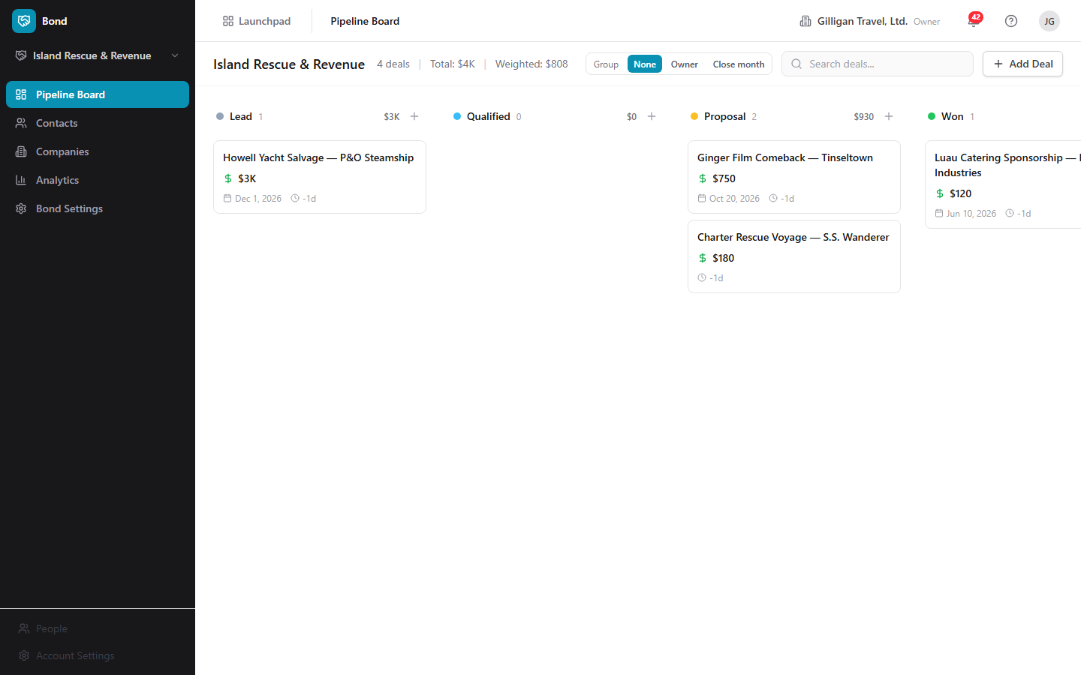
Figure 12.1 Pipeline board
The board (/) shows every deal in the active pipeline as a card in a stage column. The header shows the pipeline name and a summary: "N deals", "Total: $X", and "Weighted: $Y".
To read the board:
1. Open Pipeline Board from the sidebar. The default pipeline loads automatically.
2. Each column is a stage, with a color dot, the stage name, a deal count, and the stage's total value.
3. Each card shows the deal name, company, value, close date, days in stage, and the owner's avatar. Orange cards are rotting; red cards are severely overdue (more than 1.5 times the rotting threshold).
To move a deal to another stage:
1. Drag the deal card from its current column and drop it on the target stage column.
2. The deal's stage updates, the move is recorded in stage history, and a stage-changed event is emitted.
To search the board:
1. Type into the "Search deals..." box in the board header.
2. The board filters to deals whose name or company name matches.
To group deals into swimlanes:
1. In the board header, find the Group control.
2. Click None, Owner, or Close month.
3. Owner groups deals into a lane per owner name, with "Unassigned" last. Close month groups by close date (YYYY-MM), with "No close date" for deals lacking one.

Creating a deal
Deals are created from the board. The Create Deal dialog collects a name, an optional value, and an optional expected close date. It does not collect company, owner, probability, currency, or linked contacts; set those by editing the deal afterward (see Deal detail and outcomes), or through an MCP tool or the REST API (see Working with AI agents). You can also create a deal already linked to a contact from the contact's page (see Contact detail).
NOTE
The board's Create Deal dialog is deliberately minimal: name, optional value, optional close date. Set company, owner, probability, currency, and linked contacts afterward by editing the deal, or supply them up front through the bond_create_deal MCP tool, which an agent can use to collect the fields the dialog omits.
To add a deal at the first stage:
1. On the Pipeline Board, click Add Deal in the top-right.
2. In the "Create Deal" dialog, type a Deal Name (required), for example "Acme Corp - Enterprise Plan".
3. Optionally enter a Value ($) and an Expected Close Date.
4. Click Create Deal. The deal appears in the first stage of the pipeline.
To add a deal directly to a specific stage:
1. Hover the stage column header and click the + button ("Add deal to <stage>").
2. Fill in the same fields and click Create Deal. The deal lands in that stage.

Deal detail and outcomes
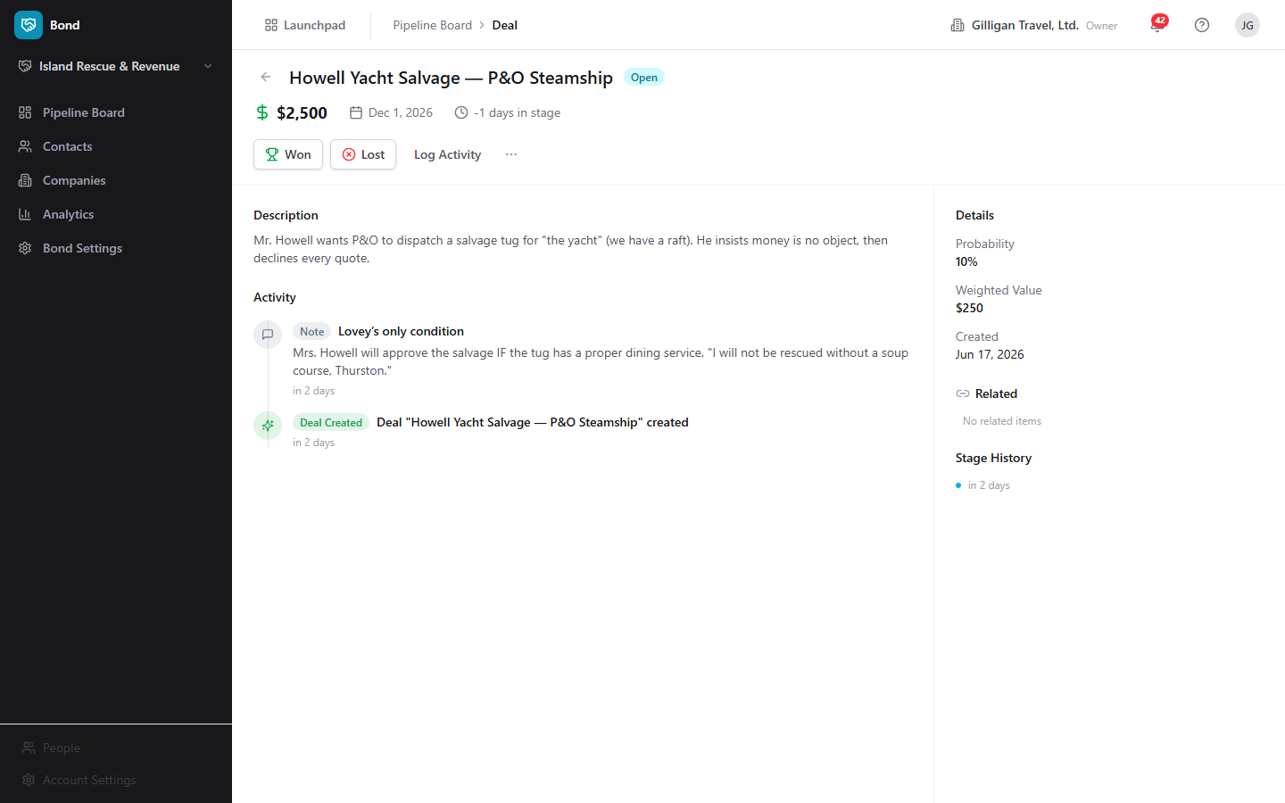
Figure 12.2 Deal detail
Open a deal card to see its full record at /deals/:id: the header with the deal name and a status badge (Open, Won, or Lost), value, company link, close date, days in stage, and owner. The left side shows the description, an inline Log Activity form, and the Activity timeline. The right side shows Details (Probability, Weighted Value, Created, Closed, Close Reason, Lost To), the Related panel, and Stage History.
To edit a deal:
1. Open the deal and click the overflow menu (the "..." button).
2. Choose Edit Deal. The "Edit Deal" dialog opens, pre-filled with the deal's current values.
3. Update the Deal Name, Description, Value ($), Expected Close Date, and other fields, then click Save Changes. The change is saved through the API and the deal updates in place.
To close a deal as won:
1. Open the deal.
2. Click Won (the trophy button). The deal moves to a Won-type stage, its probability is set to 100, and a deal-won event is emitted.
To close a deal as lost:
1. Open the deal.
2. Click Lost (the X-circle button). The "Mark Deal as Lost" dialog opens.
3. Enter a Reason for the loss and, optionally, the Lost to Competitor you lost to.
4. Click Mark as Lost. The deal moves to a Lost-type stage, its probability is set to 0, and the reason and competitor are recorded (they show in the deal's Details under Close Reason and Lost To, and feed the Analytics "Top Loss Reasons" and "Top Competitors" sections).
To delete a deal:
1. Open the deal and click the overflow menu (the "..." button).
2. Choose Delete Deal. The deal is soft-deleted and you return to the board. It can be restored later through the API or MCP.

Stage History and Related items
On a deal's detail page:
- Stage History lists each transition (from stage to stage), when it happened, who made it, and how long the deal spent in the prior stage.
- Related surfaces cross-app links: Bill invoices (by number and status), Book events, and Bam tasks (by their human-readable ID). Each source is best-effort and simply shows nothing if it is unavailable. If there are no links, the panel reads "No related items".

Contacts list
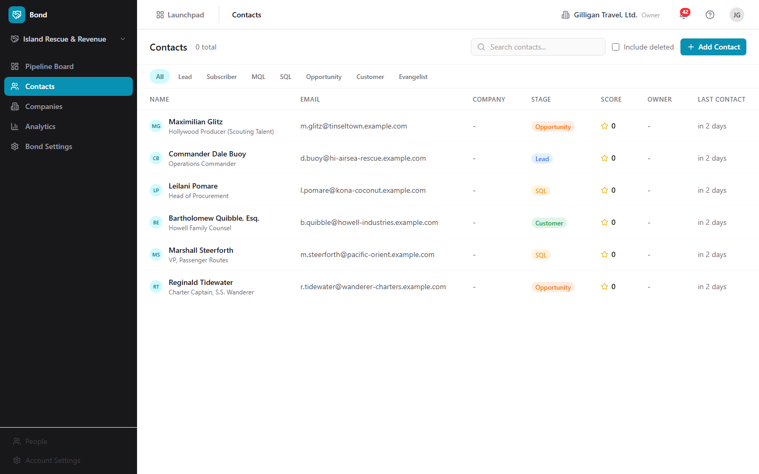
Figure 12.3 Contacts list
The Contacts list (/contacts) is your people directory. The header shows "Contacts", an "N total" count, a "Search contacts..." box, an Include deleted checkbox, and an Add Contact button.
To browse and filter contacts:
1. Open Contacts from the sidebar.
2. Click a lifecycle pill to filter: All, Lead, Subscriber, MQL, SQL, Opportunity, Customer, or Evangelist.
3. Type into "Search contacts..." to match by name, email, or phone.
4. Each row shows Name (with avatar and title), Email, Company, the lifecycle Stage badge, Score (star and number), Owner, and Last Contact.
To see deleted contacts and restore one:
1. Check Include deleted. Deleted rows appear struck through.
2. Click Restore on a deleted row to bring it back.

Creating a contact
To add a contact:
1. On the Contacts list, click Add Contact (also available from the empty-state "No contacts found").
2. In the "Create Contact" dialog, fill in any of First Name, Last Name, Email, Phone, and Job Title. At least one of first name, last name, or email is required.
3. Choose a Lifecycle Stage (Lead, Subscriber, MQL, SQL, Opportunity, Customer, Evangelist, or Other). It defaults to Lead.
4. Click Create Contact. The contact is added and you land on its detail page.

Bulk-importing contacts
Bond can import many contacts at once. Bulk import takes a JSON body with a contacts array (1 to 5000 records), not a spreadsheet upload, so there is no in-app CSV file picker; the import is driven through the REST API (POST /contacts/import) or an agent and requires admin access. Unmatched companies referenced by the records are resolved by the importer. For a single idempotent ingest by email, use the bond_upsert_contact tool instead (see Working with AI agents).

Contact detail
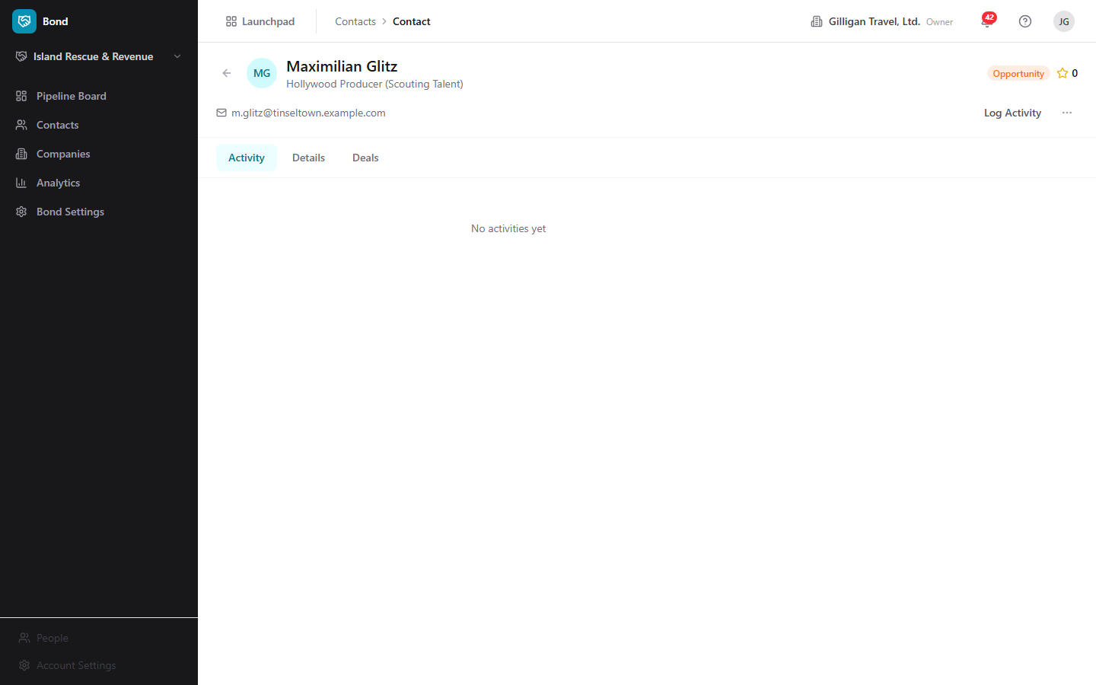
Figure 12.4 Contact detail
A contact's page (/contacts/:id) shows the avatar, name, title, a link to the company, the lifecycle badge, and the lead score. Below are the email (mailto), phone (tel), and deal count. Three tabs organize the body: activity, details, and deals.
To work a contact:
1. Open the contact.
2. Click Log Activity to record a note, call, meeting, or email (see Logging activity).
3. Use the details tab to read Lead Source, Owner, City, State/Region, Country, Created, and Last Contacted.
4. The deals tab shows a text summary of the contact's deals.
To edit a contact:
1. Click the overflow menu ("...") and choose Edit Contact. The "Edit Contact" dialog opens, pre-filled.
2. Update First Name, Last Name, Email, Phone, Job Title, or the Lifecycle Stage, then click Save Changes. The change is saved through the API.
To create a deal linked to this contact:
1. Click the overflow menu ("...") and choose Create Deal. The "Create Deal" dialog opens.
2. Type a Deal Name, an optional Value ($), and pick a Pipeline (it defaults to your org's default pipeline).
3. Click Create Deal. The deal is created at the pipeline's first active stage and is linked to this contact.
To delete a contact:
1. Click the overflow menu ("...") and choose Delete Contact. The contact is soft-deleted; restore it from the Contacts list with Include deleted.

Companies list
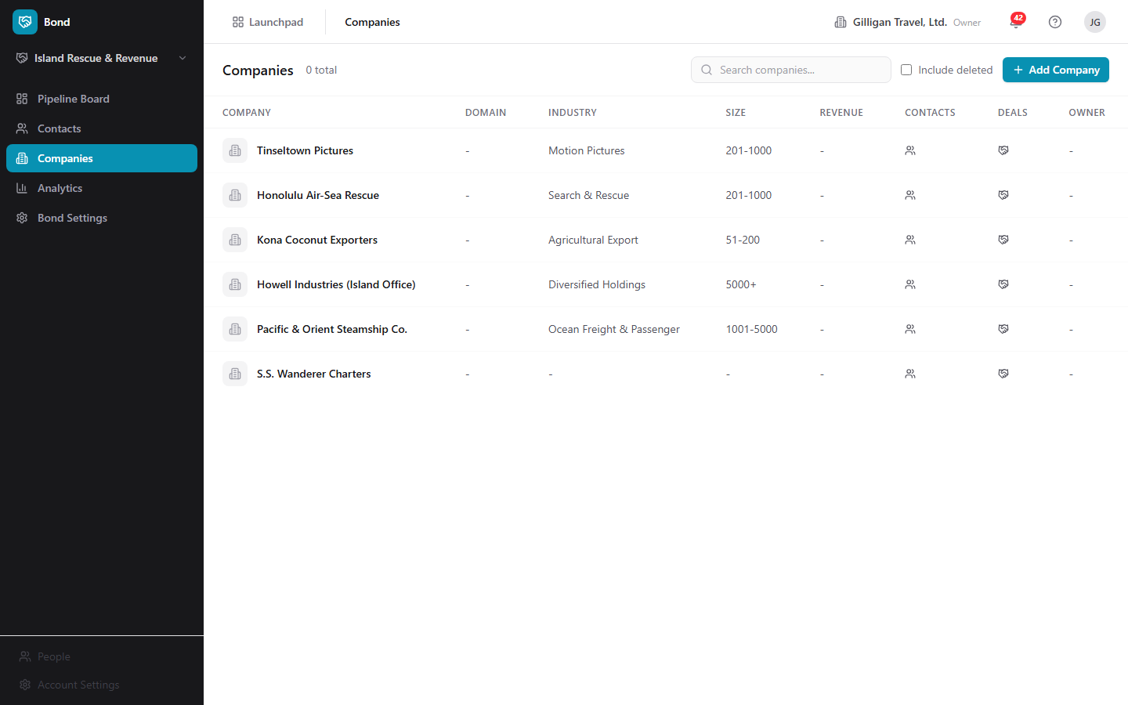
Figure 12.5 Companies list
The Companies list (/companies) holds the organizations you work with. The header shows "Companies", an "N total" count, a "Search companies..." box, an Include deleted checkbox, and an Add Company button.
To browse companies:
1. Open Companies from the sidebar.
2. Type into "Search companies..." to match by name or domain.
3. Each row shows the Company (logo and name), Domain, Industry, Size, Revenue, Contacts count, Deals count, and Owner.
4. Check Include deleted to see soft-deleted companies, each with a Restore action.

Creating a company
To add a company:
1. On the Companies list, click Add Company (also on the empty-state "No companies found").
2. In the "Create Company" dialog, type a Company Name (required).
3. Optionally fill in Domain, Industry, Company Size (a bucket: 1-10, 11-50, 51-200, 201-1000, 1001-5000, 5000+), and Website.
4. Click Create Company. The company is added and you land on its detail page.

Company detail
A company's page (/companies/:id) shows the logo, name, industry badge, and employee count, plus the domain link, phone, location, contact count, deal count, and revenue. Four tabs organize the body: activity, details, contacts, and deals.
To work a company:
1. Open the company.
2. Click Log Activity to record an activity against it.
3. Use the details tab to read Website, Owner, Address, and Created.
4. The contacts and deals tabs show text summaries.
To edit a company:
1. Click the overflow menu ("...") and choose Edit Company. The "Edit Company" dialog opens, pre-filled.
2. Update the company's fields and click Save Changes. The change is saved through the API.
To delete a company:
1. Click the overflow menu ("...") and choose Delete Company. The company is soft-deleted; restore it from the Companies list with Include deleted.

Logging activity
The Log Activity form appears on contact, company, and deal detail pages. Use it to keep a running timeline of your touches.
To log an activity:
1. On a contact, company, or deal detail page, click Log Activity.
2. Choose a type: Note, Email Sent, Email Received, Call, Meeting, or Task.
3. Enter a Subject and optional details in the "Add details..." box.
4. Click Log Activity. The entry appears in the Activity timeline with an icon and label for its type.

Analytics
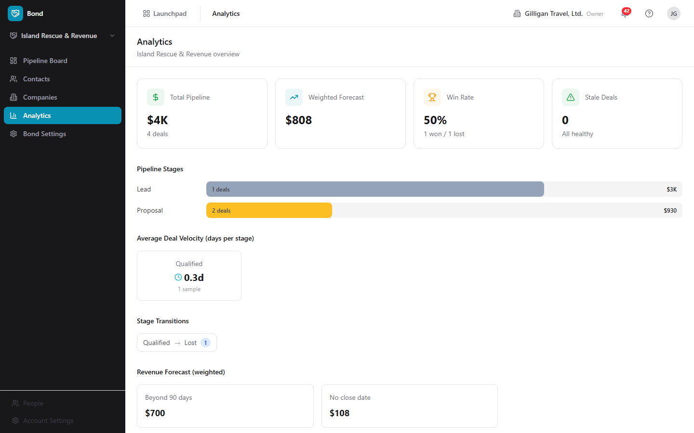
Figure 12.6 Analytics dashboard
The Analytics page (/analytics) reports on the effective pipeline (the active one, falling back to the default, then the first). The header reads "Analytics" with "<pipeline> overview".
To read your numbers:
1. Open Analytics from the sidebar.
2. The top stat cards show Total Pipeline, Weighted Forecast, Win Rate (a percent with won and lost counts), and Stale Deals ("Needs attention" or "All healthy").
3. Pipeline Stages shows a bar per active stage with deal count and value.
4. Average Deal Velocity (days per stage) shows cards with average days in each stage and the sample size.
5. Stage Transitions shows from-stage to to-stage with a count badge.
6. Revenue Forecast (weighted) breaks the weighted total into Next 30 days, Next 60 days, Next 90 days, Beyond 90 days, and No close date (only non-zero buckets show).
7. Stale Deals (N) lists clickable rows (name, stage, an X-of-Y days badge, value). Click a row to open that deal.
8. Top Loss Reasons and Top Competitors summarize why deals were lost and to whom (populated from the reason and competitor you enter when you mark a deal Lost).

Bond Settings: Pipelines
Settings opens at /settings/pipelines. The Pipelines tab lists your pipelines; expand one to see and edit its stages.
To create a pipeline:
1. Open Bond Settings, then the Pipelines tab.
2. Click New Pipeline.
3. In the "Create Pipeline" dialog, type a Pipeline Name and click Create.
4. The new pipeline is seeded with six default stages: Prospect (10%), Qualified (25%), Proposal (50%), Negotiation (75%), Closed Won (100%, Won), and Closed Lost (0%, Lost).
To inspect and manage stages:
1. Click a pipeline row to expand it.
2. Each stage row shows a color dot, the stage name, a type badge (Active, Won, or Lost), the probability percent, and "Nd rot" if a rotting threshold is set.
3. To add a stage, use the inline Add stage form: type a name, pick a type (Active, Won, or Lost), and click Add.
4. To delete a stage, hover the row and click the trash icon.
Note: each stage row shows a drag handle, but reordering stages is not wired in the Settings UI. Stage reordering, and editing a stage's probability, rotting days, or color, are available through the REST API or the bond_reorder_stages and bond_update_stage MCP tools. The Add stage form sets only the name and type.

Bond Settings: Custom Fields
Custom fields extend contacts, companies, or deals with extra data. They are defined per entity type and apply org-wide for that type (not per pipeline).
To add a custom field:
1. Open Bond Settings, then the Custom Fields tab.
2. Optionally narrow the list with the entity filter (All Types, Contact, Company, or Deal).
3. Click New Field.
4. In the "Create Custom Field" dialog, choose an Entity Type (Contact, Company, or Deal) and a Field Type (Text, Number, Date, Select, Multi Select, URL, Email, Phone, or Boolean).
5. Enter a Label; the Field Key is generated from it automatically (you can adjust it).
6. Check Required field if the field is mandatory.
7. For Select or Multi Select, build the Options list by entering a Value and Label and clicking Add for each option.
8. Click Create Field. Fields are grouped by entity type, each showing its label, key, type badge, and option count.
To delete a custom field:
1. Hover its row and click the trash icon.

Bond Settings: Lead Scoring
Lead scoring rules adjust each contact's lead score. Rules are org-wide and evaluated together; each matching enabled rule adds or subtracts its delta, and the final score is clamped to 0-100.
To create a scoring rule:
1. Open Bond Settings, then the Lead Scoring tab.
2. Click New Rule.
3. In the "Create Scoring Rule" dialog, enter a Rule Name and an optional Description.
4. Build the Condition: pick a Field (for example Lifecycle Stage, Lead Source, Job Title, City, Country, Current Score, or a custom field), an Operator (Equals, Not Equals, Contains, Greater Than, Less Than, Greater or Equal, Less or Equal, Exists, Not Exists), and a Value (the Value box hides for Exists and Not Exists).
5. Set a Score Delta (from -100 to 100) and leave Enabled checked to make the rule active.
6. Click Create Rule. Each rule row reads as a plain sentence, shows its +/- point delta, and offers edit and delete.
To edit a scoring rule:
1. Hover a rule row and click the edit (pencil) icon.
2. Adjust fields in the "Edit Scoring Rule" dialog and click Save Changes.
Note: there is no in-app button to recalculate scores. Recalculation runs through the REST endpoint or the bond_score_lead MCP tool (see Working with AI agents).

Restoring deleted records
Contacts, companies, and deals are soft-deleted, so a delete is recoverable.
To restore a deleted contact or company:
1. Open the Contacts or Companies list.
2. Check Include deleted.
3. Find the struck-through row and click Restore.
Deleted deals are restored through the REST API or the bond_restore_deal MCP tool, not from the board UI.

Working with AI agents
Bond exposes a large MCP catalog (over 70 tools across bond-tools.ts, plus the cross-cutting bond_find_duplicates), so an AI agent can do everything a salesperson does in the app, plus the admin configuration the current UI does not expose. Most write tools accept a name or a UUID (a pipeline or stage name, a contact email or name, a company name or domain, a deal title fragment, an owner email); an ambiguous or missing match returns a clean error instead of mutating data.
Every contact, deal, and pipeline action is an MCP tool, so an agent can work the board with a salesperson's reach plus the admin config the UI hides.
What agents commonly drive:
- Contacts: bond_create_contact, bond_update_contact, bond_list_contacts, bond_get_contact, bond_search_contacts, bond_merge_contacts, bond_delete_contact, and bond_restore_contact. bond_update_contact does the same edit the in-app Edit Contact dialog does, including lifecycle stage.
- Idempotent contact ingestion: bond_upsert_contact upserts by email. It is part of the platform's idempotent write plane and returns a created flag and an idempotency key, so repeated ingestion does not create duplicates. It also resurrects a soft-deleted contact with the same email.
- Companies: bond_create_company, bond_update_company, bond_list_companies, bond_get_company, bond_search_companies, bond_delete_company, bond_restore_company, bond_list_company_contacts, and bond_list_company_deals. bond_update_company matches the in-app Edit Company dialog.
- Deals: bond_create_deal (collects fields the in-app board dialog omits at creation, such as company, owner, and probability), bond_update_deal (the same edit the in-app Edit Deal dialog does), bond_list_deals, bond_get_deal, bond_move_deal_stage, bond_close_deal_won, and bond_close_deal_lost (records a close reason and the competitor you lost to, just like the in-app Mark Deal as Lost dialog). bond_duplicate_deal, bond_delete_deal, and bond_restore_deal round out the lifecycle, and bond_list_deal_contacts, bond_add_deal_contact, bond_remove_deal_contact, bond_get_deal_stage_history, bond_list_deal_activities, and bond_get_deal_related cover the deal detail surface.
- Activities: bond_log_activity mirrors the Log Activity form; bond_list_activities, bond_get_activity, bond_update_activity, and bond_delete_activity manage the timeline.
- Pipelines and stages (admin): bond_list_pipelines, bond_get_pipeline, bond_create_pipeline, bond_update_pipeline, bond_delete_pipeline, and the stage tools bond_list_stages, bond_create_stage, bond_update_stage, bond_delete_stage, and bond_reorder_stages. bond_reorder_stages and bond_update_stage do the stage reordering and the probability/rotting/color edits the Settings UI cannot.
- Custom fields (admin): bond_list_custom_fields, bond_get_custom_field, bond_create_custom_field, bond_update_custom_field, and bond_delete_custom_field.
- Lead scoring: bond_list_scoring_rules, bond_create_scoring_rule, bond_update_scoring_rule, and bond_delete_scoring_rule manage the rules; bond_score_lead recalculates a contact's score, the action the Settings UI has no button for.
- Reporting: bond_get_pipeline_summary, bond_get_stale_deals, bond_get_forecast, bond_get_conversion_rates, bond_get_deal_velocity, and bond_get_win_loss return the data the Analytics page renders.
- Deduplication: bond_find_duplicates returns ranked likely-duplicate contacts with confidence and signals (full-name trigram similarity, exact email match, exact normalized-phone match), and pairs with the platform dedupe_record_decision and dedupe_list_pending tools (entity type bond.contact) plus bond_merge_contacts to resolve them. There is no in-app dedupe screen; this loop is API and tool only.
- Import mappings and settings: bond_create_import_mapping and bond_list_import_mappings record external-system-to-Bond lookups for dedup; bond_get_user_settings and bond_update_user_settings manage per-user Bond preferences such as reply-to email.
Cross-cutting agent platform: Bond data is reachable through the platform read plane too. search_everything fans out across apps (including Bond) with optional asker-mode can_access filtering, and composite views like account_view assemble a contact or company picture across apps. Agents run with an identity (users.kind of agent or service), send agent_heartbeat, and are gated by agent_policies (per-agent kill switch plus glob tool allowlists such as bond.*); risky changes can be routed through the proposal queue (proposal_create / proposal_decide) for human approval, and outbound webhooks push subscribed Bolt events to agent runners. Before an agent cites a Bond entity in a shared surface, it should preflight with can_access(asker_user_id, 'bond.contact', id) (or the relevant entity type) and drop anything not allowed.
Event-driven automation: Bond emits Bolt events on the bond source for deal.created, deal.updated, deal.stage_changed, deal.won, deal.lost, contact.created, contact.upserted, activity.logged, and deal.rotting. A daily worker job emits deal.rotting for open deals that have aged past their stage's rotting threshold, so downstream Bolt rules can nudge an owner or hand off to another app.
Reviewing agent work: own-only visibility is enforced server-side, so a member or viewer service account only sees and acts on records it owns.
For the full tool catalog and schemas, see the Bond MCP-tools reference and guide in docs/apps/bond/.

User Stories

Story: Set up your first sales pipeline
Who: An org admin or owner setting up Bond.
Goal: Have a working pipeline with the stages your team sells through.
Before you start: You need admin access to Bond. A fresh org has no pipeline, so the board shows "No pipeline selected".
Steps
1. Open Bond Settings from the sidebar (or click Create Pipeline on the empty board, which takes you there).
2. On the Pipelines tab, click New Pipeline.
3. In the "Create Pipeline" dialog, type a Pipeline Name such as "Enterprise Sales" and click Create.
4. The pipeline is seeded with six stages: Prospect, Qualified, Proposal, Negotiation, Closed Won, and Closed Lost. Click the pipeline row to expand it.
5. Add any stages your team needs with the inline Add stage form (name plus type), and delete any you do not want with the trash icon on a stage row.
Result: A pipeline exists with its stages. Because at least one pipeline now exists, the Pipeline Board auto-selects it and renders columns instead of the "No pipeline selected" message, and you can start adding deals.
Related: Tune stage probability, rotting days, color, or order through the bond_update_stage and bond_reorder_stages MCP tools or the REST API; the Settings UI sets only stage name and type. See Pipeline board.

Story: Add and qualify a contact
Who: A salesperson or SDR capturing a new lead.
Goal: Get a person into Bond, classify them, and start a history of touches.
Before you start: You need read/write access. You are on the Contacts list.
Steps
1. Click Add Contact.
2. In the "Create Contact" dialog, fill in First Name, Last Name, Email, Phone, and Job Title (at least one of first name, last name, or email is required).
3. Choose a Lifecycle Stage, for example Lead or MQL, then click Create Contact.
4. On the contact's detail page, click Log Activity, pick Call or Note, write a subject and details, and click Log Activity.
5. To reclassify the contact later, open the overflow menu ("..."), choose Edit Contact, change the Lifecycle Stage, and click Save Changes.
Result: The contact exists with a lifecycle stage and a first activity in its timeline, and you can update its details and stage at any time.
Related: Agents can do the same with bond_create_contact and bond_update_contact. See Contacts list.

Story: Create a deal and move it to close
Who: A salesperson working an opportunity.
Goal: Track a deal from creation through Won or Lost.
Before you start: You need read/write access and at least one pipeline. You are on the Pipeline Board, which has the default pipeline already selected.
Steps
1. Click Add Deal (or the + on a specific stage column).
2. In the "Create Deal" dialog, type a Deal Name, an optional Value ($), and an optional Expected Close Date, then click Create Deal.
3. To set a company, owner, or other fields the create dialog omits, open the deal, use the overflow menu's Edit Deal, and Save Changes.
4. As the deal progresses, drag its card from one stage column to the next. Each move is recorded in Stage History.
5. Open the deal and use Log Activity to record calls and meetings along the way.
6. When the deal closes, open it and click Won, or click Lost and enter a Reason (and optional Lost to Competitor) in the "Mark Deal as Lost" dialog.
Result: The deal shows an Open, Won, or Lost badge, its probability is set (100 for won, 0 for lost), and a lost deal records its reason and competitor for reporting.
Related: Agents can create deals with more fields up front via bond_create_deal, edit them with bond_update_deal, and close them with bond_close_deal_won / bond_close_deal_lost. See Deal detail.

Story: Work the board with swimlanes
Who: A sales manager scanning the pipeline.
Goal: See deals grouped by who owns them or when they close, and spot the ones going stale.
Before you start: You are on the Pipeline Board with deals in the active pipeline.
Steps
1. In the board header, use the Group control and click Owner to lane deals by owner, or Close month to lane them by close date.
2. Type into "Search deals..." to narrow to a name or company.
3. Scan for orange cards (rotting) and red cards (severely overdue, more than 1.5 times past the rotting threshold).
4. Click None to return to the flat board.
Result: The board is reorganized into swimlanes and you can see, at a glance, which owner or month is loaded and which deals are aging.
Related: Triage stale deals (next story) for a focused list.

Story: Triage stale deals
Who: A sales manager or rep keeping deals from rotting.
Goal: Find deals stuck too long in a stage and re-engage them.
Before you start: You are signed in with access to the pipeline's deals.
Steps
1. Open Analytics from the sidebar.
2. Read the Stale Deals stat card ("Needs attention" or "All healthy").
3. Scroll to the Stale Deals (N) section and click a row to open that deal.
4. On the deal, click Log Activity and record a follow-up call or note to re-engage it.
Result: Each stale deal is reviewed and gets a fresh touch, which resets its activity history.
Related: Agents can pull the same list with bond_get_stale_deals. A daily worker also emits deal.rotting to Bolt so automation rules can nudge owners. See Analytics dashboard.

Story: Forecast revenue
Who: A sales leader planning the quarter.
Goal: Understand expected revenue and where deals are being lost.
Before you start: You have a pipeline with open and closed deals.
Steps
1. Open Analytics from the sidebar.
2. Read Weighted Forecast and Win Rate at the top.
3. Review the Revenue Forecast (weighted) buckets: Next 30 days, Next 60 days, Next 90 days, Beyond 90 days, and No close date.
4. Read Average Deal Velocity (days per stage) to see where deals slow down, and Top Loss Reasons and Top Competitors to see why and to whom you lose.
Result: You have a weighted forecast, a win rate, velocity per stage, and a breakdown of losses.
Related: Agents can fetch the same figures with bond_get_forecast, bond_get_pipeline_summary, bond_get_deal_velocity, and bond_get_win_loss.

Story: Manage companies
Who: An account manager organizing accounts.
Goal: Create a company, edit its details, and tie contacts and deals to it.
Before you start: You need read/write access. You are on the Companies list.
Steps
1. Click Add Company.
2. In the "Create Company" dialog, type a Company Name, and optionally a Domain, Industry, Company Size, and Website, then click Create Company.
3. On the company's detail page, open the overflow menu ("...") and choose Edit Company to update its fields; click Save Changes.
4. Use the contacts and deals tabs to see linked records (shown as summaries), and Log Activity to record touches against the account.
Result: The company exists with its linked contact and deal counts, its details are editable in place, and its activity timeline is started.
Related: Agents can manage the same record with bond_create_company and bond_update_company. See Companies list.

Story: Configure lead scoring
Who: A marketing or sales ops admin.
Goal: Automatically prioritize contacts by scoring their attributes.
Before you start: You need admin access to Bond.
Steps
1. Open Bond Settings, then the Lead Scoring tab.
2. Click New Rule.
3. Enter a Rule Name, build the Condition (Field, Operator, Value), set a Score Delta between -100 and 100, and keep Enabled checked.
4. Click Create Rule. Repeat for each scoring signal you want.
5. To change a rule later, hover its row, click the edit icon, adjust it, and click Save Changes.
Result: Enabled rules combine to produce each contact's lead score, clamped to 0-100. The score shows as a star and number on contact rows and detail pages.
Related: There is no recalculate button in the app; trigger recalculation with the bond_score_lead MCP tool or the /scoring/recalculate REST endpoint. Agents can also manage the rules themselves with bond_create_scoring_rule and bond_update_scoring_rule.

Story: Extend the schema with custom fields
Who: An admin who needs to capture data Bond does not have a built-in field for.
Goal: Add a custom field to contacts, companies, or deals.
Before you start: You need admin access to Bond.
Steps
1. Open Bond Settings, then the Custom Fields tab.
2. Click New Field.
3. Choose the Entity Type and Field Type, enter a Label (the Field Key auto-fills), and check Required field if needed.
4. For Select or Multi Select fields, add Options by entering a Value and Label and clicking Add for each.
5. Click Create Field.
Result: The new field appears grouped under its entity type. Custom fields are org-wide for that entity type, not tied to a single pipeline.
Related: Agents can manage the same definitions with bond_create_custom_field, bond_update_custom_field, and bond_delete_custom_field.

Story: Restore a deleted record
Who: Anyone who deleted a contact or company by mistake.
Goal: Bring back a soft-deleted record.
Before you start: You are on the Contacts or Companies list.
Steps
1. Check Include deleted in the list header.
2. Find the struck-through row for the record you deleted.
3. Click Restore on that row.
Result: The record returns to the active list. (Deleted deals are restored with the bond_restore_deal MCP tool or the REST API rather than the board.)

Story: Deduplicate contacts (agent-assisted)
Who: An ops admin or an AI agent cleaning the contact database.
Goal: Find and merge duplicate contacts.
Before you start: This flow runs through MCP tools and the REST API; there is no in-app dedupe screen.
Steps
1. Run bond_find_duplicates (or call GET /contacts/:id/duplicates) to get ranked likely duplicates with confidence and signals.
2. Review the candidates and record a decision with the platform dedupe_record_decision tool.
3. When two records are truly the same person, merge them with bond_merge_contacts (or POST /contacts/:id/merge). The target absorbs the source's deals, activities, and company links, and the source is soft-deleted.
WARNING
Merging contacts is one-directional and consolidating: the target keeps the source's deals, activities, and company links, and the source is then soft-deleted. Confirm you have the right target before you merge, and remember the merge loop runs only through MCP tools and the REST API, not an in-app screen.
Result: Duplicate contacts are consolidated into a single record, and your decision is recorded so the pair is not re-flagged.
Related: This is the platform dedup loop for entity type bond.contact. Pending pairs are listed with dedupe_list_pending.

Story: Hand a deal off across the suite
Who: A rep coordinating delivery after a win.
Goal: See and follow the invoices, events, and tasks tied to a deal.
Before you start: You are on a deal's detail page, and related records exist in Bill, Book, or Bam.
Steps
1. Open the deal.
2. In the right-side Related panel, review linked Bill invoices (with number and status), Book events, and Bam tasks (with their human-readable IDs).
3. Click any related item to jump to it in the other app.
Result: You can move from the deal straight to the invoice, meeting, or task that continues the work, without searching for it.
Related: Bond contacts also feed Blast email segments, and Bond data is queryable in Bench reports.

Related
- Bill - invoices linked to a deal appear in its Related panel.
- Book - scheduled events linked to a deal appear in its Related panel.
- Bam - project tasks linked to a deal appear in its Related panel, by human-readable ID.
- Blast - pulls Bond contacts into email segments.
- Bench - reports and dashboards can query Bond data.
- Bolt - reacts to Bond events (deal.created, deal.updated, deal.stage_changed, deal.won, deal.lost, contact.created, contact.upserted, activity.logged, deal.rotting) on the bond source.
- Bond MCP-tools reference and guide in docs/apps/bond/.

Check yourself
Every answer is findable in this chapter. Check your work against the Answer Key appendix at the back of the book.
1. What are the four core objects Bond organizes your sales work around?
a) Contacts, companies, deals, and pipelines
b) Leads, accounts, opportunities, and tasks
c) Contacts, deals, invoices, and events
d) People, companies, activities, and reports
2. What lifecycle stage do new contacts default to?
a) Subscriber
b) Lead
c) MQL
d) Opportunity
3. How is a deal's weighted value computed?
4. What is the range a contact's lead score is clamped to?
a) 0 to 10
b) 0 to 100
c) 1 to 5
d) -100 to 100
5. When does a deal card turn red rather than just orange?
a) When it has no owner assigned
b) When it has been open for more than 90 days
c) When it is more than 1.5 times over its stage's rotting threshold
d) When its probability drops below 25 percent
6. What are the three stage types a pipeline stage can have?
7. Which six stages does a new pipeline get seeded with?
a) Prospect, Qualified, Proposal, Negotiation, Closed Won, and Closed Lost
b) Lead, MQL, SQL, Opportunity, Customer, and Evangelist
c) New, Open, Working, Pending, Won, and Lost
d) Discovery, Demo, Quote, Contract, Won, and Lost
8. When you close a deal as Won, what does Bond set its probability to, and what happens when you close it as Lost?
9. Can members and viewers see every deal and contact in the org?
a) Yes, everyone sees everything
b) No, members and viewers see only the deals and contacts they own
c) Only if an admin grants them access per record
d) They see all contacts but only their own deals
10. When you delete a contact, company, or deal in Bond, is the record erased? How do you bring a contact or company back?
11. How is a bulk contact import driven, since there is no in-app CSV file picker?
a) By uploading a spreadsheet on the Contacts list
b) Through the REST API with a JSON contacts array (1 to 5000 records) or an agent, with admin access
c) By pasting rows into the Create Contact dialog
d) Through the Bond Settings import wizard
12. Custom fields are defined per entity type. Are they scoped per pipeline or org-wide?
13. Which Bond action has no in-app button and runs only through the REST endpoint or an MCP tool?
a) Creating a deal
b) Editing a contact's lifecycle stage
c) Recalculating a contact's lead score
d) Logging an activity

CHAPTER 13

Book
Set your hours, share a link, fill your calendar.

Book is scheduling without setup. The first time you open it, a personal calendar appears and you can start adding events, while behind the scenes Book turns your working hours into free time slots that power public booking pages and agent-driven meeting-finding. This chapter walks you from your weekly hours to a shared booking link, takes you through the cross-app Timeline that pulls Bam tasks and Bond deals alongside your events, and shows where an AI agent can do the scheduling math that has no human screen yet. By the end you will be able to publish a link an outside visitor can book, and know exactly which controls are live and which are still being finished.
At a glance
- A personal calendar provisioned automatically, with Week, Day, and Month views
- Working hours that compute free slots for availability and public booking pages
- Public booking links at /book/meet/<slug> that outsiders can use without logging in
- A cross-app Timeline that gathers Book events, Bam task due dates, and Bond deal close dates
- An agent can find a common free time across several people, the math Book has no screen for
In this chapter
Overview . Key concepts . Where to find it . Feature reference . Week view . Day view . Month view . Timeline view . New Event and Edit Event . Event detail and RSVP
Book is the BigBlueBam scheduling app. Use it to keep personal and team calendars, view what is happening across the suite on a timeline, set the working hours that drive availability, and publish public links that let outside people book time with you.

Overview
Book gives every BigBlueBam user a calendar without any extra setup. The first time you open it, a personal calendar named My Calendar is created for you automatically, so you can start adding events right away. You can add more calendars later to separate work streams, projects, or teams.
Beyond plain events, Book computes availability. It takes the working hours you define, subtracts the events that mark you as busy, and produces free time slots. Those slots power two things: public booking pages, where someone outside your org can grab a slot on your calendar, and the availability tools that AI agents use to find a meeting time across several people.
Working hours minus busy events equals availability, and that availability powers every booking page you publish.
Book also pulls other apps into one place. The Timeline view aggregates Book events with Bam task due dates and Bond deal close dates, so you can scan a week across the whole suite. Events can link to a Bam task, a Bond deal, or a Helpdesk ticket, and every Book-native event gets a LiveKit huddle room so attendees have a place to meet by video.
You can also pull an outside calendar into Book. The Connections page lets you subscribe to any public iCalendar (.ics) feed; Book fetches it, mirrors its events onto a Book calendar, and keeps them in step on a recurring schedule. Google Calendar and Microsoft Outlook two-way sync are built on the same engine and ready to drop in, but they stay disabled until an operator supplies the OAuth credentials; the .ics path needs nothing.
A few areas of Book are still being finished. Where a screen exists but does not yet do what its label implies, this document says so plainly under the relevant feature so you do not lose time on a path that cannot complete today. The remaining one is reminders and recurrence. Read that note before relying on reminder and repeat behavior.

Key concepts
- Calendar - A container for events. Each calendar has a type (personal, team, project, booking, or bureau), a color, and a timezone. One personal calendar, My Calendar, is created for you on first use and cannot be deleted. The bureau type is reserved for a system-provisioned, per-org calendar that other apps write room bookings into; you do not create it by hand.
- Event - A time block on a calendar with a title, start and end time, optional location, description, and meeting URL. Events have a status (tentative, confirmed, or cancelled; new events default to confirmed) and a visibility (free, busy, tentative, or out_of_office; default busy). Cancelling an event is a soft delete: it flips status to cancelled rather than erasing the row.
- Show as (visibility) - Controls whether an event blocks your availability. An event marked Free does not consume a slot; Busy, Tentative, and Out of Office do.
- Attendee - A person invited to an event, identified by email. Attendees carry a response status (needs_action until they answer, then accepted, declined, or tentative) and a flag for the organizer.
- RSVP - An attendee's response to an event. Only someone who is already an attendee can RSVP.
- Working hours - Your weekly availability windows, one row per day of the week. By default Monday to Friday, 09:00 to 17:00, are enabled. These windows are the raw material for availability and booking-page slots.
- Availability slot - A computed free interval, equal to your working hours minus the events that mark you busy.
- Booking page - A public scheduling link at /book/meet/<slug> that lets an outside visitor pick one of your free slots. It carries a duration, before and after buffers, advance and notice limits, and brand styling.
- Booking - The event created when a visitor books a slot on a booking page. It lands as a confirmed event on the page owner's default calendar.
- Timeline - A cross-app, date-ranged view that gathers Book events, Bam task due dates, and Bond deal close dates into one per-day list.
- External connection - A subscription to an outside calendar that Book pulls events from. The .ics feed provider works today with no credentials: paste a public iCalendar URL and Book mirrors its events onto a Book calendar, updating in place on each sync. Google Calendar and Microsoft Outlook connections use the same sync engine but require operator-supplied OAuth credentials before they can be created (see Connections below).
- Synced (mirrored) event - A Book event that Book created from an external feed. It is kept in step with the feed automatically: a re-sync updates it in place, an event removed upstream is removed from Book, and disconnecting the feed removes all of its mirrored events.
- iCal feed - A token-authenticated .ics URL that exposes one calendar to an outside calendar app. Available through the API and agents only; there is no button for it in the app yet.
TIP
Google and Outlook two-way sync stay disabled until an operator supplies OAuth credentials, but the .ics path needs nothing. Most calendar apps, including Google and Outlook, can publish a public .ics URL for any calendar you own, so paste that and Book mirrors it in with no setup.

Where to find it
Book is served at /book/. Reach it from the BigBlueBam Launchpad, or go to the path directly. Book does not have its own login screen. If you are not signed in, Book shows a "Please log in to BigBlueBam first to access Book." panel with a Go to BigBlueBam Login link to the main app at /b3/. Sign in there, then return to Book.
Prerequisites:
- A BigBlueBam account and an active session (sign in at /b3/).
- No calendar setup is required. Your personal My Calendar is provisioned the first time Book reads your calendars.
- Write actions (creating or editing events, calendars, and booking pages) require the read_write scope and the matching per-action permission (for example book.event.create). If a write is blocked, you lack the scope or permission for that resource.
Press ? anywhere in Book (when you are not typing in a field) to open the in-app Help.

Feature reference
The left sidebar has two groups. The top group holds the calendar and scheduling views: Week, Day, Month, Timeline, and Booking Pages. Below the Book Settings header sit Calendars, Working Hours, and Connections.

Week view
The default landing screen. It shows a 7-day grid with a time gutter and 24 hour rows, with event blocks placed by their start and end times.
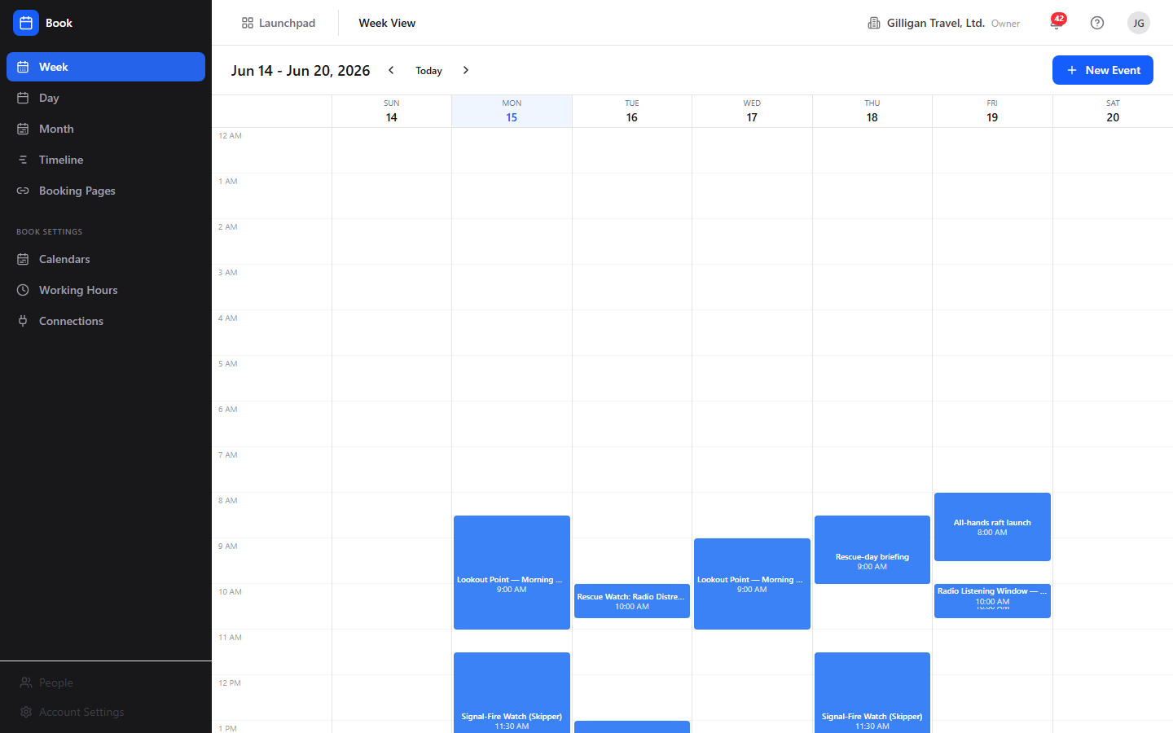
Figure 13.1 Week view
To use the Week view:
1. Open Book. You land on Week by default, or click Week in the sidebar.
2. Read the date range heading at the top (for example "Jun 9 - Jun 15, 2026").
3. Move between weeks with the left and right chevron arrows, or click Today to jump back to the current week.
4. Click an event block to open it. Note that clicking a block opens the event's edit form, not its read-only detail view.
5. Click New Event (top right, with a plus icon) to create an event.

Day view
A single day shown as one hourly column. Reached by Day in the sidebar.
To use the Day view:
1. Click Day in the sidebar.
2. Read the heading for the day shown.
3. Use the left and right chevron arrows to change day, or click Today to return to today.
4. Click New Event to add an event.

Month view
A full-month grid of day cells with event chips.
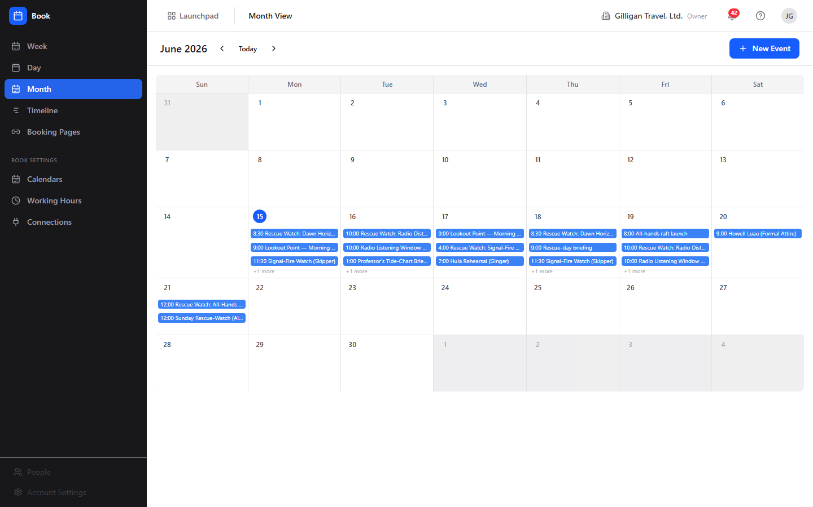
Figure 13.2 Month view
To use the Month view:
1. Click Month in the sidebar.
2. Read the month heading (for example "June 2026").
3. Use the left and right chevron arrows to change month.
4. Click an event chip to open that event (this opens the event edit form).
5. Click New Event to add an event.
Note: Book's calendar views do not support drag-to-create or drag-to-resize. Create and change events only through the New Event form and the edit form.

Timeline view
A cross-app view that groups items by day across a week. It gathers Book events (blue), Bam task due dates (orange), and Bond deal close dates (teal), with a legend reading "Book Events / Bam Tasks / Bond Deals".
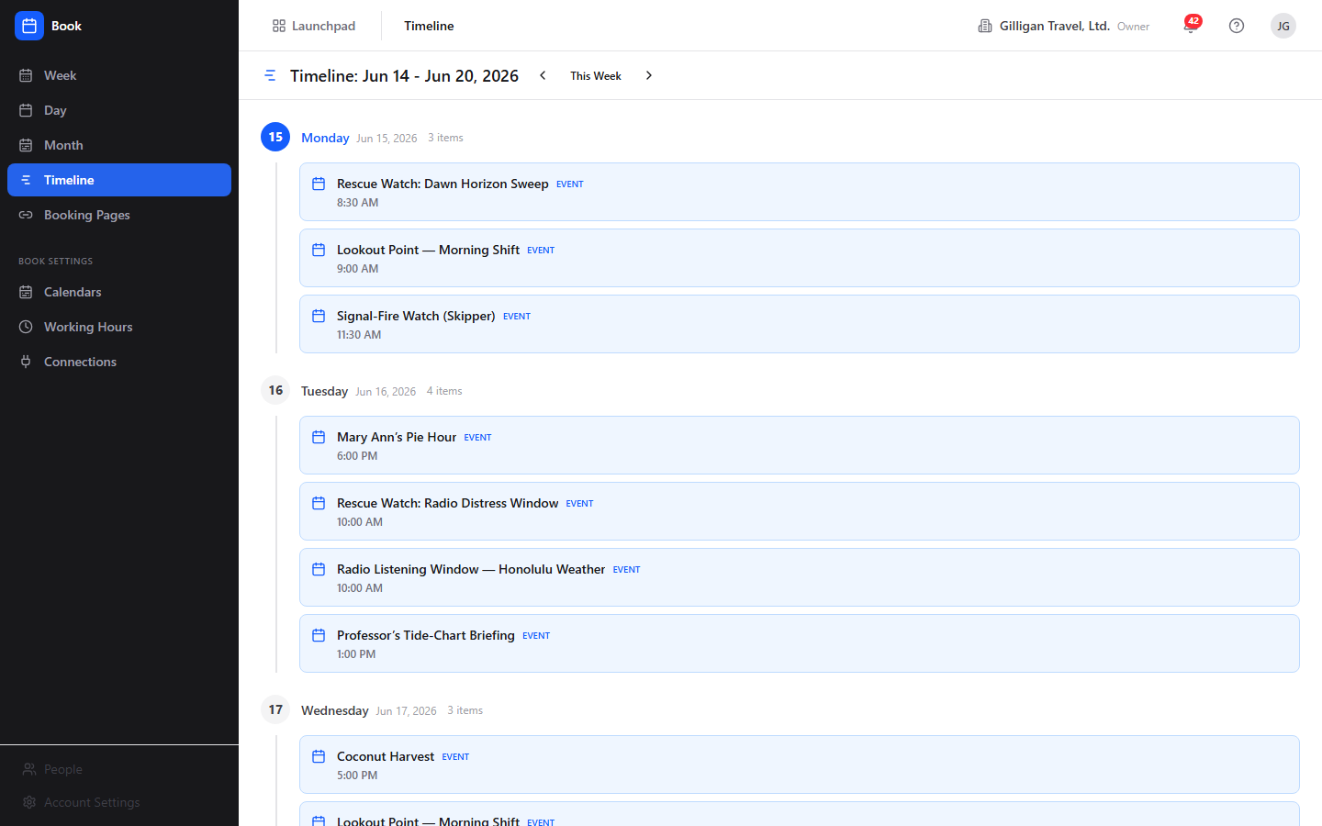
Figure 13.3 Cross-app timeline
To use the Timeline:
1. Click Timeline in the sidebar.
2. Read the heading (for example "Timeline: Jun 9 - Jun 15, 2026").
3. Move between weeks with the left and right chevron arrows, or click This Week to return to the current week.
4. Scan the per-day grouping; each item carries a source label (Event, Task, or Deal) and, for timed items, its time.
5. Click a Book item to open that event (this opens the event edit form).
The Timeline reads Book events, Bam task due dates, and Bond deal close dates from the API and renders each under the right source style, with timed items showing their time. Bam and Bond items appear with their own Task and Deal styling. To read the same data with an agent, use the book_get_timeline MCP tool.

New Event and Edit Event
The form for creating a new event or changing an existing one. Reached by New Event from any calendar view (which opens "New Event"), or by opening an event and choosing Edit (which opens "Edit Event").
To create an event:
1. From any calendar view, click New Event. The form opens with the heading New Event.
2. Enter a Title (required; placeholder "Team standup").
3. Choose a Calendar (required) from the dropdown. The form preselects your default calendar.
4. Toggle All day if the event has no specific time. When off, set Start and End. When on, set Start Date and End Date.
5. Optionally add a Description (placeholder "Add details, agenda, or notes...") and a Location (placeholder "Conference room, address, or video URL").
6. Optionally set Repeat (No repeat, Daily, Weekly, Every 2 weeks, Monthly) and Show as (Busy, Free, Tentative, Out of Office).
7. Click Create Event. If anything is missing you will see "Title is required", "Select a calendar", or "End must be after start".
To edit an event:
1. Open an event and click Edit, or click the event in a calendar view (which goes straight to this form). The heading reads Edit Event.
2. Change any field.
3. Click Update Event. Use Cancel or Back to Event to leave without saving.
Notes and current limitations:
- The form shows a Reminder dropdown and a Color picker, but neither is sent when you save. Book has no reminder feature and no reminder job, and event color is not stored on the event (color lives on the calendar). Treat both controls as inactive.
- You cannot add or edit attendees from this form. Attendees are set when an event is created through the API or an agent tool (book_create_event).
- Repeat is stored but not expanded. Choosing a repeat option records the rule on the single event; Book does not yet generate the future occurrences, so a "weekly" event remains one event.

Event detail and RSVP
The read-only detail view of an event, reached by visiting an event's direct URL (/book/events/<id>). It shows the event's status pill and visibility label, time and timezone, location, meeting URL link, and description.
To view an event and respond to it:
1. Open the event detail page. A Back to Calendar link sits at the top.
2. Review the details card: time and timezone, the Location line, the meeting URL link, and the description.
3. If you are an attendee, find the Your response panel and click Accept, Maybe, or Decline. "Maybe" records a tentative response.
4. See the Attendees (N) list for each person's response status; the organizer's row is marked "(organizer)".
5. If the event came from a booking page, an amber Booked via scheduling link panel appears with the booker's name and email.
6. Click Edit to change the event, or Cancel (trash icon) and confirm "Cancel this event?" to soft-cancel it.
Notes:
- RSVP only works if you are already an attendee. If you are not on the attendee list, the response is rejected.
- The calendar and Timeline views link straight to the edit form, so the detail view is reached mainly by opening an event's direct URL.
- Cancelling an event sets its status to cancelled; it then drops out of availability and the timeline rather than being deleted.

Booking Pages list
Your public scheduling links. The heading reads "Booking Pages" with the subtitle "Public scheduling links for clients and prospects". You only ever see your own pages here.
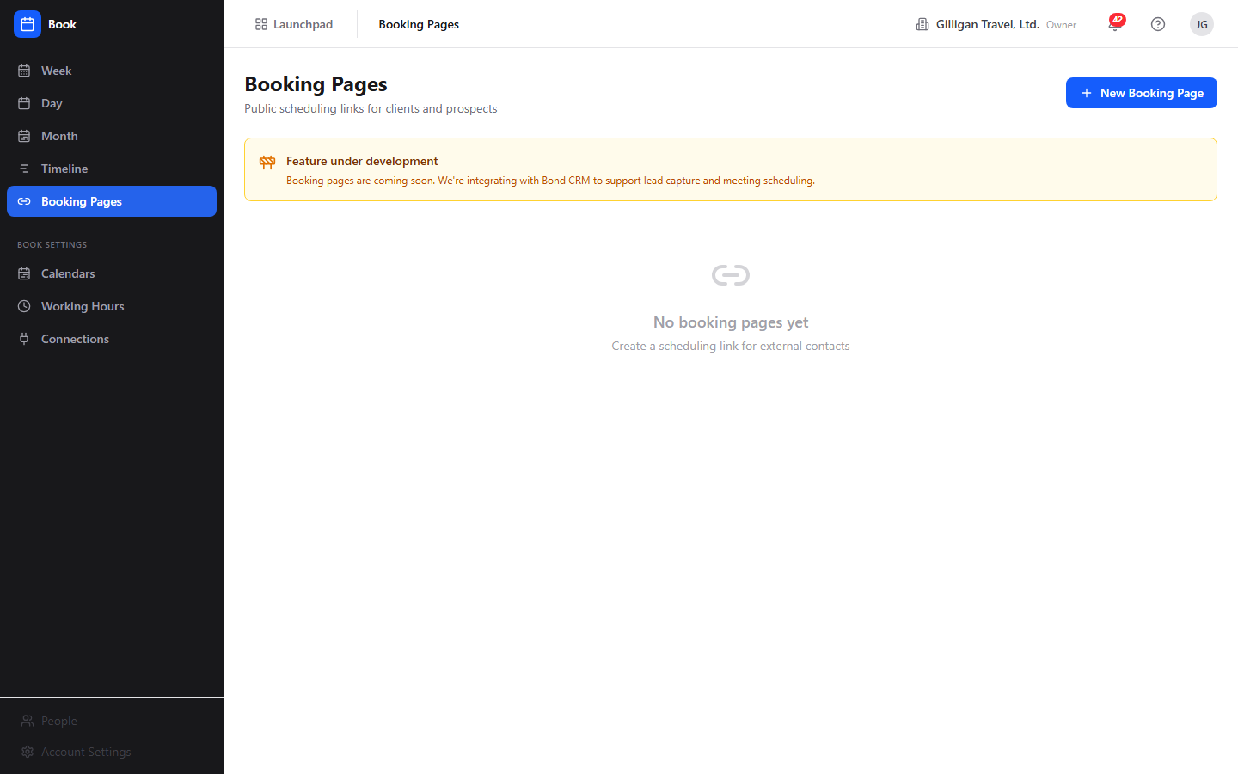
Figure 13.4 Booking pages
To manage booking pages:
1. Click Booking Pages in the sidebar.
2. Each page row shows its title, an Active or Disabled pill, its /meet/<slug> link, its duration ("{n} min"), its creation date, and its description.
3. Click New Booking Page to create one.
4. Click Edit on a page to change it, or the trash icon to delete it (confirm "Delete this booking page?").
Note: the list still renders an amber Feature under development banner that reads "Booking pages are coming soon. We're integrating with Bond CRM to support lead capture and meeting scheduling." That banner is stale. The page list, creation, editing, deletion, the public booking flow, and the on-booking Bond contact creation are all shipped and working. The screenshot above includes this banner.

Booking page editor
The form for creating or editing a booking page. Reached by New Booking Page ("New Booking Page" heading) or Edit ("Edit Booking Page" heading).
To create a booking page:
1. Click New Booking Page.
2. Enter a Title (placeholder "30-Minute Intro Call").
3. Enter a URL Slug after the "/meet/" prefix (placeholder "intro-call"). Slugs use lowercase letters, numbers, and hyphens only, and must be unique within your org. A duplicate slug is rejected with "Slug already in use".
4. Optionally add a Description and adjust Duration (min), Buffer Before (min), Buffer After (min), and Brand Color.
5. Click Create. Use Cancel or Back to Booking Pages to leave.
To edit an existing page:
1. From the Booking Pages list, click Edit on the page you want.
2. The form opens with the heading Edit Booking Page and loads the page's current title, slug, description, duration, buffers, and brand color.
3. Change any field and click Update.
Current limitations:
- The editor exposes only title, slug, description, duration, buffers, and brand color. The booking page model also supports advance limit, minimum notice, confirmation message, redirect URL, logo, an enabled flag, and the cross-app flags auto_create_bond_contact, auto_create_bam_task, and bam_project_id. None of these are surfaced in the editor today, so to change them use the book_update_booking_page MCP tool. Because auto_create_bond_contact defaults to on at the data layer, new pages create a Bond contact on each booking by default even though there is no toggle for it in the editor.
NOTE
The booking-page editor exposes only title, slug, description, duration, buffers, and brand color. Because auto_create_bond_contact defaults to on at the data layer and the editor has no toggle for it, every new page creates or updates a Bond contact by email on each booking. To change that, set the flag with the book_update_booking_page MCP tool.

Public Meet page
The public scheduling page a visitor sees at /book/meet/<slug>. It does not require login. It shows the page title, "with {owner}", the duration, and the description, then a Pick a time section that groups available slots by day, then a Your details form with Full name (required), Email (required), and Notes (optional), and a submit button labelled "Book {time}" (or "Pick a time above" until a slot is chosen). On success it shows a Booking confirmed screen with the page's confirmation message.
To book time as a visitor:
1. Open the page's /book/meet/<slug> link. The available times for the next two weeks load under Pick a time, grouped by day.
2. Click a time slot to select it.
3. Fill in Full name and Email (both required), and an optional note in Notes (optional).
4. Click Book {time}.
5. The page shows the Booking confirmed screen with the owner's confirmation message. If the page has a redirect URL configured, you are sent there instead.
The slots offered come from the owner's working hours minus the events that mark them busy, cut into meeting-sized chunks that respect the page's duration and before and after buffers. Booking creates a confirmed event on the owner's default calendar. Two visitors cannot grab the same slot: the booking is guarded by a row lock, and a collision returns a 409 with "This time slot is no longer available."
TRY IT
Set your Working Hours, create a booking page with a unique lowercase slug, then open its /book/meet/<slug> link in a private window and book yourself a slot. Watch the confirmed event land on your default calendar.
When a booking comes in and the page has auto_create_bond_contact on (the default), Book creates or updates a matching Bond contact by email, attributed to the booking-page owner and tagged with a booking_page lead source. Re-booking with the same email does not create a duplicate contact. The Bam-task hook on booking only runs when a page explicitly enables auto_create_bam_task and sets a bam_project_id, which the editor does not expose; set those with book_update_booking_page if you want each booking to spawn a follow-up task.

Calendars
Manage the calendars you organize events into. Found under Book Settings > Calendars. The heading reads "Calendars" with the subtitle "Manage the calendars you use to organize events".
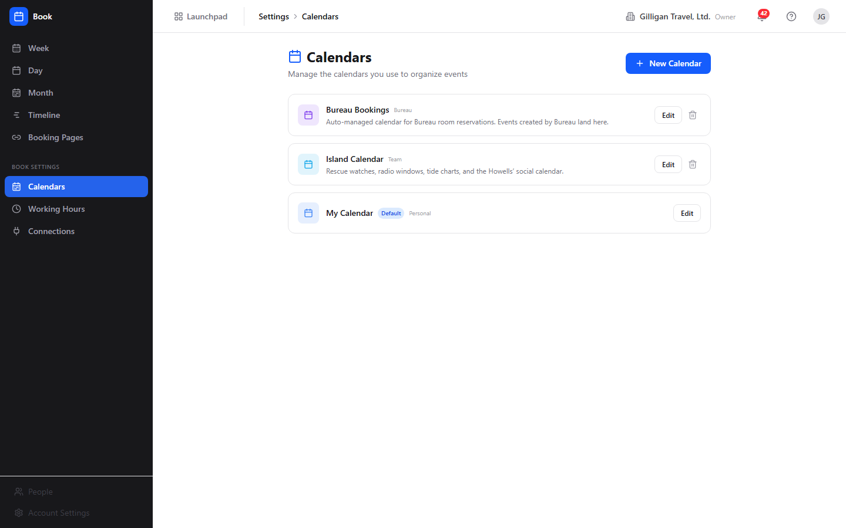
Figure 13.5 Calendars
To manage calendars:
1. Click Calendars under Book Settings.
2. Each calendar row shows its name, a Default pill where applicable, its type (lowercased), and its description.
3. Click New Calendar to open the inline New calendar form. Enter a name, pick a color from the preset swatches, and click Create (or Cancel).
4. To change a calendar, click Edit on its row, adjust the name and color, and click the check (save) button.
5. To remove a calendar, click the trash icon and confirm "Delete calendar [name]?". The default calendar cannot be deleted and has no trash icon; an attempt at the API returns "Cannot delete default calendar".
Note: your personal My Calendar is created automatically the first time this screen loads, so the list is never empty.

Working Hours
Set the weekly hours that drive your availability and booking-page slots. Found under Book Settings > Working Hours. The heading reads "Working Hours" with the subtitle "Set your available hours for booking pages and availability calculations".
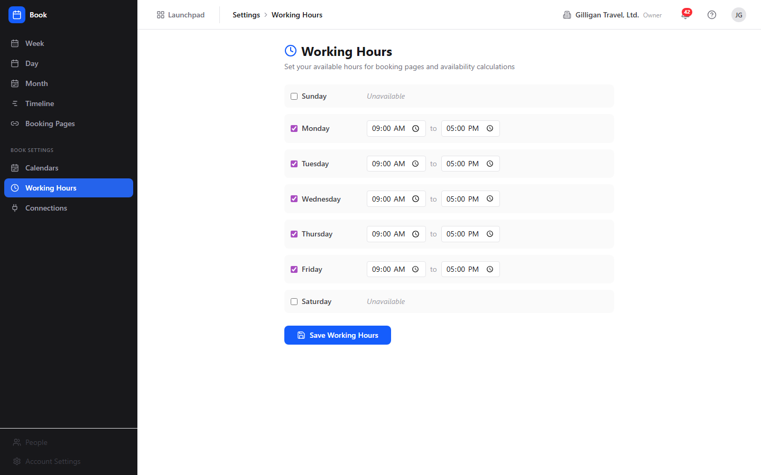
Figure 13.6 Working hours
To set your working hours:
1. Click Working Hours under Book Settings.
2. You see seven rows, Sunday through Saturday. Monday to Friday, 09:00 to 17:00, are enabled by default.
3. Check or uncheck a day to mark it available or "Unavailable".
4. For each enabled day, set its start and end times.
5. Click Save Working Hours. The save replaces your full weekly schedule with the enabled days shown, so make sure every day you want available is enabled before saving.
WARNING
Saving Working Hours is a full replace, not a merge. The save overwrites your entire weekly schedule with whatever days are currently enabled, so any day you forgot to re-enable is dropped. Confirm every day you want available is checked before you click Save Working Hours.

Connections
Subscribe to an outside calendar and pull its events into Book. Found under Book Settings > Connections. The heading reads "External Calendar Connections" with the subtitle "Subscribe to an external calendar feed (.ics URL) to pull its events into Book. Google and Outlook two-way sync require operator-supplied credentials."
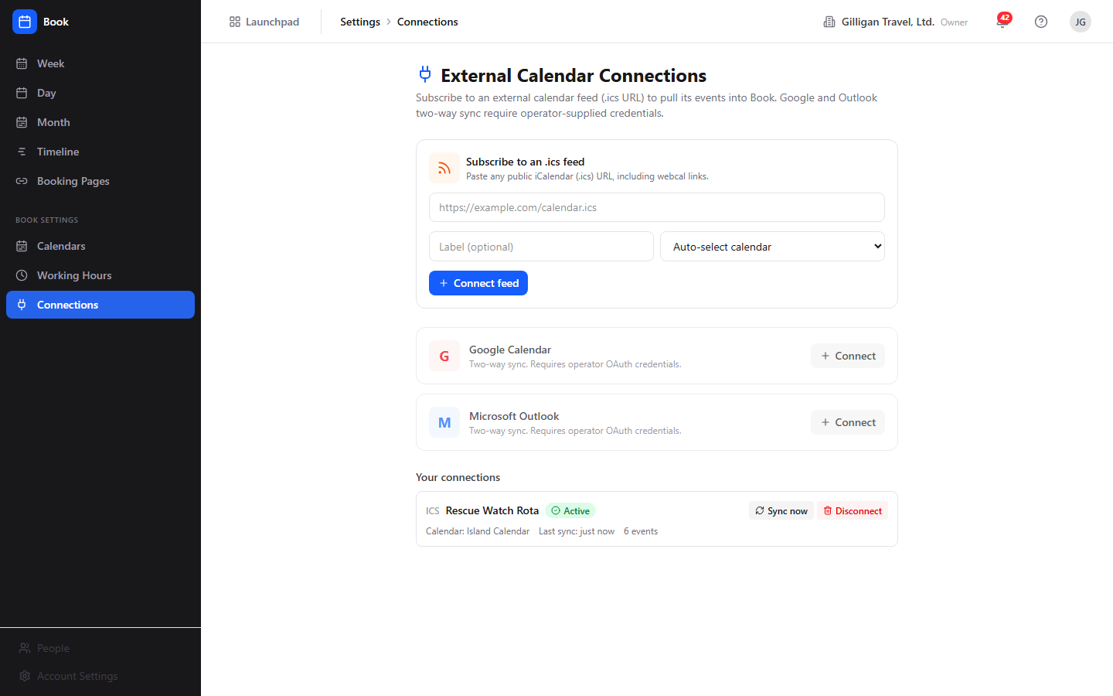
Figure 13.7 Calendar connections
The page has three parts: the .ics feed subscribe form (the working, no-credentials path), the Google Calendar and Microsoft Outlook provider cards (gated on operator OAuth credentials), and Your connections, the list of feeds you have already connected with their sync status.
To subscribe to an .ics feed:
1. Click Connections under Book Settings.
2. In the Subscribe to an .ics feed card, paste a public iCalendar URL (any https://...ics or webcal://... link).
3. Optionally give it a Label and pick the Book calendar to mirror its events into (leave Auto-select calendar to use your default).
4. Click Connect feed. Book validates the URL, stores it, and the connection appears under Your connections.
5. Click Sync now on the connection to pull the feed immediately. The card shows a green Active pill, the time of the last sync, and the count of events synced, along with a "Synced: N pulled, N added, N updated, N removed" line.
How sync works:
- Book fetches the feed, parses its events, and creates a matching Book event for each on the target calendar. A re-sync updates those events in place (it does not create duplicates), removes any that were cancelled or vanished upstream, and re-adds any you deleted by hand.
- Syncs also run on their own: a background sweep refreshes every .ics connection roughly every fifteen minutes, so a subscribed calendar stays current without you pressing Sync now.
- Click Disconnect to remove a connection. This also removes every event Book mirrored from that feed, so the calendar returns to just your own events.
- .ics feeds are read-only sources: Book pulls events in but never pushes your Book events back out to the feed.
Google and Outlook: the Google Calendar and Microsoft Outlook cards offer the same sync engine with two-way sync, but their Connect buttons stay disabled until an operator sets the provider credentials on the server (GOOGLE_CLIENT_ID / GOOGLE_CLIENT_SECRET for Google, MICROSOFT_CLIENT_ID / MICROSOFT_CLIENT_SECRET for Microsoft). Until then, use an .ics feed URL, which most calendar apps (including Google and Outlook) can publish for any calendar you own.

iCal feed
Book can expose a single calendar as a token-authenticated .ics feed that an outside calendar app (Apple Calendar, Google Calendar) can subscribe to.
There is no button for this in the app. The feed is available through the API only: mint a feed token for a calendar with POST /calendars/:id/ical, then hand the resulting GET /calendars/:id/ical?token=... URL to your external calendar app. If you need this, ask an admin or an agent to mint the token for the calendar you want to share.

In-app Help
Press ? anywhere in Book (when you are not typing in a field), or navigate to /book/help, to open the shared Help viewer for Book.

Working with AI agents
Agents reach Book through 25 MCP tools. They use the same Book API and permissions you do, so an agent can only do what its account is allowed to do. Agents are especially useful for the scheduling math that Book has no human screen for: finding a common free time across several people.
An agent can intersect everyone's calendars and hand back a meeting time, the one scheduling job Book has no human screen for.
- Reading events and the timeline: book_list_events (the data behind Week, Day, Month reads), book_get_event (one event with attendees and linked-entity context), and book_get_timeline (the cross-app Timeline data).
- Creating and changing events: book_create_event (resolves a calendar by name and an attendee by email, and can set attendees, which the human form cannot), book_update_event and book_cancel_event (resolve an event by UUID or title), and book_rsvp_event (RSVP by event UUID or title).
- Availability and meeting time: book_get_availability (one person's free slots), book_get_team_availability (free slots for two or more people), book_find_meeting_time (intersects team availability and returns up to three suggestions), and book_find_meeting_time_for_users (a mixed-roster finder that treats agents and service accounts as always available while respecting human working hours). These four have no human UI in Book today, so they are the main reason to involve an agent.
- Calendars: book_list_calendars, book_create_calendar, book_update_calendar, book_delete_calendar (the last three resolve a calendar by UUID or name).
- Booking pages: book_list_booking_pages, book_create_booking_page, book_update_booking_page (set enabled: false to take a page offline without deleting it, or set the cross-app flags the editor does not expose), and book_delete_booking_page.
- Working hours: book_get_working_hours and book_set_working_hours (a full replace; include every day you want available).
- External connections: book_create_connection (subscribe to an .ics feed URL, the no-OAuth path), book_list_connections (status of every connection, with feed URLs and tokens redacted), book_sync_connection (force a sync and get the imported/created/updated/removed counts back), and book_delete_connection (remove a connection and its mirrored events). Google and Microsoft connections cannot be created until an operator supplies the OAuth credentials.
Things to know when reviewing agent work:
- An agent can add attendees at creation time even though the human event form cannot. Check the attendee list on the event detail page to confirm who was invited.
- book_update_booking_page is the way to set the booking-page options the human editor does not surface (advance limit, minimum notice, confirmation message, redirect URL, logo, the enabled flag, and the cross-app auto-create flags).
- Some caveats that apply to people apply to agents too: recurrence is not expanded and reminders do not exist. An agent cannot work around these because the backend does not implement them. External calendar sync, by contrast, does run: an agent can subscribe to an .ics feed and sync it with book_create_connection and book_sync_connection.
- Book publishes five automation events to Bolt, all from source book: event.created, event.updated, event.cancelled, event.rsvp, and booking.created. Use these to drive cross-app automations (for example, post to a Banter channel when a booking comes in). A new public booking creates or updates a Bond contact by email when the page has auto_create_bond_contact on, so a booking.created automation can safely assume the matching contact exists.
Book agents also sit on the cross-cutting agentic platform that every BigBlueBam app shares:
- Identity and heartbeat. Agent and service accounts are first-class users (users.kind is human, agent, or service), and the actor type is recorded on every action they take. Agent runners report in with agent_heartbeat, agent_self_report, and agent_audit.
- Approval queues. An agent can route a scheduling change for human sign-off with proposal_create; reviewers act on it with proposal_list and proposal_decide. This is the right pattern when an agent wants to move or cancel an event on someone else's behalf.
- Visibility preflight. Before an agent surfaces another person's calendar items in a shared place, it calls can_access so it only shows entities the asking user is allowed to see.
- Policies and webhooks. Per-agent kill switches and tool allowlists (the book.* prefix governs these Book tools) are enforced on every service-account call, and subscribed Bolt events can be pushed to agent runners over signed outbound webhooks.
For the full tool catalog and schemas, see the Book MCP-tools reference and guide in docs/apps/book/.

User Stories

Story: Set your working hours
Who: Any Book user getting started.
Goal: Define the weekly windows that determine when you are available.
Before you start: Be signed in to BigBlueBam and have Book open.
Steps
1. In the sidebar, under Book Settings, click Working Hours.
2. Review the seven day rows. Monday to Friday, 09:00 to 17:00, are enabled by default.
3. Check the days you want to be available and uncheck the rest (unchecked days show "Unavailable").
4. For each enabled day, set the start and end times.
5. Click Save Working Hours.
Result: Your weekly availability is saved. Book now uses these windows when it computes free slots for availability and for any booking pages you publish.
Related: Working Hours feature; availability tools book_get_availability and book_get_team_availability. Agents can set the same schedule with book_set_working_hours.

Story: Schedule a one-off meeting
Who: Anyone planning a meeting or a block of focused time.
Goal: Put a single event on a calendar.
Before you start: Be signed in. At least one calendar exists (your My Calendar is created automatically).
Steps
1. Open any calendar view (Week, Day, or Month) and click New Event.
2. Enter a Title (for example "Team standup").
3. Choose a Calendar (your default is preselected).
4. Leave All day off and set Start and End, or turn All day on and set Start Date and End Date.
5. Optionally add a Description, a Location, a Repeat value, and a Show as value.
6. Click Create Event.
Result: The event appears on the chosen calendar and shows in the Week, Day, and Month views. If you marked it Busy, Tentative, or Out of Office, it now reduces your availability.
Related: New Event feature. Agents do the same with book_create_event, which can also add attendees.

Story: View and adjust an event
Who: Anyone updating a meeting's details.
Goal: Change the time, location, or description of an existing event.
Before you start: The event exists and you have permission to update it.
Steps
1. In a calendar view, click the event. This opens the Edit Event form directly.
2. Change any field, for example Start, End, Location, or Description.
3. Click Update Event.
Result: The event is updated everywhere it appears.
Related: New Event and Edit Event feature. To see an event's read-only detail and attendee list instead, open its direct URL (/book/events/<id>). Agents update events with book_update_event.

Story: Cancel an event
Who: Anyone calling off a meeting.
Goal: Remove an event from calendars and availability without losing its record.
Before you start: The event exists and you can delete it.
Steps
1. Open the event's detail page at its direct URL (/book/events/<id>).
2. Click Cancel (the trash icon).
3. Confirm "Cancel this event?".
Result: The event's status becomes cancelled. It disappears from availability and the timeline but its record is retained (soft delete).
Related: Event detail feature. Agents cancel with book_cancel_event.

Story: RSVP to an invitation
Who: An attendee invited to an event.
Goal: Tell the organizer whether you will attend.
Before you start: You are listed as an attendee on the event.
Steps
1. Open the event's detail page (/book/events/<id>).
2. Find the Your response panel.
3. Click Accept, Maybe, or Decline. "Maybe" records a tentative response.
Result: Your response status updates in the Attendees list. If you are not an attendee, the response is rejected.
Related: Event detail and RSVP feature. Agents RSVP with book_rsvp_event.

Story: Manage multiple calendars
Who: Anyone separating work into distinct calendars.
Goal: Add, rename, recolor, or remove calendars.
Before you start: Be signed in with calendar write permission.
Steps
1. Under Book Settings, click Calendars.
2. Click New Calendar, enter a name, pick a color swatch, and click Create.
3. To change a calendar, click Edit on its row, adjust the name and color, and click the check (save) button.
4. To remove a non-default calendar, click its trash icon and confirm "Delete calendar [name]?".
Result: Your calendar list reflects the changes. The default calendar stays put; it has no trash icon and the API rejects an attempt to delete it with "Cannot delete default calendar".
Related: Calendars feature. Agents manage calendars with book_list_calendars, book_create_calendar, book_update_calendar, and book_delete_calendar.

Story: Create and share a public booking page
Who: Someone who wants outside people to book time with them.
Goal: Publish a scheduling link at /book/meet/<slug> and share it.
Before you start: Set your Working Hours first, since they define the offered slots. Have booking-page write permission.
Steps
1. Click Booking Pages in the sidebar, then New Booking Page.
2. Enter a Title (for example "30-Minute Intro Call").
3. Enter a URL Slug after "/meet/" using lowercase letters, numbers, and hyphens (for example "intro-call").
4. Optionally set Description, Duration (min), Buffer Before (min), Buffer After (min), and Brand Color.
5. Click Create.
6. Copy the page's /meet/<slug> link from the Booking Pages list and share it. To change the page later, click Edit on its row.
Result: The page appears in your Booking Pages list with an Active pill and its /meet/<slug> link. A visitor who opens the link sees your available times, picks a slot, and books; the booking lands as a confirmed event on your default calendar, and a matching Bond contact is created or updated by email (unless the page's auto_create_bond_contact flag has been turned off).
Related: Booking Pages list, Booking page editor, and Public Meet page features. Agents create pages with book_create_booking_page and edit them (including the options the editor does not surface) with book_update_booking_page.

Story: Book time as an outside visitor
Who: A prospect or client with a booking-page link.
Goal: Reserve a time on the page owner's calendar.
Before you start: You have a /book/meet/<slug> link. No login is required.
Steps
1. Open the link. Under Pick a time, the next two weeks of available slots load, grouped by day.
2. Click a time slot to select it.
3. Fill in Full name and Email, and an optional Notes (optional).
4. Click Book {time}.
Result: You see the Booking confirmed screen with the owner's confirmation message (or you are sent to the page's redirect URL, if set). The owner's default calendar gains a confirmed event, and a Bond contact is created or updated from your email when the page has that on.
Related: Public Meet page feature. The booking emits a booking.created Bolt event from source book, which Bolt rules can react to.

Story: See everything happening this week across apps
Who: Anyone who wants a single week-at-a-glance across the suite.
Goal: Scan Book events, Bam task due dates, and Bond deal close dates together.
Before you start: Be signed in.
Steps
1. Click Timeline in the sidebar.
2. Read the date-range heading (for example "Timeline: Jun 9 - Jun 15, 2026").
3. Move between weeks with the left and right chevron arrows, or click This Week.
4. Scan the per-day items, using the source labels and the "Book Events / Bam Tasks / Bond Deals" legend.
Result: You see the week's items grouped by day. Book events show in blue with their time, Bam tasks in orange on their due date, and Bond deals in teal on their close date. Click a Book item to open its event.
Related: Timeline feature. Agents read the same data with book_get_timeline.

Story: Find a common meeting time across several people (agent-driven)
Who: A user working with an AI agent, or the agent itself.
Goal: Identify a time when everyone on a list is free.
Before you start: Each person has set their Working Hours, and you have an agent with Book access. There is no human screen for this in Book today, so it runs through an agent.
Steps
1. Ask the agent to find a meeting time for the people you name (by email is fine; the tools resolve identifiers).
2. The agent calls book_get_team_availability to gather each person's free slots, or book_find_meeting_time to get up to three suggested times directly.
3. For a roster that mixes people with agents or service accounts, the agent uses book_find_meeting_time_for_users, which treats agents and service accounts as always available while honoring human working hours.
4. Review the suggested times and ask the agent to create the event with book_create_event.
Result: You get one or more candidate times that fit everyone's availability, and an event can be created on the spot.
Related: Working with AI agents. Tools: book_get_availability, book_get_team_availability, book_find_meeting_time, book_find_meeting_time_for_users, book_create_event.

Story: Subscribe to a Book calendar from an outside app (iCal, agent or API)
Who: Someone who wants a Book calendar to appear in Apple Calendar or Google Calendar.
Goal: Get a subscribable .ics feed URL for one calendar.
Before you start: There is no button for this in Book. You need an admin or an agent to mint the feed token through the API.
Steps
1. Ask an admin or agent to mint an iCal feed token for the specific calendar you want to share (POST /calendars/:id/ical).
2. Receive the public feed URL with its ?token=... query (GET /calendars/:id/ical?token=...).
3. In your external calendar app, add a subscribed calendar by URL and paste the feed URL.
Result: Your outside calendar app shows that Book calendar's events. There is no in-app control to generate or revoke the feed today.
Related: iCal feed feature.

Related
- Bam (/b3/) - Sign in here first; Book has no login of its own. Bam tasks with due dates appear on the Book Timeline, and events can link to a Bam task.
- Bond (/bond/) - Bond deal close dates appear on the Book Timeline, and events can link to a Bond deal. A public booking creates or updates a Bond contact by email when the page has auto_create_bond_contact on (the default).
- Helpdesk (/helpdesk/) - Events can link to a Helpdesk ticket.
- Bolt (/bolt/) - Subscribe to Book's automation events (event.created, event.updated, event.cancelled, event.rsvp, booking.created, all from source book) to drive cross-app workflows.
- Banter (/banter/) - A common automation target, for example posting to a channel when a booking arrives.
- Book MCP-tools reference and guide in docs/apps/book/ for the full catalog of the 25 agent tools and their schemas.

Check yourself
Every answer is findable in this chapter. Check your work against the Answer Key appendix at the back of the book.
1. What is created for you automatically the first time you open Book, and can it be deleted?
a) A team calendar; yes, it can be deleted
b) A personal calendar named My Calendar; no, it cannot be deleted
c) A booking page; yes, it can be deleted
d) Nothing is created until you add a calendar
2. What status and visibility does a brand-new event get by default?
a) status tentative, visibility free
b) status confirmed, visibility busy
c) status confirmed, visibility free
d) status cancelled, visibility out_of_office
3. When you cancel an event, what actually happens to it?
4. Which event visibility setting does NOT consume an availability slot?
a) Busy
b) Free
c) Tentative
d) Out of Office
5. What are the default working hours when you first set up Book?
6. Where does the event created by a public booking land?
a) On a new calendar created for the booking
b) As a confirmed event on the page owner's default calendar
c) On the visitor's calendar
d) Nowhere until the owner accepts it
7. Which two controls appear on the New Event form but do nothing when you save, and why?
8. What happens if you choose a Repeat option like Weekly on an event?
a) Book generates all future occurrences immediately
b) The rule is stored on the single event but not expanded, so it remains one event
c) The event is rejected as unsupported
d) It creates a recurring booking page
9. Which calendar feed provider works today with no credentials, and which two require operator-supplied OAuth before they can be connected?
10. Roughly how often does the background sweep refresh every .ics connection on its own?
a) Every minute
b) Every fifteen minutes
c) Once an hour
d) Once a day
11. What does disconnecting an .ics feed do to the events Book pulled from it?
12. When two visitors try to grab the same booking slot at once, what stops a double-booking?
a) The slot is simply offered to both
b) A row lock guards the booking, and a collision returns a 409 'This time slot is no longer available'
c) The second visitor is silently dropped
d) Both bookings are created and merged later
13. Why can't you add attendees from the human New Event form, and how can attendees be added instead?

CHAPTER 14

Brief
Write together, ship the words.

Brief is where your team writes together. Every document is a rich-text page you can co-edit live, comment on in the margins, version, and organize into folders scoped to a project. This chapter takes you from a blank page to a published document, shows how two people type at once without stepping on each other, and points out where an AI agent can do the things the buttons cannot. By the end you will be able to write, format, publish, and promote a document, and find any of them fast.
At a glance
- Rich-text editing on Tiptap, with a formatting toolbar and slash commands
- Real-time co-editing with live cursors and presence, merged conflict-free
- Four-status lifecycle: Draft, In Review, Approved, and Archived
- Folders, project scope, versions, comments, and stars to keep work tidy
- Promote a finished document one-way into a Beacon knowledge-base article
In this chapter
Overview . Key concepts . Where to find it . Feature reference . Home . Browse the document list . Create a document . Write and format . The "Brief summary (optional)" field . Set visibility
Brief is your team's collaborative document editor: a place to write, format,
co-edit, comment on, and organize documents, then promote the ones that
matter into your knowledge base. Reach for it when you need a shared,
structured document that more than one person works on at once.

Overview
Brief stores your team's writing as Documents. Each document has a title, a
URL slug, an optional icon, a rich-text body, a status, a visibility level, an
optional project, and an optional folder. Documents are edited in a rich-text
editor (built on Tiptap) with a formatting toolbar and slash commands, and two
or more people can type in the same document at the same time with live cursors.
Beyond writing, Brief organizes documents into Folders and scopes them to
Projects, keeps numbered Versions as you publish, supports threaded and
text-anchored Comments for review, lets you Star documents for quick
access, and can Promote a finished document into a Beacon knowledge-base
article. Documents can also be Linked to Bam tasks and Beacon articles so
related work stays connected.
Brief is part of the BigBlueBam suite. It shares your platform login with Bam
and the other apps, pulls its project list from Bam, and publishes events to
Bolt so automations can react when a document is created, updated, published, or
promoted. Search runs as keyword search over titles and body text, with optional
semantic search when a vector store is configured.
Brief is currently in BETA. The sidebar header shows a beta badge.

Key concepts
- Document - A single piece of writing. It has a title, a globally unique
slug, an optional icon (up to 2 characters), a rich-text body, a word count, a
status, a visibility, an optional project, and an optional folder.
- Editor - The Tiptap rich-text surface where you write. It has a formatting
toolbar, slash commands (type /), a live word count, a Table of Contents
built from your headings, and a Settings sidebar for icon, visibility,
project, and starting template.
- Status - The document's place in its lifecycle. The four statuses are
Draft, In Review, Approved, and Archived. New documents start
as Draft. Saving a draft keeps it Draft; publishing sets it to Approved. There
is no button in the editor that sets In Review today; that status is set only
through the API or an agent (see Working with AI agents).
- Visibility - Who can see the document. There are three valid levels:
Organization (all org members), Project (the creator, collaborators,
or members of that project), and Private (the creator and collaborators
only). The editor's Visibility menu also lists a "Public" option, but Public
is not a valid setting and selecting it produces a validation error; choose
Organization, Project, or Private instead (see Set visibility).
- Folder - A named container for documents. Folders can be nested and can be
scoped to a project. You create folders from the sidebar; renaming and deleting
folders is not available in the UI today (an agent can do both, see Working
with AI agents).
- Project scope - A filter in the sidebar that limits the documents and
folders you see to one project, or shows everything with "All Projects".
- Version - A numbered snapshot of a document. Versions are listed read-only
in the document detail sidebar; creating and restoring versions is done through
the API or an agent (see Working with AI agents).
- Comment - A note on a document. Comments can be threaded (a reply to
another comment) and can be anchored to a span of text. Comments can be marked
resolved and appear in the detail sidebar.
- Star - A per-user bookmark on a document. Starred documents show on the
Home and Starred screens.
- Template - A pre-built starting point for a new document. You pick a
template from the Templates screen and the editor pre-fills with its content.
- Link - A typed connection from a document to a Bam task or a Beacon
article. Links show read-only under "Linked Items" in the detail sidebar;
creating links is done through an agent or the API (see Linked Items).
- Promote to Beacon - Graduating a finished document into a Beacon
knowledge-base article. This is one-way: once promoted, the document records
the Beacon it became.
- Real-time collaboration - Two or more people editing the same document at
once. You see other editors' cursors and presence while you type, and readers
on the detail page see edits appear live.
NOTE
Brief has no editor button for the In Review status. The two save buttons only produce Draft or Approved; In Review is set through the API or by an agent with brief_update.

Where to find it
Brief lives at /brief/. You must be logged in to BigBlueBam first; Brief has
no login of its own and uses the shared platform session. If you are not signed
in, Brief shows a gate page with a link to the BigBlueBam login at /b3/.
The left sidebar has five navigation items: Home (/), Documents
(/documents), Templates (/templates), Search (/search), and
Starred (/starred). Below the nav is a Folders section with a button
to add a folder, and a project-scope selector at the top of the sidebar that
shows the active project name or "All Projects".
What you can do depends on your role and on each document's visibility. Editing a
document requires edit access: you are the document's creator, or a SuperUser, or
an org Admin or Owner (admins and owners can edit any document in the org).
Creating documents, folders, and links, and promoting to Beacon, each require
the matching permission and the read_write scope on your session or API key.
Press the ? key (when your cursor is not in a text field) to open the in-app
help from any Brief screen.
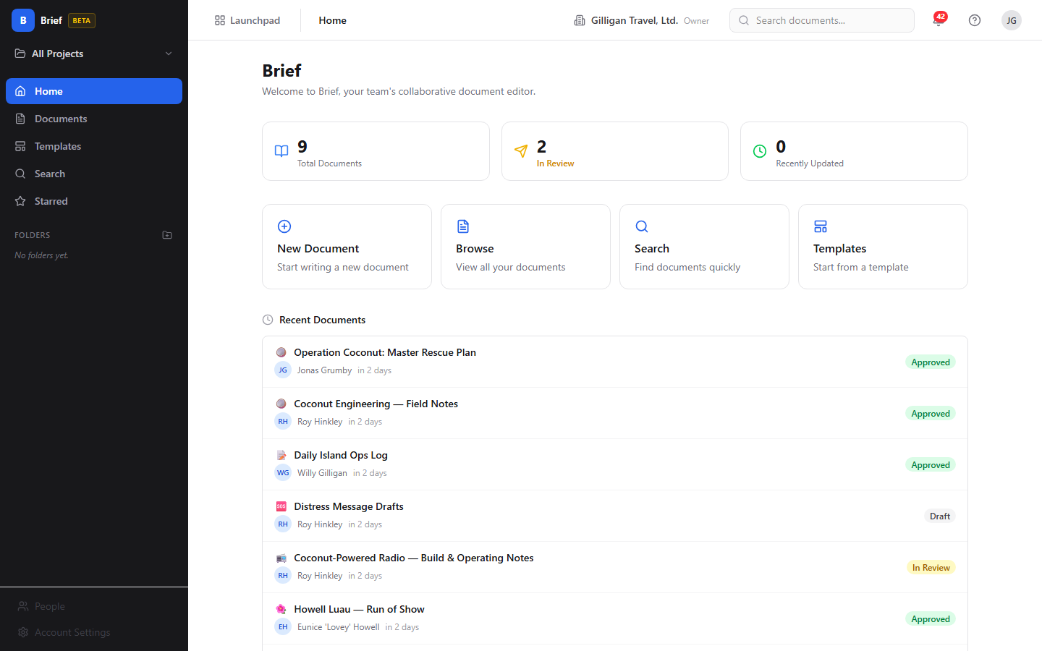
Figure 14.1 Brief home

Feature reference

Home
The Home screen welcomes you and gives quick entry points into Brief. It lives at
/brief/ and shows three stat cards, four quick-action cards, and lists of your
recent and starred documents.
What you see:
1. A header reading "Brief" and "Welcome to Brief, your team's collaborative
document editor."
2. Three stat cards: Total Documents, In Review, and Recently
Updated. Each card links to the Documents list when clicked. Note: the
"Recently Updated" card always reads 0 today; use the Documents list sorted by
update time to find recent work.
3. Four quick-action cards: New Document (opens the editor at /new),
Browse (opens the Documents list), Search (opens Search), and
Templates (opens the Templates browser).
4. A Recent Documents list of up to 8 documents and a Starred Documents
list of up to 5, each row showing the icon, title, author, and status.

Browse the document list
The Documents list shows every document you can see, with filters. It lives at
/documents.
To browse and filter documents:
1. Open Documents from the sidebar.
2. Use the "Search documents..." box in the toolbar to filter the visible
cards by title text.
3. Use the status chips - All, Draft, In Review, Approved,
Archived - to filter by status.
4. The toolbar shows the current scope as "Showing docs for: &lt;project&gt;" or
"Showing all org documents", set by the sidebar project-scope selector. If you
arrived through a folder, a folder filter chip appears with an X to clear it.
5. Click any document card to open its detail page. Each card shows the icon,
title, a star if pinned, the author, a relative time, the word count, and a
status badge.
6. If there are more results, click Load more to page through them.
If no documents match, the list shows "No documents yet. Create your first one."
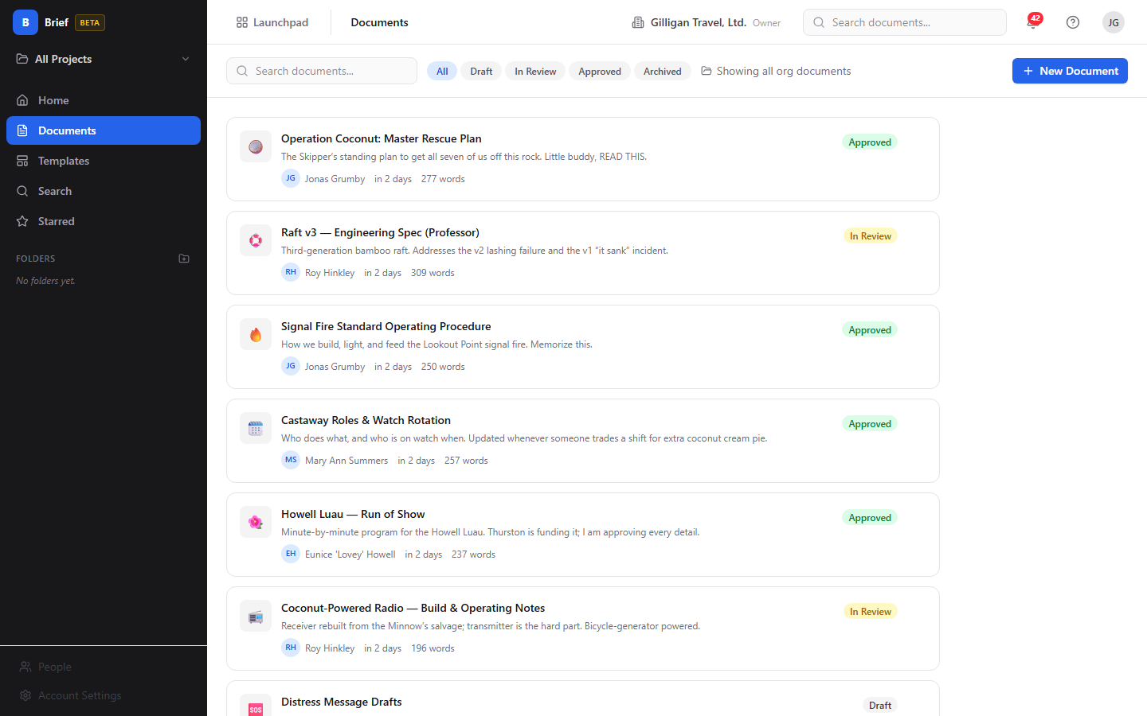
Figure 14.2 Document list

Create a document
You create documents in the editor, either blank or from a template.
To create a new document:
1. Click New Document on Home, or New Document in the Documents toolbar.
This opens the editor at /new.
2. Type a title in the "Document title..." field at the top.
3. Write your content in the body. Use the toolbar, slash commands, or both (see
Write and format).
4. Optionally set the icon, visibility, project, and starting template in the
right sidebar (see Set visibility, Choose a project, and Start from a
template).
5. Click Save Draft to save it as a Draft, or Publish to save it as
Approved.
When you save, Brief takes you to the new document's detail page.
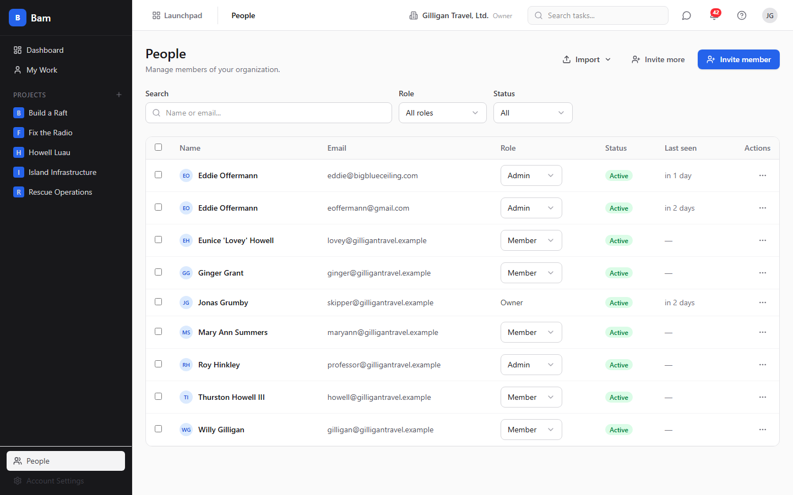
Figure 14.3 Document editor

Write and format
The editor gives you a formatting toolbar, slash commands, and inline embeds.
To format text with the toolbar:
1. In the editor, select the text you want to format.
2. Use the toolbar to apply a block style (Paragraph, Heading 1 through
Heading 4), inline styles (Bold, Italic, Underline,
Strikethrough, Inline code), alignment (left, center,
right), Highlight, lists (Bullet, Ordered, Task list),
Blockquote, or Code block.
3. To add a link, click the link button, type a URL, and click Add. To add
an image, click the image button and provide a URL when prompted. Use
Insert table (3x3) to drop in a table and the horizontal-rule button for a
divider.
4. Use Undo and Redo to step backward or forward.
To use slash commands:
1. In the body, type / on a new line.
2. Pick from the menu: Heading 1, Heading 2, Heading 3, Bullet
List, Numbered List, Task List, Code Block, Blockquote,
Horizontal Rule, Table, or Image.
The footer shows a live word count as you type. The right sidebar shows a
Table of Contents built from your headings.
Note: the editor renders task-embed, mention, callout, beacon-embed, and
channel-link nodes if a document already contains them, but the toolbar and slash
menu do not include a control to insert a Beacon embed or a mention.

The "Brief summary (optional)" field
Below the toolbar the editor shows a "Brief summary (optional)..." input.
This field is not stored by Brief today; anything you type in it is dropped on
save and will not appear on the document later. Treat it as non-functional and
put any summary text in the document body instead.
TIP
Skip the "Brief summary (optional)" input. Anything you type there is dropped on save and never appears on the document. Put summary text in the body instead.

Set visibility
Visibility controls who can open a document. You set it in the editor's right
sidebar under Settings.
To set visibility:
1. In the editor, find the Visibility menu in the right sidebar.
2. Choose Organization (all org members), Project (creator,
collaborators, or project members), or Private (creator and collaborators
only).
3. Save or publish the document.
Do not choose Public. The menu lists it, but Public is not a valid value and
selecting it makes the save fail with a validation error. The three valid
choices are Organization, Project, and Private. New documents default to
Organization in the editor.
WARNING
The Visibility menu lists Public, but it is not a valid value. Selecting it makes the save fail with a validation error. Choose Organization, Project, or Private instead.

Set an icon
To give a document an icon:
1. In the editor's right sidebar under Settings, find Icon (emoji).
2. Type a short emoji or up to 2 characters.
3. Save or publish. The icon shows on cards, lists, and the detail header.

Choose a project
You can scope a new document to a project so it appears under that project's
filter.
To choose a project for a new document:
1. In the editor's right sidebar, find Project (optional) (shown only when
creating, not when editing an existing document).
2. Choose a project, or choose Organization-wide (no project) to leave it
unscoped.
3. Save or publish.

Start from a template
Templates give you a pre-built starting point.
To start a document from a template:
1. Open Templates from the sidebar. Each card shows an icon, name, category,
and description.
2. Click a template card. Brief opens the editor pre-filled with that template's
content.
3. Finish writing and click Save Draft or Publish.
Alternatively, when creating a blank document you can pick a template from the
Start from template menu in the editor sidebar (choose Blank document for
none).
If there are no templates, the Templates screen shows "No templates available
yet." with "Templates can be created by administrators." There is no
template-authoring screen in Brief today; templates come from the API, an agent,
or seed data. An agent can create, update, and delete org-level templates (see
Working with AI agents).
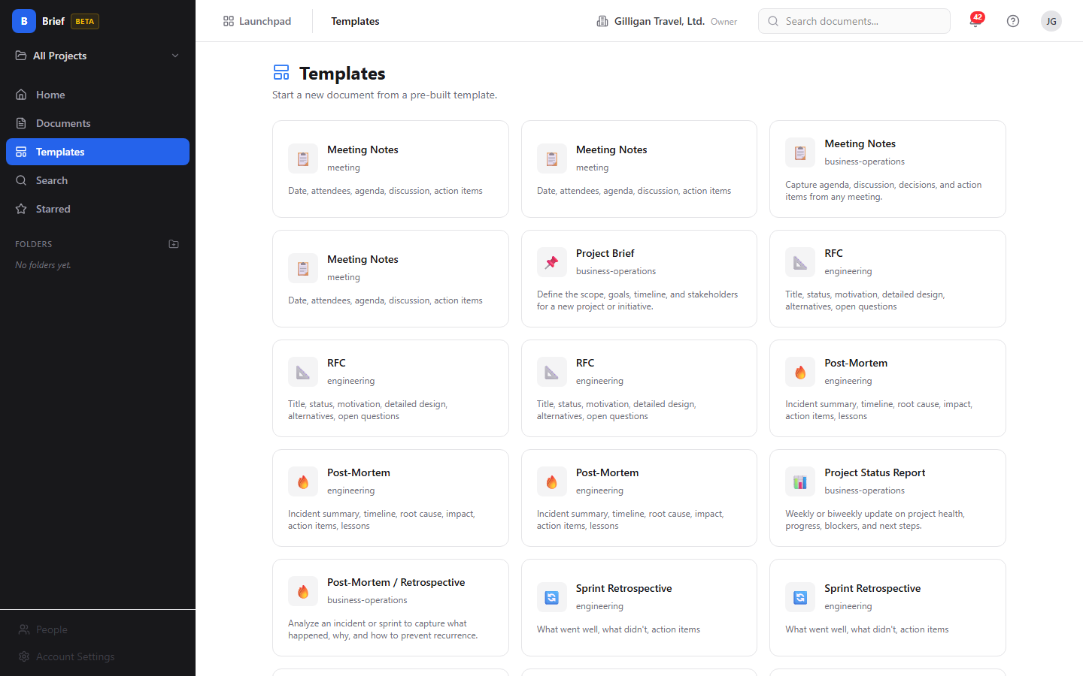
Figure 14.4 Template browser

Save a draft and publish
The editor has two save buttons in the header.
- Save Draft keeps the document's status as Draft.
- Publish sets the document's status to Approved.
To publish a document:
1. In the editor, finish your title and content.
2. Click Publish. The status becomes Approved and Brief returns you to the
document detail page.
A title is required before either button is enabled.

Read a document
The document detail page shows the document and its metadata. It lives at
/documents/:idOrSlug.
What you see:
1. A header with the icon, title, status badge, a star toggle, and an Edit
button that opens the editor.
2. The document body. While someone is editing, readers see edits appear live.
If a document has no content, the body shows "No content yet."
3. An action bar with Duplicate, Export, Promote to Beacon, and
Archive (or Restore when the document is archived).
4. A right sidebar with Status, Author, Project (or
"Organization-wide" if none), Created, Last Updated, Published
(when present), Word Count, Version, Linked Items, and
Comments.
Note: the Published date and the Version number are not stored by Brief
today, so the Published row may be absent and the Version button can read
"vundefined". The version list that expands underneath it is populated only if
versions were created through the API or an agent.

Figure 14.5 Document detail

Edit an existing document and co-edit in real time
To edit a document:
1. Open the document and click Edit, or open it directly at
/documents/:idOrSlug/edit.
2. Make your changes. Your edits sync live to anyone else in the same document.
3. The header shows presence chips for everyone currently editing.
4. Click Save Draft or Publish when done.
When two or more people open the same document's editor, each sees the others'
cursors and presence, and readers on the detail page see the changes as they
happen. Brief uses a conflict-free shared editing model (Yjs) over the
/brief/ws WebSocket, so concurrent edits merge without overwriting each other.
Two people, one document, live cursors. Edits merge conflict-free, so nobody overwrites anybody.

Comments
Comments let your team review a document in the detail sidebar. A comment can be
a top-level note, a threaded reply, or anchored to a span of text.
To add a comment:
1. Open the document.
2. In the right sidebar under Comments (N), type into the "Add a
comment..." box.
3. Click Comment.
To resolve a comment, use the Resolve control on the comment. The comment's
author, or an org Admin or Owner or SuperUser, can delete a comment.

Star a document
Starring bookmarks a document for quick access from Home and Starred.
To star or unstar a document:
1. Open the document.
2. Click the star button in the header. Its tooltip reads Star document when
not starred and Remove star when it is.
3. Find your starred documents on the Starred screen and in the Starred list
on Home.

Duplicate a document
To make a copy:
1. Open the document.
2. Click Duplicate in the action bar. Brief creates a Draft copy named
"&lt;title&gt; (copy)" and opens it.

Export a document
To export a document to a file:
1. Open the document (or open it in the editor).
2. Click Export in the action bar or editor header.
3. Choose Markdown (.md) or HTML (.html). The file downloads.

Archive and restore
Archiving hides a document from normal lists; you can restore it later.
To archive a document:
1. Open the document.
2. Click Archive in the action bar.
To restore an archived document:
1. Filter the Documents list by the Archived status chip and open the
document, or open it by URL.
2. Click Restore in the action bar. The document returns to Draft status.

Promote to Beacon
When a document is ready to become lasting knowledge, promote it into a Beacon
article.
Promote graduates a finished document straight into a Beacon article, one way and on purpose.
To promote a document:
1. Open the document.
2. Click Promote to Beacon in the action bar.
3. Brief creates a Beacon article from the document and takes you to it at
/beacon/<id>.
Promotion is one-way; a document that has already been promoted cannot be
promoted again.

Linked Items
The detail sidebar shows a read-only Linked Items section listing the Bam
tasks and Beacon articles connected to the document. Task links open in Bam at
/b3/tasks/:id and Beacon links open in Beacon.
There is no button in the Brief UI to create or remove a link. Links are created
and removed through an agent or the API (see Working with AI agents).

Folders and project scope
Folders and the project-scope selector live in the sidebar and filter what you
see.
To create a folder:
1. In the sidebar Folders section, click the add (+) button.
2. Type a name in the inline "Folder name" input.
3. Press Enter to save, or Escape to cancel.
To filter by project scope:
1. Click the project-scope selector at the top of the sidebar.
2. Choose All Projects or a specific project. Documents and folders filter to
that scope.
Renaming, moving, and deleting folders are not available in the Brief UI today;
an agent or the API can do all three (see Working with AI agents).

Search
Search finds documents by title, body content, or author.
To search:
1. Open Search from the sidebar, or click the "Search documents..." box
in the header (which opens the Search screen).
2. Type at least 2 characters in the "Type to search..." box.
3. Results list each document's title, creator, time, and status. Click a result
to open it.
TRY IT
Open Search from the sidebar, type two or more characters in the "Type to search..." box, and click a result to jump straight into that document.
If you type fewer than 2 characters, Search shows "Type at least 2 characters to
search." If nothing matches, it shows "No documents found for &quot;&lt;query&gt;&quot;."
Note: search results do not currently show a body excerpt under each title.
Keyword search matches against the title and body text.
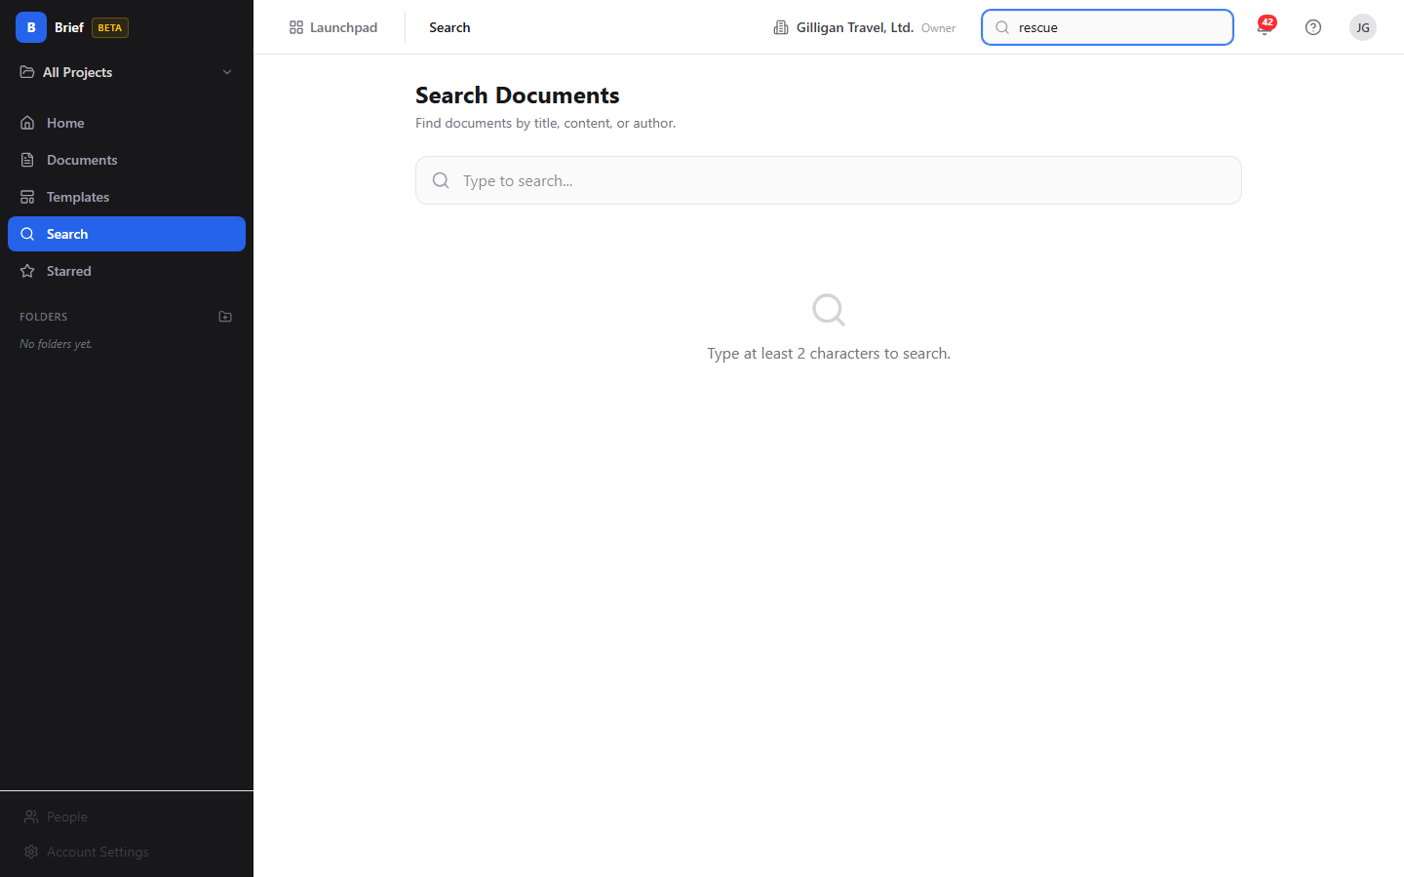
Figure 14.6 Search results

Working with AI agents
Agents work with Brief through the Model Context Protocol (MCP). Brief exposes 48
MCP tools that span the entire app: documents, search, comments, versions, links,
collaborators, embeds, templates, and folders. Each tool forwards your bearer
token, so an agent can only do what your account is allowed to do, and write
tools require the read_write scope. Brief enforces Organization, Project, and
Private visibility on the server regardless of how a tool is called.
Many of these tools have no human button in Brief. They are the only way to do
things like append content, set the In Review status, create or remove links,
manage collaborators, author templates, or rename and delete folders.
Authoring and maintenance:
- brief_create creates a document (title, project, folder, template, markdown
content, visibility).
- brief_update_content replaces the document body; brief_append_content adds
to the end of it. brief_append_content has no human button, so appending is
agent or API only.
- brief_update changes metadata such as title, status, visibility, folder,
icon, and pinned. This is the only way to set the In Review status, which
has no control in the editor.
- brief_archive, brief_restore, brief_duplicate, and brief_star cover the
lifecycle and bookmarking actions.
Search and reading:
- brief_list, brief_get, brief_recent, brief_starred, and brief_stats
cover listing, opening, and counting documents. brief_search runs the keyword
search; brief_semantic_search runs vector search and falls back to full-text
search when the vector index is unavailable. Brief is also a registered source
for the platform-wide search_everything tool.
Review:
- brief_comment_list, brief_comment_add, brief_comment_resolve,
brief_comment_edit, and brief_comment_delete cover reading, adding,
resolving, editing, and deleting comments. brief_comment_react and
brief_comment_unreact add and remove emoji reactions, which have no UI.
Versions:
- brief_versions lists versions, brief_version_get fetches one,
brief_version_create records a named snapshot, brief_version_restore
restores a version, and brief_version_diff computes a line-by-line diff
between two versions. There is no human button to create, restore, or diff
versions, so version management is agent or API only.
Export:
- brief_export_markdown and brief_export_html return the document as Markdown
or as a standalone styled HTML page, the same content the Export button
downloads.
Cross-app links and graduation:
- brief_links_list lists every task and Beacon link on a document.
brief_link_task creates a link to a Bam task (by UUID or by a human reference
like FRND-42); brief_link_beacon creates a link to a Beacon article;
brief_link_remove removes either kind. These tools are the only way to create
or remove links, since "Linked Items" is read-only in the UI.
- brief_promote_to_beacon graduates a document into a Beacon article, the same
action as the Promote to Beacon button.
Sharing, organizing, and templates:
- brief_collaborators_list, brief_collaborator_add,
brief_collaborator_update, and brief_collaborator_remove manage per-document
collaborators with view, comment, or edit permission. Brief has no
share dialog, so collaborator management is agent or API only; to share a single
document with specific people, use these tools or set the document's visibility
to Project or Organization.
- brief_folders_list, brief_folder_create, brief_folder_update, and
brief_folder_delete manage the folder tree. The UI can only create folders, so
renaming, moving, and deleting are agent or API only.
- brief_templates_list, brief_template_create, brief_template_update, and
brief_template_delete manage org-level templates. There is no
template-authoring screen, so template CRUD is agent or API only.
- brief_embeds_list and brief_embed_delete read and remove embedded file
records.
Cross-cutting agent platform. Brief plugs into the suite-wide agentic surfaces
that every app shares:
- Identity and heartbeat. Agent and service accounts are first-class:
agent_heartbeat, agent_self_report, and agent_audit let a runner announce
itself and report its activity, and every write an agent makes is stamped with
its actor type in the unified activity log.
- Approvals. When a change should pause for a human, agents file it with
proposal_create; a reviewer lists and decides with proposal_list and
proposal_decide. This is the safe path for an agent to draft a sensitive
document, comment, or promotion and wait for sign-off before it lands.
- Cross-app read plane. search_everything fans out across Brief and the
other apps, and resolve_references turns mentions into resolved entities.
Brief contributes documents to both.
- Visibility preflight. Before posting a Brief document link into a shared
surface in another app, an agent should call can_access for the reader and
drop anything the reader is not allowed to see. Brief still enforces visibility
on the server, so this is a courtesy check that avoids dangling links.
- Policies and webhooks. Per-agent kill switches and tool allowlists
(agent_policies) gate which brief.* tools a given service account may call,
and outbound webhooks push subscribed Bolt events (such as document.published
and document.promoted) to agent runners.
For the full tool catalog see docs/apps/brief/mcp-tools.md.

User Stories

Story: Write your first document and publish it
Who: A team member new to Brief.
Goal: Create a document, write some content, and publish it.
Before you start: You are signed in to BigBlueBam and have the read_write
scope.
Steps
1. Open Brief at /brief/.
2. Click New Document on the Home screen.
3. Type a title in the "Document title..." field.
4. Write your content in the body, using the toolbar or typing / for slash
commands.
5. In the right sidebar, set Visibility to Organization, Project, or
Private. Do not choose Public.
6. Click Publish.
Result: The document is saved with status Approved and Brief opens its detail
page.
Related: Save a draft and publish; Set visibility. An agent can do the same
with brief_create followed by brief_update_content.

Story: Start from a template
Who: Anyone who wants a structured starting point.
Goal: Create a document pre-filled from a template.
Before you start: At least one template exists. You have read_write scope.
Steps
1. Open Templates from the sidebar.
2. Click the template card you want.
3. The editor opens pre-filled with the template's content. Add a title and your
own content.
4. Click Save Draft or Publish.
Result: A new document exists based on the template.
Related: Start from a template; Create a document. An agent can author the
template itself with brief_template_create.

Story: Organize documents with folders and project scope
Who: Someone keeping a growing set of documents tidy.
Goal: Create a folder and scope work to one project.
Before you start: You have folder-create permission and read_write scope.
Steps
1. In the sidebar Folders section, click the add (+) button.
2. Type a name in the "Folder name" input and press Enter.
3. Click the project-scope selector at the top of the sidebar and choose a
project so the list and folders filter to it.
4. Create documents while that scope is active; choose the project in the
editor's Project (optional) menu when creating.
Result: Your documents are grouped by folder and project and easy to find
through the sidebar filters.
Related: Folders and project scope; Browse the document list. An agent can
rename, move, or delete a folder with brief_folder_update and
brief_folder_delete, which the UI cannot do.

Story: Co-edit a document in real time
Who: Two teammates drafting together.
Goal: Edit the same document at the same time and see each other's changes.
Before you start: Both have edit access to the document and read_write
scope.
Steps
1. The first person opens the document and clicks Edit.
2. The second person opens the same document and clicks Edit.
3. Both type. Each sees the other's cursor and a presence chip in the header.
4. Anyone reading the document on its detail page sees the edits appear live.
5. When finished, click Save Draft or Publish.
Result: Both edits merge into one document with no overwriting, and readers
saw the changes as they happened.
Related: Edit an existing document and co-edit in real time.

Story: Find a document
Who: Anyone who knows roughly what they are looking for.
Goal: Locate a document by title, content, or author.
Before you start: You are signed in.
Steps
1. Open Search from the sidebar, or click the "Search documents..." box
in the header.
2. Type at least 2 characters in the "Type to search..." box.
3. Read the results and click the one you want.
Result: Brief opens the matching document.
Related: Search; Browse the document list. An agent can search with
brief_search, or brief_semantic_search for a meaning-based match.

Story: Review a document with comments
Who: A reviewer giving feedback.
Goal: Leave a comment and have it resolved.
Before you start: You can see the document. The author or an admin can
resolve.
Steps
1. Open the document.
2. In the right sidebar under Comments, type into the "Add a comment..."
box.
3. Click Comment.
4. When the feedback is addressed, the author or an admin clicks Resolve on
the comment.
Result: The comment is recorded on the document and marked resolved when
done.
Related: Comments. An agent can use brief_comment_add and
brief_comment_resolve, and can anchor a comment to a span of text with the
anchor_text option.

Story: Star a document for quick access
Who: Anyone with documents they return to often.
Goal: Bookmark a document so it is one click away.
Before you start: You can see the document.
Steps
1. Open the document.
2. Click the star button in the header (tooltip Star document).
3. Open the Starred screen, or the Starred list on Home, to find it again.
Result: The document appears in your Starred views.
Related: Star a document. An agent can toggle the star with brief_star.

Story: Duplicate a document to reuse its structure
Who: Someone who wants to start from an existing document.
Goal: Make an editable copy.
Before you start: You can see the source document.
Steps
1. Open the document.
2. Click Duplicate in the action bar.
3. Brief opens the new copy, named "&lt;title&gt; (copy)" and set to Draft.
Result: A draft copy exists for you to edit independently.
Related: Duplicate a document. An agent can use brief_duplicate, optionally
copying into a different project.

Story: Export a document to a file
Who: Anyone who needs the document outside Brief.
Goal: Download the document as Markdown or HTML.
Before you start: You can see the document.
Steps
1. Open the document, or open it in the editor.
2. Click Export.
3. Choose Markdown (.md) or HTML (.html).
Result: The file downloads to your machine.
Related: Export a document. An agent can fetch the same content with
brief_export_markdown or brief_export_html.

Story: Archive a document and restore it later
Who: Someone clearing out finished or obsolete documents.
Goal: Remove a document from normal views without deleting it, then bring it
back.
Before you start: You have edit access to the document.
Steps
1. Open the document and click Archive in the action bar.
2. To find it later, filter the Documents list by the Archived status chip.
3. Open the archived document and click Restore.
Result: The document is hidden while archived and returns to Draft status
when restored.
Related: Archive and restore. An agent can use brief_archive and
brief_restore.

Story: Promote a document into Beacon knowledge
Who: Someone graduating a finished document into the knowledge base.
Goal: Turn a Brief document into a Beacon article.
Before you start: The document is not already promoted, and you have the
promote permission and edit access.
Steps
1. Open the document.
2. Click Promote to Beacon in the action bar.
3. Brief creates the Beacon article and opens it at /beacon/<id>.
Result: The document is recorded as promoted and a matching Beacon article
exists.
Related: Promote to Beacon. An agent can use brief_promote_to_beacon.

Story: Link a spec document to a task (agent driven)
Who: An agent connecting a specification document to the work that
implements it.
Goal: Attach a Brief document to a Bam task so it shows under Linked Items.
Before you start: The agent has read_write scope and access to both the
document and the task. Linking has no human UI.
Steps
1. The agent calls brief_link_task with the document (by UUID, slug, or exact
title) and the task (by UUID or a human reference like FRND-42), choosing a
link type such as spec.
2. The link is created.
3. A human opening the document sees it under Linked Items in the detail
sidebar; clicking it opens the task in Bam.
Result: The document and task are connected and the relationship is visible
to readers.
Related: Linked Items; Working with AI agents. An agent can also link a
Beacon article with brief_link_beacon and remove either link with
brief_link_remove.

Story: Snapshot and restore a version (agent driven)
Who: An agent or integration maintaining version history.
Goal: Record a numbered snapshot of a document and roll back to it later.
Before you start: The agent has edit access and read_write scope. There is
no human button for this.
Steps
1. The agent calls brief_version_create with an optional label and change
summary to record a snapshot.
2. A human opening the document sees the snapshot listed read-only under
Version in the detail sidebar.
3. To roll back, the agent calls brief_version_restore with the target version,
which restores the content and records a "Restored from version N" snapshot.
Result: The document has a versioned history and can be returned to an
earlier state.
Related: Read a document; Working with AI agents. An agent can compare two
snapshots with brief_version_diff.

Story: Agent authors a document end to end
Who: An automation that produces and files a document.
Goal: Create, fill, link, and graduate a document without a human in the
editor.
Before you start: The agent has read_write scope and the relevant
permissions.
Steps
1. The agent calls brief_create with a title and visibility.
2. It fills the body with brief_update_content, or builds it incrementally with
brief_append_content.
3. It connects the document to related work with brief_link_task.
4. When the document is ready as knowledge, it calls brief_promote_to_beacon.
Result: A complete, linked document exists, and a Beacon article was created
from it, all without manual editing.
Related: Working with AI agents; Promote a document into Beacon knowledge. If
the promotion should pause for review, the agent can file a proposal_create
first and wait for a human proposal_decide.

Related
- Bam - Brief pulls its project list from Bam and links documents to Bam
tasks. Linked tasks open in Bam at /b3/tasks/:id.
- Beacon - Documents promote into Beacon knowledge-base articles, and
documents can be linked to Beacon articles. See docs/apps/beacon/help.md.
- Bolt - Brief publishes document.created, document.updated,
document.published, and document.promoted events (source brief) so Bolt
automations can react.
- Brief's MCP tool catalog: docs/apps/brief/mcp-tools.md.
- Brief's product guide: docs/apps/brief/guide.md.

Check yourself
Every answer is findable in this chapter. Check your work against the Answer Key appendix at the back of the book.
1. What are Brief's four document statuses?
a) Draft, In Review, Approved, and Archived
b) Draft, Published, Locked, and Deleted
c) Open, In Progress, Closed, and Archived
d) New, Editing, Final, and Retired
2. Which visibility level does the menu list but reject as invalid?
a) Private
b) Public
c) Project
d) Organization
3. What status does a document have after you click Publish, and what status after Save Draft?
4. How long can a document icon be?
a) Up to 1 character
b) Up to 2 characters
c) Up to 5 characters
d) Any length
5. What are the three valid visibility levels and who can see a document at each?
6. How many MCP tools does Brief expose to agents?
a) 12
b) 30
c) 48
d) 60
7. What technology does Brief use to merge concurrent edits without overwriting, and over what connection?
8. What happens when you promote a document to Beacon?
a) Brief creates a Beacon article from it, and the promotion is one-way
b) The document is deleted after the article is created
c) It can be promoted again to refresh the article
d) A draft copy is made and nothing is sent to Beacon
9. Which folder actions can the Brief UI do, and which require an agent or the API?
10. How many characters must you type before Search returns results?
a) At least 1
b) At least 2
c) At least 3
d) At least 5
11. Why should you avoid the "Brief summary (optional)" field, and what should you do instead?
12. What does the Duplicate action create?
a) A Draft copy named "<title> (copy)"
b) An Approved copy with the same title
c) A new version on the same document
d) A Beacon article from the document
13. When you restore an archived document, what status does it return to?

CHAPTER 15

Bureau
The office is wherever you all are.

Bureau is the virtual office that rides along with everything else in the suite, so "who is around right now" and "let's all go look at this together" are one click away. You browse floors, drop into rooms with live occupant dots, and a floating docked box shows where you are, who else is on your page, and the actions to knock, summon, hunt, and book. This chapter walks you from dropping into your first room to running a summon, booking a conference room, and reading door states. By the end you will know how presence works, how to interrupt someone politely, and where an agent can be a first-class occupant beside you.
At a glance
- A spatial office with floors, rooms, and live occupant dots for everyone around
- Each room is a real-time audio huddle you join just by entering
- A docked box that follows you across every app with one-click invite, hunt, and summon
- Polite interruptions: knock on closed offices, with a 30-second auto-timeout
- Server-side presence so your room and call survive moving between pages
In this chapter
Overview . Key concepts . Where to find it . Feature reference . Browse floors . The live floor view (presence canvas) . Recent chats . Move yourself between rooms . See who is in a room . Knock and respond to a knock
Bureau is a virtual office layer that stays open around everything else you do in the suite, so that "who is around right now" and "let's all go look at this together" are one click away no matter which app you are in. Reach for it when you want a sense of presence, a quick huddle, or a way to pull your teammates onto the same screen.

Overview
Bureau gives your org a spatial office. You browse floors, drop into rooms, and see live occupant dots for everyone who is around. Each room maps to a real-time audio room, so entering a room can start or join a voice huddle. Around all of that, a floating docked box rides along inside every app in the suite, showing where you are, who else is on the same page, and giving you one-click actions to invite, hunt, or pull everyone to where you are looking.
Bureau solves the "remote office" feel for small-to-medium teams. It answers three questions that are otherwise hard to answer over chat alone: who is available right now, can I interrupt them, and can we all jump to the same place. Knocking on a colleague's office, summoning a room to a Board canvas, and booking a conference room are all first-class actions.
Bureau answers the three questions chat cannot: who is around, can I break in, and can we all land on the same screen.
Bureau is woven into the rest of the suite rather than standing alone. The docked box is surfaced by Board and Banter (and every other SPA) so audio huddles follow you across products. Summons and rings jump people to a URL in Board, Brief, Bond, and others. Bookings mirror to Book events. Door states, knocks, and status changes emit events that Bolt can automate against, and daily floor utilization rolls up into Bench.
The core objects you work with are floors, rooms (including personal offices), your presence (a status plus where you currently are), knocks on closed doors, summons that pull a room to a destination, and bookings that reserve a room for a window.

Key concepts
- Floor - One navigable office map. A floor owns a layout, an optional background image, a slug used in its URL, and a position in the list. One floor can be marked the default.
- Building - An optional grouping of floors for multi-site orgs. It exists in the data model and a new floor can carry a building_id, but there is no building management screen in the app today.
- Room - An addressable space on a floor. Each room maps one-to-one to an audio room. Rooms come in 8 types: Office (single owner), Huddle, Conference, Meeting, Open space, Lounge, Focus, and Lobby.
- Office - A room of type Office that has an owner. The owner can be knocked on, sets the door, and admits or declines visitors. Think of it as a personal office.
- Door state (privacy) - How a room treats visitors. Three values: Open (anyone can enter), Knock (visitors must knock to be let in), and Private (only people on the room's access list). The room stores a durable default; live overrides such as a short do-not-disturb window apply on top of it.
- Room access list (ACL) - Per-user grants for private rooms, with role member or manager. Managers can edit the room and manage its access list.
- Presence - Your live state: which floor and room you are in, your status, and the page you are currently viewing. Your presence lives on the server, so moving between pages never drops your session.
- Presence status - One of 6 values: available, busy, dnd, focus, away, in_meeting. The docked box exposes a head-down DND toggle that flips between available and DND.
- Knock - An async request to enter a closed office. A knock auto-times-out after 30 seconds if the owner does not respond.
- Summon (Bring everyone here) - Pulls every eligible co-occupant of your current room to a URL in another app. Each recipient is access-checked first, so people who cannot see the destination are not pinged with a dead link.
- Ring (Invite) - Pushes an incoming-call overlay to one specific person on a content surface. It respects DND. An admin can Force Invite, which bypasses the accept prompt with a 3-second cancellable auto-navigate.
- Hunt - Locate one org member and jump to wherever they are. It respects DND and filters out destinations you cannot access.
- Booking - A reservation of a bookable room for a window, mirrored to a Book event. Access is open (non-attendees may wander in) or locked (private for the meeting).
- Surface huddle - The audio room attached to any content surface (a Board canvas, a Brief doc, a Bond deal). The docked box auto-joins it when you navigate to that surface.
- Docked box - The floating Bureau overlay rendered inside every SPA. It shows your room, your co-occupants, the page you are viewing, the call controls, and the Bring everyone here / Invite / Hunt actions.
- Room chat - Ephemeral text chat scoped to a room or surface, kept 24 hours by default and recoverable later under Recent chats.
TIP
Room chat is ephemeral on purpose, but if a thread mattered, an admin can open its transcript and set Retention to 2 days, 3 days, 1 week, or Retain permanently before the 24-hour clock runs out.
NOTE
Only office rooms with an assigned owner can be knocked on. You cannot knock on your own office, and you cannot knock on an office that has no owner.
A summon teleports your whole room to a URL, but only the people who can actually open it get pulled.

Where to find it
Bureau is served at /bureau/. You must be logged in to BigBlueBam first; Bureau shares the Bam session. If you are not logged in you will see "Please log in to BigBlueBam first to access Bureau." with a "Go to BigBlueBam Login" link.
The sidebar (brand label "Bureau") groups navigation under:
- Floors: "All floors" (the Floors landing), then one row per floor with a live occupancy badge.
- Rooms: "Book a room" (the Room booking screen at /bureau/booking).
- History: "Recent chats".
- Admin (org admin, owner, or SuperUser only): "Edit floors", "Offices", and "Settings".
Floor and office administration require org admin, owner, or SuperUser. Audio huddles require LiveKit to be configured and the platform calling switch to be on; if calling is disabled, joining a room's audio returns a "calling disabled" error.

Feature reference

Browse floors
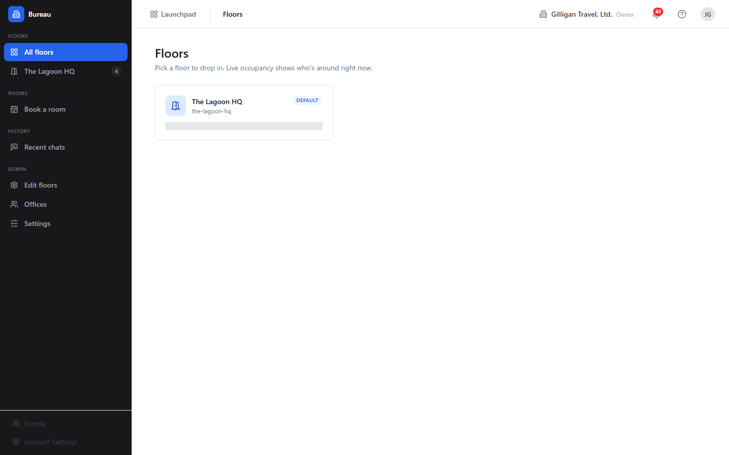
Figure 15.1 Floor directory
The Floors landing is where you pick a place to drop in.
To browse floors:
1. Open /bureau/. The page heading is "Floors" with the subtitle "Pick a floor to drop in. Live occupancy shows who's around right now."
2. Each floor card shows the floor name, its slug, a "Default" pill on the default floor, and a live count such as "3 people here now".
3. Click a floor card to open its live view.
If no floors exist yet you will see "No floors yet" and "Ask an org admin to create the first floor under Admin to Floors."

The live floor view (presence canvas)
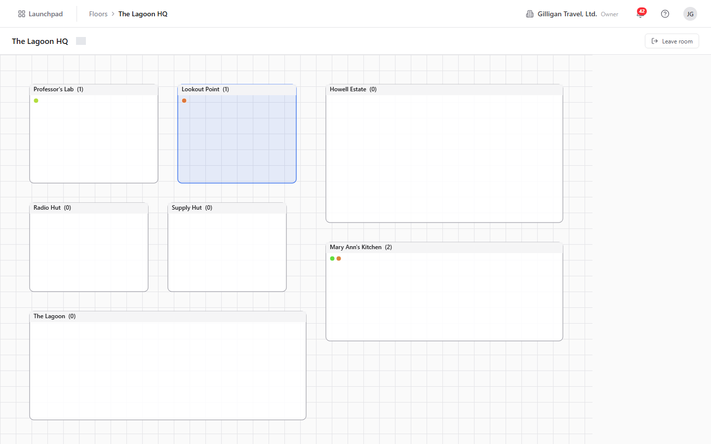
Figure 15.2 Live floor
The floor view is the spatial map. It draws one rectangle per room over a grid background, with a dot for each occupant. It is a Canvas2D scene (the canvas carries the class floor-canvas), so occupant dots are painted, not DOM elements.
To use the floor view:
1. From the Floors landing, click a floor. The URL becomes /floors/:id.
2. Read the status bar at the top: it shows the floor name and a connection chip that reads "Live" when the real-time link is healthy, or the raw connection status otherwise.
3. Click a room rectangle to enter it. Entering a room mints your audio token and places your dot inside that room. Rooms without an assigned layout zone are auto-arranged in a 4-column grid so the floor still navigates.
4. When you are inside a room, a "Leave room" button appears in the status bar. Click it to step back out.
The live map updates as people enter, leave, and change status, over the Bureau real-time connection.

Recent chats
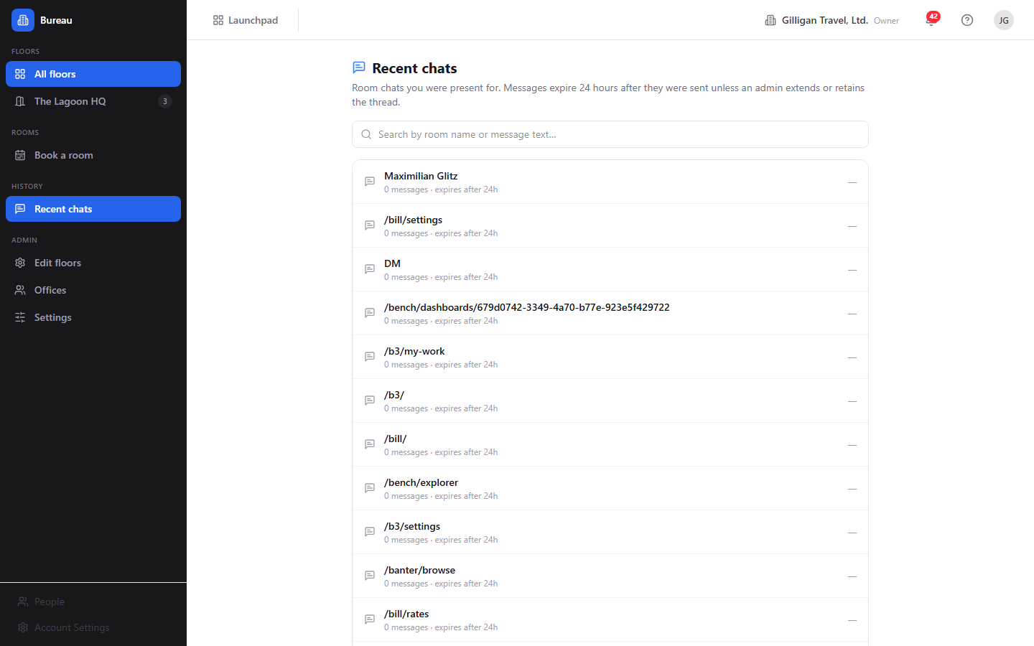
Figure 15.3 Recent chats
Room chats are ephemeral, but you can recover what was said for rooms you were present in.
To review past room chat:
1. In the sidebar, under History, click "Recent chats". The heading is "Recent chats" with the subtitle "Room chats you were present for. Messages expire 24 hours after they were sent unless an admin extends or retains the thread."
2. Use the search box ("Search by room name or message text...") to filter the thread list.
3. Each thread shows its room label, message count, retention text, and last-message time. A shield icon marks a thread that has been retained.
4. Click a thread to open its transcript dialog. Expired messages show "All messages in this chat have expired."
If you are an admin, the transcript dialog offers a "Retention" dropdown with the options "24 hours (default)", "2 days", "3 days", "1 week (max)", and "Retain permanently". Choose one to extend or pin the thread.
If you have no threads yet, you will see "No room chats yet - open the chat panel on the Bureau widget anywhere in the suite."

Move yourself between rooms
Moving rooms is how you change where you are standing and which audio huddle you are in.
To move:
1. Open a floor at /floors/:id.
2. Click the destination room rectangle. You enter that room and your audio reconnects to it.
3. To leave without entering another room, click "Leave room".
Door state is enforced on entry. You can always enter an Open room. A Knock room requires you to knock first (see below). A Private room requires you to be on its access list; otherwise entry is refused.
TRY IT
Open a floor at /floors/:id, click an Open room rectangle to drop your dot inside and connect audio, then click "Leave room" in the status bar to step back out.
AI agent note: an agent moves itself with bureau_move_self, which mints the room token and registers the agent's session so it appears in bureau_who_is_in_room and on the floor. Private rooms the agent is not on the access list for return a permission error.

See who is in a room
Before knocking, summoning, or joining, you often want to know who is already there.
To see occupants:
1. On the floor view, look at the dots inside each room rectangle.
2. Enter a room, then read the docked box: the "In:" row names the room and the people-here count, and the occupants list names everyone present (or "Just you" when you are alone). Agent occupants are prefixed "(A) ".
AI agent note: bureau_who_is_in_room returns a room's detail and its live occupant ids. It is access-filtered, so private rooms you cannot see return not-found. Use it before bureau_summon or bureau_knock to decide who would actually be pulled or disturbed. For co-presence by URL rather than by room, use bureau_who_is_here, which lists the other users on a given content surface.

Knock and respond to a knock
A knock is the polite way into a closed office.
To knock on an office:
1. On the floor, click the office whose door is set to Knock (or whose live override blocks direct entry).
2. The owner receives an incoming-knock toast in their docked box.
3. Wait for the owner's decision. If no one answers within 30 seconds the knock auto-times-out.
Only office rooms with an owner can be knocked on. You cannot knock on your own office, and you cannot knock on an office that has no owner.
To respond when someone knocks on your office, use the incoming-knock toast in your docked box:
1. "Let in" admits the visitor; they receive a fresh token and join your room.
2. "Not now" defers the knock; the visitor is told you are busy.
3. "Decline" politely rejects the visitor.
If you are in DND when someone tries to knock, the knock is blocked (the server returns 423) and the visitor is offered a leave-a-note path that delivers a Banter direct message prefixed "[Bureau knock note] ".
AI agent note: bureau_knock creates the knock; if the owner is in DND it returns a 423 with a leave-a-note pointer, which an agent should surface rather than retry. bureau_respond_knock resolves a knock as the owner with admit, defer, or decline. bureau_knock_inbox lists the pending knocks waiting at the agent's own door, and bureau_leave_note sends the DND fallback DM.

Summon (Bring everyone here)
A summon pulls everyone in your current room to whatever you are looking at in another app.
To bring everyone here:
1. Be in a Bureau room with at least one other person.
2. Navigate to the resource you want to share (for example a Board canvas, a Brief doc, or a Bond deal). The docked box "Viewing:" row shows your current location.
3. Click "Bring everyone here" in the docked box. Bureau access-checks each co-occupant against that destination, then sends a summon to everyone who can reach it.
4. Each recipient sees a "Summon" toast that names you and the destination, with Join and Stay here buttons. If auto-follow is enabled, the toast shows a "Going in Ns..." countdown with a "cancel" link, then navigates automatically.
5. Anyone who lacks access lands on the denied list, so you can follow up by granting access and re-summoning.
AI agent note: bureau_summon is high-impact and uses the confirm_action two-step. Call it once to preview the planned recipients, then again with confirm_action: true to send. The caller must be in a Bureau room or the call fails with 400. After sending, bureau_get_summon inspects who was eligible versus denied, and bureau_summon_grant_access grants access to denied users and re-summons them in one step (also a two-step confirm).

Ring (Invite)
Ring calls one specific person to a surface, like ringing their phone.
To invite one person:
1. On any located page, click "Invite..." in the docked box. The Invite popover opens.
2. Pick the member to ring. They receive an incoming-call overlay.
3. When they accept, they are navigated to your surface and auto-join the huddle.
DND is respected: if the recipient is head-down, a normal ring does not get through. Admins can right-click "Invite..." to Force Invite, which bypasses the accept prompt with a 3-second cancellable auto-navigate.

Hunt
Hunt finds one teammate and takes you to them.
To hunt a teammate:
1. Click "Hunt..." in the docked box. The Hunt popover opens.
2. Pick the member you want to find.
3. You jump to wherever they currently are.
Hunt is org-scoped: the teammate must share your active org. It respects DND (a head-down member cannot be located) and runs a destination-access preflight, so if you cannot see the surface they are on, the result is the same as "not located" - their location is never leaked through a URL you could not open.
AI agent note: bureau_where_is_user is the real, implemented Hunt tool. It returns { located: true, url, app, label, status } or { located: false } when the target is offline, in DND, in a different org, or on a surface the caller cannot see. Prefer it over the legacy bureau_locate_user stub.

Book and cancel a room
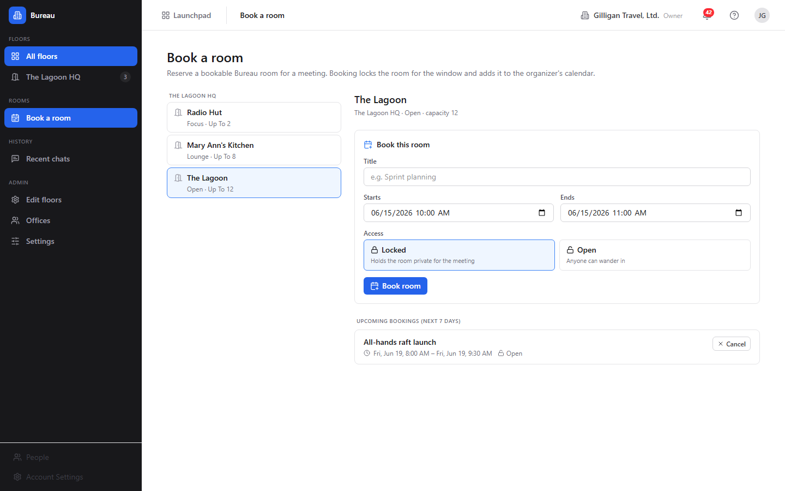
Figure 15.4 Room booking
Bookable rooms can be reserved for a window; the reservation mirrors to a Book event. There is a dedicated Room booking screen in the Bureau SPA for this.
To book a room:
1. Open /bureau/booking. The page heading is "Book a room" with the subtitle "Reserve a bookable Bureau room for a meeting. Booking locks the room for the window and adds it to the organizer's calendar."
2. The left column lists the org's bookable rooms grouped by floor. Each room shows its type and capacity. Click one to open its schedule on the right. If the org has no bookable rooms you see "No bookable rooms" and a hint that an admin can mark a room bookable in the floor editor.
3. In the "Book this room" form, enter a Title (placeholder "e.g. Sprint planning"), pick Starts and Ends (datetime-local inputs default to the next hour and the hour after), and choose Access: Locked ("Holds the room private for the meeting") or Open ("Anyone can wander in").
4. Click "Book room". Bureau writes the booking, anchors it to a Book event, and schedules lifecycle jobs that flip the room's privacy at the start time and clear it at the end time. Validation errors (missing title, end-before-start) and the server's "member bookings are disabled" 403 surface inline.
5. The "Upcoming bookings (next 7 days)" list below the form shows each reservation with its title, window, and the lock/open access badge.
To cancel a booking, click "Cancel" on its row in the upcoming-bookings list. Only the organizer or an org admin sees the Cancel button. Cancellation is a soft delete that drops the scheduled jobs and makes a best-effort attempt to cancel the linked Book event.
WARNING
Cancelling a booking is a soft delete that also makes a best-effort attempt to cancel the linked Book event. Only the organizer or an org admin sees the Cancel button, so confirm you are the one who should be tearing the reservation down.
Booking is gated by the org's members_can_book setting (see Admin - Settings below): when it is off, only admins and owners can reserve rooms, and a member's booking attempt 403s with the server message shown inline.
AI agent note: bureau_book_room and bureau_cancel_booking both use the confirm_action two-step: preview first, then confirm. bureau_list_bookings lists active bookings for a room over a window (default next 7 days), including the Book event back-link, and bureau_update_booking edits a booking's title, window, or access (organizer or admin only).

Door states (set a room's privacy)
A room's door state controls who can walk in.
The three states are Open, Knock, and Private. The durable default is set on the room, and live overrides (a lock or a short DND window) apply on top of it.
To change the durable default in the app, edit the room in the Floor editor and set its Door default (see Admin - Floor editor below). To change it directly, the office owner, a room manager, or an org admin can patch the room's door.
The Bureau SPA's room inspector only sets the durable default. Live lock and DND overrides are driven through the docked box and the real-time connection. The door button in the docked box (tooltip "Toggle door privacy") flips the live override while you are in a room.
AI agent note: bureau_set_door_state sets a room's durable default privacy. It is restricted server-side to the office owner (for offices), a room manager, or org admins and owners.

Set your status and DND
Your status tells teammates whether you can be interrupted.
The canonical status set is available, busy, dnd, focus, away, and in_meeting. The surface for changing it is the docked box and the live connection, not a settings page.
To go head-down:
1. In the docked box header, click the "DND" toggle (its tooltip reads "Go head-down: block invites and hunts (DND)").
2. While DND is on, invites ring as blocked (callers get the leave-a-note path to your Banter direct messages) and hunts cannot locate you. Only an admin or SuperUser Force Invite gets through.
3. Click "DND" again to return to available.
The in-app surface for changing status interactively is the docked box DND toggle; the rest of the status set rides the live connection. Your chosen status is now persisted on the server, so it survives a reconnect and applies even when you have no live web session - which is what lets an agent set it for you over MCP.
AI agent note: bureau_set_status is now wired (it PATCHes /me/status in the Bureau API and persists durably), so an agent can change your status on your behalf. The tool exposes the four-value subset available, busy, away, dnd; the underlying endpoint also accepts focus and in_meeting for status set through the docked box. Your live status, room, and floor are read back org-wide by bureau_get_presence and per-user by bureau_locate_user.

The cross-app docked box (audio huddles, mic, cam, screen)
The docked box is the floating Bureau overlay that rides inside every app, including Board and Banter. It is your portable presence and call console.
The box header shows a status dot and the "Bureau" label, plus:
- "CHAT" toggle - opens the ephemeral room chat panel (its tooltip reads "Open room chat (ephemeral - 24h)"); a badge shows unread messages.
- "DND" toggle - the head-down switch described above.
- A popout (picture-in-picture) button and a collapse chevron.
Below the header:
- The "In:" row names your current room (or "No room") and the people-here count.
- The occupants list names who is with you, or shows "Just you". Agents are prefixed "(A) ".
- The "Viewing:" row shows a human-readable name of the page you are on.
- "Bring everyone here" appears when you are in a room with others on a located page.
- "Invite..." and "Hunt..." are available on located pages.
When you are in an audio huddle, the call strip shows your controls:
- The mic button reads "mic" when muted and "mic on" when live. Click to toggle.
- The cam button reads "cam" when off and "cam on" when on. Click to toggle.
- The screen button reads "screen" when you are not sharing and "share" when you are. Click to start or stop a screen share.
- The door button (tooltip "Toggle door privacy"), shown only while you are in a room, flips that room's live privacy override between Private and Open.
- Video tiles render for participants with camera or screen on.
The box is draggable by its header and collapsible. Because your presence lives on the server, navigating between pages does not drop your room or your call; the box re-attaches to the surface huddle of wherever you land.

Admin - Floors list
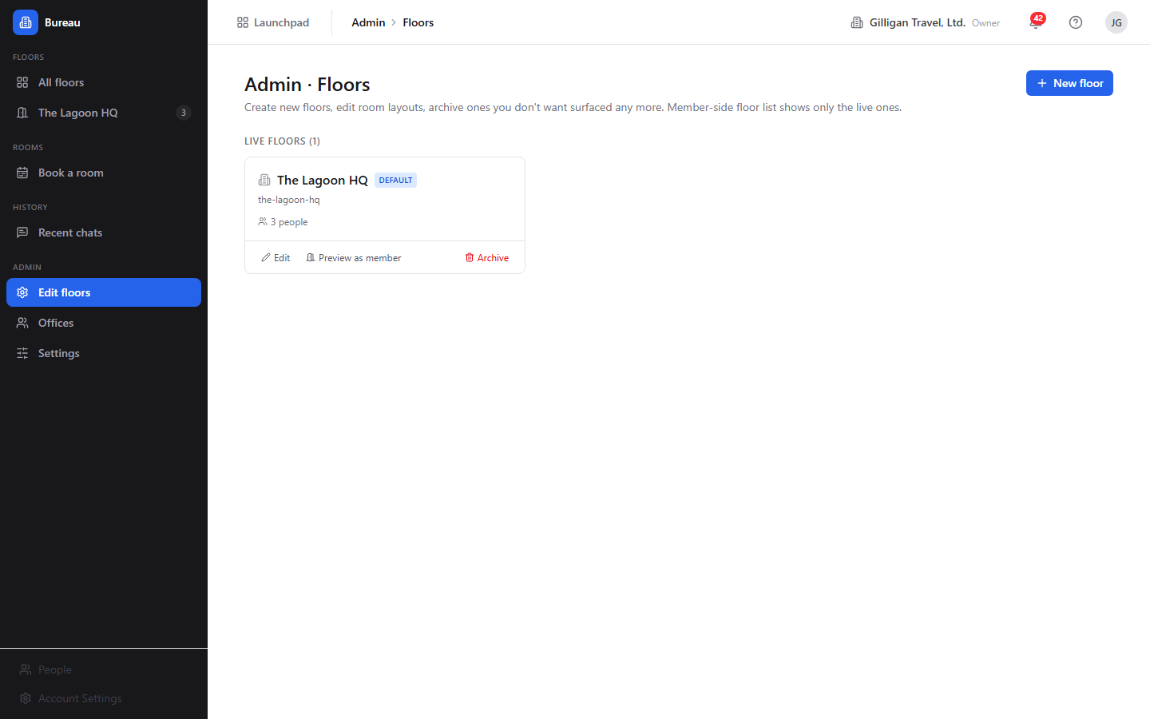
Figure 15.5 Manage floors
Admins manage the org's floors here.
To manage floors:
1. In the sidebar Admin group, click "Edit floors". The heading is "Admin · Floors".
2. The page lists "Live floors (n)" and "Archived (n)".
3. Live floor cards offer "Edit", "Preview as member", and "Archive". Archived rows offer "Restore".
4. To add a floor, click "New floor". In the dialog, enter a Name (placeholder "e.g. Engineering 3F") and a Slug (auto-generated, lowercase letters, numbers, and dashes; helper "Used in the floor URL: /floors/{slug}"). Click "Create + open editor".
Archiving a floor prompts a confirmation and hides it from the member-side floor list; you can restore it later from this page. Non-admins see "Floor administration requires admin or owner".

Admin - Floor editor
The Floor editor is the canvas where you place rooms on a floor.
To lay out a floor:
1. Open a floor in the editor (via "New floor" or "Edit"). The top toolbar shows a Back arrow, an editable floor-name input, a "{n} zones · WxH" readout, the tool selector "Select" / "New room" / "New office", the image-underlay control, and "Save".
2. To add a space, pick "New room" or "New office" and click-drag on the canvas. The empty-inspector hint reads "Click a zone to edit it, or pick "New room" / "New office" and click-drag on the floor."
3. Select a zone to open the room inspector on the right. Set:
4. To delete a room, use "Remove zone" in the inspector footer. On save it soft-deletes the room and "Live occupants are evicted to the lobby."
5. To set a background underlay, use the image-underlay control to upload an image; you can later Replace or Remove it.
6. Click "Save". Bureau writes the layout and floor name, then creates, updates, or deletes rooms to match the canvas.

Admin - Offices
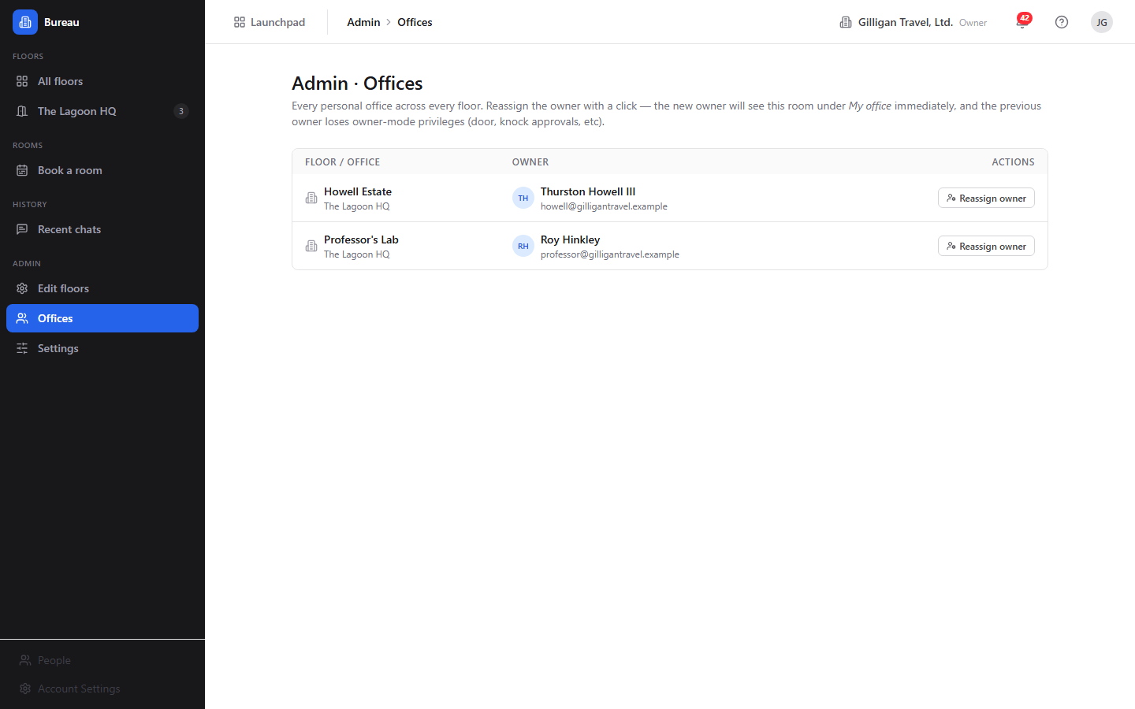
Figure 15.6 Office assignments
The Offices screen is where you assign or reassign who owns each personal office.
To assign an office owner:
1. In the sidebar Admin group, click "Offices". The heading is "Admin · Offices".
2. The table has columns "Floor / Office", "Owner" (avatar, name, and email, or "Unassigned"), and "Actions".
3. Click "Reassign owner" on a row. In the "Reassign {office}" dialog, search by name or email (placeholder "Search name or email..."); the current owner carries a "Current" tag.
4. Pick the new owner to assign the office to them. The new owner sees this room under "My office" immediately, and the previous owner loses owner-mode privileges (door, knock approvals).
Non-admins see "Office administration requires admin or owner".

Admin - Settings
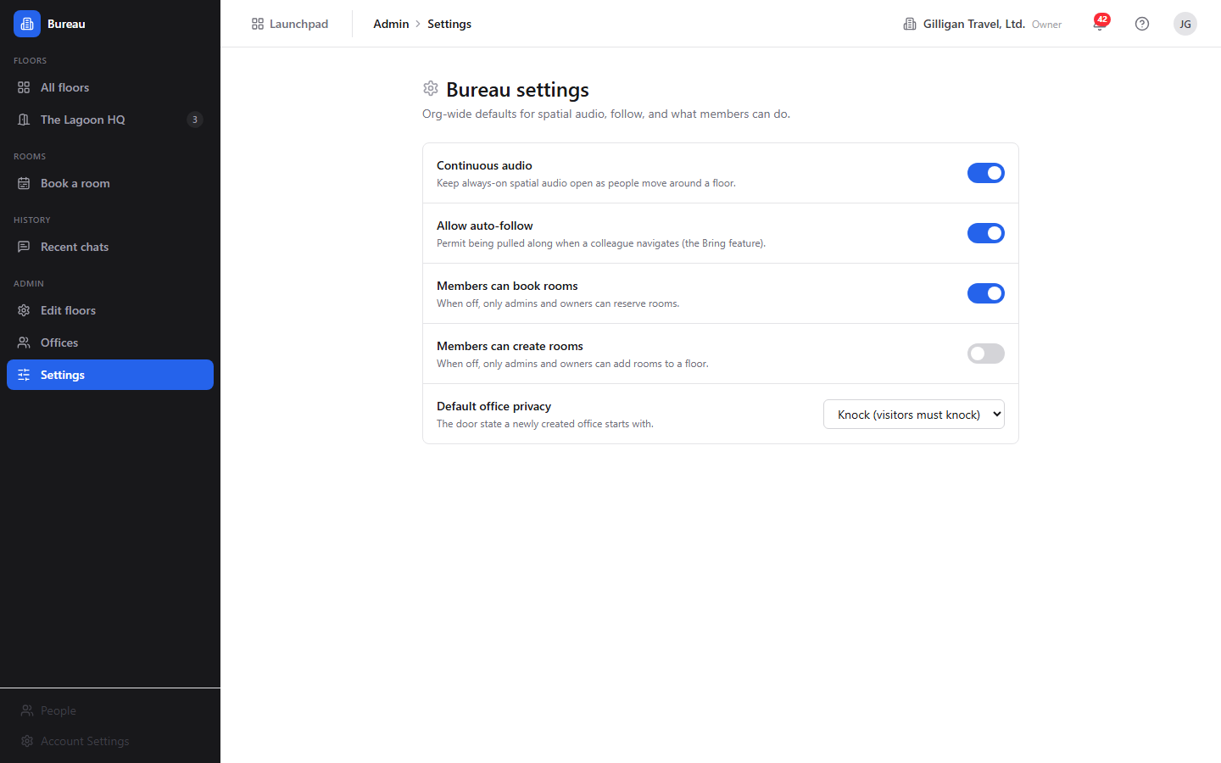
Figure 15.7 Admin settings
Bureau has org-level settings that affect who can book and create rooms, how auto-follow behaves, and how spatial audio and new offices default. There is a dedicated Bureau settings screen for them in the SPA.
To review or change org settings:
1. In the sidebar Admin group, open "Settings" (or go to /bureau/admin/settings). The heading is "Bureau settings" with the subtitle "Org-wide defaults for spatial audio, follow, and what members can do."
2. The toggles and select are:
3. Any member can read the settings; only org admins, owners, or SuperUsers can change them. For a non-admin the controls render read-only with the banner "These settings are read-only for your role. Only org admins or owners can change them." Each change saves immediately and shows a brief "Saved" badge next to the row.
AI agent note: bureau_get_settings reads the org's settings and bureau_update_settings changes them (admin/owner gated server-side), matching the toggles on this screen.

Working with AI agents
Agents are first-class spatial occupants in Bureau. An agent that enters a room shows up on the floor and in the occupants list with an "(A) " prefix. Agents drive Bureau through over 30 bureau_* MCP tools, all forwarding the calling user's token and gated by the same server-side permission checks as the UI.
What agents commonly do:
- Perceive the office with bureau_list_floors, bureau_get_floor, bureau_who_is_in_room, and bureau_who_is_here (co-presence by URL).
- Move into a room with bureau_move_self (the canonical "appear in the room" action).
- Find a person with bureau_where_is_user (the real Hunt; returns the user's current surface or { located: false }).
- Socialize with bureau_knock, bureau_respond_knock, bureau_knock_inbox, and bureau_leave_note. On a DND block, surface the leave-a-note hint rather than retrying.
- Teleport a room with bureau_summon (high-impact, two-step confirm; caller must be in a room), then inspect or recover with bureau_get_summon and bureau_summon_grant_access.
- Book and manage rooms with bureau_book_room (two-step confirm), bureau_list_bookings, bureau_update_booking, and bureau_cancel_booking (two-step confirm).
- Set a door with bureau_set_door_state.
- Administer floors and rooms with bureau_create_floor, bureau_update_floor, bureau_set_floor_background, bureau_delete_floor (two-step confirm), bureau_create_room, bureau_update_room, and bureau_delete_room (two-step confirm), all admin/owner gated server-side.
- Manage offices with bureau_list_offices, bureau_assign_office, and bureau_my_office.
- Recover chats with bureau_list_chats, bureau_get_chat_messages, and bureau_set_chat_retention.
- Read or change org settings with bureau_get_settings and bureau_update_settings.
Six high-impact tools use the confirm_action two-step (call once to preview, then again with confirm_action: true to commit): bureau_summon, bureau_summon_grant_access, bureau_book_room, bureau_cancel_booking, bureau_delete_floor, and bureau_delete_room.
The three presence tools that were previously stubs are now backed by the real Redis presence store (GET /v1/presence, GET /v1/presence/locate, PATCH /v1/me/status):
- bureau_get_presence snapshots the org-wide presence map: who is on Bureau right now, their status, and the room and floor they are in.
- bureau_locate_user returns one user's current room, floor, status, and location, or a null "not located" envelope when they have no live session. For the access-checked Hunt (which respects DND and a destination-access preflight), prefer bureau_where_is_user.
- bureau_set_status sets the caller's status and persists it durably so it survives a reconnect and applies with no live web session. The tool exposes the four-value subset available, busy, away, dnd; the endpoint also accepts focus and in_meeting for status set through the docked box.
Bureau participates in the suite-wide agentic platform alongside its own tools. Service-account agents are bound by the §15 agent_policies kill switch and tool allowlists (the bureau.* prefix), and every action is written to the unified activity view with the actor's kind (human, agent, or service). Cross-app result posting must pass the platform can_access visibility preflight, which is exactly the check Bureau already runs internally before a summon, hunt, or co-presence read reveals a destination. High-impact spatial actions can be routed through the platform approval queue (proposal_create / proposal_decide), and agents can subscribe to Bureau's Bolt events through outbound webhooks. Agents should also call agent_heartbeat so their session is treated as live.
A human reviewing agent work in Bureau should know that a summon DMs every eligible co-occupant in real time, that a hunt reveals where a teammate is, and that a booking can create or anchor a Book calendar event and can flip a room private for its window. The confirm step exists so these are previewed before they fire. For the full catalog and signatures, see the MCP-tools reference in docs/apps/bureau/.

User Stories

Story: Drop into the office and join a room
Who: Any logged-in team member, first time in Bureau.
Goal: Get into a room and be present with whoever is around.
Before you start: You are logged in to BigBlueBam. At least one floor exists.
Steps
1. Open /bureau/. The "Floors" landing lists the available floors with live occupancy counts.
2. Click a floor card to open its live view at /floors/:id.
3. On the canvas, click an Open room rectangle to enter it. Your dot appears inside, and your audio connects.
4. Read the docked box: the "In:" row names your room and the occupants list shows who is with you (or "Just you").
5. When you are done, click "Leave room" in the floor view status bar.
Result: You are present in a room, joined to its audio huddle, and visible to teammates on the floor.
Related: See who is in a room; The cross-app docked box. An agent does the same move with bureau_move_self.

Story: Knock on a busy colleague's office
Who: A team member who needs a quick word.
Goal: Get into a colleague's closed office without barging in.
Before you start: The colleague has a personal office with an owner; its door is Knock or otherwise closed.
Steps
1. Open the floor and click the colleague's office.
2. Bureau sends a knock to the owner; their docked box shows an incoming-knock toast.
3. Wait. If they click "Let in" you are admitted and join their room. If they click "Not now" the knock is deferred; if they click "Decline" it is rejected.
4. If no one answers within 30 seconds, the knock times out.
Result: You are either admitted to the office or told to come back later, without interrupting work uninvited.
Related: Triage knocks at your own office. If the owner is in DND, you are offered a leave-a-note path that lands in their Banter DMs. Agents use bureau_knock and, on a DND block, bureau_leave_note.

Story: Triage knocks at your own office
Who: An office owner who wants to manage interruptions.
Goal: Decide who gets in and when, and block interruptions during focus time.
Before you start: You own an office (a room of type Office assigned to you).
Steps
1. When someone knocks, an incoming-knock toast appears in your docked box.
2. Click "Let in" to admit, "Not now" to defer, or "Decline" to reject.
3. To stop interruptions entirely, click the "DND" toggle in the docked box header to go head-down. Knocks are then blocked and visitors are offered the leave-a-note path.
4. Click "DND" again when you are ready to be reachable.
Result: You control who enters your office, and head-down mode shields you while still letting people leave a note.
Related: Set your status and DND. Agents resolve knocks with bureau_respond_knock and review waiting visitors with bureau_knock_inbox.

Story: Bring everyone here (teleport the room)
Who: A facilitator standing in a room with teammates.
Goal: Pull everyone to a specific resource in another app so you are all looking at the same thing.
Before you start: You are in a Bureau room with at least one other person, and you can open the destination resource.
Steps
1. Stay in your room and navigate to the resource (for example a Board canvas or a Brief doc). The docked box "Viewing:" row reflects your location.
2. Click "Bring everyone here" in the docked box.
3. Bureau access-checks each co-occupant and sends a "Summon" toast to everyone who can reach the destination, with Join and Stay here buttons.
4. If a teammate appears on the denied list because they lack access, grant them access to the destination and bring everyone here again.
Result: Eligible teammates land on the same URL and join the same huddle; people without access are not sent a dead link.
Related: Ring (Invite) for one person. Agents use bureau_summon with the confirm_action two-step, then bureau_summon_grant_access to grant and re-summon the denied users.

Story: Invite one person to your screen
Who: Anyone who needs one specific colleague, now.
Goal: Ring a single person and bring them to your surface.
Before you start: You are on a located page (a content surface that supports ring).
Steps
1. Click "Invite..." in the docked box.
2. In the Invite popover, pick the member to ring. They get an incoming-call overlay.
3. When they accept, they are navigated to your surface and auto-join the huddle.
4. If you are an admin and the call cannot wait, right-click "Invite..." to Force Invite, which auto-navigates them after a 3-second cancellable countdown.
Result: The colleague is ringing-and-joined to exactly where you are.
Related: Hunt to go to them instead of pulling them to you. Ring respects DND unless an admin forces it.

Story: Hunt a teammate
Who: Someone trying to find where a colleague is working.
Goal: Jump to wherever a specific teammate currently is.
Before you start: The teammate is online and not head-down, shares your active org, and you can access where they are.
Steps
1. Click "Hunt..." in the docked box.
2. In the Hunt popover, pick the member.
3. You are navigated to their current location.
Result: You arrive where the teammate is, ready to join them.
Related: A head-down (DND) teammate cannot be located, and a surface you cannot access reads as "not located". Invite pulls them to you instead. Agents use bureau_where_is_user.

Story: Book the conference room
Who: An organizer planning a meeting.
Goal: Reserve a bookable room for a window and have it appear on the calendar.
Before you start: The target room is marked bookable, and your org allows you to book (members_can_book).
Steps
1. Open /bureau/booking (sidebar Rooms to "Book a room") and pick the room from the left column.
2. In the "Book this room" form, enter a title, set the start and end times, and choose access: Locked to hold the room private for the meeting, or Open to let others wander in.
3. Click "Book room". Bureau writes the booking, anchors it to a Book event, and schedules the privacy flip at the start and the clear at the end. The reservation appears under "Upcoming bookings".
4. To cancel, click "Cancel" on the booking's row as the organizer or an admin; the lifecycle jobs drop and the linked Book event is cancelled best-effort.
Result: The room is reserved for your window and mirrored to Book; a locked booking holds it private when it starts.
Related: The Room booking screen at /bureau/booking is where people do this in the app. Agents use bureau_book_room, bureau_list_bookings, bureau_update_booking, and bureau_cancel_booking; the book and cancel tools use the confirm_action two-step.

Story: Recover what was said in a room
Who: Anyone who needs to revisit a room conversation.
Goal: Read back ephemeral room chat before it expires, or pin it.
Before you start: You were present in the room when the messages were sent. Room chats are kept 24 hours by default.
Steps
1. In the sidebar, click "Recent chats".
2. Use the search box to find the room by name or message text.
3. Click a thread to open its transcript dialog.
4. If you are an admin, set the "Retention" dropdown to "2 days", "3 days", "1 week (max)", or "Retain permanently" to extend or pin the thread.
Result: You read the past conversation, and an admin can keep it from expiring.
Related: Room chat is opened live from the docked box "CHAT" toggle. Agents use bureau_list_chats, bureau_get_chat_messages, and bureau_set_chat_retention.

Story: Build a floor (admin)
Who: An org admin or owner setting up the office.
Goal: Create a floor and place its rooms and offices.
Before you start: You are an org admin, owner, or SuperUser.
Steps
1. In the sidebar Admin group, click "Edit floors", then "New floor".
2. Enter a Name and confirm the auto-generated Slug, then click "Create + open editor".
3. In the Floor editor, pick "New room" or "New office" and click-drag on the canvas to place spaces.
4. Select each zone and set its Name, Type, Capacity (people), Door default, Bookable, and (for offices) Owner in the inspector.
5. Optionally upload an image underlay for the floor background.
6. Click "Save".
Result: A new floor exists with its rooms and offices, ready for people to drop in. Removed zones evict any live occupants to the lobby.
Related: Assign an office owner; Door states. Agents use bureau_create_floor, bureau_create_room, and bureau_update_room.

Story: Assign an office owner (admin)
Who: An org admin or owner.
Goal: Give a personal office an owner so it can be knocked on and managed.
Before you start: You are an org admin, owner, or SuperUser, and at least one office room exists.
Steps
1. In the sidebar Admin group, click "Offices".
2. Find the office in the "Floor / Office" column.
3. Click "Reassign owner" in the "Actions" column.
4. Search by name or email in the dialog and pick the new owner.
Result: The office shows the new owner in the "Owner" column, and that owner now receives knocks and controls the door.
Related: Build a floor; Knock and respond to a knock. Agents use bureau_list_offices and bureau_assign_office.

Story: Agent staffs a room and pulls humans in
Who: An AI agent acting for a user.
Goal: Appear in a room, see who is there, and summon the right people to a resource.
Before you start: The agent has the user's token and the target room is reachable.
Steps
1. Call bureau_get_floor to enumerate rooms on the floor.
2. Call bureau_move_self on the target room so the agent appears as an occupant.
3. Call bureau_who_is_in_room to confirm who is present.
4. Call bureau_summon with confirm_action: false to preview the eligible recipients, then again with confirm_action: true to send everyone to the destination URL.
5. Optionally call bureau_get_summon, then bureau_summon_grant_access to grant access to anyone on the denied list and re-summon them.
Result: The agent is present in the room and the eligible co-occupants are pulled to the shared resource. Recipients who lack access are reported in the denied count.
Related: Bring everyone here; See who is in a room. The agent must be in a room before bureau_summon will succeed, and cross-app result posting should pass the platform can_access preflight.

Related
- Board - Summons and rings commonly land people on a Board canvas, and Board surfaces the same docked box so the canvas huddle follows you in.
- Brief - A Brief doc is a frequent summon and ring destination; each doc has a surface huddle the docked box auto-joins.
- Bond - Bond deals are valid summon and ring destinations for pulling the room onto a record.
- Banter - Surfaces the same docked box, and is the fallback delivery channel for the leave-a-note path when someone is in DND ("[Bureau knock note] " direct messages).
- Book - Bureau bookings mirror to Book events; cancelling a booking cancels the linked Book event best-effort.
- Bolt - Bureau emits events (entering and leaving rooms, status changes, knocks, room booked, room locked, summon issued) on the bureau source for automation.
- Bench - Daily floor utilization rolls up for reporting in Bench.
- MCP tools: this app exposes over 30 bureau_* tools. bureau_summon, bureau_summon_grant_access, bureau_book_room, bureau_cancel_booking, bureau_delete_floor, and bureau_delete_room use the confirm_action two-step. The presence tools bureau_get_presence, bureau_locate_user, and bureau_set_status are now backed by the real Redis presence store; prefer bureau_where_is_user for the access-checked, DND-respecting Hunt. See the MCP-tools reference in docs/apps/bureau/.

Check yourself
Every answer is findable in this chapter. Check your work against the Answer Key appendix at the back of the book.
1. How many room types does Bureau offer?
a) 4
b) 6
c) 8
d) 12
2. What are the three door states a room can have?
a) Open, Knock, and Private
b) Public, Locked, and Hidden
c) Available, Busy, and DND
d) Member, Manager, and Owner
3. How long does a knock wait before it auto-times-out if the owner does not respond?
4. How long are room chat messages kept by default?
a) 1 hour
b) 24 hours
c) 7 days
d) Forever
5. Name the six presence status values Bureau supports.
6. What does a summon do when a co-occupant lacks access to the destination?
a) Sends them the link anyway
b) Puts them on a denied list rather than pinging them with a dead link
c) Grants them access automatically
d) Cancels the entire summon
7. When someone knocks and you respond from the incoming-knock toast, what are the three responses you can give?
8. If you are in DND when someone tries to knock, what happens?
a) They are admitted automatically
b) The knock is blocked (the server returns 423) and they are offered a leave-a-note path
c) The knock queues until you exit DND
d) Nothing; DND does not affect knocks
9. What two access modes can a booking have, and what does each mean?
10. Which setting gates whether ordinary members can reserve rooms?
a) continuous_audio
b) members_can_book
c) allow_auto_follow
d) members_can_create_rooms
11. How does Hunt treat a teammate who is in DND or on a surface you cannot access?
a) It reveals their location anyway
b) It returns the same result as "not located"
c) It overrides their DND
d) It notifies them you tried to find them
12. Why does navigating between pages not drop your room or your call?
13. How are agent occupants shown in the occupants list and on the floor?
a) With a robot emoji
b) With an "(A) " prefix
c) In a separate panel
d) They are hidden from humans

CHAPTER 16

Helpdesk
File it, track it, close it.

Helpdesk is the public face of your support. Customers register on your org's branded portal, file tickets, follow the conversation as agents reply, and close issues out, all without ever needing a Bam account. Every ticket quietly spawns a linked Bam task, so your staff work support from the same project board they use for everything else, and the trail survives even if the ticket is later deleted. By the end of this chapter you will be able to stand up a portal, file and track a ticket, and see where an agent can triage the queue through MCP tools.
At a glance
- Branded, multi-tenant portals at /helpdesk/<org-slug>/, one per org with a settings row
- Customer sign-in that is fully separate from the Bam suite single sign-on
- Five-status ticket lifecycle with a conversation timeline, attachments, and reopen
- Every ticket mirrored to a linked Bam task so support work lives on the board
- 13 MCP tools so an agent can triage, answer, search, and configure tickets
In this chapter
Overview . Key concepts . Where to find it . Feature reference . Choose your support portal (org picker) . Register (create an account) . Login . Verify email . My Tickets list . New Ticket
Helpdesk is the public-facing support portal where your customers register, file tickets, track replies, and close out issues. Behind the scenes every ticket spawns a Bam task so your support staff can work it from the project board.
Every support ticket mirrors to a linked Bam task, so your staff work it from the project board instead of a separate inbox.

Overview
Helpdesk gives each organization its own branded support portal. Customers reach it at a public URL, create an account scoped to that org, and submit support requests as tickets. They follow each ticket as a conversation: agents reply, the status moves through its lifecycle, and the customer can attach files, change priority, mark duplicates, reopen, or close.
Customers and agents are two different identities. Customers are end users who live only in Helpdesk; they sign in with an org-scoped email and password that is completely separate from the BigBlueBam (Bam) suite single sign-on. Support agents are your Bam staff users. Agents do not use the customer portal SPA. They work tickets through the agent REST surface and through MCP tools, and they see the matching Bam task inside the Bam app. Every ticket is mirrored to a Bam task on creation, so customer replies, status changes, and closures leave a durable trail on the project board even if the ticket is later deleted.
Helpdesk is multi-tenant. Any organization that has a Helpdesk settings row gets a portal at /helpdesk/<org-slug>/, and optionally per-project portals at /helpdesk/<org-slug>/<project-slug>/. The portal that a customer lands on determines which org their account and tickets belong to.
The core objects you work with are the ticket (the support request), its messages (the conversation), its status and priority, optional attachments, and the settings that an admin uses to configure each portal.

Key concepts
- Portal - an org's public support site, served at /helpdesk/<org-slug>/. Each org with a Helpdesk settings row gets one. Per-project portals are available at /helpdesk/<org-slug>/<project-slug>/. The portal a customer lands on decides which org owns their account and tickets.
- Customer - an end user with a Helpdesk account scoped to one org. Customers have their own email and password sign-in, separate from the suite single sign-on. They use the portal SPA.
- Ticket - a single customer support request. It has a human-readable number shown as #123, a subject, a description, a status, a priority, and an optional category. Each ticket is owned by one customer and back-linked to a Bam task.
- Status - where the ticket is in its lifecycle. The five canonical statuses are Open, In Progress, Waiting on Customer, Resolved, and Closed. The stored values are open, in_progress, waiting_on_customer, resolved, and closed.
- Priority - how urgent the ticket is. Customers can set Low, Medium, or High. Agents can additionally set Critical. The badge displays all four.
- Message - a post on a ticket. Authored by the customer, an agent, or the system. Agent messages flagged as internal notes are hidden from customers.
- Category - an optional label chosen from the list an admin configured for the portal. The Category field only appears when categories are configured.
- Agent - a support staff member. Agents authenticate with a per-agent agent API key (prefixed hdag_) on the agent routes, not with the customer portal. They do not use the customer portal SPA.
- Admin - an org owner or admin who configures the portal settings.
- Duplicate - a ticket flagged as a copy of another. A customer "mark as duplicate" is annotative: it posts updates on the primary instead. An agent "merge" actually moves the messages onto the primary and closes the source.
- Attachment - a file uploaded to a ticket. It appears in the Attachments block once it has been scanned, with a Download link.
- Bam task - the project-board task created automatically for every ticket. It lives in the portal's default project so your staff can triage, assign, and track support work alongside other project work.
WARNING
An agent merge is not customer-reversible. It physically moves the source ticket's messages onto the primary and closes the source, so confirm the true primary before merging. A customer's plain mark-as-duplicate is only annotative and can be unmarked.

Where to find it
The portal is served at /helpdesk/. Visiting the bare site root redirects to the Helpdesk portal, so customers normally arrive there by default.
- /helpdesk/ with no org shows the Choose your support portal picker.
- /helpdesk/<org-slug>/ is a specific org's portal.
- /helpdesk/<org-slug>/<project-slug>/ is a per-project portal, when one is configured.
A customer needs an account on the org's portal before they can file tickets. This account uses Helpdesk's own customer sign-in, which is separate from the suite single sign-on that staff use for Bam and the other apps; a customer never needs a Bam account. Registration is built in unless the admin has disabled signups. There is no separate install step: any org with a Helpdesk settings row is live.
There is no Knowledge Base in Helpdesk. If you are looking for a searchable knowledge base, that is the separate Beacon app.
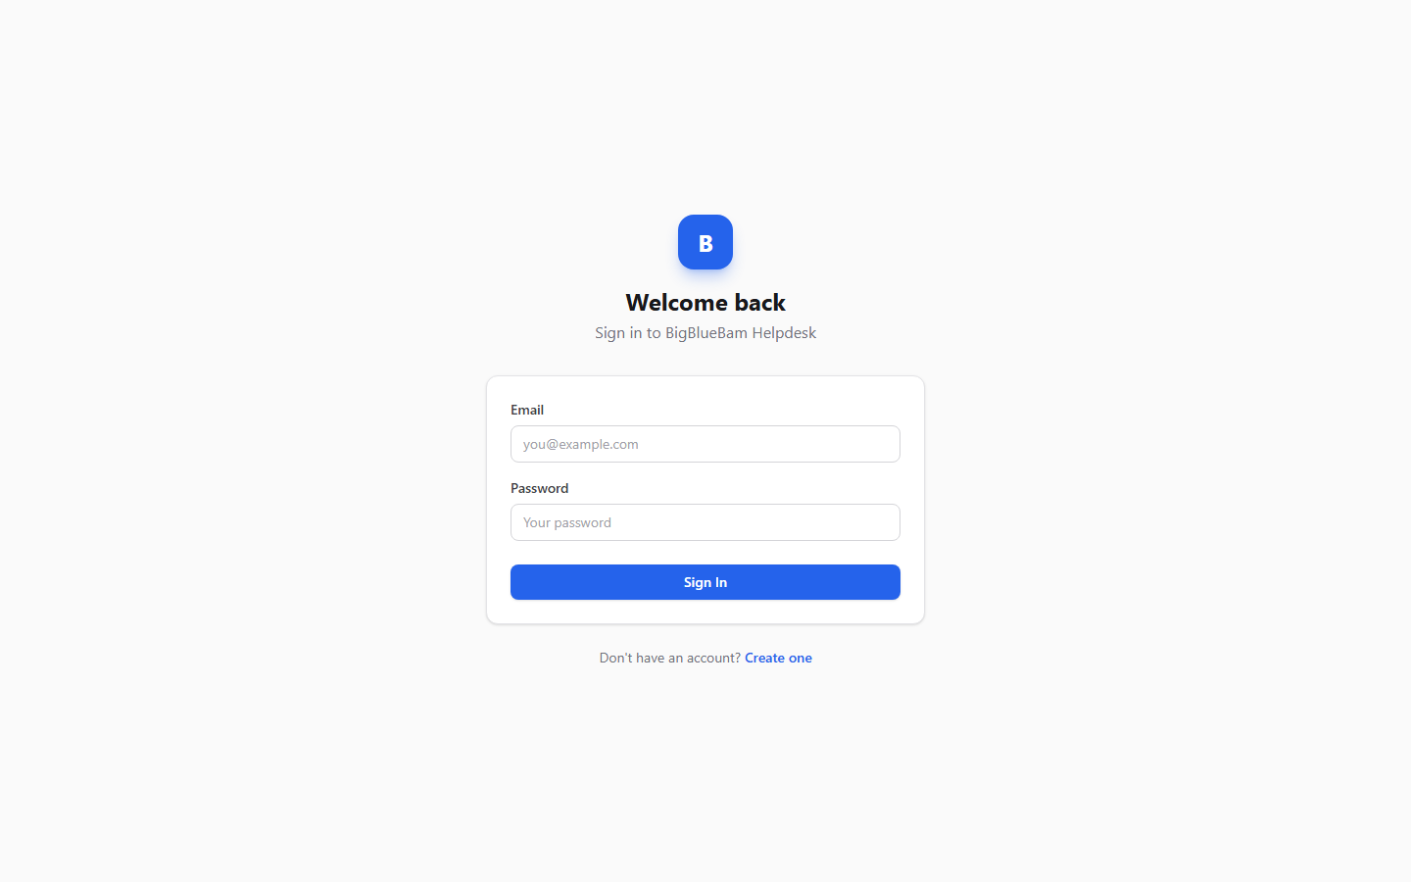
Figure 16.1 Support portal

Feature reference

Choose your support portal (org picker)
This is the landing page when you reach /helpdesk/ without a specific org. It lists every organization that has a configured portal so you can pick which one to contact.
To choose a portal:
1. Open /helpdesk/.
2. Under the heading Choose your support portal, read the subtext: "Each organization has its own helpdesk. Pick the one you want to contact."
3. Click the row for the org you want. Each row shows the org name and its /helpdesk/<slug>/ path.
4. You land on that org's portal.
If no portals are configured, you see the empty state: "No helpdesk portals are configured yet...".

Register (create an account)
Customers self-register on the org's portal. Each account is scoped to that one org and uses Helpdesk's own customer sign-in, not the suite single sign-on.
To create an account:
1. From the portal, go to the Create your account page (the subtext reads "Get support through BigBlueBam Helpdesk").
2. Fill in Email, Display Name, and Password. The password field shows the hint "Min. 12 characters" and must be at least 12 characters.
3. Click Create Account.
4. If email verification is not required, you are signed in and taken to your tickets. If it is required, you see a "Check your email" notice.
TRY IT
Open /helpdesk/, pick an org's portal, click Create your account, and register with a password of at least 12 characters. Then file a New Ticket and watch the detail page show you a number like #123.
If signups are disabled for the org, registration returns an error. If the org restricts allowed email domains, an address outside those domains is rejected. An email already in use on that org is rejected as well.

Login
To sign in:
1. Open the Welcome back page (subtext "Sign in to BigBlueBam Helpdesk").
2. Enter your Email and Password.
3. Click Sign In.
4. You land on My Tickets.
The footer link "Dont have an account? Create one" sends you to registration. If signups are disabled for the org, that link routes to the Bam beta gate instead. Repeated failed logins lock the account temporarily.

Verify email
When an org requires email verification, registration sends a link with a token. The verification page reads the token from the URL.
To verify:
1. Open the verification link from your email. The page is titled Email Verification.
2. Watch for the status: "Verifying your email...", then either "Your email has been verified!" or "Verification Failed".
3. Click Go to Login and sign in.
Verification tokens expire after 24 hours. Note that in a stack without outbound email configured, the verification email is not actually delivered; the token is created but the send is not yet wired up.

My Tickets list
Your tickets list is the home screen after you sign in. It shows every ticket you own, newest activity first.
To use the list:
1. Open My Tickets (the logo and the "My Tickets" nav button both bring you here).
2. Use the search box (placeholder "Search subject, number, or category...") to filter by subject, ticket number, or category.
3. Use the filter chips to narrow by status: all, open, in progress, waiting on customer, resolved, and closed. Each chip maps to a real ticket status, so picking one shows exactly the tickets in that state.
4. Read the columns: #, Subject, Status, Priority, Category, Updated. A New dot marks a ticket with activity you have not seen.
5. Click a row to open the ticket.
The list refreshes in real time when a new message is posted or a status changes. If you have no tickets, the empty state reads "No tickets yet" with "Create your first one!". If a search matches nothing, it reads "No tickets match your search."
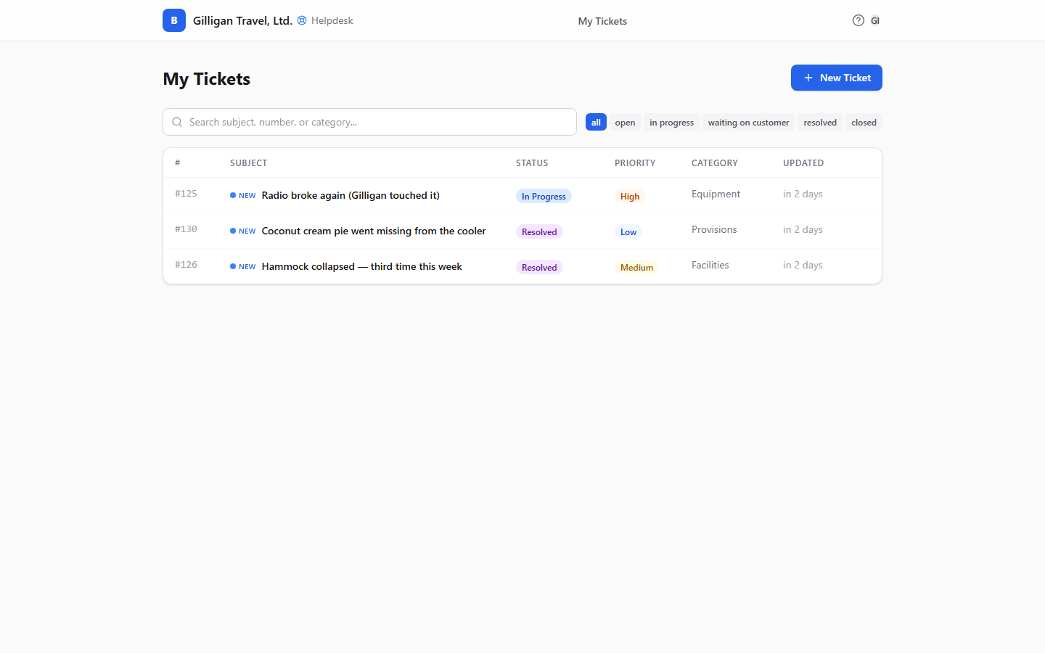
Figure 16.2 My tickets

New Ticket
This is where a customer files a support request.
To create a ticket:
1. From My Tickets, click New Ticket (the button with the plus icon). The page is headed New Ticket and has a "Back to tickets" link.
2. Fill in Subject ("Brief summary of your issue"). This is required.
3. If the portal has categories, choose one from the Category select ("Select a category..."). The field is hidden when no categories are configured.
4. Set Priority to Low, Medium, or High. Medium is the default. Customers cannot set Critical.
5. Fill in Description in the rich-text editor ("Describe your issue in detail..."). This is required. You can paste or upload inline images.
6. Click Submit Ticket (or Cancel to back out).
7. You land on the new ticket's detail page.
When you submit, the portal creates the ticket and spawns a Bam task in the portal's project so your support staff can work it. If you submit the same subject and description again within an hour, the portal returns your existing ticket instead of creating a duplicate.
TIP
Submitting the same subject and description again within an hour does not double-file. The portal hands back your existing ticket, so an accidental second click never clutters the queue.
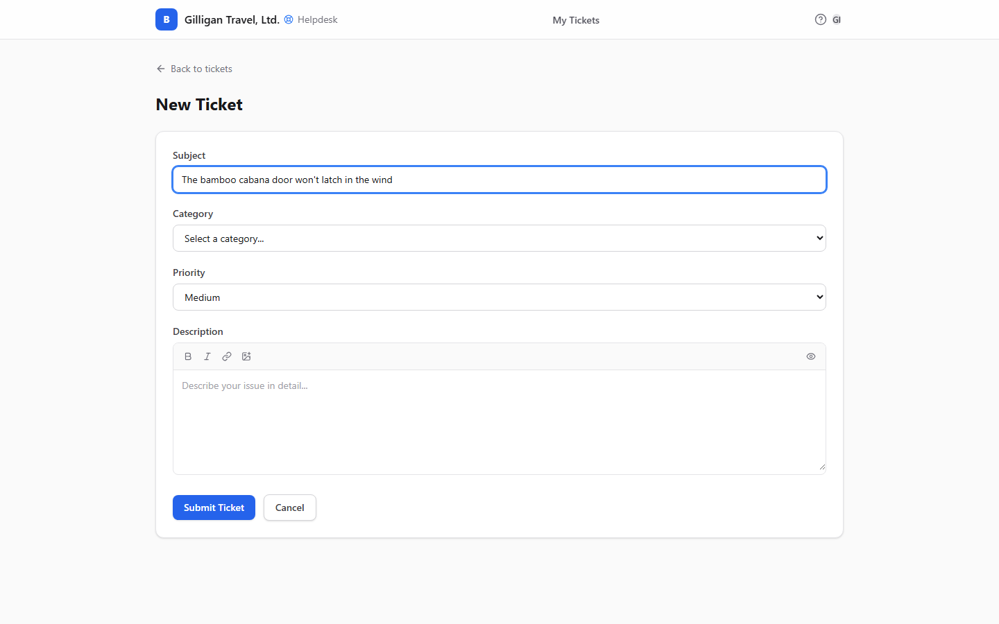
Figure 16.3 New ticket

Ticket detail (the conversation)
The ticket detail page is the full conversation and the place to take action on a ticket.
The header shows "#{number} - {subject}", a presence strip of who else is viewing, the Status badge, the Priority badge with a dropdown, the category chip when set, and "Created on {date}".
The body shows the Description, an Attachments block, and the timeline of messages and status changes. Your own messages appear on the right labeled "You"; agent and system messages appear on the left. Status changes appear as italic lines, for example "Status changed from X to Y". If the conversation is long, click "Load older messages". When there are no messages yet, the timeline reads "No messages yet."
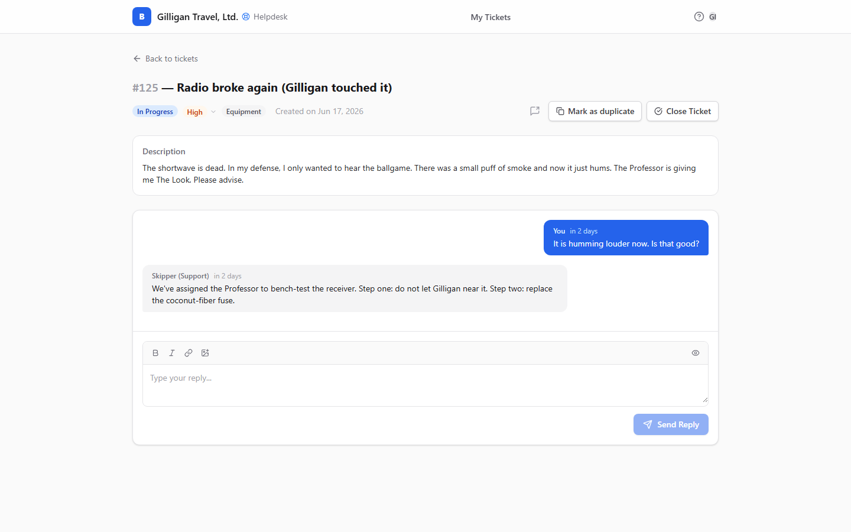
Figure 16.4 Ticket detail

Reply to a ticket
1. Scroll to the reply box at the bottom (it is hidden once a ticket is Resolved or Closed).
2. Type into the rich-text field (placeholder "Type your reply..."). You can add inline images.
3. Click Send Reply.
If the ticket was Waiting on Customer, sending a reply automatically flips it back to Open.

Change priority
1. In the header, click the Priority badge to open its dropdown.
2. Pick Low, Medium, or High.

Close a ticket
1. Click Close Ticket in the header.
2. Confirm in the "Close this ticket?" dialog.
Closing the ticket also moves its linked Bam task to a terminal state.

Reopen a ticket
1. On a Resolved or Closed ticket, find the banner "This ticket has been resolved." or "This ticket has been closed."
2. Click Reopen.

Mark as duplicate
Use this when your ticket is a copy of one you already filed.
1. Click Mark as duplicate (the copy icon). It is available only when the ticket is not already closed, resolved, or a duplicate.
2. In the Mark as duplicate dialog, type the primary ticket's number in the input ("e.g. #123").
3. Click Confirm (or Cancel).
4. A banner appears: "This ticket was marked as a duplicate of #N... Updates will be posted on that ticket." Updates now go on the primary. The primary ticket shows a "Duplicates of this ticket" callout.
To undo, click Unmark in the banner. You cannot unmark if an agent has already merged the ticket.

Share to Banter
Use this to hand a ticket off to a Banter channel for internal discussion.
1. Click the Share to Banter button (the share icon) in the header.
2. In the popover, headed Share to Banter, pick a channel from the Channel select ("Select a channel...").
3. Optionally type into the Message (optional) field ("Add a note...").
4. Click Share (or Cancel).

Attachments
1. In the Attachments block (the paperclip with a count), each file shows its name, size, type, and scan status.
2. Click Download to retrieve a file once it has been scanned. Until then it shows Unavailable.
3. To add a file, upload it from the ticket. Files are owner-scoped: only the ticket owner can delete an attachment.

Notifications prompt
On the tickets list, if your browser has not yet been asked, a banner offers browser push notifications: "Get notified when agents respond to your tickets."
To enable:
1. Click Enable notifications on the banner.
2. Allow notifications in your browser prompt.
Dismiss the banner with the X if you do not want them. Note that whether a notification actually arrives also depends on the org's notify settings and on outbound email being configured.

In-app Help
The Help viewer is built into the portal. Press the ? key from anywhere in the portal to open it; closing it returns you to your tickets. It has no separate page of its own.

The agent queue (REST and MCP only)
Support agents work tickets through the agent REST surface under /helpdesk/api/agents/, not through the customer portal. There is no agent SPA in Helpdesk. Agents authenticate with a per-agent agent API key (prefixed hdag_) sent in the X-Agent-Key header. A plain Bam session cookie alone is not accepted on the agent routes.
What agents can do on the agent surface:
- List org tickets, filtered by status, assignee, and SLA state, via the agent queue.
- Resolve a ticket by its #number, enriched with the requester and the task assignee.
- Search tickets by subject and description.
- Open full ticket detail, including internal notes that customers never see.
- Post a public reply or an internal note. The first agent reply stamps the first-response time.
- Update status, priority, or category.
- Close a ticket.
- Merge duplicates: move the messages onto a primary ticket and close the source.
- Pull a ranked list of similar tickets to find duplicates or related issues.
The agent queue shows an SLA badge for each ticket (breached, imminent, or ok). The badge's first-response target is currently a fixed 4 hours with a 0.75 imminent threshold. This is independent of the per-org SLA setting that the background breach monitor actually enforces (default 8 hours for first response, 48 hours for resolution), so the queue badge and the recorded breach events can disagree. See Related.
NOTE
The agent queue's SLA badge is hardwired to a 4-hour first-response target, but the background breach monitor enforces the per-org SLA setting (default 8 hours for first response, 48 for resolution). The badge and the recorded breaches can therefore disagree.
Most agents drive these actions through the MCP tools in Working with AI agents below, or through Bam's own ticket views.

Settings and admin
An admin configures each org's portal. Admins authenticate with a Bam org owner or admin session, or with an hdag_ agent API key. Settings are org-scoped; the row is created on first save if it does not exist.
Configurable settings:
- Default project - the project where incoming tickets create their Bam tasks. Set this from the org's non-archived projects.
- Default phase - the phase for newly created tasks.
- Default priority - the priority applied by default (low, medium, high, or critical).
- Categories - the list of categories customers can choose from on New Ticket.
- Welcome message - text shown on the portal.
- Allowed email domains - restricts which email domains may register.
- Require email verification - whether new customers must verify their email before signing in.
- Auto-close days - configured number of days before idle tickets close.
- Notify on status change and Notify on agent reply - whether to send the customer an email on those events.
To set the default project for incoming tickets:
1. As an admin, open the Helpdesk settings for the org.
2. Choose a project from the org's projects (the picker lists id, slug, and name for each non-archived project).
3. Save. New tickets now create their Bam task in that project. If no default is set, the portal falls back to the project named in the tenant context, then the oldest project.
To disable customer signups:
1. As an admin, set the signup-disabled flag for the org.
2. After that, the registration route returns a "signup disabled" error, and the portal's "Create one" link routes to the Bam beta gate instead of registration.
Note that the SLA minute settings live on the settings row but are not part of the settings update schema; they are editable only directly in the database or through a future UI. Auto-close days and the notify toggles are stored as configuration; confirm with your operator whether the backing automation is enabled in your deployment before relying on them.

Working with AI agents
Helpdesk exposes 13 MCP tools so agents and automations can triage, answer, search, and configure tickets. They proxy to the Helpdesk API and forward the caller's token, so an agent acts with its own authority. Be aware that the agent surface routes (/helpdesk/api/agents/) require an hdag_ agent API key, so a tool calling those routes acts as a configured support agent, not as a customer.
Thirteen MCP tools mean an agent can triage, answer, search, and configure tickets with its own authority.
Reading and finding tickets:
- list_tickets - list tickets with optional status, assignee, and client filters.
- get_ticket - open a ticket with its messages.
- helpdesk_get_ticket_by_number - resolve a #number to the full record, enriched with requester and task assignee.
- helpdesk_search_tickets - fuzzy search across tickets by subject and body, returning a compact projection ordered by most recently updated.
- helpdesk_find_similar_tickets - rank tickets similar to a given one, for finding duplicates or related issues. This is the dedupe surface a triage agent uses before merging.
Acting on tickets:
- reply_to_ticket - post a public reply or an internal note. It resolves the ticket number to the record first.
- update_ticket_status - change a ticket's status. Its status values are the canonical set: open, in_progress, waiting_on_customer, resolved, closed.
Configuration and intake:
- helpdesk_get_public_settings - read the public settings subset (email-verification requirement, categories, welcome message). No auth required.
- helpdesk_get_settings - read the full org settings (admin).
- helpdesk_update_settings - edit settings (admin).
- helpdesk_set_default_project - set the project that incoming tickets create their Bam task in, by org slug and project slug (admin).
- helpdesk_upsert_user - idempotently create or update a customer by org and email, for example from an external system reconciling its user list. The update path never overwrites the password.
Reporting:
- helpdesk_ticket_count_by_phrase - count tickets matching a phrase across time buckets, for trend analysis.
Two agent flows are worth calling out for human reviewers:
- Ticket to Bam task. Every ticket the portal creates already spawns a Bam task in the default project. An agent working tickets sees the same trail there. When you review an agent's work, check both the ticket conversation and the linked task.
- Similar-ticket search before merging. A triage agent should call helpdesk_find_similar_tickets to find candidates before merging duplicates. A human should confirm the proposed primary before a merge closes the source ticket, since merge moves messages and is not a customer-reversible action.
Helpdesk also participates in the cross-cutting agentic platform that spans the whole suite:
- Identity, audit, and heartbeat. Agent and service callers carry an explicit kind, and their actions are stamped onto the activity trail. Long-running runners report liveness with agent_heartbeat. Helpdesk ticket actions show up in this trail like any other app's.
- Unified activity view. Helpdesk's per-ticket activity log is one of the sources UNIONed into the platform's unified activity view, so a cross-app agent can see ticket events alongside Bam, Bond, and the rest. Helpdesk uses actor_type=agent to mean a human support agent; the platform remaps that to the human kind so it does not collide with the platform's agent identity.
- Approval queues. Sensitive proposals can be routed to a durable approval queue (proposal_create, proposal_list, proposal_decide) so a human signs off before an agent acts. Pair this with merges and bulk status changes.
- Visibility preflight. Before an agent posts ticket content into a shared cross-app surface, it must call can_access for every cited entity and drop anything the asker is not allowed to see.
- Agent policies and outbound webhooks. A per-agent kill switch and tool allowlist (the helpdesk.* prefix among them) gate which Helpdesk tools an agent may call, and outbound webhooks push subscribed Helpdesk Bolt events (ticket created, message posted, status changed, closed, reopened, user upserted, SLA breached) to agent runners.
For the complete tool catalog, see the MCP tools reference in docs/apps/helpdesk/.

User Stories

Story: File your first support ticket
Who: A customer reaching support for the first time.
Goal: Get a support request in front of an agent.
Before you start: Know which organization you need support from. Signups must be enabled on that org's portal. You do not need a Bam suite account; Helpdesk has its own customer sign-in.
Steps
1. Go to /helpdesk/. On the Choose your support portal page, click your org's row.
2. On the portal, open Create your account. Enter Email, Display Name, and a Password of at least 12 characters, then click Create Account.
3. If the org requires verification, open the link in your email, wait for "Your email has been verified!", click Go to Login, and sign in.
4. On My Tickets, click New Ticket.
5. Fill in Subject and Description. Pick a Category if the portal offers one, and set Priority (Low, Medium, or High).
6. Click Submit Ticket.
Result: You land on the ticket's detail page with a ticket number like #123. Behind the scenes a Bam task is created so support staff can pick it up.
Related: Track and reply to a ticket; an agent can intake a customer with helpdesk_upsert_user.

Story: Track a ticket and reply to an agent
Who: A customer with an open ticket.
Goal: Read the agent's reply and respond.
Before you start: You have filed at least one ticket and are signed in.
Steps
1. Open My Tickets. Rows with a New dot have activity you have not seen.
2. Click the ticket to open it.
3. Read the timeline. Agent and system messages are on the left; your own are on the right.
4. In the reply box, type into "Type your reply...".
5. Click Send Reply.
Result: Your reply appears in the timeline. If the ticket was Waiting on Customer, it flips back to Open.
Related: Attach a file or inline image.

Story: Filter your tickets by status
Who: A customer with several tickets.
Goal: Narrow the list to just the tickets in one state.
Before you start: You are on My Tickets with more than one ticket.
Steps
1. Above the list, find the filter chips: all, open, in progress, waiting on customer, resolved, closed.
2. Click the chip for the status you want, for example waiting on customer to see the tickets where the agent is waiting on you.
3. Click all to clear the filter.
Result: The list shows only the tickets in the chosen state. You can combine a chip with the search box to narrow further.
Related: My Tickets list feature.

Story: Attach a file or inline image
Who: A customer who needs to send a screenshot, log, or document.
Goal: Get a file onto the ticket.
Before you start: The ticket is open (the reply box is hidden once a ticket is Resolved or Closed).
Steps
1. Open the ticket.
2. To send an inline image, paste or upload it into the rich-text reply or description editor.
3. To send a file, add it as an attachment from the ticket.
4. Find it in the Attachments block.
Result: The file shows its name, size, type, and scan status. A Download link appears once it has been scanned; until then it shows Unavailable.

Story: Change a ticket's priority
Who: A customer whose issue became more or less urgent.
Goal: Reset the priority.
Before you start: You are on the ticket detail page.
Steps
1. In the header, click the Priority badge to open its dropdown.
2. Choose Low, Medium, or High.
Result: The badge updates. Customers cannot set Critical; only agents can.

Story: Mark a ticket as a duplicate
Who: A customer who filed the same issue twice.
Goal: Point this ticket at the original so updates land in one place.
Before you start: You know the primary ticket's number. The ticket you are marking is not already closed, resolved, or a duplicate.
Steps
1. Open the duplicate ticket and click Mark as duplicate.
2. In the dialog, type the primary ticket's number ("e.g. #123").
3. Click Confirm.
Result: A banner says the ticket is a duplicate of #N and updates will be posted on that ticket. The primary shows a "Duplicates of this ticket" callout. Click Unmark to undo, as long as an agent has not merged it.

Story: Close a ticket, then reopen it
Who: A customer whose issue is resolved, or who needs to reopen one.
Goal: Close a settled ticket, or reopen one that turned out not to be done.
Before you start: You are on the ticket detail page.
Steps
1. To close, click Close Ticket and confirm "Close this ticket?".
2. To reopen later, find the "This ticket has been resolved." or "This ticket has been closed." banner and click Reopen.
Result: Closing also moves the linked Bam task to a terminal state. Reopening returns the ticket to an active state and brings back the reply box.

Story: Share a ticket to a Banter channel
Who: A customer or agent who wants to discuss a ticket in chat.
Goal: Post a link to this ticket into a Banter channel.
Before you start: You can see the ticket and have at least one Banter channel available.
Steps
1. On the ticket, click the Share to Banter button.
2. In the popover, pick a channel from the Channel select.
3. Optionally add a note in Message (optional).
4. Click Share.
Result: The ticket is posted to the chosen Banter channel.

Story: Turn on browser notifications
Who: A customer who wants to know the moment an agent replies.
Goal: Get a browser push when there is ticket activity.
Before you start: You are on the My Tickets list and your browser has not been asked yet.
Steps
1. On the banner "Get notified when agents respond to your tickets.", click Enable notifications.
2. Allow notifications in the browser prompt.
Result: Your browser is permitted to show ticket notifications. Whether one arrives also depends on the org's notify settings and on outbound email being configured.

Story: Work the agent queue
Who: A support agent.
Goal: Triage and answer tickets.
Before you start: You have a per-agent agent API key (prefixed hdag_). A Bam session alone is not accepted on the agent routes.
Steps
1. Pull the agent queue, filtered by assignee, status, or SLA state, with list_tickets or by querying the agent queue route directly. Each ticket carries an SLA badge.
2. Open a ticket with get_ticket (or resolve a #number first with helpdesk_get_ticket_by_number). As an agent you see internal notes that customers do not.
3. Reply with reply_to_ticket, choosing a public reply or an internal note.
4. Move the ticket forward with update_ticket_status, using a canonical status (open, in_progress, waiting_on_customer, resolved, closed).
5. Close the ticket when it is done.
Result: The ticket reflects your reply and new status. The linked Bam task is updated in step with the ticket.
Related: Merge duplicates; note that the queue's SLA badge target is a fixed 4 hours and may not match the org's configured SLA.

Story: Merge duplicate tickets
Who: A support agent cleaning up duplicate reports.
Goal: Consolidate two tickets into one.
Before you start: You have agent access and a candidate ticket that may be a duplicate.
Steps
1. Call helpdesk_find_similar_tickets on the ticket to get a ranked list of candidates.
2. Confirm which ticket is the true primary.
3. Merge the source into the primary through the agent merge action.
Result: The source ticket's messages move onto the primary and the source is closed. Unlike a customer's "mark as duplicate", an agent merge is not customer-reversible, so confirm the primary before merging.

Story: Set up a new support portal
Who: An org admin or owner.
Goal: Configure the org's portal so tickets route correctly.
Before you start: You have a Bam admin or owner session, or an hdag_ agent key. The org has at least one project.
Steps
1. Open the org's Helpdesk settings (read them with helpdesk_get_settings).
2. Set the Default project so incoming tickets create their Bam task in the right place. Use helpdesk_set_default_project or set default_project_id directly.
3. Set the Categories customers can choose from, a Welcome message, and a Default priority.
4. Restrict Allowed email domains and decide whether to Require email verification.
5. Save with helpdesk_update_settings. The settings row is created if it did not exist.
Result: The portal is configured. New tickets land in the right project, and customers see your categories and welcome message.
Related: Disable signups by setting the signup-disabled flag; after that the "Create one" link routes to the Bam beta gate.

Story: Reconcile a customer from an external system
Who: An admin or an integration agent.
Goal: Make sure a customer exists in Helpdesk without disturbing an existing account.
Before you start: You have admin authority and the org slug. The intake request must carry the org context.
Steps
1. Call helpdesk_upsert_user with the org slug and the customer's email.
2. Provide the display name and any other fields.
Result: The customer is created if new, or updated if they already exist, matched on org and email. The password is never overwritten on update. A user.upserted event is emitted for downstream automations.

Story: Report on ticket trends
Who: An admin or agent watching support load.
Goal: See how often a phrase appears in tickets over time.
Before you start: You have admin authority.
Steps
1. Call helpdesk_ticket_count_by_phrase with the phrase you want to track.
2. Choose the time buckets (for example by hour, day, or week) and the time window.
Result: A time-bucketed count of tickets matching the phrase, which you can use to spot spikes or recurring issues.

Flagged behavior (known mismatches)
These are real behaviors in the current code that can surprise you. Document them so users do not chase them as bugs.
- No Knowledge Base in Helpdesk. Some older guide material describes a Helpdesk knowledge base. There is no such feature in the Helpdesk code. The knowledge base product is the separate Beacon app. Do not look for a KB in Helpdesk.
- Agent-queue SLA badge target is fixed. The agent queue's SLA badge uses a fixed 4-hour first-response target with a 0.75 imminent threshold. The actual breach monitor uses the per-org SLA settings (default 8 hours for first response, 48 hours for resolution). The badge and the recorded breaches can therefore disagree.

Related
- Bam - every ticket spawns and stays linked to a Bam task in the portal's default project. Agents work tickets from Bam's ticket views and project board. Closing a ticket moves its task to a terminal state.
- Banter - share a ticket into a Banter channel with the Share to Banter action for internal discussion.
- Beacon - the actual knowledge base product. Helpdesk has no knowledge base of its own.
- Bolt - Helpdesk emits ticket lifecycle events (created, message posted, status changed, closed, reopened, user upserted, and SLA breached) that Bolt automations can react to.
- MCP tools reference and the app guide live in docs/apps/helpdesk/. The 13 Helpdesk MCP tools are listed under Working with AI agents above.

Check yourself
Every answer is findable in this chapter. Check your work against the Answer Key appendix at the back of the book.
1. What are the five canonical ticket statuses?
a) Open, In Progress, Waiting on Customer, Resolved, Closed
b) New, Open, Pending, Done, Archived
c) Open, Assigned, Escalated, Resolved, Closed
d) Draft, Open, Blocked, Resolved, Closed
2. Which priority can an agent set that a customer cannot?
a) Low
b) Medium
c) High
d) Critical
3. What is the minimum length for a customer's portal password?
a) 8 characters
b) 10 characters
c) 12 characters
d) There is no minimum
4. If you submit the same subject and description again within an hour, what happens?
a) A second ticket is created
b) The portal returns your existing ticket instead of creating a duplicate
c) Submission is blocked with an error
d) The original ticket is overwritten
5. What credential do support agents use on the agent routes?
a) A Bam session cookie alone
b) An hdag_ agent API key in the X-Agent-Key header
c) The customer portal sign-in
d) An OAuth token from the suite single sign-on
6. If you are looking for a knowledge base, which app should you use?
a) Helpdesk's built-in KB
b) Beacon
c) Brief
d) Bench
7. What happens to a Waiting on Customer ticket when the customer sends a reply?
8. What happens to a ticket's linked Bam task when the ticket is closed?
9. How long is an email verification token valid before it expires?
10. How is a customer's mark-as-duplicate different from an agent's merge?
11. When no default project is set on the portal, where do new tickets create their Bam task?
12. Which MCP tool ranks tickets similar to a given one to find duplicates before merging?
a) helpdesk_search_tickets
b) helpdesk_find_similar_tickets
c) helpdesk_get_ticket_by_number
d) list_tickets

Answer Key
Answers to every "Check yourself" review, grouped by chapter. Each answer cites the section where you can confirm it.
Chapter 1. Bam
1. b) 6 letters (see: Key concepts: Project)
2. b) One (see: Key concepts: Sprint)
3. It can be carried forward to a target sprint, moved to the backlog, or cancelled. (see: Key concepts: Carry-forward)
4. b) Open subtasks (see: Key concepts: Done-gate)
5. New tasks default to Medium, and Bam supports seven custom field types: text, number, date, select, multi-select, checkbox, and url. (see: Key concepts: Priority and Custom field)
6. d) Mind map (see: Key concepts: Saved view)
7. a) owner, admin, and member, plus a guest role (see: Key concepts: Organization)
8. todo, active, blocked, review, done, and cancelled. (see: Key concepts: Task state)
9. a) admin, member, and viewer (see: Key concepts: Project)
10. No Swimlanes, By Assignee, By Priority, and By Epic. (see: Key concepts: Swimlane)
11. c) You cannot; watchers are populated by the system as people get involved with the task (see: Key concepts: Watcher)
12. An epic is open, in progress, or closed, and it rolls up task counts and story points. (see: Key concepts: Epic)
Chapter 2. Banter
1. c) 40,000 characters (see: Key concepts: Message)
2. a) public, private, and a DM type (see: Key concepts: Channel)
3. The roles are owner, admin, member, and viewer; a viewer is read-only and cannot post. (see: Key concepts: Channel role)
4. b) 3 to 8 people (see: Key concepts: Direct message (DM))
5. Only channel admins can pin or unpin, and a pin is channel-wide and visible to every member in the channel's pinned list. (see: Key concepts: Pin)
6. c) Only you (see: Key concepts: Bookmark)
7. b) do not disturb (see: Key concepts: Presence)
8. Banter creates #general, marks it the default, and auto-joins every active member, with the creator becoming owner. (see: Key concepts: #general)
9. a) Everyone, Admins only, Organization owners only (see: Admin: organization policy)
10. Channel creation is rate-limited to 5 per hour. (see: Create a channel)
11. b) It stays in the thread only (see: Key concepts: Thread)
12. Banter no longer starts or joins calls; every call write endpoint returns HTTP 410 Gone, Banter keeps only a read-only view of past calls and transcripts, and live audio happens in the suite-wide Bureau docked box. (see: Past calls and audio)
13. Quiet hours is a per-channel policy that holds non-urgent posts until the channel's allowed hours, used mostly by automated and agent posts. (see: Key concepts: Quiet hours)
14. a) Ctrl/Cmd+K (see: Keyboard shortcuts)
Chapter 3. Beacon
1. a) Draft, Active, Pending Review, Archived, Retired (see: Key concepts: Status)
2. c) 500 characters (see: Key concepts: Beacon)
3. Verified recently, Content is stale, Expiring soon, and Needs verification. (see: Key concepts: Freshness)
4. d) Private (see: Key concepts: Visibility)
5. It moves the article to Pending Review so an owner can review it. (see: Key concepts: Challenge)
6. c) Blocks (see: Key concepts: Link)
7. It resets the expiry date and raises the verification count. (see: Lifecycle actions)
8. b) Organization (see: Create and edit an article)
9. c) 10 MB (see: Attachments)
10. Project, then Organization, then System. (see: Expiry Policy Settings)
11. c) 1 to 20 (see: Tags)
12. It moves expired Active articles to Pending Review, and moves Pending Review articles to Archived after the grace period (it also deletes very old Drafts). (see: Expiry Policy Settings)
13. b) A created flag (see: Working with AI agents)
14. Agents cannot post comments or upload files; those actions stay human-only. (see: Working with AI agents)
Chapter 4. Bearing
1. b) At least one Period (see: Where to find it)
2. a) Number, Percentage, Currency, Yes/No (see: Key concepts: Key Result)
3. A goal's overall progress is the average of its key results' progress, and each key result's progress is clamped between 0 and 100 percent. (see: Key concepts: Key Result)
4. b) Organization, Team, Project, Individual (see: Key concepts: Scope)
5. It derives the status automatically by comparing actual progress against expected progress, which is where the goal should be based on how much of the period has elapsed, unless someone overrides it. (see: Key concepts: Expected progress)
6. c) Deletion is blocked with a conflict error (see: Periods)
7. b) planning (see: Periods)
8. The Create Goal dialog does not offer the Individual scope or an owner field; new goals are owned by you, and reassigning a goal to another owner is done through the agent tool bearing_goal_update or REST, not the human UI. (see: Create a Goal)
9. b) Updates the KR, rolls up the goal's progress, re-derives the goal's status, and writes a snapshot (see: Record progress on a Key Result)
10. It binds the key result to a Bam epic, project, sprint, or task so a background recompute job keeps the key result and its goal current as linked tasks reach a done state. Linking is available only through the MCP tools and REST, not a human screen in this build. (see: Working with AI agents)
11. b) By user ID first, then by email (see: Watch a goal)
12. My Goals splits goals into Active and Completed sections, where Completed means a goal that is achieved or missed. (see: My Goals)
Chapter 5. Bench
1. c) Nothing; it queries other products' tables through a registry (see: Overview)
2. c) Eleven (see: Widget Wizard)
3. Private, Project, or Organization. (see: Key concepts: Dashboard)
4. b) At least one (see: Key concepts: Measure)
5. count, sum, avg, min, or max. (see: Key concepts: Measure)
6. d) It is forced to Private (see: Dashboards list)
7. b) The first measure with its first aggregation, plus the first two dimensions, limited to 50 rows (see: Ad-Hoc Explorer)
8. Email, Banter Channel, and Brief Document. (see: Key concepts: Scheduled report)
9. a) PDF, PNG, and CSV (see: Key concepts: Scheduled report)
10. Their backing tables have no organization column, so the query builder's org filter fails and the query returns nothing. (see: Sources that do not return data)
11. b) Over 30%, with high, medium, or low severity (see: Working with AI agents)
12. The Default Cache TTL is 60 seconds and the Statement Timeout is 10,000 ms. (see: Bench Settings)
Chapter 6. Bill
1. b) In integer cents (see: Overview)
2. c) Finalizing an invoice (see: Overview)
3. Its number is assigned permanently and its line items can no longer be edited; invoices are only editable while in draft. (see: Overview)
4. b) No, it is computed from the due date (see: Key concepts: Invoice status)
5. draft, sent, viewed, partially_paid, paid, and void. (see: Key concepts: Invoice status)
6. An expense starts pending, a reviewer moves it to approved (or rejected), and an approved expense can be moved on to reimbursed. (see: Key concepts: Expense)
7. b) The most specific rate that applies (see: Key concepts: Rate)
8. b) Bill rejects the payment (see: Invoice detail)
9. With Auto-finalize on, every generated invoice is assigned a number and marked sent automatically; with it off (Draft), each run produces a draft for you to review, finalize, and send by hand. (see: Recurring billing)
10. b) No, it is view-and-PDF only and you record payments yourself (see: Public invoice view)
11. It produces {prefix}-{number:05d}, for example INV-00001; year-based forms like INV-2026-0042 from some seed data are not what finalize generates. (see: Working with AI agents)
12. b) Only approved expenses (see: Reports)
13. It is a UI and REST action via POST /bill/api/v1/expenses/:id/reimburse, with no dedicated MCP tool. (see: Working with AI agents)
Chapter 7. Blank
1. b) draft (see: Key concepts: Form status)
2. b) 10 (see: Public form)
3. Public (anyone with the link), Organization (members of your org), and Project members (members of a chosen Bam project). (see: Key concepts: Visibility)
4. c) SVG (see: Responses)
5. It must have at least one field. (see: Publish dialog)
6. b) Its fields and submissions (see: Forms list)
7. b) Section Header, Paragraph, Hidden Field, Page Break (see: Key concepts: Field type)
8. https://YOUR-DOMAIN/forms/<slug>, the server-rendered public form page. (see: Key concepts: Public form URL)
9. d) Nowhere; there is no Close button in the SPA, so closing is done through the API or an agent (see: Story: Close a form to stop accepting responses)
10. From their signed-in account, then the form's email field, then an explicit email in the response, in that order. (see: Access control and notifications)
11. b) Every file was validated and stored (see: Responses)
12. A BigBlueBam session or a bbam_ / bbam_svc_ API key, plus membership in an organization (all forms and submissions are scoped to your org). (see: Where to find it: Prerequisites)
Chapter 8. Blast
1. c) Six (see: Key concepts: Campaign status)
2. c) sent (see: Key concepts: Campaign status)
3. An unsubscribe mechanism (such as an {{unsubscribe_url}} merge field or text containing unsubscribe or opt-out) and a physical mailing address. (see: Key concepts: CAN-SPAM gate, and Why a send was rejected)
4. a) draft and scheduled (see: Campaign detail and Send Now)
5. It pulls its audience from Bond (contacts and segments over Bond contact fields) and pushes activity into Bolt so automation rules can react. (see: Overview)
6. b) In the Bam app under Account Settings then Integrations (see: SMTP (platform relay))
7. It does not send immediately; it schedules the campaign about an hour out and returns a note that a human must confirm before it goes. (see: Working with AI agents)
8. b) 25 (see: Campaign detail and Send Now)
9. ALL conditions (AND), which requires every condition, and ANY condition (OR), which matches any one. (see: Key concepts: Segment, and Segment builder and preview)
10. c) admin (see: Sender Domains)
11. It marks the recipient complained, increments the complaints counter, and automatically unsubscribes that address org-wide. (see: Provider webhooks (automatic, no UI))
12. b) Hard-coded templated strings (see: Working with AI agents)
Chapter 9. Blueprint
1. c) As a typed relational graph of node and edge rows (see: Overview)
2. a) Rounded, Rectangle, Diamond, Ellipse, and Hexagon (see: Key concepts: Shape)
3. c) bam.task (see: Key concepts: Linked entity)
4. a) Default, Dependency, Flow, Reference, and Inherits (see: Key concepts: Edge)
5. d) org_chart (see: Generate a diagram from a Bam project)
6. b) Mermaid (.mmd) and JSON (see: Export a diagram)
7. A pinned node is excluded from auto-layout. It keeps the position you set by hand when you run a layout pass, and it cannot be dragged until you unpin it. (see: Key concepts: Pinned and Move and pin nodes)
8. Private (you, plus collaborators), Project (project members, or the org if there is no project), and Organization (everyone in your org). (see: Key concepts: Visibility)
9. An edge from A to B means A is the parent of B. It is the default, with target-parent reversing it and none skipping parent links entirely. (see: Promote a whole graph to Bam tasks)
10. Owner, Editor, Commenter, and Viewer, granted as explicit per-diagram access on top of project or org visibility. (see: Key concepts: Collaborator and Comments, People, and version History panels)
11. Each snapshot is numbered automatically, one higher than the latest, and it saves a complete immutable copy of the whole graph that you can restore later. (see: Snapshots (versions))
12. blueprint_generate accepts 1 to 500 node specs and up to 2000 edge specs, with replace true to wipe the existing graph first or auto_layout false to skip the post-generate pass. (see: Working with AI agents)
Chapter 10. Board
1. b) project (see: Key concepts: Visibility)
2. c) dots (see: Key concepts: Background)
3. The soft limit is 500 elements, where you get a warning, and the hard limit is 2000 live elements, at which further additions are rejected. Deleted elements do not count. (see: Element limits)
4. a) yellow (see: Key concepts: Sticky note)
5. It reads your shared BigBlueBam session cookie, and your permissions come from Bam. If you are not signed in, Board shows a 'Please log in to BigBlueBam first' screen. (see: Overview)
6. c) The board creator or an org admin or owner (see: Key concepts: Lock)
7. You draw with Excalidraw's own native toolbar. Board overlays a floating board toolbar, a connection status badge, an integrity banner when the project link is broken, and a chat panel. (see: The infinite canvas)
8. b) Copies a shareable link to the board to your clipboard (see: The board toolbar)
9. There is a complete backend for collaborators but no screen in the Board app yet, and the Share button only copies the link. Until a sharing screen ships, control access through the board's visibility setting, or have an agent or API client manage collaborators directly. (see: Collaborators (no in-app management today))
10. b) JSON, SVG, and PNG (see: Export)
11. The Description field and the list's element-count and creator-name fields render blank because the backend does not store the description and does not return an element count or creator name on versions today. Only the version name, creator reference, and timestamp are saved and shown reliably. (see: Version history (snapshots))
12. b) A labeled region that groups the elements inside it (see: Key concepts: Frame)
13. It reports the realtime connection state for the canvas, shown as Live (green), Connecting (amber), or Offline (red), plus an 'N editors' chip when other people are present. (see: Real-time presence and audio)
Chapter 11. Bolt
1. b) A trigger, optional conditions, and an ordered list of actions (see: Overview)
2. b) The bare event name plus an explicit separate source field, such as deal.rotting with bond as the source (see: Key concepts: Event source)
3. Running, Success, Partial (some steps failed but all ran), Failed (halted early), and Skipped (a guard or condition prevented it). (see: Key concepts: Execution)
4. b) 60 (see: Key concepts: Limits)
5. c) 13 (see: Key concepts: Condition)
6. Stop (halt the run), Continue (run the rest anyway), or Retry (retry up to the Retry Count). (see: Key concepts: On Error)
7. c) 16 (see: Templates)
8. The Schedule source fires automations on a cron schedule rather than off another app's event, and the event type is cron.fired. (see: Key concepts: Schedule trigger)
9. b) Disabled (see: Duplicating an automation)
10. Retry appears only for runs whose status is Failed or Partial, and if the rule is over its hourly cap the retry is rejected as rate limited. (see: Retrying a failed run)
11. b) As a single linear ordered list that runs top to bottom (see: Simple mode)
12. Fields that read the event body must be prefixed with event., for example event.task.priority. (see: Key concepts: Condition)
Chapter 12. Bond
1. a) Contacts, companies, deals, and pipelines (see: Overview)
2. b) Lead (see: Key concepts: Lifecycle stage)
3. It is the deal's value multiplied by its probability. (see: Key concepts: Deal)
4. b) 0 to 100 (see: Key concepts: Lead score)
5. c) When it is more than 1.5 times over its stage's rotting threshold (see: Key concepts: Rotting (stale) deal)
6. Active, Won, or Lost. (see: Key concepts: Stage)
7. a) Prospect, Qualified, Proposal, Negotiation, Closed Won, and Closed Lost (see: Bond Settings: Pipelines)
8. Closing Won sets probability to 100 and moves it to a Won-type stage; closing Lost sets probability to 0, moves it to a Lost-type stage, and records the reason and competitor. (see: Deal detail and outcomes)
9. b) No, members and viewers see only the deals and contacts they own (see: Where to find it: Roles and visibility)
10. No, deletes are soft: the record is hidden, not erased. Restore a contact or company by checking Include deleted in its list and clicking Restore on the struck-through row. (see: Key concepts: Soft delete / Restoring deleted records)
11. b) Through the REST API with a JSON contacts array (1 to 5000 records) or an agent, with admin access (see: Bulk-importing contacts)
12. They are org-wide for that entity type (Contact, Company, or Deal), not per pipeline. (see: Key concepts: Custom field / Bond Settings: Custom Fields)
13. c) Recalculating a contact's lead score (see: Bond Settings: Lead Scoring)
Chapter 13. Book
1. b) A personal calendar named My Calendar; no, it cannot be deleted (see: Overview and Key concepts: Calendar)
2. b) status confirmed, visibility busy (see: Key concepts: Event)
3. Cancelling is a soft delete: the event's status flips to cancelled rather than the row being erased, so it drops out of availability and the timeline but its record is retained. (see: Key concepts: Event, and Story: Cancel an event)
4. b) Free (see: Key concepts: Show as (visibility))
5. Monday to Friday, 09:00 to 17:00, are enabled by default. (see: Key concepts: Working hours, and the Working Hours feature)
6. b) As a confirmed event on the page owner's default calendar (see: Key concepts: Booking, and Public Meet page)
7. The Reminder dropdown and the Color picker. Book has no reminder feature or job, and event color is not stored on the event because color lives on the calendar, so both controls are inactive. (see: New Event and Edit Event: Notes and current limitations)
8. b) The rule is stored on the single event but not expanded, so it remains one event (see: New Event and Edit Event: Notes and current limitations)
9. The .ics feed provider works with no credentials; Google Calendar and Microsoft Outlook require operator-supplied OAuth credentials before a connection can be created. (see: Connections, and Key concepts: External connection)
10. b) Every fifteen minutes (see: Connections: How sync works)
11. Disconnecting removes the connection and every event Book mirrored from that feed, so the calendar returns to just your own events. (see: Connections: How sync works, and Key concepts: Synced (mirrored) event)
12. b) A row lock guards the booking, and a collision returns a 409 'This time slot is no longer available' (see: Public Meet page)
13. The human form does not support adding or editing attendees; attendees are set when an event is created through the API or an agent tool, book_create_event. (see: New Event and Edit Event: Notes, and Working with AI agents)
Chapter 14. Brief
1. a) Draft, In Review, Approved, and Archived (see: Key concepts: Status)
2. b) Public (see: Key concepts: Visibility)
3. Publish sets the document to Approved; Save Draft keeps it as Draft. (see: Save a draft and publish)
4. b) Up to 2 characters (see: Key concepts: Document)
5. Organization (all org members), Project (the creator, collaborators, or members of that project), and Private (the creator and collaborators only). (see: Key concepts: Visibility)
6. c) 48 (see: Working with AI agents)
7. A conflict-free shared editing model (Yjs) over the /brief/ws WebSocket. (see: Edit an existing document and co-edit in real time)
8. a) Brief creates a Beacon article from it, and the promotion is one-way (see: Promote to Beacon)
9. The UI can only create folders; renaming, moving, and deleting folders are done through an agent or the API. (see: Folders and project scope)
10. b) At least 2 (see: Search)
11. It is not stored by Brief today, so anything typed there is dropped on save; put summary text in the document body instead. (see: The "Brief summary (optional)" field)
12. a) A Draft copy named "<title> (copy)" (see: Duplicate a document)
13. It returns to Draft status. (see: Archive and restore)
Chapter 15. Bureau
1. c) 8 (see: Key concepts: Room)
2. a) Open, Knock, and Private (see: Key concepts: Door state (privacy))
3. 30 seconds. (see: Key concepts: Knock)
4. b) 24 hours (see: Key concepts: Room chat)
5. available, busy, dnd, focus, away, and in_meeting. (see: Key concepts: Presence status)
6. b) Puts them on a denied list rather than pinging them with a dead link (see: Key concepts: Summon (Bring everyone here))
7. "Let in" admits them, "Not now" defers the knock, and "Decline" rejects the visitor. (see: Knock and respond to a knock)
8. b) The knock is blocked (the server returns 423) and they are offered a leave-a-note path (see: Knock and respond to a knock)
9. Open means non-attendees may wander in, and Locked means the room is held private for the meeting. (see: Key concepts: Booking)
10. b) members_can_book (see: Admin - Settings)
11. b) It returns the same result as "not located" (see: Hunt)
12. Because your presence lives on the server, so the docked box re-attaches to the surface huddle wherever you land. (see: The cross-app docked box)
13. b) With an "(A) " prefix (see: Working with AI agents)
Chapter 16. Helpdesk
1. a) Open, In Progress, Waiting on Customer, Resolved, Closed (see: Key concepts: Status)
2. d) Critical (see: Key concepts: Priority)
3. c) 12 characters (see: Register (create an account))
4. b) The portal returns your existing ticket instead of creating a duplicate (see: New Ticket)
5. b) An hdag_ agent API key in the X-Agent-Key header (see: The agent queue (REST and MCP only))
6. b) Beacon (see: Where to find it)
7. Sending a reply automatically flips the ticket back to Open. (see: Reply to a ticket)
8. Closing the ticket also moves its linked Bam task to a terminal state. (see: Close a ticket)
9. Verification tokens expire after 24 hours. (see: Verify email)
10. A customer mark-as-duplicate is annotative: it posts updates on the primary and can be unmarked. An agent merge actually moves the messages onto the primary and closes the source, and it is not customer-reversible. (see: Key concepts: Duplicate)
11. The portal falls back to the project named in the tenant context, then the oldest project. (see: Settings and admin)
12. b) helpdesk_find_similar_tickets (see: Working with AI agents)

Glossary
Key terms used throughout this book. Each is footnoted on first use in a chapter.
#general. the default channel. The first time anyone opens Banter in an org that has no channels, Banter creates #general, marks it the default, and auto-joins every active member (the creator becomes owner). You cannot delete or leave the default channel.
Action. one step Bolt runs when the automation fires. Each action calls an allowlisted MCP tool with parameters you supply. Actions run in order; this is a linear list, not a branching flow (see the note under Actions).
Activity. a timeline entry logged against a contact, company, and/or deal. Types include Note, Email Sent, Email Received, Call, Meeting, and Task, plus system-generated entries like stage changes and deal created/won/lost.
Admin. an org owner or admin who configures the portal settings.
Agent. a support staff member. Agents authenticate with a per-agent agent API key (prefixed hdag_) on the agent routes, not with the customer portal. They do not use the customer portal SPA.
Agent pattern subscription. a rule that lets an agent or service account listen to a channel and react when messages match a pattern.
At Risk. The view that lists goals whose status is at_risk or behind, sorted by how far they have fallen behind expected progress.
Attachment. a file uploaded to a ticket. It appears in the Attachments block once it has been scanned, with a Download link.
Attendee. A person invited to an event, identified by email. Attendees carry a response status (needs_action until they answer, then accepted, declined, or tentative) and a flag for the organizer.
Automation (rule). the top-level object: a trigger, optional conditions, an ordered list of actions, and limit settings. The UI calls these "Automations".
Availability slot. A computed free interval, equal to your working hours minus the events that mark you busy.
Background. the canvas backdrop pattern. One of dots (default), grid, lines, or plain.
Bam task. the project-board task created automatically for every ticket. It lives in the portal's default project so your staff can triage, assign, and track support work alongside other project work.
Beacon. A single knowledge article. Has a globally unique slug, a title, a summary (up to 500 characters), a Markdown body, a version number, a status, a visibility, an owner, an optional project, and an expiry date.
Board. one infinite-canvas whiteboard. It has a name, a description, an emoji icon, a background pattern, a visibility setting, an optional project association, and a locked flag.
Booking. The event created when a visitor books a slot on a booking page. It lands as a confirmed event on the page owner's default calendar.
Booking page. A public scheduling link at /book/meet/<slug> that lets an outside visitor pick one of your free slots. It carries a duration, before and after buffers, advance and notice limits, and brand styling.
Bookmark. your own private save of a message, with an optional note. Bookmarks are visible only to you and live on the Bookmarks page.
Building. An optional grouping of floors for multi-site orgs. It exists in the data model and a new floor can carry a building_id, but there is no building management screen in the app today.
Calendar. A container for events. Each calendar has a type (personal, team, project, booking, or bureau), a color, and a timezone. One personal calendar, My Calendar, is created for you on first use and cannot be deleted. The bureau type is reserved for a system-provisioned, per-org calendar that other apps write room bookings into; you do not create it by hand.
Campaign. A single bulk email send. Has a name, subject, body (HTML), optional plain-text body, an optional template, an optional segment, From name/email, reply-to, and rollup counters.
Campaign status. One of six states: draft, scheduled, sending, paused, sent, cancelled. A draft is editable, deletable, and sendable. A scheduled campaign can be sent or cancelled. A sending campaign can be paused or cancelled. sent is the terminal success state and the only one analytics counts. There is no "archived" state.
CAN-SPAM gate. A compliance check that runs when you send or schedule. The HTML body must contain both an unsubscribe mechanism and a physical mailing address, or the send is rejected.
Carry-forward. When you complete an active sprint, each incomplete task can be carried forward to a target sprint, moved to the backlog, or cancelled. Carried tasks show a carry-forward badge and remember their original sprint for reporting.
Category. an optional label chosen from the list an admin configured for the portal. The Category field only appears when categories are configured.
Challenge. A flag that an Active article may be wrong. Challenging moves it to Pending Review.
Channel. a named conversation space. Channels are public (anyone in the org can find and join), private (invite only), or a DM type (dm / group_dm). Each channel has a name, an optional topic and description, members with roles, and a slug that is unique within your org.
Channel role. your standing inside one channel: owner, admin, member, or viewer. A viewer is read-only and cannot post. Channel admins manage pins, members, and settings.
Check-in. Recording a new current value for a key result. Each check-in updates the KR's progress, rolls up to the goal's progress, and writes a point-in-time snapshot for the sparkline and history chart.
Client. The recipient of an invoice. Carries name, email, phone, address, tax ID, default payment terms (in days), default payment instructions, and notes. A Bill client is separate from a Bond contact or company, though it can be linked to a Bond company.
Collaborator. a user granted explicit access to one diagram at a role of owner, editor, commenter, or viewer, on top of any project- or org-level visibility. Managed in the editor's People panel, or by an agent through the API.
Comment. a note attached to the whole diagram or anchored to a single node, with a resolved flag for review threads. Read, written, and resolved in the editor's Comments panel, or by an agent through the API.
Company. an organization. Holds name, domain, industry, company size bucket, annual revenue, phone, website, logo, address, custom fields, and an owner. Contacts and deals can be linked to a company.
Condition. an extra test on the event: a field, an operator, and a value, grouped with AND or OR logic. Conditions gate the whole automation; if they are not met, the run is skipped. There are 13 operators (equals, not_equals, contains, not_contains, starts_with, ends_with, greater_than, less_than, is_empty, is_not_empty, in, not_in, matches_regex). Fields that read the event body must be prefixed event. (for example event.task.priority).
Confirmation. what a respondent sees after submitting: a message, a redirect, or a custom page.
Contact. a person you track. Holds name, email, phone, job title, avatar, lifecycle stage, lead source, lead score, address, custom fields, and an owner.
Custom field. A project-scoped field stored on each task. The seven field types are text, number, date, select, multi-select, checkbox, and url. A field can be required and can be shown on the card.
Customer. an end user with a Helpdesk account scoped to one org. Customers have their own email and password sign-in, separate from the suite single sign-on. They use the portal SPA.
Dashboard. A named container of widgets with a saved layout. Each dashboard has a visibility of Private, Project, or Organization, an optional linked project, and an optional auto-refresh interval. One dashboard per org can be the default.
Data source. A registered (product, entity) pair that maps to one underlying table with declared measures, dimensions, and filters. Bench can only query registered sources and columns, and every query is automatically scoped to your organization.
Deal. a revenue opportunity in a pipeline. Holds a name, value, currency, expected close date, probability, and a computed weighted value (value times probability). A deal is Open until it is closed Won or Lost.
Diagram. the top-level artifact. Has a name, a type, a layout algorithm, a visibility level, an optional project, and an archived flag.
Diagram type. a tag that picks the type icon and the sidebar grouping. The New diagram dialog offers Flowchart, Graph, Sequence, Class, and Mind map. Generate from Bam writes the type org_chart.
Dimension. A field to group by (for example, deal stage or campaign).
Direct message (DM). a private conversation with one other person. A group DM is a private conversation with 3 to 8 people total.
Docked box. The floating Bureau overlay rendered inside every SPA. It shows your room, your co-occupants, the page you are viewing, the call controls, and the Bring everyone here / Invite / Hunt actions.
Document. A single piece of writing. It has a title, a globally unique slug, an optional icon (up to 2 characters), a rich-text body, a word count, a status, a visibility, an optional project, and an optional folder.
Done-gate. A task cannot move into a closed state while it still has open subtasks. The board surfaces this as an alert and the API returns an INCOMPLETE_SUBTASKS error.
Door state (privacy). How a room treats visitors. Three values: Open (anyone can enter), Knock (visitors must knock to be let in), and Private (only people on the room's access list). The room stores a durable default; live overrides such as a short do-not-disturb window apply on top of it.
Duplicate. a ticket flagged as a copy of another. A customer "mark as duplicate" is annotative: it posts updates on the primary instead. An agent "merge" actually moves the messages onto the primary and closes the source.
Edge. a connection between two nodes. Carries a kind (Default, Dependency, Flow, Reference, Inherits) and an end marker (Filled arrow, Open arrow, No arrow / None).
Editor. The Tiptap rich-text surface where you write. It has a formatting toolbar, slash commands (type /), a live word count, a Table of Contents built from your headings, and a Settings sidebar for icon, visibility, project, and starting template.
Element. anything on the canvas: a sticky note, text, a shape, a connector (arrow or line), an image, or a frame. The canvas scene is stored whole, and a per-element copy is kept so the board can be searched, read, and promoted.
Engagement event. An append-only record of an open, click, unsubscribe, bounce, or complaint. These feed the analytics counters and are published to Bolt.
Epic. A grouping of tasks across sprints, with a status of open, in progress, or closed. Epics roll up task counts and story points.
Event. A time block on a calendar with a title, start and end time, optional location, description, and meeting URL. Events have a status (tentative, confirmed, or cancelled; new events default to confirmed) and a visibility (free, busy, tentative, or out_of_office; default busy). Cancelling an event is a soft delete: it flips status to cancelled rather than erasing the row.
Event source. the emitting app, stored alongside the bare event name. Bolt uses bare-name-plus-explicit-source naming, so the event is deal.rotting with bond as a separate source field, not bond.deal.rotting. The trigger dropdowns offer 14 sources: Bam, Banter, Beacon, Brief, Helpdesk, Schedule, Bond, Blast, Board, Bench, Bearing, Bill, Book, and Blank.
Execution. one run of one automation against one event. Its status is one of: Running, Success, Partial (some steps failed but all ran), Failed (halted early), or Skipped (a guard or condition prevented it). A skipped run records a reason such as cooldown active, rate limited, or conditions not met.
Execution step. one action attempt inside an execution, with its own status: success, failed, or skipped.
Expected progress. Where a goal should be based on how much of the period has elapsed. Bearing compares actual against expected to decide whether a goal is on track, at risk, or behind.
Expense. A project cost: description, amount in cents, category, vendor, date, and a billable flag. Expenses start as pending, a reviewer moves them to approved or rejected, and an approved expense can be moved on to reimbursed.
Expiry policy. Per-scope rules (System, Organization, Project) that set the minimum, maximum, and default number of days before an article expires, plus a grace period.
External connection. A subscription to an outside calendar that Book pulls events from. The .ics feed provider works today with no credentials: paste a public iCalendar URL and Book mirrors its events onto a Book calendar, updating in place on each sync. Google Calendar and Microsoft Outlook connections use the same sync engine but require operator-supplied OAuth credentials before they can be created (see Connections below).
Field. a single input or element on the form. Fields are ordered, can be marked required, and each has a stable field key (letters, digits, and underscores; must start with a letter or underscore) used as the storage key for answers.
Field type. what kind of input a field is, for example Short Text, Email, Rating, NPS, or Dropdown. You pick the type from the builder palette when you add a field. A few layout-only types (Section Header, Paragraph, Hidden Field, and Page Break) carry no submitted answer.
Filter. A condition on a field. Operators include equals, not equals, greater/less than (and -or-equal), in, is null, is not null, between, and like.
Floor. One navigable office map. A floor owns a layout, an optional background image, a slug used in its URL, and a position in the list. One floor can be marked the default.
Folder. A named container for documents. Folders can be nested and can be scoped to a project. You create folders from the sidebar; renaming and deleting folders is not available in the UI today (an agent can do both, see Working with AI agents).
Form. the top-level object you build and share. It has a name, a slug (used in its public URL), a description, fields, and behavior settings.
Form status. the lifecycle state of a form: draft (still being built), published (live and accepting responses), or closed (no longer accepting responses). New forms start as draft.
Form type. a label on the form (Public, Internal, or Embedded) found on the per-form Settings page.
Frame. a labeled region on the canvas that groups the elements inside it. Frames are used when reading or summarizing a board by section.
Freshness. A computed signal based on when the article was last verified and when it expires. The detail page and cards show one of four states: Verified recently, Content is stale, Expiring soon, or Needs verification.
Goal. An objective owned by one user inside a period. A goal has a title, an optional description, a scope, a status, and a cached progress percentage that is the average of its key results.
Goal status. Where a goal stands: draft, on_track, at_risk, behind, achieved, missed, or cancelled. Bearing derives status automatically from how actual progress compares to expected progress, unless someone overrides it.
Hunt. Locate one org member and jump to wherever they are. It respects DND and filters out destinations you cannot access.
iCal feed. A token-authenticated .ics URL that exposes one calendar to an outside calendar app. Available through the API and agents only; there is no button for it in the app yet.
Integrity issue. a flag on a board whose project link is broken (cross-org, missing, or auto-detached). You resolve it by detaching the board from the project or reassigning it to a valid one.
Invoice. A billable document addressed to one client. It snapshots your company details (the "from" side) and the client details (the "to" side) when it is created, and carries an invoice date, due date, line items, tax, totals, and payment history. Its number is literally DRAFT until you finalize it.
Invoice status. The lifecycle of an invoice. The values that the app actually sets are draft (editable, no number yet), sent (finalized, number assigned, edits locked), viewed (a client opened the public link), partially_paid (some payment recorded, balance remains), paid (paid in full), and void (cancelled). Overdue is not a stored status: it is computed from the due date as any unpaid, finalized invoice that is past due. The Invoices list Overdue filter pill and the Dashboard Overdue tile both draw from that computed set, so they populate correctly.
Key Result (KR). A measurable outcome under a goal. Each KR has a metric type (Number, Percentage, Currency, or Yes/No), a start value, a target value, a current value, and an optional unit. KR progress is clamped between 0 and 100 percent.
Knock. An async request to enter a closed office. A knock auto-times-out after 30 seconds if the owner does not respond.
Knowledge Graph. The network of Beacons. Nodes are articles; edges are either explicit typed links or implicit "Tag Affinity" edges between articles that share enough tags.
Label. A project-scoped tag with a name and color.
Layout algorithm. the auto-arrange engine, run server-side by ELK. The layout dropdown offers Layered, Force-directed, Tree, and Grid, and all four apply a layout. Tree maps to ELK's mrtree and Grid maps to ELK's rectpacking. The radial algorithm is reachable only through the API or an agent.
Lead score. a number from 0 to 100 cached on each contact. Scoring rules add or subtract points based on contact attributes.
Lead scoring rule. a condition (field, operator, value) plus a point delta. Rules are org-wide and evaluated together to compute each contact's score.
Lifecycle stage. where a contact sits in your funnel: Lead, Subscriber, MQL (marketing qualified), SQL (sales qualified), Opportunity, Customer, Evangelist, or Other. New contacts default to Lead.
Limits. per-automation guards: Max Executions / Hour (1 to 1000 in the UI, default 60) and Cooldown (seconds) (0 to 3600, default 0). There is also an internal max chain depth that prevents automations from triggering each other in an endless loop.
Line item. One row on an invoice: a description, quantity, unit (default hours), and unit price in cents. The amount is quantity times unit price. Line items can only be added, edited, or removed while the invoice is a draft.
Link. A typed connection between two articles: Related To, Supersedes, Depends On, Conflicts With, or See Also. Links are read-only in the UI today (created through MCP tools or the API; see Links between articles).
Linked entity. a cross-product reference from a node to an object in another app, such as a Bam task, a Beacon entry, a Bond deal, or a Bearing goal. Only Bam tasks have live two-way sync.
Lock. a board-level read-only switch. When a board is locked, only the board creator or an org admin or owner can edit it.
Logic (conditional display). a field can be configured to show only when another field meets a condition (for example, equals or contains a value). This is stored on the field and is available to agents through the MCP field tools; the visual builder does not yet expose a conditional editor.
Materialized view. A pre-computed rollup that the worker refreshes automatically. Three are exposed to you as queryable bench: data sources: Daily Task Throughput, Pipeline Snapshot, and Campaign Engagement.
Measure. A numeric aggregation in a query: count, sum, avg, min, or max of a field. A query needs at least one measure.
Mention. typing @ plus a name notifies that person. Org admins can also define @mention user groups (for example @engineering) that notify everyone in the group.
Merge fields. Placeholders the sender fills in per recipient: {{first_name}}, {{last_name}}, {{email}}, {{company}}, and {{unsubscribe_url}}.
Message. a single post. Messages support rich text (bold, italic, code, links), @mentions, and emoji, up to 40,000 characters. You can edit or delete your own messages.
Node. a vertex on the canvas. Carries a shape, label, markdown description, position, width and height, a pinned flag, fill color, an optional parent (for nesting), and an optional cross-product link.
Office. A room of type Office that has an owner. The owner can be knocked on, sets the door, and admits or declines visitors. Think of it as a personal office.
On Error. per-action behavior when a step fails: Stop (halt the run), Continue (run the rest anyway), or Retry (retry up to the Retry Count).
Organization (org). The top-level tenant. Org roles are owner, admin, and member, plus a guest role. Priorities are configured at the org level.
Payment. A recorded receipt against an invoice: an amount in cents, a method (Bank Transfer, Credit Card, Check, Cash, Stripe, PayPal, or Other), an optional reference, and a date.
Period. A named time box that goals live inside, for example "Q2 2026". A period has a type, a start date, an end date, and a status. The whole Bearing UI is scoped to one selected period at a time.
Period status. The lifecycle of a period. The Bearing UI shows these as draft, active, completed, and archived. You activate a period to make it the working scope and complete it when the period is over.
Phase. A board column. A phase can carry a WIP limit, a color, start and terminal flags, and an auto-state that is applied when a task enters the phase.
Pin. a channel-wide marker that any member can see in the channel's pinned list. Only channel admins can pin or unpin.
Pinned. a node excluded from auto-layout. A pinned node keeps the position you set by hand when you run a layout pass.
Pipeline. an ordered set of stages plus a currency. One pipeline can be the default. The default pipeline is selected automatically when you open the board; you can switch to another from the sidebar scope selector.
Portal. an org's public support site, served at /helpdesk/<org-slug>/. Each org with a Helpdesk settings row gets one. Per-project portals are available at /helpdesk/<org-slug>/<project-slug>/. The portal a customer lands on decides which org owns their account and tickets.
Presence. your live status: online, idle, in a call, do not disturb, or offline.
Presence status. One of 6 values: available, busy, dnd, focus, away, in_meeting. The docked box exposes a head-down DND toggle that flips between available and DND.
Priority. A per-org configurable value. The default set is Critical, High, Medium, Low, and None. New tasks default to Medium.
Project. A board with its own phases, states, labels, epics, sprints, custom fields, and templates. Every project has a task id prefix (2 to 6 uppercase letters, for example MAGE or FRND) that prefixes every task id. Project roles are admin, member, and viewer.
Project scope. A filter in the sidebar that limits the documents and folders you see to one project, or shows everything with "All Projects".
Promote to Beacon. Graduating a finished document into a Beacon knowledge-base article. This is one-way: once promoted, the document records the Beacon it became.
Public form URL. the shareable link to your published form, in the form https://YOUR-DOMAIN/forms/<slug>. This is the server-rendered page the Publish dialog hands you.
Public view token. A long opaque token on each invoice that grants read-only access (and a PDF) without logging in. It is how a sent invoice can be viewed by someone outside your org.
Quiet hours. a per-channel policy that holds non-urgent posts until the channel's allowed hours. Used mostly by automated and agent posts.
Rate. A billing rate scoped to your org, a project, a user, or a user-on-a-project, with an amount in cents and a type (hourly, daily, or fixed). When Bill bills tracked time, it resolves the most specific rate that applies.
Reaction. an emoji you toggle on a message. Click once to add, click again to remove.
Real-time collaboration. Two or more people editing the same document at once. You see other editors' cursors and presence while you type, and readers on the detail page see edits appear live.
Recipient / send log. One row per person per campaign. It tracks the status of that one email (queued, sent, delivered, bounced, complained, or failed) and drives the Recipients table on the campaign detail page.
Recurring schedule. A subscription that bills one client on a cadence (weekly, monthly, quarterly, or annually) from a saved line-item template. It carries a status (active, paused, or cancelled), a next-run date, a count of invoices generated so far, and a mode: auto-finalize (each generated invoice gets a number and is marked sent) or draft (each generated invoice is left as a draft to review). A daily worker sweep materializes invoices from schedules whose next-run date has arrived, and you can also generate one on demand.
Ring (Invite). Pushes an incoming-call overlay to one specific person on a content surface. It respects DND. An admin can Force Invite, which bypasses the accept prompt with a 3-second cancellable auto-navigate.
Roles. org roles resolve as viewer, member, admin, owner. Admins and owners get full access to any board in the org.
Room. An addressable space on a floor. Each room maps one-to-one to an audio room. Rooms come in 8 types: Office (single owner), Huddle, Conference, Meeting, Open space, Lounge, Focus, and Lobby.
Room access list (ACL). Per-user grants for private rooms, with role member or manager. Managers can edit the room and manage its access list.
Room chat. Ephemeral text chat scoped to a room or surface, kept 24 hours by default and recoverable later under Recent chats.
Rotting (stale) deal. an open deal whose days in its current stage exceed that stage's rotting threshold. The card turns orange, and red when it is more than 1.5 times over.
RSVP. An attendee's response to an event. Only someone who is already an attendee can RSVP.
Saved query. A named, reusable search configuration you can reopen later. Scope can be Private, Project, or Organization.
Saved view. A saved filter, sort, swimlane, and view-type preset. It can be private to you or shared with the project. Saved views persist the Board, List, Timeline, and Calendar view types.
Schedule trigger. the Schedule source fires automations on a cron schedule (cron.fired) rather than off another app's event.
Scheduled message. a message queued to post later at a set time, or deferred automatically when a channel is inside its quiet hours.
Scheduled report. A cron-driven dashboard snapshot delivered to a target on a schedule. Delivery methods are Email, Banter Channel, and Brief Document; export formats are PDF, PNG, and CSV.
Scope. Who a goal is for: Organization, Team, Project, or Individual. The dashboard can filter and group goals by scope.
Segment. A saved filter over Bond contacts, built from one or more conditions joined by ALL conditions (AND) or ANY condition (OR). Each segment caches a contact count so you can see roughly how many people match.
Sender domain. A domain you add and verify (SPF, DKIM, DMARC) so mailbox providers accept your mail.
Settings. Your company identity and the defaults new invoices inherit: invoice prefix, default tax rate, payment terms, payment instructions, footer text, and terms text.
Shape. the visual form of a node. The palette offers Rounded, Rectangle, Diamond, Ellipse, and Hexagon.
Show as (visibility). Controls whether an event blocks your availability. An event marked Free does not consume a slot; Busy, Tentative, and Out of Office do.
Snapshot (version). a saved, immutable copy of the whole graph that you can restore later. Browsed and restored from the editor's History panel.
Soft delete. contacts, companies, and deals are not erased when deleted. They are hidden and can be restored from their list with Include deleted.
Sprint. A time-boxed iteration with a status of planned, active, completed, or cancelled. Only one sprint can be active per project at a time. The default sprint length is 14 days. A sprint carries a goal, start and end dates, velocity, and retrospective notes.
Stage. a column on the board. Has a name, a type (Active, Won, or Lost), a probability percentage, an optional rotting threshold in days, and a color.
Star. your personal favorite flag on a diagram, used to filter the list.
Start and due dates. Each task can carry a start date and a due date. These drive the Timeline (Gantt) and Calendar views and feed the overdue and My Work groupings.
Status. The article's place in its lifecycle. The five statuses you will see in the UI are Draft, Active, Pending Review, Archived, and Retired. New articles start as Draft; publishing makes them Active.
Status update. A status post against a goal. It records a status tag, an optional body, and a snapshot of the goal's status and progress at the time it was posted.
Sticky note. a colored note. The default color is yellow. (Excalidraw has no native sticky; Board builds one from a rectangle with bound text.)
Submission. one response to a form. Submissions are listed in the Responses view and aggregated in Analytics.
Summon (Bring everyone here). Pulls every eligible co-occupant of your current room to a URL in another app. Each recipient is access-checked first, so people who cannot see the destination are not pinged with a dead link.
Surface huddle. The audio room attached to any content surface (a Board canvas, a Brief doc, a Bond deal). The docked box auto-joins it when you navigate to that surface.
Swimlane. A horizontal grouping of the board. The options are No Swimlanes, By Assignee, By Priority, and By Epic.
Synced (mirrored) event. A Book event that Book created from an external feed. It is kept in step with the feed automatically: a re-sync updates it in place, an event removed upstream is removed from Book, and disconnecting the feed removes all of its mirrored events.
Tags. Free-form labels on an article. Tags drive filtering, search tag expansion, and implicit graph edges. They are a search and filter facet: you add and remove tags as chips on the Search screen to widen or narrow results. Note: the editor shows a "Tags (comma-separated)" field, but tags typed there are not saved today (a known limitation; see Create and edit an article). Tags that appear on articles come from agent or API writes, not from the editor field.
Task. The unit of work. Each task has a human id in the form PREFIX-N (for example MAGE-38). A task holds a title, rich-text description, phase, state, sprint, epic, assignee, reporter, priority, story points, time estimate and logged time, start and due dates, labels, custom fields, links, parents and subtasks, comments, and attachments.
Task state. The status of a task, orthogonal to its phase. Each state belongs to a category (todo, active, blocked, review, done, or cancelled) and may be a closed state. Tasks in a closed state count toward velocity.
Template. A reusable email design: name, subject template, HTML body, an optional visual block layout, and a description. Templates carry a version number that bumps automatically each time you save an edit.
Templating. action parameters can interpolate values from the event with {{ event.* }}, the actor with {{ actor.id }} / {{ actor.type }}, automation metadata with {{ automation.* }}, the current time with {{ now }}, and a prior step's result with {{ step[N].result.* }}. There is no {{ actor.name }} and no top-level {{ org.* }}.
Thread. replies attached to a parent message. A reply stays in the thread unless you tick Also send to channel, which also mirrors it into the main timeline.
Ticket. a single customer support request. It has a human-readable number shown as #123, a subject, a description, a status, a priority, and an optional category. Each ticket is owned by one customer and back-linked to a Bam task.
Timeline. A cross-app, date-ranged view that gathers Book events, Bam task due dates, and Bond deal close dates into one per-day list.
Trigger. what starts an automation. It has a Trigger Source (the app that emits the event, such as Bam or Bond) and an Event Type (the bare event name, such as task.created). A trigger can also carry an optional filter.
Trigger filter. an optional set of equality rules (key matches value) checked against the raw event payload before the automation fires.
Unsubscribe. An org-wide suppression keyed on email. Once an address unsubscribes (or files a spam complaint), it is excluded from future sends across the whole org.
Verification. A recorded review confirming an article is still accurate. Verifying resets the expiry date and raises the verification count.
Version. a named snapshot of a board's canvas that you can restore later.
Visibility. Who can see the article: Public, Organization, Project, or Private. Public and Organization are visible to all org members; Private is visible only to the owner or creator; Project is visible to the owner, creator, or members of that project.
Watcher. A user subscribed to a task's notifications. Watchers are populated by the system as people get involved with a task. There is no manual add-watcher or remove-watcher control in the Bam UI.
Widget. One visualization on a dashboard. A widget has a name, a chart type, a data source and entity, and a query configuration. The renderer draws bar, line, area, pie, donut, KPI card, counter, and table widgets distinctly; any other type falls back to a table.
Working hours. Your weekly availability windows, one row per day of the week. By default Monday to Friday, 09:00 to 17:00, are enabled. These windows are the raw material for availability and booking-page slots.

Index
Key terms and the pages where they appear.

Project. A board with its own phases, states, labels, epics, sprints, custom fields, and templates. Every project has a task id prefix (2 to 6 uppercase letters, for example MAGE or FRND) that prefixes every task id. Project roles are admin, member, and viewer.
Task. The unit of work. Each task has a human id in the form PREFIX-N (for example MAGE-38). A task holds a title, rich-text description, phase, state, sprint, epic, assignee, reporter, priority, story points, time estimate and logged time, start and due dates, labels, custom fields, links, parents and subtasks, comments, and attachments.
Sprint. A time-boxed iteration with a status of planned, active, completed, or cancelled. Only one sprint can be active per project at a time. The default sprint length is 14 days. A sprint carries a goal, start and end dates, velocity, and retrospective notes.
Priority. A per-org configurable value. The default set is Critical, High, Medium, Low, and None. New tasks default to Medium.
Start and due dates. Each task can carry a start date and a due date. These drive the Timeline (Gantt) and Calendar views and feed the overdue and My Work groupings.
Phase. A board column. A phase can carry a WIP limit, a color, start and terminal flags, and an auto-state that is applied when a task enters the phase.
Task state. The status of a task, orthogonal to its phase. Each state belongs to a category (todo, active, blocked, review, done, or cancelled) and may be a closed state. Tasks in a closed state count toward velocity.
Epic. A grouping of tasks across sprints, with a status of open, in progress, or closed. Epics roll up task counts and story points.
Carry-forward. When you complete an active sprint, each incomplete task can be carried forward to a target sprint, moved to the backlog, or cancelled. Carried tasks show a carry-forward badge and remember their original sprint for reporting.
Label. A project-scoped tag with a name and color.
Custom field. A project-scoped field stored on each task. The seven field types are text, number, date, select, multi-select, checkbox, and url. A field can be required and can be shown on the card.
Saved view. A saved filter, sort, swimlane, and view-type preset. It can be private to you or shared with the project. Saved views persist the Board, List, Timeline, and Calendar view types.
Swimlane. A horizontal grouping of the board. The options are No Swimlanes, By Assignee, By Priority, and By Epic.
Watcher. A user subscribed to a task's notifications. Watchers are populated by the system as people get involved with a task. There is no manual add-watcher or remove-watcher control in the Bam UI.
Done-gate. A task cannot move into a closed state while it still has open subtasks. The board surfaces this as an alert and the API returns an INCOMPLETE_SUBTASKS error.
Message. a single post. Messages support rich text (bold, italic, code, links), @mentions, and emoji, up to 40,000 characters. You can edit or delete your own messages.
Channel. a named conversation space. Channels are public (anyone in the org can find and join), private (invite only), or a DM type (dm / group_dm). Each channel has a name, an optional topic and description, members with roles, and a slug that is unique within your org.
Channel role. your standing inside one channel: owner, admin, member, or viewer. A viewer is read-only and cannot post. Channel admins manage pins, members, and settings.
Thread. replies attached to a parent message. A reply stays in the thread unless you tick Also send to channel, which also mirrors it into the main timeline.
Reaction. an emoji you toggle on a message. Click once to add, click again to remove.
Pin. a channel-wide marker that any member can see in the channel's pinned list. Only channel admins can pin or unpin.
Bookmark. your own private save of a message, with an optional note. Bookmarks are visible only to you and live on the Bookmarks page.
Mention. typing @ plus a name notifies that person. Org admins can also define @mention user groups (for example @engineering) that notify everyone in the group.
Presence. your live status: online, idle, in a call, do not disturb, or offline.
Scheduled message. a message queued to post later at a set time, or deferred automatically when a channel is inside its quiet hours.
Quiet hours. a per-channel policy that holds non-urgent posts until the channel's allowed hours. Used mostly by automated and agent posts.
Agent pattern subscription. a rule that lets an agent or service account listen to a channel and react when messages match a pattern.
Beacon. A single knowledge article. Has a globally unique slug, a title, a summary (up to 500 characters), a Markdown body, a version number, a status, a visibility, an owner, an optional project, and an expiry date.
Visibility. Who can see the article: Public, Organization, Project, or Private. Public and Organization are visible to all org members; Private is visible only to the owner or creator; Project is visible to the owner, creator, or members of that project.
Freshness. A computed signal based on when the article was last verified and when it expires. The detail page and cards show one of four states: Verified recently, Content is stale, Expiring soon, or Needs verification.
Knowledge Graph. The network of Beacons. Nodes are articles; edges are either explicit typed links or implicit "Tag Affinity" edges between articles that share enough tags.
Tags. Free-form labels on an article. Tags drive filtering, search tag expansion, and implicit graph edges. They are a search and filter facet: you add and remove tags as chips on the Search screen to widen or narrow results. Note: the editor shows a "Tags (comma-separated)" field, but tags typed there are not saved today (a known limitation; see Create and edit an article). Tags that appear on articles come from agent or API writes, not from the editor field.
Link. A typed connection between two articles: Related To, Supersedes, Depends On, Conflicts With, or See Also. Links are read-only in the UI today (created through MCP tools or the API; see Links between articles).
Verification. A recorded review confirming an article is still accurate. Verifying resets the expiry date and raises the verification count.
Status. The article's place in its lifecycle. The five statuses you will see in the UI are Draft, Active, Pending Review, Archived, and Retired. New articles start as Draft; publishing makes them Active.
Challenge. A flag that an Active article may be wrong. Challenging moves it to Pending Review.
Saved query. A named, reusable search configuration you can reopen later. Scope can be Private, Project, or Organization.
Expiry policy. Per-scope rules (System, Organization, Project) that set the minimum, maximum, and default number of days before an article expires, plus a grace period.
Period. A named time box that goals live inside, for example "Q2 2026". A period has a type, a start date, an end date, and a status. The whole Bearing UI is scoped to one selected period at a time.
Goal. An objective owned by one user inside a period. A goal has a title, an optional description, a scope, a status, and a cached progress percentage that is the average of its key results.
At Risk. The view that lists goals whose status is at_risk or behind, sorted by how far they have fallen behind expected progress.
Period status. The lifecycle of a period. The Bearing UI shows these as draft, active, completed, and archived. You activate a period to make it the working scope and complete it when the period is over.
Scope. Who a goal is for: Organization, Team, Project, or Individual. The dashboard can filter and group goals by scope.
Goal status. Where a goal stands: draft, on_track, at_risk, behind, achieved, missed, or cancelled. Bearing derives status automatically from how actual progress compares to expected progress, unless someone overrides it.
Expected progress. Where a goal should be based on how much of the period has elapsed. Bearing compares actual against expected to decide whether a goal is on track, at risk, or behind.
Check-in. Recording a new current value for a key result. Each check-in updates the KR's progress, rolls up to the goal's progress, and writes a point-in-time snapshot for the sparkline and history chart.
Status update. A status post against a goal. It records a status tag, an optional body, and a snapshot of the goal's status and progress at the time it was posted.
Watcher. A user subscribed to a goal who is emailed when the goal's status changes.
Widget. One visualization on a dashboard. A widget has a name, a chart type, a data source and entity, and a query configuration. The renderer draws bar, line, area, pie, donut, KPI card, counter, and table widgets distinctly; any other type falls back to a table.
Data source. A registered (product, entity) pair that maps to one underlying table with declared measures, dimensions, and filters. Bench can only query registered sources and columns, and every query is automatically scoped to your organization.
Dashboard. A named container of widgets with a saved layout. Each dashboard has a visibility of Private, Project, or Organization, an optional linked project, and an optional auto-refresh interval. One dashboard per org can be the default.
Measure. A numeric aggregation in a query: count, sum, avg, min, or max of a field. A query needs at least one measure.
Dimension. A field to group by (for example, deal stage or campaign).
Filter. A condition on a field. Operators include equals, not equals, greater/less than (and -or-equal), in, is null, is not null, between, and like.
Saved query. A reusable query definition (data source, entity, and query config) you can keep and re-run later.
Scheduled report. A cron-driven dashboard snapshot delivered to a target on a schedule. Delivery methods are Email, Banter Channel, and Brief Document; export formats are PDF, PNG, and CSV.
Materialized view. A pre-computed rollup that the worker refreshes automatically. Three are exposed to you as queryable bench: data sources: Daily Task Throughput, Pipeline Snapshot, and Campaign Engagement.
Invoice. A billable document addressed to one client. It snapshots your company details (the "from" side) and the client details (the "to" side) when it is created, and carries an invoice date, due date, line items, tax, totals, and payment history. Its number is literally DRAFT until you finalize it.
Client. The recipient of an invoice. Carries name, email, phone, address, tax ID, default payment terms (in days), default payment instructions, and notes. A Bill client is separate from a Bond contact or company, though it can be linked to a Bond company.
Expense. A project cost: description, amount in cents, category, vendor, date, and a billable flag. Expenses start as pending, a reviewer moves them to approved or rejected, and an approved expense can be moved on to reimbursed.
Rate. A billing rate scoped to your org, a project, a user, or a user-on-a-project, with an amount in cents and a type (hourly, daily, or fixed). When Bill bills tracked time, it resolves the most specific rate that applies.
Payment. A recorded receipt against an invoice: an amount in cents, a method (Bank Transfer, Credit Card, Check, Cash, Stripe, PayPal, or Other), an optional reference, and a date.
Settings. Your company identity and the defaults new invoices inherit: invoice prefix, default tax rate, payment terms, payment instructions, footer text, and terms text.
Invoice status. The lifecycle of an invoice. The values that the app actually sets are draft (editable, no number yet), sent (finalized, number assigned, edits locked), viewed (a client opened the public link), partially_paid (some payment recorded, balance remains), paid (paid in full), and void (cancelled). Overdue is not a stored status: it is computed from the due date as any unpaid, finalized invoice that is past due. The Invoices list Overdue filter pill and the Dashboard Overdue tile both draw from that computed set, so they populate correctly.
Line item. One row on an invoice: a description, quantity, unit (default hours), and unit price in cents. The amount is quantity times unit price. Line items can only be added, edited, or removed while the invoice is a draft.
Recurring schedule. A subscription that bills one client on a cadence (weekly, monthly, quarterly, or annually) from a saved line-item template. It carries a status (active, paused, or cancelled), a next-run date, a count of invoices generated so far, and a mode: auto-finalize (each generated invoice gets a number and is marked sent) or draft (each generated invoice is left as a draft to review). A daily worker sweep materializes invoices from schedules whose next-run date has arrived, and you can also generate one on demand.
Public view token. A long opaque token on each invoice that grants read-only access (and a PDF) without logging in. It is how a sent invoice can be viewed by someone outside your org.
Form. the top-level object you build and share. It has a name, a slug (used in its public URL), a description, fields, and behavior settings.
Visibility. who can reach the form through its URL: Public (anyone with the link), Organization (members of your org), or Project members (members of a chosen Bam project).
Confirmation. what a respondent sees after submitting: a message, a redirect, or a custom page.
Submission. one response to a form. Submissions are listed in the Responses view and aggregated in Analytics.
Field. a single input or element on the form. Fields are ordered, can be marked required, and each has a stable field key (letters, digits, and underscores; must start with a letter or underscore) used as the storage key for answers.
Field type. what kind of input a field is, for example Short Text, Email, Rating, NPS, or Dropdown. You pick the type from the builder palette when you add a field. A few layout-only types (Section Header, Paragraph, Hidden Field, and Page Break) carry no submitted answer.
Form status. the lifecycle state of a form: draft (still being built), published (live and accepting responses), or closed (no longer accepting responses). New forms start as draft.
Form type. a label on the form (Public, Internal, or Embedded) found on the per-form Settings page.
Public form URL. the shareable link to your published form, in the form https://YOUR-DOMAIN/forms/<slug>. This is the server-rendered page the Publish dialog hands you.
Template. A reusable email design: name, subject template, HTML body, an optional visual block layout, and a description. Templates carry a version number that bumps automatically each time you save an edit.
Campaign. A single bulk email send. Has a name, subject, body (HTML), optional plain-text body, an optional template, an optional segment, From name/email, reply-to, and rollup counters.
Engagement event. An append-only record of an open, click, unsubscribe, bounce, or complaint. These feed the analytics counters and are published to Bolt.
Segment. A saved filter over Bond contacts, built from one or more conditions joined by ALL conditions (AND) or ANY condition (OR). Each segment caches a contact count so you can see roughly how many people match.
Campaign status. One of six states: draft, scheduled, sending, paused, sent, cancelled. A draft is editable, deletable, and sendable. A scheduled campaign can be sent or cancelled. A sending campaign can be paused or cancelled. sent is the terminal success state and the only one analytics counts. There is no "archived" state.
Recipient / send log. One row per person per campaign. It tracks the status of that one email (queued, sent, delivered, bounced, complained, or failed) and drives the Recipients table on the campaign detail page.
Unsubscribe. An org-wide suppression keyed on email. Once an address unsubscribes (or files a spam complaint), it is excluded from future sends across the whole org.
Sender domain. A domain you add and verify (SPF, DKIM, DMARC) so mailbox providers accept your mail.
Merge fields. Placeholders the sender fills in per recipient: {{first_name}}, {{last_name}}, {{email}}, {{company}}, and {{unsubscribe_url}}.
CAN-SPAM gate. A compliance check that runs when you send or schedule. The HTML body must contain both an unsubscribe mechanism and a physical mailing address, or the send is rejected.
Diagram. the top-level artifact. Has a name, a type, a layout algorithm, a visibility level, an optional project, and an archived flag.
Node. a vertex on the canvas. Carries a shape, label, markdown description, position, width and height, a pinned flag, fill color, an optional parent (for nesting), and an optional cross-product link.
Edge. a connection between two nodes. Carries a kind (Default, Dependency, Flow, Reference, Inherits) and an end marker (Filled arrow, Open arrow, No arrow / None).
Shape. the visual form of a node. The palette offers Rounded, Rectangle, Diamond, Ellipse, and Hexagon.
Layout algorithm. the auto-arrange engine, run server-side by ELK. The layout dropdown offers Layered, Force-directed, Tree, and Grid, and all four apply a layout. Tree maps to ELK's mrtree and Grid maps to ELK's rectpacking. The radial algorithm is reachable only through the API or an agent.
Visibility. who can see the diagram. Private (you, plus collaborators), Project (project members, or the org if there is no project), or Organization (everyone in your org).
Diagram type. a tag that picks the type icon and the sidebar grouping. The New diagram dialog offers Flowchart, Graph, Sequence, Class, and Mind map. Generate from Bam writes the type org_chart.
Pinned. a node excluded from auto-layout. A pinned node keeps the position you set by hand when you run a layout pass.
Linked entity. a cross-product reference from a node to an object in another app, such as a Bam task, a Beacon entry, a Bond deal, or a Bearing goal. Only Bam tasks have live two-way sync.
Collaborator. a user granted explicit access to one diagram at a role of owner, editor, commenter, or viewer, on top of any project- or org-level visibility. Managed in the editor's People panel, or by an agent through the API.
Comment. a note attached to the whole diagram or anchored to a single node, with a resolved flag for review threads. Read, written, and resolved in the editor's Comments panel, or by an agent through the API.
Star. your personal favorite flag on a diagram, used to filter the list.
Board. one infinite-canvas whiteboard. It has a name, a description, an emoji icon, a background pattern, a visibility setting, an optional project association, and a locked flag.
Version. a named snapshot of a board's canvas that you can restore later.
Background. the canvas backdrop pattern. One of dots (default), grid, lines, or plain.
Visibility. who can see a board. private (creator plus explicitly added collaborators), project (project members plus collaborators plus creator), or organization (every member of your org). The default is project.
Element. anything on the canvas: a sticky note, text, a shape, a connector (arrow or line), an image, or a frame. The canvas scene is stored whole, and a per-element copy is kept so the board can be searched, read, and promoted.
Sticky note. a colored note. The default color is yellow. (Excalidraw has no native sticky; Board builds one from a rectangle with bound text.)
Shape. a rectangle, diamond, ellipse, or freehand drawing from Excalidraw's toolbar.
Frame. a labeled region on the canvas that groups the elements inside it. Frames are used when reading or summarizing a board by section.
Collaborator. a person granted access to a single board with either view or edit permission. There is no in-app screen to manage collaborators today; manage them through the visibility setting or have an agent or API client do it (see Feature reference).
Lock. a board-level read-only switch. When a board is locked, only the board creator or an org admin or owner can edit it.
Star. your personal favorite marker on a board.
Template. a reusable board blueprint you start new boards from. System templates ship with the platform; your org can also create its own.
Integrity issue. a flag on a board whose project link is broken (cross-org, missing, or auto-detached). You resolve it by detaching the board from the project or reassigning it to a valid one.
Roles. org roles resolve as viewer, member, admin, owner. Admins and owners get full access to any board in the org.
Trigger. what starts an automation. It has a Trigger Source (the app that emits the event, such as Bam or Bond) and an Event Type (the bare event name, such as task.created). A trigger can also carry an optional filter.
Action. one step Bolt runs when the automation fires. Each action calls an allowlisted MCP tool with parameters you supply. Actions run in order; this is a linear list, not a branching flow (see the note under Actions).
Execution. one run of one automation against one event. Its status is one of: Running, Success, Partial (some steps failed but all ran), Failed (halted early), or Skipped (a guard or condition prevented it). A skipped run records a reason such as cooldown active, rate limited, or conditions not met.
Event source. the emitting app, stored alongside the bare event name. Bolt uses bare-name-plus-explicit-source naming, so the event is deal.rotting with bond as a separate source field, not bond.deal.rotting. The trigger dropdowns offer 14 sources: Bam, Banter, Beacon, Brief, Helpdesk, Schedule, Bond, Blast, Board, Bench, Bearing, Bill, Book, and Blank.
Trigger filter. an optional set of equality rules (key matches value) checked against the raw event payload before the automation fires.
Condition. an extra test on the event: a field, an operator, and a value, grouped with AND or OR logic. Conditions gate the whole automation; if they are not met, the run is skipped. There are 13 operators (equals, not_equals, contains, not_contains, starts_with, ends_with, greater_than, less_than, is_empty, is_not_empty, in, not_in, matches_regex). Fields that read the event body must be prefixed event. (for example event.task.priority).
On Error. per-action behavior when a step fails: Stop (halt the run), Continue (run the rest anyway), or Retry (retry up to the Retry Count).
Templating. action parameters can interpolate values from the event with {{ event.* }}, the actor with {{ actor.id }} / {{ actor.type }}, automation metadata with {{ automation.* }}, the current time with {{ now }}, and a prior step's result with {{ step[N].result.* }}. There is no {{ actor.name }} and no top-level {{ org.* }}.
Execution step. one action attempt inside an execution, with its own status: success, failed, or skipped.
Template. a pre-built automation blueprint you can instantiate and customize. Bolt ships 16 templates.
Schedule trigger. the Schedule source fires automations on a cron schedule (cron.fired) rather than off another app's event.
Limits. per-automation guards: Max Executions / Hour (1 to 1000 in the UI, default 60) and Cooldown (seconds) (0 to 3600, default 0). There is also an internal max chain depth that prevents automations from triggering each other in an endless loop.
Deal. a revenue opportunity in a pipeline. Holds a name, value, currency, expected close date, probability, and a computed weighted value (value times probability). A deal is Open until it is closed Won or Lost.
Pipeline. an ordered set of stages plus a currency. One pipeline can be the default. The default pipeline is selected automatically when you open the board; you can switch to another from the sidebar scope selector.
Stage. a column on the board. Has a name, a type (Active, Won, or Lost), a probability percentage, an optional rotting threshold in days, and a color.
Contact. a person you track. Holds name, email, phone, job title, avatar, lifecycle stage, lead source, lead score, address, custom fields, and an owner.
Lifecycle stage. where a contact sits in your funnel: Lead, Subscriber, MQL (marketing qualified), SQL (sales qualified), Opportunity, Customer, Evangelist, or Other. New contacts default to Lead.
Lead score. a number from 0 to 100 cached on each contact. Scoring rules add or subtract points based on contact attributes.
Company. an organization. Holds name, domain, industry, company size bucket, annual revenue, phone, website, logo, address, custom fields, and an owner. Contacts and deals can be linked to a company.
Activity. a timeline entry logged against a contact, company, and/or deal. Types include Note, Email Sent, Email Received, Call, Meeting, and Task, plus system-generated entries like stage changes and deal created/won/lost.
Rotting (stale) deal. an open deal whose days in its current stage exceed that stage's rotting threshold. The card turns orange, and red when it is more than 1.5 times over.
Custom field. an extra field you define per entity type (Contact, Company, or Deal). These are org-wide for that entity type, not per pipeline.
Lead scoring rule. a condition (field, operator, value) plus a point delta. Rules are org-wide and evaluated together to compute each contact's score.
Soft delete. contacts, companies, and deals are not erased when deleted. They are hidden and can be restored from their list with Include deleted.
Calendar. A container for events. Each calendar has a type (personal, team, project, booking, or bureau), a color, and a timezone. One personal calendar, My Calendar, is created for you on first use and cannot be deleted. The bureau type is reserved for a system-provisioned, per-org calendar that other apps write room bookings into; you do not create it by hand.
Working hours. Your weekly availability windows, one row per day of the week. By default Monday to Friday, 09:00 to 17:00, are enabled. These windows are the raw material for availability and booking-page slots.
Booking. The event created when a visitor books a slot on a booking page. It lands as a confirmed event on the page owner's default calendar.
Timeline. A cross-app, date-ranged view that gathers Book events, Bam task due dates, and Bond deal close dates into one per-day list.
Event. A time block on a calendar with a title, start and end time, optional location, description, and meeting URL. Events have a status (tentative, confirmed, or cancelled; new events default to confirmed) and a visibility (free, busy, tentative, or out_of_office; default busy). Cancelling an event is a soft delete: it flips status to cancelled rather than erasing the row.
Attendee. A person invited to an event, identified by email. Attendees carry a response status (needs_action until they answer, then accepted, declined, or tentative) and a flag for the organizer.
RSVP. An attendee's response to an event. Only someone who is already an attendee can RSVP.
Availability slot. A computed free interval, equal to your working hours minus the events that mark you busy.
Booking page. A public scheduling link at /book/meet/<slug> that lets an outside visitor pick one of your free slots. It carries a duration, before and after buffers, advance and notice limits, and brand styling.
External connection. A subscription to an outside calendar that Book pulls events from. The .ics feed provider works today with no credentials: paste a public iCalendar URL and Book mirrors its events onto a Book calendar, updating in place on each sync. Google Calendar and Microsoft Outlook connections use the same sync engine but require operator-supplied OAuth credentials before they can be created (see Connections below).
Synced (mirrored) event. A Book event that Book created from an external feed. It is kept in step with the feed automatically: a re-sync updates it in place, an event removed upstream is removed from Book, and disconnecting the feed removes all of its mirrored events.
iCal feed. A token-authenticated .ics URL that exposes one calendar to an outside calendar app. Available through the API and agents only; there is no button for it in the app yet.
Document. A single piece of writing. It has a title, a globally unique slug, an optional icon (up to 2 characters), a rich-text body, a word count, a status, a visibility, an optional project, and an optional folder.
Status. The document's place in its lifecycle. The four statuses are Draft, In Review, Approved, and Archived. New documents start as Draft. Saving a draft keeps it Draft; publishing sets it to Approved. There is no button in the editor that sets In Review today; that status is set only through the API or an agent (see Working with AI agents).
Visibility. Who can see the document. There are three valid levels: Organization (all org members), Project (the creator, collaborators, or members of that project), and Private (the creator and collaborators only). The editor's Visibility menu also lists a "Public" option, but Public is not a valid setting and selecting it produces a validation error; choose Organization, Project, or Private instead (see Set visibility).
Folder. A named container for documents. Folders can be nested and can be scoped to a project. You create folders from the sidebar; renaming and deleting folders is not available in the UI today (an agent can do both, see Working with AI agents).
Editor. The Tiptap rich-text surface where you write. It has a formatting toolbar, slash commands (type /), a live word count, a Table of Contents built from your headings, and a Settings sidebar for icon, visibility, project, and starting template.
Star. A per-user bookmark on a document. Starred documents show on the Home and Starred screens.
Template. A pre-built starting point for a new document. You pick a template from the Templates screen and the editor pre-fills with its content.
Project scope. A filter in the sidebar that limits the documents and folders you see to one project, or shows everything with "All Projects".
Version. A numbered snapshot of a document. Versions are listed read-only in the document detail sidebar; creating and restoring versions is done through the API or an agent (see Working with AI agents).
Comment. A note on a document. Comments can be threaded (a reply to another comment) and can be anchored to a span of text. Comments can be marked resolved and appear in the detail sidebar.
Link. A typed connection from a document to a Bam task or a Beacon article. Links show read-only under "Linked Items" in the detail sidebar; creating links is done through an agent or the API (see Linked Items).
Promote to Beacon. Graduating a finished document into a Beacon knowledge-base article. This is one-way: once promoted, the document records the Beacon it became.
Real-time collaboration. Two or more people editing the same document at once. You see other editors' cursors and presence while you type, and readers on the detail page see edits appear live.
Office. A room of type Office that has an owner. The owner can be knocked on, sets the door, and admits or declines visitors. Think of it as a personal office.
Room. An addressable space on a floor. Each room maps one-to-one to an audio room. Rooms come in 8 types: Office (single owner), Huddle, Conference, Meeting, Open space, Lounge, Focus, and Lobby.
Docked box. The floating Bureau overlay rendered inside every SPA. It shows your room, your co-occupants, the page you are viewing, the call controls, and the Bring everyone here / Invite / Hunt actions.
Hunt. Locate one org member and jump to wherever they are. It respects DND and filters out destinations you cannot access.
Booking. A reservation of a bookable room for a window, mirrored to a Book event. Access is open (non-attendees may wander in) or locked (private for the meeting).
Floor. One navigable office map. A floor owns a layout, an optional background image, a slug used in its URL, and a position in the list. One floor can be marked the default.
Presence. Your live state: which floor and room you are in, your status, and the page you are currently viewing. Your presence lives on the server, so moving between pages never drops your session.
Building. An optional grouping of floors for multi-site orgs. It exists in the data model and a new floor can carry a building_id, but there is no building management screen in the app today.
Knock. An async request to enter a closed office. A knock auto-times-out after 30 seconds if the owner does not respond.
Presence status. One of 6 values: available, busy, dnd, focus, away, in_meeting. The docked box exposes a head-down DND toggle that flips between available and DND.
Surface huddle. The audio room attached to any content surface (a Board canvas, a Brief doc, a Bond deal). The docked box auto-joins it when you navigate to that surface.
Room chat. Ephemeral text chat scoped to a room or surface, kept 24 hours by default and recoverable later under Recent chats.
Portal. an org's public support site, served at /helpdesk/<org-slug>/. Each org with a Helpdesk settings row gets one. Per-project portals are available at /helpdesk/<org-slug>/<project-slug>/. The portal a customer lands on decides which org owns their account and tickets.
Ticket. a single customer support request. It has a human-readable number shown as #123, a subject, a description, a status, a priority, and an optional category. Each ticket is owned by one customer and back-linked to a Bam task.
Status. where the ticket is in its lifecycle. The five canonical statuses are Open, In Progress, Waiting on Customer, Resolved, and Closed. The stored values are open, in_progress, waiting_on_customer, resolved, and closed.
Customer. an end user with a Helpdesk account scoped to one org. Customers have their own email and password sign-in, separate from the suite single sign-on. They use the portal SPA.
Priority. how urgent the ticket is. Customers can set Low, Medium, or High. Agents can additionally set Critical. The badge displays all four.
Agent. a support staff member. Agents authenticate with a per-agent agent API key (prefixed hdag_) on the agent routes, not with the customer portal. They do not use the customer portal SPA.
Bam task. the project-board task created automatically for every ticket. It lives in the portal's default project so your staff can triage, assign, and track support work alongside other project work.
Admin. an org owner or admin who configures the portal settings.
Category. an optional label chosen from the list an admin configured for the portal. The Category field only appears when categories are configured.
Message. a post on a ticket. Authored by the customer, an agent, or the system. Agent messages flagged as internal notes are hidden from customers.
Duplicate. a ticket flagged as a copy of another. A customer "mark as duplicate" is annotative: it posts updates on the primary instead. An agent "merge" actually moves the messages onto the primary and closes the source.
Attachment. a file uploaded to a ticket. It appears in the Attachments block once it has been scanned, with a Download link.

