

Detailed Design Document
AWS Intelligent Document Processing

Client: | [CLIENT]
Date: | April 07, 2026
Consulting Company: | [Consulting Company Name]
Submitted By: | [Name | Email | Phone]
Opportunity No: | OPP-XXXXX
Version: | 1.0

Table of Contents
1 Introduction
1.1 Purpose
1.1.1 Scope
2 Table Content
3 Image Section
4 Additional Content
5 Sign-Off

List of Figures
Figure 1: Sample Architecture Diagram

List of Tables
Table 1: Sample Deliverables Table

1 Executive Summary
This document provides the comprehensive technical design for the AWS Intelligent Document Processing (IDP) solution. It covers the target-state architecture leveraging Amazon Textract for OCR, Amazon Comprehend for entity extraction and PII detection, and Amazon Augmented AI (A2I) for human review workflows. The serverless architecture provides automated document classification, data extraction, and intelligent workflow automation.

1.1 Purpose
Define the technical architecture and design specifications that will guide the implementation team through deployment, configuration, and validation of the AI-powered document processing solution on AWS.

1.2 Scope
In-scope:
• Document ingestion and classification pipeline
• OCR and intelligent data extraction using AWS managed AI services
• Entity extraction and PII detection using Amazon Comprehend
• Human review workflows using Amazon A2I for low-confidence results
• API-based integration with enterprise systems (2 REST API integrations)
• Security controls and compliance implementation
• Monitoring and observability procedures
Out-of-scope:
• End-user training (covered in Implementation Guide)
• Ongoing support procedures (covered in Operations Runbook)
• Custom ML model development (not required for initial scope)
• Advanced GenAI capabilities (Phase 2 consideration)

1.3 Assumptions & Constraints
The following assumptions underpin the design and must be validated during implementation.
• AWS account with appropriate service limits established
• Network connectivity between on-premises and AWS environments available
• Security team has approved the proposed architecture and data handling
• Document samples available for validation testing (minimum 100 per type)
• 8-hour RTO, 4-hour RPO requirements apply for disaster recovery
• Initial scope limited to 2-3 document types (invoices, purchase orders, contracts)

1.4 References
This document should be read in conjunction with the following related materials.
• Statement of Work (SOW)
• Discovery Questionnaire responses
• AWS Well-Architected Framework (Serverless Lens)
• AWS AI/ML services documentation

2 Business Context
This section establishes the business drivers, success criteria, and compliance requirements that shape the technical design decisions.

2.1 Business Drivers
The solution addresses the following key business objectives identified during discovery.
• Operational Efficiency: Reduce manual document processing time by 75% through AI automation
• Accuracy Improvement: Achieve 95%+ extraction accuracy with human review for low-confidence results
• Scalability: Support processing of 1,000-5,000 documents per month with elastic scaling
• Cost Optimization: Reduce document processing costs through automation
• Compliance: Meet regulatory requirements for data handling and audit trails

2.2 Workload Criticality & SLA Expectations
The following service level targets define the operational requirements for the production environment and guide infrastructure sizing decisions.
Metric | Target | Measurement | Priority
Availability | 99.5% | CloudWatch uptime monitoring | Critical
Processing Time | < 30 seconds/document | CloudWatch custom metrics | High
API Response Time | < 2 seconds | API Gateway latency metrics | High
Extraction Accuracy | > 95% | Accuracy monitoring dashboard | Critical
RTO | 8 hours | DR testing validation | High
RPO | 4 hours | Backup verification | High
Table 1: Service Level Targets

2.3 Compliance & Regulatory Factors
The solution must adhere to the following regulatory and compliance requirements.
• SOC 2 Type II compliance required for all components handling customer data
• Data encryption at rest (AES-256) and in transit (TLS 1.2+) mandatory
• Audit logging required for all document access and processing operations
• PII detection and redaction capabilities for sensitive documents via Comprehend
• Document retention policies aligned with business requirements

2.4 Success Criteria
Project success will be measured against the following criteria at go-live.
• All functional requirements from SOW implemented and validated
• Extraction accuracy exceeds 95% on validation dataset
• Processing throughput meets 100+ documents per hour sustained
• Security controls pass assessment
• Operations team trained and capable of independent support
• Human review workflow operational for low-confidence documents

3 Current-State Assessment
This section documents the existing environment that the solution will integrate with or replace.

3.1 Application Landscape
The current environment consists of manual document processing workflows that will be automated.
Application | Purpose | Technology | Status
Manual Processing | Document review and data entry | Human operators | To be automated
Legacy DMS | Document storage | On-premises file server | Integration point
ERP System | Business data management | Enterprise system | Integration point
Email System | Document intake | Email server | Integration point
Table 2: Application Inventory

3.2 Infrastructure Inventory
The current infrastructure will be augmented with AWS cloud services for AI/ML processing.
Component | Quantity | Specifications | Notes
Document Storage | 1 | Existing storage | Source for migration
Network | 1 | Internet connection | AWS connectivity
Table 3: Infrastructure Inventory

3.3 Dependencies & Integration Points
The current environment has the following external dependencies that must be considered.
• Existing authentication system (integration with Amazon Cognito)
• Email or SMTP relay for notifications (Amazon SES integration)
• 2 REST API integrations for extracted data delivery to downstream systems
• Document management system for document intake

3.4 Performance Baseline
Current manual processing metrics establish the baseline for improvement targets.
• Average processing time: 10-15 minutes per document (manual)
• Daily processing capacity: 50-100 documents (8-hour shift)
• Error rate: 5-8% (human data entry errors)
• Current cost: High labor cost per document

4 Solution Architecture
The target architecture leverages AWS managed AI services to deliver intelligent document processing with high accuracy, scalability, and security.
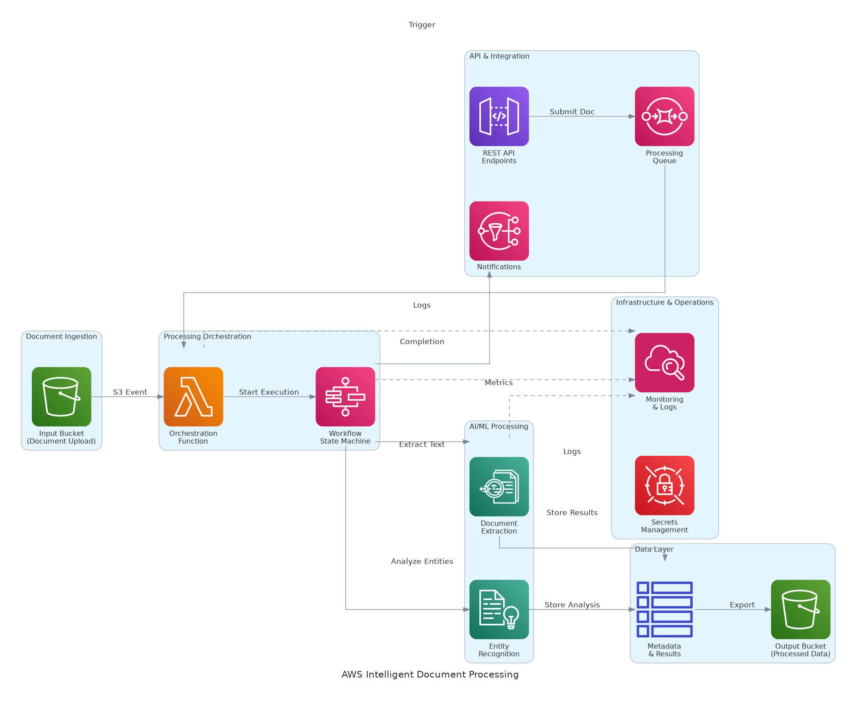
Figure 1: Solution Architecture

4.1 Architecture Principles
The following principles guide all architectural decisions throughout the solution design.
• Managed Services First: Leverage AWS managed AI services (Textract, Comprehend, A2I) for core capabilities
• Serverless Architecture: Minimize operational overhead with Lambda, Step Functions, and managed services
• Security by Design: Implement defense in depth with encryption, IAM, and VPC isolation
• Human-in-the-Loop: Amazon A2I provides human review for low-confidence results
• Infrastructure as Code: All infrastructure defined in Terraform and version-controlled
• Cost Optimization: Pay-per-use model with no idle infrastructure costs

4.2 Architecture Patterns
The solution implements the following architectural patterns to address scalability and reliability requirements.
• Primary Pattern: Event-driven serverless with Step Functions orchestration
• Data Pattern: S3 for document storage with DynamoDB for metadata and state management
• Integration Pattern: API Gateway with async processing via SQS/SNS
• Human Review Pattern: Amazon A2I for confidence-based routing to human reviewers
• Deployment Pattern: Blue-green deployment with automated rollback

4.3 Component Design
The solution comprises the following logical components, each with specific responsibilities and scaling characteristics.
Component | Purpose | Technology | Dependencies | Scaling
API Gateway | Request routing, rate limiting | Amazon API Gateway | Cognito | Managed
Document Ingestion | File upload and validation | S3 + Lambda | API Gateway | Managed
OCR Service | Text extraction from documents | Amazon Textract | S3 | Managed
NLP Service | Entity extraction and PII detection | Amazon Comprehend | Textract output | Managed
Human Review | Low-confidence document review | Amazon A2I | Comprehend output | Managed
Orchestration | Workflow coordination | Step Functions | All services | Managed
Data Store | Metadata and results | DynamoDB | Lambda | On-demand
Notification | Event notifications | SNS/SQS | Step Functions | Managed
Table 4: Solution Components

4.4 Technology Stack
The technology stack has been selected based on requirements for AI/ML capabilities, scalability, and AWS best practices.
Layer | Technology | Rationale
AI/ML - OCR | Amazon Textract | Industry-leading OCR with forms and tables support
AI/ML - NLP | Amazon Comprehend | Entity extraction, sentiment, PII detection
AI/ML - Human Review | Amazon A2I | Managed human review workflows for quality assurance
Compute | AWS Lambda | Serverless, pay-per-use, auto-scaling
Orchestration | AWS Step Functions | Visual workflow, error handling, retries
Storage | Amazon S3 | Durable document storage with lifecycle policies
Database | Amazon DynamoDB | Serverless NoSQL for metadata and state
API | Amazon API Gateway | RESTful APIs with authentication and throttling
Messaging | Amazon SQS/SNS | Async processing and event notifications
Monitoring | Amazon CloudWatch | Metrics, logs, alarms, and dashboards
Table 5: Technology Stack

5 Security & Compliance
This section details the security controls, compliance mappings, and governance mechanisms implemented in the solution.

5.1 Identity & Access Management
Access control follows AWS best practices with centralized identity management.
• Authentication: Amazon Cognito for user authentication with MFA
• Authorization: IAM roles with least privilege for all services
• Federation: SAML 2.0 federation with enterprise identity provider (if required)
• Service Accounts: IAM roles for Lambda with automatic credential rotation
• API Security: API Gateway with Cognito authorizers

5.1.1 Role Definitions
The following roles define access levels within the system, following the principle of least privilege.
Role | Permissions | Scope
Administrator | Full system access, IAM management | All AWS resources
Developer | Lambda, API Gateway, DynamoDB | Application resources
Operator | CloudWatch, read-only access | Monitoring only
Human Reviewer | A2I human review tasks | Review interface only
Auditor | CloudTrail, read-only access | All environments
Table 6: Role Permissions

5.2 Secrets Management
All sensitive credentials are managed through AWS Secrets Manager.
• AWS Secrets Manager for all application secrets
• Automatic rotation for credentials (30-day cycle)
• API keys stored with versioning and access logging
• No secrets in code repositories or Lambda environment variables
• KMS customer-managed keys for secret encryption

5.3 Network Security
Network security implements defense-in-depth with multiple layers of protection.
• VPC Isolation: Lambda functions deployed in private subnets
• Security Groups: Restrictive inbound/outbound rules per service
• VPC Endpoints: Private connectivity to S3, DynamoDB, Textract, Comprehend
• NAT Gateway: Controlled internet access for external API calls only
• WAF: Web Application Firewall on API Gateway for public endpoints (optional)

5.4 Data Protection
Data protection controls ensure confidentiality and integrity throughout the data lifecycle.
• Encryption at Rest: S3 SSE-KMS with customer-managed keys
• Encryption in Transit: TLS 1.2+ for all communications
• Key Management: AWS KMS with automatic key rotation
• PII Detection: Amazon Comprehend PII detection and optional redaction
• Data Classification: Tagging based on content sensitivity

5.5 Compliance Mappings
The following table maps compliance requirements to specific implementation controls.
Framework | Requirement | Implementation
SOC 2 | Access control | IAM, Cognito, MFA, audit logging
SOC 2 | Encryption | KMS encryption at rest, TLS 1.2+ in transit
SOC 2 | Audit trails | CloudTrail, CloudWatch Logs
Internal | Data retention | S3 lifecycle policies per business requirements
Internal | Access logging | API Gateway access logs, CloudTrail
Table 7: Compliance Requirements

5.6 Audit Logging & SIEM Integration
Comprehensive audit logging supports security monitoring and compliance requirements.
• CloudTrail for all AWS API calls with S3 log archival
• CloudWatch Logs for application and Lambda function logs
• VPC Flow Logs for network traffic analysis
• API Gateway access logs for request/response tracking
• Log retention: 90 days hot (CloudWatch), per policy cold (S3)

6 Data Architecture
This section defines the data model, storage strategy, and governance controls for the solution.

6.1 Data Model

6.1.1 Conceptual Model
The solution manages the following core entities:
• Documents: Uploaded documents with metadata and processing state
• Extractions: Structured data extracted from documents
• Jobs: Processing job tracking and audit trail
• Reviews: Human review tasks and outcomes from A2I

6.1.2 Logical Model
The logical data model defines the primary entities and their relationships within the system.
Entity | Key Attributes | Relationships | Volume
Document | doc_id, s3_uri, upload_time, status | Has many Extractions | 5K/month
Extraction | extraction_id, doc_id, field_name, value, confidence | Belongs to Document | 50K/month
ProcessingJob | job_id, doc_id, status, timestamps | References Document | 5K/month
HumanReview | review_id, doc_id, reviewer, outcome | References Document | 500/month
AuditLog | log_id, action, user, timestamp | References all entities | 50K/month
Table 8: Data Model Entities

6.2 Data Flow Design
1. Ingestion: Documents uploaded via API Gateway to S3 with server-side encryption
2. Trigger: S3 event triggers Step Functions workflow
3. OCR Processing: Amazon Textract extracts text, tables, and forms
4. NLP Analysis: Amazon Comprehend extracts entities and detects PII
5. Confidence Check: Results evaluated against confidence threshold (85%)
6. Human Review: Low-confidence documents routed to A2I for human review
7. Validation: Business rules validate extracted data
8. Storage: Results stored in DynamoDB with S3 for raw outputs
9. Notification: SNS publishes completion events for downstream systems

6.3 Data Storage Strategy
• Raw Documents: S3 Standard with intelligent tiering after 30 days
• Processing Outputs: S3 Standard-IA after 90 days
• Metadata: DynamoDB on-demand with point-in-time recovery
• Logs: CloudWatch Logs with S3 archival per retention policy

6.4 Data Governance
Data governance policies ensure proper handling, retention, and quality management.
• Classification: Internal, Confidential (auto-tagged via Comprehend PII detection)
• Retention: Configurable per document type and business policy
• Quality: Confidence score thresholds, human review routing via A2I
• Lineage: Full processing lineage tracked in DynamoDB

7 Integration Design
This section documents the integration patterns, APIs, and external system connections.

7.1 External System Integrations
The solution integrates with the following external systems using standardized protocols.
System | Type | Protocol | Format | Error Handling | SLA
Downstream System 1 | Real-time | REST | JSON | Retry with backoff | 99%
Downstream System 2 | Real-time | REST | JSON | Retry with backoff | 99%
Email Notifications | Event-driven | SES | Email | DLQ processing | 99%
Document Intake | Event-driven | S3 | Files | DLQ processing | 99%
Table 9: System Integrations

7.2 API Design
APIs follow REST principles with OpenAPI 3.0 specification.
• Style: RESTful with OpenAPI 3.0 documentation
• Versioning: URL path versioning (v1)
• Authentication: Cognito JWT tokens
• Rate Limiting: 100 requests/minute per client (configurable)

7.2.1 API Endpoints
The following REST API endpoints provide programmatic access to document processing.
Method | Endpoint | Auth | Description
POST | /api/v1/documents | Bearer JWT | Upload document for processing
GET | /api/v1/documents/{id} | Bearer JWT | Get document status and results
GET | /api/v1/documents/{id}/extractions | Bearer JWT | Get extracted data
GET | /api/v1/documents | Bearer JWT | List documents with filtering
DELETE | /api/v1/documents/{id} | Bearer JWT | Delete document and data
Table 10: API Endpoints

7.3 Messaging & Event Patterns
Asynchronous messaging enables loose coupling and reliable event processing.
• SQS Queues: Document processing queue with DLQ for failures
• SNS Topics: Processing completion, error notifications
• Retry Policy: Exponential backoff with maximum 3 attempts

8 Infrastructure & Operations
This section covers the infrastructure design, deployment architecture, and operational procedures.

8.1 Network Design
The VPC architecture provides isolation and security through segmentation.
• VPC CIDR: 10.0.0.0/16
• Public Subnets: 10.0.1.0/24, 10.0.2.0/24 (NAT Gateway, optional ALB)
• Private Subnets: 10.0.10.0/24, 10.0.11.0/24 (Lambda, endpoints)

8.2 Compute Sizing
Serverless compute eliminates traditional sizing but requires concurrency planning.
Component | Memory | Timeout | Concurrency | Scaling
Document Processor | 1024 MB | 300s | 50 reserved | Auto
Textract Handler | 512 MB | 60s | 25 reserved | Auto
Comprehend Handler | 512 MB | 60s | 25 reserved | Auto
API Handler | 256 MB | 30s | 50 reserved | Auto
Table 11: Solution Components

8.3 High Availability Design
The solution eliminates single points of failure through AWS managed service redundancy.
• Multi-AZ deployment for all services (Lambda, DynamoDB, S3)
• S3 cross-region replication for disaster recovery (optional)
• DynamoDB on-demand with automatic failover

8.4 Disaster Recovery
Disaster recovery capabilities ensure business continuity in the event of regional failure.
• RPO: 4 hours (S3 replication, DynamoDB backups)
• RTO: 8 hours (infrastructure as code redeployment)
• Backup: DynamoDB point-in-time recovery, S3 versioning
• DR Site: Warm standby in secondary region (optional, Phase 2)

8.5 Monitoring & Alerting
Comprehensive monitoring provides visibility across infrastructure and applications.
• Infrastructure: Lambda duration, errors, throttles, concurrency
• Application: Processing latency, success rates, queue depth
• Business: Documents processed, extraction accuracy, cost per document
• Alerting: SNS integration with email/PagerDuty escalation

8.5.1 Alert Definitions
The following alerts ensure proactive incident detection and response.
Alert | Condition | Severity | Response
Lambda Errors | Error rate > 5% for 5 min | Critical | Page on-call
Processing Latency | p95 > 60s for 10 min | Warning | Investigate
Extraction Accuracy | Accuracy < 90% for 1 hour | Warning | Review samples
Queue Depth | > 500 messages for 15 min | Warning | Scale investigation
DLQ Messages | Any messages in DLQ | Warning | Review failures
Table 12: Monitoring Alerts

8.6 Logging & Observability
Centralized logging and distributed tracing enable rapid troubleshooting.
• CloudWatch Logs for all Lambda functions and API Gateway
• X-Ray distributed tracing for end-to-end request flow
• Custom CloudWatch dashboards for operations and business metrics
• Log Insights queries for troubleshooting and analysis

8.7 Cost Model
Estimated monthly infrastructure costs based on 5,000 documents/month processing.
Category | Monthly Estimate | Optimization | Savings
Textract | $250-500 | Batch processing | 20%
Comprehend | $100-200 | Entity detection only | 30%
A2I | $50-100 | Review threshold tuning | Variable
Lambda | $50 | Memory right-sizing | 15%
S3 Storage | $25 | Lifecycle policies | 50%
DynamoDB | $25 | On-demand capacity | N/A
Other (API GW, etc.) | $50 | N/A | N/A
Table 13: Cost Estimates
Total Estimated Monthly: $550-950 (AWS services only)

9 Implementation Approach
This section outlines the deployment strategy, tooling, and sequencing for the implementation.

9.1 Migration/Deployment Strategy
The deployment strategy minimizes risk through phased rollout with validation gates.
• Approach: Phased deployment with pilot document types first
• Pattern: Blue-green deployment for Lambda and API Gateway
• Validation: Extraction accuracy testing at each phase gate
• Rollback: Lambda version rollback capability

9.2 Sequencing & Wave Planning
The implementation follows a phased approach with clear exit criteria.
Phase | Activities | Duration | Exit Criteria
1 | Foundation (VPC, IAM, S3, monitoring) | 3 weeks | Infrastructure validated
2 | AI Services (Textract, Comprehend integration) | 4 weeks | OCR accuracy > 95%
3 | Human Review (A2I workflow configuration) | 2 weeks | Review workflow operational
4 | Integration & Testing | 3 weeks | UAT complete, security validated
5 | Go-Live & Hypercare | 4 weeks | Production stable, team trained
Table 14: Implementation Phases
Total Implementation: ~16 weeks (4 months) + 4 weeks hypercare = 6 months

9.3 Tooling & Automation
The following tools provide the automation foundation for infrastructure operations.
Category | Tool | Purpose
Infrastructure as Code | Terraform | Cloud resource provisioning
CI/CD | AWS CodePipeline / GitHub Actions | Build, test, deploy automation
Container Registry | Amazon ECR | Lambda container images (if needed)
Secrets Management | AWS Secrets Manager | Credential storage and rotation
Monitoring | CloudWatch + Datadog | Dashboards and alerting
Table 15: Tools and Technologies

9.4 Cutover Approach
The cutover strategy enables gradual migration with rollback capability.
• Type: Phased cutover by document type
• Duration: 1-week parallel run per document type
• Validation: Accuracy comparison between manual and automated
• Decision Point: Go/no-go 48 hours before each phase

9.5 Rollback Strategy
Rollback procedures are documented and tested for rapid recovery.
• Lambda function rollback via version aliases
• Infrastructure rollback via Terraform state
• Maximum rollback window: 24 hours post-deployment

10 Appendices

10.1 Architecture Diagrams
The following diagrams provide visual representation of the solution architecture.
• Solution Architecture Diagram (included in Solution Architecture section)
• Data Flow Diagram
• Network Topology Diagram
• Security Architecture Diagram

10.2 Naming Conventions
All AWS resources follow standardized naming conventions.
Resource Type | Pattern | Example
S3 Bucket | `{env}-{app}-{purpose}-{account}` | `prod-idp-documents-123456789`
Lambda Function | `{env}-{app}-{function}` | `prod-idp-document-processor`
DynamoDB Table | `{env}-{app}-{entity}` | `prod-idp-documents`
IAM Role | `{env}-{app}-{service}-role` | `prod-idp-lambda-role`
Table 16: Naming Conventions

10.3 Tagging Standards
Resource tagging enables cost allocation, automation, and compliance reporting.
Tag | Required | Example Values
Environment | Yes | dev, staging, prod
Application | Yes | intelligent-document-processing
Owner | Yes | project-team
CostCenter | Yes | CC-IDP-001
DataClassification | Yes | internal, confidential
Table 17: Tagging Standards

10.4 Risk Register
The following risks have been identified with corresponding mitigation strategies.
Risk | Likelihood | Impact | Mitigation
Extraction accuracy below target | Medium | High | Iterative testing, human review fallback via A2I
Textract extraction errors | Low | Medium | Confidence thresholds, manual review queue
Processing latency spikes | Low | Medium | Auto-scaling, queue-based processing, monitoring
Data breach | Low | Critical | Encryption, IAM, VPC isolation, audit logging
Cost overrun | Low | Medium | Budget alerts, usage monitoring, optimization
Table 18: Risk Register

10.5 Glossary
The following terms and acronyms are used throughout this document.
Term | Definition
IDP | Intelligent Document Processing
OCR | Optical Character Recognition
NLP | Natural Language Processing
A2I | Amazon Augmented AI (human review service)
PII | Personally Identifiable Information
DLQ | Dead Letter Queue
RPO | Recovery Point Objective
RTO | Recovery Time Objective
SLA | Service Level Agreement
Table 19: Glossary


eoframework.org

