

Detailed Design Document
Azure Sentinel SIEM

Client: | [CLIENT]
Date: | November 27, 2025
Consulting Company: | [Consulting Company Name]
Submitted By: | [Name | Email | Phone]
Opportunity No: | OPP-XXXXX
Version: | 1.0

Table of Contents
1 Introduction
1.1 Purpose
1.1.1 Scope
2 Table Content
3 Image Section
4 Additional Content
5 Sign-Off

List of Figures
Figure 1: Sample Architecture Diagram

List of Tables
Table 1: Sample Deliverables Table

1 Executive Summary
This document provides the comprehensive technical design for the Azure Sentinel SIEM solution. It covers the target-state architecture leveraging Microsoft Sentinel for cloud-native security information and event management, Azure Log Analytics for data ingestion and analysis, and Azure Logic Apps for security orchestration and automated response (SOAR). The design delivers AI-powered threat detection, unified security visibility, and automated incident response capabilities.

1.1 Purpose
Define the technical architecture and design specifications that will guide the implementation team through deployment, configuration, and validation of the enterprise SIEM/SOAR solution on Microsoft Azure.

1.2 Scope
In-scope:
• Azure Sentinel workspace deployment and configuration
• Data connector integration for 15+ security sources
• Analytics rules deployment (50+ built-in and custom rules)
• SOAR playbook development (12 Logic App workflows)
• Threat intelligence feed integration
• Security operations center (SOC) workflow enablement
• Compliance monitoring and reporting dashboards
Out-of-scope:
• End-user training (covered in Implementation Guide)
• Ongoing managed security services (separate engagement)
• Custom machine learning model development
• Third-party SIEM replacement (parallel operation)

1.3 Assumptions & Constraints
The following assumptions underpin the design and must be validated during implementation.
• Azure subscription with appropriate service quotas established
• Azure AD tenant configured with appropriate licensing (E5 or equivalent)
• Network connectivity for data source integration available
• Security team has approved the proposed detection rules and playbooks
• SOC team available for training and knowledge transfer
• Data ingestion volume estimate: 500GB/day (scalable to 2TB/day)

1.4 References
This document should be read in conjunction with the following related materials.
• Statement of Work (SOW)
• Discovery Questionnaire responses
• Microsoft Security Best Practices documentation
• MITRE ATT&CK Framework mapping

2 Business Context
This section establishes the business drivers, success criteria, and compliance requirements that shape the technical design decisions.

2.1 Business Drivers
The solution addresses the following key business objectives identified during discovery.
• Threat Detection: Reduce mean time to detect (MTTD) from hours to minutes using AI-powered analytics
• Incident Response: Reduce mean time to respond (MTTR) by 90% through automated playbooks
• Unified Visibility: Consolidate security monitoring across cloud, on-premises, and hybrid environments
• Cost Optimization: Reduce security tool sprawl through platform consolidation
• Compliance: Meet regulatory requirements for security monitoring and audit trails

2.2 Workload Criticality & SLA Expectations
The following service level targets define the operational requirements for the production environment and guide infrastructure sizing decisions.
Metric | Target | Measurement | Priority
Availability | 99.9% | Azure Service Health | Critical
MTTD | < 15 minutes | Custom KPI dashboard | Critical
MTTR | < 60 minutes | Incident tracking | High
Detection Accuracy | > 95% | Validation testing | Critical
False Positive Rate | < 50% | Alert analysis | High
Query Response | < 30 seconds | Log Analytics metrics | Medium
Table 1: Service Level Targets

2.3 Compliance & Regulatory Factors
The solution must adhere to the following regulatory and compliance requirements.
• SOC 2 Type II compliance required for all security operations
• Data encryption at rest (AES-256) and in transit (TLS 1.2+) mandatory
• Audit logging required for all administrative and investigative activities
• Data retention policies: 90 days hot, 2 years archive (configurable per regulation)
• GDPR, HIPAA, PCI DSS compliance controls as applicable

2.4 Success Criteria
Project success will be measured against the following criteria at go-live.
• 15+ data connectors configured and ingesting data
• 50+ analytics rules deployed and generating alerts
• 12 SOAR playbooks operational with automated response
• MTTD below 15-minute target validated through testing
• SOC team trained and operational on platform

3 Current-State Assessment
This section documents the existing security monitoring environment and identifies gaps addressed by the solution.

3.1 Existing Security Tools

3.1.1 N/A - Greenfield Implementation
This implementation represents a new security monitoring capability. The following legacy tools may operate in parallel during transition:
• On-premises SIEM (if applicable): Parallel operation during 30-day hypercare
• Endpoint protection: Integration via Defender for Endpoint connector
• Network security: Firewall log forwarding via CEF/Syslog
• Identity: Azure AD sign-in and audit log integration

3.2 Gap Analysis
Capability | Current State | Target State
Threat Detection | Manual analysis, 4+ hour MTTD | AI-powered, <15 minute MTTD
Incident Response | Manual procedures, 4+ hour MTTR | Automated playbooks, <60 minute MTTR
Visibility | Fragmented tools, limited correlation | Unified platform, cross-source correlation
Compliance | Manual reporting | Automated compliance dashboards
Threat Intelligence | Limited integration | 10+ TI feeds integrated
Table 2: Gap Analysis

4 Solution Architecture
This section provides the comprehensive technical architecture for the Azure Sentinel SIEM solution.

4.1 Architecture Diagram
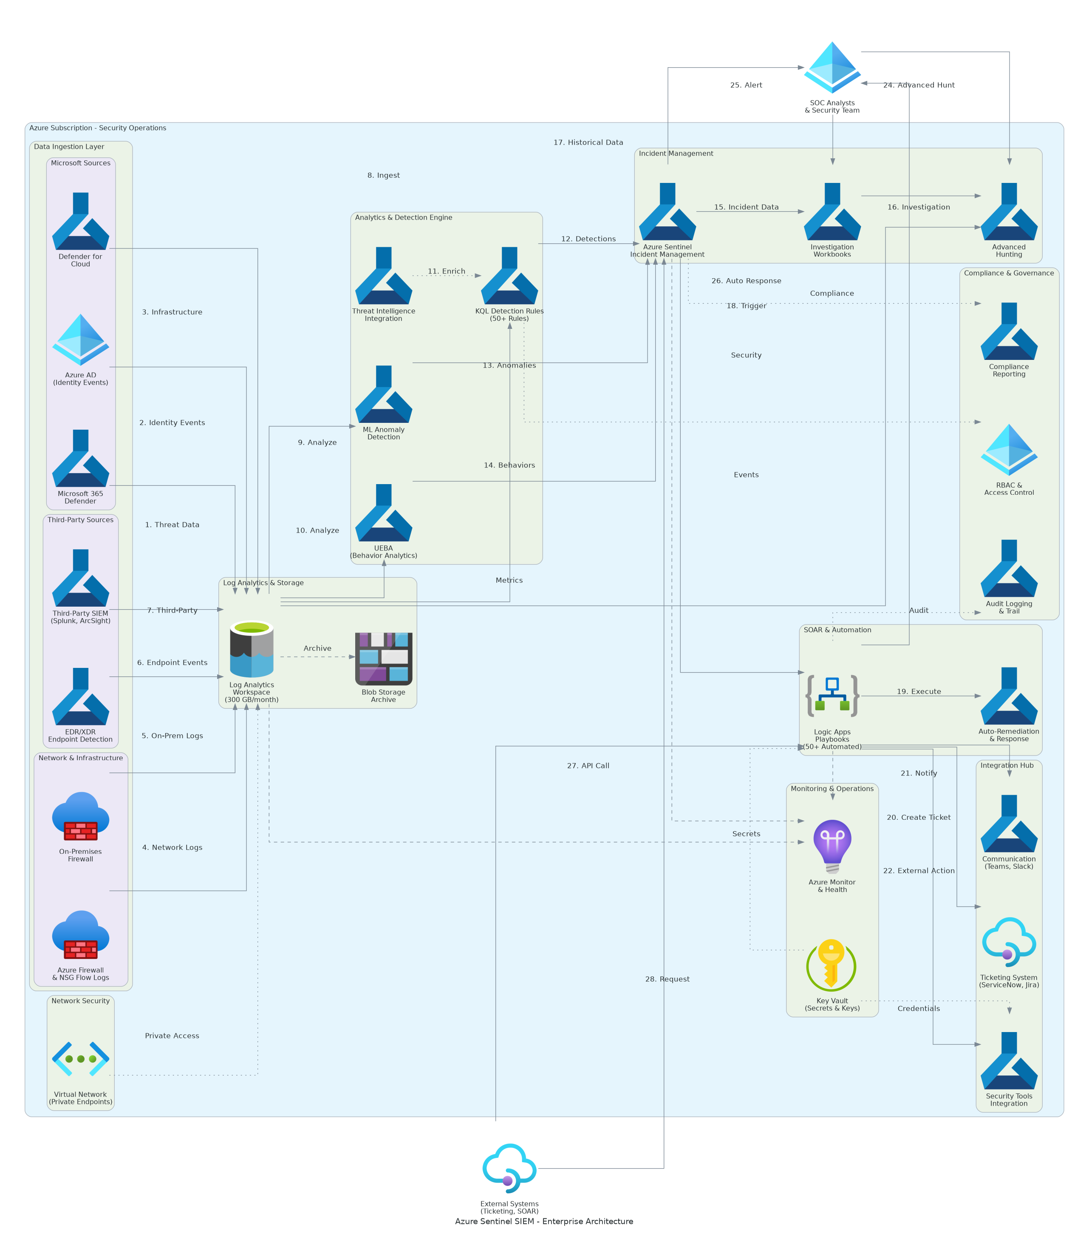
Figure 1: Solution Architecture

4.2 Design Principles
• Security First: Defense-in-depth architecture with zero-trust principles
• Scalability: Cloud-native design supporting petabyte-scale data ingestion
• Reliability: High availability with 99.9% SLA leveraging Azure platform
• Performance: Optimized for real-time threat detection and rapid query response
• Compliance: Built-in compliance controls and audit capabilities

4.3 Core Components

4.3.1 Azure Sentinel
Primary SIEM/SOAR service providing:
• Cloud-native security analytics platform
• AI-powered threat detection using Fusion ML
• Built-in SOAR capabilities via Logic Apps
• UEBA (User and Entity Behavior Analytics)
• Integration with Microsoft security ecosystem

4.3.2 Log Analytics Workspace
Data ingestion and query engine providing:
• Centralized log collection and storage
• KQL (Kusto Query Language) analytics
• Configurable retention policies (90 days hot, 2 years archive)
• Performance tier: PerGB2018 with commitment tier pricing

4.3.3 Azure Logic Apps
Security orchestration providing:
• Automated incident response playbooks
• Integration with external systems (ServiceNow, Teams)
• Custom workflow automation
• API-based security actions

4.4 Data Sources Architecture

4.4.1 Native Microsoft Connectors
• Azure AD: Sign-in logs, audit logs, risky sign-ins
• Microsoft 365 Defender: Endpoint, email, identity protection
• Office 365: Exchange, SharePoint, Teams activity
• Defender for Cloud: Security alerts, recommendations
• Azure Activity: Subscription-level operations

4.4.2 Infrastructure Connectors
• Azure Firewall: Network traffic and threat logs
• NSG Flow Logs: Network security group traffic
• Azure DNS: DNS query logs
• Key Vault: Access and operations audit

4.4.3 Third-Party Connectors
• CEF/Syslog: Firewall, proxy, network devices
• REST API: Custom application integration
• Threat Intelligence: STIX/TAXII feeds

4.5 Analytics Architecture

4.5.1 Detection Layers
1. Scheduled Analytics Rules: KQL-based pattern detection
2. Fusion ML: AI-powered multi-stage attack detection
3. UEBA: Behavioral anomaly detection for users/entities
4. Threat Intelligence: IoC matching across data sources

4.5.2 Rule Categories
• Microsoft Security: 30 built-in high-fidelity rules
• Custom Rules: 20 organization-specific detections
• UEBA Rules: Behavioral analytics rules
• Threat Intelligence Rules: IoC-based detection

5 Security & Compliance
This section details the security controls and compliance implementation.

5.1 Identity & Access Management

5.1.1 RBAC Configuration
Role | Permissions | Assignment
Microsoft Sentinel Contributor | Full Sentinel access | Security Admins
Microsoft Sentinel Reader | Read-only access | SOC Analysts
Logic App Contributor | Playbook management | Automation Engineers
Log Analytics Contributor | Workspace management | Platform Admins
Table 3: Role Permissions

5.1.2 Privileged Access
• Multi-factor authentication required for all admin access
• Just-in-time (JIT) access for elevated permissions
• Conditional Access policies enforcing device compliance
• Regular access reviews and certification

5.2 Data Protection

5.2.1 Encryption Standards
• At Rest: AES-256 encryption via Azure Storage Service Encryption
• In Transit: TLS 1.2+ for all data transmission
• Key Management: Azure Key Vault for customer-managed keys (optional)

5.2.2 Data Retention
• Hot storage: 90 days (queryable, fast access)
• Archive storage: 2 years (compliance retention)
• Immutable storage available for legal hold requirements

5.3 Audit & Monitoring

5.3.1 Activity Logging
• All administrative actions logged to Azure Activity Log
• Sentinel workspace operations audited
• Playbook executions tracked in Logic Apps run history
• User investigation activities captured

5.3.2 Compliance Dashboards
• Built-in compliance workbooks (CIS, NIST, ISO 27001)
• Custom compliance reporting
• Automated compliance scoring

6 Data Architecture
This section documents the data flow, storage, and management design.

6.1 Data Ingestion Pipeline

6.2 Data Flow Design

6.2.1 Ingestion Path
1. Native Connectors: Direct API integration (Office 365, Azure AD)
2. Agent-Based: Azure Monitor Agent for Windows/Linux servers
3. CEF/Syslog: Log forwarder for third-party devices
4. REST API: Custom integration for applications

6.2.2 Processing Pipeline
1. Normalization: ASIM (Advanced Security Information Model)
2. Enrichment: Threat intelligence correlation
3. Analytics: Real-time rule evaluation
4. Storage: Log Analytics workspace retention

6.3 Storage Tiers
Tier | Retention | Use Case | Cost Model
Hot | 90 days | Active investigation | PerGB ingestion
Archive | 2 years | Compliance/forensics | Archive rates
Export | Custom | Long-term archive | Storage account
Table 4: Tier

7 Integration Design
This section documents external system integrations.

7.1 SOAR Integrations

7.1.1 ServiceNow Integration
• Automated incident ticket creation
• Bi-directional status synchronization
• Priority mapping from Sentinel severity

7.1.2 Microsoft Teams Integration
• Real-time alert notifications to SOC channel
• Adaptive cards for incident details
• Interactive approval workflows

7.1.3 Email Integration
• Critical alert notifications
• Executive summary reports
• Escalation notifications

7.2 API Integration

7.2.1 Sentinel REST API
• Custom application integration
• Automated rule management
• Incident lifecycle automation

7.2.2 Log Analytics Query API
• Programmatic data access
• Custom reporting integration
• External dashboard connectivity

8 Infrastructure & Operations
This section documents operational architecture and management procedures.

8.1 High Availability

8.1.1 Platform Resilience
• Azure Sentinel: 99.9% SLA (Azure-managed)
• Log Analytics: Zone-redundant storage
• Logic Apps: Multi-zone deployment

8.1.2 Disaster Recovery
• Data replicated across Azure storage redundancy
• Configuration exported as Infrastructure as Code
• Recovery procedures documented in runbook

8.2 Monitoring & Alerting

8.2.1 Platform Health
• Azure Service Health integration
• Ingestion lag monitoring
• Connector health alerts

8.2.2 Key Metrics
Metric | Threshold | Alert Severity | Response
Ingestion Lag | > 15 minutes | Warning | Investigate connector
Query Latency | > 60 seconds | Warning | Review query efficiency
Playbook Failures | > 5% | Critical | Check Logic App logs
Daily Ingestion | > 90% cap | Warning | Increase commitment tier
Table 5: Monitoring Alerts

8.3 Capacity Planning

8.3.1 Current Sizing
• Estimated daily ingestion: 500GB/day
• Commitment tier: 500GB/day
• Projected growth: 20% annually

8.3.2 Scaling Triggers
• Ingestion consistently >80% of commitment tier
• Query performance degradation
• New data source onboarding

9 Implementation Approach
This section outlines the phased implementation methodology.

9.1 Phase Overview
Phase | Activities | Duration | Exit Criteria
1 | Foundation & Workspace | Weeks 1-4 | Sentinel enabled, RBAC configured
2 | Data Connectors | Weeks 5-8 | 15+ connectors ingesting
3 | Analytics & Detection | Weeks 9-12 | 50+ rules deployed, tuned
4 | Automation & SOAR | Weeks 13-16 | 12 playbooks operational
5 | Testing & Validation | Weeks 17-18 | All tests passing
6 | Go-Live & Hypercare | Weeks 19-22 | Production stable
Table 6: Implementation Phases

9.2 Risk Mitigation
Risk | Impact | Mitigation
Data ingestion delays | Detection gaps | Parallel connector testing
High false positive rate | SOC fatigue | Iterative rule tuning
Integration failures | Automation gaps | Staged playbook deployment
Performance issues | Query delays | Capacity planning validation
Table 7: Risk Register

10 Appendices

10.1 Appendix A: Analytics Rule Catalog
The complete analytics rule catalog is maintained in `/delivery/docs/analytics-rules.md` and includes:
• 30 Microsoft built-in rules (high-fidelity)
• 20 custom organization-specific rules
• MITRE ATT&CK mapping for all rules
• Tuning guidance and threshold recommendations

10.2 Appendix B: Data Connector Reference
Connector | Data Tables | Volume Est. | Priority
Azure AD | SigninLogs, AuditLogs | 50GB/day | Critical
Office 365 | OfficeActivity | 100GB/day | Critical
Defender for Endpoint | DeviceEvents | 150GB/day | Critical
Defender for Cloud | SecurityAlert | 10GB/day | High
Azure Firewall | AzureDiagnostics | 100GB/day | High
CEF/Syslog | CommonSecurityLog | 90GB/day | Medium
Table 8: Connector

10.3 Appendix C: SOAR Playbook Reference
Playbook | Function | Trigger
Enrich-IP-Address | IP reputation lookup | High severity alert
Enrich-User-Identity | User risk assessment | User-related incident
Block-IP-Firewall | Automated IP blocking | Confirmed malicious IP
Disable-User-Account | Account disable action | Confirmed compromise
Create-ServiceNow-Ticket | ITSM integration | All incidents
Notify-SOC-Teams | Teams notification | High/Critical severity
Table 9: Playbook

10.4 Appendix D: Compliance Mapping
The solution supports the following compliance frameworks with built-in workbooks:
• SOC 2: Security, availability, processing integrity controls
• ISO 27001: Information security management controls
• NIST CSF: Identify, Protect, Detect, Respond, Recover
• CIS Controls: Critical security controls mapping
• MITRE ATT&CK: Technique detection coverage
Document Version: 2.0
Last Updated: [DATE]
Prepared By: Solution Architecture Team
Review Status: Approved


eoframework.org

