

Detailed Design Document
GitHub Advanced Security

Client: | [CLIENT]
Date: | November 28, 2025
Consulting Company: | [Consulting Company Name]
Submitted By: | [Name | Email | Phone]
Opportunity No: | OPP-XXXXX
Version: | 1.0

Table of Contents
1 Introduction
1.1 Purpose
1.1.1 Scope
2 Table Content
3 Image Section
4 Additional Content
5 Sign-Off

List of Figures
Figure 1: Sample Architecture Diagram

List of Tables
Table 1: Sample Deliverables Table

1 Executive Summary
This document provides the comprehensive technical design for the GitHub Advanced Security (GHAS) implementation. It covers the target-state architecture leveraging CodeQL for static analysis, secret scanning with push protection, and Dependabot for dependency vulnerability management. The solution integrates with enterprise SIEM systems (Splunk/Azure Sentinel) and issue tracking platforms (JIRA/ServiceNow) to deliver automated DevSecOps workflows.

1.1 Purpose
Define the technical architecture and design specifications that will guide the implementation team through deployment, configuration, and validation of the application security platform on GitHub Enterprise Cloud.

1.2 Scope
In-scope:
• GitHub Enterprise Cloud organization setup with SAML SSO
• GitHub Advanced Security licensing and enablement for 200 repositories
• CodeQL code scanning for 5 languages (JavaScript, Python, Java, C#, Go)
• Secret scanning with push protection organization-wide
• Dependabot vulnerability alerts and security updates
• Custom CodeQL query development (15 organization-specific rules)
• SIEM integration via webhooks (Splunk, Azure Sentinel)
• Issue tracking integration (JIRA, ServiceNow)
• Security policy enforcement and branch protection rules
• Security champion program and developer training
Out-of-scope:
• End-user training delivery (covered in Training Plan)
• Ongoing support procedures (covered in Operations Runbook)
• Self-hosted GitHub Enterprise Server deployment
• C/C++ language scanning (Phase 2 consideration)

1.3 Assumptions & Constraints
The following assumptions underpin the design and must be validated during implementation.
• GitHub Enterprise Cloud licensing secured for 100 users
• GitHub Advanced Security licensing for 80 active committers
• Corporate SAML identity provider available for SSO integration
• Network access to GitHub.com from developer workstations
• SIEM platform (Splunk or Azure Sentinel) available for webhook integration
• Development teams can allocate time for security champion training

1.4 References
This document should be read in conjunction with the following related materials.
• Statement of Work (SOW)
• Discovery Questionnaire responses
• GitHub Advanced Security documentation
• CodeQL query reference documentation

2 Business Context
This section establishes the business drivers, success criteria, and compliance requirements that shape the technical design decisions.

2.1 Business Drivers
The solution addresses the following key business objectives identified during discovery.
• Shift Left Security: Detect vulnerabilities during development, not after deployment
• Developer Productivity: Integrate security into existing workflows without disruption
• Secret Protection: Prevent credential leaks through automated blocking
• Compliance Automation: Automate evidence collection for SOC 2, PCI-DSS audits
• Risk Reduction: Reduce application security incidents by 70%+

2.2 Workload Criticality & SLA Expectations
The following service level targets define the operational requirements for the production environment and guide configuration decisions.
Metric | Target | Measurement | Priority
Detection Accuracy | > 95% | Validation against known vulnerabilities | Critical
PR Scan Duration | < 15 minutes | GitHub Actions workflow timing | High
False Positive Rate | < 10% | Alert review and classification | High
Push Protection Latency | < 2 seconds | Git push timing | High
SIEM Alert Latency | < 30 seconds | Webhook delivery timing | Medium
Platform Availability | 99.9% | GitHub status monitoring | Critical
Table 1: Service Level Targets

2.3 Compliance & Regulatory Factors
The solution must adhere to the following regulatory and compliance requirements.
• SOC 2 Type II compliance for all security controls and audit logging
• PCI-DSS 6.5.x secure coding requirements for applicable repositories
• Audit logging required for all security events and policy changes
• Secret detection and blocking capabilities for credential protection
• Repository access controls aligned with principle of least privilege

2.4 Success Criteria
Project success will be measured against the following criteria at go-live.
• CodeQL enabled on all 200 repositories with 95%+ detection accuracy
• Secret scanning with push protection blocking 100% of known patterns
• Dependabot alerts enabled and security updates automated
• SIEM integration operational with <30 second alert delivery
• Security champions certified across all 8 development teams
• Zero critical vulnerabilities at time of production deployment

3 Current-State Assessment
This section documents the existing environment that the solution will integrate with or enhance.

3.1 Application Landscape
The current environment consists of development repositories that will be secured with GHAS.
Application | Purpose | Technology | Status
Manual Code Review | Security assessment | Human reviewers | To be automated
Existing Repositories | Application source code | Various languages | Integration point
CI/CD Pipelines | Build and deployment | GitHub Actions | Integration point
Identity Provider | User authentication | Corporate IdP | Integration point
Table 2: Application Inventory

3.2 Infrastructure Inventory
The current infrastructure will be augmented with GitHub Advanced Security capabilities.
Component | Quantity | Specifications | Notes
Repositories | 200 | Various languages | All require GHAS enablement
Active Committers | 80 | Unique 90-day committers | GHAS licensing basis
GitHub Users | 100 | Enterprise Cloud users | Enterprise license scope
Table 3: Infrastructure Inventory

3.3 Dependencies & Integration Points
The current environment has the following external dependencies that must be considered.
• Existing SAML identity provider for GitHub SSO
• GitHub.com internet connectivity for Enterprise Cloud
• SIEM platform (Splunk/Azure Sentinel) for webhook integration
• Issue tracking system (JIRA/ServiceNow) for ticket creation
• Collaboration platforms (Slack/Teams) for notifications

3.4 Performance Baseline
Current manual security review metrics establish the baseline for improvement targets.
• Average security review time: 2-4 hours per pull request (manual)
• Coverage rate: ~30% of pull requests reviewed for security
• Vulnerability escape rate: 60-70% of issues found post-merge
• Secret incident frequency: 2-3 credential leaks per month
• Remediation time: 120+ days average for known vulnerabilities

4 Solution Architecture
The target architecture leverages GitHub Advanced Security services to deliver automated application security with high accuracy, minimal developer friction, and comprehensive audit logging.
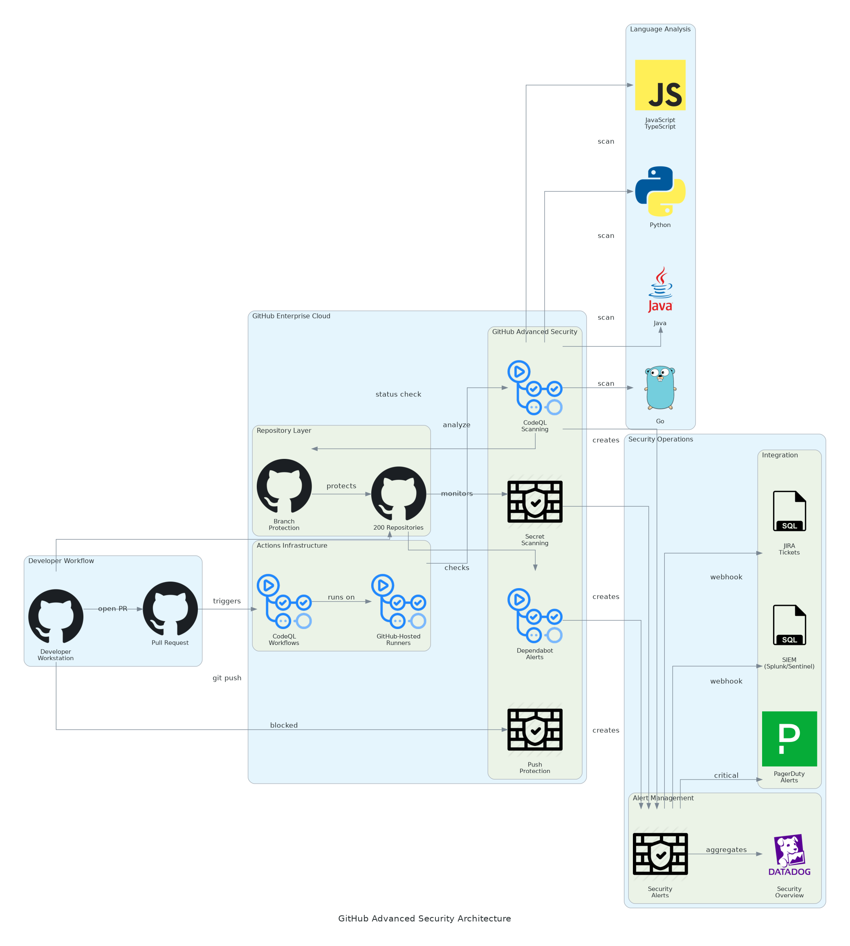
Figure 1: Solution Architecture

4.1 Architecture Principles
The following principles guide all architectural decisions throughout the solution design.
• Native Integration: Leverage GitHub-native security features for seamless developer experience
• Push Protection: Block secrets at commit time rather than alerting after exposure
• Automated Remediation: Enable automated fix PRs through Dependabot security updates
• Human-in-the-Loop: Security champion review for complex or ambiguous findings
• Policy as Code: Define security policies in repository configuration for versioning
• Observable by Default: All security events logged and forwarded to enterprise SIEM

4.2 Architecture Patterns
The solution implements the following architectural patterns to address security and scalability requirements.
• Primary Pattern: Event-driven security scanning with PR integration
• Detection Pattern: CodeQL semantic analysis for vulnerability detection
• Protection Pattern: Push protection for real-time secret blocking
• Integration Pattern: Webhooks for SIEM and issue tracking integration
• Governance Pattern: Branch protection rules with required security checks

4.3 Component Design
The solution comprises the following logical components, each with specific responsibilities and scaling characteristics.
Component | Purpose | Technology | Dependencies | Scaling
GitHub Enterprise | Platform hosting | GitHub Enterprise Cloud | SAML IdP | Managed
CodeQL Scanning | Static code analysis | CodeQL engine | GitHub Actions | Managed
Secret Scanning | Credential detection | Pattern matching + partners | Repository access | Managed
Push Protection | Real-time blocking | GitHub platform | Secret scanning | Managed
Dependabot | Dependency scanning | Dependabot engine | Repository access | Managed
GitHub Actions | CI/CD orchestration | Workflow engine | Compute minutes | Managed
Webhooks | Event delivery | HTTPS callbacks | External endpoints | Managed
Table 4: Solution Components

4.4 Technology Stack
The technology stack has been selected based on requirements for security detection, developer experience, and enterprise integration.
Layer | Technology | Rationale
Platform | GitHub Enterprise Cloud | Enterprise features, SAML SSO, audit logging
Code Scanning | CodeQL | Semantic analysis, multi-language support
Secret Scanning | GitHub Secret Scanning | 200+ partner patterns, custom patterns
Dependency Scanning | Dependabot | Native GitHub integration, auto-fix PRs
CI/CD | GitHub Actions | Native integration, workflow automation
Authentication | SAML SSO | Enterprise identity federation
Audit Logging | GitHub Audit Log API | Compliance and monitoring
Table 5: Technology Stack

5 Security & Compliance
This section details the security controls, compliance mappings, and governance mechanisms implemented in the solution.

5.1 Identity & Access Management
Access control follows enterprise standards with centralized identity management.
• Authentication: SAML 2.0 SSO with corporate identity provider
• Multi-Factor: MFA required for all organization members
• Authorization: Repository permissions following principle of least privilege
• Teams: GitHub Teams aligned with organizational structure
• Service Accounts: GitHub Apps with scoped permissions for automation

5.1.1 Role Definitions
The following roles define access levels within the GitHub organization, following the principle of least privilege.
Role | Permissions | Scope
Organization Owner | Full admin access, billing, SSO | Organization-wide
Security Admin | Security settings, alert management | Organization-wide
Repository Admin | Repository settings, branch protection | Per-repository
Developer | Code push, PR creation, alert viewing | Per-repository
Security Champion | Alert triage, dismissal rights | Assigned repositories
Table 6: Role Permissions

5.2 Secrets Management
GitHub secret scanning and push protection provide comprehensive secret management.
• Push protection enabled organization-wide to block secrets before commit
• Partner program integration for 200+ secret types with validity checking
• Custom patterns for organization-specific API keys and tokens
• Secret bypass workflow requiring manager approval
• Historical scanning for detecting secrets in existing commits

5.3 Network Security
Network security leverages GitHub's managed infrastructure with enterprise controls.
• TLS Encryption: All GitHub traffic encrypted with TLS 1.2+
• API Security: GitHub API access controlled via OAuth/personal access tokens
• Webhook Security: HMAC signatures for webhook payload validation
• IP Allowlisting: Optional GitHub Actions IP ranges for firewall rules

5.4 Data Protection
Data protection controls ensure code confidentiality and integrity.
• Encryption at Rest: GitHub encrypts all repository data at rest
• Encryption in Transit: TLS 1.2+ for all communications
• Access Logging: Audit log captures all repository access
• Data Residency: GitHub Enterprise Cloud data residency options

5.5 Compliance Mappings
The following table maps compliance requirements to specific implementation controls.
Framework | Requirement | Implementation
SOC 2 | Access control | SAML SSO, MFA, role-based permissions
SOC 2 | Change management | Branch protection, required reviews
SOC 2 | Audit trails | GitHub audit log with SIEM integration
PCI-DSS 6.5 | Secure coding | CodeQL detection of OWASP Top 10
Internal | Secret protection | Push protection, secret scanning
Table 7: Compliance Requirements

5.6 Audit Logging & SIEM Integration
Comprehensive audit logging supports security monitoring and compliance requirements.
• GitHub audit log API for all organization and repository events
• Webhook integration for real-time alert forwarding to SIEM
• Audit log streaming to Amazon S3 or Azure Blob (optional)
• Log retention per GitHub Enterprise Cloud policies (7 days by default)
• SIEM correlation with other security tools via webhook events

6 Data Architecture
This section defines the data model, storage strategy, and governance controls for the solution.

6.1 Data Model

6.1.1 Conceptual Model
The solution manages the following core entities:
• Repositories: Source code repositories with security scanning enabled
• Alerts: Security vulnerabilities detected by CodeQL, secret scanning, Dependabot
• Policies: Security policies and branch protection rules
• Audit Events: All security-relevant actions and changes

6.1.2 Logical Model
The logical data model defines the primary entities and their relationships within the system.
Entity | Key Attributes | Relationships | Volume
Repository | repo_id, name, visibility, security_enabled | Has many Alerts | 200
Code Scanning Alert | alert_id, rule, severity, state, location | Belongs to Repository | ~500/month
Secret Scanning Alert | alert_id, secret_type, state, commit_sha | Belongs to Repository | ~100/month
Dependabot Alert | alert_id, package, severity, CVE | Belongs to Repository | ~200/month
Audit Event | event_id, action, actor, timestamp | References all entities | ~10K/month
Table 8: Data Model Entities

6.2 Data Flow Design
1. Code Commit: Developer pushes code to branch or creates pull request
2. Push Protection: Secret scanning evaluates commit for secrets, blocks if detected
3. PR Creation: Pull request triggers CodeQL workflow via GitHub Actions
4. CodeQL Analysis: Semantic analysis executed with configured query suites
5. Alert Creation: Findings create alerts visible in Security tab
6. Webhook Delivery: Alerts forwarded to SIEM via configured webhooks
7. Notification: Developers notified via PR checks and email
8. Remediation: Developer fixes issue and updates pull request
9. Alert Resolution: Alert automatically closed when fix merged

6.3 Data Storage Strategy
• Repository Data: GitHub-managed encrypted storage
• Security Alerts: GitHub Security tab with API access
• Audit Logs: GitHub audit log with 7-day hot retention
• SIEM Archive: Long-term storage in enterprise SIEM

6.4 Data Governance
Data governance policies ensure proper handling, retention, and quality management.
• Classification: Repository visibility (public, internal, private)
• Retention: Alerts retained until resolved or dismissed
• Quality: False positive tracking via dismissal reason codes
• Access: Role-based access to security alerts

7 Integration Design
This section documents the integration patterns, APIs, and external system connections.

7.1 External System Integrations
The solution integrates with the following external systems using standardized protocols.
System | Type | Protocol | Format | Error Handling | SLA
Splunk | Real-time | Webhook | JSON | Retry queue | 99%
Azure Sentinel | Real-time | Webhook | JSON | Retry queue | 99%
JIRA | Event-driven | REST API | JSON | Error logging | 99%
ServiceNow | Event-driven | REST API | JSON | Error logging | 99%
Slack | Event-driven | Webhook | JSON | Best effort | 95%
Microsoft Teams | Event-driven | Webhook | JSON | Best effort | 95%
Table 9: System Integrations

7.2 API Design
GitHub APIs provide programmatic access to security features.
• Style: RESTful with GraphQL option
• Authentication: Personal access tokens or GitHub App tokens
• Rate Limiting: 5,000 requests/hour for authenticated requests
• Documentation: docs.github.com/rest

7.2.1 API Endpoints
The following REST API endpoints provide programmatic access to security features.
Method | Endpoint | Auth | Description
GET | /repos/{owner}/{repo}/code-scanning/alerts | Bearer Token | List code scanning alerts
GET | /repos/{owner}/{repo}/secret-scanning/alerts | Bearer Token | List secret scanning alerts
GET | /repos/{owner}/{repo}/dependabot/alerts | Bearer Token | List Dependabot alerts
PATCH | /repos/{owner}/{repo}/code-scanning/alerts/{id} | Bearer Token | Update alert state
GET | /orgs/{org}/audit-log | Bearer Token | Query audit log events
Table 10: API Endpoints

7.3 Webhook Event Patterns
Webhooks enable real-time integration with enterprise systems.
• Event Types: code_scanning_alert, secret_scanning_alert, dependabot_alert
• Delivery: HTTPS POST with HMAC signature
• Retry Policy: GitHub retries failed deliveries for up to 3 days
• Payload: JSON with alert details and repository context

8 Infrastructure & Operations
This section covers the infrastructure design, deployment architecture, and operational procedures.

8.1 GitHub Organization Design
The GitHub organization structure provides security and access control boundaries.
• Organization: Single GitHub organization for enterprise
• Teams: GitHub Teams aligned with development team structure
• Repositories: 200 repositories organized by project/domain
• Settings: Organization-level security defaults enabled

8.2 Security Scanning Configuration
Scanning configuration provides comprehensive vulnerability detection.
Component | Configuration | Query Suite | Schedule | Scope
CodeQL - JavaScript | Enabled | security-extended | PR + daily | All JS/TS repos
CodeQL - Python | Enabled | security-extended | PR + daily | All Python repos
CodeQL - Java | Enabled | security-extended | PR + daily | All Java repos
CodeQL - C# | Enabled | security-extended | PR + daily | All C# repos
CodeQL - Go | Enabled | security-extended | PR + daily | All Go repos
Secret Scanning | Enabled | Partner + Custom | Real-time | All repos
Push Protection | Enabled | All patterns | Real-time | All repos
Dependabot Alerts | Enabled | All ecosystems | Daily | All repos
Table 11: Component

8.3 High Availability Design
The solution leverages GitHub's managed infrastructure for high availability.
• GitHub Enterprise Cloud 99.9% uptime SLA
• Multi-region GitHub infrastructure
• Automatic failover and disaster recovery
• No customer-managed infrastructure required

8.4 Disaster Recovery
Disaster recovery capabilities are provided by GitHub's managed platform.
• RPO: Real-time (GitHub manages replication)
• RTO: Minutes (GitHub SLA)
• Backup: Git repository cloning for offline backup (optional)
• DR Site: GitHub manages multi-region redundancy

8.5 Monitoring & Alerting
Comprehensive monitoring provides visibility across the security platform.
• Platform Status: GitHub status page monitoring
• Security Metrics: Security Overview dashboard
• Alert Volume: CloudWatch/Datadog metrics via webhooks
• SLA Monitoring: Detection accuracy and scan duration tracking

8.5.1 Alert Definitions
The following alerts ensure proactive incident detection and response.
Alert | Condition | Severity | Response
Detection Accuracy Drop | Accuracy < 93% for 1 week | Warning | Review detection patterns
Scan Duration Increase | PR scan > 20 min average | Warning | Investigate repository size
SIEM Webhook Failures | > 10% delivery failures | Warning | Check SIEM connectivity
Critical Vuln Unresolved | Critical alert > 24 hours | Critical | Escalate to security team
Push Protection Bypass | Any bypass request | Info | Review bypass justification
Table 12: Monitoring Alerts

8.6 Logging & Observability
Centralized logging enables security monitoring and troubleshooting.
• GitHub audit log for all organization and repository events
• Webhook delivery logs in GitHub organization settings
• GitHub Actions workflow logs for CodeQL scan details
• SIEM aggregation for cross-platform correlation

8.7 Cost Model
Estimated annual licensing costs based on 100 users and 80 active committers.
Category | Annual Cost | Optimization | Notes
GitHub Enterprise Cloud | $210,000 | User management | 100 users @ $2,100/user
GitHub Advanced Security | $201,600 | Committer tracking | 80 committers @ $2,520
GitHub Actions | $11,700 | Workflow optimization | 50K+ minutes included
Third-Party Tools | $20,000 | N/A | Datadog, JIRA integration
Support & Maintenance | $67,000 | Optional | Managed services
Table 13: Category And Annual Cost
Total Estimated Annual: $510,300 (required) + $67,000 (optional managed services)

9 Implementation Approach
This section outlines the deployment strategy, tooling, and sequencing for the implementation.

9.1 Migration/Deployment Strategy
The deployment strategy minimizes risk through phased rollout with validation gates.
• Approach: Pilot-validate-expand with 10 repositories first
• Pattern: Phased enablement by team/language
• Validation: Detection accuracy testing at each phase gate
• Rollback: Repository-level disablement if issues arise

9.2 Sequencing & Wave Planning
The implementation follows a phased approach with clear exit criteria.
Phase | Activities | Duration | Exit Criteria
1 | Discovery & Assessment | 3 weeks | Repository inventory, language analysis
2 | Pilot (10 repositories) | 3 weeks | 95%+ detection accuracy validated
3 | Expansion (190 repositories) | 10 weeks | All repos enabled, policies enforced
4 | Testing & Validation | 4 weeks | UAT complete, integrations validated
5 | Go-Live & Hypercare | 6 weeks | Production stable, team trained
Table 14: Implementation Phases
Total Implementation: ~26 weeks (6 months)

9.3 Tooling & Automation
The following tools provide the automation foundation for GHAS operations.
Category | Tool | Purpose
Configuration Management | GitHub organization settings | Org-level security defaults
CI/CD | GitHub Actions | CodeQL workflow execution
Automation | GitHub API / CLI | Bulk repository configuration
Monitoring | GitHub Security Overview | Organization security posture
Dashboards | Datadog / CloudWatch | Metrics and alerting
Table 15: Tools and Technologies

9.4 Cutover Approach
The cutover strategy enables gradual rollout with monitoring.
• Type: Phased enablement by repository
• Duration: 1-week monitoring per phase
• Validation: Detection accuracy and developer impact
• Decision Point: Go/no-go 48 hours before each phase

9.5 Rollback Strategy
Rollback procedures are documented for rapid recovery.
• CodeQL workflow disablement per repository
• Push protection bypass for specific patterns
• Dependabot pause at repository level
• Maximum rollback window: Immediate

10 Appendices

10.1 Architecture Diagrams
The following diagrams provide visual representation of the solution architecture.
• Solution Architecture Diagram (included in Solution Architecture section)
• Data Flow Diagram
• Integration Architecture Diagram
• Security Controls Diagram

10.2 Naming Conventions
All GitHub resources follow standardized naming conventions.
Resource Type | Pattern | Example
Repository | `{project}-{component}` | `ecommerce-api`
Team | `{department}-{function}` | `engineering-backend`
Workflow | `{type}-{language}.yml` | `codeql-javascript.yml`
Custom Query | `{category}-{pattern}.ql` | `auth-sql-injection.ql`
Table 16: Naming Conventions

10.3 Tagging Standards
Repository topics enable organization and filtering.
Topic | Required | Example Values
language | Yes | javascript, python, java
team | Yes | platform, payments, mobile
security-tier | Yes | critical, standard, low
compliance | No | pci-dss, hipaa, sox
Table 17: Topic

10.4 Risk Register
The following risks have been identified with corresponding mitigation strategies.
Risk | Likelihood | Impact | Mitigation
Detection accuracy below target | Medium | High | Iterative tuning, custom queries
Developer adoption resistance | Medium | Medium | Champion program, training
False positive impact on velocity | Medium | Medium | Tuning, dismiss rules
SIEM integration failures | Low | Medium | Retry logic, monitoring
Push protection bypass abuse | Low | High | Approval workflow, audit logging
Table 18: Risk Register

10.5 Glossary
The following terms and acronyms are used throughout this document.
Term | Definition
GHAS | GitHub Advanced Security
CodeQL | GitHub's semantic code analysis engine
SAST | Static Application Security Testing
CWE | Common Weakness Enumeration
CVE | Common Vulnerabilities and Exposures
CVSS | Common Vulnerability Scoring System
SSO | Single Sign-On
MFA | Multi-Factor Authentication
SIEM | Security Information and Event Management
Table 19: Glossary


eoframework.org

