

Detailed Design Document
GitHub Actions Enterprise CI/CD

Client: | [CLIENT]
Date: | November 28, 2025
Consulting Company: | [Consulting Company Name]
Submitted By: | [Name | Email | Phone]
Opportunity No: | OPP-XXXXX
Version: | 1.0

Table of Contents
1 Introduction
1.1 Purpose
1.1.1 Scope
2 Table Content
3 Image Section
4 Additional Content
5 Sign-Off

List of Figures
Figure 1: Sample Architecture Diagram

List of Tables
Table 1: Sample Deliverables Table

1 Executive Summary
This document provides the comprehensive technical design for the GitHub Actions Enterprise CI/CD platform implementation. It covers the target-state architecture leveraging GitHub Enterprise Cloud, self-hosted runners on AWS EC2, OIDC authentication for keyless AWS access, and Kubernetes (EKS) deployment automation. The solution migrates 50 applications from Jenkins to GitHub Actions with reusable workflow templates.

1.1 Purpose
Define the technical architecture and design specifications that will guide the implementation team through deployment, configuration, and validation of the enterprise CI/CD platform on GitHub Enterprise Cloud with self-hosted runner infrastructure.

1.2 Scope
In-scope:
• GitHub Enterprise Cloud organization setup and configuration
• Self-hosted runner infrastructure on AWS EC2 (20 runners)
• Auto-scaling runner groups using AWS ASG
• OIDC authentication for keyless AWS deployments
• 15 reusable workflow templates for .NET, Node.js, Python, Docker
• Container registry integration (GitHub Packages, AWS ECR)
• Kubernetes (EKS) deployment automation
• Monitoring integration (Datadog, CloudWatch, PagerDuty)
• Environment protection rules and approval workflows
Out-of-scope:
• End-user training delivery (covered in Training Plan)
• Ongoing support procedures (covered in Operations Runbook)
• Self-hosted GitHub Enterprise Server
• Migration of GitLab CI pipelines (separate project)

1.3 Assumptions & Constraints
The following assumptions underpin the design and must be validated during implementation.
• GitHub Enterprise Cloud licensing secured for 100 users
• AWS accounts available for development, staging, and production
• Existing EKS clusters accessible for deployment targets
• Jenkins pipelines documented and available for analysis
• Network connectivity between runners and deployment targets

1.4 References
This document should be read in conjunction with the following related materials.
• Statement of Work (SOW)
• Discovery Questionnaire responses
• GitHub Actions documentation
• AWS IAM OIDC provider documentation

2 Business Context
This section establishes the business drivers, success criteria, and compliance requirements that shape the technical design decisions.

2.1 Business Drivers
The solution addresses the following key business objectives identified during discovery.
• Platform Modernization: Replace aging Jenkins infrastructure with cloud-native CI/CD
• Developer Velocity: Enable daily production deployments with <10 minute pipelines
• Cost Optimization: Eliminate $200K+ annual Jenkins infrastructure and maintenance costs
• Security Improvement: Remove static AWS credentials with OIDC keyless authentication
• Standardization: Establish reusable workflow templates across all development teams

2.2 Workload Criticality & SLA Expectations
The following service level targets define the operational requirements for the production environment and guide configuration decisions.
Metric | Target | Measurement | Priority
Pipeline Duration | < 10 minutes | Workflow completion time | Critical
Deployment Success Rate | > 95% | Successful deployments / total | Critical
Platform Availability | 99.9% | GitHub + runner uptime | High
Concurrent Build Capacity | 25+ builds | Simultaneous workflow runs | High
Queue Wait Time | < 30 seconds | Job queue to execution start | Medium
Runner Utilization | 60-80% | Active time / available time | Medium
Table 1: Service Level Targets

2.3 Compliance & Regulatory Factors
The solution must adhere to the following regulatory and compliance requirements.
• SOC 2 Type II compliance for all CI/CD platform operations
• No static credentials in workflows (OIDC required)
• Audit logging for all deployment activities
• Environment protection rules for production deployments
• Secrets management via GitHub Actions encrypted secrets

2.4 Success Criteria
Project success will be measured against the following criteria at go-live.
• All 50 applications migrated from Jenkins to GitHub Actions
• Average pipeline duration under 10 minutes
• 95%+ deployment success rate achieved
• Jenkins infrastructure fully decommissioned
• 15 reusable workflow templates operational
• DevOps and developer training completed (95%+ attendance)

3 Current-State Assessment
This section documents the existing environment that the solution will integrate with or enhance.

3.1 Application Landscape
The current environment consists of development applications requiring CI/CD migration.
Application Type | Technology | Count | Migration Complexity
.NET Core | C# .NET 6+ | 18 | Medium
.NET Framework | C# .NET 4.8 | 8 | High (Windows)
Node.js | TypeScript/JS | 12 | Low
Python | Python 3.x | 7 | Low
Docker/Container | Multi-language | 5 | Medium
Table 2: Application Inventory

3.2 Infrastructure Inventory
The current Jenkins infrastructure being replaced.
Component | Quantity | Specifications | Notes
Jenkins Master | 1 | c5.xlarge EC2 | To be decommissioned
Jenkins Agents | 20 | c5.2xlarge EC2 | To be replaced with GHA runners
Jenkins Storage | 500GB | EBS gp3 | To be decommissioned
Jenkins Maintenance | N/A | ~$40K/year | Labor cost eliminated
Table 3: Infrastructure Inventory

3.3 Dependencies & Integration Points
The current environment has the following external dependencies that must be considered.
• AWS accounts (dev, staging, production) with IAM access
• EKS clusters for Kubernetes deployments
• GitHub Enterprise Cloud organization
• Container registries (ECR, GitHub Packages)
• Monitoring platforms (Datadog, CloudWatch)
• Notification services (Slack, PagerDuty)

3.4 Performance Baseline
Current Jenkins metrics establish the baseline for improvement targets.
• Average pipeline duration: 45 minutes
• Deployment success rate: 70%
• Deployments per week: 7
• Concurrent build capacity: 10 jobs
• Build queue wait time: 5-10 minutes

4 Solution Architecture
The target architecture leverages GitHub Actions with self-hosted runners to deliver high-performance CI/CD with keyless AWS authentication and Kubernetes deployment automation.
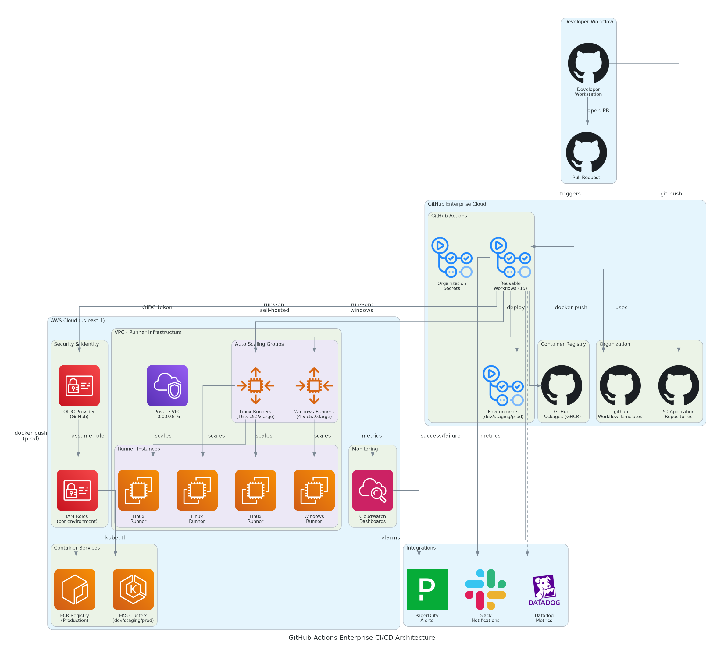
Figure 1: Solution Architecture

4.1 Architecture Principles
The following principles guide all architectural decisions throughout the solution design.
• Self-Hosted Runners: Cost-optimized runners in customer VPC for performance and security
• Reusable Workflows: Standardized templates reduce duplication and ensure consistency
• Keyless Authentication: OIDC eliminates static credentials from all workflows
• Environment Protection: Approval gates ensure controlled production deployments
• Infrastructure as Code: Terraform manages all runner infrastructure
• Observable by Default: All workflows and runners emit metrics to monitoring platforms

4.2 Architecture Patterns
The solution implements the following architectural patterns to address CI/CD requirements.
• Primary Pattern: GitHub-native CI/CD with self-hosted execution
• Compute Pattern: Auto-scaling runner groups for elastic capacity
• Auth Pattern: OIDC federation for AWS service access
• Deploy Pattern: GitOps with environment-based promotion
• Caching Pattern: Dependency and Docker layer caching for speed

4.3 Component Design
The solution comprises the following logical components, each with specific responsibilities and scaling characteristics.
Component | Purpose | Technology | Dependencies | Scaling
GitHub Enterprise | CI/CD platform | GitHub Enterprise Cloud | License | Managed
Linux Runners | Build execution | EC2 c5.2xlarge Ubuntu | AWS ASG | Auto-scale
Windows Runners | .NET Framework builds | EC2 c5.2xlarge Server 2022 | AWS ASG | Auto-scale
OIDC Provider | Keyless AWS auth | AWS IAM OIDC | GitHub | Managed
GitHub Packages | Container registry | GHCR | GitHub | Managed
AWS ECR | Production images | ECR | AWS | Managed
EKS Clusters | Deployment targets | Kubernetes 1.28+ | AWS | Managed
Table 4: Solution Components

4.4 Technology Stack
The technology stack has been selected based on requirements for performance, cost optimization, and enterprise integration.
Layer | Technology | Rationale
CI/CD Platform | GitHub Enterprise Cloud | Native Git integration, enterprise features
Compute | EC2 c5.2xlarge instances | 8 vCPU, 16GB RAM for builds
Container Runtime | Docker with BuildKit | Layer caching, multi-stage builds
Infrastructure | Terraform 1.5+ | Infrastructure as code, state management
Container Registry | GitHub Packages + AWS ECR | Development and production separation
Kubernetes | AWS EKS 1.28+ | Managed Kubernetes for deployments
Monitoring | Datadog + CloudWatch | APM and infrastructure monitoring
Table 5: Technology Stack

5 Security & Compliance
This section details the security controls, compliance mappings, and governance mechanisms implemented in the solution.

5.1 Identity & Access Management
Access control follows enterprise standards with OIDC-based service authentication.
• GitHub Authentication: SAML SSO with corporate identity provider
• AWS Authentication: OIDC provider for keyless credential exchange
• Runner Registration: Organization-level runner tokens
• Secrets Management: GitHub Actions encrypted secrets per environment

5.1.1 Role Definitions
The following roles define access levels within the GitHub organization.
Role | Permissions | Scope
Organization Owner | Full admin access, billing, runner management | Organization-wide
DevOps Admin | Runner configuration, workflow management | Organization-wide
Repository Admin | Repository settings, secrets, environments | Per-repository
Developer | Code push, PR creation, workflow viewing | Per-repository
Approver | Production deployment approval | Environment-specific
Table 6: Role Permissions

5.2 Secrets Management
Secrets are managed using GitHub Actions encrypted secrets with environment scoping.
• Organization-level secrets for shared credentials (Datadog, PagerDuty)
• Repository-level secrets for application-specific configuration
• Environment-level secrets for deployment credentials
• No static AWS credentials (OIDC used exclusively)
• Secret rotation supported via GitHub API

5.3 Network Security
Network security leverages AWS VPC for runner isolation.
• Runner VPC: Runners deployed in private subnets
• Security Groups: Outbound-only access to GitHub and deployment targets
• NAT Gateway: Internet access for package downloads
• VPC Endpoints: Direct AWS service access without internet
• No Inbound Access: Runners initiate all connections

5.4 Data Protection
Data protection controls ensure code and artifact confidentiality.
• TLS Encryption: All GitHub and AWS traffic encrypted in transit
• Storage Encryption: EBS volumes encrypted at rest
• Artifact Handling: Temporary storage, automatic cleanup
• Log Masking: Secrets masked in workflow logs

5.5 Compliance Mappings
The following table maps compliance requirements to specific implementation controls.
Framework | Requirement | Implementation
SOC 2 | Access control | SAML SSO, OIDC, environment protection
SOC 2 | Change management | PR-based workflows, approval gates
SOC 2 | Audit trails | GitHub audit log, CloudWatch logs
Internal | No static credentials | OIDC for all AWS access
Internal | Approval workflows | Environment protection rules
Table 7: Compliance Requirements

5.6 Audit Logging & Monitoring
Comprehensive audit logging supports security monitoring and compliance.
• GitHub audit log for organization and repository events
• CloudWatch logs for runner activity and workflow execution
• Datadog APM for workflow performance metrics
• PagerDuty integration for critical alert escalation

6 Data Architecture
This section defines the data model, storage strategy, and governance controls for the solution.

6.1 Data Model

6.1.1 Conceptual Model
The solution manages the following core entities:
• Workflows: YAML-defined CI/CD pipelines
• Runs: Workflow execution instances with logs and artifacts
• Runners: Self-hosted compute instances for job execution
• Environments: Deployment target configurations with protection rules
• Artifacts: Build outputs and deployment packages

6.1.2 Logical Model
The logical data model defines the primary entities and their relationships.
Entity | Key Attributes | Relationships | Volume
Repository | repo_id, name, workflows | Has many Workflows | 50
Workflow Run | run_id, status, duration, logs | Belongs to Repository | ~200/day
Runner | runner_id, os, labels, status | Belongs to Organization | 20
Environment | env_id, name, protection_rules | Belongs to Repository | 150 (3 per repo)
Artifact | artifact_id, name, size, expires | Belongs to Workflow Run | ~200/day
Table 8: Data Model Entities

6.2 Data Flow Design
1. Code Push: Developer pushes code to repository branch
2. Workflow Trigger: GitHub triggers workflow based on event
3. Job Queue: Jobs queued for runner assignment
4. Runner Execution: Self-hosted runner executes job steps
5. Artifact Upload: Build artifacts uploaded to GitHub storage
6. Container Push: Docker images pushed to registry
7. Deployment: Application deployed to target environment
8. Metrics: Performance metrics sent to monitoring platform

6.3 Data Storage Strategy
• Workflow Logs: GitHub-managed storage, 90-day retention
• Build Artifacts: GitHub artifact storage, 7-day retention
• Container Images: GitHub Packages (90 days), ECR (production, unlimited)
• Runner Logs: CloudWatch Logs, 30-day retention
• Metrics: Datadog, 15-month retention

6.4 Data Governance
Data governance policies ensure proper handling and retention.
• Classification: Workflows and logs as internal/confidential
• Retention: Configurable per artifact type and environment
• Backup: Git repositories backed up via standard git cloning
• Cleanup: Automated artifact and image lifecycle policies

7 Integration Design
This section documents the integration patterns, APIs, and external system connections.

7.1 External System Integrations
The solution integrates with the following external systems.
System | Type | Protocol | Format | Error Handling | SLA
AWS (OIDC) | Real-time | HTTPS | JSON | Token refresh | 99.9%
AWS ECR | Real-time | Docker | OCI | Retry logic | 99.9%
AWS EKS | Real-time | HTTPS | K8s API | Retry with backoff | 99.9%
Datadog | Real-time | HTTPS | JSON | Queue/retry | 99%
Slack | Event-driven | Webhook | JSON | Best effort | 95%
PagerDuty | Event-driven | HTTPS | JSON | Retry | 99%
Table 9: System Integrations

7.2 API Design
GitHub APIs provide programmatic access to CI/CD features.
• Style: RESTful with GraphQL option
• Authentication: Personal access tokens or GitHub App tokens
• Rate Limiting: 5,000 requests/hour for authenticated requests
• Documentation: docs.github.com/rest

7.2.1 API Endpoints
The following REST API endpoints provide workflow management.
Method | Endpoint | Auth | Description
GET | /repos/{owner}/{repo}/actions/runs | Bearer Token | List workflow runs
POST | /repos/{owner}/{repo}/actions/workflows/{id}/dispatches | Bearer Token | Trigger workflow
GET | /repos/{owner}/{repo}/actions/artifacts | Bearer Token | List artifacts
DELETE | /repos/{owner}/{repo}/actions/runs/{id} | Bearer Token | Delete workflow run
GET | /orgs/{org}/actions/runners | Bearer Token | List organization runners
Table 10: API Endpoints

7.3 OIDC Integration Pattern
GitHub OIDC enables keyless AWS authentication.
• Provider: token.actions.githubusercontent.com
• Audience: sts.amazonaws.com
• Subject Claim: repo:{org}/{repo}:environment:{env}
• Token Lifetime: 1 hour maximum
• Role Assumption: IAM roles per repository/environment

8 Infrastructure & Operations
This section covers the infrastructure design, deployment architecture, and operational procedures.

8.1 Self-Hosted Runner Infrastructure
Runner infrastructure provides elastic compute for workflow execution.
Component | Linux Fleet | Windows Fleet | Total | Notes
Instance Type | c5.2xlarge | c5.2xlarge | - | 8 vCPU, 16GB RAM
Instance Count | 16 | 4 | 20 | Default capacity
ASG Minimum | 8 | 2 | 10 | Always-on runners
ASG Maximum | 24 | 6 | 30 | Peak capacity
OS | Ubuntu 22.04 | Server 2022 | - | Custom AMIs
Table 11: Component

8.2 Auto-Scaling Configuration
Auto-scaling provides elastic capacity based on queue depth.
Parameter | Value | Rationale
Scale-Up Trigger | Queue depth > 5 jobs | Respond to build demand
Scale-Up Increment | +2 instances | Gradual scale
Scale-Down Trigger | 15 minutes idle | Cost optimization
Scale-Down Decrement | -1 instance | Gradual reduction
Health Check | GitHub API runner status | Verify runner registered
Cooldown Period | 5 minutes | Prevent thrashing
Table 12: Parameter

8.3 High Availability Design
The solution provides high availability through multi-AZ deployment.
• Runners distributed across 2+ availability zones
• ASG automatically replaces unhealthy instances
• GitHub Actions handles job retry for failed runners
• No single point of failure in runner infrastructure

8.4 Disaster Recovery
Disaster recovery capabilities for CI/CD infrastructure.
• RPO: Zero (all workflows stored in Git)
• RTO: < 4 hours (Terraform rebuild)
• Backup: Infrastructure as code in version control
• Recovery: Terraform apply rebuilds all infrastructure

8.5 Monitoring & Alerting
Comprehensive monitoring provides visibility across the CI/CD platform.
• GitHub Status: github.com/status monitoring
• Runner Health: CloudWatch metrics + Datadog
• Workflow Metrics: Datadog APM integration
• Cost Monitoring: AWS Cost Explorer + CloudWatch Billing

8.5.1 Alert Definitions
The following alerts ensure proactive incident detection.
Alert | Condition | Severity | Response
Pipeline Duration High | > 15 minutes average | Warning | Review slow workflows
Runner Utilization High | > 90% for 30 minutes | Warning | Scale up runners
Runner Offline | Runner unregistered > 5 min | Critical | ASG replacement
Deployment Failure | Prod deployment failed | Critical | PagerDuty escalation
Build Queue Backlog | > 20 queued jobs | Warning | Scale up runners
Table 13: Monitoring Alerts

8.6 Cost Model
Estimated monthly costs for CI/CD infrastructure.
Category | Monthly Cost | Annual Cost | Optimization
EC2 Runners (20x c5.2xlarge) | $5,000 | $60,000 | Reserved instances
EBS Storage | $500 | $6,000 | GP3 volumes
NAT Gateway | $300 | $3,600 | VPC endpoints
Data Transfer | $200 | $2,400 | Regional optimization
GitHub Enterprise | $17,670 | $212,040 | License optimization
Datadog | $1,500 | $18,000 | Custom metrics
Total | $25,170 | $302,040
Table 14: Category And Monthly Cost
Note: Jenkins elimination saves $200K+/year

9 Implementation Approach
This section outlines the deployment strategy, tooling, and sequencing for the implementation.

9.1 Migration Strategy
The deployment strategy minimizes risk through phased migration with validation gates.
• Approach: Pilot-validate-expand with 10 applications first
• Pattern: Technology stack-based migration waves
• Validation: Performance testing at each phase gate
• Parallel: Jenkins and Actions run in parallel during migration

9.2 Sequencing & Wave Planning
The implementation follows a phased approach with clear exit criteria.
Phase | Activities | Duration | Exit Criteria
1 | Discovery & Assessment | 3 weeks | Pipeline inventory, runner sizing
2 | Infrastructure Build | 3 weeks | Runners operational, OIDC configured
3 | Pilot (10 apps) | 3 weeks | <10 min pipelines, 95%+ success
4 | Workflow Library | 2 weeks | 15 templates deployed
5 | Migration Waves | 6 weeks | All 50 apps migrated
6 | Testing & Validation | 3 weeks | UAT complete, performance validated
7 | Go-Live & Hypercare | 6 weeks | Production stable, Jenkins retired
Table 15: Implementation Phases
Total Implementation: ~26 weeks (6 months)

9.3 Tooling & Automation
The following tools provide the automation foundation for CI/CD operations.
Category | Tool | Purpose
Infrastructure | Terraform 1.5+ | Runner infrastructure as code
Configuration | GitHub CLI (gh) | Organization and repo configuration
Automation | Python scripts | Bulk workflow deployment
Monitoring | Datadog | Workflow and runner metrics
Alerting | PagerDuty | Critical incident escalation
Table 16: Tools and Technologies

9.4 Cutover Approach
The cutover strategy enables parallel operation during migration.
• Type: Gradual migration with parallel operation
• Duration: 2-week parallel period per application
• Validation: Success rate and duration comparison
• Decision Point: Jenkins retirement after all apps migrated

9.5 Rollback Strategy
Rollback procedures are documented for rapid recovery.
• Jenkins pipelines preserved during migration
• Rollback: Re-enable Jenkins pipeline for specific application
• Runner infrastructure: Terraform destroy and rebuild
• Maximum rollback window: 30 days post-migration

10 Appendices

10.1 Architecture Diagrams
The following diagrams provide visual representation of the solution architecture.
• Solution Architecture Diagram (included in Solution Architecture section)
• Runner Infrastructure Diagram
• OIDC Authentication Flow Diagram
• Deployment Pipeline Diagram

10.2 Naming Conventions
All resources follow standardized naming conventions.
Resource Type | Pattern | Example
Workflow File | `{action}-{stack}.yml` | `build-deploy-dotnet.yml`
Runner AMI | `gha-runner-{os}-{version}` | `gha-runner-ubuntu-22.04-v1.0`
ASG | `gha-runners-{os}-asg` | `gha-runners-linux-asg`
IAM Role | `github-actions-{env}-deploy` | `github-actions-prod-deploy`
Environment | `{env}` | `production`
Table 17: Naming Conventions

10.3 Tagging Standards
AWS resources follow consistent tagging standards.
Tag | Required | Example Values
Project | Yes | github-actions-cicd
Environment | Yes | production, staging, development
Owner | Yes | devops-team
CostCenter | Yes | engineering-devops
ManagedBy | Yes | terraform
Table 18: Tagging Standards

10.4 Risk Register
The following risks have been identified with corresponding mitigation strategies.
Risk | Likelihood | Impact | Mitigation
Pipeline performance below target | Medium | High | Self-hosted runners, caching, parallel jobs
Migration complexity for Windows apps | Medium | Medium | Dedicated Windows runners, Framework support
Developer adoption resistance | Low | Medium | Training, reusable templates, champion program
Runner capacity constraints | Low | High | Auto-scaling, capacity monitoring
OIDC configuration complexity | Medium | Medium | Documented patterns, validation testing
Table 19: Risk Register

10.5 Glossary
The following terms and acronyms are used throughout this document.
Term | Definition
GHA | GitHub Actions
OIDC | OpenID Connect
ASG | Auto Scaling Group
ECR | Elastic Container Registry
EKS | Elastic Kubernetes Service
GHCR | GitHub Container Registry
CI/CD | Continuous Integration / Continuous Deployment
IaC | Infrastructure as Code
Table 20: Glossary


eoframework.org

