

Statement of Work
Azure Virtual Desktop Implementation

Client: | '[Client Name]'
Date: | November 15, 2025
Consulting Company: | Your Consulting Company
Submitted By: | '[Consultant Name | Email | Phone]'
Opportunity No: | OPP-2025-001
Version: | '1.0'

Table of Contents

1 Introduction
1.1 Purpose
1.1.1 Scope
2 Table Content
3 Image Section
4 Additional Content
5 Sign-Off

List of Figures
Figure 1: Architecture Diagram 11

List of Tables
Table 1: Engagement Scope Parameters 3
Table 2: Project Milestones 4
Table 3: Project Deliverables and Acceptance Criteria 5
Table 4: Roles and Responsibilities (RACI Matrix) 6
Table 5: Investment Summary 7

1 Executive Summary
This Statement of Work defines the scope, deliverables, timeline, and terms for the Azure Virtual Desktop implementation. This engagement will transform your organization's capabilities by delivering a comprehensive, enterprise-grade solution designed to meet your specific business requirements.
Project Duration: 12 weeks (as detailed in Timeline & Milestones section)
Key Objectives:
• Deploy and configure Azure Virtual Desktop according to best practices
• Integrate with existing enterprise systems and workflows
• Train technical staff on operations and management
• Achieve defined success metrics and business outcomes

2 Background & Objectives

2.1 Business Context
layout: two_column
Transforming Workforce Mobility with Azure Virtual Desktop
• Opportunity
• Enable hybrid and remote workforce without compromising security or performance
• Reduce infrastructure costs by 30-40% compared to traditional VDI and physical desktops
• Modernize desktop management with cloud-based administration and simplified operations
Success Criteria
• 100% user adoption with minimal support calls through intuitive experience
• 20-30% reduction in IT operational costs through cloud-based management
• ROI realization within 18-24 months through infrastructure consolidation and labor savings

3 Scope of Work

3.1 In Scope
layout: single
Proven Methodology for Azure Virtual Desktop Success
• Phase 1: Discovery & Planning (Weeks 1-2)
• Assess current environment and user requirements
• Design AVD architecture with security and performance considerations
• Plan network connectivity and application compatibility validation
Phase 2: Infrastructure Deployment (Weeks 3-5)
• Deploy Azure Virtual Network and identity infrastructure
• Configure D4s_v5 session hosts with Windows 11 Multi-Session
• Set up Azure Files Premium and FSLogix profile containers
Phase 3: Application Deployment, Migration & Hypercare (Weeks 6-10)
• Deploy Microsoft 365 and critical business applications with UAT validation
• Migrate users in waves to new AVD environment with application testing
• Provide 30-day hypercare support and transition to operations team

3.1.1 Scope Parameters
This engagement is sized based on the following parameters:
Note: Changes to these parameters may require scope adjustment and additional investment.

3.2 Out of Scope
These items are not in scope unless added via change control:
• Custom development beyond standard configuration
• Third-party application licensing (unless specified)
• Hardware procurement or disposal
• End-user training (technical team only)
• Ongoing managed services post-hypercare

4 Deliverables & Timeline

4.1 Project Milestones
**layout:** table
**Path to Modern Workplace Delivery**
Phase No | Phase Description | Timeline | Key Deliverables
Phase 1 | Discovery & Planning | Weeks 1-2 | Requirements validated, Architecture designed, Project plan approved
Phase 2 | Infrastructure Deployment | Weeks 3-5 | Azure networking live, Session hosts operational, FSLogix configured
Phase 3 | Application Deployment, Migration & Hypercare | Weeks 6-10 | Applications deployed, Users migrated in waves, 30-day hypercare support
Table 2: Project Milestones

4.2 Key Deliverables
# | Deliverable | Type | Due Date | Acceptance By
1 | Solution Architecture Document | Document | Week 4 | Client IT Lead
2 | Configuration Runbook | Document | Week 8 | Operations Team
3 | Test Results Report | Document | Week 10 | QA Lead
4 | As-Built Documentation | Document | Week 12 | Client IT Lead
5 | Knowledge Transfer Sessions | Training | Week 12 | Technical Team
Table 3: Project Deliverables and Acceptance Criteria

5 Roles & Responsibilities

5.1 RACI Matrix
Task/Deliverable | Vendor PM | Vendor Arch | Vendor Eng | Client IT | Client Mgmt | SME
Solution Architecture | C | A | R | C | I | C
Infrastructure Setup | C | R | R | C | I | I
Configuration & Tuning | A | R | R | C | I | I
Integration Development | C | A | R | C | I | I
Testing & Validation | R | R | R | A | I | C
Knowledge Transfer | R | R | C | A | I | I
Project Management | A | I | I | C | R | I
Table 4: Roles and Responsibilities (RACI Matrix)
Legend: R = Responsible | A = Accountable | C = Consulted | I = Informed

5.2 Key Personnel
Vendor Team:
• Project Manager: Overall delivery accountability
• Solution Architect: Technical design and oversight
• Engineers: Implementation and configuration
• Support Specialist: Training and hypercare
Client Team:
• IT Lead: Primary technical contact
• Management Sponsor: Executive oversight
• Operations Team: Knowledge transfer recipients
• Subject Matter Experts: Requirements validation

6 Architecture & Design

6.1 Solution Architecture
layout: visual
Secure, Scalable Azure Virtual Desktop Architecture
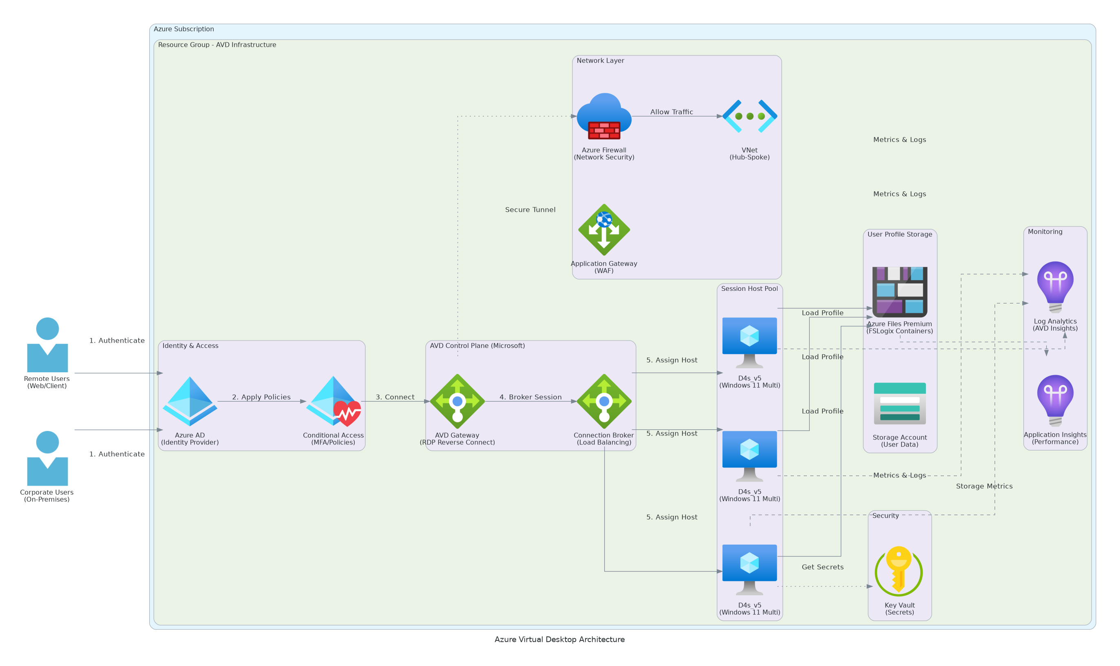
Figure 1: Architecture Diagram
• AVD Core Components
• Windows 11 Multi-Session VMs with 20 session hosts supporting 100 concurrent users
• Azure AD integration for unified identity and conditional access policies
• FSLogix user profile containers for seamless profile roaming and application persistence
Platform Architecture
• Azure Virtual Network with hub-spoke topology for connectivity and security
• Azure Files Premium storage for FSLogix containers and user data
• Azure Monitor with Log Analytics for comprehensive diagnostics and compliance
• Intune device management for BYOD and corporate device support

6.2 Technical Implementation
The implementation will follow industry best practices with:
• Infrastructure as Code for repeatable deployments
• Configuration management for consistency
• Automated testing and validation
• Comprehensive monitoring and alerting
• Security-first design principles

7 Security & Compliance

7.1 Identity & Access Management
• Role-based access control (RBAC) implementation
• Least-privilege principle enforcement
• Multi-factor authentication (MFA) required
• Service accounts with minimal permissions
• Regular access reviews and certification

7.2 Monitoring & Threat Detection
• Real-time security monitoring and alerting
• Audit logging for all administrative actions
• Anomaly detection and behavioral analysis
• Incident response integration
• Compliance reporting dashboards

7.3 Compliance & Governance
• Industry standard compliance frameworks (SOC 2, ISO 27001)
• Data classification and protection policies
• Encryption for data at-rest and in-transit
• Regular security assessments
• Policy enforcement automation

8 Testing & Validation

8.1 Testing Strategy
Functional Validation:
• End-to-end workflow testing
• Integration point validation
• User acceptance testing coordination
• Data integrity verification
Performance Testing:
• Load testing under expected conditions
• Stress testing at 2x capacity
• Response time benchmarking
• Scalability validation
Security Testing:
• Vulnerability scanning
• Access control validation
• Compliance verification
• Penetration testing coordination (if required)

8.2 Go-Live Readiness
• [ ] All functional tests passed
• [ ] Performance benchmarks achieved
• [ ] Security validation complete
• [ ] Documentation finalized
• [ ] Team training completed
• [ ] Stakeholder sign-off obtained

9 Handover & Support

9.1 Knowledge Transfer
Training Sessions:
• 3x live knowledge transfer sessions (recorded)
• Operations runbook walkthrough
• Monitoring and alerting procedures
• Incident response playbooks
• Best practices documentation
Documentation Package:
• As-built architecture documentation
• Configuration management guide
• Operational runbooks
• Troubleshooting guide
• Optimization recommendations

9.2 Hypercare Support
Duration: 4 weeks post-go-live
Coverage:
• Business hours support (8 AM - 6 PM local time)
• 4-hour response time for critical issues
• Daily health check calls (first 2 weeks)
• Weekly status meetings
Scope:
• Issue investigation and resolution
• Performance tuning and optimization
• Configuration adjustments
• Continued knowledge transfer

10 Investment Summary
Cost Category | Year 1 List | Credits | Year 1 Net | Year 2 | Year 3 | 3-Year Total
Cloud Infrastructure | $0 | $0 | $0 | $0 | $0 | $0
Professional Services | $0 | $0 | $0 | $0 | $0 | $0
Software Licenses | $0 | $0 | $0 | $0 | $0 | $0
Support & Maintenance | $0 | $0 | $0 | $0 | $0 | $0
TOTAL INVESTMENT | $0 | $0 | $0 | $0 | $0 | $0
Table 5: Investment Summary

11 Terms & Conditions

11.1 General Terms
All services will be delivered in accordance with the executed Master Services Agreement (MSA) between Vendor and Client.

11.2 Scope Changes
Any changes to scope, schedule, or cost require a formal Change Request approved by both parties. Impact assessment will be provided within 5 business days.

11.3 Intellectual Property
• Client retains ownership of all configurations and documentation specific to their environment
• Vendor retains proprietary methodologies, tools, and accelerators
• Pre-existing IP remains with original owner

11.4 Service Levels
• Deliverables provided per agreed schedule
• Hypercare period: 4 weeks with defined response times
• Extended support available via managed services contract

11.5 Confidentiality
• All exchanged artifacts under NDA protection
• Client data handled per security requirements
• No disclosure to third parties without consent

11.6 Termination
• Either party may terminate with 30 days written notice
• Payment due for all completed work
• Deliverables transferred upon termination

12 Sign-Off
By signing below, both parties agree to the scope, approach, and terms outlined in this Statement of Work.
CLIENT | CONSULTING COMPANY
Signature: ____________________ | Signature: ____________________
Name: ____________________ | Name: ____________________
Title: ____________________ | Title: ____________________
Date: ____________________ | Date: ____________________

This Statement of Work constitutes the complete agreement between the parties for the services described herein.


eoframework.org

