

Detailed Design Document
Cisco DNA Center Network Analytics

Client: | [CLIENT]
Date: | November 27, 2025
Consulting Company: | [Consulting Company Name]
Submitted By: | [Name | Email | Phone]
Opportunity No: | OPP-XXXXX
Version: | 1.0

Table of Contents
1 Introduction
1.1 Purpose
1.1.1 Scope
2 Table Content
3 Image Section
4 Additional Content
5 Sign-Off

List of Figures
Figure 1: Sample Architecture Diagram

List of Tables
Table 1: Sample Deliverables Table

1 Executive Summary
This document provides the comprehensive technical design for the Cisco DNA Center Network Analytics solution. It covers the target-state architecture leveraging DNA Center for centralized network management, AI Network Analytics for predictive insights and anomaly detection, and policy-based automation for network operations. The solution transforms reactive network troubleshooting into proactive AI-powered management.

1.1 Purpose
Define the technical architecture and design specifications that will guide the implementation team through deployment, configuration, and validation of the AI-powered network analytics platform using Cisco DNA Center.

1.2 Scope
In-scope:
• DNA Center HA deployment and configuration
• Device onboarding for 200 network devices (Catalyst 9000, ISR 4000, Catalyst 9800, Nexus 9000)
• AI Network Analytics with predictive insights and anomaly detection
• Policy-based automation (VLAN provisioning, ACL deployment, compliance)
• Application experience monitoring (O365, Webex, SAP)
• Active Directory integration for authentication and RBAC
• ServiceNow ITSM integration for automated incident management
• NetBox IPAM integration for inventory synchronization
• 32 hours team training and operational handoff
Out-of-scope:
• SD-Access fabric deployment (optional scope, Phase 2 consideration)
• SD-WAN integration (separate initiative)
• Multi-site DNA Center deployment (single data center per SOW)
• Custom AI model development (DNA Center built-in AI sufficient)

1.3 Assumptions & Constraints
The following assumptions underpin the design and must be validated during implementation.
• Cisco DNA Center DN2-HW-APL appliances available for HA deployment
• All 200 devices running minimum IOS-XE 16.12 or compatible versions
• Network connectivity between DNA Center and all managed devices
• Active Directory infrastructure available with required service accounts
• ServiceNow instance accessible with API integration permissions
• NetBox instance deployed and accessible for IPAM integration
• Change management process available for device configuration changes

1.4 References
This document should be read in conjunction with the following related materials.
• Statement of Work (SOW) - Network Analytics Implementation
• Discovery Questionnaire responses
• Cisco DNA Center 2.3.x Administration Guide
• Cisco AI Network Analytics Configuration Guide

2 Business Context
This section establishes the business drivers, success criteria, and compliance requirements that shape the technical design decisions.

2.1 Business Drivers
The solution addresses the following key business objectives identified during discovery.
• Operational Efficiency: Reduce network management overhead by 60% through AI-powered automation
• MTTR Reduction: Achieve 75% reduction in mean time to resolution through AI-assisted troubleshooting
• Proactive Operations: Enable 14-day predictive failure detection to prevent unplanned outages
• Network Uptime: Maintain 99.9% network availability through proactive maintenance
• Configuration Consistency: Reduce configuration errors by 85% through policy automation

2.2 Workload Criticality & SLA Expectations
The following service level targets define the operational requirements for the production environment and guide infrastructure sizing decisions.
Metric | Target | Measurement | Priority
Network Uptime | 99.9% | DNA Center availability monitoring | Critical
MTTR | 75% reduction | Incident resolution time tracking | Critical
Predictive Accuracy | >85% | AI prediction vs actual failures | High
Device Provisioning | <1 hour | PnP deployment time measurement | High
Config Error Reduction | 85% | Pre/post automation comparison | High
False Positive Rate | <5% | Anomaly alert accuracy tracking | High
Table 1: Service Level Targets

2.3 Compliance & Regulatory Factors
The solution must adhere to the following regulatory and compliance requirements.
• All administrative access via encrypted HTTPS (TLS 1.2+)
• Role-based access control via Active Directory integration
• Audit logging for all configuration changes and administrative actions
• Device credentials encrypted at rest within DNA Center
• 365-day audit log retention for compliance requirements

2.4 Success Criteria
Project success will be measured against the following criteria at go-live.
• DNA Center HA operational with 200 devices onboarded
• AI Network Analytics baselines established for all device types
• Policy automation functional (VLAN, ACL, compliance)
• ServiceNow and NetBox integrations operational
• Team trained (32 hours) and capable of independent operations
• MTTR reduction and config error targets validated during UAT

3 Current-State Assessment
This section documents the existing environment that the solution will integrate with or replace.

3.1 Application Landscape
The current environment consists of manual network management workflows that will be automated.
Application | Purpose | Technology | Status
Manual CLI Configuration | Device management | SSH/Telnet | To be automated
SNMP Monitoring | Basic health monitoring | SNMP v2c/v3 | To be enhanced
ServiceNow | IT service management | ITSM platform | Integration point
NetBox | IP address management | IPAM platform | Integration point
Active Directory | Identity management | LDAP/AD | Integration point
Table 2: Application Inventory

3.2 Infrastructure Inventory
The current network infrastructure to be managed by DNA Center.
Device Type | Quantity | Models | Management Status
Campus Switches | 120 | Catalyst 9200, 9300, 9400 | IOS-XE 16.12+ required
Branch Routers | 50 | ISR 4221, 4331, 4351 | IOS-XE 16.12+ required
Wireless Controllers | 10 | Catalyst 9800-40, 9800-CL | IOS-XE 17.x
Data Center Switches | 20 | Nexus 9300, 9500 | NX-OS 9.x
Table 3: Device Type

3.3 Dependencies & Integration Points
The current environment has the following external dependencies that must be considered.
• Active Directory servers for LDAP authentication and RBAC
• ServiceNow ITSM for incident management and ticketing
• NetBox IPAM for device inventory and IP management
• Syslog server for centralized log aggregation
• NTP servers for time synchronization across all components

3.4 Performance Baseline
Current manual management metrics establish the baseline for improvement targets.
• Average device configuration time: 4 hours (manual CLI)
• Mean time to resolution: 4-6 hours per incident
• Configuration error rate: 15% (human error)
• Network availability: 99.5% (reactive maintenance)

4 Solution Architecture
The target architecture leverages Cisco DNA Center to deliver AI-powered network analytics with centralized management, predictive insights, and policy automation.
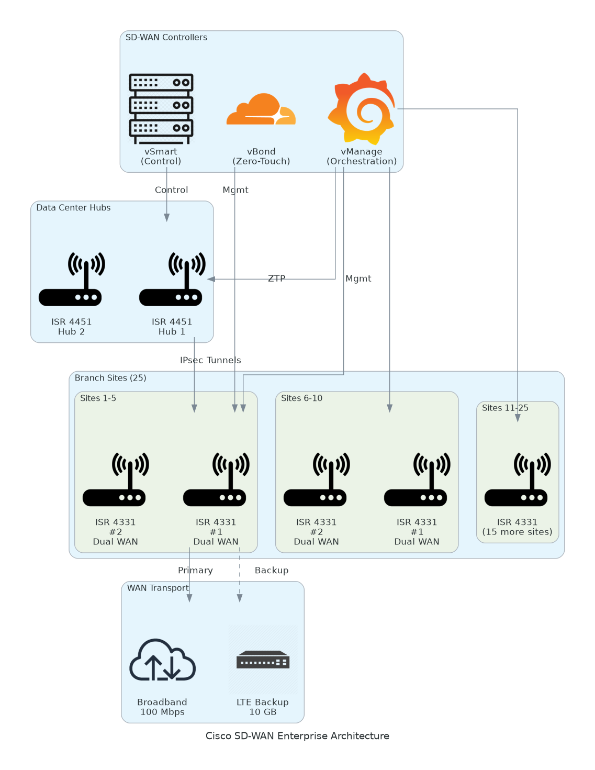
Figure 1: Solution Architecture

4.1 Architecture Principles
The following principles guide all architectural decisions throughout the solution design.
• Centralized Management: Single pane of glass for all network operations via DNA Center
• AI-First Operations: Leverage machine learning for anomaly detection and predictive insights
• Policy-Based Automation: Template-driven provisioning reduces manual configuration
• High Availability: HA deployment eliminates single points of failure
• Integration Ready: REST APIs for ServiceNow, NetBox, and custom integrations
• Security by Design: RBAC, encryption, and audit logging throughout

4.2 Architecture Patterns
The solution implements the following architectural patterns to address scalability and reliability requirements.
• Primary Pattern: Centralized controller with distributed device management
• Data Pattern: DNA Center as single source of truth with NetBox sync
• Integration Pattern: REST API webhooks for ServiceNow ticketing
• Automation Pattern: Policy templates with staged deployment
• HA Pattern: Active/Standby with automatic failover

4.3 Component Design
The solution comprises the following logical components, each with specific responsibilities and scaling characteristics.
Component | Purpose | Technology | Dependencies | Scaling
DNA Center Primary | Controller, analytics | DN2-HW-APL | Network connectivity | 500 devices
DNA Center Secondary | HA standby | DN2-HW-APL | Primary appliance | Hot standby
AI Analytics Engine | Anomaly/prediction | Built-in ML | Device telemetry | Subscription
Policy Engine | Template automation | DNA Center | Device credentials | Per device
Integration Hub | ServiceNow/NetBox | REST APIs | External systems | API limits
Table 4: Solution Components

4.4 Technology Stack
The technology stack has been selected based on requirements for network management, AI analytics, and enterprise integration.
Layer | Technology | Rationale
Controller | Cisco DNA Center 2.3.5+ | Industry-leading network controller
AI/ML | AI Network Analytics | Built-in anomaly detection and prediction
Device Protocol | NETCONF/RESTCONF | Programmable interface for IOS-XE
Telemetry | Model-Driven Telemetry | Real-time streaming for analytics
Authentication | Active Directory/LDAP | Enterprise identity integration
ITSM | ServiceNow REST API | Automated ticket creation
IPAM | NetBox REST API | Inventory synchronization
Monitoring | DNA Center Assurance | Built-in dashboards and alerting
Table 5: Technology Stack

5 Security & Compliance
This section details the security controls, compliance mappings, and governance mechanisms implemented in the solution.

5.1 Identity & Access Management
Access control follows enterprise best practices with centralized identity management.
• Authentication: Active Directory via LDAPS for all user access
• Authorization: RBAC with Admin and Viewer roles mapped to AD groups
• Local Admin: Emergency access only for DNA Center recovery
• Service Accounts: Dedicated accounts for integrations (ServiceNow, NetBox)
• Session Management: 30-minute timeout, concurrent session limits

5.1.1 Role Definitions
The following roles define access levels within the system, following the principle of least privilege.
Role | Permissions | Scope
DNA-Center-Admins | Full system access, device configuration | All DNA Center functions
DNA-Center-Viewers | Dashboard view, reports only | Read-only access
Service Account | API access for integrations | Specific API endpoints
Local Admin | Emergency recovery access | DNA Center platform only
Table 6: Role Permissions

5.2 Secrets Management
All sensitive credentials are managed securely within DNA Center.
• Device CLI credentials encrypted at rest (AES-256)
• SNMP community strings encrypted and version-controlled
• Enable secrets stored with encryption
• Integration API tokens stored in DNA Center credential manager
• No plaintext credentials in configuration templates

5.3 Network Security
Network security implements defense-in-depth with multiple layers of protection.
• Management VLAN: Isolated VLAN for DNA Center and device management
• Firewall Rules: Restrictive ACLs for management traffic
• Device Access: NETCONF (TCP 830), SSH (TCP 22) only
• TLS Encryption: All web and API traffic encrypted
• Certificate Management: CA-signed certificate for DNA Center

5.4 Data Protection
Data protection controls ensure confidentiality and integrity throughout the data lifecycle.
• Encryption at Rest: Device configurations and credentials encrypted
• Encryption in Transit: TLS 1.2+ for all communications
• Backup Encryption: Backup files encrypted with DNA Center keys
• Audit Logging: All changes logged with timestamps and users
• Data Retention: Configurable retention per compliance requirements

5.5 Compliance Mappings
The following table maps compliance requirements to specific implementation controls.
Framework | Requirement | Implementation
Internal | Access control | AD integration, RBAC, MFA
Internal | Encryption | TLS 1.2+, AES-256 at rest
Internal | Audit trails | DNA Center audit logging, syslog
Internal | Change management | Staged deployment, approval workflow
Internal | Data retention | 365-day log retention
Table 7: Compliance Requirements

5.6 Audit Logging & SIEM Integration
Comprehensive audit logging supports security monitoring and compliance requirements.
• DNA Center audit logs for all administrative actions
• Syslog forwarding to centralized log management
• Device configuration change tracking
• Login attempt logging (success and failure)
• Log retention: 365 days per compliance requirements

6 Data Architecture
This section defines the data model, storage strategy, and governance controls for the solution.

6.1 Data Model

6.1.1 Conceptual Model
The solution manages the following core entities:
• Devices: Network devices with configuration and health status
• Telemetry: Real-time streaming data from devices
• Baselines: AI-established performance baselines
• Policies: Configuration templates and compliance rules
• Incidents: Alerts and ServiceNow tickets

6.1.2 Logical Model
The logical data model defines the primary entities and their relationships within the system.
Entity | Key Attributes | Relationships | Volume
Device | device_id, IP, model, version, health | Has telemetry, policies | 200 devices
Telemetry | timestamp, metric, value, device_id | Belongs to Device | 1M+ records/day
Baseline | device_type, metric, threshold, confidence | References Devices | Per device type
Policy | template_id, name, config, compliance | Applied to Devices | 50+ templates
Incident | incident_id, severity, device, description | References Device | 100+/month
Table 8: Data Model Entities

6.2 Data Flow Design
1. Device Telemetry: Devices stream telemetry to DNA Center via Model-Driven Telemetry
2. Data Ingestion: DNA Center aggregates telemetry from 200 devices
3. Baseline Processing: AI Analytics establishes and updates baselines
4. Anomaly Detection: Real-time comparison against baselines
5. Prediction Engine: ML models predict failures 14 days in advance
6. Alert Generation: Anomalies trigger alerts and optional ServiceNow tickets
7. Integration Sync: Device inventory synced to NetBox every 15 minutes

6.3 Data Storage Strategy
• Configuration Database: DNA Center internal database with encryption
• Telemetry Storage: Time-series optimized storage within DNA Center
• Backup Storage: Network storage (/backup/dnac/) with encryption
• Log Storage: Syslog server with 365-day retention

6.4 Data Governance
Data governance policies ensure proper handling, retention, and quality management.
• Classification: Internal, Confidential (device credentials)
• Retention: Configurable per data type (30-365 days)
• Quality: AI confidence thresholds, human review for alerts
• Lineage: Configuration change tracking with timestamps

7 Integration Design
This section documents the integration patterns, APIs, and external system connections.

7.1 External System Integrations
The solution integrates with the following external systems using standardized protocols.
System | Type | Protocol | Format | Error Handling | SLA
ServiceNow | Real-time | REST | JSON | Retry with backoff | 99%
NetBox | Scheduled | REST | JSON | Retry with backoff | 99%
Active Directory | Real-time | LDAPS | LDAP | Failover to secondary | 99%
Syslog Server | Real-time | UDP/TCP | Syslog | Buffer and retry | 99%
Table 9: System Integrations

7.2 API Design
DNA Center provides comprehensive REST APIs for integration.
• Style: RESTful with comprehensive documentation
• Versioning: URL path versioning (v1, v2)
• Authentication: Token-based (Intent API token)
• Rate Limiting: Configurable per integration

7.2.1 API Endpoints
The following REST API endpoints are used for integrations.
Method | Endpoint | Auth | Description
GET | /dna/intent/api/v1/network-device | Token | List network devices
GET | /dna/intent/api/v1/issues | Token | Get network issues
POST | /dna/intent/api/v1/template-programmer/template | Token | Deploy template
GET | /dna/intent/api/v1/compliance | Token | Check compliance status
Table 10: API Endpoints

7.3 Messaging & Event Patterns
Event-driven messaging enables real-time integration with external systems.
• Webhooks: DNA Center events trigger ServiceNow ticket creation
• Polling: NetBox sync via scheduled API polling (15-minute interval)
• Retry Policy: Exponential backoff with maximum 3 attempts

8 Infrastructure & Operations
This section covers the infrastructure design, deployment architecture, and operational procedures.

8.1 Network Design
DNA Center requires dedicated management connectivity to all network devices.
• Management VLAN: VLAN 100 (10.100.1.0/24)
• DNA Center Primary: 10.100.1.10
• DNA Center Secondary: 10.100.1.11
• DNA Center VIP: 10.100.1.12

8.2 Compute Sizing
DNA Center appliance specifications for 200-device deployment.
Component | CPU | Memory | Storage | Scaling
DNA Center Primary | 32 cores | 256 GB | 3.2 TB SSD | 500 devices
DNA Center Secondary | 32 cores | 256 GB | 3.2 TB SSD | Hot standby
Table 11: Solution Components

8.3 High Availability Design
The solution eliminates single points of failure through HA configuration.
• Active/Standby appliance pair
• Virtual IP for automatic failover
• Synchronous data replication
• 60-second failover trigger

8.4 Disaster Recovery
Disaster recovery capabilities ensure business continuity.
• RPO: 24 hours (daily backups)
• RTO: 4 hours (restore from backup)
• Backup: Daily at 02:00 to network storage
• Retention: 30 days of backups

8.5 Monitoring & Alerting
Comprehensive monitoring provides visibility across infrastructure and applications.
• Infrastructure: DNA Center health, appliance metrics
• Application: Device health, AI analytics accuracy
• Business: MTTR metrics, device provisioning times
• Alerting: Email notifications via SMTP, ServiceNow tickets

8.5.1 Alert Definitions
The following alerts ensure proactive incident detection and response.
Alert | Condition | Severity | Response
Device Unreachable | Connectivity lost > 5 min | Critical | Investigate immediately
AI Anomaly Detected | Confidence > 85% | High | Review AI insights
Compliance Drift | Config deviation detected | Medium | Review and remediate
Prediction Alert | Failure predicted in 14 days | Warning | Schedule maintenance
Integration Failure | ServiceNow/NetBox sync failed | Medium | Check integration logs
Table 12: Monitoring Alerts

8.6 Logging & Observability
Centralized logging enables rapid troubleshooting.
• DNA Center audit logs for all administrative actions
• Device configuration change logs
• Integration sync logs
• Syslog forwarding to centralized SIEM
• 365-day retention for compliance

8.7 Cost Model
Estimated costs based on 200-device deployment (Year 1).
Category | Year 1 Cost | Annual Recurring | Notes
Hardware (2x DN2-HW-APL) | $120,000 | $0 | One-time purchase
DNA Advantage Licenses | $90,000 | $90,000 | 200 devices
AI Analytics Subscription | Included | Included | With DNA Advantage
SmartNet Support | $18,000 | $18,000 | 24x7 support
Total Year 1 | $228,000 | $128,000
Table 13: Category And Year 1 Cost

9 Implementation Approach
This section outlines the deployment strategy, tooling, and sequencing for the implementation.

9.1 Migration/Deployment Strategy
The deployment strategy minimizes risk through phased rollout with validation gates.
• Approach: Phased deployment with pilot (50 devices) first
• Pattern: Wave-based device onboarding
• Validation: AI analytics accuracy testing at each phase gate
• Rollback: Device removal capability if issues detected

9.2 Sequencing & Wave Planning
The implementation follows a phased approach with clear exit criteria.
Phase | Activities | Duration | Exit Criteria
1 | Foundation (DNA Center HA, AD) | 4 weeks | HA operational, pilot devices onboarded
2 | Full Deployment (150 devices, AI) | 4 weeks | All devices onboarded, baselines established
3 | Integration (ServiceNow, NetBox) | 4 weeks | Integrations operational
4 | Testing & Training | 4 weeks | UAT complete, team trained
Table 14: Implementation Phases
Total Implementation: 16 weeks + 4 weeks hypercare

9.3 Tooling & Automation
The following tools provide the automation foundation for infrastructure operations.
Category | Tool | Purpose
Provisioning | DNA Center PnP | Zero-touch device provisioning
Configuration | DNA Center Templates | Policy-based configuration
Monitoring | DNA Center Assurance | Dashboard and alerting
Integration | REST APIs | ServiceNow, NetBox connectivity
Automation | DNA Center Workflows | Event-driven automation
Table 15: Tools and Technologies

9.4 Cutover Approach
The cutover strategy enables gradual migration with rollback capability.
• Type: Phased cutover by device wave
• Duration: 1-week validation per wave
• Validation: AI analytics and policy verification
• Decision Point: Go/no-go 24 hours before each wave

9.5 Rollback Strategy
Rollback procedures are documented and tested for rapid recovery.
• Device removal from DNA Center if issues detected
• Policy rollback via template versioning
• Maximum rollback window: 24 hours post-deployment

10 Appendices

10.1 Architecture Diagrams
The following diagrams provide visual representation of the solution architecture.
• Solution Architecture Diagram (included in Solution Architecture section)
• Network Topology Diagram
• Integration Architecture Diagram
• HA Configuration Diagram

10.2 Naming Conventions
All resources follow standardized naming conventions.
Resource Type | Pattern | Example
DNA Center | `dnac-{role}-{environment}` | `dnac-primary-prod`
Device Group | `{location}-{type}-{env}` | `campus-switches-prod`
Policy Template | `{type}-{purpose}-v{version}` | `vlan-provisioning-v1`
Integration | `int-{system}-{direction}` | `int-servicenow-outbound`
Table 16: Naming Conventions

10.3 Tagging Standards
Resource tagging enables cost allocation, automation, and compliance reporting.
Tag | Required | Example Values
Environment | Yes | dev, test, prod
Application | Yes | network-analytics
Owner | Yes | network-team
CostCenter | Yes | IT-Network
Table 17: Tagging Standards

10.4 Risk Register
The following risks have been identified with corresponding mitigation strategies.
Risk | Likelihood | Impact | Mitigation
Device IOS version incompatible | Medium | High | Pre-deployment audit, upgrade path
AI false positive rate high | Low | Medium | Threshold tuning, baseline adjustment
Integration sync failures | Low | Medium | Retry logic, monitoring, alerting
HA failover issues | Low | Critical | Regular failover testing
User adoption challenges | Medium | Medium | Training program, documentation
Table 18: Risk Register

10.5 Glossary
The following terms and acronyms are used throughout this document.
Term | Definition
DNA Center | Cisco Digital Network Architecture Center
AI Analytics | Machine learning-based network insights
PnP | Plug and Play (zero-touch provisioning)
NETCONF | Network Configuration Protocol
MTTR | Mean Time to Resolution
RBAC | Role-Based Access Control
HA | High Availability
VIP | Virtual IP Address
Table 19: Glossary


eoframework.org

