

Detailed Design Document
HashiCorp Multi-Cloud Platform

Client: | [CLIENT]
Date: | November 28, 2025
Consulting Company: | [Consulting Company Name]
Submitted By: | [Name | Email | Phone]
Opportunity No: | OPP-XXXXX
Version: | 1.0

Table of Contents
1 Introduction
1.1 Purpose
1.1.1 Scope
2 Table Content
3 Image Section
4 Additional Content
5 Sign-Off

List of Figures
Figure 1: Sample Architecture Diagram

List of Tables
Table 1: Sample Deliverables Table

1 Executive Summary
This document provides the comprehensive technical design for the HashiCorp Multi-Cloud Platform implementation. It covers the target-state architecture leveraging HashiCorp Terraform Cloud for infrastructure automation, HashiCorp Vault for secrets management, and HashiCorp Consul for service mesh capabilities across AWS, Azure, and GCP environments.

1.1 Purpose
Define the technical architecture and design specifications that will guide the implementation team through deployment, configuration, and validation of the unified multi-cloud infrastructure automation platform.

1.2 Scope
In-scope:
• Terraform Cloud deployment on AWS EKS with high availability
• HashiCorp Vault implementation for centralized secrets management
• HashiCorp Consul deployment for service mesh capabilities
• Sentinel policy development for governance and compliance
• Workspace migration from Terraform OSS to Terraform Cloud
• VCS integration with GitHub for GitOps workflows
• Integration with CI/CD pipelines and monitoring systems
• Security controls and compliance implementation
Out-of-scope:
• End-user training (covered in Implementation Guide)
• Ongoing support procedures (covered in Operations Runbook)
• Custom Terraform provider development
• Cloud provider account setup or billing management
• Application code development or refactoring

1.3 Assumptions & Constraints
The following assumptions underpin the design and must be validated during implementation.
• AWS account with appropriate permissions for EKS, RDS, and EC2 deployment established
• Azure and GCP accounts with service principal/account credentials available
• GitHub Enterprise or GitHub.com access with webhook configuration permissions
• Existing Terraform code compatible with Terraform Cloud (OSS versions 0.12+)
• Network connectivity between platform and target cloud environments available
• 4-hour RTO, 1-hour RPO requirements apply for disaster recovery

1.4 References
This document should be read in conjunction with the following related materials.
• Statement of Work (SOW)
• Solution Briefing presentation
• HashiCorp Terraform Cloud documentation
• HashiCorp Vault documentation
• AWS Well-Architected Framework

2 Business Context
This section establishes the business drivers, success criteria, and compliance requirements that shape the technical design decisions.

2.1 Business Drivers
The solution addresses the following key business objectives identified during discovery.
• Unified Infrastructure: Eliminate fragmented multi-cloud tooling and establish consistent provisioning across AWS, Azure, and GCP
• Automated Governance: Deploy Sentinel policies for automated security, compliance, and cost controls before changes reach production
• Centralized Secrets: Implement HashiCorp Vault for unified secrets management with dynamic cloud credentials and automated rotation
• Reduced Provisioning Time: Reduce infrastructure provisioning from 5-7 days to 1-2 days through self-service capabilities
• Lower Operational Costs: Reduce infrastructure operations costs by 60% through automation and policy-driven governance

2.2 Workload Criticality & SLA Expectations
The following service level targets define the operational requirements for the production environment and guide infrastructure sizing decisions.
Metric | Target | Measurement | Priority
Platform Availability | 99.9% | CloudWatch uptime monitoring | Critical
Workspace Run Success | > 98% | Terraform Cloud metrics | High
Policy Compliance | > 95% | Sentinel enforcement metrics | Critical
Concurrent Runs | 15 runs | Terraform Cloud capacity | High
RTO | 4 hours | DR testing validation | High
RPO | 1 hour | Backup verification | High
Table 1: Service Level Targets

2.3 Compliance & Regulatory Factors
The solution must adhere to the following regulatory and compliance requirements.
• SOC 2 Type II compliance required for platform handling infrastructure state
• ISO 27001 compliance alignment for security controls
• Encryption at rest (AES-256) and in transit (TLS 1.2+) mandatory
• Audit logging required for all infrastructure changes and secrets access
• Policy enforcement for regulatory compliance frameworks via Sentinel

2.4 Success Criteria
Project success will be measured against the following criteria at go-live.
• 100 Terraform workspaces migrated to centralized platform
• 50 Sentinel policies deployed and enforced across all environments
• 75%+ reduction in infrastructure provisioning time validated
• 95%+ policy compliance rate achieved
• Operations team trained and capable of independent platform management
• HashiCorp Vault dynamic credentials operational for all three clouds

3 Current-State Assessment
This section documents the existing environment that the solution will integrate with or replace.

3.1 Application Landscape
The current environment consists of fragmented infrastructure tooling that will be unified.
Application | Purpose | Technology | Status
Terraform OSS | Infrastructure provisioning | Terraform CLI | To be migrated
CloudFormation | AWS-specific IaC | AWS native | To be replaced
ARM Templates | Azure-specific IaC | Azure native | To be replaced
Manual Provisioning | GCP resources | Console/gcloud | To be automated
Table 2: Application Inventory

3.2 Infrastructure Inventory
The current infrastructure consists of the following components that will be managed by the new platform.
Component | Quantity | Specifications | Notes
AWS Resources | ~1000 | VPC, EC2, RDS, EKS, S3, IAM | Primary cloud environment
Azure Resources | ~800 | VNet, VMs, AKS, Storage | Secondary cloud
GCP Resources | ~700 | VPC, Compute, GKE, Storage | Tertiary cloud
State Files | 100+ | S3, local, Azure Blob | To be centralized
Table 3: Infrastructure Inventory

3.3 Dependencies & Integration Points
The current environment has the following external dependencies that must be considered.
• GitHub Enterprise for version control and webhooks
• Datadog for monitoring integration
• Slack for notifications
• ServiceNow for change management approval workflows
• Active Directory for SSO authentication

3.4 Network Topology
Current multi-cloud network architecture:
• AWS: Multiple VPCs across us-east-1, eu-west-1, ap-southeast-1
• Azure: Virtual Networks in corresponding regions
• GCP: VPCs with cross-cloud connectivity
• VPN/Direct Connect for hybrid connectivity

3.5 Security Posture
The current security controls provide a baseline that will be enhanced in the target architecture.
• Cloud-native IAM with manual credential management
• No centralized secrets rotation
• Manual policy enforcement through reviews
• Inconsistent compliance across cloud providers
• Ad-hoc audit logging per cloud

3.6 Performance Baseline
Current infrastructure provisioning metrics establish the baseline for improvement targets.
• Average provisioning time: 5-7 days per environment
• Manual approval chain: 2-3 days
• Configuration drift: Unknown, no automated detection
• Compliance rate: ~60-70% (estimated)

4 Solution Architecture
The target architecture leverages HashiCorp products to deliver unified multi-cloud infrastructure automation with centralized governance, secrets management, and service mesh capabilities.
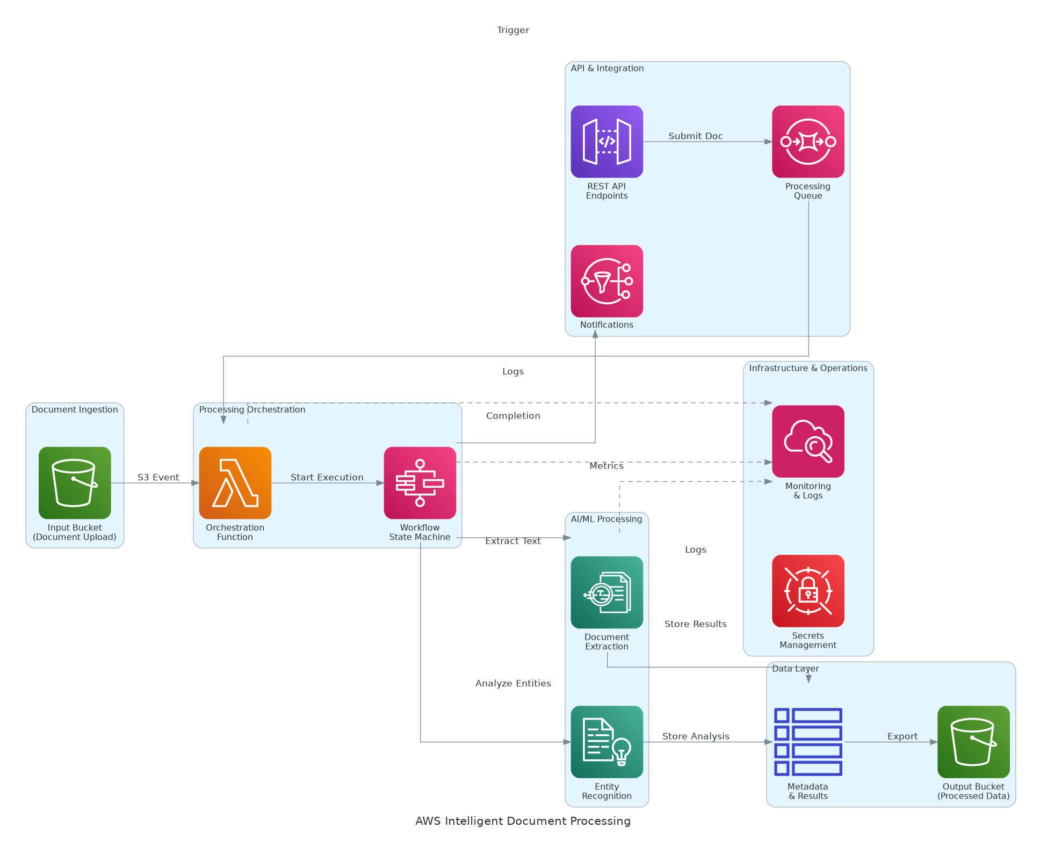
Figure 1: Solution Architecture

4.1 Architecture Principles
The following principles guide all architectural decisions throughout the solution design.
• Centralized Platform: Single platform for all infrastructure provisioning across cloud providers
• Policy-Driven Automation: Sentinel policies enforce governance before changes reach production
• Secrets as Code: Dynamic credentials via Vault eliminate static credential management
• Infrastructure as Code: All platform infrastructure defined in Terraform and version-controlled
• GitOps Workflows: VCS-driven automation ensures audit trail and collaboration
• High Availability: Multi-node deployment with automatic failover

4.2 Architecture Patterns
The solution implements the following architectural patterns to address scalability and reliability requirements.
• Primary Pattern: Centralized platform with distributed execution across cloud providers
• State Pattern: Centralized state management in Terraform Cloud with locking
• Secrets Pattern: Dynamic short-lived credentials via Vault secrets engines
• Governance Pattern: Policy as code with Sentinel for pre-apply validation
• Mesh Pattern: Consul service discovery for cross-cloud service communication

4.3 Component Design
The solution comprises the following logical components, each with specific responsibilities and scaling characteristics.
Component | Purpose | Technology | Dependencies | Scaling
Terraform Cloud | Infrastructure orchestration | Kubernetes on EKS | RDS, S3, KMS | Horizontal
HashiCorp Vault | Secrets management | EC2 HA cluster | KMS, RDS | Horizontal
Consul Server | Service mesh control plane | EKS deployment | Vault | Horizontal
Sentinel | Policy enforcement | Terraform Cloud | Policy repository | N/A
API Gateway | External access | ALB | Terraform Cloud | Managed
Monitoring | Observability | CloudWatch, Datadog | All components | Managed
Table 4: Solution Components

4.4 Technology Stack
The technology stack has been selected based on requirements for multi-cloud automation, security, and operational excellence.
Layer | Technology | Rationale
Infrastructure Automation | Terraform Cloud Business | Centralized state, RBAC, Sentinel policies
Secrets Management | HashiCorp Vault Plus | Dynamic credentials, encryption as a service
Service Mesh | HashiCorp Consul Enterprise | Cross-cloud service discovery and security
Container Orchestration | Amazon EKS | High availability, managed Kubernetes
Database | Amazon RDS PostgreSQL | Terraform Cloud and Vault backend storage
Monitoring | CloudWatch + Datadog | Comprehensive metrics, logs, alerting
Notifications | Slack, PagerDuty | Real-time alerts and incident management
Table 5: Technology Stack

5 Security & Compliance
This section details the security controls, compliance mappings, and governance mechanisms implemented in the solution.

5.1 Identity & Access Management
Access control follows a zero-trust model with centralized identity management.
• Authentication: SSO via SAML 2.0 with enterprise identity provider
• Authorization: Role-based access control (RBAC) for all Terraform Cloud workspaces
• MFA: Required for all platform access
• Service Accounts: HashiCorp Vault dynamic credentials for cloud provider access
• API Security: Team API tokens with automatic expiration

5.1.1 Role Definitions
The following roles define access levels within the system, following the principle of least privilege.
Role | Permissions | Scope
Admin | Full platform administration | All workspaces and settings
Security | Policy management, Vault administration | Security-related resources
Operator | Workspace management, trigger runs | Assigned workspaces
Viewer | Read-only access to runs and state | Assigned workspaces
Auditor | Read-only access, audit logs | All workspaces (no apply)
Table 6: Role Permissions

5.2 Secrets Management
All sensitive credentials are managed through HashiCorp Vault.
• Centralized Vault cluster for all secrets across clouds
• Dynamic credential generation for AWS, Azure, GCP
• Automatic credential rotation (1-hour default TTL)
• Encryption as a service for sensitive configuration data
• No static credentials in code or environment variables
• Audit logging for all secrets access

5.3 Network Security
Network security implements defense-in-depth with multiple layers of protection.
• VPC Isolation: Platform deployed in dedicated VPC with private subnets
• Security Groups: Restrictive inbound/outbound rules for all components
• VPC Endpoints: Private connectivity to AWS services (S3, KMS, RDS)
• TLS: All communication encrypted with TLS 1.2+
• Network Policies: Kubernetes network policies for pod isolation

5.4 Data Protection
Data protection controls ensure confidentiality and integrity throughout the data lifecycle.
• State Encryption: All Terraform state encrypted at rest with KMS
• Transit Encryption: TLS 1.2+ for all platform communication
• Vault Auto-Unseal: AWS KMS for secure Vault initialization
• Sensitive Variable Masking: Credentials masked in Terraform Cloud logs
• Backup Encryption: All backups encrypted with customer-managed keys

5.5 Compliance Mappings
The following table maps compliance requirements to specific implementation controls.
Framework | Requirement | Implementation
SOC 2 | Access control | RBAC, SSO, MFA, audit logging
SOC 2 | Encryption | KMS encryption, TLS 1.2+
SOC 2 | Change management | Sentinel policies, approval workflows
ISO 27001 | Asset management | Resource tagging enforcement
ISO 27001 | Access control | Least privilege, dynamic credentials
Table 7: Compliance Requirements

5.6 Audit Logging & SIEM Integration
Comprehensive audit logging supports security monitoring and compliance requirements.
• Terraform Cloud audit logs for all infrastructure changes
• HashiCorp Vault audit logs for all secrets access and authentication
• CloudWatch Logs for platform component logging
• CloudTrail for AWS API calls
• Log retention: 90 days hot, 1 year cold storage

6 Data Architecture
This section defines the data model, storage strategy, and governance controls for the solution.

6.1 Data Model

6.1.1 Conceptual Model
The solution manages the following core data entities:
• Workspaces: Terraform workspace configurations and settings
• State Files: Infrastructure state representing managed resources
• Secrets: Dynamic and static credentials for cloud access
• Policies: Sentinel policies for governance enforcement
• Audit Logs: All platform activity for compliance

6.1.2 Logical Model
The logical data model defines the primary entities and their relationships within the system.
Entity | Key Attributes | Relationships | Volume
Workspace | ID, name, VCS config, variables | Has many Runs, State versions | 100+
State | ID, workspace_id, version, resources | Belongs to Workspace | 2 TB
Secret | Path, type, TTL, metadata | Belongs to Secrets Engine | 500+
Policy Set | ID, name, policies, workspaces | Has many Policies, Workspaces | 50+
Audit Event | ID, timestamp, user, action, resource | References all entities | 10M/year
Table 8: Data Model Entities

6.2 Data Flow Design
1. Infrastructure Request: Developer commits Terraform code to GitHub
2. VCS Webhook: GitHub triggers Terraform Cloud run
3. Credential Retrieval: Terraform Cloud fetches dynamic credentials from Vault
4. Policy Check: Sentinel policies evaluated before plan/apply
5. Execution: Terraform provisions/modifies infrastructure
6. State Update: State stored in Terraform Cloud with versioning
7. Notification: Results sent to Slack/ServiceNow

6.3 Data Migration Strategy
Data migration follows a phased approach to minimize risk and ensure integrity.
• Approach: Phased workspace migration with parallel run validation
• State Migration: Remote state migration from S3/local to Terraform Cloud
• Validation: Resource count verification, drift detection
• Rollback: State versioning enables rollback if needed

6.4 Data Governance
Data governance policies ensure proper handling, retention, and quality management.
• Classification: State files contain infrastructure secrets (Confidential)
• Retention: State versions retained per workspace policy
• Access: RBAC controls state access per workspace
• Backup: Daily encrypted backups with 7-day retention

7 Integration Design
This section documents the integration patterns, APIs, and external system connections.

7.1 External System Integrations
The solution integrates with the following external systems using standardized protocols and error handling.
System | Type | Protocol | Format | Error Handling | SLA
GitHub | VCS | Webhooks | JSON | Retry with backoff | 99.9%
Datadog | Monitoring | REST API | JSON | Circuit breaker | 99.9%
Slack | Notifications | Webhooks | JSON | Dead letter queue | 99.9%
ServiceNow | Change Mgmt | REST API | JSON | Retry with backoff | 99.5%
Table 9: System Integrations

7.2 API Design
Terraform Cloud and Vault provide REST APIs for integration.
• Terraform Cloud API: Workspace management, run triggers, state access
• Vault API: Secrets retrieval, authentication, audit queries
• Authentication: API tokens with team-based access control
• Rate Limiting: Configurable per organization

7.2.1 API Endpoints
The following REST API endpoints provide programmatic access to core system functionality.
Method | Endpoint | Auth | Description
GET | /api/v2/workspaces | Bearer | List organization workspaces
POST | /api/v2/runs | Bearer | Queue a new Terraform run
GET | /api/v2/runs/{id} | Bearer | Get run status and details
GET | /v1/secret/data/{path} | Vault Token | Retrieve secret from Vault
Table 10: API Endpoints

7.3 Authentication & SSO Flows
Single sign-on provides seamless authentication across all platform components.
• SAML 2.0 federation with enterprise identity provider
• Terraform Cloud organization-level SSO enforcement
• Vault authentication via OIDC or LDAP
• Team membership synced from identity provider groups

7.4 Messaging & Event Patterns
Event-driven integration enables loose coupling and reliable notification.
• VCS Webhooks: GitHub to Terraform Cloud for run triggers
• Run Notifications: Terraform Cloud to Slack for run status
• Change Management: Terraform Cloud to ServiceNow for approvals
• Alerting: CloudWatch/Datadog to PagerDuty for incidents

8 Infrastructure & Operations
This section covers the infrastructure design, deployment architecture, and operational procedures.

8.1 Network Design
The virtual network architecture provides isolation and security through segmentation.
• VPC CIDR: 10.100.0.0/16
• Public Subnets: 10.100.1.0/24, 10.100.2.0/24 (load balancers)
• Private Subnets: 10.100.10.0/24, 10.100.11.0/24 (EKS nodes)
• Database Subnets: 10.100.20.0/24, 10.100.21.0/24 (RDS)

8.2 Compute Sizing
Instance sizing has been determined based on workload requirements and concurrent run capacity.
Component | Instance Type | vCPU | Memory | Count
EKS Nodes | t3.xlarge | 4 | 16 GB | 3
Vault Nodes | t3.medium | 2 | 4 GB | 3
RDS | db.t3.large | 2 | 8 GB | 1 (Multi-AZ)
ALB | Managed | N/A | N/A | 1
Table 11: Compute Sizing

8.3 High Availability Design
The solution eliminates single points of failure through redundancy at every tier.
• Multi-AZ deployment for all platform components
• EKS cluster with auto-healing and node replacement
• Vault HA cluster with auto-unseal
• RDS Multi-AZ with automated failover
• ALB with health checks and automatic routing

8.4 Disaster Recovery
Disaster recovery capabilities ensure business continuity in the event of regional failure.
• RPO: 1 hour (continuous replication)
• RTO: 4 hours (automated recovery procedures)
• Backup: Daily RDS snapshots, Vault auto-snapshots
• DR Site: Cross-region backup replication

8.5 Monitoring & Alerting
Comprehensive monitoring provides visibility across infrastructure, applications, and business metrics.
• Infrastructure: CloudWatch metrics for EKS, RDS, EC2
• Application: Terraform Cloud run metrics, Vault audit logs
• Business: Workspace counts, policy compliance, run success rates
• Alerting: Datadog + PagerDuty with escalation policies

8.5.1 Alert Definitions
The following alerts have been configured to ensure proactive incident detection and response.
Alert | Condition | Severity | Response
Platform Down | Uptime < 99% for 5 min | Critical | Page on-call
Run Queue Backlog | Queue > 50 for 15 min | Warning | Scale workers
Vault Unavailable | 3+ health check failures | Critical | Page on-call
Policy Failures | > 10% failure rate | Warning | Review policies
Table 12: Monitoring Alerts

8.6 Logging & Observability
Centralized logging and distributed tracing enable rapid troubleshooting and analysis.
• CloudWatch Logs for all platform components
• Terraform Cloud audit logs for run history
• Vault audit logs for secrets access
• Custom dashboards in Datadog

8.7 Cost Model
The estimated monthly infrastructure costs are based on production workload requirements.
Category | Monthly Estimate | Optimization | Savings
EKS Cluster | $1,314 | Reserved instances | 30%
RDS | $912 | Reserved capacity | 25%
Vault (EC2) | $657 | Reserved instances | 30%
Networking | $300 | NAT optimization | 20%
Table 13: Cost Estimates

9 Implementation Approach
This section outlines the deployment strategy, tooling, and sequencing for the implementation.

9.1 Migration/Deployment Strategy
The deployment strategy minimizes risk through phased rollout with validation gates.
• Approach: Phased workspace migration with parallel operation
• Pattern: Pilot (25 workspaces) → Expand (75) → Full (100)
• Validation: State integrity verification at each phase
• Rollback: Terraform state versioning enables rollback

9.2 Sequencing & Wave Planning
The implementation follows a phased approach with clear exit criteria to ensure quality and minimize risk.
Phase | Activities | Duration | Exit Criteria
1 | Foundation: Platform deployment, Vault setup, 25 workspaces | 3 months | Platform operational, pilot validated
2 | Expansion: 75 more workspaces, Sentinel policies | 3 months | 100 workspaces, policies enforced
3 | Optimization: Consul mesh, advanced automation | 3 months | Full platform capabilities, training complete
Table 14: Implementation Phases

9.3 Tooling & Automation
The following tools provide the automation foundation for infrastructure provisioning, deployment, and operations.
Category | Tool | Purpose
Infrastructure as Code | Terraform | Platform infrastructure provisioning
Configuration | Ansible | Vault and Consul configuration
CI/CD | GitHub Actions | Automated testing and deployment
Secrets | HashiCorp Vault | Credential management
Policy | Sentinel | Governance enforcement
Table 15: Tools and Technologies

9.4 Cutover Approach
The cutover strategy balances risk mitigation with project timeline requirements.
• Type: Progressive migration with parallel operation
• Duration: 2-week parallel run per workspace wave
• Validation: Resource count, state integrity verification
• Decision Point: Go/no-go after pilot wave validation

9.5 Downtime Expectations
Service availability impacts during implementation have been minimized through careful planning.
• Planned Downtime: Zero infrastructure downtime during migration
• Terraform OSS: Remains operational during transition
• Migration Window: Workspaces switched during maintenance windows
• Rollback: Immediate rollback capability to original state backend

9.6 Rollback Strategy
Rollback procedures are documented and tested to enable rapid recovery if issues arise.
• State file rollback via Terraform Cloud versioning
• Workspace rollback to Terraform OSS backend
• Vault rollback via auto-snapshots
• Maximum rollback window: 7 days post-migration

10 Appendices

10.1 Architecture Diagrams
The following diagrams provide visual representation of the solution architecture.
• Solution Architecture Diagram (included in Solution Architecture section)
• Network Topology Diagram
• Data Flow Diagram
• Security Architecture Diagram

10.2 Naming Conventions
All cloud resources follow standardized naming conventions to ensure consistency and enable automated resource management.
Resource Type | Pattern | Example
Workspace | `{env}-{app}-{cloud}` | `prod-webapp-aws`
Sentinel Policy | `{domain}-{control}` | `security-require-encryption`
Vault Path | `{cloud}/{env}/{service}` | `aws/prod/rds`
EKS Cluster | `{project}-{env}-eks` | `tfc-prod-eks`
Table 16: Naming Conventions

10.3 Tagging Standards
Resource tagging enables cost allocation, operational automation, and compliance reporting across the environment.
Tag | Required | Example Values
Environment | Yes | dev, staging, prod
Project | Yes | multi-cloud-platform
Owner | Yes | platform-team
CostCenter | Yes | CC-INFRA-001
ManagedBy | Yes | terraform-cloud
Table 17: Tagging Standards

10.4 Risk Register
The following risks have been identified during the design phase with corresponding mitigation strategies.
Risk | Likelihood | Impact | Mitigation
State corruption during migration | Low | High | Parallel validation, versioning, rollback plan
Policy breaks existing workflows | Medium | Medium | Advisory mode first, tuning period
Credential exposure | Low | Critical | Vault dynamic credentials, short TTL
Platform unavailability | Low | High | HA deployment, DR procedures
User adoption resistance | Medium | Medium | Training, self-service templates, demos
Table 18: Risk Register

10.5 Glossary
The following terms and acronyms are used throughout this document.
Term | Definition
GitOps | Operational framework using Git as single source of truth
HCL | HashiCorp Configuration Language
IaC | Infrastructure as Code
RBAC | Role-Based Access Control
Sentinel | HashiCorp policy-as-code framework
State | Terraform's record of managed infrastructure
TTL | Time To Live (credential expiration)
VCS | Version Control System
Workspace | Terraform Cloud unit of infrastructure management
Table 19: Glossary


eoframework.org

