

Detailed Design Document
HashiCorp Terraform Enterprise

Client: | [CLIENT]
Date: | November 28, 2025
Consulting Company: | [Consulting Company Name]
Submitted By: | [Name | Email | Phone]
Opportunity No: | OPP-XXXXX
Version: | 1.0

Table of Contents
1 Introduction
1.1 Purpose
1.1.1 Scope
2 Table Content
3 Image Section
4 Additional Content
5 Sign-Off

List of Figures
Figure 1: Sample Architecture Diagram

List of Tables
Table 1: Sample Deliverables Table

1 Executive Summary
This document provides the comprehensive technical design for the HashiCorp Terraform Enterprise implementation. It covers the target-state architecture for deploying Terraform Enterprise on AWS EKS with centralized workspace management, Sentinel policy enforcement, and HashiCorp Vault integration for dynamic credentials.

1.1 Purpose
Define the technical architecture and design specifications that will guide the implementation team through deployment, configuration, and validation of the enterprise infrastructure as code platform.

1.2 Scope
In-scope:
• Terraform Enterprise deployment on Kubernetes (AWS EKS)
• PostgreSQL RDS backend for state storage
• Migration of 50 Terraform workspaces from OSS to Enterprise
• Sentinel policy development for security, compliance, and cost governance
• VCS integration with GitHub for GitOps workflows
• Private module registry implementation
• HashiCorp Vault integration for dynamic AWS credentials
• Integration with CI/CD pipelines and monitoring systems
• Security controls and compliance implementation
Out-of-scope:
• End-user training (covered in Implementation Guide)
• Ongoing support procedures (covered in Operations Runbook)
• Custom Terraform provider development
• AWS account setup or billing management
• Application code development or refactoring

1.3 Assumptions & Constraints
The following assumptions underpin the design and must be validated during implementation.
• AWS account with appropriate permissions for EKS, RDS, S3, KMS, and IAM established
• Existing Terraform code compatible with Terraform Enterprise (version 0.12+)
• GitHub repository access and webhook configuration permissions available
• Network connectivity meets Terraform Enterprise requirements for AWS API access
• 4-hour RTO, 1-hour RPO requirements apply for disaster recovery
• HashiCorp Terraform Enterprise license procured and activated

1.4 References
This document should be read in conjunction with the following related materials.
• Statement of Work (SOW)
• Solution Briefing presentation
• HashiCorp Terraform Enterprise documentation
• HashiCorp Vault documentation
• AWS Well-Architected Framework

2 Business Context
This section establishes the business drivers, success criteria, and compliance requirements that shape the technical design decisions.

2.1 Business Drivers
The solution addresses the following key business objectives identified during discovery.
• Centralize Infrastructure as Code: Implement Terraform Enterprise for unified workspace management with centralized state storage, eliminating locking conflicts
• Automate Policy Enforcement: Deploy Sentinel policies for automated security, compliance, and cost governance
• Enable Self-Service Provisioning: Implement VCS-driven workflows with approval gates for self-service infrastructure
• Reduce Provisioning Time: Reduce infrastructure provisioning time by 80% through automated workflows
• Ensure Compliance: Achieve 100% policy compliance across all infrastructure changes

2.2 Workload Criticality & SLA Expectations
The following service level targets define the operational requirements for the production environment.
Metric | Target | Measurement | Priority
Platform Availability | 99.9% | CloudWatch uptime monitoring | Critical
Workspace Run Success | > 98% | Terraform Enterprise metrics | High
Policy Compliance | 100% | Sentinel enforcement metrics | Critical
Concurrent Runs | 10 runs | Terraform Enterprise capacity | High
RTO | 4 hours | DR testing validation | High
RPO | 1 hour | Backup verification | High
Table 1: Service Level Targets

2.3 Compliance & Regulatory Factors
The solution must adhere to the following regulatory and compliance requirements.
• SOC 2 Type II compliance required for platform handling infrastructure state
• ISO 27001 compliance alignment for security controls
• Encryption at rest (AES-256) and in transit (TLS 1.2+) mandatory
• Audit logging required for all infrastructure changes and state access
• Policy enforcement for regulatory compliance frameworks via Sentinel

2.4 Success Criteria
Project success will be measured against the following criteria at go-live.
• 50 Terraform workspaces migrated to centralized platform
• 40 Sentinel policies deployed and enforced across all environments
• 80%+ reduction in infrastructure provisioning time validated
• 100% policy compliance rate achieved
• Operations team trained and capable of independent platform management
• HashiCorp Vault dynamic credentials operational for AWS

3 Current-State Assessment
This section documents the existing environment that the solution will integrate with or replace.

3.1 Application Landscape
The current environment consists of fragmented Terraform usage that will be unified.
Application | Purpose | Technology | Status
Terraform OSS | Infrastructure provisioning | Terraform CLI | To be migrated
S3 State Backend | State storage | AWS S3 | To be replaced
Local State | Development state | File system | To be replaced
Manual Approvals | Change management | Email/Slack | To be automated
Table 2: Application Inventory

3.2 Infrastructure Inventory
The current infrastructure consists of the following components that will be managed by the new platform.
Component | Quantity | Specifications | Notes
Terraform Workspaces | 50+ | Distributed across teams | To be centralized
State Files | 50+ | S3, local storage | To be migrated
AWS Resources | ~500 | VPC, EC2, RDS, S3, IAM | Managed by TFE
Development Teams | 5 | 25 total users | Platform access
Table 3: Infrastructure Inventory

3.3 Dependencies & Integration Points
The current environment has the following external dependencies that must be considered.
• GitHub Enterprise for version control and webhooks
• AWS IAM for authentication and authorization
• Slack for notifications
• Existing CI/CD pipelines (GitHub Actions, Jenkins)
• Active Directory for SSO authentication

3.4 Security Posture
The current security controls provide a baseline that will be enhanced in the target architecture.
• AWS IAM with manual credential management
• No centralized policy enforcement
• Manual code reviews for security validation
• Inconsistent compliance across teams
• Ad-hoc audit logging

3.5 Performance Baseline
Current infrastructure provisioning metrics establish the baseline for improvement targets.
• Average provisioning time: 5 days per environment
• Manual approval chain: 3-5 days
• Configuration drift: Unknown, no automated detection
• Compliance rate: ~60% (estimated)

4 Solution Architecture
The target architecture leverages HashiCorp Terraform Enterprise to deliver centralized infrastructure automation with governance, secrets management, and GitOps workflows.
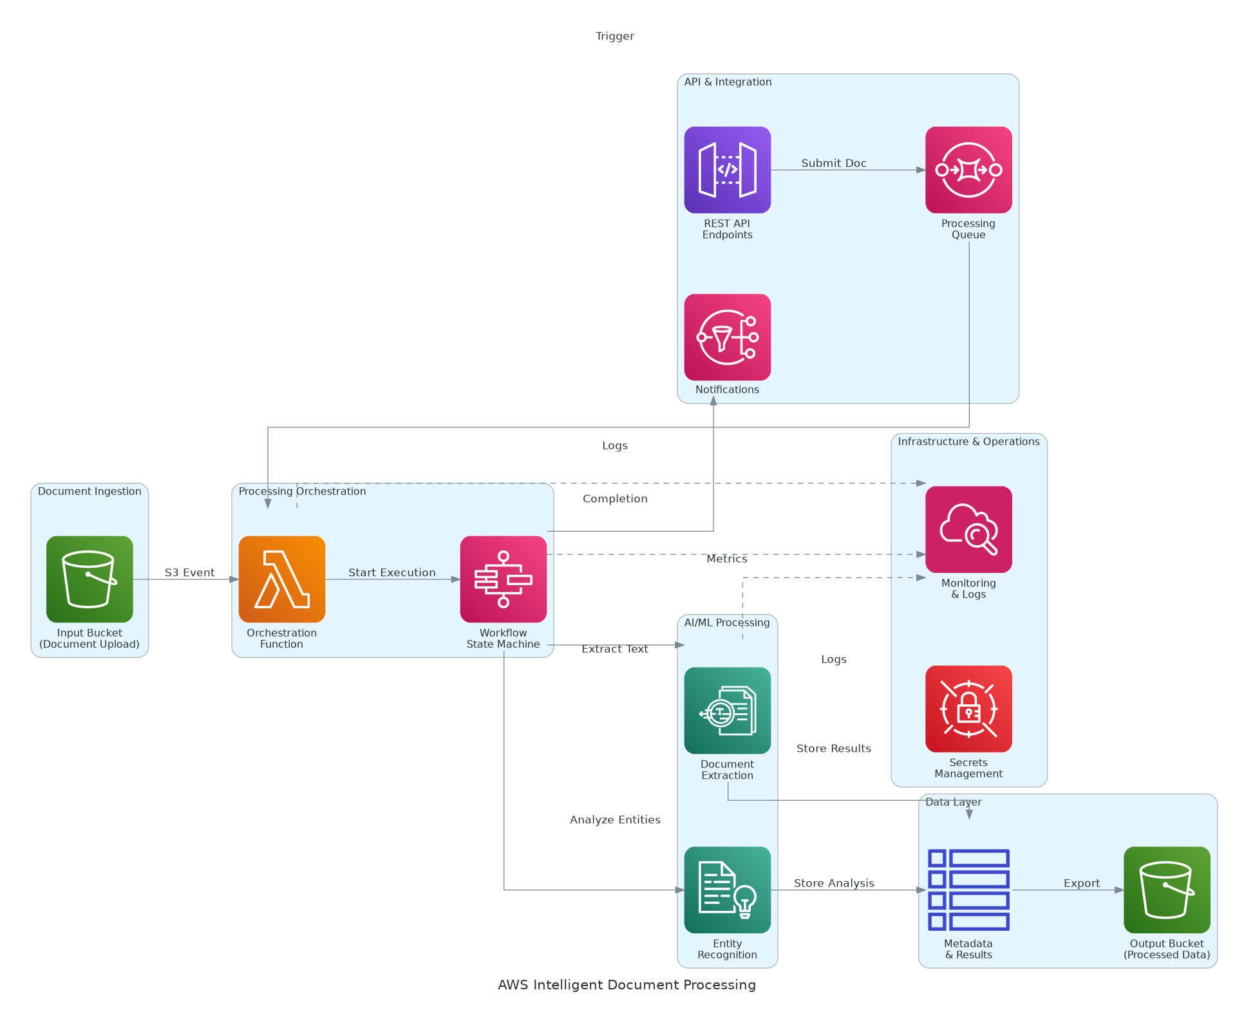
Figure 1: Solution Architecture

4.1 Architecture Principles
The following principles guide all architectural decisions throughout the solution design.
• Centralized Platform: Single platform for all infrastructure provisioning
• Policy-Driven Automation: Sentinel policies enforce governance before changes
• Infrastructure as Code: All platform infrastructure defined in Terraform
• GitOps Workflows: VCS-driven automation ensures audit trail
• High Availability: Multi-node deployment with automatic failover

4.2 Architecture Patterns
The solution implements the following architectural patterns to address scalability and reliability requirements.
• Primary Pattern: Centralized platform with remote execution
• State Pattern: Centralized state management with locking
• Governance Pattern: Policy as code with Sentinel
• Secrets Pattern: Dynamic credentials via Vault integration

4.3 Component Design
The solution comprises the following logical components, each with specific responsibilities.
Component | Purpose | Technology | Dependencies | Scaling
Terraform Enterprise | Infrastructure orchestration | Kubernetes on EKS | RDS, S3, KMS | Horizontal
PostgreSQL Backend | State storage | Amazon RDS | KMS | Vertical
Sentinel Engine | Policy enforcement | Terraform Enterprise | Policy repository | N/A
Private Registry | Module management | Terraform Enterprise | VCS | N/A
Vault Integration | Secrets management | HashiCorp Vault | KMS | Horizontal
Monitoring | Observability | CloudWatch, Datadog | All components | Managed
Table 4: Solution Components

4.4 Technology Stack
The technology stack has been selected based on requirements for infrastructure automation, security, and operational excellence.
Layer | Technology | Rationale
Infrastructure Automation | Terraform Enterprise | Centralized state, RBAC, Sentinel policies
Container Orchestration | Amazon EKS | High availability, managed Kubernetes
Database | Amazon RDS PostgreSQL | Terraform Enterprise state backend
Secrets Management | HashiCorp Vault | Dynamic AWS credentials
Monitoring | CloudWatch, Datadog | Comprehensive metrics, logs, alerting
Version Control | GitHub | GitOps workflows and collaboration
Table 5: Technology Stack

5 Security & Compliance
This section details the security controls, compliance mappings, and governance mechanisms implemented in the solution.

5.1 Identity & Access Management
Access control follows a zero-trust model with centralized identity management.
• Authentication: SSO via SAML 2.0 with enterprise identity provider
• Authorization: Role-based access control (RBAC) for all workspaces
• MFA: Required for all platform access
• Service Accounts: HashiCorp Vault dynamic credentials for AWS access
• API Security: Team API tokens with automatic expiration

5.1.1 Role Definitions
The following roles define access levels within the system.
Role | Permissions | Scope
Admin | Full platform administration | All workspaces and settings
Security-Reviewer | Policy management, audit access | Security-related resources
Operator | Workspace management, trigger runs | Assigned workspaces
Plan-Only | Trigger plans, view state | Assigned workspaces
Viewer | Read-only access to runs and state | Assigned workspaces
Table 6: Role Permissions

5.2 Secrets Management
All sensitive credentials are managed through HashiCorp Vault.
• Dynamic AWS credential generation via Vault AWS secrets engine
• 1-hour TTL for automatic credential rotation
• No static credentials in code or environment variables
• Audit logging for all secrets access

5.3 Network Security
Network security implements defense-in-depth with multiple layers.
• VPC Isolation: Platform deployed in dedicated VPC with private subnets
• Security Groups: Restrictive inbound/outbound rules
• VPC Endpoints: Private connectivity to AWS services
• TLS: All communication encrypted with TLS 1.2+

5.4 Data Protection
Data protection controls ensure confidentiality and integrity.
• State Encryption: All Terraform state encrypted at rest with KMS
• Transit Encryption: TLS 1.2+ for all platform communication
• Sensitive Variable Masking: Credentials masked in logs
• Backup Encryption: All backups encrypted with customer-managed keys

5.5 Compliance Mappings
The following table maps compliance requirements to implementation controls.
Framework | Requirement | Implementation
SOC 2 | Access control | RBAC, SSO, MFA, audit logging
SOC 2 | Encryption | KMS encryption, TLS 1.2+
SOC 2 | Change management | Sentinel policies, approval workflows
ISO 27001 | Asset management | Resource tagging enforcement
ISO 27001 | Access control | Least privilege, dynamic credentials
Table 7: Compliance Requirements

5.6 Audit Logging & SIEM Integration
Comprehensive audit logging supports security monitoring.
• Terraform Enterprise audit logs for all infrastructure changes
• CloudWatch Logs for platform component logging
• CloudTrail for AWS API calls
• Log retention: 90 days hot, 1 year cold storage

6 Data Architecture
This section defines the data model, storage strategy, and governance controls.

6.1 Data Model

6.1.1 Logical Model
The logical data model defines the primary entities within the system.
Entity | Key Attributes | Relationships | Volume
Workspace | ID, name, VCS config, variables | Has many Runs, State versions | 50+
State | ID, workspace_id, version, resources | Belongs to Workspace | 500 MB
Policy Set | ID, name, policies, workspaces | Has many Policies | 40+
Module | ID, name, version, providers | Referenced by Workspaces | 15+
Audit Event | ID, timestamp, user, action | References all entities | 1M/year
Table 8: Data Model Entities

6.2 Data Flow Design
1. Infrastructure Request: Developer commits Terraform code to GitHub
2. VCS Webhook: GitHub triggers Terraform Enterprise run
3. Credential Retrieval: TFE fetches dynamic credentials from Vault
4. Policy Check: Sentinel policies evaluated before plan/apply
5. Execution: Terraform provisions/modifies infrastructure
6. State Update: State stored in TFE with versioning
7. Notification: Results sent to Slack

6.3 Data Migration Strategy
Data migration follows a phased approach to minimize risk.
• Approach: Phased workspace migration with parallel validation
• State Migration: Remote state migration from S3/local to TFE
• Validation: Resource count verification, drift detection
• Rollback: State versioning enables rollback if needed

6.4 Data Governance
Data governance policies ensure proper handling and retention.
• Classification: State files contain infrastructure secrets (Confidential)
• Retention: State versions retained per workspace policy
• Access: RBAC controls state access per workspace
• Backup: Daily encrypted backups with 7-day retention

7 Integration Design
This section documents the integration patterns, APIs, and external system connections.

7.1 External System Integrations
The solution integrates with the following external systems.
System | Type | Protocol | Format | Error Handling | SLA
GitHub | VCS | Webhooks | JSON | Retry with backoff | 99.9%
Vault | Secrets | REST API | JSON | Circuit breaker | 99.9%
Slack | Notifications | Webhooks | JSON | Dead letter queue | 99.9%
Datadog | Monitoring | REST API | JSON | Retry with backoff | 99.9%
Table 9: System Integrations

7.2 API Design
Terraform Enterprise provides REST APIs for integration.
• Workspace API: Workspace management, run triggers, state access
• Policy API: Policy set management and enforcement
• Authentication: API tokens with team-based access control
• Rate Limiting: Configurable per organization

7.3 Authentication & SSO Flows
Single sign-on provides seamless authentication.
• SAML 2.0 federation with enterprise identity provider
• Organization-level SSO enforcement
• Team membership synced from identity provider groups

8 Infrastructure & Operations
This section covers the infrastructure design and operational procedures.

8.1 Network Design
The virtual network architecture provides isolation and security.
• VPC CIDR: 10.50.0.0/16
• Public Subnets: 10.50.1.0/24, 10.50.2.0/24 (load balancers)
• Private Subnets: 10.50.10.0/24, 10.50.11.0/24 (EKS nodes)
• Database Subnets: 10.50.20.0/24, 10.50.21.0/24 (RDS)

8.2 Compute Sizing
Instance sizing based on workload requirements and concurrent run capacity.
Component | Instance Type | vCPU | Memory | Count
EKS Nodes | t3.large | 2 | 8 GB | 3
RDS | db.t3.medium | 2 | 4 GB | 1 (Multi-AZ)
ALB | Managed | N/A | N/A | 1
Table 10: Compute Sizing

8.3 High Availability Design
The solution eliminates single points of failure through redundancy.
• Multi-AZ deployment for all platform components
• EKS cluster with auto-healing and node replacement
• RDS Multi-AZ with automated failover
• ALB with health checks and automatic routing

8.4 Disaster Recovery
Disaster recovery capabilities ensure business continuity.
• RPO: 1 hour (continuous replication)
• RTO: 4 hours (automated recovery procedures)
• Backup: Daily RDS snapshots, TFE configuration backups
• DR Testing: Quarterly failover testing

8.5 Monitoring & Alerting
Comprehensive monitoring provides visibility across infrastructure.
• Infrastructure: CloudWatch metrics for EKS, RDS
• Application: Terraform Enterprise run metrics
• Business: Workspace counts, policy compliance, run success rates
• Alerting: Datadog + PagerDuty with escalation policies

8.5.1 Alert Definitions
The following alerts ensure proactive incident detection.
Alert | Condition | Severity | Response
Platform Down | Uptime < 99% for 5 min | Critical | Page on-call
Run Queue Backlog | Queue > 30 for 15 min | Warning | Scale workers
Policy Failures | > 10% failure rate | Warning | Review policies
State Lock Timeout | Lock > 30 min | Warning | Investigate
Table 11: Monitoring Alerts

8.6 Cost Model
The estimated monthly infrastructure costs based on production requirements.
Category | Monthly Estimate | Optimization | Savings
EKS Cluster | $876 | Reserved instances | 30%
RDS | $621 | Reserved capacity | 25%
Networking | $250 | NAT optimization | 20%
Storage | $120 | Lifecycle policies | 15%
Table 12: Cost Estimates

9 Implementation Approach
This section outlines the deployment strategy, tooling, and sequencing.

9.1 Migration/Deployment Strategy
The deployment strategy minimizes risk through phased rollout.
• Approach: Phased workspace migration with parallel operation
• Pattern: Pilot (10 workspaces) → Expand (40) → Complete (50)
• Validation: State integrity verification at each phase
• Rollback: Terraform state versioning enables rollback

9.2 Sequencing & Wave Planning
The implementation follows a phased approach with clear exit criteria.
Phase | Activities | Duration | Exit Criteria
1 | Foundation: Platform deployment, 50 workspaces migrated | 2 months | Platform operational, workspaces migrated
2 | Governance: Sentinel policies, Vault integration | 2 months | Policies enforced, credentials dynamic
3 | Optimization: Self-service, advanced features, training | 2 months | Full capabilities, training complete
Table 13: Implementation Phases

9.3 Tooling & Automation
The following tools provide automation foundation.
Category | Tool | Purpose
Infrastructure as Code | Terraform | Platform infrastructure provisioning
Configuration | Ansible | TFE configuration automation
CI/CD | GitHub Actions | Automated testing and deployment
Secrets | HashiCorp Vault | Credential management
Policy | Sentinel | Governance enforcement
Table 14: Tools and Technologies

9.4 Cutover Approach
The cutover strategy balances risk mitigation with project timeline.
• Type: Progressive migration with parallel operation
• Duration: 2-week parallel run per workspace wave
• Validation: Resource count, state integrity verification
• Decision Point: Go/no-go after pilot wave validation

10 Appendices

10.1 Naming Conventions
All resources follow standardized naming conventions.
Resource Type | Pattern | Example
Workspace | `{env}-{app}-{team}` | `prod-webapp-platform`
Sentinel Policy | `{domain}-{control}` | `security-require-encryption`
Module | `{provider}-{resource}` | `aws-vpc-network`
EKS Cluster | `{project}-{env}-eks` | `tfe-prod-eks`
Table 15: Naming Conventions

10.2 Tagging Standards
Resource tagging enables cost allocation and compliance reporting.
Tag | Required | Example Values
Environment | Yes | dev, staging, prod
Project | Yes | terraform-enterprise
Owner | Yes | platform-team
CostCenter | Yes | CC-DEVOPS-001
ManagedBy | Yes | terraform-enterprise
Table 16: Tagging Standards

10.3 Risk Register
The following risks have been identified with mitigation strategies.
Risk | Likelihood | Impact | Mitigation
State corruption during migration | Low | High | Parallel validation, versioning, rollback plan
Policy breaks existing workflows | Medium | Medium | Advisory mode first, tuning period
User adoption resistance | Medium | Medium | Training, self-service templates, demos
Platform unavailability | Low | High | HA deployment, DR procedures
Table 17: Risk Register

10.4 Glossary
The following terms and acronyms are used throughout this document.
Term | Definition
GitOps | Operational framework using Git as single source of truth
HCL | HashiCorp Configuration Language
IaC | Infrastructure as Code
RBAC | Role-Based Access Control
Sentinel | HashiCorp policy-as-code framework
State | Terraform's record of managed infrastructure
TFE | Terraform Enterprise
VCS | Version Control System
Workspace | Terraform Enterprise unit of infrastructure management
Table 18: Glossary


eoframework.org

