

Detailed Design Document
Azure DevOps Enterprise Platform

Client: | [CLIENT]
Date: | November 28, 2025
Consulting Company: | [Consulting Company Name]
Submitted By: | [Name | Email | Phone]
Opportunity No: | OPP-XXXXX
Version: | 1.0

Table of Contents
1 Introduction
1.1 Purpose
1.1.1 Scope
2 Table Content
3 Image Section
4 Additional Content
5 Sign-Off

List of Figures
Figure 1: Sample Architecture Diagram

List of Tables
Table 1: Sample Deliverables Table

1 Executive Summary
This document provides the comprehensive technical design for the Azure DevOps Enterprise Platform solution. It covers the target-state architecture leveraging Azure DevOps Services for CI/CD automation, Azure Container Registry for container management, Azure Kubernetes Service for orchestration, and supporting services for security, monitoring, and compliance.

1.1 Purpose
Define the technical architecture and design specifications that will guide the implementation team through deployment, configuration, and validation of the enterprise DevOps platform on Microsoft Azure.

1.2 Scope
In-scope:
• Azure DevOps organization setup and configuration
• CI/CD pipeline framework with YAML templates
• Container registry and Kubernetes cluster deployment
• Security scanning and quality gates integration
• Infrastructure as Code (Terraform/ARM) automation
• Monitoring and observability implementation
Out-of-scope:
• Application development (client responsibility)
• Custom tool development beyond standard configuration
• Third-party application licensing
• Ongoing managed services post-hypercare

1.3 Assumptions & Constraints
The following assumptions underpin the design and must be validated during implementation.
• Azure subscription with appropriate service quotas established
• Azure AD tenant configured for SSO integration
• Network connectivity available for hybrid scenarios
• Development teams available for pilot program
• Existing source control migration requirements documented

1.4 References
This document should be read in conjunction with the following related materials.
• Statement of Work (SOW)
• Discovery Questionnaire responses
• Azure DevOps documentation
• Kubernetes best practices documentation

2 Business Context
This section establishes the business drivers, success criteria, and compliance requirements that shape the technical design decisions.

2.1 Business Drivers
The solution addresses the following key business objectives identified during discovery.
• Deployment Acceleration: Reduce deployment cycles by 60% through automated CI/CD pipelines
• Developer Productivity: Improve developer efficiency by 45% through tooling and automation
• Quality Enhancement: Reduce production defects by 70% through automated testing
• Cost Optimization: Achieve 40% reduction in development and deployment costs

2.2 Workload Criticality & SLA Expectations
The following service level targets define the operational requirements for the production environment.
Metric | Target | Measurement | Priority
Platform Availability | 99.9% | Azure Service Health | Critical
Build Time | < 10 minutes | Pipeline metrics | High
Deployment Time | < 5 minutes | Deployment metrics | High
Pipeline Queue Time | < 2 minutes | Agent pool metrics | Medium
API Response Time | < 500ms (p95) | Application Insights | Medium
Table 1: Service Level Targets

2.3 Compliance & Regulatory Factors
The solution must adhere to the following regulatory and compliance requirements.
• SOC 2 Type II compliance for platform security controls
• Data encryption at rest (AES-256) and in transit (TLS 1.2+)
• Audit logging for all administrative and pipeline activities
• GDPR compliance for data handling where applicable

2.4 Success Criteria
Project success will be measured against the following criteria at go-live.
• Deployment frequency increased to daily releases
• Lead time from commit to production < 4 hours
• Change failure rate < 5%
• Mean time to recovery < 1 hour

3 Current-State Assessment
This section documents the existing development environment and identifies gaps addressed by the solution.

3.1 Existing Development Tools

3.1.1 N/A - Platform Modernization
This implementation represents a modernization of existing development practices. Current tooling to be migrated:
• Source control: Migration from existing repositories to Azure Repos
• Build systems: Conversion to Azure Pipelines
• Artifact management: Consolidation to Azure Artifacts
• Project tracking: Integration with Azure Boards

3.2 Gap Analysis
Capability | Current State | Target State
Deployment | Manual, 4+ hours | Automated, < 5 minutes
Build | Single-threaded, slow | Parallel, optimized
Testing | Manual, inconsistent | Automated, comprehensive
Security | Ad-hoc scanning | Integrated DevSecOps
Monitoring | Limited visibility | Full observability
Table 2: Gap Analysis

4 Solution Architecture
This section provides the comprehensive technical architecture for the Azure DevOps Enterprise Platform.

4.1 Architecture Diagram
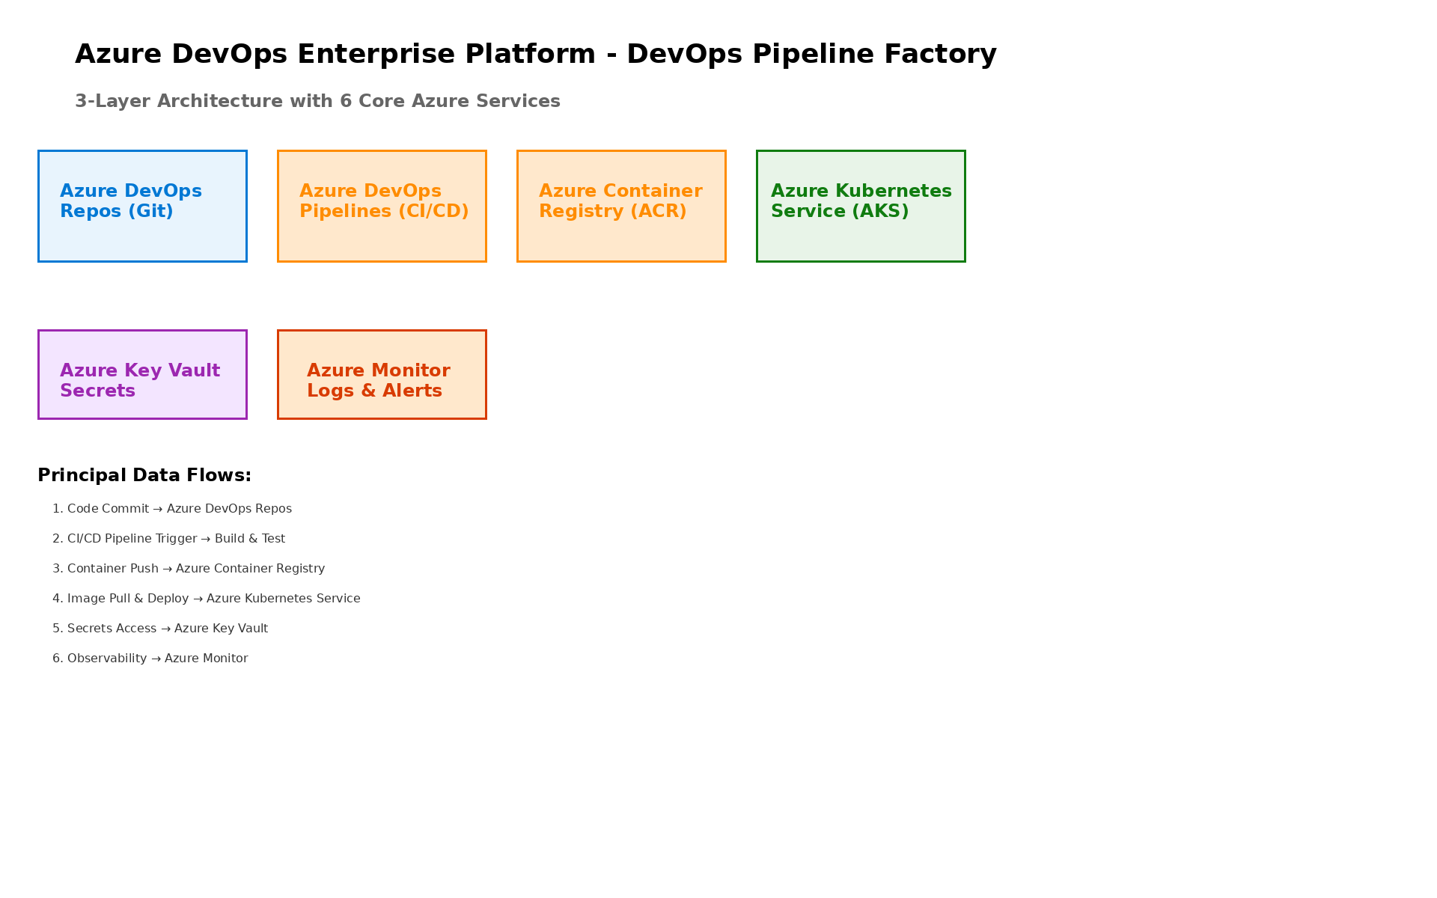
Figure 1: Solution Architecture

4.2 Design Principles
• Security First: Defense-in-depth security architecture with DevSecOps integration
• Scalability: Horizontal and vertical scaling for build and deployment workloads
• Reliability: High availability with 99.9% SLA target
• Performance: Optimized for fast builds and deployments
• Compliance: Built-in compliance controls and audit capabilities

4.3 Core Components

4.3.1 Azure DevOps Services
Primary DevOps platform providing:
• Azure Repos: Git repositories with advanced branching strategies
• Azure Pipelines: CI/CD automation with YAML-based definitions
• Azure Boards: Agile project management and work item tracking
• Azure Test Plans: Comprehensive test management and execution
• Azure Artifacts: Package management and artifact storage

4.3.2 Supporting Azure Services
Infrastructure services providing:
• Azure Container Registry: Container image storage and security scanning
• Azure Kubernetes Service: Container orchestration platform
• Azure Key Vault: Secrets and certificate management
• Azure Application Insights: Application performance monitoring
• Azure Log Analytics: Centralized logging and analytics

4.3.3 Integration Components
Platform integration through:
• Service Connections: Secure connections to Azure subscriptions
• Variable Groups: Centralized configuration management
• Environments: Deployment target management with approvals
• Extensions: Third-party integrations (SonarCloud, WhiteSource)

5 Security & Compliance
This section details the security controls and compliance implementation.

5.1 Identity & Access Management

5.1.1 RBAC Configuration
Role | Permissions | Assignment
Project Collection Admin | Full organization access | Platform Admins
Project Admin | Project-level management | Team Leads
Contributors | Code and pipeline access | Developers
Readers | Read-only access | Stakeholders
Table 3: Role Permissions

5.1.2 Privileged Access
• Azure AD integration with SSO
• Multi-factor authentication enforcement
• Conditional Access policies
• Just-in-time access for elevated permissions

5.2 DevSecOps Integration

5.2.1 Security Scanning
• SAST: SonarCloud integration for static code analysis
• DAST: OWASP ZAP for dynamic security testing
• SCA: WhiteSource for dependency vulnerability scanning
• Container Scanning: Azure Security Center integration
• IaC Scanning: Terraform and ARM template security analysis

5.2.2 Compliance Framework
• SOC 2 Type II: Security, availability, processing integrity
• ISO 27001: Information security management controls
• PCI DSS: Payment card security (where applicable)
• GDPR: Data protection and privacy

6 Data Architecture
This section documents the data flow, storage, and management design.

6.1 Data Flow Design

6.1.1 Development Workflow

6.1.2 Pipeline Data Flow
1. Code Commit: Developers push to feature branches
2. PR Validation: Automated builds and tests on pull requests
3. CI Pipeline: Full build, test, and security scanning
4. Artifact Creation: Packages stored in Azure Artifacts
5. CD Pipeline: Multi-stage deployment with approvals
6. Production: Monitoring and feedback loop

6.2 Artifact Management

6.2.1 Storage Tiers
Tier | Retention | Use Case | Storage
Build Artifacts | 30 days | CI outputs | Azure Artifacts
Container Images | 90 days | Docker images | ACR
Release Packages | 1 year | Production releases | Azure Artifacts
Table 4: Tier

7 Integration Design
This section documents external system integrations.

7.1 Tool Integrations

7.1.1 ITSM Integration
• ServiceNow ticket creation from pipeline failures
• Work item synchronization with Jira (if applicable)
• Incident management integration

7.1.2 Communication Integration
• Microsoft Teams notifications for builds/deployments
• Slack integration for alerts
• Email notifications for approvals

7.2 API Integration

7.2.1 Azure DevOps REST API
• Custom integrations via REST API
• Webhook support for external triggers
• Extension marketplace integrations

8 Infrastructure & Operations
This section documents operational architecture and management procedures.

8.1 High Availability

8.1.1 Platform Resilience
• Azure DevOps: 99.9% SLA (Microsoft-managed)
• AKS: Zone-redundant control plane
• ACR: Geo-replication enabled

8.1.2 Disaster Recovery
• RTO Target: < 4 hours
• RPO Target: < 1 hour
• Automated backups with point-in-time recovery

8.2 Monitoring & Alerting

8.2.1 Key Metrics
Metric | Threshold | Alert Severity | Response
Build Failures | > 10% | Warning | Review pipeline
Queue Time | > 5 minutes | Warning | Scale agents
Agent Offline | > 50% | Critical | Investigate infrastructure
Deployment Failures | > 5% | Critical | Review and rollback
Table 5: Monitoring Alerts

8.3 Capacity Planning

8.3.1 Current Sizing
• Microsoft-hosted agents: 10 parallel jobs
• Self-hosted agents: 5 parallel jobs
• Projected growth: 20% annually

9 Implementation Approach
This section outlines the phased implementation methodology.

9.1 Phase Overview
Phase | Activities | Duration | Exit Criteria
1 | Foundation Setup | Weeks 1-4 | Organization configured
2 | Pipeline Framework | Weeks 5-8 | CI/CD templates ready
3 | Security Integration | Weeks 9-10 | DevSecOps operational
4 | Testing & Validation | Weeks 11-12 | All tests passing
Table 6: Implementation Phases

9.2 Risk Mitigation
Risk | Impact | Mitigation
Migration delays | Schedule slip | Phased migration approach
User adoption | Low utilization | Comprehensive training
Security gaps | Compliance issues | DevSecOps integration
Performance issues | Developer friction | Capacity planning
Table 7: Risk Register

10 Appendices

10.1 Appendix A: Pipeline Template Catalog
The pipeline template library includes:
• Build templates: .NET, Java, Python, Node.js, Docker
• Deploy templates: AKS, App Service, Azure Functions
• Security templates: SAST, DAST, SCA scanning
• Utility templates: Notifications, approvals, rollback

10.2 Appendix B: Extension Reference
Extension | Purpose | Category
SonarCloud | Code quality and security | Security
WhiteSource | Dependency scanning | Security
Terraform | Infrastructure as Code | Deployment
Azure Key Vault | Secrets management | Security
Table 8: Extension

10.3 Appendix C: Environment Reference
Environment | Purpose | Approval
Development | Developer testing | Automatic
Testing | QA validation | Team Lead
Staging | Pre-production | Release Manager
Production | Live environment | Change Advisory Board
Table 9: Environment
Document Version: 2.0
Last Updated: [DATE]
Prepared By: Solution Architecture Team
Review Status: Approved


eoframework.org

