

Statement of Work
Azure - Azure DevOps Enterprise Platform Implementation

Client: | [Client Name]
Date: | November 15, 2025
Consulting Company: | Your Consulting Company
Submitted By: | [Consultant Name | Email | Phone]
Opportunity No: | OPP-2025-001
Version: | 1.0

Table of Contents
1 Introduction
1.1 Purpose
1.1.1 Scope
2 Table Content
3 Image Section
4 Additional Content
5 Sign-Off

List of Figures
Figure 1: Sample Architecture Diagram

List of Tables
Table 1: Sample Deliverables Table

1 Executive Summary
This Statement of Work defines the scope, deliverables, timeline, and terms for the Azure DevOps Enterprise Platform implementation. This engagement will transform your organization's capabilities by delivering a comprehensive, enterprise-grade solution designed to meet your specific business requirements.
Project Duration: 12 weeks (as detailed in Timeline & Milestones section)
Key Objectives:
• Deploy and configure Azure DevOps Enterprise Platform according to best practices
• Integrate with existing enterprise systems and workflows
• Train technical staff on operations and management
• Achieve defined success metrics and business outcomes

2 Background & Objectives

2.1 Business Context
[Client Name] requires a modern DevOps platform to accelerate software delivery while maintaining security, quality, and compliance. This Azure DevOps Enterprise Platform implementation will transform development workflows through automated CI/CD pipelines, container orchestration, and integrated security controls enabling teams to ship code faster with confidence.
Accelerating Software Delivery with Enterprise CI/CD
• Opportunity
• Reduce time-to-market by 10x through automated CI/CD pipelines and orchestration
• Achieve 99%+ deployment success rates and eliminate manual deployment errors
• Enable development teams to ship code safely with built-in security and compliance controls
• Success Criteria
• Deploy to production 10+ times per day with zero-downtime releases
• Reduce manual deployment effort by 90% through pipeline automation
• ROI realization within 6-12 months through improved productivity and reduced firefighting

3 Scope of Work

3.1 In Scope
The following services and deliverables are included in this SOW, delivered through a proven three-phase methodology:
• Phase 1: Foundation (Weeks 1-4)
• Azure DevOps repository setup and branching strategy
• Design core CI/CD pipeline framework and reusable templates
• Establish security policies and approval workflows
• Phase 2: Build & Deploy (Weeks 5-8)
• Implement automated testing and security scanning
• Deploy container registry and Kubernetes cluster
• Configure artifact management and release orchestration
• Phase 3: Security & Scale (Weeks 9-12)
• Integrate Key Vault for secrets rotation and compliance
• Configure monitoring and alerting for production visibility
• Enable blue-green and canary deployments for safe releases

3.1.1 Scope Parameters
This engagement is sized based on the following parameters:
Table: Engagement Scope Parameters
Note: Changes to these parameters may require scope adjustment and additional investment.

3.2 Out of Scope
These items are not in scope unless added via change control:
• Custom development beyond standard configuration
• Third-party application licensing (unless specified)
• Hardware procurement or disposal
• End-user training (technical team only)
• Ongoing managed services post-hypercare

4 Deliverables & Timeline

4.1 Project Milestones
The implementation will be delivered in three phases over 12 weeks, with clear milestones and deliverables at each stage:
Phase No | Phase Description | Timeline | Key Deliverables
Phase 1 | Foundation & CI Setup | Weeks 1-4 | Azure DevOps repositories, CI pipeline templates, Security policies defined
Phase 2 | Build & Deployment | Weeks 5-8 | Container registry, AKS cluster operational, Automated releases, Multi-environment support
Phase 3 | Security & Operations | Weeks 9-12 | Key Vault integration, Advanced deployments (blue-green, canary), Monitoring and alerting live
Table 1: Deliverables And Timeline

4.2 Key Deliverables
The following deliverables will be provided throughout the engagement, with specified delivery dates and acceptance criteria:
# | Deliverable | Type | Due Date | Acceptance By
1 | Solution Architecture Document | Document | Week 4 | Client IT Lead
2 | Configuration Runbook | Document | Week 8 | Operations Team
3 | Test Results Report | Document | Week 10 | QA Lead
4 | As-Built Documentation | Document | Week 12 | Client IT Lead
5 | Knowledge Transfer Sessions | Training | Week 12 | Technical Team
Table 2: Project Deliverables and Acceptance Criteria

5 Roles & Responsibilities

5.1 RACI Matrix
Task/Deliverable | Vendor PM | Vendor Arch | Vendor Eng | Client IT | Client Mgmt | SME
Solution Architecture | C | A | R | C | I | C
Infrastructure Setup | C | R | R | C | I | I
Configuration & Tuning | A | R | R | C | I | I
Integration Development | C | A | R | C | I | I
Testing & Validation | R | R | R | A | I | C
Knowledge Transfer | R | R | C | A | I | I
Project Management | A | I | I | C | R | I
Table 3: Roles and Responsibilities (RACI Matrix)
Legend: R = Responsible | A = Accountable | C = Consulted | I = Informed

5.2 Key Personnel
Vendor Team:
• Project Manager: Overall delivery accountability
• Solution Architect: Technical design and oversight
• Engineers: Implementation and configuration
• Support Specialist: Training and hypercare
Client Team:
• IT Lead: Primary technical contact
• Management Sponsor: Executive oversight
• Operations Team: Knowledge transfer recipients
• Subject Matter Experts: Requirements validation

6 Architecture & Design

6.1 Solution Architecture
The Azure DevOps Enterprise Platform will be architected to deliver automated CI/CD capabilities with integrated security and scalability through the following key components:
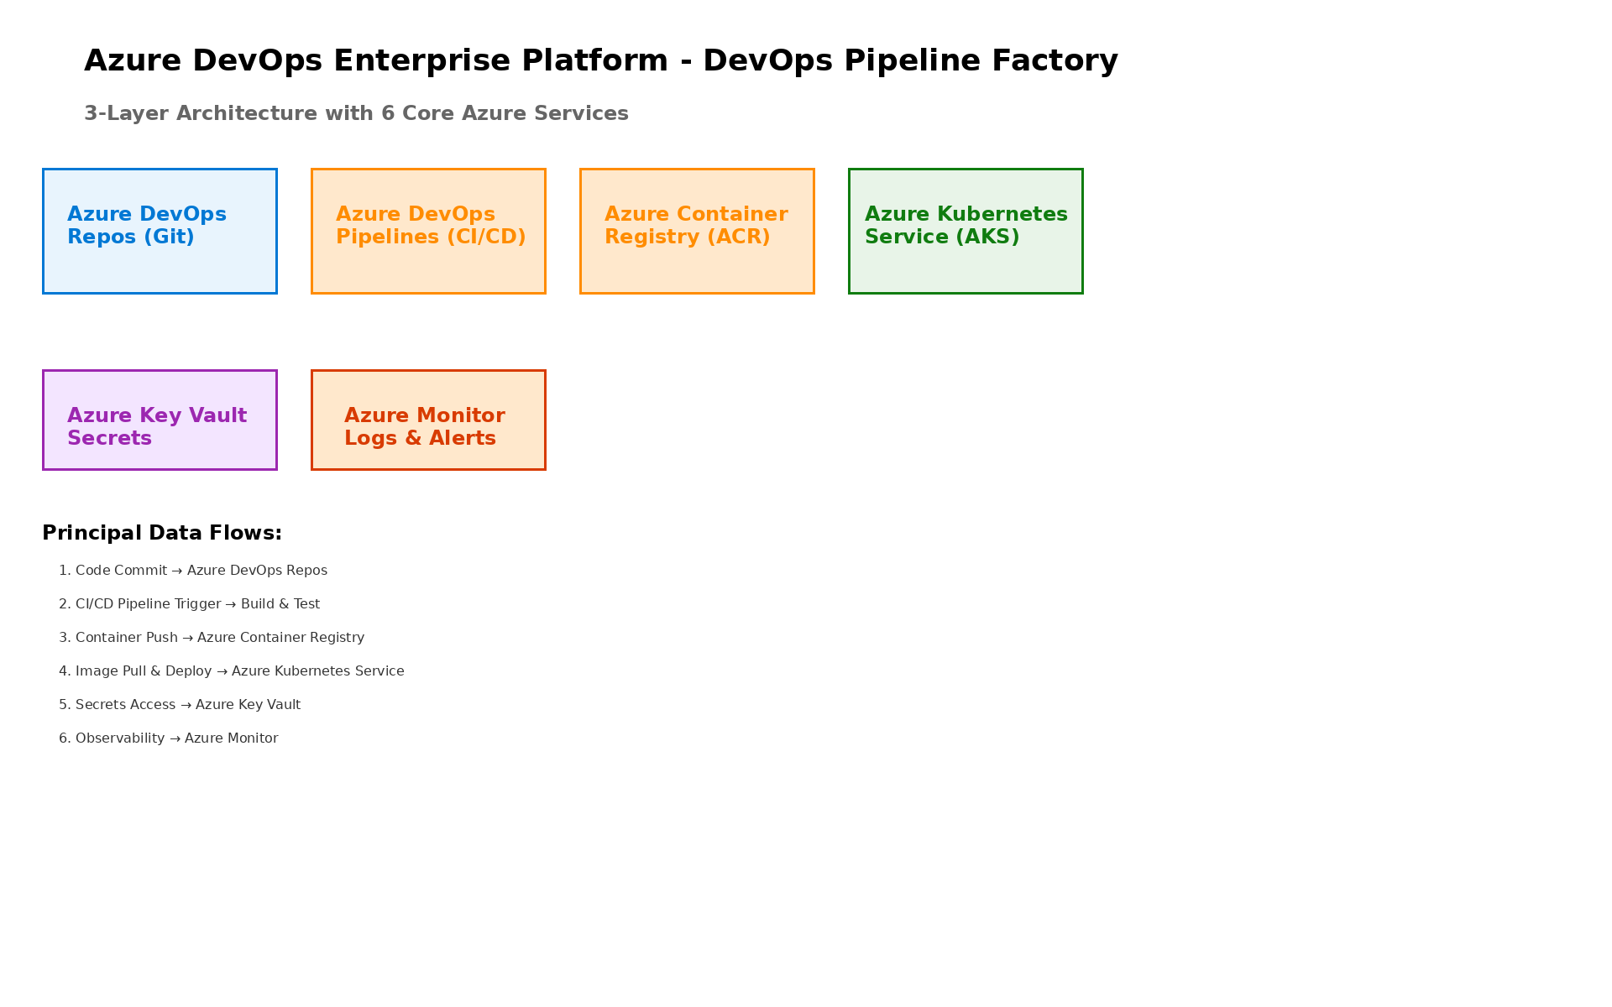
Figure 1: Architecture Diagram
• CI/CD Orchestration
• Azure DevOps (Repos + Pipelines) for unified source control and pipeline automation
• Multi-stage pipelines with automated testing, security scanning, and approval workflows
• Container & Deployment
• Azure Container Registry for secure image storage and vulnerability scanning
• Azure Kubernetes Service (AKS) for scalable container orchestration and auto-scaling
• Security & Operations
• Azure Key Vault for centralized secrets management and compliance
• Azure Monitor for comprehensive logging, metrics, and alerting

6.2 Technical Implementation
The implementation will follow industry best practices with:
• Infrastructure as Code for repeatable deployments
• Configuration management for consistency
• Automated testing and validation
• Comprehensive monitoring and alerting
• Security-first design principles

7 Security & Compliance

7.1 Identity & Access Management
• Role-based access control (RBAC) implementation
• Least-privilege principle enforcement
• Multi-factor authentication (MFA) required
• Service accounts with minimal permissions
• Regular access reviews and certification

7.2 Monitoring & Threat Detection
• Real-time security monitoring and alerting
• Audit logging for all administrative actions
• Anomaly detection and behavioral analysis
• Incident response integration
• Compliance reporting dashboards

7.3 Compliance & Governance
• Industry standard compliance frameworks (SOC 2, ISO 27001)
• Data classification and protection policies
• Encryption for data at-rest and in-transit
• Regular security assessments
• Policy enforcement automation

8 Testing & Validation

8.1 Testing Strategy
Functional Validation:
• End-to-end workflow testing
• Integration point validation
• User acceptance testing coordination
• Data integrity verification
Performance Testing:
• Load testing under expected conditions
• Stress testing at 2x capacity
• Response time benchmarking
• Scalability validation
Security Testing:
• Vulnerability scanning
• Access control validation
• Compliance verification
• Penetration testing coordination (if required)

8.2 Go-Live Readiness
• [ ] All functional tests passed
• [ ] Performance benchmarks achieved
• [ ] Security validation complete
• [ ] Documentation finalized
• [ ] Team training completed
• [ ] Stakeholder sign-off obtained

9 Handover & Support

9.1 Knowledge Transfer
Training Sessions:
• 3x live knowledge transfer sessions (recorded)
• Operations runbook walkthrough
• Monitoring and alerting procedures
• Incident response playbooks
• Best practices documentation
Documentation Package:
• As-built architecture documentation
• Configuration management guide
• Operational runbooks
• Troubleshooting guide
• Optimization recommendations

9.2 Hypercare Support
Duration: 4 weeks post-go-live
Coverage:
• Business hours support (8 AM - 6 PM local time)
• 4-hour response time for critical issues
• Daily health check calls (first 2 weeks)
• Weekly status meetings
Scope:
• Issue investigation and resolution
• Performance tuning and optimization
• Configuration adjustments
• Continued knowledge transfer

10 Investment Summary
Cost Category | Year 1 List | AWS/Partner Credits | Year 1 Net | Year 2 | Year 3 | 3-Year Total
Professional Services | $100,000 | ($8,000) | $92,000 | $0 | $0 | $92,000
Cloud Infrastructure | $6,200 | $0 | $6,200 | $6,200 | $6,200 | $18,600
Support & Maintenance | $1,524 | $0 | $1,524 | $1,524 | $1,524 | $4,572
TOTAL INVESTMENT | $107,724 | ($8,000) | $99,724 | $7,724 | $7,724 | $115,172
Table 4: Total Investment Summary

11 Terms & Conditions

11.1 General Terms
All services will be delivered in accordance with the executed Master Services Agreement (MSA) between Vendor and Client.

11.2 Scope Changes
Any changes to scope, schedule, or cost require a formal Change Request approved by both parties. Impact assessment will be provided within 5 business days.

11.3 Intellectual Property
• Client retains ownership of all configurations and documentation specific to their environment
• Vendor retains proprietary methodologies, tools, and accelerators
• Pre-existing IP remains with original owner

11.4 Service Levels
• Deliverables provided per agreed schedule
• Hypercare period: 4 weeks with defined response times
• Extended support available via managed services contract

11.5 Confidentiality
• All exchanged artifacts under NDA protection
• Client data handled per security requirements
• No disclosure to third parties without consent

11.6 Termination
• Either party may terminate with 30 days written notice
• Payment due for all completed work
• Deliverables transferred upon termination

12 Sign-Off
By signing below, both parties agree to the scope, approach, and terms outlined in this Statement of Work.
CLIENT | CONSULTING COMPANY
Name: ___________________________ | Name: ___________________________
Title: ___________________________ | Title: ___________________________
Signature: ___________________________ | Signature: ___________________________
Date: ___________________________ | Date: ___________________________


eoframework.org

