

Statement of Work
Azure - Azure Virtual WAN Global Network Implementation

Client: | [Client Name]
Date: | November 15, 2025
Consulting Company: | Your Consulting Company
Submitted By: | [Consultant Name | Email | Phone]
Opportunity No: | OPP-2025-001
Version: | 1.0

Table of Contents
1 Introduction
1.1 Purpose
1.1.1 Scope
2 Table Content
3 Image Section
4 Additional Content
5 Sign-Off

List of Figures
Figure 1: Sample Architecture Diagram

List of Tables
Table 1: Sample Deliverables Table

1 Executive Summary
This Statement of Work defines the scope, deliverables, timeline, and terms for the Azure Virtual WAN Global Network implementation. This engagement will transform your organization's capabilities by delivering a comprehensive, enterprise-grade solution designed to meet your specific business requirements.
Project Duration: 12 weeks (as detailed in Timeline & Milestones section)
Key Objectives:
• Deploy and configure Azure Virtual WAN Global Network according to best practices
• Integrate with existing enterprise systems and workflows
• Train technical staff on operations and management
• Achieve defined success metrics and business outcomes

2 Background & Objectives

2.1 Business Context
[Client Name] requires a simplified global network architecture to connect distributed branch offices, data centers, and cloud resources. This Azure Virtual WAN implementation will modernize network connectivity through centralized management, automated routing, and integrated security enabling consistent performance and policy enforcement across all locations.
Simplify Global Network Architecture
• Opportunity
• Consolidate multiple WAN technologies (MPLS, VPN, ExpressRoute) into a unified cloud-based network hub
• Reduce operational complexity by 60% through centralized management and automated connectivity
• Optimize bandwidth costs by 40-50% while improving branch office security and performance
• Enable rapid scale to new branch offices in days instead of weeks
• Success Criteria
• Achieve unified connectivity across all 10+ branch offices within 6 months
• Reduce WAN-related incident resolution time by 70% through centralized visibility
• Maintain 99.9% network uptime with automatic failover across regions
• Enable secure, high-performance access to Azure services and SaaS applications

3 Scope of Work

3.1 In Scope
The following services and deliverables are included in this SOW, delivered through a proven three-phase methodology:
• Phase 1: Assessment & Design (Months 1-2)
• Audit current network topology and branch connectivity methods
• Design hub locations, security policies, and network segmentation
• Validate ExpressRoute peering locations and bandwidth requirements
• Phase 2: Hub Deployment & Branch Migration (Months 3-4)
• Provision Virtual WAN hubs with VPN gateways in primary and secondary regions
• Establish ExpressRoute circuits and configure routing policies
• Migrate branch offices in waves with minimal disruption
• Phase 3: Security, Optimization & Handoff (Months 5-6)
• Deploy Azure Firewall with centralized threat protection policies
• Optimize routing and traffic flow across hubs
• Complete training and operational handoff to network team

3.1.1 Scope Parameters
This engagement is sized based on the following parameters:
Table: Engagement Scope Parameters
Note: Changes to these parameters may require scope adjustment and additional investment.

3.2 Out of Scope
These items are not in scope unless added via change control:
• Custom development beyond standard configuration
• Third-party application licensing (unless specified)
• Hardware procurement or disposal
• End-user training (technical team only)
• Ongoing managed services post-hypercare

4 Deliverables & Timeline

4.1 Project Milestones
The implementation will be delivered in three phases over 6 months, with clear milestones and deliverables at each stage:
Phase No | Phase Description | Timeline | Key Deliverables
Phase 1 | Assessment & Design | Months 1-2 | Network audit complete, Hub design approved, ExpressRoute peering confirmed
Phase 2 | Hub & Branch Deployment | Months 3-4 | Primary hub operational, 5 branches migrated, Secondary hub deployed
Phase 3 | Security & Optimization | Months 5-6 | Firewall policies deployed, Threat detection enabled, Operations handoff complete
Table 1: Deliverables And Timeline

4.2 Key Deliverables
The following deliverables will be provided throughout the engagement, with specified delivery dates and acceptance criteria:
# | Deliverable | Type | Due Date | Acceptance By
1 | Solution Architecture Document | Document | Week 4 | Client IT Lead
2 | Configuration Runbook | Document | Week 8 | Operations Team
3 | Test Results Report | Document | Week 10 | QA Lead
4 | As-Built Documentation | Document | Week 12 | Client IT Lead
5 | Knowledge Transfer Sessions | Training | Week 12 | Technical Team
Table 2: Project Deliverables and Acceptance Criteria

5 Roles & Responsibilities

5.1 RACI Matrix
Task/Deliverable | Vendor PM | Vendor Arch | Vendor Eng | Client IT | Client Mgmt | SME
Solution Architecture | C | A | R | C | I | C
Infrastructure Setup | C | R | R | C | I | I
Configuration & Tuning | A | R | R | C | I | I
Integration Development | C | A | R | C | I | I
Testing & Validation | R | R | R | A | I | C
Knowledge Transfer | R | R | C | A | I | I
Project Management | A | I | I | C | R | I
Table 3: Roles and Responsibilities (RACI Matrix)
Legend: R = Responsible | A = Accountable | C = Consulted | I = Informed

5.2 Key Personnel
Vendor Team:
• Project Manager: Overall delivery accountability
• Solution Architect: Technical design and oversight
• Engineers: Implementation and configuration
• Support Specialist: Training and hypercare
Client Team:
• IT Lead: Primary technical contact
• Management Sponsor: Executive oversight
• Operations Team: Knowledge transfer recipients
• Subject Matter Experts: Requirements validation

6 Architecture & Design

6.1 Solution Architecture
The Azure Virtual WAN solution will be architected to provide global network connectivity with centralized routing and security through the following key components:
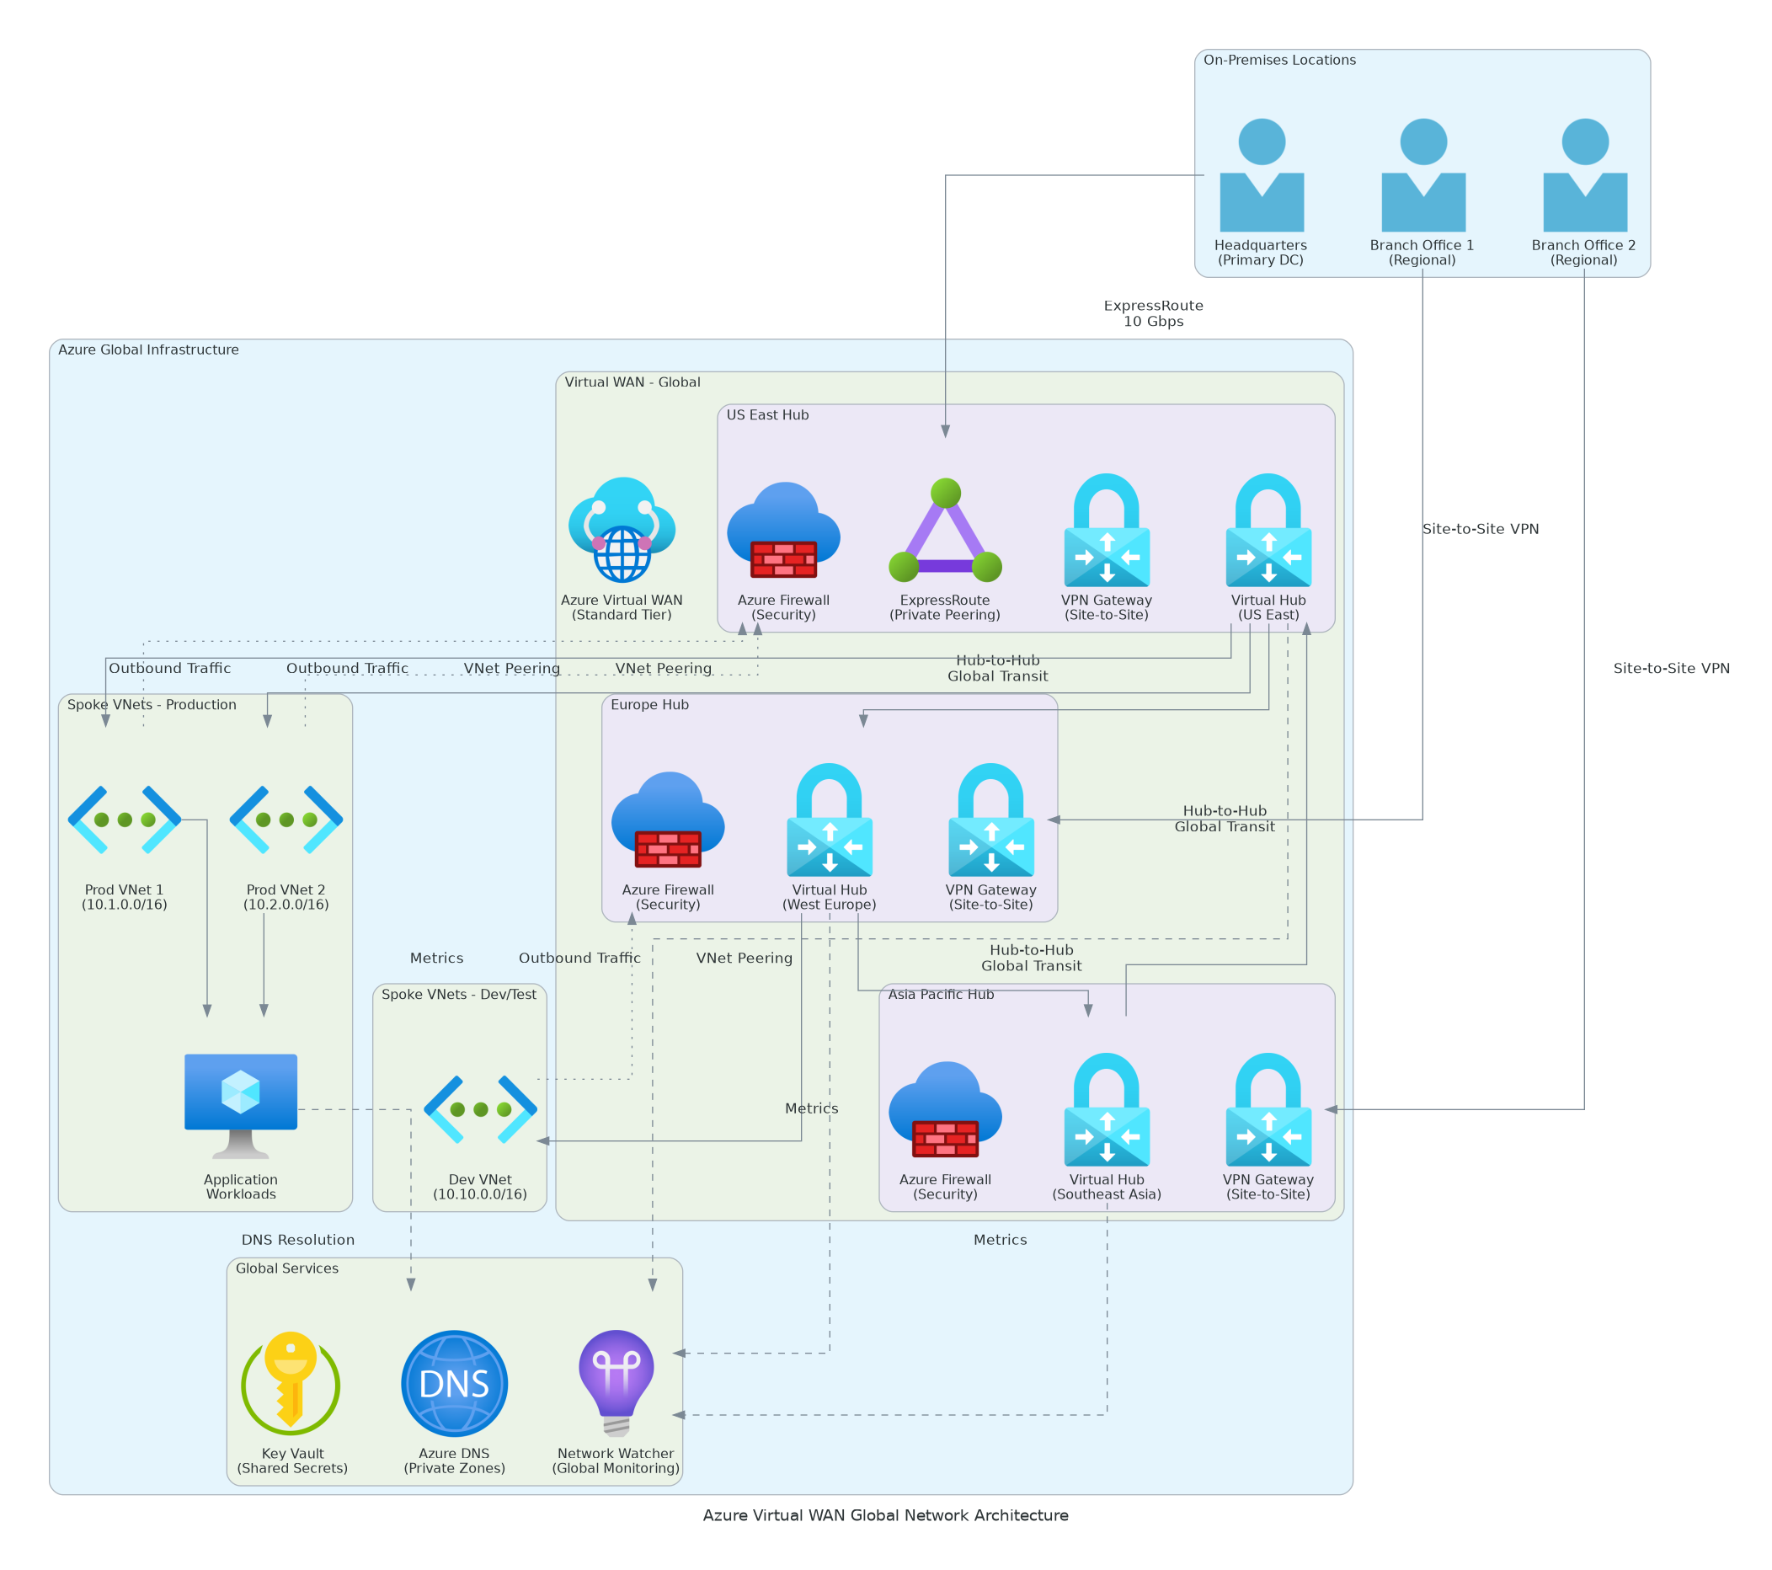
Figure 1: Architecture Diagram
• Core Components
• Virtual WAN Hubs: Two regional hubs (US, Europe) providing centralized routing and connectivity
• Branch Connectivity: VPN gateways and ExpressRoute circuits connecting 10 branch offices
• Security & Monitoring: Azure Firewall Premium with unified visibility across all connections
• Technology Stack
• Azure Virtual WAN Standard for hub management and routing
• Site-to-Site VPN and ExpressRoute for branch connectivity with SLA guarantees
• Azure Firewall Premium and Monitor for threat detection and observability

6.2 Technical Implementation
The implementation will follow industry best practices with:
• Infrastructure as Code for repeatable deployments
• Configuration management for consistency
• Automated testing and validation
• Comprehensive monitoring and alerting
• Security-first design principles

7 Security & Compliance

7.1 Identity & Access Management
• Role-based access control (RBAC) implementation
• Least-privilege principle enforcement
• Multi-factor authentication (MFA) required
• Service accounts with minimal permissions
• Regular access reviews and certification

7.2 Monitoring & Threat Detection
• Real-time security monitoring and alerting
• Audit logging for all administrative actions
• Anomaly detection and behavioral analysis
• Incident response integration
• Compliance reporting dashboards

7.3 Compliance & Governance
• Industry standard compliance frameworks (SOC 2, ISO 27001)
• Data classification and protection policies
• Encryption for data at-rest and in-transit
• Regular security assessments
• Policy enforcement automation

8 Testing & Validation

8.1 Testing Strategy
Functional Validation:
• End-to-end workflow testing
• Integration point validation
• User acceptance testing coordination
• Data integrity verification
Performance Testing:
• Load testing under expected conditions
• Stress testing at 2x capacity
• Response time benchmarking
• Scalability validation
Security Testing:
• Vulnerability scanning
• Access control validation
• Compliance verification
• Penetration testing coordination (if required)

8.2 Go-Live Readiness
• [ ] All functional tests passed
• [ ] Performance benchmarks achieved
• [ ] Security validation complete
• [ ] Documentation finalized
• [ ] Team training completed
• [ ] Stakeholder sign-off obtained

9 Handover & Support

9.1 Knowledge Transfer
Training Sessions:
• 3x live knowledge transfer sessions (recorded)
• Operations runbook walkthrough
• Monitoring and alerting procedures
• Incident response playbooks
• Best practices documentation
Documentation Package:
• As-built architecture documentation
• Configuration management guide
• Operational runbooks
• Troubleshooting guide
• Optimization recommendations

9.2 Hypercare Support
Duration: 4 weeks post-go-live
Coverage:
• Business hours support (8 AM - 6 PM local time)
• 4-hour response time for critical issues
• Daily health check calls (first 2 weeks)
• Weekly status meetings
Scope:
• Issue investigation and resolution
• Performance tuning and optimization
• Configuration adjustments
• Continued knowledge transfer

10 Investment Summary
Cost Category | Year 1 List | AWS/Partner Credits | Year 1 Net | Year 2 | Year 3 | 3-Year Total
Professional Services | $90,500 | ($12,000) | $78,500 | $0 | $0 | $78,500
Cloud Infrastructure | $50,496 | $0 | $50,496 | $50,496 | $50,496 | $151,488
Software Licenses | $3,600 | $0 | $3,600 | $3,600 | $3,600 | $10,800
Support & Maintenance | $11,448 | $0 | $11,448 | $11,448 | $11,448 | $34,344
TOTAL INVESTMENT | $156,044 | ($12,000) | $144,044 | $65,544 | $65,544 | $275,132
Table 4: Total Investment Summary

11 Terms & Conditions

11.1 General Terms
All services will be delivered in accordance with the executed Master Services Agreement (MSA) between Vendor and Client.

11.2 Scope Changes
Any changes to scope, schedule, or cost require a formal Change Request approved by both parties. Impact assessment will be provided within 5 business days.

11.3 Intellectual Property
• Client retains ownership of all configurations and documentation specific to their environment
• Vendor retains proprietary methodologies, tools, and accelerators
• Pre-existing IP remains with original owner

11.4 Service Levels
• Deliverables provided per agreed schedule
• Hypercare period: 4 weeks with defined response times
• Extended support available via managed services contract

11.5 Confidentiality
• All exchanged artifacts under NDA protection
• Client data handled per security requirements
• No disclosure to third parties without consent

11.6 Termination
• Either party may terminate with 30 days written notice
• Payment due for all completed work
• Deliverables transferred upon termination

12 Sign-Off
By signing below, both parties agree to the scope, approach, and terms outlined in this Statement of Work.
CLIENT | CONSULTING COMPANY
Name: ___________________________ | Name: ___________________________
Title: ___________________________ | Title: ___________________________
Signature: ___________________________ | Signature: ___________________________
Date: ___________________________ | Date: ___________________________


eoframework.org

