

Detailed Design Document
NVIDIA DGX SuperPOD AI Infrastructure

Client: | [CLIENT]
Date: | November 28, 2025
Consulting Company: | [Consulting Company Name]
Submitted By: | [Name | Email | Phone]
Opportunity No: | OPP-XXXXX
Version: | 1.0

Table of Contents
1 Introduction
1.1 Purpose
1.1.1 Scope
2 Table Content
3 Image Section
4 Additional Content
5 Sign-Off

List of Figures
Figure 1: Sample Architecture Diagram

List of Tables
Table 1: Sample Deliverables Table

1 Executive Summary
This document provides the comprehensive technical design for the NVIDIA DGX SuperPOD AI Infrastructure implementation. It covers the target-state architecture for an 8-node DGX H100 cluster with NVIDIA Quantum-2 InfiniBand fabric, Base Command storage platform, and enterprise AI software stack including Slurm workload management, NGC containers, and DCGM monitoring.

1.1 Purpose
Define the technical architecture and design specifications that will guide the implementation team through deployment, configuration, and validation of the enterprise AI supercomputing infrastructure.

1.2 Scope
In-scope:
• 8x DGX H100 systems with 64 H100 80GB GPUs (32 petaFLOPS FP8)
• NVIDIA Quantum-2 InfiniBand 400 Gbps fabric with 4x QM9700 switches
• Base Command 1 PB NVMe storage cluster with 14 GB/s throughput
• Slurm workload manager with GPU-aware scheduling
• NGC container runtime and AI framework deployment
• DCGM monitoring with Prometheus/Grafana dashboards
• LDAP/AD integration for user authentication
• Security controls and network segmentation
Out-of-scope:
• End-user training (covered in Implementation Guide)
• Ongoing support procedures (covered in Operations Runbook)
• Phase 2 expansion to 16+ DGX systems
• Inference cluster deployment (future phase)

1.3 Assumptions & Constraints
The following assumptions underpin the design and must be validated during implementation.
• Datacenter has 500 kW power capacity available for DGX SuperPOD
• Cooling infrastructure supports 500 kW thermal load
• Network connectivity to corporate LDAP/AD available
• 99.5% uptime SLA requirement applies
• 50+ data scientists will use the platform concurrently
• Primary workloads: LLM training, computer vision, drug discovery

1.4 References
This document should be read in conjunction with the following related materials.
• Statement of Work (SOW)
• NVIDIA DGX SuperPOD Reference Architecture
• NVIDIA Base Command Platform documentation
• Slurm workload manager documentation

2 Business Context
This section establishes the business drivers, success criteria, and compliance requirements that shape the technical design decisions.

2.1 Business Drivers
The solution addresses the following key business objectives identified during discovery.
• Training Acceleration: Reduce AI model training time by 10x compared to cloud GPU instances
• Cost Optimization: Achieve 70% cost reduction vs. cloud GPU compute over 5 years
• Research Velocity: Support 50+ data scientists with dedicated GPU resources
• Model Scale: Enable training of 100B+ parameter foundation models in-house
• Data Security: Keep sensitive training data on-premises under organizational control

2.2 Workload Criticality & SLA Expectations
The following service level targets define the operational requirements for the production environment.
Metric | Target | Measurement | Priority
System Availability | 99.5% | DCGM uptime monitoring | Critical
GPU Utilization | 70-80% | DCGM metrics | High
InfiniBand Latency | < 2 microseconds | perftest validation | Critical
Storage Throughput | 14 GB/s sustained | IOR benchmark | Critical
Job Queue Wait Time | < 30 minutes | Slurm metrics | Medium
Table 1: Service Level Targets

2.3 Compliance & Regulatory Factors
The solution must adhere to the following security and compliance requirements.
• SSH key-based authentication required; password authentication disabled
• LDAP/AD integration for centralized user management
• Network segmentation between management and compute networks
• Audit logging for all administrative operations
• Data encryption for sensitive datasets at rest

2.4 Success Criteria
Project success will be measured against the following criteria at go-live.
• 32 petaFLOPS FP8 aggregate compute validated via MLPerf benchmarks
• InfiniBand fabric latency < 2 microseconds confirmed
• Storage throughput meets 14 GB/s sustained read/write
• All 64 GPUs operational and visible to Slurm scheduler
• 52+ researchers onboarded and productive

3 Current-State Assessment
This section documents the existing environment that the DGX SuperPOD will integrate with.

3.1 Application Landscape
The current AI infrastructure relies on cloud GPU resources with limited scale.
Application | Purpose | Technology | Status
Cloud GPU Instances | AI training | AWS p4d.24xlarge | To be augmented
JupyterHub | Interactive development | Cloud-hosted | To be migrated
MLflow | Experiment tracking | On-premises | Integration point
LDAP/AD | User authentication | On-premises | Integration point
Table 2: Application Inventory

3.2 Infrastructure Inventory
The datacenter will be upgraded to support the DGX SuperPOD installation.
Component | Quantity | Specifications | Notes
Power Infrastructure | 1 | 500 kW capacity | Upgrade required
Cooling System | 1 | 500 kW thermal | Upgrade required
Network Switches | 2 | 100 GbE management | Existing infrastructure
Rack Space | 4 | 42U racks | New installation
Table 3: Infrastructure Inventory

3.3 Dependencies & Integration Points
The DGX SuperPOD has the following external dependencies.
• Corporate LDAP/AD for user authentication and group membership
• DNS servers for hostname resolution
• NTP servers for time synchronization
• SMTP relay for alerting notifications
• Existing MLflow server for experiment tracking integration

3.4 Network Topology
Current network provides 100 GbE connectivity for management traffic with dedicated InfiniBand fabric for GPU communication.
• Management Network: 100 GbE Ethernet for SSH, monitoring, and job submission
• Compute Fabric: 400 Gbps InfiniBand NDR for GPU-to-GPU communication
• Storage Network: InfiniBand for GPUDirect Storage access

3.5 Performance Baseline
Current cloud GPU performance establishes the baseline for improvement targets.
• Cloud training time (GPT-3 scale): 12+ months on AWS p4d.24xlarge
• Cloud GPU cost: $2.5M annually for equivalent compute
• GPU utilization: Variable due to spot instance interruptions
• Data transfer overhead: Significant for large datasets

4 Solution Architecture
The target architecture delivers enterprise-grade AI supercomputing with 32 petaFLOPS FP8 performance, high-bandwidth InfiniBand fabric, and enterprise storage.
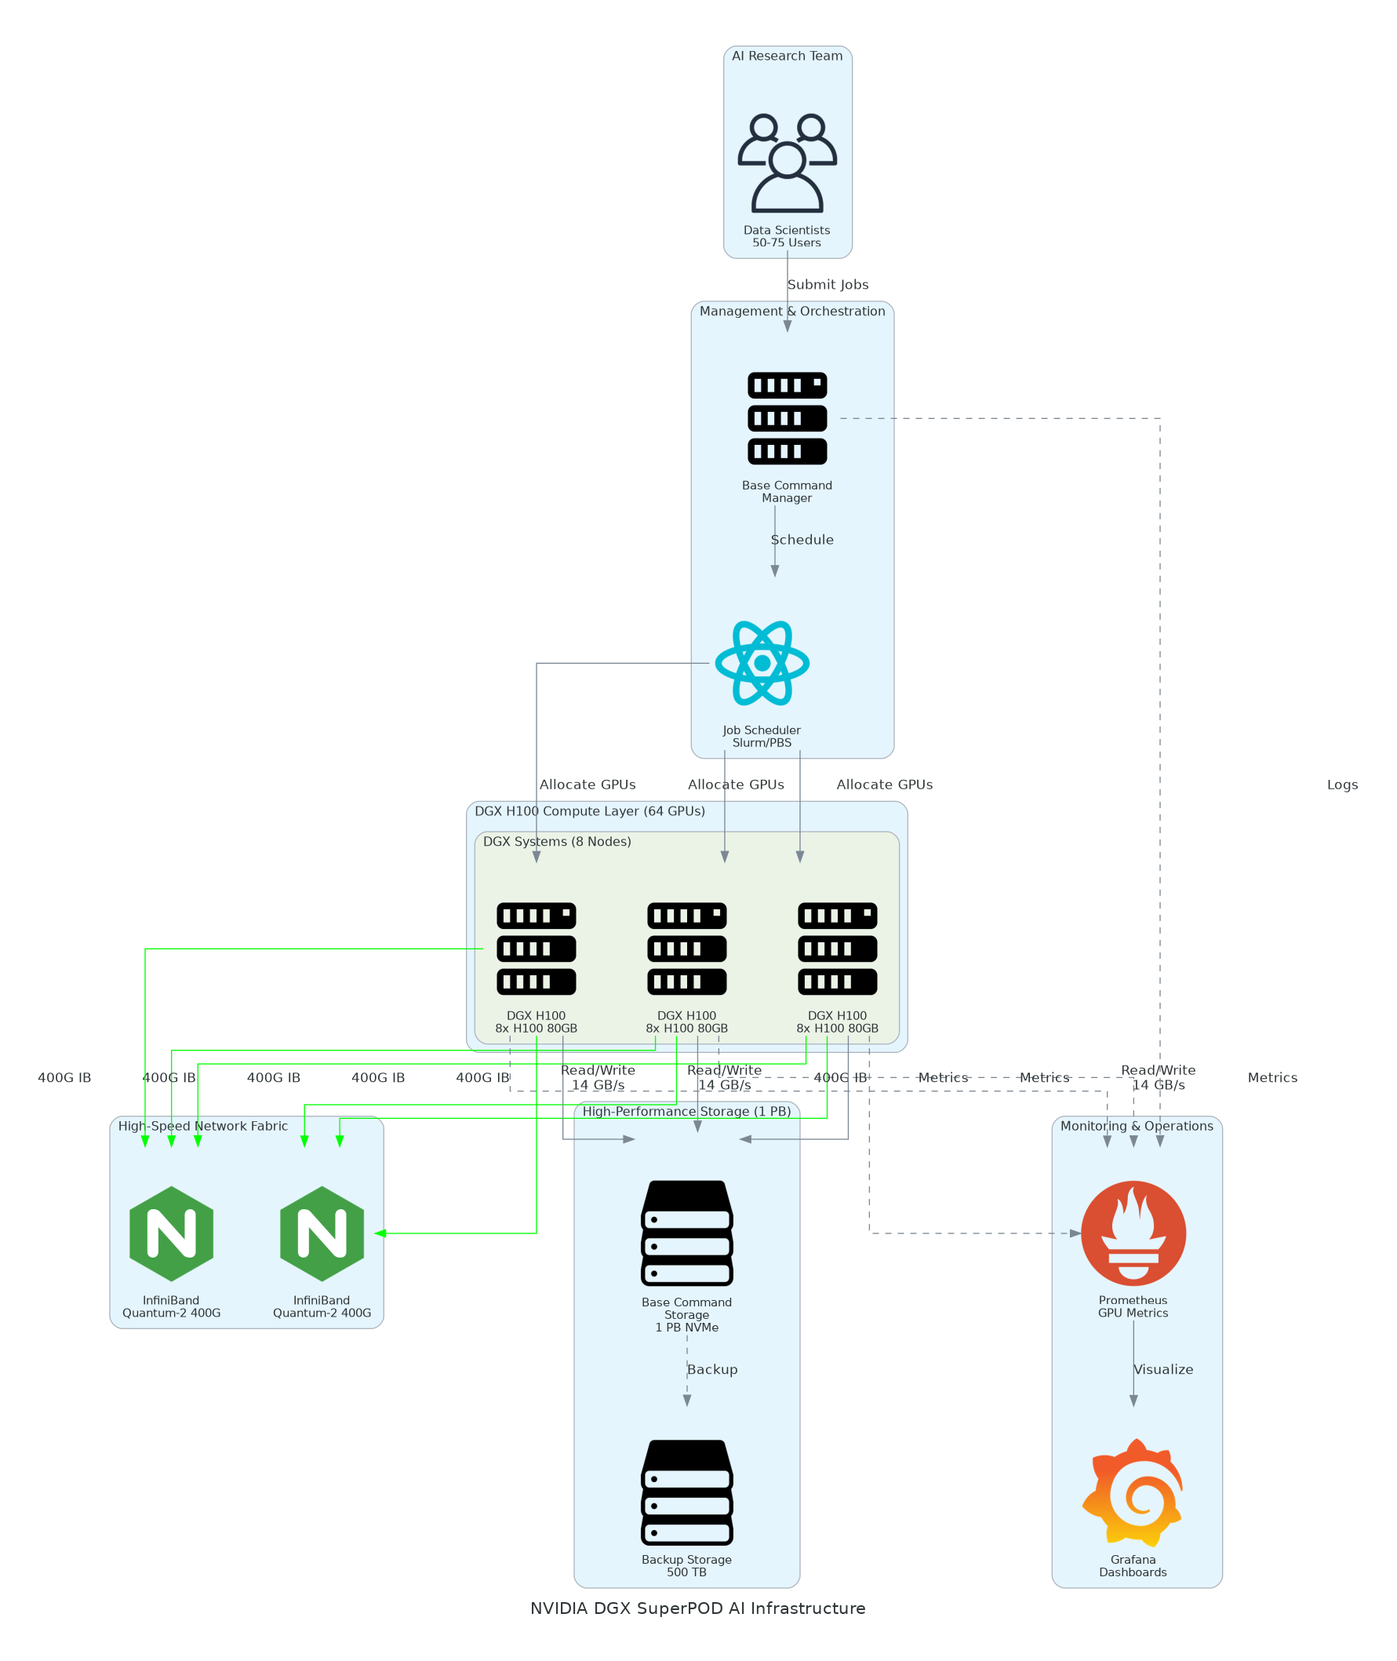
Figure 1: Solution Architecture

4.1 Architecture Principles
The following principles guide all architectural decisions throughout the solution design.
• Performance First: Optimize for maximum GPU utilization and training throughput
• Scalability: Design fabric and storage for future expansion to 16+ DGX systems
• Reliability: Eliminate single points of failure with redundant InfiniBand connections
• Security by Design: Network segmentation, SSH key authentication, audit logging
• Operational Excellence: Comprehensive monitoring with proactive alerting

4.2 Architecture Patterns
The solution implements the following architectural patterns for HPC AI workloads.
• Primary Pattern: Shared HPC cluster with Slurm fair-share scheduling
• Storage Pattern: Parallel filesystem with GPUDirect Storage for high-throughput I/O
• Network Pattern: Non-blocking InfiniBand fabric with RDMA for GPU communication
• Container Pattern: NGC containers for reproducible AI environments

4.3 Component Design
The solution comprises the following components with specific responsibilities.
Component | Purpose | Technology | Dependencies | Scaling
DGX H100 Nodes | GPU compute | 8x DGX H100 | Power, cooling | Horizontal
InfiniBand Fabric | GPU communication | Quantum-2 QM9700 | DGX nodes | Switch expansion
Storage Cluster | Dataset and checkpoint | Base Command 1 PB | InfiniBand | Capacity expansion
Slurm Controller | Job scheduling | Slurm 23.02 | All nodes | HA pair
Login Nodes | User access | Linux servers | LDAP, Slurm | Horizontal
Monitoring Stack | Observability | Prometheus/Grafana | DCGM | Vertical
Table 4: Solution Components

4.4 Technology Stack
The technology stack has been selected based on NVIDIA best practices and enterprise requirements.
Layer | Technology | Rationale
Compute | DGX H100 with H100 80GB GPUs | Latest generation, 4 petaFLOPS per node
Network | Quantum-2 InfiniBand 400 Gbps | Lowest latency for distributed training
Storage | Base Command NVMe | 14 GB/s throughput, GPUDirect Storage
Scheduler | Slurm 23.02 | Industry standard, GPU-aware scheduling
Containers | NGC Catalog | Optimized AI frameworks, regular updates
Monitoring | DCGM + Prometheus + Grafana | GPU-specific metrics, alerting
Table 5: Technology Stack

5 Security & Compliance
This section details the security controls and governance mechanisms implemented in the solution.

5.1 Identity & Access Management
Access control follows enterprise security standards with centralized authentication.
• Authentication: LDAP/AD integration with SSH key-based access
• Authorization: Slurm account-based access control with partition restrictions
• MFA: Required for administrative access via jump host
• Service Accounts: Dedicated accounts for monitoring and automation

5.1.1 Role Definitions
The following roles define access levels within the DGX SuperPOD.
Role | Permissions | Scope
DGX Administrator | Full system access, node management | All DGX nodes
Slurm Operator | Job management, queue administration | Slurm scheduler
Data Scientist | Job submission, GPU allocation | Assigned partitions
Auditor | Read-only monitoring access | Dashboards only
Table 6: Role Permissions

5.2 Secrets Management
Sensitive credentials are managed through secure practices.
• SSH keys stored in user home directories with 600 permissions
• LDAP bind credentials stored in Slurm configuration with restricted access
• Monitoring credentials managed via Kubernetes secrets
• No plaintext passwords in configuration files

5.3 Network Security
Network security implements defense-in-depth with segmentation.
• Management Network: VLAN-isolated, firewall-protected access
• Compute Fabric: Dedicated InfiniBand network, no external routing
• Storage Network: InfiniBand-only access, no Ethernet exposure
• Jump Host: Required for administrative SSH access

5.4 Data Protection
Data protection controls ensure confidentiality of training data and models.
• Encryption at Rest: Optional for sensitive datasets via dm-crypt
• Encryption in Transit: SSH for management, InfiniBand for compute
• Access Controls: POSIX permissions with LDAP group enforcement
• Backup: Daily checkpoint backup to secondary storage

5.5 Compliance Mappings
The following table maps security requirements to implementation controls.
Requirement | Control | Implementation
Access Control | SSH key authentication | Password authentication disabled
Audit Logging | Centralized logging | rsyslog to SIEM integration
Network Isolation | VLAN segmentation | Management and compute separated
Data Protection | File permissions | LDAP group-based access control
Table 7: Security Controls

5.6 Audit Logging & SIEM Integration
Comprehensive audit logging supports security monitoring.
• SSH access logs forwarded to centralized SIEM
• Slurm job submission and completion logged
• DCGM hardware events captured
• Log retention: 90 days online, 1 year archive

6 Data Architecture
This section defines the data model, storage strategy, and data management for AI workloads.

6.1 Data Model

6.1.1 Conceptual Model
The DGX SuperPOD manages the following data categories:
• Training Datasets: Input data for model training (TB to PB scale)
• Model Checkpoints: Intermediate training state for fault tolerance
• Trained Models: Final model artifacts for deployment
• Experiment Metadata: MLflow tracking data and hyperparameters

6.1.2 Logical Model
The storage hierarchy supports different access patterns and performance requirements.
Data Type | Storage Location | Access Pattern | Retention
Training Data | /shared/datasets | Read-heavy, sequential | Permanent
Checkpoints | /shared/checkpoints | Write-heavy, periodic | 30 days
Models | /shared/models | Read-heavy, random | Permanent
Scratch | /local/scratch | High-throughput, temporary | Job lifetime
Table 8: Data Type

6.2 Data Flow Design
1. Data Ingestion: Datasets uploaded to /shared/datasets via login nodes
2. Job Execution: Slurm allocates GPUs and mounts shared storage
3. Training I/O: GPUDirect Storage for high-throughput data loading
4. Checkpointing: Periodic saves to /shared/checkpoints for fault tolerance
5. Model Export: Final models saved to /shared/models for deployment

6.3 Data Migration Strategy
Training datasets will be migrated from existing storage.
• Approach: Staged migration with parallel operation during transition
• Validation: Checksum verification for data integrity
• Cutover: Users redirect to new storage paths after validation

6.4 Data Governance
Data governance policies ensure proper handling of training data.
• Classification: Public datasets, proprietary data, sensitive data
• Retention: Based on project requirements and compliance
• Access: LDAP group-based permissions per project
• Backup: Daily snapshots with 30-day retention

7 Integration Design
This section documents the integration patterns and external system connections.

7.1 External System Integrations
The DGX SuperPOD integrates with the following external systems.
System | Type | Protocol | Format | Error Handling | SLA
LDAP/AD | Real-time | LDAP | Binary | Retry with backoff | 99.9%
MLflow | Real-time | HTTP | JSON | Circuit breaker | 99.5%
SMTP Relay | Async | SMTP | Email | Queue and retry | 99.0%
NTP Servers | Real-time | NTP | Binary | Fallback servers | 99.99%
Table 9: System Integrations

7.2 API Design
Slurm provides the primary interface for job submission and management.
• Job Submission: sbatch, srun commands via SSH
• Queue Queries: squeue, sinfo for job and node status
• Accounting: sacct for job history and resource usage
• REST API: Slurm REST API for programmatic access (optional)

7.2.1 API Endpoints
The following interfaces provide programmatic access to DGX SuperPOD resources.
Method | Endpoint | Auth | Description
SSH | login.dgx.internal | SSH Key | Interactive and batch job submission
HTTP | grafana.dgx.internal | LDAP | Monitoring dashboard access
HTTP | jupyterhub.dgx.internal | LDAP | Interactive notebook access
REST | slurm-api.dgx.internal | Token | Programmatic job management
Table 10: API Endpoints

7.3 Authentication & SSO Flows
Single sign-on provides seamless authentication across DGX SuperPOD services.
• LDAP/AD authentication for all user access
• SSH key-based authentication for command-line access
• LDAP group membership controls Slurm partition access
• JupyterHub OAuth integration with corporate IdP

7.4 Messaging & Event Patterns
Event-driven patterns support operational automation.
• Job Events: Slurm prolog/epilog scripts for job lifecycle hooks
• Alerting: Prometheus AlertManager for threshold-based notifications
• Logging: rsyslog forwarding to centralized log management

8 Infrastructure & Operations
This section covers the infrastructure design, deployment architecture, and operational procedures.

8.1 Network Design
The network architecture provides isolated management and high-performance compute fabrics.
• Management VLAN: 10.100.0.0/24 for SSH, monitoring, Slurm
• BMC Network: 10.100.1.0/24 for out-of-band management
• InfiniBand Fabric: Dedicated non-routed fabric for GPU communication
• Storage Network: InfiniBand for GPUDirect Storage access

8.2 Compute Sizing
DGX H100 systems provide the GPU compute foundation.
Component | Specification | Per Node | Total | Count
GPUs | H100 80GB SXM | 8 | 64 | 8 nodes
GPU Memory | HBM3 | 640 GB | 5.1 TB | 8 nodes
System RAM | DDR5 | 2 TB | 16 TB | 8 nodes
Local NVMe | SSD | 30 TB | 240 TB | 8 nodes
Table 11: Component

8.3 High Availability Design
The solution eliminates single points of failure where possible.
• Dual InfiniBand connections per DGX node for fabric redundancy
• Slurm controller with backup controller configuration
• Redundant power feeds per DGX system
• RAID protection on shared storage

8.4 Disaster Recovery
Disaster recovery capabilities protect against data loss.
• RPO: 24 hours (daily checkpoint backup)
• RTO: 4 hours (node replacement from spares)
• Backup: Daily snapshot of shared storage
• Recovery: Documented procedures in operations runbook

8.5 Monitoring & Alerting
Comprehensive monitoring provides visibility across the DGX SuperPOD.
• GPU Metrics: DCGM exporter for utilization, temperature, memory
• System Metrics: Node exporter for CPU, memory, disk, network
• Slurm Metrics: Custom exporter for queue depth, job status
• Alerting: Prometheus AlertManager with PagerDuty integration

8.5.1 Alert Definitions
The following alerts ensure proactive incident detection.
Alert | Condition | Severity | Response
GPU Temperature High | > 83°C for 5 min | Critical | Reduce workload, check cooling
GPU Memory Full | > 95% for 10 min | Warning | Investigate job memory usage
InfiniBand Errors | > 100 errors/hour | Warning | Check cable connections
Storage Full | < 10% free | Critical | Archive old data, expand storage
Table 12: Monitoring Alerts

8.6 Logging & Observability
Centralized logging enables troubleshooting and audit compliance.
• Slurm job logs aggregated to shared storage
• System logs forwarded via rsyslog to SIEM
• DCGM events captured in Prometheus
• Grafana dashboards for visualization

8.7 Cost Model
The DGX SuperPOD investment and ongoing costs are summarized below.
Category | Year 1 Investment | Annual Operating | Notes
Hardware | $4,370,000 | $0 | 8x DGX H100, InfiniBand, storage
Facilities | $350,000 | $75,000 | Power/cooling upgrade, electricity
Software | $196,200 | $76,640 | AI Enterprise licenses
Support | $320,000 | $320,000 | NVIDIA Enterprise Support
Total | $5,236,200 | $471,640 | Year 1 net after credits
Table 13: Category And Year 1 Investment

9 Implementation Approach
This section outlines the deployment strategy, tooling, and sequencing for the implementation.

9.1 Migration/Deployment Strategy
The deployment follows a phased approach with validation at each stage.
• Approach: Phased installation with parallel cloud operation during transition
• Pattern: Incremental node deployment with validation
• Validation: Performance benchmarks at each milestone
• Rollback: Cloud resources maintained during hypercare

9.2 Sequencing & Wave Planning
The implementation follows a phased approach with clear exit criteria.
Phase | Activities | Duration | Exit Criteria
Discovery | Site assessment, architecture design | 4 weeks | Design approved
Site Prep | Power/cooling upgrade, rack installation | 3 weeks | Datacenter ready
Deployment | DGX installation, InfiniBand fabric, storage | 6 weeks | Hardware operational
Testing | Performance benchmarks, UAT | 2 weeks | All tests passing
Hypercare | Production support, optimization | 4 weeks | Team self-sufficient
Table 14: Implementation Phases

9.3 Tooling & Automation
The following tools provide automation for deployment and operations.
Category | Tool | Purpose
Configuration | Ansible | DGX OS configuration, user management
Monitoring | DCGM + Prometheus | GPU metrics collection
Visualization | Grafana | Dashboard and alerting
Scheduling | Slurm | Workload management
Containers | NGC + Singularity | AI framework deployment
Table 15: Tools and Technologies

9.4 Cutover Approach
The cutover strategy transitions users from cloud to DGX SuperPOD.
• Type: Phased migration with parallel operation
• Duration: 2-week transition period per team
• Validation: Workload validation on DGX before cloud decommission
• Decision Point: Team lead sign-off for each migration wave

9.5 Downtime Expectations
Service availability impacts during implementation.
• Planned Downtime: 4-hour maintenance windows for firmware updates
• Unplanned Downtime: Target < 4 hours MTTR
• Mitigation: Spare node available for rapid replacement

9.6 Rollback Strategy
Rollback procedures enable recovery from deployment issues.
• Cloud GPU resources maintained during hypercare period
• DGX node isolation via Slurm for troubleshooting
• Checkpoint-based training recovery for interrupted jobs
• Maximum rollback: Return to cloud for affected workloads

10 Appendices

10.1 Architecture Diagrams
The following diagrams provide visual representation of the solution architecture.
• Solution Architecture Diagram (included in Solution Architecture section)
• InfiniBand Fabric Topology Diagram
• Network VLAN Diagram
• Storage Architecture Diagram

10.2 Naming Conventions
All resources follow standardized naming conventions for consistency.
Resource Type | Pattern | Example
DGX Nodes | dgx-{nn} | dgx-01, dgx-02
InfiniBand Switches | ib-sw-{nn} | ib-sw-01, ib-sw-02
Storage Volumes | vol-{purpose} | vol-datasets, vol-checkpoints
Slurm Partitions | {team}-{priority} | nlp-high, cv-normal
Table 16: Naming Conventions

10.3 Tagging Standards
Resource tagging enables cost allocation and operational automation.
Tag | Required | Example Values
Environment | Yes | production, development
Project | Yes | llm-research, cv-training
Team | Yes | nlp-team, cv-team
CostCenter | Yes | CC-AI-001
Table 17: Tagging Standards

10.4 Risk Register
The following risks have been identified with corresponding mitigation strategies.
Risk | Likelihood | Impact | Mitigation
Power capacity insufficient | Low | High | Site assessment confirms 500 kW available
Cooling inadequate | Low | High | Thermal survey validates capacity
InfiniBand cabling errors | Medium | Medium | Detailed cable mapping, NVIDIA validation
Slurm configuration issues | Medium | Medium | Phased rollout, tuning during hypercare
User adoption challenges | Low | Medium | Comprehensive training program
Table 18: Risk Register

10.5 Glossary
The following terms and acronyms are used throughout this document.
Term | Definition
DGX | NVIDIA's integrated AI system with GPUs, networking, and software
FP8 | 8-bit floating point precision for AI training
GPUDirect | NVIDIA technology for direct GPU memory access
HBM3 | High Bandwidth Memory generation 3
InfiniBand | High-performance networking standard for HPC
NCCL | NVIDIA Collective Communications Library
NDR | Next Data Rate InfiniBand (400 Gbps)
NGC | NVIDIA GPU Cloud container registry
petaFLOPS | 10^15 floating-point operations per second
RDMA | Remote Direct Memory Access
Slurm | Simple Linux Utility for Resource Management
Table 19: Glossary


eoframework.org

