

Detailed Design Document
NVIDIA GPU Compute Cluster with Kubernetes

Client: | [CLIENT]
Date: | November 28, 2025
Consulting Company: | [Consulting Company Name]
Submitted By: | [Name | Email | Phone]
Opportunity No: | OPP-XXXXX
Version: | 1.0

Table of Contents
1 Introduction
1.1 Purpose
1.1.1 Scope
2 Table Content
3 Image Section
4 Additional Content
5 Sign-Off

List of Figures
Figure 1: Sample Architecture Diagram

List of Tables
Table 1: Sample Deliverables Table

1 Executive Summary
This document provides the comprehensive technical design for the NVIDIA GPU Compute Cluster with Kubernetes implementation. It covers the target-state architecture for an 8-server GPU cluster with 32 A100 40GB GPUs, 100 GbE RoCE networking, 200 TB NetApp storage, and Kubernetes orchestration with NVIDIA GPU Operator, Kubeflow, MLflow, and Triton.

1.1 Purpose
Define the technical architecture and design specifications that will guide the implementation team through deployment, configuration, and validation of the enterprise GPU compute cluster for AI/ML workloads.

1.2 Scope
In-scope:
• 8x Dell R750xa servers with 32 NVIDIA A100 40GB GPUs
• 100 GbE networking with RoCE for distributed training
• 200 TB NetApp AFF NVMe storage cluster
• Kubernetes with NVIDIA GPU Operator and time-slicing
• Kubeflow for ML pipelines, MLflow for experiment tracking
• Triton Inference Server for model serving
• JupyterHub for interactive data science
Out-of-scope:
• Custom ML model development
• Ongoing managed services
• Phase 2 expansion to 64+ GPUs

1.3 Assumptions & Constraints
• Datacenter has power and cooling capacity for 8 GPU servers
• 100 GbE network infrastructure available
• 20+ data scientists will use the platform
• 99.5% uptime SLA requirement

1.4 References
• Statement of Work (SOW)
• NVIDIA GPU Operator documentation
• Kubernetes best practices for GPU scheduling
• Kubeflow and MLflow documentation

2 Business Context

2.1 Business Drivers
• Training Acceleration: Reduce AI model training time by 10x vs CPU baseline
• Cost Optimization: Replace $480K annual cloud GPU spend with owned infrastructure
• GPU Utilization: Achieve 80%+ utilization through Kubernetes scheduling
• MLOps Platform: Standardize ML workflows with Kubeflow, MLflow, Triton

2.2 Workload Criticality & SLA Expectations
Metric | Target | Measurement | Priority
Cluster Availability | 99.5% | Kubernetes monitoring | Critical
GPU Utilization | 80%+ | DCGM metrics | High
Training Performance | 10x vs CPU | Benchmark validation | Critical
Inference Latency | <50ms p99 | Triton metrics | High
Table 1: Service Level Targets

2.3 Compliance & Regulatory Factors
• LDAP/AD integration for centralized user management
• Kubernetes RBAC for namespace isolation
• Network policies for traffic segmentation

2.4 Success Criteria
• 32 A100 GPUs operational with Kubernetes scheduling
• GPU Operator managing drivers and device plugin
• Kubeflow pipelines executing with GPU resources
• Triton serving 50+ production models

3 Current-State Assessment

3.1 Application Landscape
Application | Purpose | Technology | Status
Cloud GPU Instances | AI training | AWS p3.8xlarge | To be replaced
JupyterHub | Interactive dev | Cloud-hosted | To be migrated
MLflow | Experiment tracking | On-premises | Integration point
Table 2: Application Inventory

3.2 Infrastructure Inventory
Component | Quantity | Specifications | Notes
GPU Servers | 8 | Dell R750xa with 4x A100 | New deployment
Network | 2 | 100 GbE switches | RoCE enabled
Storage | 1 | NetApp AFF 200 TB | NVMe all-flash
Table 3: Infrastructure Inventory

3.3 Dependencies & Integration Points
• Corporate LDAP/AD for authentication
• DNS and NTP servers
• Existing MLflow instance

3.4 Network Topology
• Management Network: 25 GbE for SSH and monitoring
• GPU Network: 100 GbE RoCE for NCCL and distributed training
• Storage Network: 100 GbE for NFS mounts

3.5 Performance Baseline
• Cloud GPU training: Limited by spot availability and cost
• Target: 10x acceleration with dedicated on-premises cluster

4 Solution Architecture
The following diagram illustrates the target-state architecture for the GPU compute cluster, showing the relationship between compute nodes, Kubernetes orchestration, storage, and the MLOps platform components.
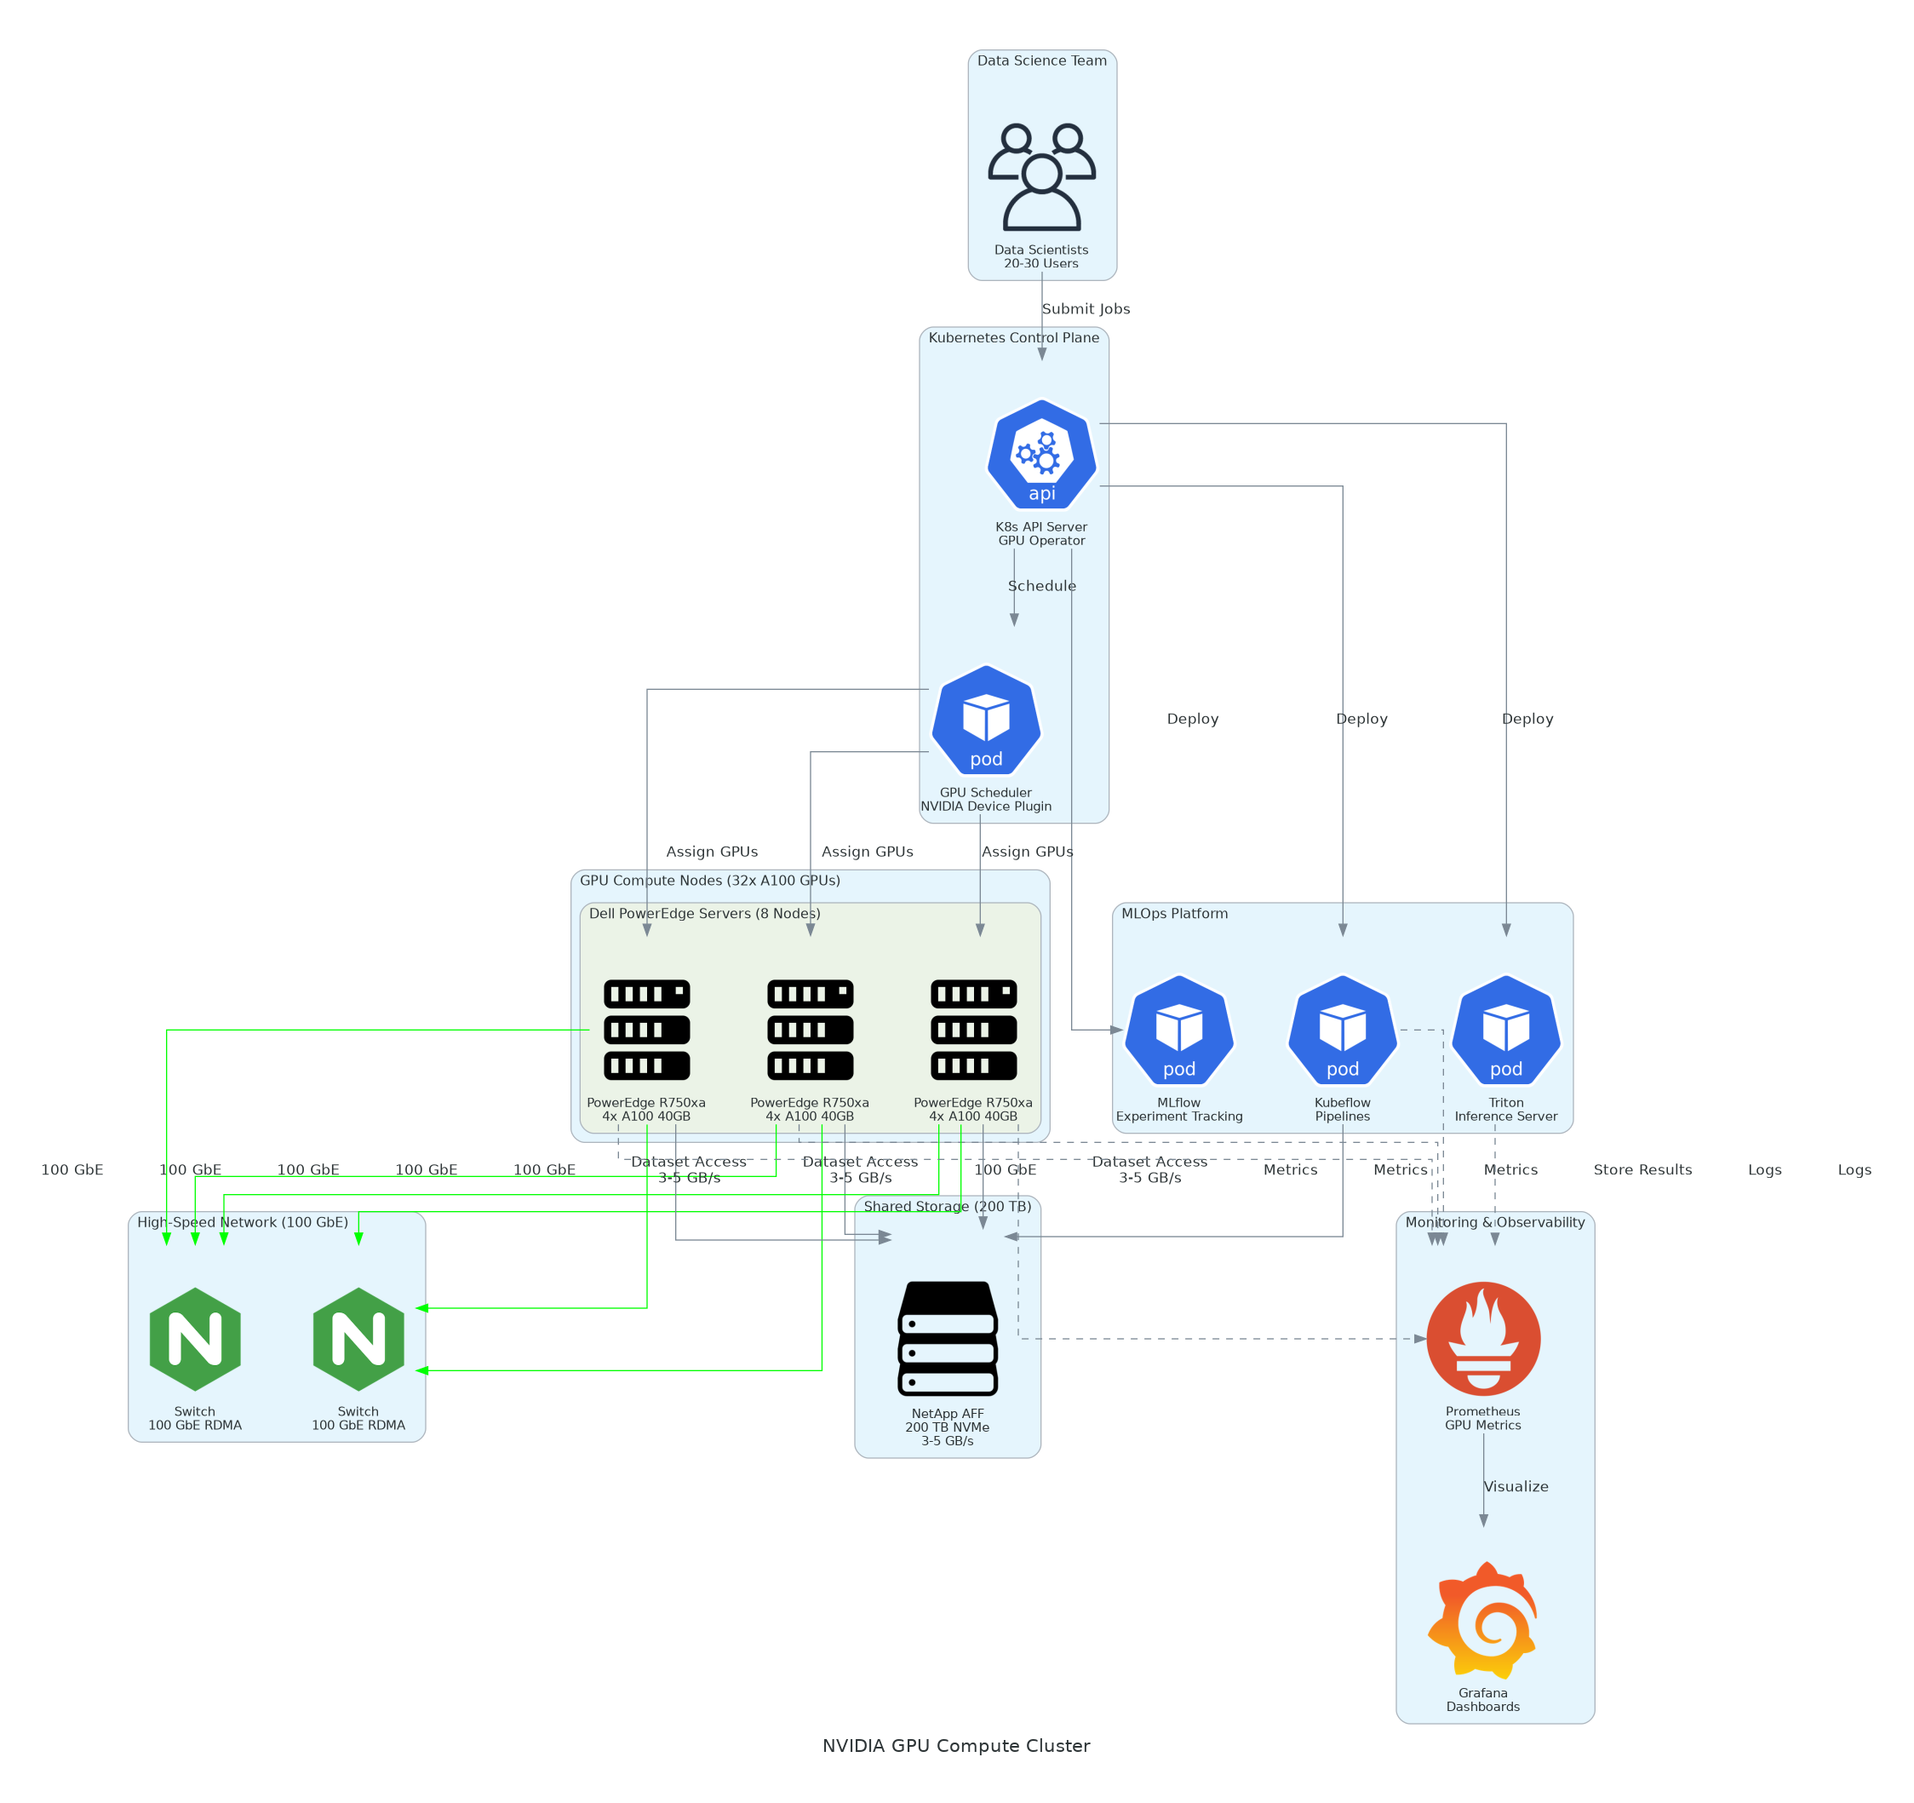
Figure 1: Solution Architecture

4.1 Architecture Principles
• Performance: Optimize for GPU utilization and training throughput
• Scalability: Design for future expansion to 64+ GPUs
• Reliability: HA control plane, workload rescheduling on failure
• Security: RBAC, network policies, namespace isolation

4.2 Architecture Patterns
• Kubernetes-native GPU scheduling with device plugin
• MLOps pipeline pattern with Kubeflow
• Model serving with Triton Inference Server

4.3 Component Design
Component | Purpose | Technology | Dependencies | Scaling
GPU Servers | AI compute | Dell R750xa | Power, cooling | Horizontal
Kubernetes | Orchestration | K8s 1.28 | All servers | Control plane HA
GPU Operator | Driver management | NVIDIA Operator | Kubernetes | Per-node
Kubeflow | ML pipelines | Kubeflow 1.8 | Kubernetes | Horizontal
MLflow | Experiment tracking | MLflow 2.9 | Storage | Vertical
Triton | Model serving | Triton 24.01 | GPU nodes | Horizontal
Table 4: Solution Components

4.4 Technology Stack
Layer | Technology | Rationale
Compute | A100 40GB | Industry-standard AI accelerator
Orchestration | Kubernetes | Cloud-native GPU scheduling
ML Platform | Kubeflow + MLflow | End-to-end ML lifecycle
Inference | Triton | High-performance model serving
Table 5: Technology Stack

5 Security & Compliance

5.1 Identity & Access Management
• LDAP/AD integration for user authentication
• Kubernetes RBAC for namespace access control
• JupyterHub OAuth for single sign-on

5.1.1 Role Definitions
Role | Permissions | Scope
Cluster Admin | Full cluster access | All namespaces
Data Scientist | GPU pod creation | Assigned namespace
ML Engineer | Pipeline management | Kubeflow namespace
Table 6: Role Permissions

5.2 Secrets Management
• Kubernetes secrets for credentials
• External secrets operator integration

5.3 Network Security
• Calico network policies for namespace isolation
• No external access to GPU network

5.4 Data Protection
• NFS permissions for dataset access control
• Model artifacts stored on shared storage

5.5 Compliance Mappings
Requirement | Control | Implementation
Access Control | Kubernetes RBAC | Namespace isolation
Audit Logging | Kubernetes audit | API server logging
Table 7: Security Controls

5.6 Audit Logging & SIEM Integration
• Kubernetes API audit logs
• DCGM events for GPU monitoring

6 Data Architecture

6.1 Data Model

6.1.1 Conceptual Model
• Training datasets on shared storage
• Model checkpoints for fault tolerance
• MLflow artifacts for experiment tracking

6.1.2 Logical Model
Data Type | Location | Access Pattern | Retention
Datasets | /shared/datasets | Read-heavy | Permanent
Checkpoints | /shared/checkpoints | Write-heavy | 30 days
Models | /shared/models | Read-heavy | Permanent
Table 8: Data Type

6.2 Data Flow Design
1. Data loaded from /shared/datasets
2. Training runs on GPU pods
3. Checkpoints saved periodically
4. Final model stored in MLflow

6.3 Data Migration Strategy
• Datasets copied from cloud storage
• Checksum validation for integrity

6.4 Data Governance
• LDAP group-based access control
• Project-based dataset organization

7 Integration Design

7.1 External System Integrations
System | Type | Protocol | Format | Error Handling | SLA
LDAP/AD | Real-time | LDAP | Binary | Retry | 99.9%
MLflow | Real-time | HTTP | JSON | Circuit breaker | 99.5%
Table 9: System Integrations

7.2 API Design
• kubectl for cluster management
• Kubeflow SDK for pipeline submission
• MLflow tracking API for experiments
• Triton HTTP/gRPC for inference

7.2.1 API Endpoints
Method | Endpoint | Auth | Description
HTTPS | kubeflow.internal | OIDC | ML pipeline access
HTTPS | mlflow.internal | LDAP | Experiment tracking
HTTPS | triton.internal | API Key | Model inference
Table 10: API Endpoints

7.3 Authentication & SSO Flows
• LDAP authentication for all services
• Kubernetes service accounts for workloads

7.4 Messaging & Event Patterns
• Kubernetes events for workload status
• Prometheus alerting for thresholds

8 Infrastructure & Operations

8.1 Network Design
• Management VLAN: 10.100.0.0/24
• GPU/Storage VLAN: 10.200.0.0/24 (RoCE enabled)

8.2 Compute Sizing
Component | Specification | Per Server | Total | Count
GPUs | A100 40GB | 4 | 32 | 8 servers
GPU Memory | HBM2e | 160 GB | 1.28 TB | 8 servers
System RAM | DDR4 | 1 TB | 8 TB | 8 servers
Table 11: Component

8.3 High Availability Design
• 3-node Kubernetes control plane
• Pod rescheduling on node failure
• Redundant network connections

8.4 Disaster Recovery
• Daily etcd backups
• Storage snapshots

8.5 Monitoring & Alerting
• DCGM for GPU metrics
• Prometheus + Grafana dashboards
• Alertmanager for notifications

8.5.1 Alert Definitions
Alert | Condition | Severity | Response
GPU Temp High | >80°C | Warning | Check cooling
Node Down | Unreachable 5m | Critical | Investigate
Table 12: Monitoring Alerts

8.6 Logging & Observability
• Centralized logging with Elasticsearch
• Kubernetes events and pod logs

8.7 Cost Model
Category | Year 1 | Annual Operating | Notes
Hardware | $840,000 | - | Servers, GPUs, network
Storage | $180,000 | $20,000 | NetApp AFF
Software | $96,000 | $96,000 | NVIDIA AI Enterprise
Services | $84,000 | - | Implementation
Total | $1,200,000 | $116,000
Table 13: Category And Year 1

9 Implementation Approach

9.1 Migration/Deployment Strategy
• Phased deployment with Kubernetes first
• GPU Operator installation after cluster ready
• MLOps stack after GPU scheduling validated

9.2 Sequencing & Wave Planning
Phase | Activities | Duration | Exit Criteria
Discovery | Requirements, design | 3 weeks | Design approved
Infrastructure | Servers, network, storage | 4 weeks | Hardware ready
Kubernetes | K8s, GPU Operator, MLOps | 4 weeks | Platform operational
Testing | Validation, UAT | 2 weeks | Tests passing
Hypercare | Production support | 3 weeks | Team self-sufficient
Table 14: Implementation Phases

9.3 Tooling & Automation
Category | Tool | Purpose
IaC | Ansible | Server configuration
K8s Deploy | Helm | Application deployment
Monitoring | Prometheus | Metrics collection
Table 15: Tools and Technologies

9.4 Cutover Approach
• Phased user migration from cloud
• Parallel operation during transition

9.5 Downtime Expectations
• Planned: 4-hour maintenance windows
• Unplanned: <4 hour MTTR target

9.6 Rollback Strategy
• Cloud resources maintained during hypercare
• Kubernetes rollback for failed deployments

10 Appendices

10.1 Architecture Diagrams
• Solution Architecture (included above)
• Network Topology Diagram
• Kubernetes Cluster Diagram

10.2 Naming Conventions
Resource Type | Pattern | Example
GPU Servers | gpu-node-{nn} | gpu-node-01
Namespaces | {team}-{env} | ds-team-prod
PVCs | {app}-data | training-data
Table 16: Naming Conventions

10.3 Tagging Standards
Tag | Required | Example
Team | Yes | data-science
Project | Yes | model-training
Table 17: Tagging Standards

10.4 Risk Register
Risk | Likelihood | Impact | Mitigation
GPU driver issues | Medium | High | GPU Operator manages
Network bottleneck | Low | Medium | RoCE validated
Storage performance | Low | Medium | NVMe all-flash
Table 18: Risk Register

10.5 Glossary
Term | Definition
A100 | NVIDIA Ampere architecture GPU
GPU Operator | NVIDIA Kubernetes operator for GPU management
RoCE | RDMA over Converged Ethernet
Kubeflow | ML pipeline orchestration platform
Table 19: Glossary


eoframework.org

