

Detailed Design Document
microsoft-azure - Azure Document Intelligence

Client: | [CLIENT]
Date: | December 03, 2025
Consulting Company: | [Consulting Company Name]
Submitted By: | [Name | Email | Phone]
Opportunity No: | OPP-XXXXX
Version: | 1.0

Table of Contents
1 Introduction
1.1 Purpose
1.1.1 Scope
2 Table Content
3 Image Section
4 Additional Content
5 Sign-Off

List of Figures
Figure 1: Sample Architecture Diagram

List of Tables
Table 1: Sample Deliverables Table

1 Executive Summary
This document provides the comprehensive technical design for the Azure Document Intelligence implementation. It covers the target-state architecture, security controls, data design, integration patterns, and implementation approach required for successful deployment of intelligent document processing capabilities.

1.1 Purpose
Define the technical architecture and design specifications that will guide the implementation team through deployment, configuration, and validation of the Azure Document Intelligence solution for automated document extraction and processing.

1.2 Scope
In-scope:
• Azure Document Intelligence service configuration and model training
• Document processing pipeline with Azure Functions
• Integration with ERP and CRM systems via REST APIs
• Security controls including private endpoints and managed identities
• Monitoring and operational procedures with Azure Monitor
Out-of-scope:
• End-user training (covered in Implementation Guide)
• Ongoing support procedures (covered in Operations Runbook)
• Custom application development beyond processing pipeline

1.3 Assumptions & Constraints
The following assumptions underpin the design and must be validated during implementation.
• Azure subscription with Contributor access available and configured
• Network connectivity to client ERP and CRM systems established
• Document types (invoices, receipts, forms) confirmed during discovery
• 4-hour RTO, 1-hour RPO requirements apply per SOW
• Single region deployment (East US) as specified in Statement of Work

1.4 References
This document should be read in conjunction with the following related materials.
• Statement of Work (SOW) - Azure Document Intelligence Implementation
• Discovery Questionnaire responses
• Azure Document Intelligence best practices documentation
• Client security standards and compliance requirements

2 Business Context
This section establishes the business drivers, success criteria, and compliance requirements that shape the technical design decisions.

2.1 Business Drivers
The solution addresses the following key business objectives identified during discovery.
• Processing Efficiency: Reduce manual document processing time by 80-90%
• Extraction Accuracy: Achieve 95%+ accuracy in data extraction from documents
• Cost Optimization: Reduce document processing costs by 70% through automation
• Scalability: Support 4x growth in document volume without re-architecture
• Compliance: Maintain full audit trail and SOC 2 compliance

2.2 Workload Criticality & SLA Expectations
The following service level targets define the operational requirements for the production environment and guide infrastructure sizing decisions.
Metric | Target | Measurement | Priority
Availability | 99.5% | Azure Monitor uptime | Critical
Processing Time | < 5 minutes | End-to-end latency | High
Extraction Accuracy | 95%+ | Field-level validation | Critical
RTO | 4 hours | DR testing | Critical
RPO | 1 hour | Backup verification | Critical
Table 1: Service Level Targets

2.3 Compliance & Regulatory Factors
The solution must adhere to the following regulatory and compliance requirements.
• SOC 2 Type II compliance required for all components handling document data
• Data residency requirements mandate primary storage in East US region
• Audit logging required for all document processing and administrative actions
• Encryption at rest and in transit mandatory for all data flows
• 7-year document retention policy with lifecycle management

2.4 Success Criteria
Project success will be measured against the following criteria at go-live.
• All functional requirements from SOW implemented and validated
• 95%+ extraction accuracy achieved across invoice, receipt, and form document types
• Performance targets met under load testing conditions (2,000 docs/month capacity)
• Security controls pass client security review
• Operations team trained and capable of independent support

3 Current-State Assessment
This section documents the existing environment that the solution will integrate with or replace.

3.1 Application Landscape
The current environment consists of manual document processing workflows that will be automated with the new solution.
Application | Purpose | Technology | Status
ERP System | Invoice and payment processing | REST API | Integration point
CRM System | Customer and document records | REST API | Integration point
Manual Processing | Document data entry | Manual workflow | To be automated
Table 2: Application Inventory

3.2 Infrastructure Inventory
The current infrastructure consists of manual processes that will be replaced by cloud-native Azure services.
Component | Quantity | Specifications | Notes
Document Processing Staff | 3 | Manual data entry operators | To be reallocated
File Storage | 1 | On-premises file shares | To be migrated
ERP Integration | 1 | Existing API endpoints | Integration target
Table 3: Infrastructure Inventory

3.3 Dependencies & Integration Points
The current environment has the following external dependencies that must be considered during implementation.
• ERP system REST API for invoice data transmission
• CRM system REST API for document metadata storage
• Azure Active Directory for user authentication
• Network connectivity between Azure and client systems

3.4 Network Topology
Current network topology includes:
• Client corporate network with VPN connectivity
• Azure subscription in East US region
• Private endpoint connectivity for Azure services
• Network security groups for traffic control

3.5 Security Posture
The current security controls provide a baseline that will be enhanced in the target architecture.
• Azure AD for identity management with conditional access
• Network security groups for perimeter control
• TLS encryption for data in transit
• Regular security assessments and penetration testing

3.6 Performance Baseline
Current system performance metrics establish the baseline for improvement targets.
• Manual processing time: 12-15 minutes per document average
• Manual accuracy rate: 92-95% with human error
• Monthly document volume: 500-1,000 documents
• Error correction rate: 8-12% of documents require rework

4 Solution Architecture
The target architecture leverages Azure cognitive services and serverless compute to deliver scalable, reliable document processing with minimal operational overhead.
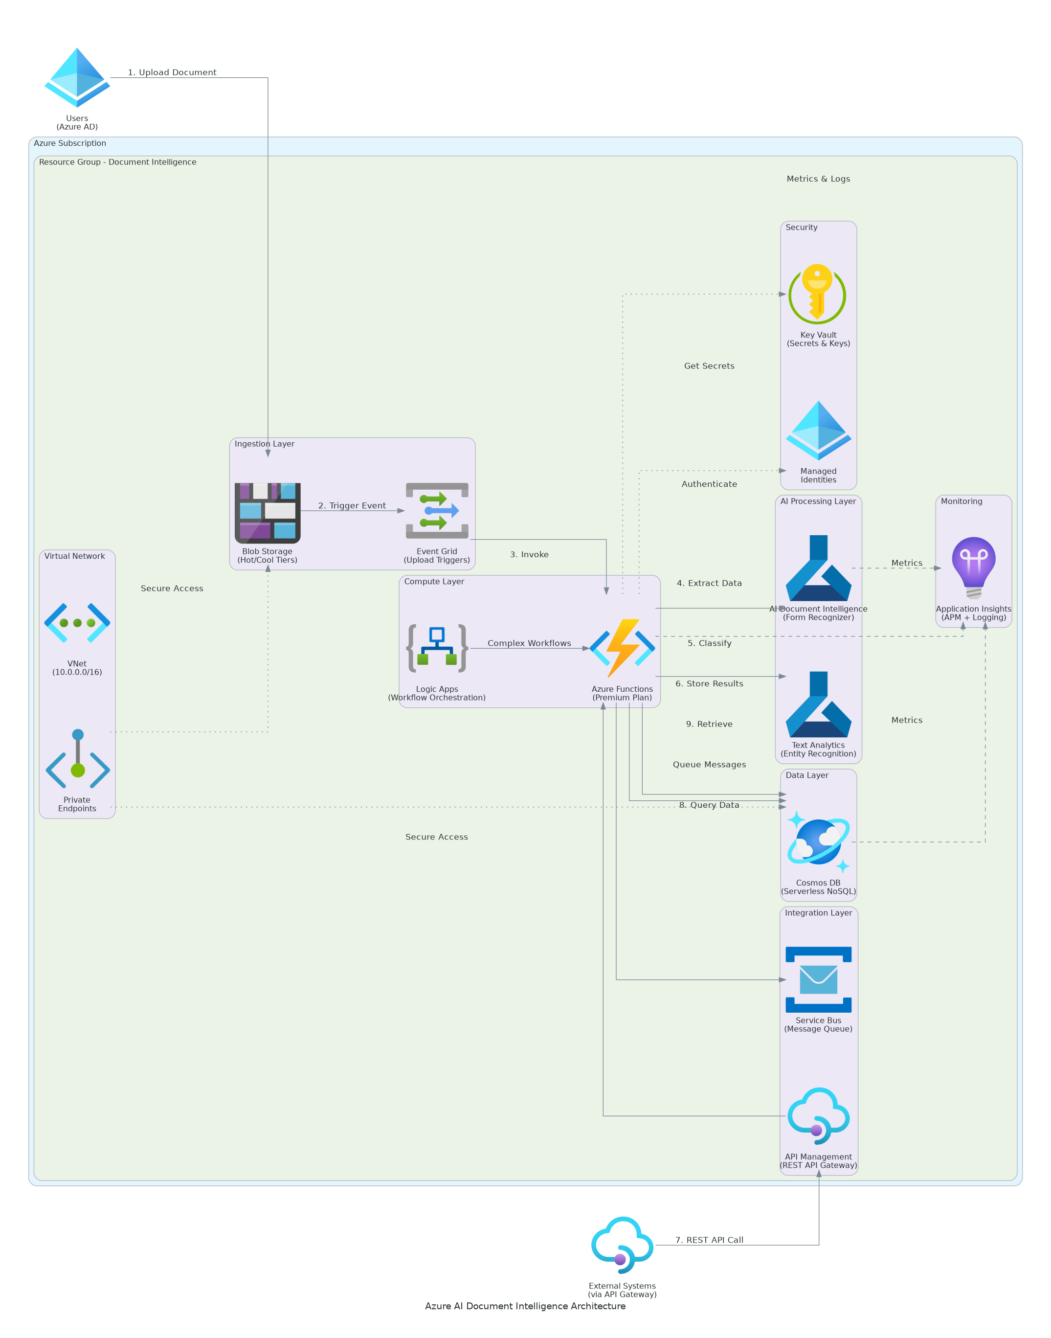
Figure 1: Solution Architecture

4.1 Architecture Principles
The following principles guide all architectural decisions throughout the solution design.
• Cloud-Native Design: Leverage Azure managed services to reduce operational burden
• Security by Design: Implement defense in depth with Zero Trust principles
• Serverless First: Use Azure Functions for event-driven, scalable processing
• Infrastructure as Code: All infrastructure defined in Bicep templates and version-controlled
• Observability: Comprehensive monitoring, logging, and alerting with Azure Monitor

4.2 Architecture Patterns
The solution implements the following architectural patterns to address scalability and reliability requirements.
• Primary Pattern: Event-driven serverless processing with Azure Functions
• Data Pattern: Document storage with metadata in Cosmos DB
• Integration Pattern: REST APIs with retry logic and dead-letter queues
• Deployment Pattern: Blue-green with Infrastructure as Code automation

4.3 Component Design
The solution comprises the following logical components, each with specific responsibilities and scaling characteristics.
Component | Purpose | Technology | Dependencies | Scaling
API Management | Request routing, authentication | Azure API Management | Azure AD | Managed
Processing Engine | Document orchestration | Azure Functions Premium | Doc Intelligence | Horizontal
AI/ML Services | OCR and extraction | Azure Document Intelligence | None | Managed
Document Storage | Input and processed docs | Azure Blob Storage | Key Vault | Managed
Metadata Store | Processing state, results | Azure Cosmos DB | Key Vault | Serverless
Secrets Management | API keys, connection strings | Azure Key Vault | Azure AD | Managed
Table 4: Solution Components

4.4 Technology Stack
The technology stack has been selected based on requirements for scalability, maintainability, and alignment with Azure best practices.
Layer | Technology | Rationale
AI/ML | Azure Document Intelligence | Pre-built and custom models for document extraction
Compute | Azure Functions Premium (EP1) | Serverless with VNet integration support
Storage | Azure Blob Storage | Scalable document storage with lifecycle policies
Database | Azure Cosmos DB Serverless | Flexible schema for metadata with auto-scaling
Monitoring | Azure Monitor + App Insights | Integrated monitoring, logging, and alerting
Security | Azure Key Vault + Managed Identity | Centralized secrets with passwordless auth
Table 5: Technology Stack

5 Security & Compliance
This section details the security controls, compliance mappings, and governance mechanisms implemented in the solution.

5.1 Identity & Access Management
Access control follows a zero-trust model with Azure AD integration and managed identities.
• Authentication: Azure AD with OAuth 2.0 for user and service authentication
• Authorization: Role-based access control (RBAC) with least privilege
• MFA: Required for all administrative access via Azure AD conditional access
• Service Accounts: User-assigned managed identities for all Azure service authentication

5.1.1 Role Definitions
The following roles define access levels within the system, following the principle of least privilege.
Role | Permissions | Scope
Administrator | Full system access, configuration changes | All Azure resources
Operator | Monitor dashboards, basic troubleshooting | Production environment
Reviewer | Human review queue access, correction submission | Review application
User | Document submission only | API and upload interface
Table 6: Role Permissions

5.2 Secrets Management
All sensitive credentials are managed through Azure Key Vault with managed identity access.
• Azure Key Vault for all API keys, connection strings, and certificates
• Automatic rotation for Document Intelligence API keys (90-day cycle)
• Managed identity access eliminates stored credentials in code
• No secrets in code repositories or configuration files

5.3 Network Security
Network security implements defense-in-depth with private endpoints and network isolation.
• VNet Integration: Azure Functions deployed with VNet integration
• Private Endpoints: All Azure services accessed via private endpoints
• Network Security Groups: Deny-by-default with explicit allow rules
• No Public Access: Storage and Cosmos DB public access disabled

5.4 Data Protection
Data protection controls ensure confidentiality and integrity throughout the document lifecycle.
• Encryption at Rest: Azure Storage Service Encryption with customer-managed keys
• Encryption in Transit: TLS 1.2+ for all communications
• Key Management: Azure Key Vault with customer-controlled key rotation
• Data Classification: Documents tagged with sensitivity levels

5.5 Compliance Mappings
The following table maps compliance requirements to specific implementation controls.
Framework | Requirement | Implementation
SOC 2 | Access control | Azure AD RBAC, MFA, audit logging
SOC 2 | Encryption | AES-256 at rest, TLS 1.2 in transit
SOC 2 | Audit logging | Azure Monitor, Log Analytics retention
GDPR | Data residency | East US region deployment only
GDPR | Right to erasure | Automated data deletion workflows
Table 7: Compliance Requirements

5.6 Audit Logging & SIEM Integration
Comprehensive audit logging supports security monitoring and compliance requirements.
• All authentication events logged to Log Analytics workspace
• Document processing events captured with full metadata
• Administrative actions logged with user context and timestamp
• Log retention: 90 days hot storage, 365 days archive
• Azure Monitor alerts for security-relevant events

6 Data Architecture
This section defines the data model, storage strategy, migration approach, and governance controls for the solution.

6.1 Data Model

6.1.1 Conceptual Model
The solution manages the following core entities:
• Documents: Uploaded documents with metadata and processing state
• Extraction Results: Structured data extracted from documents
• Processing Events: Audit trail of all processing activities
• Configurations: System settings and model configurations

6.1.2 Logical Model
The logical data model defines the primary entities and their relationships within the system.
Entity | Key Attributes | Relationships | Volume
Document | ID, type, status, uploaded_at | Has many ExtractionResults | 2,000/month
ExtractionResult | ID, document_id, fields, confidence | Belongs to Document | 2,000/month
ProcessingEvent | ID, document_id, event_type, timestamp | References Document | 10,000/month
Configuration | ID, model_id, threshold, updated_at | None | < 100
Table 8: Data Model Entities

6.2 Data Flow Design
1. Ingestion: Documents uploaded to input Blob Storage container via API or direct upload
2. Trigger: Blob trigger fires Azure Function for document processing
3. Analysis: Document Intelligence service extracts text and structured data
4. Routing: Confidence check determines automatic approval or human review
5. Integration: Approved data transmitted to ERP/CRM via REST APIs
6. Archive: Processed documents moved to archive container with lifecycle policies

6.3 Data Migration Strategy
Data migration follows a phased approach to minimize risk and ensure data integrity.
• Approach: Net-new implementation with no historical document migration required
• Validation: Sample document testing during UAT phase
• Rollback: Manual fallback available throughout transition period
• Cutover: Phased cutover with parallel processing during transition

6.4 Data Governance
Data governance policies ensure proper handling, retention, and quality management.
• Classification: Documents classified by type (invoice, receipt, form)
• Retention: 7 years in archive storage with lifecycle policies
• Quality: Automated validation rules with confidence thresholds
• Access: Role-based with full audit logging

7 Integration Design
This section documents the integration patterns, APIs, and external system connections.

7.1 External System Integrations
The solution integrates with the following external systems using standardized protocols and error handling.
System | Type | Protocol | Format | Error Handling | SLA
ERP System | Real-time | REST/HTTPS | JSON | Retry with backoff | 99.5%
CRM System | Batch | REST/HTTPS | JSON | Dead letter queue | 99.5%
Human Review | Real-time | Internal API | JSON | Queue persistence | 99.9%
Azure AD | Real-time | OAuth 2.0 | JWT | Failover to cache | 99.99%
Table 9: System Integrations

7.2 API Design

7.2.1 API Standards
All APIs follow RESTful design principles with OpenAPI 3.0 documentation.
• Authentication: OAuth 2.0 bearer tokens via Azure AD
• Versioning: URL path versioning (v1, v2)
• Rate Limiting: 1,000 requests per minute per client
• Error Handling: Standard HTTP status codes with JSON error bodies

7.2.2 API Endpoints
The following endpoints are exposed for document processing operations.
Endpoint | Method | Purpose | Response
/api/v1/documents | POST | Submit document for processing | Document ID, status
/api/v1/documents/{id} | GET | Get document processing status | Status, metadata
/api/v1/documents/{id}/results | GET | Get extraction results | Extracted data
/api/v1/documents | GET | List documents with filters | Document list
Table 10: API Endpoints

7.3 Integration Error Handling
Integration error handling ensures resilience and data consistency.
• Retry Policy: Exponential backoff with 3 retries (1s, 5s, 30s)
• Circuit Breaker: Open after 5 consecutive failures, half-open after 60s
• Dead Letter Queue: Failed messages retained for 7 days for analysis
• Alerting: Immediate notification on integration failure patterns

8 Infrastructure & Operations
This section defines the infrastructure components, deployment approach, and operational procedures.

8.1 Infrastructure Components

8.1.1 Compute Resources
Resource | SKU | Configuration | Purpose
Azure Functions | Premium EP1 | VNet integrated, 1-10 instances | Document processing
App Service Plan | Premium V3 | Reserved capacity for Functions | Compute hosting
Table 11: Resource

8.1.2 Storage Resources
Resource | SKU | Configuration | Purpose
Blob Storage | Standard GRS | Hot/Cool/Archive tiers | Document storage
Cosmos DB | Serverless | Point-in-time recovery | Metadata storage
Key Vault | Standard | Soft delete enabled | Secrets management
Table 12: Resource

8.1.3 AI/ML Resources
Resource | SKU | Configuration | Purpose
Document Intelligence | S0 | Standard tier | OCR and extraction
Custom Models | Included | 3 document types trained | Form processing
Table 13: Resource

8.2 High Availability Design
The solution implements high availability through Azure managed service capabilities.
• Azure Functions: Auto-scaling with health probes
• Storage: GRS replication with automatic failover
• Cosmos DB: Multi-region write capability (single region per SOW)
• Document Intelligence: Azure-managed high availability

8.3 Disaster Recovery
Disaster recovery procedures ensure business continuity in the event of regional failure.
• RTO: 4 hours for full service restoration
• RPO: 1 hour for data consistency
• Backup: Daily automated backups with 30-day retention
• Recovery: Infrastructure as Code enables rapid rebuild from Bicep templates

8.4 Monitoring Strategy
Comprehensive monitoring ensures operational visibility and proactive issue detection.
• Azure Monitor: Infrastructure metrics, alerts, and dashboards
• Application Insights: Application performance monitoring
• Log Analytics: Centralized logging with KQL queries
• Alerting: Email and Teams notifications for critical events

9 Implementation Approach
This section outlines the phased implementation strategy for the solution.

9.1 Implementation Phases
The implementation follows a phased approach with validation gates at each stage.
Phase | Activities | Duration | Exit Criteria
Phase 1 | Foundation and model training | 6 weeks | AI models trained with 90%+ accuracy
Phase 2 | Pipeline development and integration | 5 weeks | End-to-end processing working
Phase 3 | Optimization and production deployment | 5 weeks | Go-live with 95%+ accuracy
Table 14: Implementation Phases

9.2 Deployment Strategy
Deployment follows Infrastructure as Code principles with Bicep templates.
• Environment Promotion: Dev to staging to production with same templates
• Feature Flags: Controlled feature activation during rollout
• Rollback: Quick recovery via Bicep redeployment
• Validation: Automated testing at each promotion stage

9.3 Migration Approach
Migration follows a phased cutover strategy to minimize risk.
• Parallel Processing: Run manual and automated in parallel during transition
• Gradual Shift: 25% to 75% to 100% automated over 3 weeks
• Fallback: Manual processing available throughout transition
• Validation: Daily accuracy checks during cutover period

10 Appendices

10.1 Appendix A: Azure Resource Naming Convention
All Azure resources follow the naming convention: `{resource-type}-{solution}-{environment}-{region}-{instance}`
Example: `func-docintel-prod-eus-001`

10.2 Appendix B: Network Architecture Details

10.2.1 IP Address Allocation
Subnet | CIDR | Purpose
Functions | 10.0.1.0/24 | Azure Functions VNet integration
Private Endpoints | 10.0.2.0/24 | Private endpoint connections
Table 15: Subnet

10.3 Appendix C: Glossary
• Document Intelligence: Azure AI service for document OCR and extraction
• Pre-built Model: Microsoft-trained model for common document types
• Custom Model: Client-trained model for organization-specific documents
• Confidence Score: AI certainty level for extracted field values (0-100%)
• Human Review: Manual verification process for low-confidence extractions


eoframework.org

