Multiple Detection
library(RColorBrewer)
library(ggplot2)
library(gridExtra)
library(dplyr)
library(forecast)
library(daltoolbox)
library(daltoolboxdp)
library(tspredit)
library(harbinger)
source("https://raw.githubusercontent.com/eogasawara/TSED/refs/heads/main/code/header.R")

Theoretical Overview
This appendix shows how to run multiple detectors on the same series and combine their outputs into an integrated view. ## Example Overview and Goals We will: load a non-stationary series, run FBIAD, LSTM, and GFT detectors, print detections for each, and build a combined detection mask. ### Libraries and Setup Load only the packages required by this appendix, then source the shared helpers.
library(RColorBrewer)
library(ggplot2)
library(gridExtra)
library(dplyr)
library(forecast)
library(daltoolbox)
library(daltoolboxdp)
library(tspredit)
library(harbinger)
source("https://raw.githubusercontent.com/eogasawara/TSED/refs/heads/main/code/header.R")

What You Will Do
Run three detectors (FBIAD, LSTM, GFT), inspect results, and combine detections. ### Data Loading and Prep Load a non-stationary example series.
data(examples_harbinger)

Other Steps
Additional supporting steps that glue the workflow.
dataset <- examples_harbinger$nonstationarity

Visualization and Output
Plot the series with detected events and optionally save figures. Combine ggplot layers in one chunk for clarity.
har_plot(harbinger(), dataset$serie)
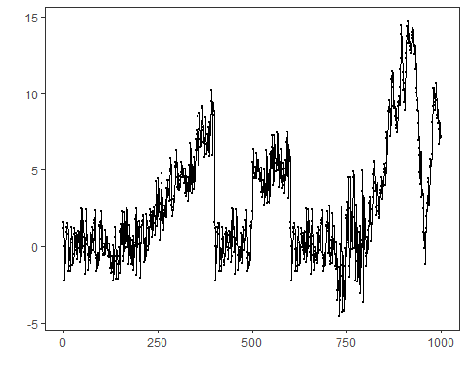 ### Detector A: FBIAD Configure and fit FBIAD, then detect events. ### Model Configuration Define the detector/model and its key hyperparameters.
model_a <- hanr_fbiad()

Other Steps
Additional supporting steps that glue the workflow.
model_a <- fit(model_a, dataset$serie)

Event Detection
Run the detector to obtain event flags or scores.
detection_a <- detect(model_a, dataset$serie)

Other Steps
Additional supporting steps that glue the workflow.
print(detection_a |> dplyr::filter(event == TRUE))
## idx event type
## 1 394 TRUE anomaly
## 2 400 TRUE anomaly
## 3 401 TRUE anomaly
## 4 414 TRUE anomaly
## 5 593 TRUE anomaly
## 6 598 TRUE anomaly
## 7 604 TRUE anomaly
## 8 756 TRUE anomaly
## 9 938 TRUE anomaly
## 10 941 TRUE anomaly
## 11 943 TRUE anomaly
## 12 949 TRUE anomaly
## 13 959 TRUE anomaly
## 14 979 TRUE anomaly
## 15 982 TRUE anomaly

Visualization and Output
Plot the series with detected events and optionally save figures. Combine ggplot layers in one chunk for clarity.
grfa <- har_plot(model_a, dataset$serie, detection_a, dataset$event) +
labs(caption = "(a) FBIAD") + theme(plot.caption = element_text(hjust = 0.5)) + font

Detector B: LSTM
Configure and fit LSTM-based detector, then detect events. ### Model Configuration Define the detector/model and its key hyperparameters.
model_b <- hanr_ml(ts_lstm(ts_norm_diff(), input_size = 4, epochs = 10000))

Other Steps
Additional supporting steps that glue the workflow.
model_b <- fit(model_b, dataset$serie)

Event Detection
Run the detector to obtain event flags or scores.
detection_b <- detect(model_b, dataset$serie)

Other Steps
Additional supporting steps that glue the workflow.
print(detection_b |> dplyr::filter(event == TRUE))
## idx event type
## 1 401 TRUE anomaly
## 2 501 TRUE anomaly
## 3 601 TRUE anomaly
## 4 732 TRUE anomaly
## 5 737 TRUE anomaly
## 6 747 TRUE anomaly
## 7 750 TRUE anomaly
## 8 756 TRUE anomaly
## 9 758 TRUE anomaly
## 10 761 TRUE anomaly
## 11 768 TRUE anomaly
## 12 771 TRUE anomaly
## 13 774 TRUE anomaly
## 14 787 TRUE anomaly
## 15 795 TRUE anomaly

Visualization and Output
Plot the series with detected events and optionally save figures. Combine ggplot layers in one chunk for clarity.
grfb <- har_plot(model_b, dataset$serie, detection_b, dataset$event) +
labs(caption = "(b) LSTM") + theme(plot.caption = element_text(hjust = 0.5)) + font

Detector C: GFT
Configure and fit graph Fourier transform-based detector, then detect events. ### Model Configuration Define the detector/model and its key hyperparameters.
model_c <- hcp_gft()

Other Steps
Additional supporting steps that glue the workflow.
model_c <- fit(model_c, dataset$serie)

Event Detection
Run the detector to obtain event flags or scores.
detection_c <- detect(model_c, dataset$serie)

Other Steps
Additional supporting steps that glue the workflow.
print(detection_c |> dplyr::filter(event == TRUE))
## idx event type
## 1 178 TRUE changepoint
## 2 400 TRUE changepoint
## 3 600 TRUE changepoint
## 4 850 TRUE changepoint

Visualization and Output
Plot the series with detected events and optionally save figures. Combine ggplot layers in one chunk for clarity.
grfc <- har_plot(model_c, dataset$serie, detection_c, dataset$event) +
labs(caption = "(c) GFT") + theme(plot.caption = element_text(hjust = 0.5)) + font

Integrated View
Combine detections by logical OR and label non-GFT positives as anomalies.
detection_d <- detection_c
detection_d$event <- detection_a$event | detection_b$event | detection_c$event
detection_d$type[(!detection_c$event)] <- "anomaly"
detection_d$type[!detection_d$event] <- ""

Visualization and Output
Plot the series with detected events and optionally save figures. Combine ggplot layers in one chunk for clarity.
grfd <- har_plot(harbinger(), dataset$serie, detection_d, dataset$event) +
labs(caption = "(d) Integrated View (FBIAD+LSTM+GFT)") + theme(plot.caption = element_text(hjust = 0.5)) + font

Panel Visualization
Arrange the four panels. Uncomment to save as an image.
# mypng(file = "figures/multiple-detection.png", width = 1600, height = 1260)
gridExtra::grid.arrange(grfa, grfb, grfc, grfd,
layout_matrix = matrix(c(1, 2, 3, 4), byrow = TRUE, ncol = 2))
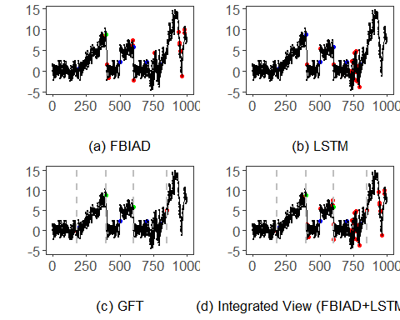
# dev.off()

References
- General: Box, G. E. P. & Jenkins, G. (1970). Time Series Analysis.
- Ogasawara, E., Salles, R., Porto, F., Pacitti, E. Event Detection in Time Series. Springer, 2025. doi:10.1007/978-3-031-75941-3.

