Threshold
library(RColorBrewer)
library(ggplot2)
library(daltoolbox)
library(harbinger)
library(gridExtra)
source("https://raw.githubusercontent.com/eogasawara/TSED/refs/heads/main/code/header.R")

Theoretical Overview
This appendix explores how different outlier thresholding strategies affect event detection results. ## Example Overview and Goals We will: run ARIMA-based detection with default thresholding, with a boxplot rule, and with a high-group consolidation rule, then compare plots. ### Libraries and Setup Load only the packages required by this appendix, then source the shared helpers.
library(RColorBrewer)
library(ggplot2)
library(daltoolbox)
library(harbinger)
library(gridExtra)
source("https://raw.githubusercontent.com/eogasawara/TSED/refs/heads/main/code/header.R")

High-Group Check Helper
When contiguous outliers are found, retain only the index with largest residual within each group.
har_outliers_checks_highgroup <- function(outliers, values) {
threshold <- attr(outliers, "threshold")
values <- abs(values)
if (is_matrix_or_df(values)) values <- rowSums(values)
size <- length(values)
group <- split(outliers, cumsum(c(1, diff(outliers) != 1)))
keep <- rep(FALSE, size)
for (g in group) {
if (length(g) > 0) {
i <- which.max(values[g]); i <- g[i]
keep[i] <- TRUE
}
}
attr(keep, "threshold") <- threshold
return(keep)
}

Data Loading and Prep
Read a simple anomalies example dataset.
data(examples_anomalies)

Other Steps
Additional supporting steps that glue the workflow.
dataset <- examples_anomalies$simple

Visualization and Output
Plot the series with detected events and optionally save figures. Combine ggplot layers in one chunk for clarity.
grf1 <- har_plot(harbinger(), dataset$serie)

ARIMA + Default Threshold
Run ARIMA detection with default thresholding. ### Model Configuration Define the detector/model and its key hyperparameters.
model <- hanr_arima()

Other Steps
Additional supporting steps that glue the workflow.
model <- fit(model, dataset$serie)

Event Detection
Run the detector to obtain event flags or scores.
detection <- detect(model, dataset$serie)

Visualization and Output
Plot the series with detected events and optionally save figures. Combine ggplot layers in one chunk for clarity.
grf2 <- har_plot(model, attr(detection, "res"), detection,
dataset$event, yline = attr(detection, "threshold"))

ARIMA + Boxplot Rule
Replace the outlier function with a boxplot rule. ### Model Configuration Define the detector/model and its key hyperparameters.
model <- hanr_arima()

Other Steps
Additional supporting steps that glue the workflow.
model$har_outliers <- harutils()$har_outliers_boxplot
model <- fit(model, dataset$serie)

Event Detection
Run the detector to obtain event flags or scores.
detection <- detect(model, dataset$serie)

Visualization and Output
Plot the series with detected events and optionally save figures. Combine ggplot layers in one chunk for clarity.
grf3 <- har_plot(model, attr(detection, "res"), detection,
dataset$event, yline = attr(detection, "threshold"))

ARIMA + High-Group Filter
Keep only the highest residual per contiguous outlier group. ### Model Configuration Define the detector/model and its key hyperparameters.
model <- hanr_arima()

Other Steps
Additional supporting steps that glue the workflow.
model$har_outliers_check <- harutils()$har_outliers_checks_highgroup
model <- fit(model, dataset$serie)

Event Detection
Run the detector to obtain event flags or scores.
detection <- detect(model, dataset$serie)

Visualization and Output
Plot the series with detected events and optionally save figures. Combine ggplot layers in one chunk for clarity.
grf4 <- har_plot(model, attr(detection, "res"), detection,
dataset$event, yline = attr(detection, "threshold"))

Panel Layout
Arrange the four panels. Uncomment to save as an image.
# mypng(file = "threshold.png", width = 1440, height = 1260)
gridExtra::grid.arrange(grf1, grf2, grf3, grf4,
layout_matrix = matrix(c(1, 2, 3, 4), byrow = TRUE, ncol = 2))
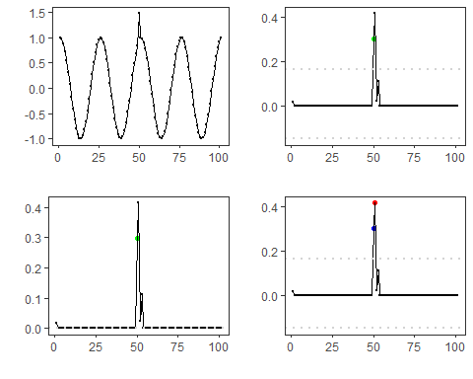
# dev.off()

References
- General: Box, G. E. P. & Jenkins, G. (1970). Time Series Analysis.
- Ogasawara, E., Salles, R., Porto, F., Pacitti, E. Event Detection in Time Series. Springer, 2025. doi:10.1007/978-3-031-75941-3.

