Chapter 1: Labeled Motif
library(ggplot2)
library(RColorBrewer)
library(daltoolbox)
library(harbinger)
source("https://raw.githubusercontent.com/eogasawara/TSED/refs/heads/main/code/header.R")

Theoretical Overview
This example focuses on motif discovery and discords (e.g., SAX/Matrix Profile). Motifs are recurring patterns; discords are anomalous subsequences. Symbolic or matrix-profile methods efficiently discover both. ## Example Overview and Goals We will: set up libraries, load a labeled dataset, configure and fit a detector, run detection, align detections with labeled motifs, and visualize the results. ### What You Will Do You will: prepare the environment, load a labeled ECG dataset, fit a detector, detect motifs/discords, map labels for clarity, and visualize the outcome. ### Setup and Libraries Load project utilities and required packages.
# Shared helpers (themes, saving utilities, etc.)

Data Loading and Prep
Read the dataset and perform minimal preparation for modeling.
# Load example motif datasets
data(examples_motifs)
# Select a labeled ECG time series (MIT-BIH record 102)
data <- examples_motifs$mitdb102
rownames(data) <- 1:nrow(data) # ensure a simple, sequential index

Model Configuration and Detection
Configure a generic detector and run detection on the labeled series.
# Fit a default Harbinger detector and detect candidate events
model <- fit(harbinger(), data$serie)
detection <- detect(model, data$serie)

Label Alignment
Map labels for better interpretability in the inspection and plot.
# Add optional descriptive fields: type, sequence id, and sequence length
detection$type <- NA
detection$seq <- NA
detection$seqlen <- NA
# Mark labeled events as motifs for clarity in downstream visualization
detection$event[data$event] <- TRUE
detection$type[data$event] <- "motif"
detection$seq[data$event] <- 1
detection$seqlen[data$event] <- 50
# Show only detected (or labeled) events
print(detection[detection$event, ])
## idx event type seq seqlen
## 3290 3290 TRUE motif 1 50
## 3587 3587 TRUE motif 1 50
## 3889 3889 TRUE motif 1 50

Visualization and Output
Plot the series with detected/labeled events and save the figure.
grf <- har_plot(model, data$serie, detection, data$event) +
font +
theme(axis.text.x = element_text(angle = 90, vjust = 0.5, hjust = 1))
#save_png(grf, "figures/chap1_labeled_motif.png", 1280, 720)
grf
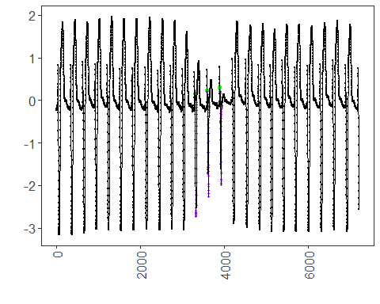 ## References * Yeh, C.-C. M., et al. (2016). Matrix Profile I: All Pairs Similarity Joins for Time Series. * Ogasawara, E., Salles, R., Porto, F., Pacitti, E. Event Detection in Time Series. Springer, 2025. doi:10.1007/978-3-031-75941-3.

