Chapter 1: Ygt Detect Arima
library(ggplot2)
library(RColorBrewer)
library(daltoolbox)
library(harbinger)
source("https://raw.githubusercontent.com/eogasawara/TSED/refs/heads/main/code/header.R")

Theoretical Overview
This example focuses on ARIMA-based modeling and residual detection. Autoregressive Integrated Moving Average (ARIMA) models capture autocorrelation and trend; events are indicated by unusual residuals or structural breaks. ## Example Overview and Goals We will: set up libraries, load data, configure and fit an ARIMA-based detector, run detection, inspect results, and visualize the output. ### What You Will Do You will: prepare the environment, load a dataset, configure an ARIMA-based detector, fit it, detect events, inspect detections, and visualize the results. ### Setup and Libraries Load project utilities and required packages.
# Shared helpers (themes, saving utilities, etc.)

Data Loading and Prep
Read the dataset and prepare it for modeling.
# Load example time series
data(examples_harbinger)
# Select yearly global temperature series and initialize labels
data <- examples_harbinger$global_temperature_yearly
data$event <- FALSE

Model Configuration
Define the ARIMA-based detector and key options.
# ARIMA-based anomaly/residual detector
model <- hanr_arima()

Fit the Model
Train (fit) the detector to the time series.
model <- fit(model, data$serie)

Event Detection
Run the detector to produce event flags and scores.
detection <- detect(model, data$serie)

Inspect Results
Display detected events, if any, for a quick check.
print(detection |> dplyr::filter(event == TRUE))
## idx event type
## 1 28 TRUE anomaly
## 2 115 TRUE anomaly
## 3 141 TRUE anomaly

Visualization and Output
Plot the series with detected events and save the figure.
grf <- har_plot(model, data$serie, detection, data$event, idx = data$i) +
font +
scale_x_date(
breaks = "10 years",
date_labels = "%Y",
limits = c(as.Date("1850-01-01"), as.Date("2030-01-01"))
) +
theme(axis.text.x = element_text(angle = 90, vjust = 0.5, hjust = 1))
#save_png(grf, "figures/chap1_ygt_detect_arima.png", 1280, 720)
grf
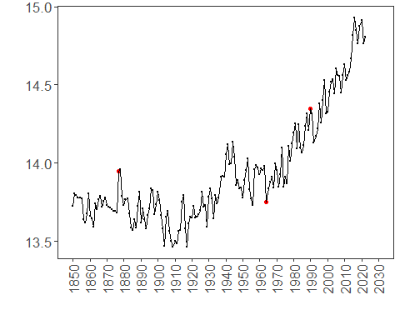 ## References * Box, G. E. P., Jenkins, G. M., Reinsel, G. C., & Ljung, G. M. (2015). Time Series Analysis: Forecasting and Control. * Ogasawara, E., Salles, R., Porto, F., Pacitti, E. Event Detection in Time Series. Springer, 2025. doi:10.1007/978-3-031-75941-3.

