Periodicidade Implicita

Theoretical Overview
This example focuses on Motif discovery and discords (SAX/Matrix Profile). Motifs are recurring patterns; discords are anomalous subsequences. Symbolic or matrix-profile methods efficiently discover them. ## Example Overview and Goals We demonstrate a complete, reproducible workflow: setting up libraries, loading data, configuring a detector, fitting it, running detection, optionally evaluating, and visualizing the results. ### Other Steps Additional supporting steps that glue the workflow.
## Implicit Periodicity Detection (English, commented)
# Parameters for a synthetic sinusoidal time series
n <- 1024 # number of observations
period <- 9 # seasonality period (e.g., 9 time steps)
amplitude <- 5 # sinusoid amplitude
# Generate the series: sinusoid + Gaussian noise
t <- 1:n
seasonality <- amplitude * sin(2 * pi * t / period)
noise <- rnorm(n, mean = 0, sd = 2)
ts_data <- ts(10 + seasonality + noise)

Visualization and Output
Plot the series with detected events and optionally save figures. Combine ggplot layers in one chunk for clarity.
plot(
ts_data,
main = paste("Series with implicit seasonality (period ~", period, ")"),
ylab = "Value",
xlab = "Time"
)
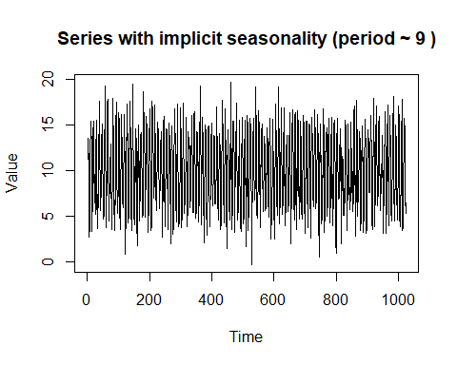 ### Other Steps Additional supporting steps that glue the workflow.
# ACF configuration
lag.max <- 36
# Compute ACF without plotting
acf_obj <- acf(ts_data, lag.max = lag.max, plot = FALSE)
# Consider lags from 1 to lag.max (remove lag 0)
lags <- 1:lag.max
acf_vals <- acf_obj$acf[-1]
# 95% significance threshold for the ACF values
sig_limit <- qnorm((1 + 0.95)/2) / sqrt(length(ts_data))
# Keep significant lags (not used below but informative)
significant_lags <- lags[abs(acf_vals) > sig_limit]
# Heuristic function to estimate periodicity from ACF local maxima
find_periodicity <- function(acf_vals, lags, span = 3) {
# Detect local maxima in a sliding window of size 'span'
n <- length(acf_vals)
peak_indices <- c()
for (i in (span + 1):(n - span)) {
window <- acf_vals[(i - span):(i + span)]
center <- acf_vals[i]
if (center == max(window) && center > 0) {
peak_indices <- c(peak_indices, i)
}
}
# Case 1: multiple peaks — use the most frequent spacing between peaks
if (length(peak_indices) >= 2) {
if (max(peak_indices) <= length(lags)) {
lag_peaks <- lags[peak_indices]
spacing <- diff(lag_peaks)
period_mode <- as.numeric(names(sort(table(spacing), decreasing = TRUE)[1]))
return(period_mode)
}
}
# Case 2: single peak — return the corresponding lag
if (length(peak_indices) == 1) {
return(lags[peak_indices])
}
# No clear periodicity
return(NULL)
}
period_est <- find_periodicity(acf_vals, lags)
if (!is.null(period_est)) {
message("Estimated implicit periodicity: ~", period_est, " lags.")
} else {
message("No clear periodicity detected.")
}
## Estimated implicit periodicity: ~9 lags.
# ACF visualization
acf(ts_data, lag.max = lag.max, main = "ACF - Implicit Seasonality Detection")
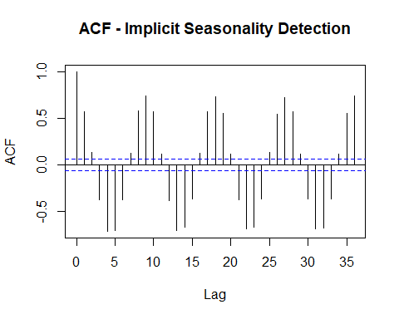 ## References * Yeh, C.-C. M., et al. (2016). Matrix Profile I: All Pairs Similarity Joins for Time Series. * Ogasawara, E., Salles, R., Porto, F., Pacitti, E. Event Detection in Time Series. Springer, 2025. doi:10.1007/978-3-031-75941-3.

