Chapter 2: Sw
library(ggplot2)
library(RColorBrewer)
library(ggpmisc)
library(daltoolbox)
source("https://raw.githubusercontent.com/eogasawara/TSED/refs/heads/main/code/header.R")

Theoretical Overview
This example focuses on sliding windows for feature construction and visualization. ## Example Overview and Goals We will: set up libraries, load a short slice of the series, compute color-coded sliding windows, and visualize how windows relate to the time axis. ### What You Will Do You will: prepare the environment, build sliding windows of size 3, and plot colored tiles aligned with the series. ### Setup and Libraries Short rationale for the libraries and any project-specific sources.
options(scipen = 999)

Other Steps
Additional supporting steps that glue the workflow. ### Other Steps Additional supporting steps that glue the workflow.
# Load example dataset

Data Loading and Prep
Read the dataset and perform any minimal preparation required for modeling.
data(examples_harbinger)

Other Steps
Additional supporting steps that glue the workflow.
data <- examples_harbinger$global_temperature_yearly
data <- data[(nrow(data)-23+1):nrow(data),]
y <- data$serie
n <- length(y)
obj <- smoothing_freq(n = 9)
obj <- fit(obj, y)
yl <- transform(obj, y)
yl <- as.integer(names(yl))
colorsg <- brewer.pal(9, 'Greys')
colors <- colorsg[yl]
bcolors <- rep("black", n)
ats <- function(y) {
yts <- ts(y, frequency=1, start = c(2000, 1))
return(yts)
}
sw_size <- 3
xw <- ts_data(y, sw_size)
xw <- round(xw, 2)
xwt <- as.data.frame(xw)
xwt$sw <- 1:nrow(xwt)
xwt <- xwt |> dplyr::select(sw, t2, t1, t0)
xwt <- head(xwt, 5)
xwt$sw <- as.character(xwt$sw)
xwt$t2 <- as.character(xwt$t2)
xwt$t1 <- as.character(xwt$t1)
xwt$t0 <- as.character(xwt$t0)
xwt <- rbind(xwt, data.frame(sw = '...', t2 = '...', t1 = '...', t0 = '...'))
colnames(xwt) <- c('sw', 't-2', 't-1', 't')
xwt <- (xwt)
colors <- colorsg[yl]
bcolors <- rep("black", n)
yb <- ats(rep(14.25, n))
ysw1 <- ats(rep(14.15, n))
ysw1[1:(sw_size-1)] <- NA
ysw2 <- ysw1 - 0.025
ysw3 <- ysw2 - 0.025
colors1 <- c(rep(NA, 2), colors[3:n])
colors2 <- c(rep(NA, 2), colors[2:(n-1)])
colors3 <- c(rep(NA, 2), colors[1:(n-2)])

Visualization and Output
Plot the series with detected events and optionally save figures. Combine ggplot layers in one chunk for clarity.
grf <- autoplot(ats(y)) + theme_bw(base_size = 10) + geom_point(size=1)
grf <- grf + theme(plot.title = element_blank())
grf <- grf + theme(panel.grid.major = element_blank()) + theme(panel.grid.minor = element_blank())
grf <- grf + ylab("temperature")
grf <- grf + xlab("year")
grf <- grf + ggplot2::annotate(geom="table", x = 2000, y = 15, label = list(xwt), size = 5)
grf <- grf + ggplot2::annotate(geom="text", x=2013, y=14.3, label="colored representatation for the time series", color="black")
grf <- grf + geom_tile(aes(y=yb), height=0.025, width=1, size = 1, fill = colors, color=bcolors, alpha=0.5)
grf <- grf + ggplot2::annotate(geom="text", x=2013, y=14.2, label="colored representatation for the sliding windows of size 3", color="black")
grf <- grf + ggplot2::annotate(geom="text", x=2001, y=ysw1[4], label="t", color="black")
grf <- grf + geom_tile(aes(y=ysw1), height=0.025, width=1, size = 1, fill = colors1, color=bcolors, alpha=0.5)
grf <- grf + ggplot2::annotate(geom="text", x=2001, y=ysw2[4], label="t-1", color="black")
grf <- grf + geom_tile(aes(y=ysw2), height=0.025, width=1, size = 1, fill = colors2, color=bcolors, alpha=0.5)
grf <- grf + ggplot2::annotate(geom="text", x=2001, y=ysw3[4], label="t-2", color="black")
grf <- grf + geom_tile(aes(y=ysw3), height=0.025, width=1, size = 1, fill = colors3, color=bcolors, alpha=0.5)
grf <- grf + font

Visualization and Output
Plot the series with detected events and optionally save figures. Combine ggplot layers in one chunk for clarity.
#save_png(grf, "figures/chap2_sw.png", width = 1280, height = 720)
grf
## Warning: Removed 2 rows containing missing values or values outside the scale range (`geom_tile()`).
## Removed 2 rows containing missing values or values outside the scale range (`geom_tile()`).
## Removed 2 rows containing missing values or values outside the scale range (`geom_tile()`).
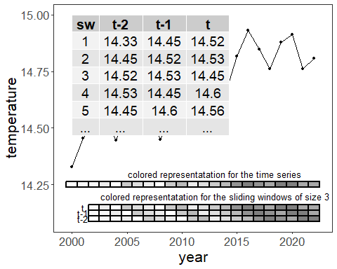 ### Other Steps Additional supporting steps that glue the workflow. ## References * General: Box, G. E. P. & Jenkins, G. (1970). Time Series Analysis. * Ogasawara, E., Salles, R., Porto, F., Pacitti, E. Event Detection in Time Series. Springer, 2025. doi:10.1007/978-3-031-75941-3.

