Chapter 3: Example
library(ggplot2)
library(RColorBrewer)
library(daltoolbox)
library(harbinger)
source("https://raw.githubusercontent.com/eogasawara/TSED/refs/heads/main/code/header.R")

Theoretical Overview
This example demonstrates a simple event-detection workflow using Harbinger on a labeled time series with a clear train/test split. We show how to fit, detect, and visualize detections against ground-truth labels. ## Example Overview and Goals We will: load a toy dataset, split it into train/test, fit a baseline detector, run detection on the full series, and produce a plot overlaying detections and labels. ### Knitr Options Keep the output readable by suppressing non-essential noise.

Setup and Libraries
Load project helpers and the required packages.
library(ggplot2)
library(RColorBrewer)
library(daltoolbox)
library(harbinger)
source("https://raw.githubusercontent.com/eogasawara/TSED/refs/heads/main/code/header.R")

Data
Load the example dataset with labeled anomalies and inspect its structure.
data("examples_anomalies") # built-in toy anomalous series
dataset <- examples_anomalies$tt_warped # choose time-warped example
dataset$event <- factor(dataset$event, labels = c("FALSE", "TRUE"))
head(dataset)
## serie event
## 1 1.0000000 FALSE
## 2 0.9689124 FALSE
## 3 0.8775826 FALSE
## 4 0.7316889 FALSE
## 5 0.5403023 FALSE
## 6 0.3153224 FALSE

Train/Test Split and Exploratory Plot
Create a simple temporal split and visualize the raw series.
# Quick look at the raw series
plot_ts(x = seq_along(dataset$serie), y = dataset$serie)
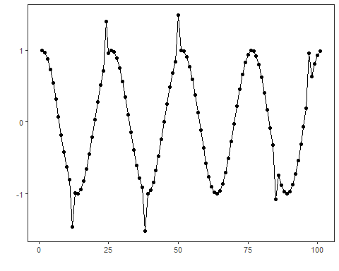
# Keep label levels for later use (optional)
slevels <- levels(dataset$event)
# Temporal split: first 75 points for training, the rest for testing
train <- dataset[1:75, ]
test <- dataset[-(1:75), ]

Model Configuration
Use a default Harbinger detector (baseline choice for illustration).
model <- harbinger()

Fit and Detect
Fit on the training subset and run detection on the full sequence.
model <- fit(model, train$serie) # fit on training window
detection <- detect(model, dataset$serie) # detect over full series
grf <- har_plot(model, dataset$serie, detection, as.logical(dataset$event))
grf <- grf + geom_vline(xintercept = 75, col = "black", linetype = "dashed")
grf <- grf + font

Visualization and Output
Plot detections, show the train/test delimiter, and save the figure.
#save_png(grf, "figures/chap3_example.png", 1280, 720)
grf
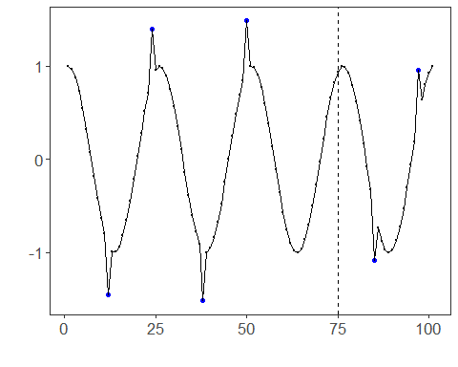 ## References * Yeh, C.-C. M., et al. (2016). Matrix Profile I: All Pairs Similarity Joins for Time Series. * Ogasawara, E., Salles, R., Porto, F., Pacitti, E. Event Detection in Time Series. Springer, 2025. doi:10.1007/978-3-031-75941-3.

