Chapter 3: Kmeans
library(ggplot2)
library(RColorBrewer)
library(daltoolbox)
library(harbinger)
source("https://raw.githubusercontent.com/eogasawara/TSED/refs/heads/main/code/header.R")

Theoretical Overview
This example focuses on k-means clustering. Clustering time windows and labeling outliers can identify unusual behavior segments. ## Example Overview and Goals We will: load a labeled toy series, configure k-means on windowed features, detect cluster outliers, evaluate, and visualize. ### What You Will Do Prepare the environment, run k-means-based detection, print/evaluate detections, and plot. ### Setup and Libraries Load helpers and packages.

Data Loading and Prep
Load a toy anomalies dataset.
data("examples_anomalies")
dataset <- examples_anomalies$tt_warped

Other Steps
Additional supporting steps that glue the workflow.
plot_ts(x = seq_along(dataset$serie), y = dataset$serie)
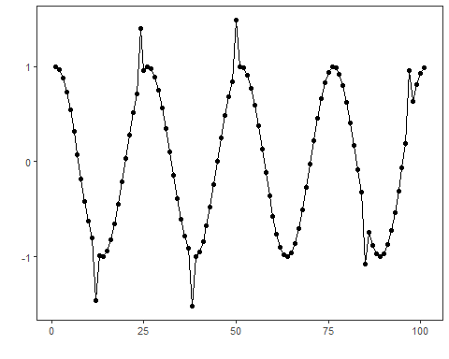
model <- hanct_kmeans(1)
model <- fit(model, dataset$serie)

Event Detection
Run the detector to obtain event flags or scores.
detection <- detect(model, dataset$serie)

Other Steps
Additional supporting steps that glue the workflow.
print(detection |> dplyr::filter(event == TRUE))
## idx event type
## 1 12 TRUE anomaly
## 2 38 TRUE anomaly
## 3 50 TRUE anomaly

Evaluation
Compute evaluation metrics or diagnostics if ground truth is available.
evaluation <- daltoolbox::evaluate(model, detection$event, dataset$event)

Other Steps
Additional supporting steps that glue the workflow.
print(evaluation$confMatrix)
## event
## detection TRUE FALSE
## TRUE 3 0
## FALSE 3 95

Visualization and Output
Plot the series with detected events and optionally save figures. Combine ggplot layers in one chunk for clarity.
grf <- har_plot(model, dataset$serie, detection, dataset$event)

Other Steps
Additional supporting steps that glue the workflow.
grf <- grf + font

Visualization and Output
Plot the series with detected events and optionally save figures. Combine ggplot layers in one chunk for clarity.
#save_png(grf, "figures/chap3_kmeans.png", 1280, 720)
grf
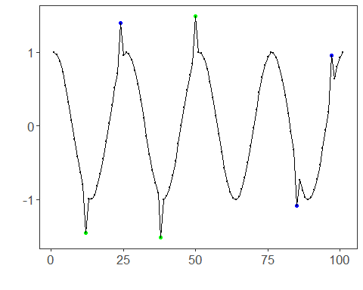 ## References * MacQueen, J. (1967). Some methods for classification and analysis of multivariate observations. * Ogasawara, E., Salles, R., Porto, F., Pacitti, E. Event Detection in Time Series. Springer, 2025. doi:10.1007/978-3-031-75941-3.

