Chapter 3: Seattle
library(ggplot2)
library(RColorBrewer)
library(readxl)
library(daltoolbox)
library(harbinger)
library(dplyr)
source("https://raw.githubusercontent.com/eogasawara/TSED/refs/heads/main/code/header.R")

Theoretical Overview
This example uses weekly maxima of Seattle 2019 temperatures to illustrate detection on real and synthetic variants. ## Example Overview and Goals We will: fetch and pre-process weekly temperatures, run FBIAD detection, then generate a synthetic variant and compare results side-by-side. ### What You Will Do Build two plots: real (2019 weeks) and a perturbed synthetic sequence. ### Setup and Libraries Load helpers and packages.

Other Steps
Additional supporting steps that glue the workflow.
graphic_seattle <- function() {
#Read the dataset and perform any minimal preparation required for modeling.
load(url("https://raw.githubusercontent.com/eogasawara/TSED/refs/heads/main/data/seattle.RData"))
seattle$Day <- 1:nrow(seattle)
seattle$Week <- as.integer(seattle$Day/7) + 1
seattle$temp <- seattle$Max...4
#seattle$temp <- as.numeric(seattle$Avg...5)
seattle$temp <- (seattle$temp - 32)/1.8
seattle <- seattle |> select(day = Day, week = Week, temp = temp) |> group_by(week) |> summarise(temp = max(temp))
seattle$event <- FALSE
seattle$event[12] <- TRUE
# Configure detector and fit to the series
model <- hanr_fbiad(sw_size=12)
# fitting the model
model <- fit(model, seattle$temp)
# making detections using hanr_fbiad
# Run event detection
detection <- detect(model, seattle$temp)
print(detection[detection$event,])
# ploting the results
# Plot detections over the series
grf <- har_plot(model, seattle$temp, detection, seattle$event)
grf <- grf + scale_x_continuous(breaks = seq(4, 52, by = 4), "(a) Seattle 2019 (weeks)")
grf <- grf + ylab("temperature (°C)")
grf <- grf + font
return(grf)
}

Data Loading and Prep
Helper functions to build the two plots.
graphic_seattle_seq <- function() {
load(url("https://raw.githubusercontent.com/eogasawara/TSED/refs/heads/main/data/seattle.RData"))
seattle$Day <- 1:nrow(seattle)
seattle$Week <- as.integer(seattle$Day/7) + 1
seattle$temp <- seattle$Max...4
#seattle$temp <- as.numeric(seattle$Avg...5)
seattle$temp <- (seattle$temp - 32)/1.8
seattle <- seattle |> select(day = Day, week = Week, temp = temp) |> group_by(week) |> summarise(temp = max(temp))
seattle$event <- FALSE
seattle$event[24:26] <- TRUE
seattle$temp[12] <- 0.8*seattle$temp[12]
seattle$temp[19] <- 0.8*seattle$temp[19]
seattle$temp[26] <- 1.15*seattle$temp[24]
seattle$temp[25] <- 1.25*seattle$temp[24]
seattle$temp[24] <- 1.15*seattle$temp[24]
seattle$temp[35] <- 0.8*seattle$temp[35]
model <- harbinger()
# fitting the model
model <- fit(model, seattle$temp)
# making detections using hanr_fbiad
detection <- detect(model, seattle$temp)
print(detection[detection$event,])
# ploting the results
grf <- har_plot(model, seattle$temp, detection, seattle$event)
grf <- grf + scale_x_continuous(breaks = seq(4, 52, by = 4), "(b) Synthetic time series (weeks)")
grf <- grf + ylab("temperature (°C)")
grf <- grf + font
return(grf)
}

Visualization and Output
Plot the series with detected events and optionally save figures. Combine ggplot layers in one chunk for clarity.
grfS <- graphic_seattle()
## idx event type
## 12 12 TRUE anomaly
## 35 35 TRUE anomaly
grfSeq <- graphic_seattle_seq()
## [1] idx event type
## <0 rows> (or 0-length row.names)
#mypng(file="figures/chap3_seattle.png", width = 1600, height = 720) #144 #720*1.75
gridExtra::grid.arrange(grfS, grfSeq,
layout_matrix = matrix(c(1,2), byrow = TRUE, ncol = 2))
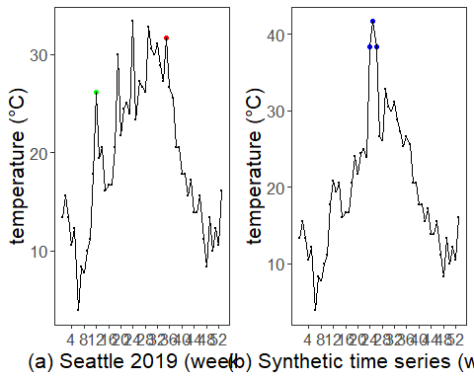
#dev.off()

References
- General: Box, G. E. P. & Jenkins, G. (1970). Time Series Analysis.
- Ogasawara, E., Salles, R., Porto, F., Pacitti, E. Event Detection in Time Series. Springer, 2025. doi:10.1007/978-3-031-75941-3.

