Chapter 4: Gft
library(ggplot2)
library(RColorBrewer)
library(daltoolbox)
library(harbinger)
source("https://raw.githubusercontent.com/eogasawara/TSED/refs/heads/main/code/header.R")

Theoretical Overview
This example focuses on Event detection in time series. This example follows a general event-detection workflow: data preparation, model configuration, fitting, detection, optional evaluation, and visualization. ## Example Overview and Goals We demonstrate a complete, reproducible workflow: setting up libraries, loading data, configuring a detector, fitting it, running detection, optionally evaluating, and visualizing the results. ### Setup and Libraries Load helpers and required packages.
library(ggplot2)
library(RColorBrewer)
library(daltoolbox)
library(harbinger)
source("https://raw.githubusercontent.com/eogasawara/TSED/refs/heads/main/code/header.R")

Data
Load the example series.
data(examples_changepoints)
data <- examples_changepoints$complex
model <- fit(hcp_gft(), data$serie)

Event Detection
detection <- detect(model, data$serie)
print(detection$idx[detection$event])
## [1] 200 307 391

Visualization and Output
grf <- har_plot(model, data$serie, detection) + ylab("value") + font
#save_png(grf, "figures/chap4_gft.png", 1280, 720)
grf
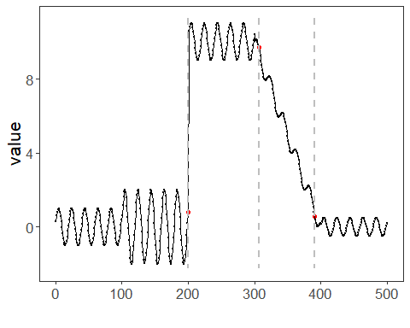 ## References * General: Box, G. E. P. & Jenkins, G. (1970). Time Series Analysis. * Ogasawara, E., Salles, R., Porto, F., Pacitti, E. Event Detection in Time Series. Springer, 2025. doi:10.1007/978-3-031-75941-3.

