Chapter 4: HDDM (Hoeffding Drift Detection Method)
library(ggplot2)
library(RColorBrewer)
library(daltoolbox)
library(harbinger)
library(heimdall)
source("https://raw.githubusercontent.com/eogasawara/TSED/refs/heads/main/code/header.R")

Theoretical Overview
HDDM uses Hoeffding bounds to detect significant changes in a classifier’s error rate over time, offering statistically grounded drift detection for data streams. ## Example Overview and Goals We derive a simple binary prediction stream from the series, update HDDM sequentially, and visualize drift detections over the original signal. ### Knitr Options Keep output clean and reproducible.

Setup and Libraries
Load helpers and detectors.
library(ggplot2)
library(RColorBrewer)
library(daltoolbox)
library(harbinger)
library(heimdall)
source("https://raw.githubusercontent.com/eogasawara/TSED/refs/heads/main/code/header.R")

Data
Load the change-point example and build a simple prediction stream.
data(examples_changepoints)
data <- examples_changepoints$complex
data$event <- NULL
data$prediction <- data$serie > 4

Online Detection
Run HDDM on the prediction stream and collect detections.
model <- dfr_hddm()
detection <- c()
state <- list(obj = model, pred = FALSE)
for (i in seq_along(data$serie)) {
state <- update_state(state$obj, data$prediction[i])
if (state$drift) {
type <- 'changepoint'
state$obj <- reset_state(state$obj)
} else {
type <- ''
}
detection <- rbind(detection, list(idx = i, event = state$drift, type = type))
}
detection <- as.data.frame(detection)

Visualization and Output
Plot the series with detections and save the figure.
grf <- har_plot(model, data$serie, detection) + ylab("value")
grf
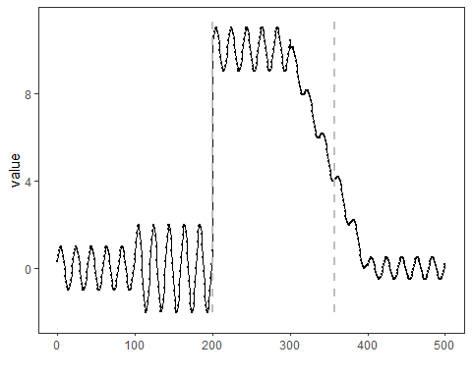
#save_png(grf, "figures/chap4_hddm.png", 1280, 720)

References
- General: Box, G. E. P. & Jenkins, G. (1970). Time Series Analysis.
- Ogasawara, E., Salles, R., Porto, F., Pacitti, E. Event Detection in Time Series. Springer, 2025. doi:10.1007/978-3-031-75941-3.

