Chapter 4: KSWIN (Kolmogorov–Smirnov WINdowing)
library(ggplot2)
library(RColorBrewer)
library(daltoolbox)
library(harbinger)
library(heimdall)
source("https://raw.githubusercontent.com/eogasawara/TSED/refs/heads/main/code/header.R")

Theoretical Overview
KSWIN compares two sliding windows via the Kolmogorov–Smirnov test to detect distributional changes in streaming data. ## Example Overview and Goals We update a KSWIN detector sequentially with the raw signal, collect drift flags, and plot detections over the series. ### Knitr Options Keep output clean and reproducible.

Setup and Libraries
Load helpers and detectors.
library(ggplot2)
library(RColorBrewer)
library(daltoolbox)
library(harbinger)
library(heimdall)
source("https://raw.githubusercontent.com/eogasawara/TSED/refs/heads/main/code/header.R")

Data
Load the example series for streaming detection.
data(examples_changepoints)
data <- examples_changepoints$complex
data$event <- NULL

Online Detection
Run KSWIN and collect a detection frame.
model <- dfr_kswin(target_feat = 'serie')
detection <- c()
state <- list(obj = model, pred = FALSE)
for (i in seq_along(data$serie)) {
state <- update_state(state$obj, data$serie[i])
if (state$drift) {
type <- 'changepoint'
state$obj <- reset_state(state$obj)
} else {
type <- ''
}
detection <- rbind(detection, list(idx = i, event = state$drift, type = type))
}
detection <- as.data.frame(detection)

Visualization and Output
Plot the series with detections and save the figure.
grf <- har_plot(model, data$serie, detection) + ylab("value")
#save_png(grf, "figures/chap4_kswin.png", 1280, 720)
grf
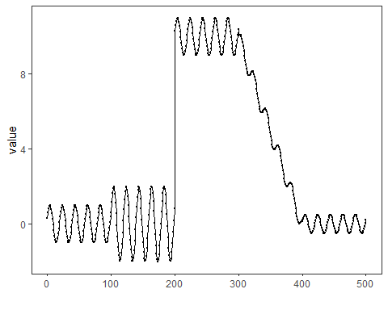 ## References * General: Box, G. E. P. & Jenkins, G. (1970). Time Series Analysis. * Ogasawara, E., Salles, R., Porto, F., Pacitti, E. Event Detection in Time Series. Springer, 2025. doi:10.1007/978-3-031-75941-3.

