Chapter 4: Model Management
library(RColorBrewer)
library(daltoolbox)
library(harbinger)
library(heimdall)
library(reticulate)
library(ggplot2)
source("https://raw.githubusercontent.com/eogasawara/TSED/refs/heads/main/code/header.R")

Theoretical Overview
Model management breaks a long series into regimes where different models apply. Vertical lines M[0]..M[3] illustrate regime boundaries and a candidate unknown model region (?M) to be identified. ## Example Overview and Goals We demonstrate a complete, reproducible workflow: setting up libraries, loading data, configuring a detector, fitting it, running detection, optionally evaluating, and visualizing the results. ### Knitr Options Keep output clean and reproducible.
library(RColorBrewer)
library(daltoolbox)
library(harbinger)
library(heimdall)
library(reticulate)
library(ggplot2)
source("https://raw.githubusercontent.com/eogasawara/TSED/refs/heads/main/code/header.R")

Synthetic Data
x <- seq(0,3.1,0.1)
y1 <- sin(x)
x <- seq(3.2,4.7,0.1)
y <- (x - 3.2)*1/1.5
x <- seq(3.2,6.2,0.1)
y2 <- c(y[1:(length(y)-1)], rev(y))
x <- seq(4.8,5.8,0.1)
y <- (x - 4.8)*1/2
x <- seq(4.8,7.8,0.1)
y3 <- c(y[1:(length(y)-1)], rep(0.5, 10), rev(y))
y4 <- 0.8*y1
x <- seq(0,12.5,0.1)
y <- c(y1, y2, y3, y4)
data <- data.frame(x, y)

Visualization and Output
Draw the synthetic series and mark hypothetical model regimes; save the figure.
grf <- ggplot(data, aes(x=x, y=y)) +
geom_line() +
geom_vline(xintercept = 0, linetype="dotted", color = "black", size=1) +
ggplot2::annotate(geom="text", x=-0.2, y=0.1, label="M[0]", color="black", parse = TRUE) +
geom_vline(xintercept = 3.2, linetype="dotted", color = "black", size=1) +
ggplot2::annotate(geom="text", x=1.6, y=0.1, label="M[1]", color="black", parse = TRUE) +
geom_vline(xintercept = 6.25, linetype="dotted", color = "black", size=1) +
ggplot2::annotate(geom="text", x=4.7, y=0.1, label="M[2]", color="black", parse = TRUE) +
geom_vline(xintercept = 9.35, linetype="dotted", color = "black", size=1) +
ggplot2::annotate(geom="text", x=7.8, y=0.1, label="M[3]", color="black", parse = TRUE) +
ggplot2::annotate(geom="text", x=10.9, y=0.1, label="?M", color="black", parse = TRUE) +
theme_classic()
#save_png(grf, "figures/chap4_model_management.png", 1280, 720)
grf
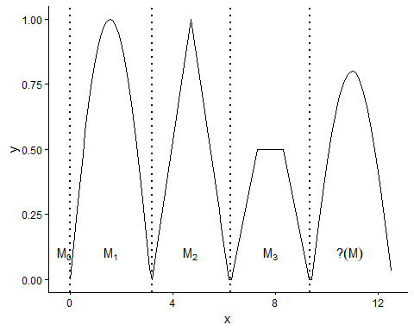 ## References * General: Box, G. E. P. & Jenkins, G. (1970). Time Series Analysis. * Ogasawara, E., Salles, R., Porto, F., Pacitti, E. Event Detection in Time Series. Springer, 2025. doi:10.1007/978-3-031-75941-3.

