Chapter 4: Page–Hinkley
library(ggplot2)
library(RColorBrewer)
library(daltoolbox)
library(harbinger)
library(heimdall)
source("https://raw.githubusercontent.com/eogasawara/TSED/refs/heads/main/code/header.R")

Theoretical Overview
The Page–Hinkley test is a sequential method for detecting abrupt changes in the mean of a signal. It maintains a cumulative statistic and triggers a change when deviations exceed a threshold. ## Example Overview and Goals We stream through a synthetic series, update the Page–Hinkley detector state at each time step, reset on drift, collect detections, and plot results. ### Knitr Options Keep output clean and reproducible.

Setup and Libraries
Load helpers and required packages.
library(ggplot2)
library(RColorBrewer)
library(daltoolbox)
library(harbinger)
library(heimdall)
source("https://raw.githubusercontent.com/eogasawara/TSED/refs/heads/main/code/header.R")

Data
Load the change-point example series.
data(examples_changepoints)
data <- examples_changepoints$complex
data$event <- NULL

Online Detection Loop
Run Page–Hinkley in a streaming fashion and collect a detection data frame compatible with har_plot.
model <- dfr_page_hinkley(target_feat = 'serie')
detection <- c()
state <- list(obj = model, pred = FALSE)
for (i in seq_along(data$serie)) {
state <- update_state(state$obj, data$serie[i]) # update sequentially
if (state$drift) {
type <- 'changepoint'
state$obj <- reset_state(state$obj) # reset after drift
} else {
type <- ''
}
detection <- rbind(detection, list(idx = i, event = state$drift, type = type))
}
detection <- as.data.frame(detection)

Visualization and Output
Plot the series with detected changes and save the figure.
grf <- har_plot(model, data$serie, detection) + ylab("value")
#save_png(grf, "figures/chap4_page_hinkley.png", 1280, 720)
grf
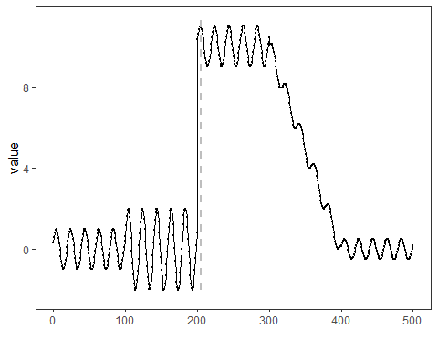 ## References * Page, E. S. (1954). Continuous inspection schemes. * Hinkley, D. V. (1971). Inference about the change-point in a sequence of random variables. * Ogasawara, E., Salles, R., Porto, F., Pacitti, E. Event Detection in Time Series. Springer, 2025. doi:10.1007/978-3-031-75941-3.

