Chapter 5: PAA + SAX
library(ggplot2)

Theoretical Overview
This example introduces the PAA (Piecewise Aggregate Approximation) and SAX (Symbolic Aggregate approXimation) representations. PAA compresses a series by averaging over fixed-length windows; SAX discretizes the PAA values into symbols using normal-distribution breakpoints, enabling string-based operations on time series. ## Example Overview and Goals We generate a simple synthetic series, apply z-score normalization, compute a PAA with block size 5, then discretize with a 3-symbol SAX alphabet to illustrate both representations in a single plot. ### Knitr Options Make the output clean and reproducible.

Setup and Libraries
Load plotting library.
library(ggplot2)

Workflow
Generate a synthetic series, normalize, compute PAA, discretize with SAX, and prepare for plotting.
# 1) Generate a simple synthetic series with mild noise
set.seed(42)
n <- 60
time <- seq_len(n)
series <- sin(0.2 * time) + rnorm(n, mean = 0, sd = 0.2)
# 2) Z-score normalization for scale invariance
series_norm <- scale(series)
# 3) PAA with block size = 5 (average every 5 points)
block <- 5
blocks <- seq(1, n, by = block)
paa <- sapply(blocks, function(i) mean(series_norm[i:(i + block - 1)]))
paa_rep <- rep(paa, each = block) # expand to original length for plotting
# 4) SAX with 3 symbols using N(0,1) breakpoints [-0.43, 0.43]
breakpoints <- c(-Inf, -0.43, 0.43, Inf)
alphabet <- c("a", "b", "c")
sax <- cut(paa, breaks = breakpoints, labels = alphabet, include.lowest = TRUE)
sax_labels <- rep(as.character(sax), each = block) # align with original timeline
# 5) Build plotting data frame
df <- data.frame(
Time = time,
Series = as.numeric(series_norm),
PAA = paa_rep,
SAX = sax_labels
)

Visualization and Output
Overlay raw (normalized) series, PAA steps, and SAX symbols.
p <- ggplot(df, aes(x = Time)) +
geom_line(aes(y = Series), color = "gray70", linewidth = 1.2) +
geom_line(aes(y = PAA), color = "orange", linetype = "dashed", linewidth = 1) +
geom_text(aes(y = 2, label = SAX), size = 5) +
labs(title = "PAA and SAX Representation in Time Series",
x = "Time", y = "Value (normalized)") +
ylim(-2.5, 2.5) +
theme_minimal()
#ggplot2::ggsave(filename = "figures/chap5_paa_sax.png", plot = p, width = 12.8, height = 7.2, units = "in", dpi = 100)
p
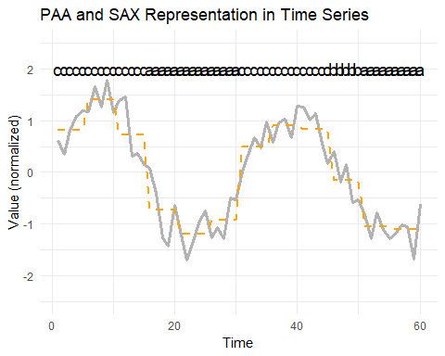 ## References * Yeh, C.-C. M., et al. (2016). Matrix Profile I: All Pairs Similarity Joins for Time Series. * Ogasawara, E., Salles, R., Porto, F., Pacitti, E. Event Detection in Time Series. Springer, 2025. doi:10.1007/978-3-031-75941-3.

