Chapter 5: Motifs via Matrix Profile
library(ggplot2)
library(RColorBrewer)
library(daltoolbox)
library(harbinger)
source("https://raw.githubusercontent.com/eogasawara/TSED/refs/heads/main/code/header.R")

Theoretical Overview
Matrix Profile (MP) enables fast nearest-neighbor search across all subsequences. Motifs are highly repeated patterns corresponding to low MP distances. MP can be computed with algorithms such as STAMP/STOMP. ## Example Overview and Goals We load an ECG-like series, configure a motif detector using MP with STAMP, fit it, run detection, print discovered motifs, and plot results. ### Knitr Options Keep output clean and reproducible.

Setup and Libraries
Load helpers and packages.
library(ggplot2)
library(RColorBrewer)
library(daltoolbox)
library(harbinger)
source("https://raw.githubusercontent.com/eogasawara/TSED/refs/heads/main/code/header.R")

Data
Load example series.
data(examples_motifs)
data <- examples_motifs$mitdb102
rownames(data) <- 1:nrow(data)
data$event <- FALSE

Model, Fit, and Detect
Configure MP-based motif detector and run detection.
# hmo_mp parameters:
# - mode = "stamp": randomized MP algorithm
# - w = 25: window size
# - qtd = 10: number of motifs to return
model <- fit(hmo_mp(mode = "stamp", w = 25, qtd = 10), data$serie)
detection <- detect(model, data$serie)
print(detection[detection$event, ])
## idx event type seq seqlen
## 34 34 TRUE motif 3 25
## 75 75 TRUE motif 2 25
## 76 76 TRUE motif 1 25
## 335 335 TRUE motif 3 25
## 376 376 TRUE motif 2 25
## 630 630 TRUE motif 3 25
## 671 671 TRUE motif 1 25
## 918 918 TRUE motif 3 25
## 958 958 TRUE motif 1 25
## 1251 1251 TRUE motif 2 25
## 1504 1504 TRUE motif 3 25
## 1803 1803 TRUE motif 3 25
## 2115 2115 TRUE motif 3 25
## 2160 2160 TRUE motif 1 25
## 2423 2423 TRUE motif 3 25
## 2466 2466 TRUE motif 2 25
## 2757 2757 TRUE motif 2 25
## 2758 2758 TRUE motif 1 25
## 3291 3291 TRUE motif 3 25
## 4232 4232 TRUE motif 2 25
## 4506 4506 TRUE motif 3 25
## 4851 4851 TRUE motif 2 25
## 5133 5133 TRUE motif 1 25
## 5382 5382 TRUE motif 3 25
## 5422 5422 TRUE motif 1 25
## 5711 5711 TRUE motif 2 25
## 6013 6013 TRUE motif 2 25
## 6278 6278 TRUE motif 3 25
## 6319 6319 TRUE motif 2 25
## 6619 6619 TRUE motif 2 25
## 6929 6929 TRUE motif 2 25

Visualization and Output
Plot the series with detected motifs and save the figure.
grf <- har_plot(model, data$serie, detection) + font
#save_png(grf, "figures/chap5_motifs_mp.png", 1280, 720)
grf
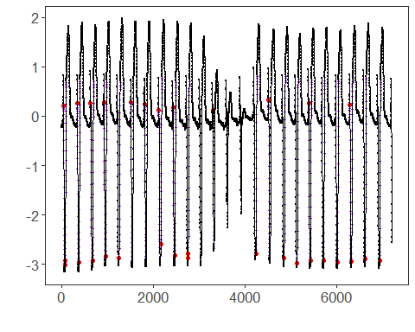 ## References * Yeh, C.-C. M., et al. (2016). Matrix Profile I: All Pairs Similarity Joins for Time Series. * Ogasawara, E., Salles, R., Porto, F., Pacitti, E. Event Detection in Time Series. Springer, 2025. doi:10.1007/978-3-031-75941-3.

