Chapter 7: ROC
library(RColorBrewer)
library(ggplot2)
library(caret)
library(PRROC)
library(dplyr)
library(patchwork)
source("https://raw.githubusercontent.com/eogasawara/TSED/refs/heads/main/code/header.R")

Theoretical Overview
This chapter focuses on threshold-based evaluation with ROC and Precision–Recall (PR) curves. ROC shows the tradeoff between True Positive Rate and False Positive Rate as the decision threshold varies; PR highlights precision vs. recall, which is often more informative for imbalanced data. ## Example Overview and Goals We demonstrate a complete, reproducible workflow: setting up libraries, loading data, configuring a detector, fitting it, running detection, optionally evaluating, and visualizing the results. ### Knitr Options Make output clean and reproducible.

Setup and Libraries
Short rationale for the libraries and any project-specific sources.

Setup and Libraries
Short rationale for the libraries and any project-specific sources.

Other Steps
Additional supporting steps that glue the workflow.
# Synthetic probabilities and binary labels (for illustration)
actual_labels <- c(TRUE, TRUE, FALSE, TRUE, TRUE, FALSE, FALSE, FALSE, TRUE, FALSE)
evt <- c(0.9, 0.8, 0.7, 0.6, 0.55, 0.54, 0.53, 0.51, 0.5, 0.4)
# Flip class mapping and invert scores to show varying thresholds
actual_labels <- !actual_labels
evt <- 1 - evt
data <- data.frame(detect = evt >= 0.5, evt, actual_labels)
print(data)
## detect evt actual_labels
## 1 FALSE 0.10 FALSE
## 2 FALSE 0.20 FALSE
## 3 FALSE 0.30 TRUE
## 4 FALSE 0.40 FALSE
## 5 FALSE 0.45 FALSE
## 6 FALSE 0.46 TRUE
## 7 FALSE 0.47 TRUE
## 8 FALSE 0.49 TRUE
## 9 TRUE 0.50 FALSE
## 10 TRUE 0.60 TRUE
actual_labels <- as.integer(actual_labels)
predictions <- data.frame(evt)
predicted_probs <- evt
# Generate precision-recall curve with PRROC
pr <- pr.curve(scores.class0 = predicted_probs, weights.class0 = actual_labels,
sorted = FALSE, curve = TRUE)

Other Steps
Additional supporting steps that glue the workflow.
pr_df <- data.frame(recall = pr$curve[,1], precision = pr$curve[,2])
pr_df <- pr_df |> group_by(recall) |> summarise(precision = max(precision))

Visualization and Output
Plot the series with detected events and optionally save figures. Combine ggplot layers in one chunk for clarity.
grf <- ggplot(pr_df, aes(x = recall, y = precision))

Other Steps
Additional supporting steps that glue the workflow.
grf <- grf + theme_minimal()
grf <- grf + geom_line(color = "blue")
grf <- grf + ggplot2::annotate(geom="text", x=0.5, y=1.025, label=sprintf("PR curve = %.2f", pr$auc.integral), color="blue")
grf <- grf + ggplot2::annotate(geom="text", x=0.5, y=0.975, label="skilled method", color="darkgreen")
grf <- grf + geom_segment(aes(x = 0, y = 1, xend = 1, yend = 1), col="darkgreen", linewidth = 0.5, linetype="dashed")
grf <- grf + ggplot2::annotate(geom="text", x=0.5, y=0.525, label="unskilled method", color="red")
grf <- grf + geom_segment(aes(x = 0, y = 0.5, xend = 1, yend = 0.5), col="red", linewidth = 0.5, linetype="dashed")
grf <- grf + labs(caption = "(b)")
grf <- grf + theme(plot.caption = element_text(hjust = 0.5))
grfPR <- grf
grfPR
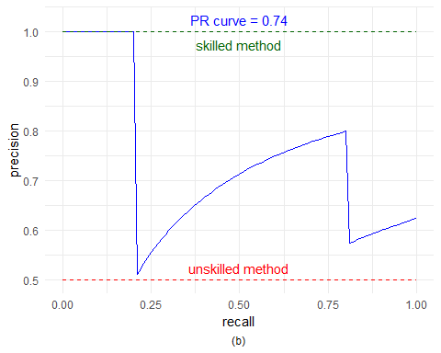 ### Other Steps Additional supporting steps that glue the workflow.
# Generate ROC curve
proc <- roc.curve(scores.class0 = predicted_probs, weights.class0 = actual_labels,
sorted = FALSE, curve = TRUE)

Other Steps
Additional supporting steps that glue the workflow.
roc_df <- data.frame(FPR = proc$curve[,1], TPR = proc$curve[,2])
roc_df <- roc_df |> group_by(FPR) |> summarise(TPR = max(TPR))

Visualization and Output
Plot the series with detected events and optionally save figures. Combine ggplot layers in one chunk for clarity.
grf <-ggplot(roc_df, aes(x = FPR, y = TPR))

Other Steps
Additional supporting steps that glue the workflow.
grf <- grf + theme_minimal()
grf <- grf + geom_line(color = "blue")
grf <- grf + ggplot2::annotate(geom="text", x=0.25, y=0.95, label="perfect performance", color="darkgreen")
grf <- grf + geom_segment(aes(x = 0, y = 0, xend = 0, yend = 1), col="darkgreen", linewidth = 0.5, linetype="dashed")
grf <- grf + geom_segment(aes(x = 0, y = 1, xend = 1, yend = 1), col="darkgreen", linewidth = 0.5, linetype="dashed")
grf <- grf + ggplot2::annotate(geom="text", x=0.65, y=0.4, label="random performance", color="red")
grf <- grf + geom_abline(intercept = 0, slope = 1, linetype = "dashed", color = "red")
grf <- grf + ggplot2::annotate(geom="text", x=0.5, y=1.05, label=sprintf("ROC curve = %.2f", proc$auc), color="blue")
grf <- grf + labs(caption = "(a)")
grf <- grf + theme(plot.caption = element_text(hjust = 0.5))
grfROC <- grf

Visualization and Output
Plot the series with detected events and optionally save figures. Combine ggplot layers in one chunk for clarity.
grfROC
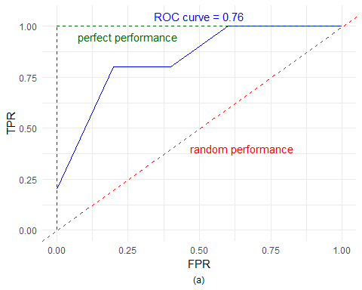 ### Other Steps Additional supporting steps that glue the workflow.
# To print precision and recall values
print(proc$curve)
## [,1] [,2] [,3]
## [1,] 0.0 0.0 0.60
## [2,] 0.0 0.2 0.50
## [3,] 0.2 0.2 0.49
## [4,] 0.2 0.4 0.47
## [5,] 0.2 0.6 0.46
## [6,] 0.2 0.8 0.45
## [7,] 0.4 0.8 0.40
## [8,] 0.6 0.8 0.30
## [9,] 0.6 1.0 0.20
## [10,] 0.8 1.0 0.10
## [11,] 1.0 1.0 0.10

Visualization and Output
Plot the series with detected events and optionally save figures. Combine ggplot layers in one chunk for clarity.
grf <- wrap_plots(grfROC, grfPR, ncol = 2, widths = c(1, 1, 1), heights = c(1))
#save_png(grf, "figures/chap7_roc.png", width = 1280, height = 720)
grf
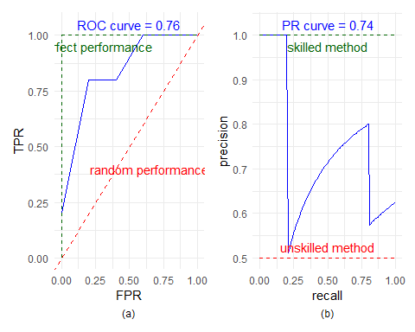 ## References * Fawcett, T. (2006). An introduction to ROC analysis. * Ogasawara, E., Salles, R., Porto, F., Pacitti, E. Event Detection in Time Series. Springer, 2025. doi:10.1007/978-3-031-75941-3.

