Chapter 8: Production
library(RefManageR)
library(tibble)
library(readxl)
library(writexl)
library(dplyr)
library(stringr)
library(tidyr)
library(ggplot2)
library(RColorBrewer)
library(daltoolbox)
library(scales)
source("https://raw.githubusercontent.com/eogasawara/TSED/refs/heads/main/code/header.R")

Theoretical Overview
This chapter visualizes bibliometric production over time across event-related topics (anomaly, change point, motif, event detection/prediction), highlighting growth patterns. ## Example Overview and Goals We demonstrate a complete, reproducible workflow: setting up libraries, loading data, configuring a detector, fitting it, running detection, optionally evaluating, and visualizing the results. ### Knitr Options Keep output clean and reproducible.

Setup and Libraries
Short rationale for the libraries and any project-specific sources.
# Color palette for multi-series plots (four distinct hues)
colors <- brewer.pal(9, "Set1")[c(1,2,3,4)]

Data Loading and Prep
Read the dataset and perform any minimal preparation required for modeling.
load(url("https://raw.githubusercontent.com/eogasawara/TSED/refs/heads/main/data/event_detection.RData"))
load(url("https://raw.githubusercontent.com/eogasawara/TSED/refs/heads/main/data/event_prediction.RData"))
load(url("https://raw.githubusercontent.com/eogasawara/TSED/refs/heads/main/data/anomalies.RData"))
load(url("https://raw.githubusercontent.com/eogasawara/TSED/refs/heads/main/data/change_point.RData"))
load(url("https://raw.githubusercontent.com/eogasawara/TSED/refs/heads/main/data/concept_drift.RData"))
load(url("https://raw.githubusercontent.com/eogasawara/TSED/refs/heads/main/data/motif.RData"))

Other Steps
Additional supporting steps that glue the workflow.
papers_by_year <- function(data, name) {
data$key <- row.names(data)
data$title <- str_to_lower(data$title)
data <- data |> dplyr::select(key, type, year, title)
data$year <- as.numeric(data$year)
data$year[data$year > 2023] <- 2023
data <- data |> dplyr::group_by(year) |> dplyr::summarise(qtd = n()) |> dplyr::arrange(year)
data$name <- name
data <- data |> select(year, name, qtd)
return(data)
}
data <- NULL
result <- papers_by_year(anomalies, "anomaly")
data <- rbind(result, data)
result <- papers_by_year(rbind(change_point, concept_drift), "change point")
data <- rbind(result, data)
result <- papers_by_year(motif, "motif")
data <- rbind(result, data)
result <- papers_by_year(rbind(event_detection, event_prediction), "event detection")
data <- rbind(result, data)
area_year <- tidyr::pivot_wider(data, names_from = "name", values_from="qtd")
area_year <- area_year |> dplyr::arrange(year)
colnames(area_year)[1] <- "x"
head(area_year)
## # A tibble: 6 × 5
## x `event detection` motif `change point` anomaly
## <dbl> <int> <int> <int> <int>
## 1 1954 NA NA NA 1
## 2 1968 NA NA NA 1
## 3 1969 NA NA NA 1
## 4 1973 NA NA NA 1
## 5 1974 NA NA NA 1
## 6 1975 NA NA NA 3
# Build log-scaled production curves; expand x-axis for visual margin
invisible(seq(1950, 2020, 10))
grf <- plot_series(area_year, colors = colors) + scale_y_continuous(trans = log10_trans())
grf <- grf + font
grf <- grf + scale_x_continuous(expand = expansion(add = 10))

Visualization and Output
Plot production curves (log-scaled) and save the figure.
#save_png(grf, "figures/chap8_production.png", 1280, 720)
grf
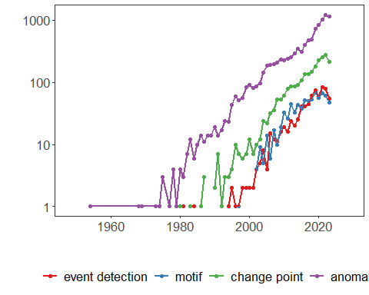 ## References * General: Box, G. E. P. & Jenkins, G. (1970). Time Series Analysis. * Ogasawara, E., Salles, R., Porto, F., Pacitti, E. Event Detection in Time Series. Springer, 2025. doi:10.1007/978-3-031-75941-3.

