R Package installation and loading
Package checking and instalation
if(!require(daltoolbox)) {
install.packages("daltoolbox")
}
Package loading
library(daltoolbox)

Variable definitions and evaluation
Variable definition
weight <- 60
height = 1.75
subject <- "A"
healthy <- TRUE
Variable evaluation
weight
## [1] 60

Functions for type checking
is.numeric(weight) # variable
## [1] TRUE
is.double(weight)
## [1] TRUE
is.integer(weight)
## [1] FALSE
is.character(subject)
## [1] TRUE

Functions for variable conversion
weight <- as.integer(weight)
is.integer(weight)
## [1] TRUE

Formulas and String formatting
Computing the body mass index (BMI) from the weight and height
#Body mass index (BMI)
bmi <- weight/height^2
bmi
## [1] 19.59184
Functions for string manipulation
message <- sprintf("%.1f", bmi)
print(message)
## [1] "19.6"

Vectors
definition
weight <- c(60, 72, 57, 90, 95, 72)
height <- c(1.75, 1.80, 1.65, 1.90, 1.74, 1.91)
subject <- c("A", "B", "C", "D", "E", "F")
evaluation
weight
## [1] 60 72 57 90 95 72
height
## [1] 1.75 1.80 1.65 1.90 1.74 1.91
subject
## [1] "A" "B" "C" "D" "E" "F"

Establishing the vector size
vector of size 10
vec <- rep(0, 10)
vec
## [1] 0 0 0 0 0 0 0 0 0 0
vector length
length(weight)
## [1] 6

Vector limits
from one to the length of the vector
weight[1]
## [1] 60
weight[length(weight)]
## [1] 72

Iteration: for loop
from one to the length of weight
bmi <- 0
for (i in 1:length(weight)) {
bmi[i] <- weight[i]/height[i]^2
}
evaluation of the bmi vector
bmi
## [1] 19.59184 22.22222 20.93664 24.93075 31.37799 19.73630

Iteration: while loop
run while i is below or equal to the length of weight
bmi <- 0
i <- 1
while (i <= length(weight)) {
bmi[i] <- weight[i]/height[i]^2
i <- i + 1
}
bmi
## [1] 19.59184 22.22222 20.93664 24.93075 31.37799 19.73630

Remove a variable
rm(bmi)
exists("bmi")
## [1] FALSE

Processing vectors at once
bmi <- weight/height^2
bmi
## [1] 19.59184 22.22222 20.93664 24.93075 31.37799 19.73630

Creating functions
name <- function(parameters) { body }
compute_bmi <- function(weight, height) {
bmi <- weight/height^2
return(bmi)
}
calling it
bmi <- compute_bmi(60, 1.75)
bmi
## [1] 19.59184

Function processing vectors
bmi <- compute_bmi(weight, height)
bmi
## [1] 19.59184 22.22222 20.93664 24.93075 31.37799 19.73630

Example: function to compute the average
(iterating in all elements of the vector)
average <- function(vec) {
s <- 0
n <- length(vec)
for (x in vec) {
s <- s + x
}
return(s/n)
}
invoking the function
avg_bmi <- average(bmi)
avg_bmi
## [1] 23.13262

Example of a function to compute the average (improved version)
manipulating vectors at once
average <- function(vec) {
s <- sum(vec)
n <- length(vec)
return(s/n)
}
invoking the function
avg_bmi <- average(bmi)
avg_bmi
## [1] 23.13262

Example: function using mean function
Major statistical functions are available in R
average <- function(vec) {
return(mean(vec))
}
invoking the function
avg_bmi <- average(bmi)
avg_bmi
## [1] 23.13262

Not available (NA)
Operations with NA lead to NA.
x <- c(10, NA, 13)
y <- average(x)
y
## [1] NA
Addressing NA with na.rm=TRUE
average <- function(vec) {
return(mean(vec, na.rm=TRUE))
}
x <- c(10, NA, 13)
y <- average(x)
y
## [1] 11.5

Plotting basic graphics
defining variables
weight <- c(60, 72, 57, 90, 95, 72)
height <- c(1.75, 1.80, 1.65, 1.90, 1.74, 1.91)
bmi <- weight/height^2
scatter plots
plot(height, weight)
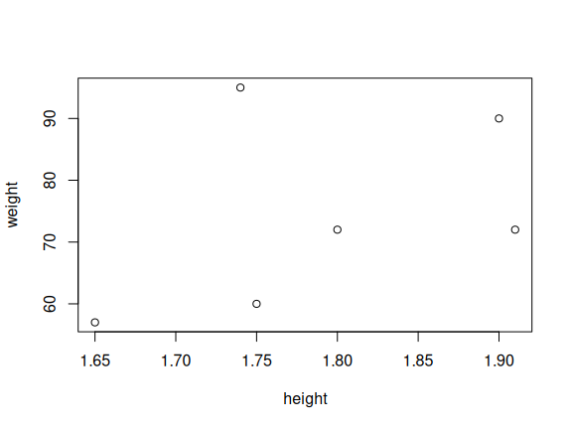

Most functions contain many default parameters
plot(height, weight, pch=2)
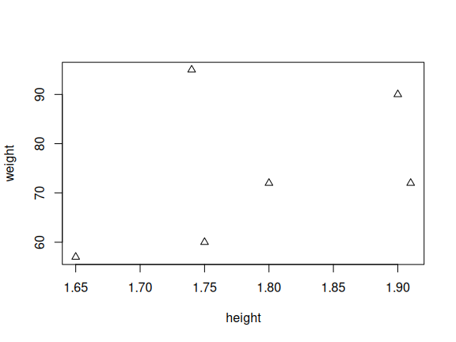

Canvas for plotting is still active until a new plot
plot(height, weight)
hh = c(1.65, 1.70, 1.75, 1.80, 1.85, 1.90)
lines(hh, 22.5 * hh^2)
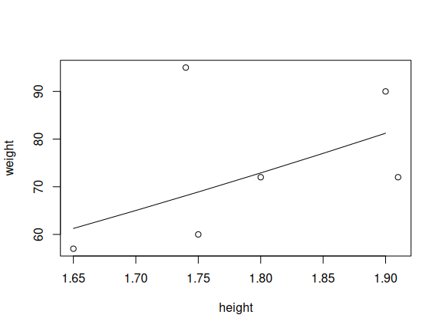

Factors
Factors are used to handle categorical data.
pain <- c(0,3,2,2,1)
fpain <- factor(pain,levels=0:3, ordered=TRUE)
fpain
## [1] 0 3 2 2 1
## Levels: 0 < 1 < 2 < 3
Levels provide correspondence between numerical values and categorical labels
levels(fpain) <- c("none","mild","medium","severe")
fpain
## [1] none severe medium medium mild
## Levels: none < mild < medium < severe

Convert height to factor with levels: small, medium, high
coding setting element by element
lev <- rep("", length(height))
for (i in 1:length(height)) {
if (height[i] < 1.5)
lev[i] <- "short"
else if (height[i] < 1.9)
lev[i] <- "medium"
else
lev[i] <- "tall"
}
lev <- factor(lev, levels=c("small", "medium", "tall"), ordered=TRUE)
lev
## [1] medium medium medium tall medium tall
## Levels: small < medium < tall

Using the function cut
lev <- cut(height, breaks=c(0, 1.5, 1.9, .Machine$double.xmax), ordered=TRUE)
lev
## [1] (1.5,1.9] (1.5,1.9] (1.5,1.9] (1.5,1.9] (1.5,1.9] (1.9,1.8e+308]
## Levels: (0,1.5] < (1.5,1.9] < (1.9,1.8e+308]
levels(lev) <- c("short", "medium", "tall")
lev
## [1] medium medium medium medium medium tall
## Levels: short < medium < tall

Matrix
Matrices can be filled from vectors or data frames.
x <- 1:9
x
## [1] 1 2 3 4 5 6 7 8 9
Converting a vector to matrix
dim(x) <- c(3,3)
x
## [,1] [,2] [,3]
## [1,] 1 4 7
## [2,] 2 5 8
## [3,] 3 6 9

Scalar multiplication
y <- 3*x
y
## [,1] [,2] [,3]
## [1,] 3 12 21
## [2,] 6 15 24
## [3,] 9 18 27

Matrix manipulation
Converting a vector to a matrix by row
x <- matrix(1:9,nrow=3,byrow=TRUE)
x
## [,1] [,2] [,3]
## [1,] 1 2 3
## [2,] 4 5 6
## [3,] 7 8 9
transposing a matrix
x <- t(x)
x
## [,1] [,2] [,3]
## [1,] 1 4 7
## [2,] 2 5 8
## [3,] 3 6 9

Lists
Lists are used to work with “objects”
a <- c(5260,5470,5640,6180,6390,6515,6805,7515,7515,8230,8770)
b <- c(3910,4220,3885,5160,5645,4680,5265,5975,6790,6900,7335)
mybag <- list(a, b, 0, "a")
mybag
## [[1]]
## [1] 5260 5470 5640 6180 6390 6515 6805 7515 7515 8230 8770
##
## [[2]]
## [1] 3910 4220 3885 5160 5645 4680 5265 5975 6790 6900 7335
##
## [[3]]
## [1] 0
##
## [[4]]
## [1] "a"

Adding elements into a list
n <- length(mybag)
mybag[[n+1]] <- "b"
mybag
## [[1]]
## [1] 5260 5470 5640 6180 6390 6515 6805 7515 7515 8230 8770
##
## [[2]]
## [1] 3910 4220 3885 5160 5645 4680 5265 5975 6790 6900 7335
##
## [[3]]
## [1] 0
##
## [[4]]
## [1] "a"
##
## [[5]]
## [1] "b"

List slicing
slice <- mybag[1]
slice
## [[1]]
## [1] 5260 5470 5640 6180 6390 6515 6805 7515 7515 8230 8770
is.list(slice)
## [1] TRUE

Lists: member reference
Picking the first element
h <- mybag[[1]]
h
## [1] 5260 5470 5640 6180 6390 6515 6805 7515 7515 8230 8770
An element can be evaluated. In this case, it is a vector.
is.vector(h)
## [1] TRUE
is.list(h)
## [1] FALSE

Creating lists with attributes
They are properties on the list
mybag <- list(x=a, y=b, const=0, lit="a")
mybag
## $x
## [1] 5260 5470 5640 6180 6390 6515 6805 7515 7515 8230 8770
##
## $y
## [1] 3910 4220 3885 5160 5645 4680 5265 5975 6790 6900 7335
##
## $const
## [1] 0
##
## $lit
## [1] "a"

Adding, accessing, and removing elements
mybag$c <- mybag$x - mybag$y
mybag$const <- NULL
mybag$lit <- NULL
mybag
## $x
## [1] 5260 5470 5640 6180 6390 6515 6805 7515 7515 8230 8770
##
## $y
## [1] 3910 4220 3885 5160 5645 4680 5265 5975 6790 6900 7335
##
## $c
## [1] 1350 1250 1755 1020 745 1835 1540 1540 725 1330 1435

Data frames
Data frames (tables) provide support for structured data.
a <- c(5260,5470,5640,6180,6390,6515,6805,7515,7515,8230,8770)
b <- c(3910,4220,3885,5160,5645,4680,5265,5975,6790,6900,7335)
data <- data.frame(A=a, B=b)
head(data)
## A B
## 1 5260 3910
## 2 5470 4220
## 3 5640 3885
## 4 6180 5160
## 5 6390 5645
## 6 6515 4680

Adding a column in a data frame
data$c <- data$A + data$B
head(data)
## A B c
## 1 5260 3910 9170
## 2 5470 4220 9690
## 3 5640 3885 9525
## 4 6180 5160 11340
## 5 6390 5645 12035
## 6 6515 4680 11195

Removing a column of a data frame
data$A <- NULL
head(data)
## B c
## 1 3910 9170
## 2 4220 9690
## 3 3885 9525
## 4 5160 11340
## 5 5645 12035
## 6 4680 11195

Reading a csv file
There are many functions for reading CSV, Excel, and RData formats.
wine = read.table(
"http://archive.ics.uci.edu/ml/machine-learning-databases/wine/wine.data",
header = TRUE, sep = ",")
colnames(wine) <- c('Type', 'Alcohol', 'Malic', 'Ash',
'Alcalinity', 'Magnesium', 'Phenols',
'Flavanoids', 'Nonflavanoids',
'Proanthocyanins', 'Color', 'Hue',
'Dilution', 'Proline')
head(wine)
## Type Alcohol Malic Ash Alcalinity Magnesium Phenols Flavanoids Nonflavanoids Proanthocyanins Color Hue Dilution Proline
## 1 1 13.20 1.78 2.14 11.2 100 2.65 2.76 0.26 1.28 4.38 1.05 3.40 1050
## 2 1 13.16 2.36 2.67 18.6 101 2.80 3.24 0.30 2.81 5.68 1.03 3.17 1185
## 3 1 14.37 1.95 2.50 16.8 113 3.85 3.49 0.24 2.18 7.80 0.86 3.45 1480
## 4 1 13.24 2.59 2.87 21.0 118 2.80 2.69 0.39 1.82 4.32 1.04 2.93 735
## 5 1 14.20 1.76 2.45 15.2 112 3.27 3.39 0.34 1.97 6.75 1.05 2.85 1450
## 6 1 14.39 1.87 2.45 14.6 96 2.50 2.52 0.30 1.98 5.25 1.02 3.58 1290

saving in binary format
saving a data frame
save(wine, file="wine.RData")
removing a data frame from memory
rm(wine)
loading it
load("wine.RData")
head(wine, 3)
## Type Alcohol Malic Ash Alcalinity Magnesium Phenols Flavanoids Nonflavanoids Proanthocyanins Color Hue Dilution Proline
## 1 1 13.20 1.78 2.14 11.2 100 2.65 2.76 0.26 1.28 4.38 1.05 3.40 1050
## 2 1 13.16 2.36 2.67 18.6 101 2.80 3.24 0.30 2.81 5.68 1.03 3.17 1185
## 3 1 14.37 1.95 2.50 16.8 113 3.85 3.49 0.24 2.18 7.80 0.86 3.45 1480

exporting data.frame into csv file
write.table(wine, file="wine.csv", row.names=FALSE, quote = FALSE, sep = ",")

filtering vectors
a <- c(5260,5470,5640,6180,6390,6515,6805,7515,7515,8230,8770)
# logical vector
bool <- (a > 7000)
bool
## [1] FALSE FALSE FALSE FALSE FALSE FALSE FALSE TRUE TRUE TRUE TRUE
# selecting elements from positions that are true
a[bool]
## [1] 7515 7515 8230 8770
a[a > 7000]
## [1] 7515 7515 8230 8770

filtering data frames
a <- c(5260,5470,5640,6180,6390,6515,6805,7515,7515,8230,8770)
b <- c(3910,4220,3885,5160,5645,4680,5265,5975,6790,6900,7335)
data <- data.frame(a = a, b = b)
head(data[data$a > 7000,])
## a b
## 8 7515 5975
## 9 7515 6790
## 10 8230 6900
## 11 8770 7335

filtering data frames (rows and columns)
head(data[data$a > 7000,c(1)])
## [1] 7515 7515 8230 8770

Benchmarking performance of matrix and data frames
rheight <- rnorm(100000, 1.8, sd=0.2)
rweight <- rnorm(100000, 72, sd=15)

Computing a column at once in a data frame
start_time <- Sys.time()
hw <- data.frame(height=rheight, weight=rweight)
hw$bmi <- hw$weight/hw$height^2
end_time <- Sys.time()
end_time - start_time
## Time difference of 0.001963615 secs
object.size(hw)
## 2400984 bytes

Computing a column in a data frame cell by cell
start_time <- Sys.time()
hw <- data.frame(height=rheight, weight=rweight)
for (i in 1:nrow(hw)) {
hw$bmi[i] <- hw$weight[i]/hw$height[i]^2
}
end_time <- Sys.time()
end_time - start_time
## Time difference of 7.399405 secs

Converting a data frame to a matrix, processing it, and going back
start_time <- Sys.time()
hw <- data.frame(height=rheight, weight=rweight)
hw <- as.matrix(hw)
hw <- cbind(hw, 0)
for (i in 1:nrow(hw)) {
hw[i,3] <- hw[i,2]/hw[i,1]^2
}
hw <- as.data.frame(hw)
end_time <- Sys.time()
end_time - start_time
## Time difference of 0.2869551 secs

Pipelines
The operator |> creates a pipeline.
The first parameter of the next invoked function receives the data from the pipeline.
Library $dplyr$ contains a set of functions that support relational algebra operations.
flight_data <- read.table(text = "Year Quarter Flights Delays
2016 1 11 6
2016 2 12 5
2016 3 13 3
2016 4 12 5
2017 1 10 4
2017 2 9 3
2017 3 11 4
2017 4 25 15
2018 1 14 3
2018 2 12 5
2018 3 13 3
2018 4 15 4",
header = TRUE,sep = "")

Displaying the data frame
head(flight_data)
## Year Quarter Flights Delays
## 1 2016 1 11 6
## 2 2016 2 12 5
## 3 2016 3 13 3
## 4 2016 4 12 5
## 5 2017 1 10 4
## 6 2017 2 9 3

Basic Query
library(dplyr)
result <- flight_data |>
filter(Delays > 5) |>
select(Year, Quarter, Flights)
head(result)
## Year Quarter Flights
## 1 2016 1 11
## 2 2017 4 25

Aggregated query
result <- flight_data |>
group_by(Year) |>
summarize(mean = mean(Flights), sd = sd(Flights))
head(result)
## # A tibble: 3 × 3
## Year mean sd
## <int> <dbl> <dbl>
## 1 2016 12 0.816
## 2 2017 13.8 7.54
## 3 2018 13.5 1.29

Table join
Store table
stores <- data.frame(
city = c("Rio de Janeiro", "Sao Paulo", "Paris", "New York", "Tokyo"),
value = c(10, 12, 20, 25, 18))
head(stores)
## city value
## 1 Rio de Janeiro 10
## 2 Sao Paulo 12
## 3 Paris 20
## 4 New York 25
## 5 Tokyo 18
Division table
divisions <- data.frame(
city = c("Rio de Janeiro", "Sao Paulo", "Paris", "New York", "Tokyo"),
country = c("Brazil", "Brazil", "France", "US", "Japan"))
head(divisions)
## city country
## 1 Rio de Janeiro Brazil
## 2 Sao Paulo Brazil
## 3 Paris France
## 4 New York US
## 5 Tokyo Japan

Merge function
The function $merge$ can be used to join data frames. It can be used to produce inner, left, right, and outer joins.
stdiv <- merge(stores, divisions, by.x="city", by.y="city")
head(stdiv)
## city value country
## 1 New York 25 US
## 2 Paris 20 France
## 3 Rio de Janeiro 10 Brazil
## 4 Sao Paulo 12 Brazil
## 5 Tokyo 18 Japan

Aggregating merged data frame
result <- stdiv |> group_by(country) |>
summarize(count = n(), amount = sum(value))
head(result)
## # A tibble: 4 × 3
## country count amount
## <chr> <int> <dbl>
## 1 Brazil 2 22
## 2 France 1 20
## 3 Japan 1 18
## 4 US 1 25

Statistical analysis
There are many statistical tests in R. One of the most used is the t-test. It checks if the mean of observations is not different from a theoretical value.
weight <- c(60, 72, 57, 90, 95, 72)
height <- c(1.75, 1.80, 1.65, 1.90, 1.74, 1.91)
bmi <- weight/height^2
t.test(bmi, mu=22.5)
##
## One Sample t-test
##
## data: bmi
## t = 0.34488, df = 5, p-value = 0.7442
## alternative hypothesis: true mean is not equal to 22.5
## 95 percent confidence interval:
## 18.41734 27.84791
## sample estimates:
## mean of x
## 23.13262

Python + R integration
Python code at retic.py
import pyreadr
import pandas
def add(x, y):
return x + y
def read_rdata_mem(data):
x = data["x"]
print(x)
y = data["y"]
data["z"] = x + y
return(data)
Library reticulate enables seamless integration with Python
library(reticulate)
source_python('https://raw.githubusercontent.com/eogasawara/datamining/refs/heads/main/python/retic.py')
x <- add(5, 10)
x
## [1] 15

Python + R dataset integration
data <- data.frame(x = c(1:5), y=c(11:15))
dfm <- read_rdata_mem(data)
## 0 1
## 1 2
## 2 3
## 3 4
## 4 5
## Name: x, dtype: int32
head(dfm)
## x y z
## 1 1 11 12
## 2 2 12 14
## 3 3 13 16
## 4 4 14 18
## 5 5 15 20

