Plotting charts
# The easiest way to get ggplot2 is to install the whole tidyverse
#install.packages("tidyverse")
#install.packages("ggplot2")

ggplot easy encapsulation through daltoolbox
library(daltoolbox)
library(ggplot2)

Color Brewer R Package
#install.packages("RColorBrewer")
library(RColorBrewer)
colors <- brewer.pal(4, 'Set1')

Basic setup for examples
Iris datasets
head(iris, 3)
## Sepal.Length Sepal.Width Petal.Length Petal.Width Species
## 1 5.1 3.5 1.4 0.2 setosa
## 2 4.9 3.0 1.4 0.2 setosa
## 3 4.7 3.2 1.3 0.2 setosa
Options from graphics: colors and font size
colors <- brewer.pal(4, 'Set1')
font <- theme(text = element_text(size=16))

Scatter plot
library(dplyr)
data <- iris |> select(x = Sepal.Length, value = Sepal.Width, variable = Species)
#head(data)
grf <- plot_scatter(data, label_x = "Sepal.Length", label_y = "Sepal.Width", colors=colors[1:3]) + font
plot(grf)
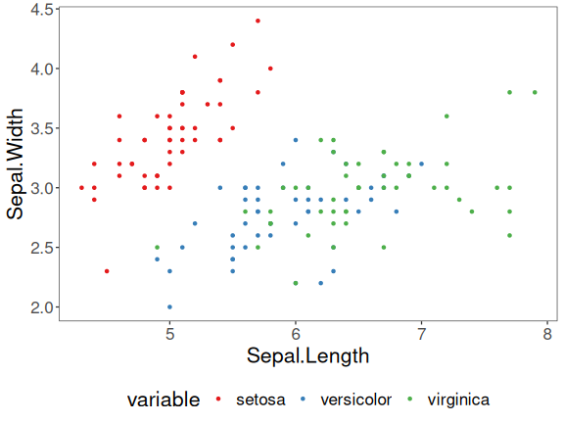

Bar plot
library(dplyr)
data <- iris |> group_by(Species) |> summarize(Sepal.Length=mean(Sepal.Length))
#head(data)
grf <- plot_bar(data, colors=colors[1:3]) + font
plot(grf)
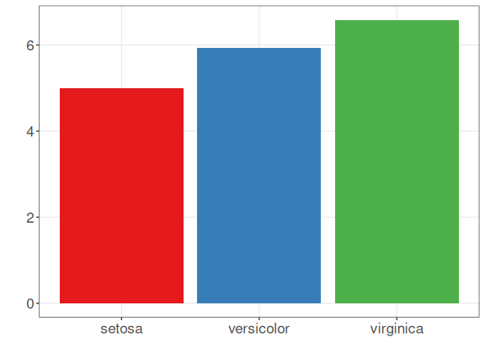

Lollipop plot
library(dplyr)
data <- iris |> group_by(Species) |> summarize(Sepal.Length=mean(Sepal.Length))
#head(data)
grf <- plot_lollipop(data, colors=colors[1], max_value_gap=0.2) + font + coord_flip()
plot(grf)
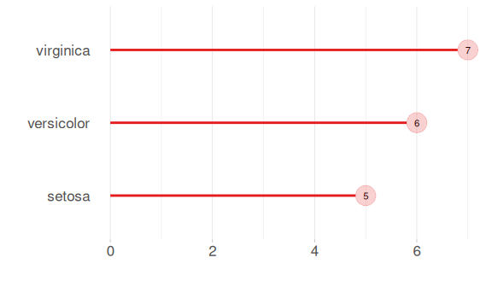

Bar graph with error
library(dplyr)
data <- iris |> group_by(Species) |> summarize(mean=mean(Sepal.Length), sd=sd(Sepal.Length))
#head(data)
grf <- plot_bar(data, colors=colors[1], alpha=1) + font
grf <- grf + geom_errorbar(aes(x=Species, ymin=mean-sd, ymax=mean+sd),
width=0.2, colour="darkred", alpha=0.8, size=1.1)
plot(grf)
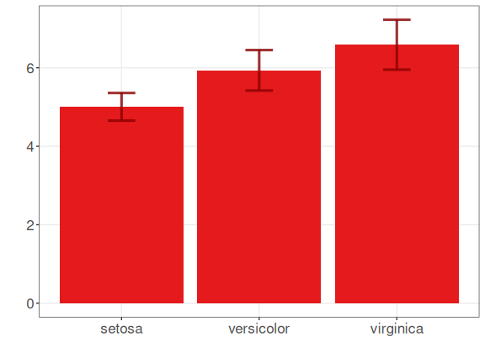

Pie plot
library(dplyr)
data <- iris |> group_by(Species) |> summarize(n = n())
#head(data)
grf <- plot_pieplot(data, colors=colors[1:3]) + font
plot(grf)
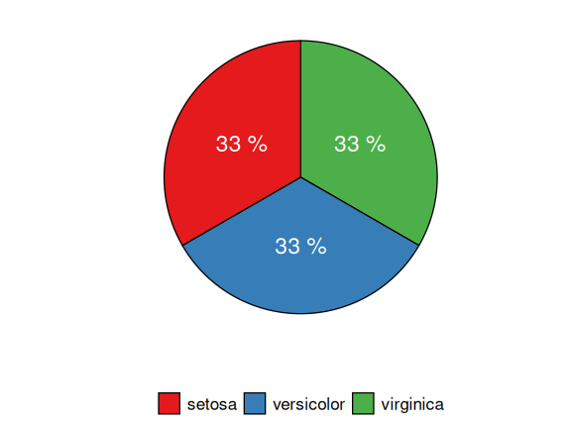

Grouped bar
library(dplyr)
data <- iris |> group_by(Species) |> summarize(Sepal.Length=mean(Sepal.Length), Sepal.Width=mean(Sepal.Width))
#head(data)
grf <- plot_groupedbar(data, colors=colors[1:2]) + font
plot(grf)
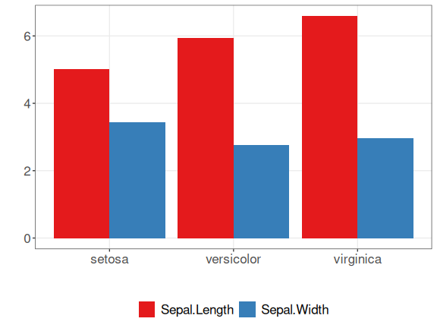

Stacked-bar
library(dplyr)
data <- iris |> group_by(Species) |> summarize(Sepal.Length=mean(Sepal.Length), Sepal.Width=mean(Sepal.Width))
#head(data)
grf <- plot_stackedbar(data, colors=colors[1:2]) + font
grf <- grf + theme(axis.text.x = element_text(angle=90, hjust=1))
plot(grf)
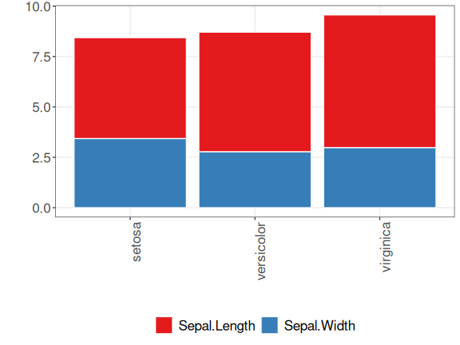

Line chart
x <- seq(0, 10, 0.25)
serie <- data.frame(x, y=sin(x))
#head(serie)
grf <- plot_series(serie, colors=colors[1]) + font
plot(grf)
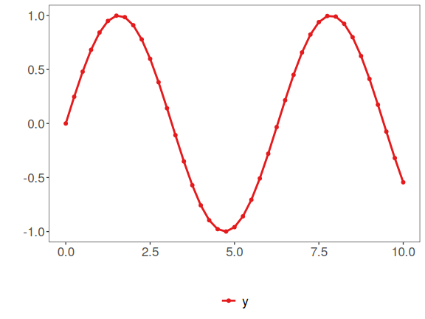

Data distribution example
example <- data.frame(exponential = rexp(10000, rate = 1),
uniform = runif(10000, min=2.5, max = 3.5),
normal = rnorm(10000, mean = 5))
head(example)
## exponential uniform normal
## 1 0.73379885 2.822246 6.514519
## 2 0.12864993 2.879088 3.755980
## 3 0.05641327 3.180636 4.203267
## 4 1.04825356 3.154170 5.443147
## 5 2.75666840 2.519673 4.636143
## 6 0.42226514 3.099570 2.059943

Histogram
library(dplyr)
data <- example |> select(exponential)
#head(data)
grf <- plot_hist(data, label_x = "exponential", color=colors[1]) + font
## Using as id variables
plot(grf)
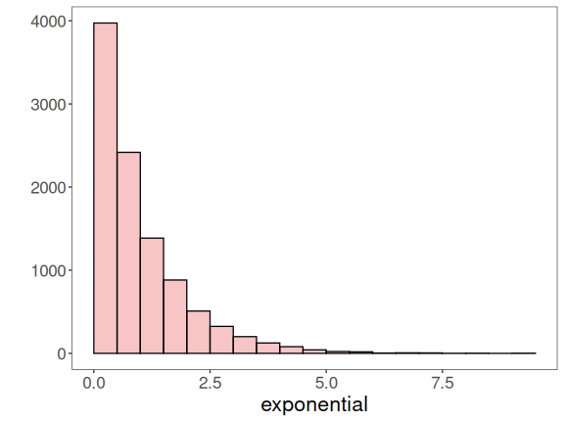

Multiple Histograms
{
library(gridExtra)
grfe <- plot_hist(example |> select(exponential), label_x = "exponential", color=colors[1]) + font
grfu <- plot_hist(example |> select(uniform), label_x = "uniform", color=colors[1]) + font
grfn <- plot_hist(example |> select(normal), label_x = "normal", color=colors[1]) + font
grid.arrange(grfe, grfu, grfn, ncol=3)
}
## Using as id variables
## Using as id variables
## Using as id variables
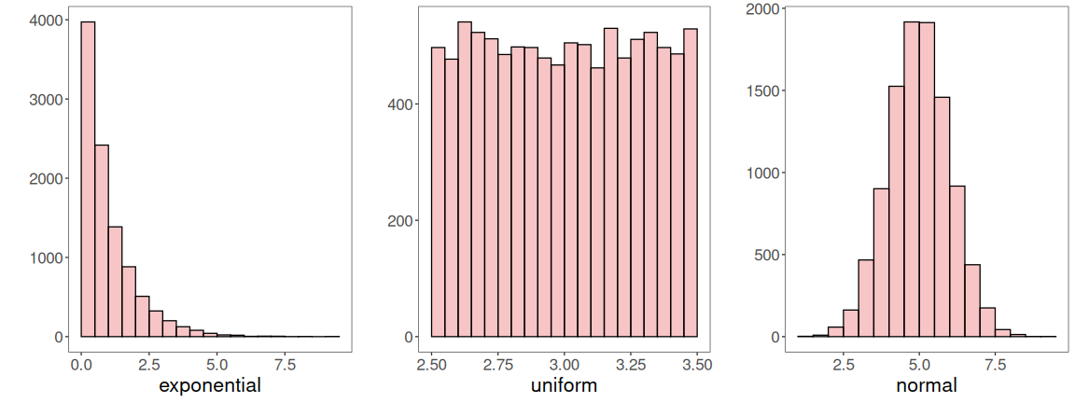

Density plot
library(dplyr)
data <- example |> select(normal)
#head(data)
grf <- plot_density(data, label_x = "normal", color=colors[1]) + font
## Using as id variables
plot(grf)
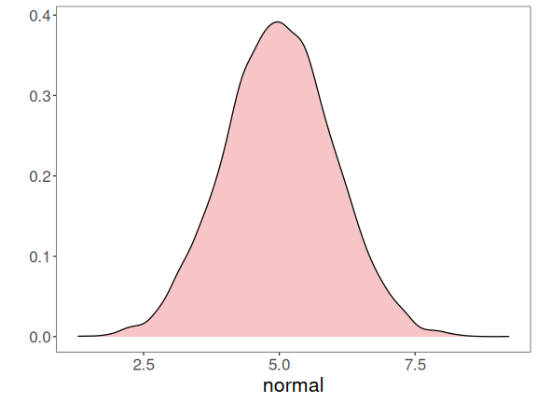

Box plot
library(dplyr)
data <- example |> select(normal)
#head(data)
grf <- plot_boxplot(data, color="white") + font
## Using as id variables
plot(grf)
## Ignoring unknown labels:
## • colour : "normal"
