Exploratory analysis
A brief exploratory analysis example.

Basic configuration for exploratory analysis
# basic packages
library(daltoolbox)
library(RColorBrewer)
library(ggplot2)
library(WVPlots)
library(GGally)
# choosing colors
colors <- brewer.pal(4, 'Set1')
# setting the font size for all charts
font <- theme(text = element_text(size=16))
# additional packages
{
library(dplyr)
library(reshape)
library(corrplot)
library(WVPlots)
library(GGally)
library(aplpack)
library(daltoolbox)
}
# additional packages
# ============================================================
# Correlation heatmap (publication/dissertation style) with values
# Function: plot_correlation(df, ...)
# - Uses ggplot2 and tidy tools
# - Handles missing values
# - Lets you choose method, triangle, variable selection, ordering, etc.
# ============================================================
plot_correlation <- function(df,
vars = NULL,
method = c("pearson", "spearman", "kendall"),
use = "pairwise.complete.obs",
triangle = c("full", "upper", "lower"),
reorder = c("none", "hclust", "alphabetical"),
digits = 2,
label_size = 3,
tile_color = "white",
show_diag = TRUE,
title = NULL) {
# ---- Dependencies (explicitly) ----
needed <- c("ggplot2", "dplyr", "tidyr", "tibble")
missing_pkgs <- needed[!vapply(needed, requireNamespace, logical(1), quietly = TRUE)]
if (length(missing_pkgs) > 0) {
stop("Missing packages: ", paste(missing_pkgs, collapse = ", "),
". Install with install.packages(c(", paste0('"', missing_pkgs, '"', collapse = ", "), ")).")
}
method <- match.arg(method)
triangle <- match.arg(triangle)
reorder <- match.arg(reorder)
# ---- Select numeric columns / user vars ----
if (!is.null(vars)) {
if (!all(vars %in% names(df))) {
bad <- vars[!vars %in% names(df)]
stop("These vars are not in df: ", paste(bad, collapse = ", "))
}
df2 <- df[, vars, drop = FALSE]
} else {
df2 <- df[, vapply(df, is.numeric, logical(1)), drop = FALSE]
}
if (ncol(df2) < 2) {
stop("Need at least 2 numeric columns to compute correlations.")
}
# ---- Correlation matrix ----
corr <- stats::cor(df2, use = use, method = method)
# ---- Reorder variables (optional) ----
var_names <- colnames(corr)
if (reorder == "alphabetical") {
ord <- order(var_names)
corr <- corr[ord, ord, drop = FALSE]
} else if (reorder == "hclust") {
# distance based on correlation; robust to small numerical issues
d <- stats::as.dist(1 - corr)
hc <- stats::hclust(d, method = "complete")
ord <- hc$order
corr <- corr[ord, ord, drop = FALSE]
}
# ---- Tidy long format ----
corr_long <- as.data.frame(corr) |>
tibble::rownames_to_column("Var1") |>
tidyr::pivot_longer(-Var1, names_to = "Var2", values_to = "value") |>
dplyr::mutate(
Var1 = factor(Var1, levels = rownames(corr)),
Var2 = factor(Var2, levels = colnames(corr))
)
# ---- Filter triangle (optional) ----
# Use factor indices to compare positions
corr_long <- corr_long |>
dplyr::mutate(
i = as.integer(Var1),
j = as.integer(Var2)
)
if (triangle == "upper") {
corr_long <- corr_long |>
dplyr::filter(j > i | (show_diag & j == i))
} else if (triangle == "lower") {
corr_long <- corr_long |>
dplyr::filter(i > j | (show_diag & j == i))
} else {
if (!show_diag) corr_long <- corr_long |>
dplyr::filter(i != j)
}
# ---- Labels ----
corr_long <- corr_long |>
dplyr::mutate(label = dplyr::if_else(is.na(value), "", format(round(value, digits), nsmall = digits)))
# ---- Plot ----
ggplot2::ggplot(corr_long, ggplot2::aes(x = Var1, y = Var2, fill = value)) +
ggplot2::geom_tile(color = tile_color, linewidth = 0.3) +
ggplot2::geom_text(ggplot2::aes(label = label), size = label_size) +
ggplot2::scale_fill_gradient2(
low = "#4575b4",
mid = "white",
high = "#d73027",
midpoint = 0,
limits = c(-1, 1),
oob = scales::squish,
name = paste0("Corr (", method, ")")
) +
ggplot2::coord_fixed() +
ggplot2::labs(
title = title,
x = NULL,
y = NULL
) +
ggplot2::theme_minimal(base_size = 12) +
ggplot2::theme(
panel.grid = ggplot2::element_blank(),
axis.text.x = ggplot2::element_text(angle = 45, hjust = 1),
plot.title = ggplot2::element_text(face = "bold")
)
}
plot_pair <- function(data, cnames, title = NULL, clabel = NULL, colors) {
grf <- PairPlot(data, cnames, title, group_var = clabel, palette=NULL) + theme_bw(base_size = 10)
if (is.null(clabel))
grf <- grf + geom_point(color=colors)
else
grf <- grf + scale_color_manual(values=colors)
return (grf)
}
plot_pair_adv <- function(data, cnames, title = NULL, clabel= NULL, colors) {
if (!is.null(clabel)) {
data$clabel <- data[,clabel]
cnames <- c(cnames, 'clabel')
}
icol <- match(cnames, colnames(data))
icol <- icol[!is.na(icol)]
if (!is.null(clabel)) {
grf <- ggpairs(data, columns = icol, aes(colour = clabel, alpha = 0.4)) + theme_bw(base_size = 10)
for(i in 1:grf$nrow) {
for(j in 1:grf$ncol){
grf[i,j] <- grf[i,j] +
scale_fill_manual(values=colors) +
scale_color_manual(values=colors)
}
}
}
else {
grf <- ggpairs(data, columns = icol, aes(colour = colors)) + theme_bw(base_size = 10)
}
return(grf)
}

============================================================

Example usage

============================================================

Example with mtcars (only numeric columns)
p1 <- plot_correlation(mtcars, method = “pearson”, triangle = “full”, reorder = “hclust”, digits = 2, title = “Correlation heatmap (mtcars)”) print(p1)

Example selecting variables explicitly
p2 <- plot_correlation(mtcars, vars = c(“mpg”, “disp”, “hp”, “wt”, “qsec”), method = “spearman”, triangle = “upper”, reorder = “hclust”, digits = 2, title = “Spearman correlation (upper triangle)”) print(p2)

Iris datasets
The exploratory analysis is done using iris dataset. There are three basic species
head(iris[c(1:2,51:52,101:102),])
## Sepal.Length Sepal.Width Petal.Length Petal.Width Species
## 1 5.1 3.5 1.4 0.2 setosa
## 2 4.9 3.0 1.4 0.2 setosa
## 51 7.0 3.2 4.7 1.4 versicolor
## 52 6.4 3.2 4.5 1.5 versicolor
## 101 6.3 3.3 6.0 2.5 virginica
## 102 5.8 2.7 5.1 1.9 virginica

Data Summary
A preliminary analysis using the $Sepal.Length$ attribute.
This should be done for all attributes.
sum <- summary(iris$Sepal.Length)
sum
## Min. 1st Qu. Median Mean 3rd Qu. Max.
## 4.300 5.100 5.800 5.843 6.400 7.900
IQR <- sum["3rd Qu."]-sum["1st Qu."]
IQR
## 3rd Qu.
## 1.3

Histogram analysis
grf <- plot_hist(iris |> dplyr::select(Sepal.Length),
label_x = "Sepal Length", color=colors[1]) + font
## Using as id variables
plot(grf)
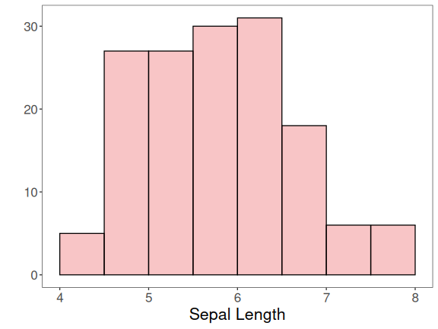
Grouping graphics
{
grf1 <- plot_hist(iris |> dplyr::select(Sepal.Length),
label_x = "Sepal.Length", color=colors[1]) + font
grf2 <- plot_hist(iris |> dplyr::select(Sepal.Width),
label_x = "Sepal.Width", color=colors[1]) + font
grf3 <- plot_hist(iris |> dplyr::select(Petal.Length),
label_x = "Petal.Length", color=colors[1]) + font
grf4 <- plot_hist(iris |> dplyr::select(Petal.Width),
label_x = "Petal.Width", color=colors[1]) + font
}
## Using as id variables
## Using as id variables
## Using as id variables
## Using as id variables
library(gridExtra)
grid.arrange(grf1, grf2, grf3, grf4, ncol=2)
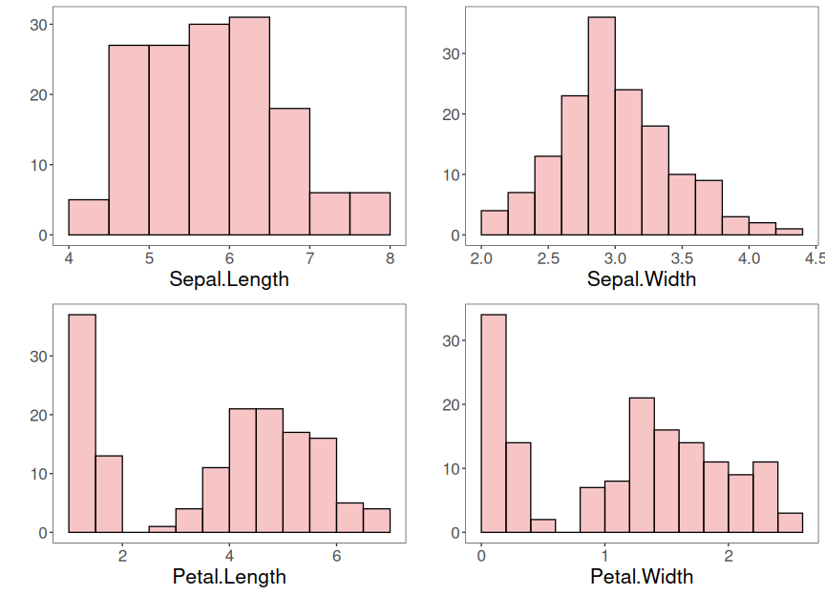

Density distribution
{
grf1 <- plot_density(iris |> dplyr::select(Sepal.Length),
label_x = "Sepal.Length", color=colors[1]) + font
grf2 <- plot_density(iris |> dplyr::select(Sepal.Width),
label_x = "Sepal.Width", color=colors[1]) + font
grf3 <- plot_density(iris |> dplyr::select(Petal.Length),
label_x = "Petal.Length", color=colors[1]) + font
grf4 <- plot_density(iris |> dplyr::select(Petal.Width),
label_x = "Petal.Width", color=colors[1]) + font
}
## Using as id variables
## Using as id variables
## Using as id variables
## Using as id variables
grid.arrange(grf1, grf2, grf3, grf4, ncol=2)
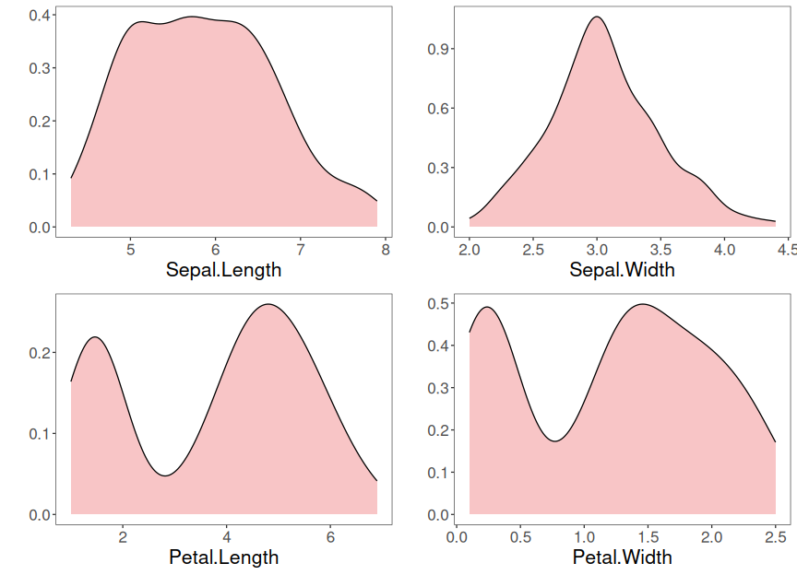

Box-plot analysis
grf <- plot_boxplot(iris, colors=colors[1]) + font
## Using Species as id variables
plot(grf)
## Ignoring unknown labels:
## • colour : "c(\"Sepal.Length\", \"Sepal.Width\", \"Petal.Length\", \"Petal.Width\", \"Species\")"
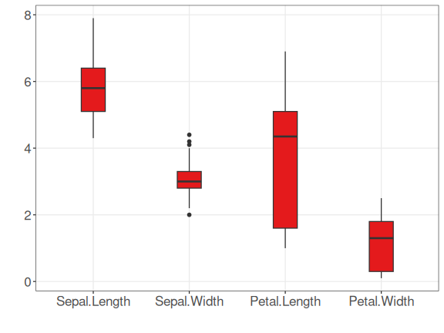

Consider the classification problem targeting to predict the species
Until previous analysis, the goal of classification problem was not explored.

Density distribution colored by the classifier
grfA <- plot_density_class(iris |> dplyr::select(Species, Sepal.Length),
class_label="Species", label_x = "Sepal.Length", color=colors[c(1:3)]) + font
grfB <- plot_density_class(iris |> dplyr::select(Species, Sepal.Width),
class_label="Species", label_x = "Sepal.Width", color=colors[c(1:3)]) + font
grfC <- plot_density_class(iris |> dplyr::select(Species, Petal.Length),
class_label="Species", label_x = "Petal.Length", color=colors[c(1:3)]) + font
grfD <- plot_density_class(iris |> dplyr::select(Species, Petal.Width),
class_label="Species", label_x = "Petal.Width", color=colors[c(1:3)]) + font
grid.arrange(grfA, grfB, grfC, grfD, ncol=2, nrow=2)
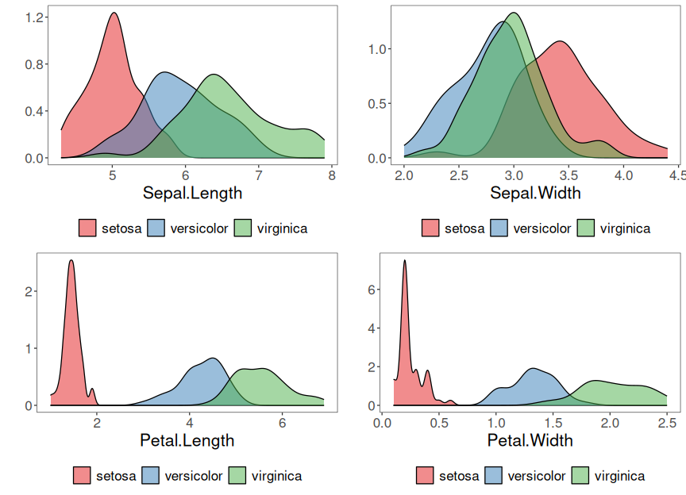

Box-plot analysis grouped by the classifier
grfA <- plot_boxplot_class(iris |> dplyr::select(Species, Sepal.Length),
class_label="Species", label_x = "Sepal.Length", color=colors[c(1:3)]) + font
grfB <- plot_boxplot_class(iris |> dplyr::select(Species, Sepal.Width),
class_label="Species", label_x = "Sepal.Width", color=colors[c(1:3)]) + font
grfC <- plot_boxplot_class(iris |> dplyr::select(Species, Petal.Length),
class_label="Species", label_x = "Petal.Length", color=colors[c(1:3)]) + font
grfD <- plot_boxplot_class(iris |> dplyr::select(Species, Petal.Width),
class_label="Species", label_x = "Petal.Width", color=colors[c(1:3)]) + font
grid.arrange(grfA, grfB, grfC, grfD, ncol=2, nrow=2)
## Ignoring unknown labels:
## • colour : "c(\"setosa\", \"versicolor\", \"virginica\")"
## Ignoring unknown labels:
## • colour : "c(\"setosa\", \"versicolor\", \"virginica\")"
## Ignoring unknown labels:
## • colour : "c(\"setosa\", \"versicolor\", \"virginica\")"
## Ignoring unknown labels:
## • colour : "c(\"setosa\", \"versicolor\", \"virginica\")"
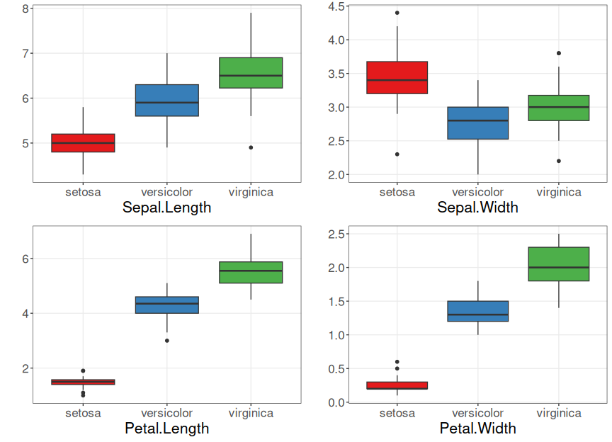

Scatter plot
grf <- plot_scatter(iris |> dplyr::select(x=Sepal.Length, value=Sepal.Width) |> mutate(variable = "iris"),
label_x = "Sepal.Length") +
theme(legend.position = "none") + font
plot(grf)
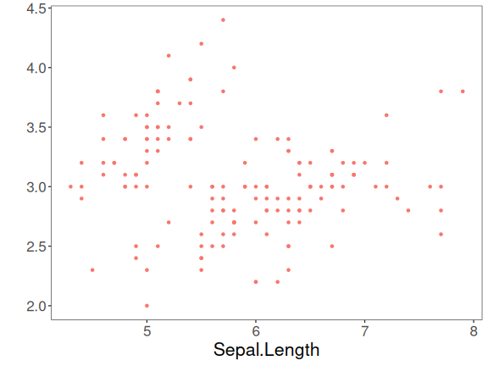
grf <- plot_scatter(iris |> dplyr::select(x = Sepal.Length, value = Sepal.Width, variable = Species),
label_x = "Sepal.Length", label_y = "Sepal.Width", colors=colors[1:3]) + font
plot(grf)
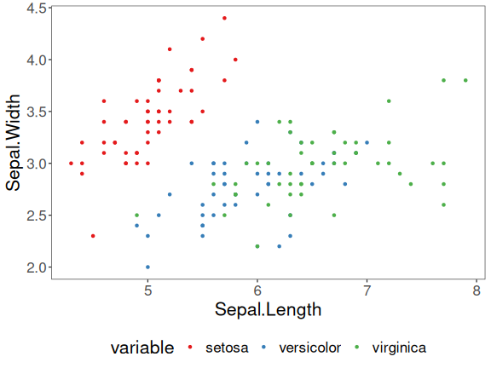

Correlation matrix
grf <- plot_correlation(iris |>
dplyr::select(Sepal.Width, Sepal.Length, Petal.Width, Petal.Length))
grf
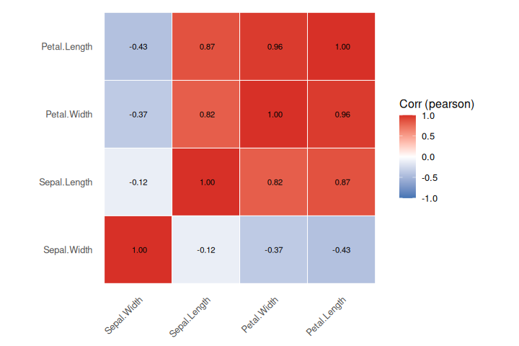

Matrix dispersion
grf <- plot_pair(data=iris, cnames=colnames(iris)[1:4],
title="Iris", colors=colors[1])
plot(grf)
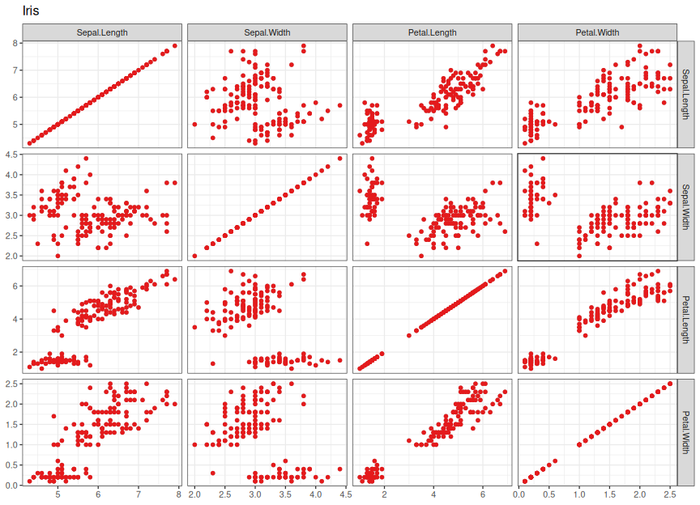

Matrix dispersion by the classifier
grf <- plot_pair(data=iris, cnames=colnames(iris)[1:4],
clabel='Species', title="Iris", colors=colors[1:3])
plot(grf)
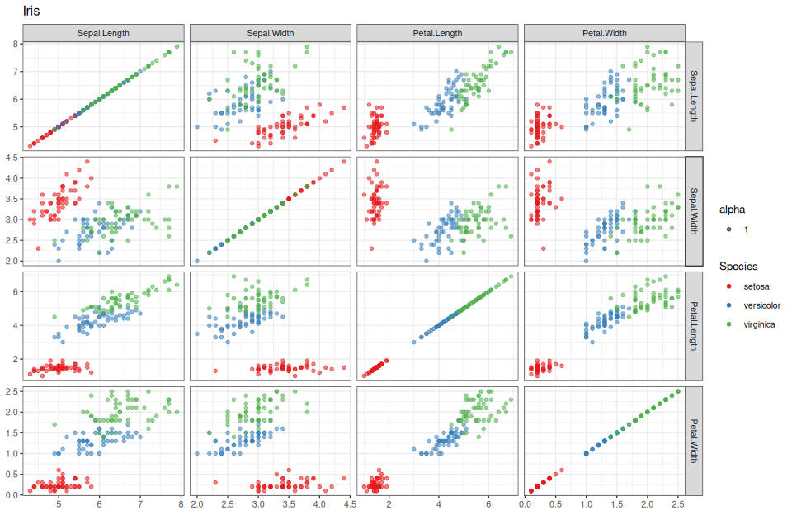

Advanced matrix dispersion
grf <- plot_pair_adv(data=iris, cnames=colnames(iris)[1:4],
title="Iris", colors=colors[1])
grf
## plot: [1, 1] [=====>-------------------------------------------------------------------------------------------] 6% est: 0s
## plot: [1, 2] [===========>-------------------------------------------------------------------------------------] 12% est: 1s
## plot: [1, 3] [=================>-------------------------------------------------------------------------------] 19% est: 1s
## plot: [1, 4] [=======================>-------------------------------------------------------------------------] 25% est: 1s
## plot: [2, 1] [=============================>-------------------------------------------------------------------] 31% est: 1s
## plot: [2, 2] [===================================>-------------------------------------------------------------] 38% est: 1s
## plot: [2, 3] [=========================================>-------------------------------------------------------] 44% est: 1s
## plot: [2, 4] [===============================================>-------------------------------------------------] 50% est: 1s
## plot: [3, 1] [======================================================>------------------------------------------] 56% est: 1s
## plot: [3, 2] [============================================================>------------------------------------] 62% est: 1s
## plot: [3, 3] [==================================================================>------------------------------] 69% est: 0s
## plot: [3, 4] [========================================================================>------------------------] 75% est: 0s
## plot: [4, 1] [==============================================================================>------------------] 81% est: 0s
## plot: [4, 2] [====================================================================================>------------] 88% est: 0s
## plot: [4, 3] [==========================================================================================>------] 94% est: 0s
## plot: [4, 4] [=================================================================================================]100% est: 0s
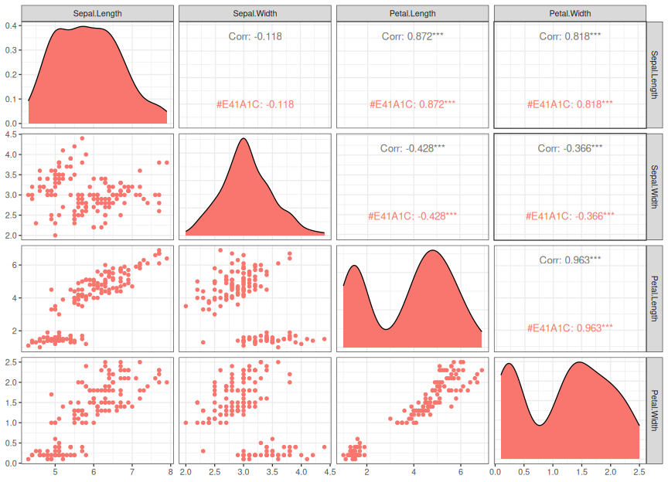

Advanced matrix dispersion with the classifier
grf <- plot_pair_adv(data=iris, cnames=colnames(iris)[1:4],
title="Iris", clabel='Species', colors=colors[1:3])
grf
## plot: [1, 1] [===>---------------------------------------------------------------------------------------------] 4% est: 0s
## plot: [1, 2] [=======>-----------------------------------------------------------------------------------------] 8% est: 2s
## plot: [1, 3] [===========>-------------------------------------------------------------------------------------] 12% est: 2s
## plot: [1, 4] [===============>---------------------------------------------------------------------------------] 16% est: 2s
## plot: [1, 5] [==================>------------------------------------------------------------------------------] 20% est: 2s
## plot: [2, 1] [======================>--------------------------------------------------------------------------] 24% est: 2s
## plot: [2, 2] [==========================>----------------------------------------------------------------------] 28% est: 2s
## plot: [2, 3] [==============================>------------------------------------------------------------------] 32% est: 2s
## plot: [2, 4] [==================================>--------------------------------------------------------------] 36% est: 2s
## plot: [2, 5] [======================================>----------------------------------------------------------] 40% est: 2s
## plot: [3, 1] [==========================================>------------------------------------------------------] 44% est: 2s
## plot: [3, 2] [==============================================>--------------------------------------------------] 48% est: 1s
## plot: [3, 3] [=================================================>-----------------------------------------------] 52% est: 1s
## plot: [3, 4] [=====================================================>-------------------------------------------] 56% est: 1s
## plot: [3, 5] [=========================================================>---------------------------------------] 60% est: 1s
## plot: [4, 1] [=============================================================>-----------------------------------] 64% est: 1s
## plot: [4, 2] [=================================================================>-------------------------------] 68% est: 1s
## plot: [4, 3] [=====================================================================>---------------------------] 72% est: 1s
## plot: [4, 4] [=========================================================================>-----------------------] 76% est: 1s
## plot: [4, 5] [=============================================================================>-------------------] 80% est: 1s
## plot: [5, 1] [================================================================================>----------------] 84% est: 0s
## `stat_bin()` using `bins = 30`. Pick better value `binwidth`. plot: [5, 2]
## [====================================================================================>------------] 88% est: 0s `stat_bin()`
## using `bins = 30`. Pick better value `binwidth`. plot: [5, 3]
## [========================================================================================>--------] 92% est: 0s `stat_bin()`
## using `bins = 30`. Pick better value `binwidth`. plot: [5, 4]
## [============================================================================================>----] 96% est: 0s `stat_bin()`
## using `bins = 30`. Pick better value `binwidth`. plot: [5, 5]
## [=================================================================================================]100% est: 0s
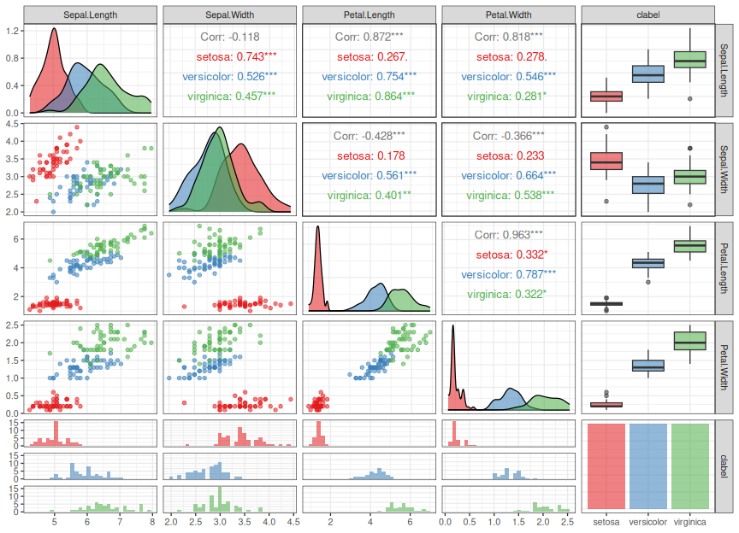

Parallel coordinates
grf <- ggparcoord(data = iris, columns = c(1:4), group=5) +
theme_bw(base_size = 10) + scale_color_manual(values=colors[1:3]) + font
plot(grf)
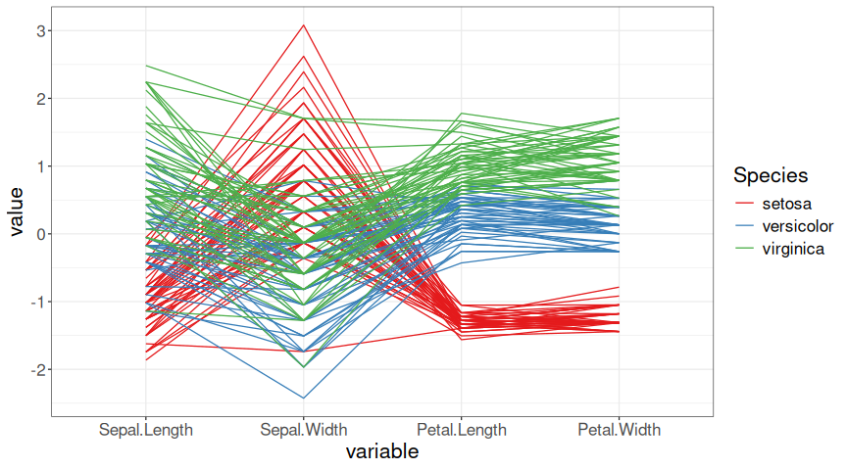

Images
mat <- as.matrix(iris[,1:4])
x <- (1:nrow(mat))
y <- (1:ncol(mat))
image(x, y, mat, col = brewer.pal(11, 'Spectral'), axes = FALSE,
main = "Iris", xlab="sample", ylab="Attributes")
axis(2, at = seq(0, ncol(mat), by = 1))
axis(1, at = seq(0, nrow(mat), by = 10))
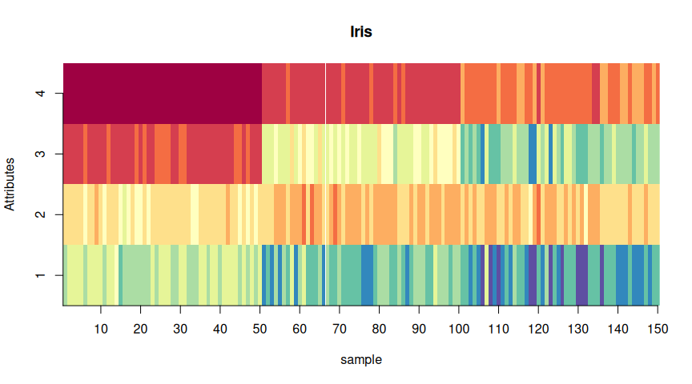

Chernoff faces
set.seed(1)
sample_rows = sample(1:nrow(iris), 25)
isample = iris[sample_rows,]
labels = as.character(rownames(isample))
isample$Species <- NULL
faces(isample, labels = labels, print.info=F, cex=1)
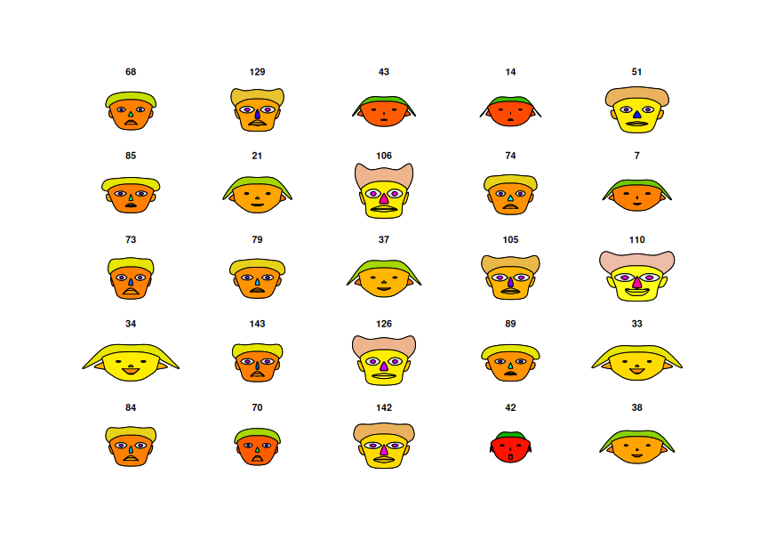

Chernoff faces with the classifier
set.seed(1)
sample_rows = sample(1:nrow(iris), 25)
isample = iris[sample_rows,]
labels = as.character(isample$Species)
isample$Species <- NULL
faces(isample, labels = labels, print.info=F, cex=1)
