Plotting charts
# The easiest way to get ggplot2 is to install the whole tidyverse
#install.packages("tidyverse")
#install.packages("ggplot2")

ggplot easy encapsulation through daltoolbox
library(daltoolbox)
library(ggplot2)

Color Brewer R Package
#install.packages("RColorBrewer")
library(RColorBrewer)
colors <- brewer.pal(4, 'Set1')

Basic setup for examples
Iris datasets
head(iris, 3)
## Sepal.Length Sepal.Width Petal.Length Petal.Width Species
## 1 5.1 3.5 1.4 0.2 setosa
## 2 4.9 3.0 1.4 0.2 setosa
## 3 4.7 3.2 1.3 0.2 setosa
Options from graphics: colors and font size
colors <- brewer.pal(4, 'Set1')
font <- theme(text = element_text(size=16))

Scatter plot
data <- data.frame(
x = iris$Sepal.Length,
value = iris$Sepal.Width,
variable = iris$Species
)
#head(data)
grf <- plot_scatter(data, label_x = "Sepal.Length", label_y = "Sepal.Width", colors=colors[1:3]) + font
plot(grf)
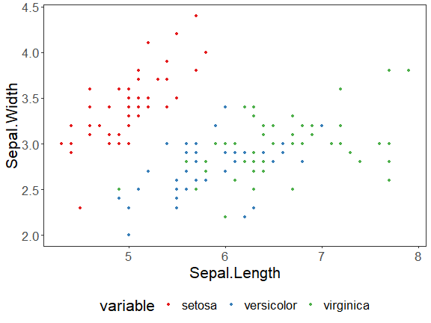

Bar plot
agg <- aggregation("Species", Sepal.Length = mean(Sepal.Length))
data <- transform(agg, iris)
#head(data)
grf <- plot_bar(data, colors=colors[1:3]) + font
plot(grf)
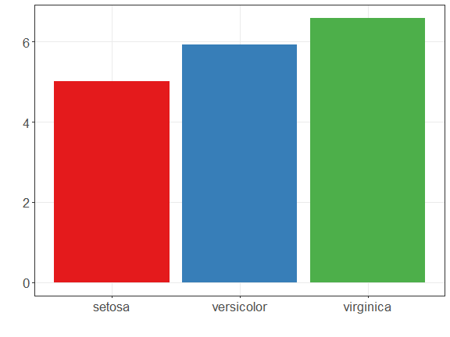

Lollipop plot
agg <- aggregation("Species", Sepal.Length = mean(Sepal.Length))
data <- transform(agg, iris)
#head(data)
grf <- plot_lollipop(data, colors=colors[1], max_value_gap=0.2) + font + coord_flip()
plot(grf)
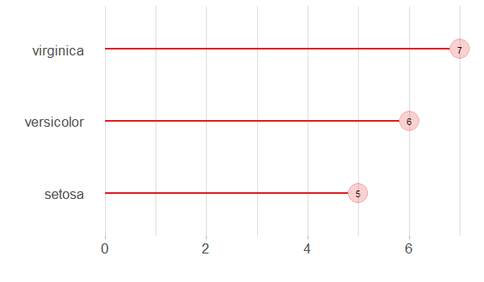

Bar graph with error
agg <- aggregation("Species", mean = mean(Sepal.Length), sd = sd(Sepal.Length))
data <- transform(agg, iris)
#head(data)
grf <- plot_bar(data, colors=colors[1], alpha=1) + font
grf <- grf + geom_errorbar(data = data, inherit.aes = FALSE,
aes(x=Species, ymin=mean-sd, ymax=mean+sd),
width=0.2, colour="darkred", alpha=0.8, size=1.1)
plot(grf)
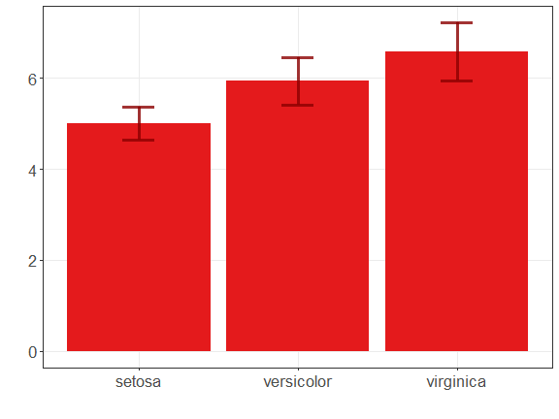

Pie plot
agg <- aggregation("Species", n = n())
data <- transform(agg, iris)
#head(data)
grf <- plot_pieplot(data, colors=colors[1:3]) + font
plot(grf)
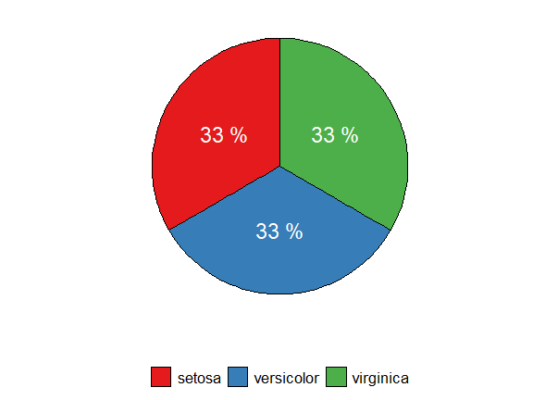

Grouped bar
agg <- aggregation("Species",
Sepal.Length = mean(Sepal.Length),
Sepal.Width = mean(Sepal.Width)
)
data <- transform(agg, iris)
#head(data)
grf <- plot_groupedbar(data, colors=colors[1:2]) + font
plot(grf)
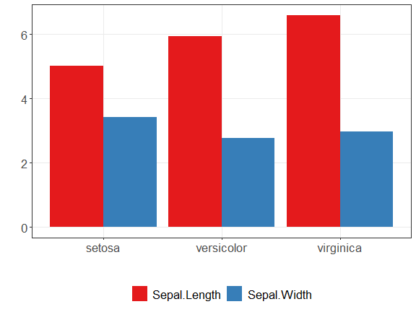

Stacked-bar
agg <- aggregation("Species",
Sepal.Length = mean(Sepal.Length),
Sepal.Width = mean(Sepal.Width)
)
data <- transform(agg, iris)
#head(data)
grf <- plot_stackedbar(data, colors=colors[1:2]) + font
grf <- grf + theme(axis.text.x = element_text(angle=90, hjust=1))
plot(grf)
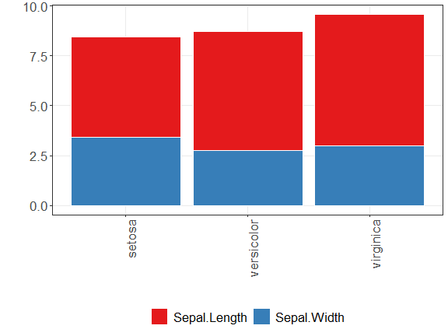

Line chart
x <- seq(0, 10, 0.25)
serie <- data.frame(x, y=sin(x))
#head(serie)
grf <- plot_series(serie, colors=colors[1]) + font
plot(grf)
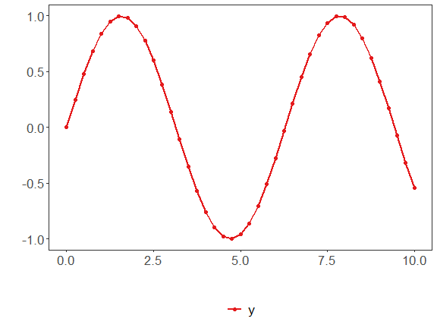

Data distribution example
example <- data.frame(exponential = rexp(10000, rate = 1),
uniform = runif(10000, min=2.5, max = 3.5),
normal = rnorm(10000, mean = 5))
head(example)
## exponential uniform normal
## 1 0.72300963 3.254571 6.390905
## 2 0.01899546 3.058701 6.393282
## 3 0.42360542 3.021129 3.378690
## 4 0.10473704 3.369768 4.272402
## 5 1.22241971 2.673003 3.939171
## 6 0.34497174 3.054448 4.688597

Histogram
data <- data.frame(exponential = example$exponential)
#head(data)
grf <- plot_hist(data, label_x = "exponential", color=colors[1]) + font
plot(grf)
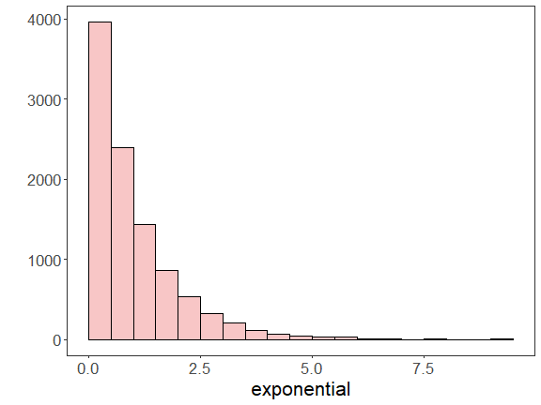

Multiple Histograms
{
library(gridExtra)
grfe <- plot_hist(data.frame(exponential = example$exponential), label_x = "exponential", color=colors[1]) + font
grfu <- plot_hist(data.frame(uniform = example$uniform), label_x = "uniform", color=colors[1]) + font
grfn <- plot_hist(data.frame(normal = example$normal), label_x = "normal", color=colors[1]) + font
grid.arrange(grfe, grfu, grfn, ncol=3)
}
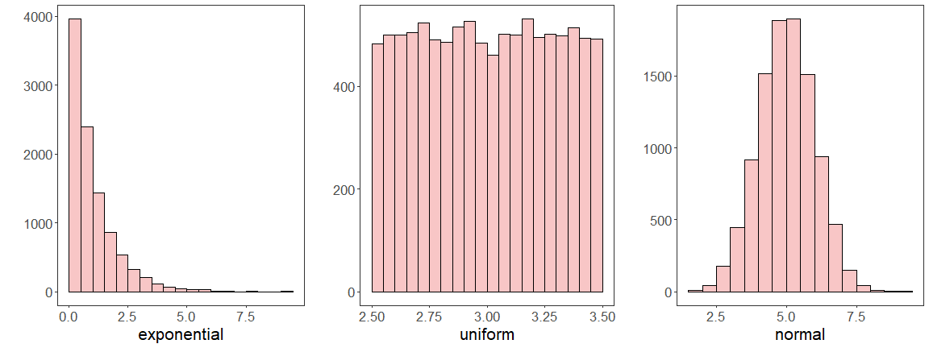

Density plot
data <- data.frame(normal = example$normal)
#head(data)
grf <- plot_density(data, label_x = "normal", color=colors[1]) + font
plot(grf)
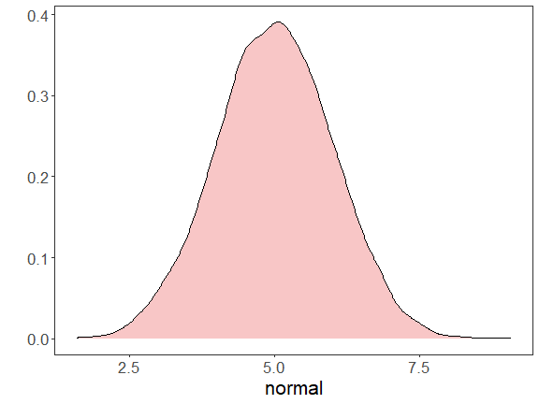

Box plot
data <- data.frame(normal = example$normal)
#head(data)
grf <- plot_boxplot(data, colors="white") + font
plot(grf)
