Regressão - Fundamentos e Modelos
Exemplos alinhados aos slides de 4-Regressao.pdf.
Cada chunk indica o slide correspondente.

Configuração
# Slides 1–7: conceitos e taxonomia
require_pkg <- function(pkg) {
if (!requireNamespace(pkg, quietly = TRUE)) {
stop(sprintf("Pacote '%s' nao instalado. Instale com install.packages('%s').", pkg, pkg))
}
invisible(TRUE)
}
pkgs <- c("daltoolbox", "ggplot2", "dplyr", "MASS")
invisible(lapply(pkgs, require_pkg))
suppressPackageStartupMessages({
library(daltoolbox)
library(ggplot2)
library(dplyr)
library(MASS)
})

Dataset e divisão treino/teste
# Slide 10: Boston Housing Dataset
data(Boston)
str(Boston)
## 'data.frame': 506 obs. of 14 variables:
## $ crim : num 0.00632 0.02731 0.02729 0.03237 0.06905 ...
## $ zn : num 18 0 0 0 0 0 12.5 12.5 12.5 12.5 ...
## $ indus : num 2.31 7.07 7.07 2.18 2.18 2.18 7.87 7.87 7.87 7.87 ...
## $ chas : int 0 0 0 0 0 0 0 0 0 0 ...
## $ nox : num 0.538 0.469 0.469 0.458 0.458 0.458 0.524 0.524 0.524 0.524 ...
## $ rm : num 6.58 6.42 7.18 7 7.15 ...
## $ age : num 65.2 78.9 61.1 45.8 54.2 58.7 66.6 96.1 100 85.9 ...
## $ dis : num 4.09 4.97 4.97 6.06 6.06 ...
## $ rad : int 1 2 2 3 3 3 5 5 5 5 ...
## $ tax : num 296 242 242 222 222 222 311 311 311 311 ...
## $ ptratio: num 15.3 17.8 17.8 18.7 18.7 18.7 15.2 15.2 15.2 15.2 ...
## $ black : num 397 397 393 395 397 ...
## $ lstat : num 4.98 9.14 4.03 2.94 5.33 ...
## $ medv : num 24 21.6 34.7 33.4 36.2 28.7 22.9 27.1 16.5 18.9 ...
head(Boston)
## crim zn indus chas nox rm age dis rad tax ptratio black lstat medv
## 1 0.00632 18 2.31 0 0.538 6.575 65.2 4.0900 1 296 15.3 396.90 4.98 24.0
## 2 0.02731 0 7.07 0 0.469 6.421 78.9 4.9671 2 242 17.8 396.90 9.14 21.6
## 3 0.02729 0 7.07 0 0.469 7.185 61.1 4.9671 2 242 17.8 392.83 4.03 34.7
## 4 0.03237 0 2.18 0 0.458 6.998 45.8 6.0622 3 222 18.7 394.63 2.94 33.4
## 5 0.06905 0 2.18 0 0.458 7.147 54.2 6.0622 3 222 18.7 396.90 5.33 36.2
## 6 0.02985 0 2.18 0 0.458 6.430 58.7 6.0622 3 222 18.7 394.12 5.21 28.7
# Slide 10: preparação treino/teste
set.seed(1)
idx <- sample(seq_len(nrow(Boston)), size = floor(0.7 * nrow(Boston)))
train <- Boston[idx, ]
test <- Boston[-idx, ]
rmse <- function(y, yhat) sqrt(mean((y - yhat)^2))
mae <- function(y, yhat) mean(abs(y - yhat))

Regressão linear simples
# Slides 8 e 11: regressão linear simples e ajuste
lm_simple <- lm(medv ~ lstat, data = train)
summary(lm_simple)
##
## Call:
## lm(formula = medv ~ lstat, data = train)
##
## Residuals:
## Min 1Q Median 3Q Max
## -10.273 -4.237 -1.514 1.914 23.458
##
## Coefficients:
## Estimate Std. Error t value Pr(>|t|)
## (Intercept) 35.44531 0.69048 51.34 <2e-16 ***
## lstat -1.00263 0.04819 -20.81 <2e-16 ***
## ---
## Signif. codes: 0 '***' 0.001 '**' 0.01 '*' 0.05 '.' 0.1 ' ' 1
##
## Residual standard error: 6.412 on 352 degrees of freedom
## Multiple R-squared: 0.5515, Adjusted R-squared: 0.5503
## F-statistic: 432.9 on 1 and 352 DF, p-value: < 2.2e-16
pred_simple <- predict(lm_simple, newdata = test)
rmse(test$medv, pred_simple)
## [1] 5.791294
mae(test$medv, pred_simple)
## [1] 4.440043
# Slide 17: visualização do ajuste
ggplot(train, aes(x = lstat, y = medv)) +
geom_point(alpha = 0.6) +
geom_smooth(method = "lm", se = TRUE, color = "red") +
labs(title = "Regressao Linear Simples: medv ~ lstat")
## `geom_smooth()` using formula = 'y ~ x'
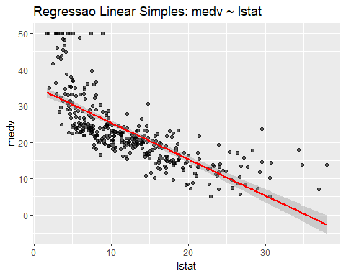
# Slide 16: intervalos de predição e confiança
pred_int <- predict(lm_simple, newdata = test, interval = "prediction")
head(pred_int)
## fit lwr upr
## 5 30.10128 17.454987 42.74758
## 6 30.22160 17.574690 42.86851
## 7 22.98260 10.354375 35.61082
## 8 16.24491 3.600790 28.88903
## 9 5.43654 -7.299741 18.17282
## 10 18.30031 5.664436 30.93618
conf_int <- predict(lm_simple, newdata = test, interval = "confidence")
head(conf_int)
## fit lwr upr
## 5 30.10128 29.14941 31.05316
## 6 30.22160 29.26162 31.18158
## 7 22.98260 22.31235 23.65284
## 8 16.24491 15.32240 17.16742
## 9 5.43654 3.65046 7.22262
## 10 18.30031 17.49877 19.10184
# Slide 18: diagnóstico visual
par(mfrow = c(2, 2))
plot(lm_simple)
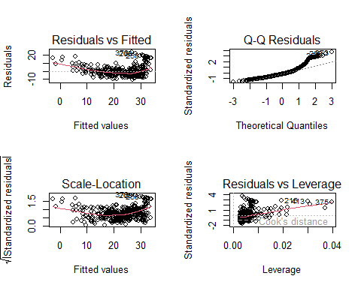
par(mfrow = c(1, 1))

Regressão polinomial
# Slides 21–26: regressão polinomial e overfitting
lm_poly2 <- lm(medv ~ poly(lstat, 2, raw = TRUE), data = train)
summary(lm_poly2)
##
## Call:
## lm(formula = medv ~ poly(lstat, 2, raw = TRUE), data = train)
##
## Residuals:
## Min 1Q Median 3Q Max
## -11.2327 -4.1001 -0.3772 2.4898 24.1548
##
## Coefficients:
## Estimate Std. Error t value Pr(>|t|)
## (Intercept) 44.506809 1.018352 43.70 <2e-16 ***
## poly(lstat, 2, raw = TRUE)1 -2.536197 0.145750 -17.40 <2e-16 ***
## poly(lstat, 2, raw = TRUE)2 0.048948 0.004458 10.98 <2e-16 ***
## ---
## Signif. codes: 0 '***' 0.001 '**' 0.01 '*' 0.05 '.' 0.1 ' ' 1
##
## Residual standard error: 5.54 on 351 degrees of freedom
## Multiple R-squared: 0.6662, Adjusted R-squared: 0.6643
## F-statistic: 350.2 on 2 and 351 DF, p-value: < 2.2e-16
anova(lm_simple, lm_poly2)
## Analysis of Variance Table
##
## Model 1: medv ~ lstat
## Model 2: medv ~ poly(lstat, 2, raw = TRUE)
## Res.Df RSS Df Sum of Sq F Pr(>F)
## 1 352 14472
## 2 351 10772 1 3699.5 120.55 < 2.2e-16 ***
## ---
## Signif. codes: 0 '***' 0.001 '**' 0.01 '*' 0.05 '.' 0.1 ' ' 1
# Slide 23: visualização da regressão polinomial
grid <- data.frame(lstat = seq(min(train$lstat), max(train$lstat), length.out = 200))
grid$pred <- predict(lm_poly2, newdata = grid)
ggplot(train, aes(x = lstat, y = medv)) +
geom_point(alpha = 0.5) +
geom_line(data = grid, aes(x = lstat, y = pred), color = "blue", linewidth = 1) +
labs(title = "Regressao Polinomial (grau 2): medv ~ lstat")
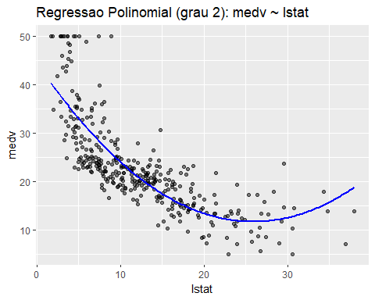

Regressão múltipla
# Slides 27–29: regressão múltipla e interpretação
lm_multi <- lm(medv ~ lstat + rm + ptratio, data = train)
summary(lm_multi)
##
## Call:
## lm(formula = medv ~ lstat + rm + ptratio, data = train)
##
## Residuals:
## Min 1Q Median 3Q Max
## -12.1020 -3.2174 -0.6043 1.8613 29.2970
##
## Coefficients:
## Estimate Std. Error t value Pr(>|t|)
## (Intercept) 12.30766 4.68672 2.626 0.00902 **
## lstat -0.52334 0.05159 -10.143 < 2e-16 ***
## rm 5.50996 0.50310 10.952 < 2e-16 ***
## ptratio -0.95685 0.14051 -6.810 4.27e-11 ***
## ---
## Signif. codes: 0 '***' 0.001 '**' 0.01 '*' 0.05 '.' 0.1 ' ' 1
##
## Residual standard error: 5.127 on 350 degrees of freedom
## Multiple R-squared: 0.7149, Adjusted R-squared: 0.7125
## F-statistic: 292.5 on 3 and 350 DF, p-value: < 2.2e-16
pred_multi <- predict(lm_multi, newdata = test)
rmse(test$medv, pred_multi)
## [1] 5.561335
mae(test$medv, pred_multi)
## [1] 3.707664
# Slide 30: ANOVA para regressão múltipla
lm_multi2 <- lm(medv ~ lstat + rm + ptratio + nox, data = train)
anova(lm_multi, lm_multi2)
## Analysis of Variance Table
##
## Model 1: medv ~ lstat + rm + ptratio
## Model 2: medv ~ lstat + rm + ptratio + nox
## Res.Df RSS Df Sum of Sq F Pr(>F)
## 1 350 9199.9
## 2 349 9187.1 1 12.813 0.4868 0.4858
# Slide 31: multicolinearidade (VIF)
vif_calc <- function(model) {
X <- model.matrix(model)[, -1, drop = FALSE]
vifs <- numeric(ncol(X))
names(vifs) <- colnames(X)
for (j in seq_len(ncol(X))) {
y <- X[, j]
x <- X[, -j, drop = FALSE]
r2 <- summary(lm(y ~ x))$r.squared
vifs[j] <- 1 / (1 - r2)
}
vifs
}
vif_calc(lm_multi2)
## lstat rm ptratio nox
## 2.436583 1.771009 1.241960 1.546373
# Slide 32: superfície de regressão múltipla
grid2 <- expand.grid(
lstat = seq(min(train$lstat), max(train$lstat), length.out = 30),
rm = seq(min(train$rm), max(train$rm), length.out = 30),
ptratio = mean(train$ptratio),
nox = mean(train$nox)
)
grid2$pred <- predict(lm_multi2, newdata = grid2)
ggplot(grid2, aes(x = lstat, y = rm, z = pred)) +
geom_contour_filled() +
labs(title = "Superficie de Regressao (medv ~ lstat + rm + ptratio + nox)")
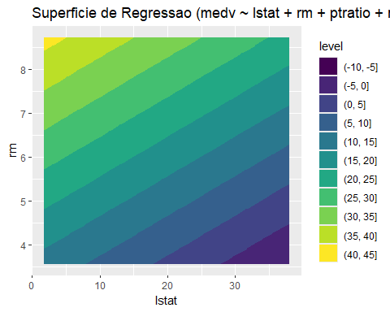
# Slide 33: alta dimensionalidade
lm_full <- lm(medv ~ ., data = train)
summary(lm_full)
##
## Call:
## lm(formula = medv ~ ., data = train)
##
## Residuals:
## Min 1Q Median 3Q Max
## -11.1732 -2.7272 -0.5408 1.6594 23.9450
##
## Coefficients:
## Estimate Std. Error t value Pr(>|t|)
## (Intercept) 28.209249 6.094508 4.629 5.24e-06 ***
## crim -0.070644 0.042379 -1.667 0.096439 .
## zn 0.036046 0.016006 2.252 0.024959 *
## indus 0.030055 0.069986 0.429 0.667874
## chas 3.419418 0.933343 3.664 0.000288 ***
## nox -14.582615 4.374454 -3.334 0.000952 ***
## rm 4.856324 0.493995 9.831 < 2e-16 ***
## age -0.014469 0.015251 -0.949 0.343431
## dis -1.411125 0.231606 -6.093 3.01e-09 ***
## rad 0.303706 0.075162 4.041 6.59e-05 ***
## tax -0.013742 0.004219 -3.257 0.001238 **
## ptratio -0.941851 0.154394 -6.100 2.88e-09 ***
## black 0.010698 0.003084 3.469 0.000590 ***
## lstat -0.480384 0.061173 -7.853 5.37e-14 ***
## ---
## Signif. codes: 0 '***' 0.001 '**' 0.01 '*' 0.05 '.' 0.1 ' ' 1
##
## Residual standard error: 4.593 on 340 degrees of freedom
## Multiple R-squared: 0.7778, Adjusted R-squared: 0.7693
## F-statistic: 91.52 on 13 and 340 DF, p-value: < 2.2e-16

Modelos supervisionados (DALToolbox)
# Slides 19–20: extensões da regressão linear (modelos mais complexos)
# Complemento prático com DALToolbox
Boston_m <- as.matrix(Boston)
set.seed(1)
sr <- sample_random()
sr <- train_test(sr, Boston_m)
boston_train <- sr$train
boston_test <- sr$test
# Slide 7: taxonomia (árvore de regressão)
model_dtree <- reg_dtree("medv")
model_dtree <- fit(model_dtree, boston_train)
train_pred <- predict(model_dtree, boston_train)
evaluate(model_dtree, boston_train[, "medv"], train_pred)$metrics
## mse smape R2
## 1 12.68065 0.1345098 0.8591168
test_pred <- predict(model_dtree, boston_test)
evaluate(model_dtree, boston_test[, "medv"], test_pred)$metrics
## mse smape R2
## 1 29.38142 0.1642396 0.5117372
# Slide 7: taxonomia (kNN para regressão)
model_knn <- reg_knn("medv", k = 5)
model_knn <- fit(model_knn, boston_train)
train_pred <- predict(model_knn, boston_train)
evaluate(model_knn, boston_train[, "medv"], train_pred)$metrics
## mse smape R2
## 1 27.02782 0.155995 0.6997184
test_pred <- predict(model_knn, boston_test)
evaluate(model_knn, boston_test[, "medv"], test_pred)$metrics
## mse smape R2
## 1 26.9483 0.1791238 0.552171
# Slide 7: taxonomia (MLP para regressão)
model_mlp <- reg_mlp("medv", size = 5, decay = 0.54)
model_mlp <- fit(model_mlp, boston_train)
train_pred <- predict(model_mlp, boston_train)
evaluate(model_mlp, boston_train[, "medv"], train_pred)$metrics
## mse smape R2
## 1 7.815809 0.09907171 0.9131656
test_pred <- predict(model_mlp, boston_test)
evaluate(model_mlp, boston_test[, "medv"], test_pred)$metrics
## mse smape R2
## 1 17.59761 0.1396753 0.7075616
# Slide 7: taxonomia (Random Forest para regressão)
model_rf <- reg_rf("medv", mtry = 7, ntree = 30)
model_rf <- fit(model_rf, boston_train)
train_pred <- predict(model_rf, boston_train)
evaluate(model_rf, boston_train[, "medv"], train_pred)$metrics
## mse smape R2
## 1 1.247833 0.03846161 0.9861365
test_pred <- predict(model_rf, boston_test)
evaluate(model_rf, boston_test[, "medv"], test_pred)$metrics
## mse smape R2
## 1 12.6109 0.1170046 0.790431
# Slide 7: taxonomia (SVR)
model_svm <- reg_svm("medv", epsilon = 0.2, cost = 40.000)
model_svm <- fit(model_svm, boston_train)
train_pred <- predict(model_svm, boston_train)
evaluate(model_svm, boston_train[, "medv"], train_pred)$metrics
## mse smape R2
## 1 2.855767 0.0700268 0.9682722
test_pred <- predict(model_svm, boston_test)
evaluate(model_svm, boston_test[, "medv"], test_pred)$metrics
## mse smape R2
## 1 14.65598 0.1363336 0.7564457
# Slide 19: extensões e ajuste de modelos (tuning)
tune <- reg_tune(
reg_svm("medv"),
ranges = list(seq(0, 1, 0.2), cost = seq(20, 100, 20), kernel = c("radial"))
)
model_tuned <- fit(tune, boston_train)
train_pred <- predict(model_tuned, boston_train)
evaluate(model_tuned, boston_train[, "medv"], train_pred)$metrics
## mse smape R2
## 1 1.468661 0.0461686 0.983683
test_pred <- predict(model_tuned, boston_test)
evaluate(model_tuned, boston_test[, "medv"], test_pred)$metrics
## mse smape R2
## 1 16.50897 0.141226 0.7256526

Referências
- Montgomery, D. C., Peck, E. A., Vining, G. (2012). Introduction to Linear Regression Analysis.
- James, G., Witten, D., Hastie, T., Tibshirani, R. (2021). An Introduction to Statistical Learning.
- Draper, N. R., Smith, H. (1998). Applied Regression Analysis.
- Breiman, L. (2001). Random Forests. Machine Learning.
- Drucker, H. et al. (1997). Support Vector Regression Machines.

