Regression
# DAL ToolBox
# version 1.0.77
library(daltoolbox)
library(MASS)
library(plotly)
library(reshape2)

Dataset
Both independent and dependent variables are numeric.
head(Boston)
## crim zn indus chas nox rm age dis rad tax ptratio black lstat
## 1 0.00632 18 2.31 0 0.538 6.575 65.2 4.0900 1 296 15.3 396.90 4.98
## 2 0.02731 0 7.07 0 0.469 6.421 78.9 4.9671 2 242 17.8 396.90 9.14
## 3 0.02729 0 7.07 0 0.469 7.185 61.1 4.9671 2 242 17.8 392.83 4.03
## 4 0.03237 0 2.18 0 0.458 6.998 45.8 6.0622 3 222 18.7 394.63 2.94
## 5 0.06905 0 2.18 0 0.458 7.147 54.2 6.0622 3 222 18.7 396.90 5.33
## 6 0.02985 0 2.18 0 0.458 6.430 58.7 6.0622 3 222 18.7 394.12 5.21
## medv
## 1 24.0
## 2 21.6
## 3 34.7
## 4 33.4
## 5 36.2
## 6 28.7

Fitting a first model
Explaining house price using lower status population variable.
$lm$ builds the model.
$summary$ describes the significance of the built model.
lm.fit = lm(medv ~ lstat, data = Boston)
summary(lm.fit)
##
## Call:
## lm(formula = medv ~ lstat, data = Boston)
##
## Residuals:
## Min 1Q Median 3Q Max
## -15.168 -3.990 -1.318 2.034 24.500
##
## Coefficients:
## Estimate Std. Error t value Pr(>|t|)
## (Intercept) 34.55384 0.56263 61.41 <2e-16 ***
## lstat -0.95005 0.03873 -24.53 <2e-16 ***
## ---
## Signif. codes: 0 '***' 0.001 '**' 0.01 '*' 0.05 '.' 0.1 ' ' 1
##
## Residual standard error: 6.216 on 504 degrees of freedom
## Multiple R-squared: 0.5441, Adjusted R-squared: 0.5432
## F-statistic: 601.6 on 1 and 504 DF, p-value: < 2.2e-16

prediction
The $predict$ function makes predictions from the adjusted model.
The predictions can be presented with either $confidence$ and $prediction$ intervals.
These intervals can be analyzed at https://statisticsbyjim.com/hypothesis-testing/confidence-prediction-tolerance-intervals/
predict(lm.fit, data.frame(lstat =(c(5, 10, 15))), interval = "confidence")
## fit lwr upr
## 1 29.80359 29.00741 30.59978
## 2 25.05335 24.47413 25.63256
## 3 20.30310 19.73159 20.87461
predict(lm.fit, data.frame(lstat =(c(5, 10, 15))), interval = "prediction")
## fit lwr upr
## 1 29.80359 17.565675 42.04151
## 2 25.05335 12.827626 37.27907
## 3 20.30310 8.077742 32.52846

Plotting the regression model
It is a good practice to plot the regression model. It enables us to have a feeling of its quality.
axis_x <- seq(min(Boston$lstat), max(Boston$lstat), by = 0.5)
axis_y <- predict(lm.fit, data.frame(lstat=axis_x))
data_adj = data.frame(lstat=axis_x, medv=axis_y)
ggplot(Boston) + geom_point(aes(x = lstat, y = medv)) + geom_line(data=data_adj,aes(x=lstat,y=medv), color="Blue") + theme_bw(base_size = 10)
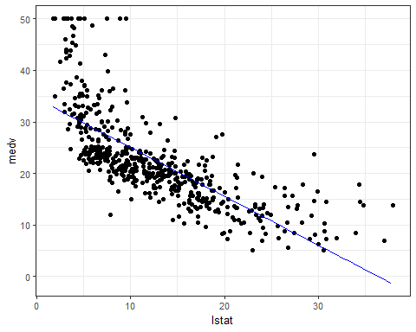

Polynomial regression
It is possible to introduce polynomial dimensions of independent data.
lm.fit_p =lm(medv~lstat+I(lstat^2), data=Boston)
summary (lm.fit_p)
##
## Call:
## lm(formula = medv ~ lstat + I(lstat^2), data = Boston)
##
## Residuals:
## Min 1Q Median 3Q Max
## -15.2834 -3.8313 -0.5295 2.3095 25.4148
##
## Coefficients:
## Estimate Std. Error t value Pr(>|t|)
## (Intercept) 42.862007 0.872084 49.15 <2e-16 ***
## lstat -2.332821 0.123803 -18.84 <2e-16 ***
## I(lstat^2) 0.043547 0.003745 11.63 <2e-16 ***
## ---
## Signif. codes: 0 '***' 0.001 '**' 0.01 '*' 0.05 '.' 0.1 ' ' 1
##
## Residual standard error: 5.524 on 503 degrees of freedom
## Multiple R-squared: 0.6407, Adjusted R-squared: 0.6393
## F-statistic: 448.5 on 2 and 503 DF, p-value: < 2.2e-16

Plotting the polynomial regression model
It seems to be better adjusted with the data. Is it significant?
axis_x <- seq(min(Boston$lstat), max(Boston$lstat), by = 0.5)
axis_x2 <- axis_x^2
axis_y <- predict(lm.fit_p, data.frame(lstat=axis_x, `I(lstat^2)`=axis_x2))
data_adj = data.frame(lstat=axis_x, medv=axis_y)
ggplot(Boston) + geom_point(aes(x = lstat, y = medv)) + geom_line(data=data_adj,aes(x=lstat,y=medv), color="Blue") + theme_bw(base_size = 10)
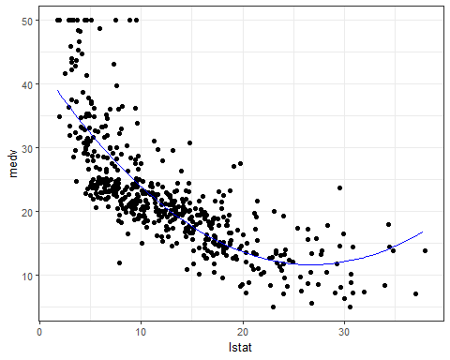

ANOVA test
It is possible to check if a built model is significantly better than another model using the ANOVA test.
The null hypothesis is that both models are not different ($p-value>5\%$). The alternative hypothesis says that they are different ($p-value<5\%$).
anova(lm.fit, lm.fit_p)
## Analysis of Variance Table
##
## Model 1: medv ~ lstat
## Model 2: medv ~ lstat + I(lstat^2)
## Res.Df RSS Df Sum of Sq F Pr(>F)
## 1 504 19472
## 2 503 15347 1 4125.1 135.2 < 2.2e-16 ***
## ---
## Signif. codes: 0 '***' 0.001 '**' 0.01 '*' 0.05 '.' 0.1 ' ' 1

Multiple regression
It is possible to use more than one dimension as independent data for the regression model.
lm.fit2 =lm(medv~lstat+age, data=Boston)
summary (lm.fit2)
##
## Call:
## lm(formula = medv ~ lstat + age, data = Boston)
##
## Residuals:
## Min 1Q Median 3Q Max
## -15.981 -3.978 -1.283 1.968 23.158
##
## Coefficients:
## Estimate Std. Error t value Pr(>|t|)
## (Intercept) 33.22276 0.73085 45.458 < 2e-16 ***
## lstat -1.03207 0.04819 -21.416 < 2e-16 ***
## age 0.03454 0.01223 2.826 0.00491 **
## ---
## Signif. codes: 0 '***' 0.001 '**' 0.01 '*' 0.05 '.' 0.1 ' ' 1
##
## Residual standard error: 6.173 on 503 degrees of freedom
## Multiple R-squared: 0.5513, Adjusted R-squared: 0.5495
## F-statistic: 309 on 2 and 503 DF, p-value: < 2.2e-16

Checking the significance of the model
anova(lm.fit ,lm.fit2)
## Analysis of Variance Table
##
## Model 1: medv ~ lstat
## Model 2: medv ~ lstat + age
## Res.Df RSS Df Sum of Sq F Pr(>F)
## 1 504 19472
## 2 503 19168 1 304.25 7.984 0.004907 **
## ---
## Signif. codes: 0 '***' 0.001 '**' 0.01 '*' 0.05 '.' 0.1 ' ' 1

Logistic Regression
In this example the predicted dependent variable is categorical.
head(iris)
## Sepal.Length Sepal.Width Petal.Length Petal.Width Species
## 1 5.1 3.5 1.4 0.2 setosa
## 2 4.9 3.0 1.4 0.2 setosa
## 3 4.7 3.2 1.3 0.2 setosa
## 4 4.6 3.1 1.5 0.2 setosa
## 5 5.0 3.6 1.4 0.2 setosa
## 6 5.4 3.9 1.7 0.4 setosa
To make the problem simpler, let us assume that we intend to predict if a species is $versicolor$ or if it is $other$ species.
data <- iris
data$versicolor <- as.integer(data$Species=="versicolor")
data$Species <- c('other', 'versicolor')[data$versicolor+1]
Using preprocessing functions, we separate both training and test data.
tt <- daltoolbox::train_test(daltoolbox::sample_random(), data)
train <- tt$train
test <- tt$test
head(train)
## Sepal.Length Sepal.Width Petal.Length Petal.Width Species versicolor
## 103 7.1 3.0 5.9 2.1 other 0
## 60 5.2 2.7 3.9 1.4 versicolor 1
## 51 7.0 3.2 4.7 1.4 versicolor 1
## 34 5.5 4.2 1.4 0.2 other 0
## 138 6.4 3.1 5.5 1.8 other 0
## 129 6.4 2.8 5.6 2.1 other 0
This dataset is unbalanced using this perspective. If the prediction for $versicolor$ is higher than its probability, it can be classified as $versicolor$.
t <- mean(train$versicolor)
print(t)
## [1] 0.3333333
The creation of the logistic regression model using all independent variables uses $glm$ function.
pred <- glm(versicolor ~ .-Species, data=train, family = binomial)
The quality of adjustment using training data is measured using the confusion table.
res <- predict(pred, train, type="response")
res <- as.integer(res >= t)
table(res, train$versicolor)
##
## res 0 1
## 0 62 6
## 1 18 34
The quality of prediction using the test data is measured using the confusion table.
res <- predict(pred, test, type="response")
res <- res >= t
table(res, test$versicolor)
##
## res 0 1
## FALSE 11 1
## TRUE 9 9
Creation of the logistic regression model using the independent variables with lower entropy during binning transformation.
pred <- glm(versicolor ~ Petal.Length + Petal.Width, data=train, family = binomial)
The quality of adjustment using training data is measured using the confusion table.
res <- predict(pred, train, type="response")
res <- as.integer(res >= t)
table(res, train$versicolor)
##
## res 0 1
## 0 66 7
## 1 14 33
The quality of prediction using the test data is measured using the confusion table.
res <- predict(pred, test, type="response")
res <- as.integer(res >= t)
table(res, test$versicolor)
##
## res 0 1
## 0 12 1
## 1 8 9

