Considere dois métodos A e B, onde desejamos comparar os seus desempenhos.
#dado sintético
set.seed(1)
trials <- 30
MethodA <- rnorm(trials, mean=10, sd = 2)
MethodB <- rnorm(trials, mean=11, sd = 2)
data <- data.frame(MethodA, MethodB)
head(data)
## MethodA MethodB
## 1 8.747092 13.717359
## 2 10.367287 10.794425
## 3 8.328743 11.775343
## 4 13.190562 10.892390
## 5 10.659016 8.245881
## 6 8.359063 10.170011
boxplot(data)
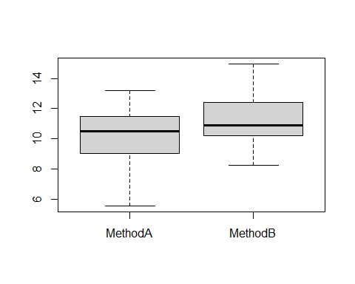
res <- wilcox.test(MethodA, MethodB, paired=TRUE, exact=FALSE)
res
##
## Wilcoxon signed rank test with continuity correction
##
## data: MethodA and MethodB
## V = 129, p-value = 0.03413
## alternative hypothesis: true location shift is not equal to 0
Análise do Effect Size
library(rstatix)
Execute este mesmo experimento com menos tentativas (trials) (5, 10)
methods = c(rep("MethodA", length(MethodA)), rep("MethodB", length(MethodB)))
data_effect = data.frame(methods, y = c(MethodA, MethodB))
wilcox_effsize(y ~ methods, paired=TRUE, data=data_effect)
## # A tibble: 1 × 7
## .y. group1 group2 effsize n1 n2 magnitude
## * <chr> <chr> <chr> <dbl> <int> <int> <ord>
## 1 y MethodA MethodB 0.389 30 30 moderate
Altere as médias para avaliar a magnitude do efeito.

