weight <- c(60, 72, 57, 90, 95, 72)
height <- c(1.75, 1.80, 1.65, 1.90, 1.74, 1.91)
subject <- c("A", "B", "C", "D", "E", "F")
plot(height, weight)
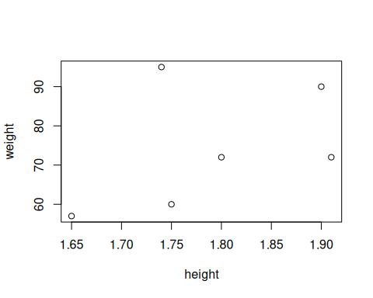
plot(height, weight, pch=2)
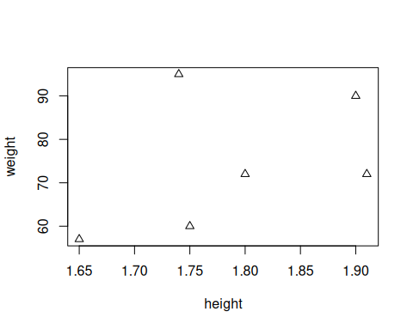
args(plot.default)
## function (x, y = NULL, type = "p", xlim = NULL, ylim = NULL,
## log = "", main = NULL, sub = NULL, xlab = NULL, ylab = NULL,
## ann = par("ann"), axes = TRUE, frame.plot = axes, panel.first = NULL,
## panel.last = NULL, asp = NA, xgap.axis = NA, ygap.axis = NA,
## ...)
## NULL
#?plot
plot(height, weight)
hh = c(1.65, 1.70, 1.75, 1.80, 1.85, 1.90)
lines(hh, 22.5 * hh^2)
