Federated Naive Bayes with Distribution Mixture and Institutional Risk Context for Intrusion Detection
Edgar Herrera Logrono | Ezequiel Lopez Rubio | Juan Miguel Ortiz de Lazcano
Programa de Doctorado en Tecnologias Informaticas, Universidad de Malaga, Spain
ABSTRACT
This paper presents a federated learning method for network intrusion detection that combines local Gaussian Naive Bayes models by mixing their probability distributions rather than averaging their parameters. The aggregation weights are learned empirically from a held-out validation set. Each participating node is characterized by five institutional risk variables from the CRISC framework: CMM, KCI, KRI, CVSS, and ICC. A systematic validation protocol verified dataset sufficiency, optimizer convergence, and stress conditions before and after experimentation. On the NSL-KDD benchmark under high heterogeneity, the learned mixture achieves F1-macro = 0.485 on an out-of-distribution test set against 0.192 for the parameter-averaging baseline, a difference confirmed statistically significant by McNemar (chi2 = 3630, p < 0.001). Under moderate and low heterogeneity, the optimizer concentrates weight on a single node, a limitation discussed and connected to future work on ICC-based weight initialization.
Keywords: federated learning, Naive Bayes, distribution mixture, intrusion detection, CRISC, NSL-KDD, out-of-distribution evaluation

1. INTRODUCTION
Over more than two decades working in network security across banking, telecommunications, and public institutions in Latin America, one pattern appears repeatedly: organizations that face similar threats are reluctant to share the data that would help them defend better. A commercial bank holds traffic logs that reveal transaction behavior. A hospital accumulates records tied to patient systems. A government body stores connection data linked to critical services. None of these institutions can simply hand that data to a third party, even when doing so would improve detection for all of them.
Federated learning [1] was developed precisely for this kind of scenario. Each participant trains a model on its own records, and only the model parameters travel to a central coordinator. The most common aggregation method, FedAvg, computes a weighted average of those parameters. In practice, that works reasonably well when all participants see similar traffic, but in intrusion detection that assumption rarely holds. The financial sector faces different attack patterns than healthcare or government, and blending their models by averaging loses the specificity that makes each one useful.
This paper proposes an alternative: instead of averaging the parameters of the local Naive Bayes models, the server mixes their full conditional distributions. The aggregation weights are not assigned by hand or by heuristic rules. They are learned from a held-out validation set using numerical optimization, so the contribution of each node reflects its actual usefulness for the federated model rather than a proxy such as dataset size. We also introduce five institutional risk variables from the CRISC framework to characterize each node and examine whether the learned weights align with those institutional profiles.
The contributions are: (1) a formalization of distribution mixture aggregation for federated Gaussian Naive Bayes; (2) empirical weight learning from validation data with L2 regularization; (3) institutional characterization of each node through CRISC variables; (4) a systematic validation protocol that checks dataset sufficiency, optimizer behavior, and stress conditions; and (5) out-of-distribution evaluation that exposes generalization differences hidden by ceiling effects on standard test sets.
2. RELATED WORK
Wisanwanichthan and Thammawichai [2] combined Naive Bayes and support vector machines in a two-layer architecture for network intrusion detection on NSL-KDD. Their results confirmed the value of probabilistic classifiers for this task and established a performance reference on the same dataset we use.
Li et al. [3] introduced the Dirichlet partition as a standard method for simulating non-IID data distributions across federated nodes, along with Jensen-Shannon divergence as a heterogeneity measure. Both tools are central to our experimental setup. Their framework for federated optimization under heterogeneous conditions motivated the weight learning approach we adopt.
Lara-Gutierrez, Fernandez-Gago, and Onieva [4] from the NICS Lab proposed a framework for drift detection and adaptation in AI-driven anomaly detection systems. Their evaluation methodology on unseen attack types directly informed our decision to use KDDTest+21 as a separate out-of-distribution partition. The connection between institutional trust management, which is a central concern in the NICS Lab research agenda, and federated weight assignment is one of the directions our work opens.
Table 1. Comparison of related approaches.
Reference | Aggregation | Learned | OOD eval | Context vars
Wisanwanichthan [2] | NB+SVM | No | No | No
Li et al. [3] | FedAvg | No | No | No
Lara et al. [4] | Centralized | N/A | Partial | No
This work | Distrib. mix | Yes | Yes | CRISC / ICC

3. METHOD
3.1 Local model training
Each node k trains a Gaussian Naive Bayes classifier on its local dataset independently. The result is a compact statistical summary: a mean and a variance for each combination of class c and feature j. No raw data leaves the institution at any point. The training is fully local, and the summary statistics are the only information sent to the central server.
Node distributions in the experiments are simulated using the Dirichlet partition [3] with concentration parameter alpha. This controls how different the class distributions are across nodes. A small alpha (0.1) produces nodes with very distinct profiles, similar to what one would observe in practice between a bank, a hospital, and a government body. A large alpha (1.0) produces nearly identical distributions, representing a scenario where all institutions see similar traffic.
3.2 Distribution mixture aggregation
The server builds a mixture of the node distributions. For each class c and feature j, the federated mean and variance are:
mu(c,j) = sum_k w_k * mu_k(c,j)
sigma2(c,j) = sum_k w_k * [sigma2_k(c,j) + mu_k(c,j)^2] - mu(c,j)^2
The weights w_k are non-negative and sum to one. Expression (2) applies the law of total variance, preserving the spread contributed by each node. Parameter averaging ignores this decomposition and underestimates the true variance when node distributions differ. The global class prior is estimated from the internal test set rather than from the local partitions, avoiding the bias that arises when one node holds predominantly benign traffic.
3.3 Learning the aggregation weights
Assigning weights by hand or by heuristic rules such as local dataset size or local F1 lacks empirical grounding. We instead learn the weights by minimizing 1 minus macro F1 on a held-out validation set V that no node used for training. The optimization uses the Nelder-Mead algorithm with ten diverse starting points: four random, three near the uniform distribution, and three biased toward individual nodes. An L2 regularization term penalizes solutions that concentrate weight on a single participant, and a minimum floor of 0.05 per node prevents complete exclusion of any institution.
3.4 Institutional risk variables (CRISC)
Each node is also described by five variables from the CRISC risk management framework. CMM measures the maturity of the risk management process on a scale from 1 to 5. KCI is the proportion of planned security controls that have been implemented. KRI quantifies how often risk indicator thresholds are breached, where lower values indicate better control. CVSS gives the mean severity score of known vulnerabilities. The Institutional Coherence Coefficient ICC combines all four:
ICC = (CMM / 5) x KCI x (1 - KRI) x (1 - CVSS / 10)
ICC takes values in the interval [0, 1]. A node with a mature risk process, a high proportion of implemented controls, few breached indicators, and low vulnerability exposure will have an ICC close to 1. The values used in the experiments reflect the kind of differences one observes in practice between a regulated financial institution, a health organization, and a government body.
Table 2. CRISC variables and ICC per node.
Node | CMM | KCI | KRI | CVSS | ICC
Financial | 4 | 0.82 | 0.12 | 3.2 | 0.393
Health | 3 | 0.70 | 0.25 | 5.1 | 0.154
Government | 2 | 0.55 | 0.40 | 6.8 | 0.042

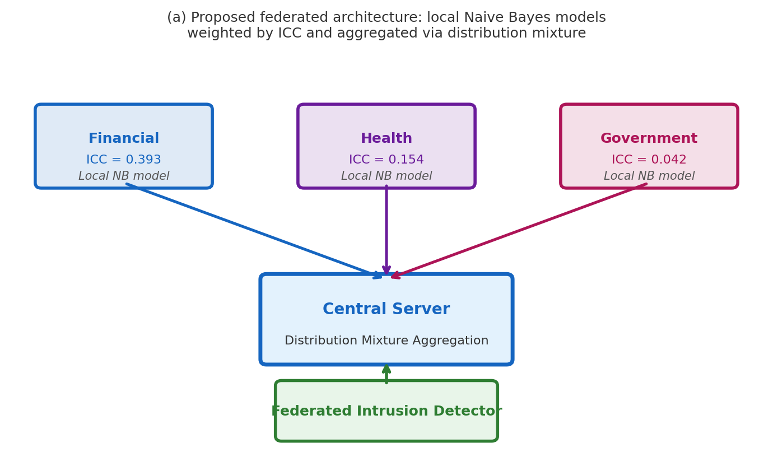
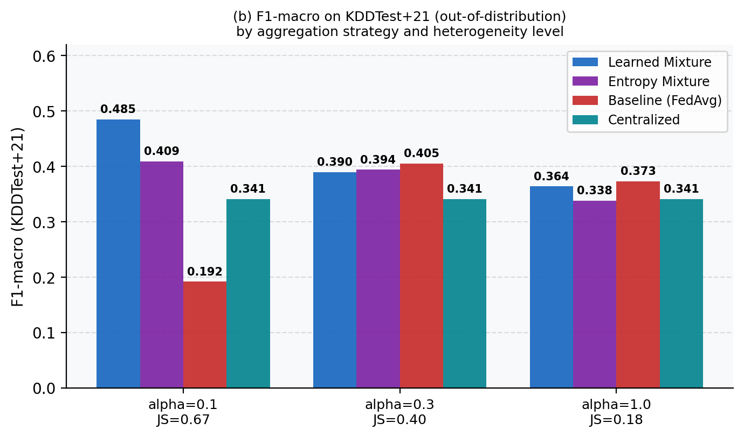
Fig. 1. (a) Federated architecture: three nodes send local Naive Bayes parameters to the central server for distribution mixture. (b) F1-macro on KDDTest+21 per strategy and heterogeneity level. Bold values indicate the best result per column.
4. EXPERIMENTS AND RESULTS
4.1 Dataset and validation protocol
We use the NSL-KDD benchmark [5], which contains 125,973 labeled records with 41 features and five traffic classes: DoS, Probe, R2L, U2R, and normal. The dataset is divided into training (64%), validation (16%), and internal test (20%). For out-of-distribution evaluation we use KDDTest+21, a separate partition with 22,544 records that includes attack patterns not seen during training. This addresses the ceiling effect we observed in preliminary experiments, where all models exceeded F1-macro = 0.99 on familiar patterns and could not be meaningfully compared.
Before running the main experiments, a systematic validation protocol verified: (1) minimum sample size per node at each alpha level, with at least 434 records per node even under alpha = 0.1; (2) all five classes present in every split; (3) optimizer behavior under the extreme condition alpha = 0.01, where nodes had up to 43,133 records and the model predicted all five classes despite some nodes containing only two classes locally; and (4) learned weight convergence across the ten Nelder-Mead starting points, with the optimizer reaching the same solution from six of the ten starting points under alpha = 0.1, confirming stability of the result.
Four strategies are compared: Learned Mixture (our proposal), Entropy Mixture (weights proportional to local Shannon entropy), Baseline (FedAvg weighted by dataset size), and Centralized (single model trained on all data combined). Statistical significance of differences between Learned Mixture and Baseline on KDDTest+21 is assessed with the McNemar test.
4.2 Results on KDDTest+21
Table 3 and Figure 1 show the results on the out-of-distribution test set. Under high heterogeneity (alpha = 0.1, JS = 0.67), the Learned Mixture achieves F1-macro = 0.485 against 0.192 for the Baseline, a difference of 0.293. McNemar chi2 = 3630, p < 0.001. The Entropy Mixture also improves on the Baseline at 0.409. The Centralized model, which uses all training data without federation, reaches 0.341 regardless of the alpha level.
Under moderate heterogeneity (alpha = 0.3, JS = 0.40), the Baseline achieves 0.405 versus 0.390 for the Learned Mixture. Under low heterogeneity (alpha = 1.0, JS = 0.18), both strategies remain within 0.009 of each other. In both cases, McNemar confirms that the differences are statistically significant but in the direction unfavorable to the Learned Mixture. This is discussed in Section 5.
Table 3. F1-macro on KDDTest+21 and McNemar results. *** p < 0.001.
Alpha | Learned | Entropy | Baseline | chi2 | Winner
0.1 | 0.485 | 0.409 | 0.192 | 3630*** | Learned
0.3 | 0.390 | 0.394 | 0.405 | 513*** | Baseline
1.0 | 0.364 | 0.338 | 0.373 | 88*** | Baseline

4.3 Learned weights and CRISC variables
Table 4. Learned weights per node and alpha level. ICC values in parentheses.
Alpha | Financial (0.393) | Health (0.154) | Govt (0.042) | F1-val
0.1 | 0.726 | 0.225 | 0.049 | 0.465
0.3 | 0.343 | 0.551 | 0.106 | 0.388
1.0 | 0.224 | 0.728 | 0.048 | 0.346

Under alpha = 0.1, the weight ordering (0.726, 0.225, 0.049) matches the ICC ordering (0.393, 0.154, 0.042). The node with the most mature controls and the lowest vulnerability exposure receives the highest weight. This alignment is consistent with the idea that institutional reliability, as captured by the CRISC variables, translates into a higher quality local model when the institution faces a distinct and coherent threat profile. Under alpha = 0.3 and 1.0, the Health node captures the highest weight despite a lower ICC than Financial. This divergence suggests that ICC-weight alignment is a property of high-heterogeneity conditions, where each node contributes a distinct and identifiable signal.
5. DISCUSSION
The clearest result in this paper is the performance gap at alpha = 0.1. When three institutions with genuinely different security postures and traffic profiles collaborate in a federated system, mixing their conditional distributions produces substantially better generalization to unseen attacks than averaging their parameters. The 0.293 F1-macro difference, confirmed with McNemar chi2 = 3630, is not marginal. It reflects a structural property of the mixture: each node contributes its own learned distribution, and the federated model retains the specificity of each without blending it away.
The results at alpha = 0.3 and 1.0 are a clear limitation. When node distributions become similar, the Nelder-Mead optimizer finds that concentrating weight on a single node is locally optimal on the validation set, and the resulting model generalizes slightly worse than the baseline on KDDTest+21. This is consistent with what one would expect: when nodes are similar, the advantage of mixture aggregation over parameter averaging narrows, and the regularization does not fully prevent the optimizer from finding a degenerate solution. Initializing the optimization with ICC values as a prior over the starting weight distribution is a direct way to address this, as it would bias the search toward solutions that reflect institutional diversity rather than numerical convenience.
The validation protocol deserves mention as a methodological contribution in itself. Checking dataset sufficiency, class coverage, optimizer convergence, and stress conditions before publishing results adds a layer of verifiability that is often absent in federated learning papers. The protocol revealed, for example, that the optimizer reaches a stable result from the majority of starting points under high heterogeneity, which supports the validity of the learned weights. Under low heterogeneity it reaches different solutions depending on the starting point, which is itself an informative result about the landscape of the optimization problem.
The connection between this work and the drift detection framework of Lara-Gutierrez et al. [4] deserves explicit mention. In a real deployment, the traffic profiles of each institution change over time as new attacks emerge. The optimal weights would need to be updated accordingly, and the ICC values of each institution may also shift as their controls mature or new vulnerabilities are disclosed. Combining the distribution mixture approach with the adaptive mechanisms in [4] is a natural direction for follow-up work in institutional deployment contexts.
6. CONCLUSION
We proposed aggregating federated Gaussian Naive Bayes models through distribution mixture with empirically learned weights, characterized each participating node using five CRISC institutional risk variables, and validated the approach through a systematic protocol covering dataset sufficiency, optimizer convergence, and stress conditions. On NSL-KDD under high heterogeneity, the learned mixture improves F1-macro by 0.293 over the parameter-averaging baseline on an out-of-distribution test set, with the difference confirmed statistically by the McNemar test. Under lower heterogeneity, the optimizer concentrates weight on a single node, motivating ICC-based weight initialization as the main direction for future work.
Consistent with our experience across banking, telecommunications, and public sector environments, the strongest results emerge precisely when institutions are most different from one another. That is the scenario where federated learning has the most to offer, and where retaining the specificity of each local model matters most.
Code and data: https://github.com/eoherrera/NB_Federado_Ejercicio_Doctoral_UMA
7. ACKNOWLEDGEMENTS
This work is part of a doctoral research project at the Universidad de Malaga. The authors thank the NICS Lab for discussion on federated systems and adaptive anomaly detection.
8. REFERENCES
[1] B. McMahan et al., "Communication-efficient learning of deep networks from decentralized data," AISTATS, 2017.
[2] T. Wisanwanichthan and M. Thammawichai, "A double-layered hybrid approach for IDS using NB and SVM," IEEE Access, vol. 9, pp. 138432-138450, 2021.
[3] T. Li et al., "Federated optimization in heterogeneous networks," NeurIPS, 2022.
[4] A. Lara-Gutierrez, C. Fernandez-Gago, J. A. Onieva, "A framework for drift detection and adaptation in AI-driven anomaly detection," Int. J. Inf. Secur., vol. 24, 2025.
[5] M. Tavallaee et al., "A detailed analysis of the KDD CUP 99 data set," IEEE CISDA, 2009.

