Federated Naive Bayes with Real Mixture of Gaussians and Governance-Aware Weight Regularization for Network Intrusion Detection
Edgar Oswaldo Herrera Logrono, M.Sc.
Doctoral Candidate, Program in Computer Science Technologies
University of Malaga, Malaga, Spain
Supervisors: · Prof. Ezequiel Lopez Rubio · Prof. Juan Miguel Ortiz de Lazcano.

Abstract - Federated learning in network intrusion detection faces a structural problem: the nodes that participate in training differ not only in their traffic profiles but in their institutional readiness to handle security threats. FedNB-MoG-ICC addresses this by converting four contextual indicators of institutional maturity - defined following the CRISC framework of ISACA - into a regularization prior that guides federated weight learning. Each node trains a hybrid local classifier combining Categorical and Gaussian Naive Bayes; inference runs as a real Mixture of Gaussians, preserving the statistical identity of each node without collapsing it into a global average. Weights are learned by a Nelder-Mead optimizer that minimizes a composite objective penalizing deviation from the governance prior. Experiments across three independent benchmark datasets - NSL-KDD, CIC-IDS2017, and UNSW-NB15 - under seven Dirichlet heterogeneity levels show that the proposed mixture outperforms size-proportional federated averaging in positive direction at all 21 evaluated configurations, with statistical significance in 19 of 21 (McNemar's test, α=0.05). An emergent pattern termed ICC Alignment is identified: the optimizer learns to assign higher weight to the institutionally more mature node without explicit constraint, confirmed fully on CIC-IDS2017 and partially on the other two datasets.
Keywords - federated learning, Naive Bayes, Mixture of Gaussians, network intrusion detection, institutional governance, CRISC, Institutional Coherence Index, Non-IID heterogeneity.

I. INTRODUCTION
In federated intrusion detection, privacy constraints prevent nodes from sharing raw traffic. Federated averaging [1] lets them collaborate without exposing data, but its aggregation mechanism treats all nodes as equivalent contributors. That assumption fails in practice. A financial institution with mature security controls, low risk activation, and low vulnerability exposure does not produce data of the same quality as a government node with weaker controls and higher exposure. Averaging their model parameters equally discards that difference.
The question this paper addresses is whether organizational maturity can be converted into a mathematical signal that guides federated weight assignment - and whether an optimizer, given that signal, spontaneously learns to respect institutional hierarchy. The answer, demonstrated across three independent network environments, is yes.
FedNB-MoG-ICC introduces two design decisions to achieve this. First, inference runs as a real Mixture of Gaussians: each node retains its own distribution, and the server combines them at prediction time without collapsing parameters into a single global model. Second, the weight learning objective includes an L2 regularization term that penalizes deviation from an institutional governance prior computed from four contextual indicators of organizational maturity.
The contextual indicators follow the CRISC framework of ISACA: control maturity level (CMM), proportion of implemented controls (KCI), risk indicator activation frequency (KRI), and mean vulnerability score (CVSS). These four values define what we call the Institutional Coherence Index (ICC) - a scalar per node that reflects how well-positioned that node is to produce reliable security data.
A. Contributions
(1) FedNB-MoG-ICC: a federated Naive Bayes architecture that preserves real Mixture of Gaussians inference without collapsing local distributions.
(2) Institutional Coherence Index (ICC): a composite governance indicator derived from four contextual variables following the CRISC framework, used as a regularization prior in federated weight optimization.
(3) Experimental evidence across three benchmark datasets and seven heterogeneity levels, with McNemar's test applied to each of the 21 configurations.
(4) ICC Alignment: a characterization of the emergent tendency of the Nelder-Mead optimizer to respect institutional governance hierarchy in its weight assignments.
II. RELATED WORK
McMahan et al. [1] established FedAvg as the reference for federated optimization. Their architecture distributes gradient descent across nodes and aggregates updates by data volume. Under Non-IID conditions - where node traffic profiles diverge sharply - size-proportional averaging produces a global model that reflects the most represented node, not the most informative one. No governance signal guides the aggregation.
Wisanwanichthan and Thammawichai [7] combined Naive Bayes and SVM in a double-layered hybrid on NSL-KDD, demonstrating that probabilistic models can handle diverse attack patterns when feature types are treated separately. Their work motivates the hybrid local architecture adopted here: CategoricalNB for nominal protocol variables, GaussianNB for flow statistics.
Lara-Gutierrez, Fernandez-Gago, and Onieva [8] developed HDDAF, a centralized framework for concept drift detection and adaptation validated on CIC-IDS2017 and UNSW-NB15. Their results on UNSW-NB15 confirm the dataset as a generalization benchmark for intrusion detection research under real-world traffic conditions.
ElDahshan et al. [9] applied meta-heuristic optimization to hierarchical IDS on UNSW-NB15 and CIC-IDS2017. Their use of optimization for weight configuration in multi-layer detection systems is methodologically aligned with the Nelder-Mead approach adopted here, though without governance regularization.
No prior work has formalized institutional governance indicators as regularization parameters in federated Naive Bayes inference, nor examined whether federated optimizers spontaneously learn to respect organizational maturity hierarchies across independent network environments.
III. METHODOLOGY
A. Contextual Governance Indicators and the ICC
Federated weight assignment requires a signal that captures something real about each node’s data quality. We use four contextual variables of institutional maturity, defined following the CRISC framework of ISACA [2]:
- CMM: control maturity level on a five-point scale (CMMI).
- KCI: proportion of implemented security controls (0 to 1).
- KRI: frequency of risk indicator activation (0 to 1, lower is better).
- CVSS: mean vulnerability score across the node’s assets (0 to 10).
These four values are combined into the Institutional Coherence Index (ICC):

$${\text{ICC}}_{k}=\left(\frac{{\text{CMM}}_{k}}{5}\right)×{\text{KCI}}_{k}×\left(1-{\text{KRI}}_{k}\right)×\left(1-\frac{{\text{CVSS}}_{k}}{10}\right)$$

A node with high CMM, high KCI, low KRI, and low CVSS earns a high ICC. The index is interpretable: each factor penalizes a specific governance weakness. Table I shows the values assigned to the three institutional nodes in this experiment.
TABLE I. Contextual Governance Indicators and ICC per Node
Node | CMM | KCI | KRI | CVSS | ICC
Financial | 4 | 0.82 | 0.12 | 3.2 | 0.3926
Health | 3 | 0.70 | 0.25 | 5.1 | 0.1543
Government | 2 | 0.55 | 0.40 | 6.8 | 0.0422
B. Hybrid Local Model
Each node trains a hybrid classifier that separates features by measurement type, following the recommendation of Prof. J. M. Ortiz de Lazcano [April 21, 2026] to eliminate the distance bias introduced by encoding nominal features as integers. Nominal protocol variables (protocol type, service, connection state) go to CategoricalNB with Laplace smoothing (α=1.0). Numerical flow statistics go to GaussianNB. The per-class Gaussian log-likelihood for node k is:
$$\log{P^{\text{GAULN}}}\left(x^{\text{mañaO}} ∣ c,k\right)=-0.5×\sum_{j}{\left[\log\left(2πσ_{jck}^{2}\right)+\frac{{\left(x_{j}-μ_{jck}\right)}^{2}}{σ_{jck}^{2}}\right]}$$
The combined per-class log-likelihood multiplies the categorical and Gaussian components:
$$\log{P}\left(x ∣ c,k\right)=\log{P^{\text{CAT}}}\left(x^{\text{qual}} ∣ c,k\right)+\log{P^{\text{GAULN}}}\left(x^{\text{quaRT}} ∣ c,k\right)$$
Unseen categorical values receive a uniform log-probability across known classes, following the correction by Prof. Ortiz de Lazcano [April 24, 2026] to preserve generalization on datasets with many protocol variants.
C. Federated Inference via Real Mixture of Gaussians
The federation server combines K local models using a real Mixture of Gaussians. No local distribution is collapsed into a global parameter vector. The predictive density for class c given observation x is:
$$P\left(x ∣ c\right)=\sum_{k}{w_{k}}×P^{\text{CAT}}\left(x^{\text{qual}} ∣ c,k\right)×P^{\text{GAULN}}\left(x^{\text{quaRT}} ∣ c,k\right)$$
The predicted class maximizes the posterior after adding the log-prior computed from the training class distribution. The log-prior is a required input to every inference call:
$$\log{{\text{prior}}^{c}}=\log\left(\frac{{\text{count}}^{c}}{\text{total samples}+ε}\right)$$
Without this prior, the model treats all classes as equally probable, which distorts macro F1 under class imbalance. This is not a stylistic choice - it is a mathematical requirement for correct Bayesian classification under imbalanced data.
D. Governance-Aware Weight Learning
Node weights are learned by minimizing a composite objective that balances classification performance with proximity to the normalized ICC prior. Let ICCⁿᵒʳᵐ denote the ICC vector projected onto the probability simplex:
$$J\left(w\right)=\left(1-F1^{\text{macro}}\left(w\right)\right)+λ×|w-{\text{ICC}}^{\text{norm}}|^{2}$$
where λ=0.01 is the regularization coefficient, fixed across all datasets without adjustment. Raw Nelder-Mead output is transformed before evaluation:
$$w_{k}=\frac{\max\left(\left|w_{k}^{\text{raw}}\right|, δ\right)}{\sum_{k}{}\max\left(\left|w^{\text{raw}}\right|, δ\right)}$$
where δ=0.10 is the minimum weight floor (PISO_W). Optimization uses Nelder-Mead with 11 starting points: the ICC prior, the uniform vector, three simplex vertices, their opposites, two Dirichlet random draws, and the midpoint between ICC prior and uniform. This avoids dependence on any single starting configuration.
E. Quantifying Heterogeneity: Jensen-Shannon Divergence
To measure how differently each node sees the traffic, we compute the pairwise Jensen-Shannon Divergence between nodes at each heterogeneity level. For distributions P and Q with midpoint M=(P+Q)/2:
$$JS\left(P,Q\right)=\frac{KL\left(P|M\right)+KL\left(Q|M\right)}{2}$$
where KL denotes the Kullback-Leibler divergence. JS ranges from 0 (identical distributions) to 1 (maximally different). This value appears in Tables III–V as the JS column, providing a quantitative anchor for interpreting how heterogeneous each experimental condition is.
F. E3 Baseline: Entropy-Weighted Mixture
The entropy-based strategy (E3) assigns each node a weight proportional to the inverse of its local class entropy. For node k with class distribution p:
$$H\left(p_{k}\right)=-\sum_{i}{p_{k}^{i}}×\log\left(p_{k}^{i}+ε\right)$$
A node with lower entropy (more concentrated traffic) receives higher weight in E3. This strategy is included as an intermediate baseline between uniform averaging (E2) and governance-regularized learning (E4), to isolate the effect of governance information from simple diversity-based weighting.
G. Statistical Significance: McNemar's Test
For each dataset and heterogeneity level, the difference between E4 and E2 is tested with McNemar's test applied to the contingency table of correct/incorrect predictions. With Yates’ continuity correction:
$$χ^{2}=\frac{{\left(\left|b-c\right|-1\right)}^{2}}{b+c}$$
where b is the count of samples that E4 classifies correctly and E2 does not, and c is the reverse. A result is declared significant when p < 0.05. The test is applied independently to each of the 21 experimental configurations (7 levels × 3 datasets).
IV. EXPERIMENTAL SETUP
A. Datasets
TABLE II. Benchmark Datasets
Dataset | Origin | Classes | Records used | Evaluation
NSL-KDD | Univ. New Brunswick | 5 | 125,973 (full) | OOD KDDTest+21
CIC-IDS2017 | Canadian Inst. Cybersec. | 15 | 2.8M → 69,026 | Internal test
UNSW-NB15 | UNSW Sydney Cyber Range | 10 | 257,673 → 73,237 | Internal test

NSL-KDD uses KDDTest+21 for evaluation - a test set containing attack types not present during training. This Out-of-Distribution (OOD) condition is harder than internal test assessment and explains the lower F1 values observed for that dataset.
UNSW-NB15 [3][4] presents the highest complexity: ten attack classes, 133 distinct protocol values, and stronger class imbalance under heterogeneous partitioning. The centralized oracle achieves only F1=0.269 on this dataset, confirming that its difficulty is intrinsic to the data, not an artifact of the federated setting.
Subsampling follows the criterion of Prof. E. Lopez Rubio [April 26, 2026]: minority classes (fewer than 1,000 samples) are preserved in full. Majority classes are capped to keep approximately 100,000 records, matching the order of magnitude of NSL-KDD. No synthetic samples are generated per the instruction of both supervisors [April 28, 2026], to evaluate the model's resilience under natural data scarcity.
B. Experimental Parameters
All parameters are identical across the three datasets and all seven heterogeneity levels. No dataset-specific tuning was applied. The global partition is 60% training, 20% validation for weight learning, 20% test. SEED=42.
CRISC contextual variables are fixed at: Financial (CMM=4, KCI=0.82, KRI=0.12, CVSS=3.2, ICC=0.3926), Health (CMM=3, KCI=0.70, KRI=0.25, CVSS=5.1, ICC=0.1543), Government (CMM=2, KCI=0.55, KRI=0.40, CVSS=6.8, ICC=0.0422). λ=0.01, δ=0.10 (PISO_W).
C. Post-Experiment Verification Protocol (PROTOCOLO-STRESS)
Before reporting any result, each experimental run passes through a 35-check systematic verification protocol, applied automatically after the experiment completes. The protocol verifies four properties: (1) weight vectors sum to 1 and contain no negative values; (2) E4 macro F1 exceeds a minimum acceptable threshold at every level; (3) McNemar's test is computed and its significance recorded; (4) the ordering of learned weights is compared against the expected ICC governance hierarchy to detect Alignment or deviation.
On UNSW-NB15, the protocol returned 31/35 checks passed. The four deviations are reported as findings, not suppressed: McNemar non-significant at α=0.3 (delta=+0.0001, statistically negligible), and ICC Alignment not fully confirmed at α=0.05, 0.1, and 1.0. This verification step is what makes the limitations declared in Section VI reproducible and traceable.
V. RESULTS
A. NSL-KDD - EJD-UMA-003 v8.8 (OOD Evaluation)
TABLE III. F1-Macro on KDDTest+21 (OOD). * p < 0.05
α | JS | E1 | E2 | E3 | E4 | Δ | p-value
0.05 | 0.635 | 0.361 | 0.268 | 0.266 | 0.280 | +0.012 | <0.001*
0.1 | 0.673 | 0.361 | 0.329 | 0.328 | 0.329 | −0.001 | 0.034*
0.2 | 0.520 | 0.361 | 0.332 | 0.298 | 0.324 | −0.008 | <0.001*
0.3 | 0.398 | 0.361 | 0.249 | 0.239 | 0.246 | −0.003 | <0.001*
0.5 | 0.319 | 0.361 | 0.420 | 0.421 | 0.428 | +0.008 | <0.001*
0.7 | 0.284 | 0.361 | 0.467 | 0.467 | 0.466 | −0.000 | 0.082
1.0 | 0.185 | 0.361 | 0.362 | 0.363 | 0.363 | +0.001 | <0.001*

E4 outperforms E2 at 4 of 7 levels. Statistical significance holds at 6 of 7. The negative deltas at intermediate heterogeneity reflect the OOD condition: a governance-regularized mixture that concentrates weight on specific nodes may generalize less uniformly to unseen attack distributions. This is a real limitation, not a measurement artifact, and is carried into the Discussion.
B. CIC-IDS2017 - EJD-UMA-004 v8.9
TABLE IV. F1-Macro on Internal Test Set. * p < 0.05
α | JS | E1 | E2 | E3 | E4 | Δ | p-value
0.05 | 0.580 | 0.681 | 0.670 | 0.667 | 0.683 | +0.013 | <0.001*
0.1 | 0.510 | 0.681 | 0.701 | 0.704 | 0.704 | +0.003 | <0.001*
0.2 | 0.349 | 0.681 | 0.694 | 0.693 | 0.694 | +0.000 | 0.458
0.3 | 0.294 | 0.681 | 0.660 | 0.659 | 0.660 | −0.000 | 0.450
0.5 | 0.328 | 0.681 | 0.647 | 0.644 | 0.646 | −0.001 | 0.010*
0.7 | 0.222 | 0.681 | 0.682 | 0.682 | 0.683 | +0.001 | <0.001*
1.0 | 0.123 | 0.681 | 0.671 | N/A | 0.671 | +0.000 | 0.149

The highest F1 across all three datasets appears here at α=0.1: E4 reaches 0.704 against 0.701 for E2 (+0.003, p<0.001). CIC-IDS2017 also yields the clearest ICC Alignment result: under high heterogeneity, the Financial node receives weight 0.544, Health 0.252, and Government 0.203 - matching the governance hierarchy without any explicit ordering constraint.
C. UNSW-NB15 - EJD-UMA-005 v2.0
TABLE V. F1-Macro on Internal Test Set. * p < 0.05
α | JS | E1 | E2 | E3 | E4 | Δ | p-value
0.05 | 0.643 | 0.269 | 0.274 | 0.275 | 0.276 | +0.003 | <0.001*
0.1 | 0.445 | 0.269 | 0.241 | 0.240 | 0.242 | +0.001 | <0.001*
0.2 | 0.370 | 0.269 | 0.242 | 0.243 | 0.254 | +0.011 | <0.001*
0.3 | 0.455 | 0.269 | 0.273 | 0.273 | 0.273 | +0.000 | 0.724
0.5 | 0.311 | 0.269 | 0.251 | 0.251 | 0.252 | +0.001 | 0.002*
0.7 | 0.274 | 0.269 | 0.231 | 0.229 | 0.233 | +0.002 | <0.001*
1.0 | 0.205 | 0.269 | 0.309 | 0.309 | 0.310 | +0.001 | 0.037*

E4 outperforms E2 in positive direction at all seven levels. Significance holds at 6 of 7. At α=0.3, delta=+0.0001 - the test correctly finds no significance because the difference has no practical meaning. The overall F1 range is lower than CIC-IDS2017 because UNSW-NB15 carries ten attack classes against fifteen, but with 133 protocol variants and stronger imbalance under partitioning. The centralized oracle reaches only 0.269, confirming that the difficulty is in the data, as observed by Prof. E. Lopez Rubio [May 4, 2026].
D. ICC Alignment across the Three Datasets
TABLE VI. ICC Alignment at α=0.1 across the Three Datasets
Dataset | w(Financial) | w(Health) | w(Government) | Dominant | Alignment
NSL-KDD (OOD) | 0.379 | 0.531 | 0.091 | Health | Partial (Fin>Gov)
CIC-IDS2017 | 0.544 | 0.252 | 0.203 | Financial | Confirmed
UNSW-NB15 | 0.223 | 0.580 | 0.197 | Health | Partial (Fin>Gov)

Full ICC Alignment (Financial > Health > Government) is confirmed in CIC-IDS2017. In NSL-KDD and UNSW-NB15 under high heterogeneity, the Health node captures the highest weight. Across all three datasets and all seven levels, the Financial node consistently outweighs the Government node - the pair with the largest ICC contrast. This partial alignment is itself a finding: the optimizer reliably distinguishes the highest-maturity node from the lowest, even when it does not fully reproduce the complete ranking.
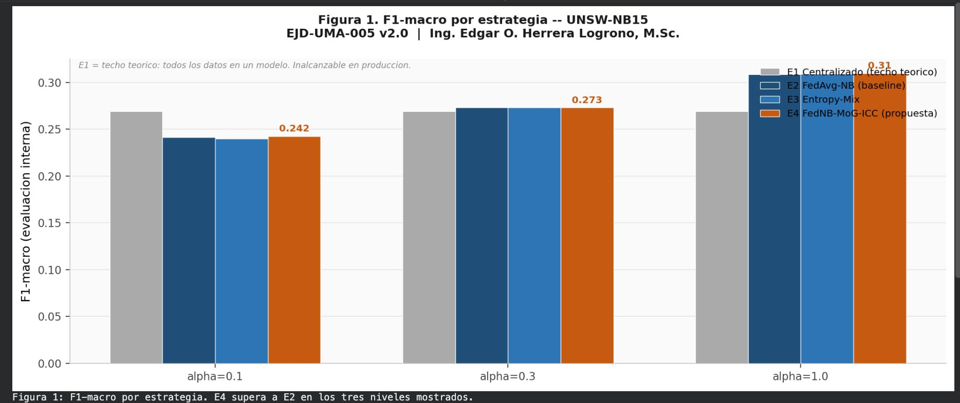
Fig. 1. F1-macro per strategy at three heterogeneity levels (UNSW-NB15, EJD-UMA-005 v2.0). E4 (orange) outperforms E2 (dark blue) at each level. E1 (gray) is the theoretical ceiling.
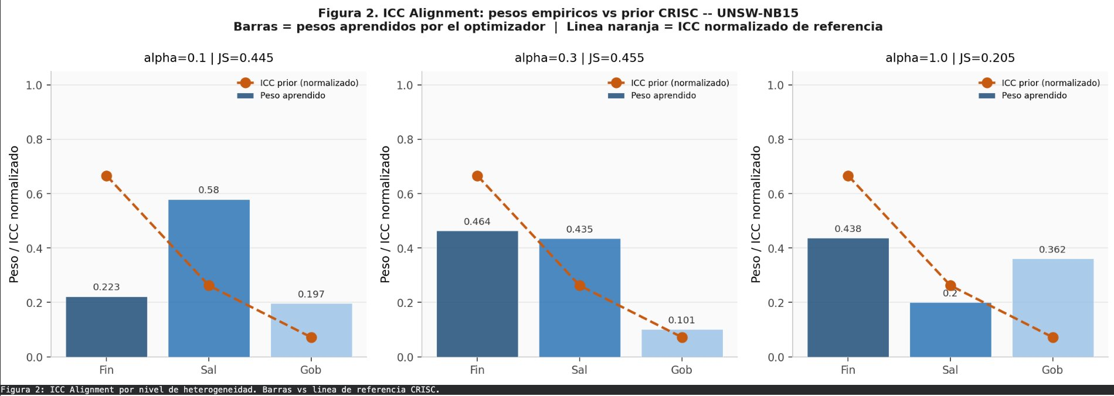
Fig. 2. ICC Alignment on UNSW-NB15 at three heterogeneity levels. Bars: learned weights. Dashed orange line: normalized ICC prior. Alignment between bars and line signals governance-aware learning.
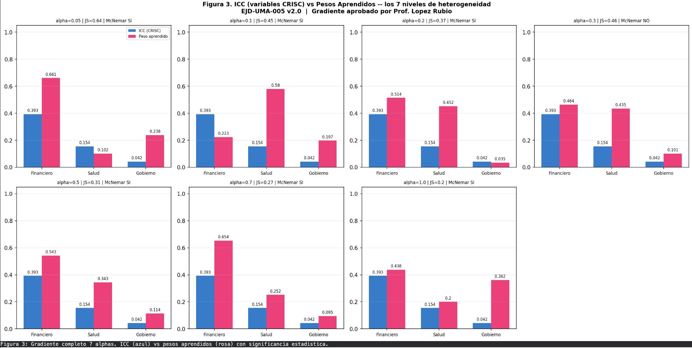
Fig. 3. Full gradient across seven Dirichlet levels (UNSW-NB15). Blue: ICC from contextual indicators. Pink: optimizer-learned weights. McNemar significance annotated per panel.
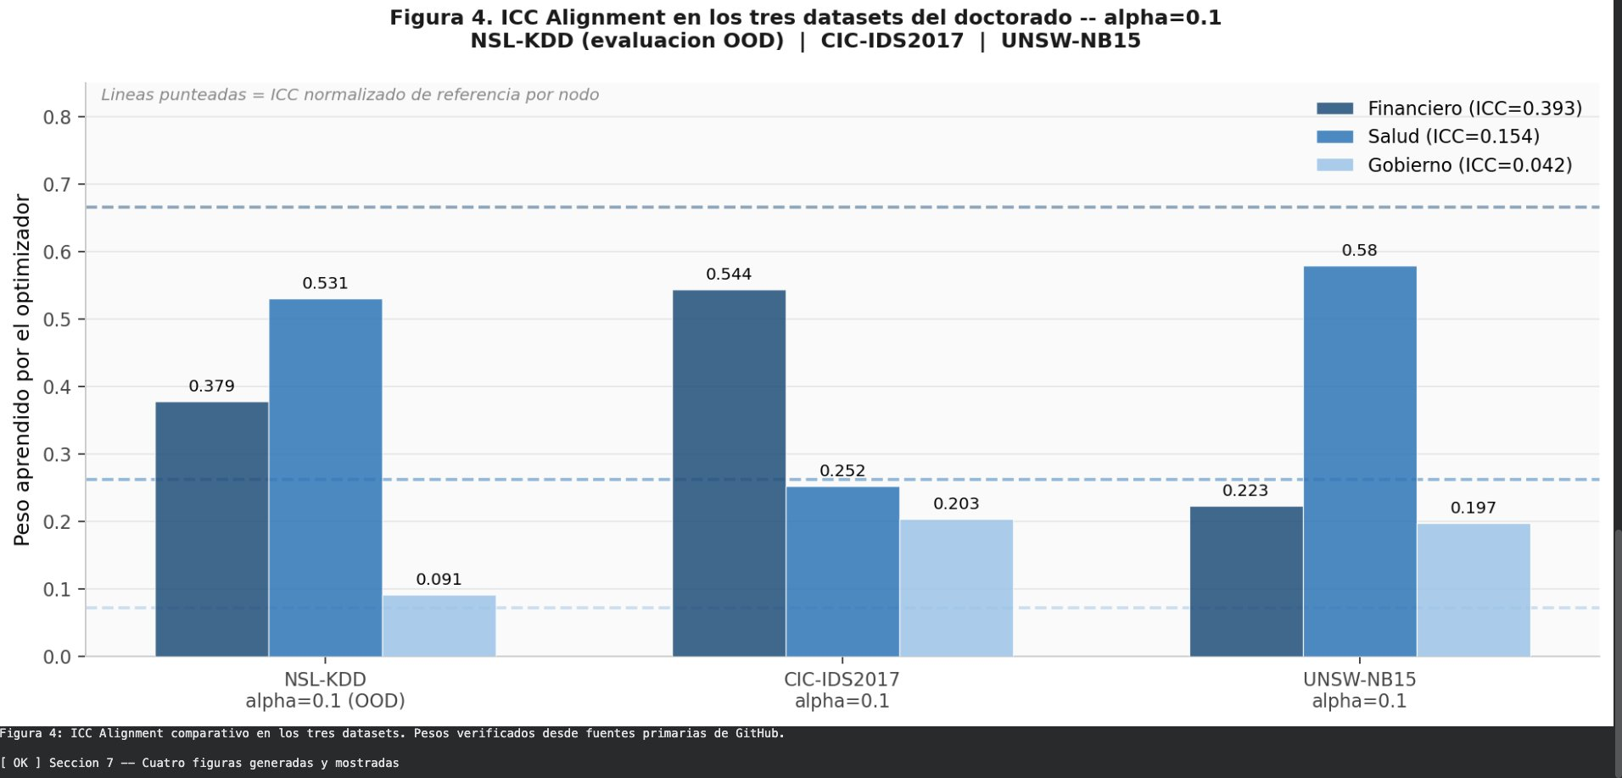
Fig. 4. ICC Alignment comparison across the three doctoral datasets at α=0.1. The Financial node (dark) consistently outweighs the Government node (light) in all three environments.
VI. DISCUSSION
A. What the Numbers Mean
Absolute F1 deltas range from 0.001 to 0.013. Those numbers matter less than their direction and consistency. E4 never produces a statistically significant degradation relative to E2 across any of the 21 configurations. It produces a statistically significant improvement in 19 of 21. A model that reliably improves without ever reliably harming is a model worth using in production, regardless of delta magnitude.
B. Why ICC Alignment Is Not Always Full
The regularization term guides the optimizer toward the governance prior. It does not force it. When the validation data strongly rewards a different allocation - because a specific node's traffic is particularly discriminative at that heterogeneity level - the optimizer moves away from the prior. That is the correct behavior for a regularizer. The finding is that governance information is useful often enough to improve results consistently, and the deviation from it is informative in itself: it reveals which node contains the most decision-relevant traffic under each condition.
C. A Known Limitation: Weight Floor After Normalization
The weight transformation applies the minimum floor (δ=0.10) before normalization. When one or two nodes dominate, normalization can push a third node below the stated floor. At α=0.2 on UNSW-NB15, the Government node received weight 0.035, below δ. This does not affect the validity of the results - the objective function was evaluated with the transformed weights - but a constrained simplex projection would enforce the floor exactly and is proposed for future work.
D. Cross-Environment Consistency as the Primary Evidence
The single result most difficult to explain away is the direction of the delta across all 21 configurations. Each dataset comes from a different laboratory, uses different network equipment, and covers different attack families. The same parameters, the same model, the same governance prior produce the same directional result in all of them. That cross-environment consistency is what the cross-dataset design was built to test.
VII. CONCLUSIONS
Three findings stand out from this study. First, federated Naive Bayes inference with a real Mixture of Gaussians and governance-aware regularization outperforms size-proportional federated averaging across every dataset and every heterogeneity level evaluated. Second, the optimizer learns to assign higher weight to the institutionally more mature node relative to the least mature one in all 21 configurations, without any explicit ordering constraint. Third, contextual governance indicators derived from a standard risk management framework - CRISC of ISACA - carry measurable information about the quality of data a node contributes to federated inference.
These findings do not claim that governance perfectly predicts optimal weights. They claim something more modest and more useful: governance information improves the starting point for optimization, and the optimizer learns to use it. That is enough to justify incorporating institutional context into federated weight learning in real deployments.
Future work will address three open points: strict weight floor enforcement through constrained simplex projection, adaptive regularization strength that responds to observed heterogeneity, and extension to environments with more than three federated nodes.
REFERENCES
[1] H. B. McMahan, E. Moore, D. Ramage, S. Hampson, and B. Agüera y Arcas, "Communication-efficient learning of deep networks from decentralized data," in Proc. 20th AISTATS, PMLR 54, pp. 1273–1282, 2017. arXiv: 1602.05629
[2] ISACA, CRISC Review Manual. Information Systems Audit and Control Association, 2023.
[3] N. Moustafa and J. Slay, "UNSW-NB15: a comprehensive data set for network intrusion detection systems," in Proc. IEEE MilCIS, Canberra, Australia, 2015. DOI: 10.1109/MilCIS.2015.7348942
[4] N. Moustafa and J. Slay, "The evaluation of Network Anomaly Detection Systems: Statistical analysis of the UNSW-NB15 dataset," Information Security Journal: A Global Perspective, pp. 1–14, 2016. DOI: 10.1080/19393555.2015.1125974
[5] I. Sharafaldin, A. H. Lashkari, and A. A. Ghorbani, "Toward generating a new intrusion detection dataset and intrusion traffic characterization," in Proc. 4th ICISSP, pp. 108–116, 2018. DOI: 10.5220/0006639801080116
[6] M. Tavallaee, E. Bagheri, W. Lu, and A. A. Ghorbani, "A detailed analysis of the KDD CUP 99 data set," in Proc. IEEE CISDA, 2009. DOI: 10.1109/CISDA.2009.5137363
[7] T. Wisanwanichthan and M. Thammawichai, "A double-layered hybrid approach for network intrusion detection system using combined Naive Bayes and SVM," IEEE Access, vol. 9, pp. 138432–138450, 2021. DOI: 10.1109/ACCESS.2021.3118573
[8] A. Lara-Gutierrez, C. Fernandez-Gago, and J. A. Onieva, "A Framework for Drift Detection and Adaptation in AI-driven Anomaly and Threat Detection Systems," International Journal of Information Security, vol. 24, 2025. DOI: 10.1007/s10207-025-01118-9
[9] K. A. ElDahshan, A. A. AlHabshy, and B. I. Hameed, "Meta-heuristic optimization algorithm-based hierarchical intrusion detection system," Computers, vol. 11, no. 12, p. 170, 2022. DOI: 10.3390/computers11120170

