E-Commerce Business Analytics Technical Report
Online Retail dataset, Dec 2010 to Dec 2011 | Methodology, findings, and recommendations

1. Objective
This project analyzes one year of e-commerce transactions from a UK-based wholesale retailer to identify revenue drivers, customer behavior patterns, timing effects, return risks, and near-term growth opportunities.

2. Data and Preparation
The source workbook contains 541,909 raw transaction rows. The project pipeline removed exact duplicates, preserved guest orders with flags, split returns into a dedicated dataset, filtered non-product adjustments from clean sales, added time features, and generated customer and product summary tables.
- 5,268 exact duplicate lines removed.
- 536,641 cleaned master rows retained for auditability.
- 522,537 canonical sales rows used for revenue-focused analyses.
- 10,587 return or cancellation rows isolated for return analysis.
- Guests retained for sales analysis but excluded from customer-level segmentation and cohorts.

3. Headline Performance
Clean sales generated GBP 10,247,219 across 19,773 orders and 4,334 identified customers. Average order value was GBP 518, with a median of GBP 302.
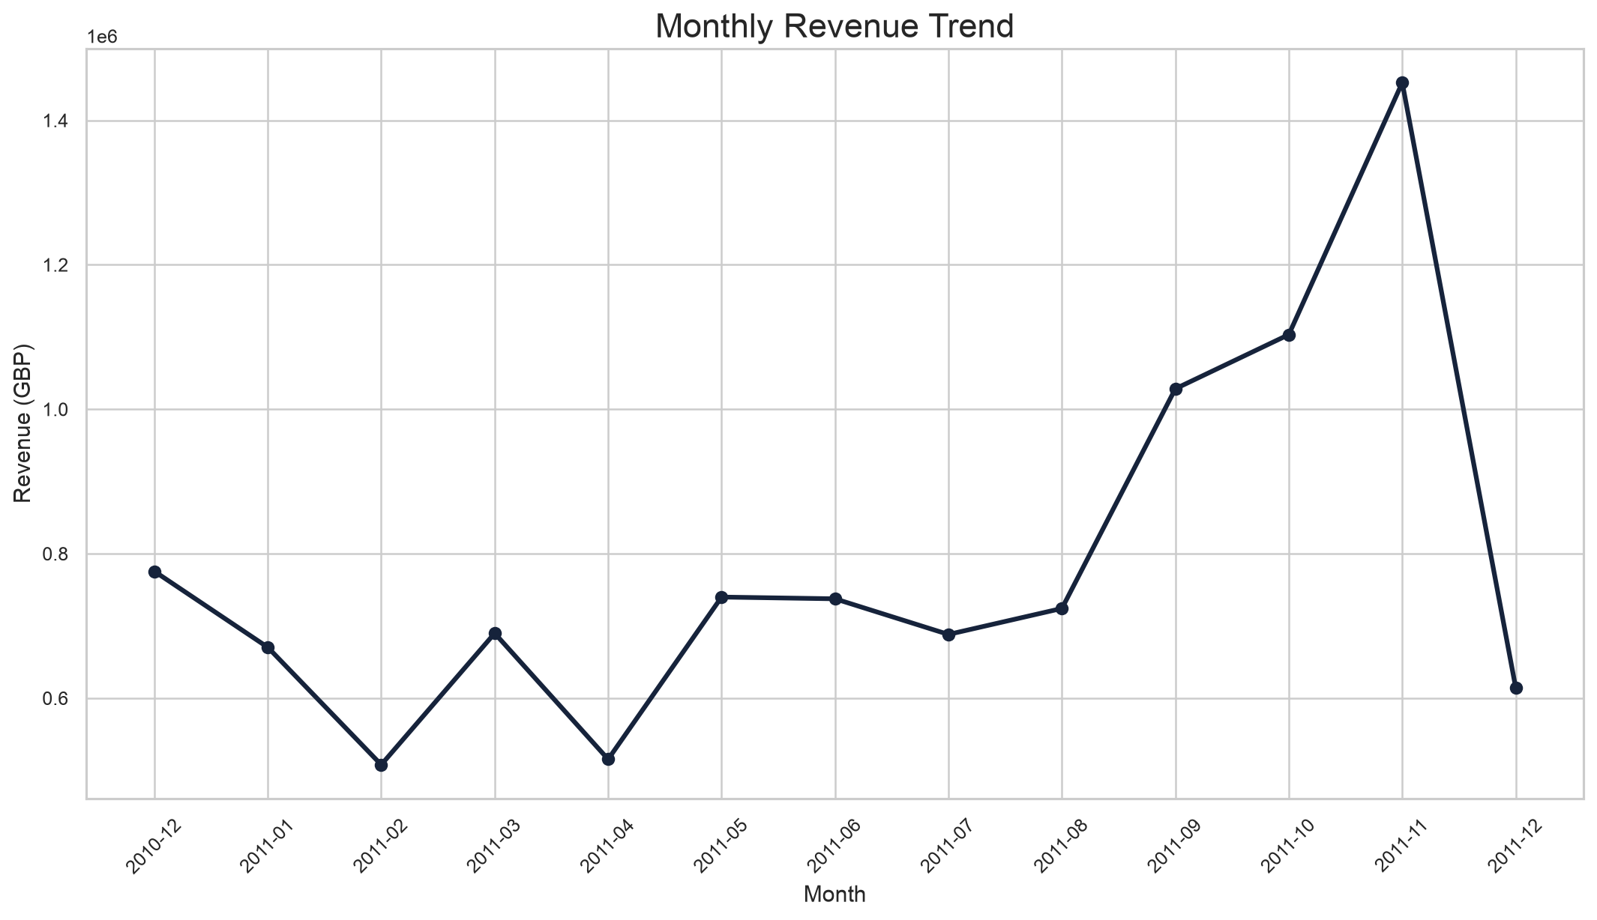
Revenue accelerated strongly in the final quarter, peaking in November 2011. September through November formed the clearest expansion period, suggesting holiday demand and merchandising momentum.

4. Product and Pricing Performance
Revenue concentration is led by a small set of gift-oriented products. The leading SKU, REGENCY CAKESTAND 3 TIER, delivered the highest revenue contribution, while several low-price, high-volume items acted as basket builders.
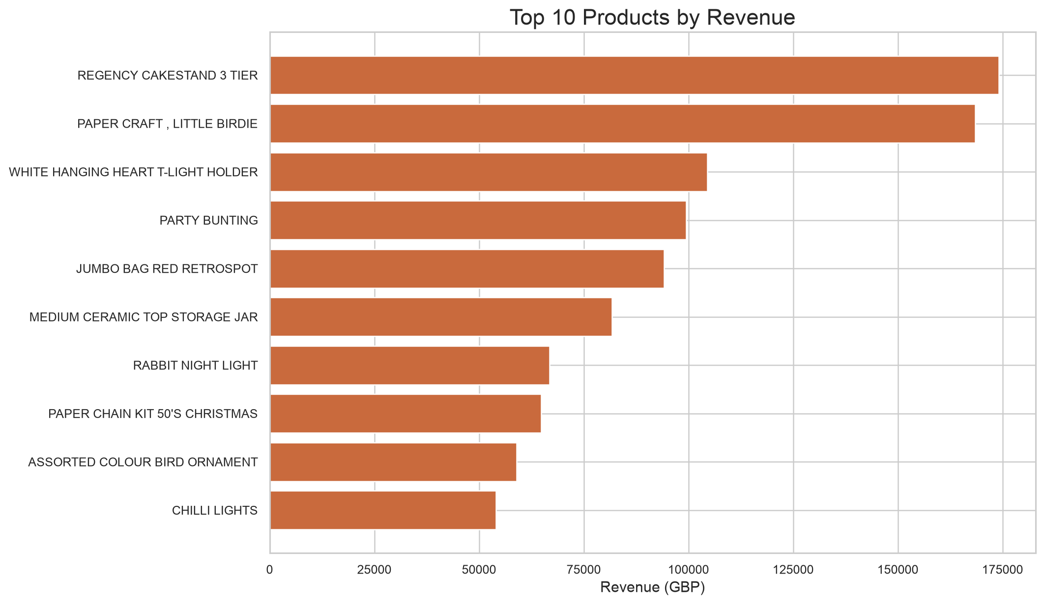
- Top revenue SKUs combine broad customer reach with premium-enough pricing to preserve margin potential.
- The GBP 2-5 price band drives the largest share of revenue, while GBP 1-2 provides major unit volume support.
- Extremely high-volume single-order anomalies should be separated from ordinary merchandising decisions when planning inventory.

5. Customer, Geography, and Retention
Repeat customers represent 65.3% of identified customers. RFM segmentation shows a large Champions segment, but also a substantial At Risk / Lapsed group that should be actively reactivated.
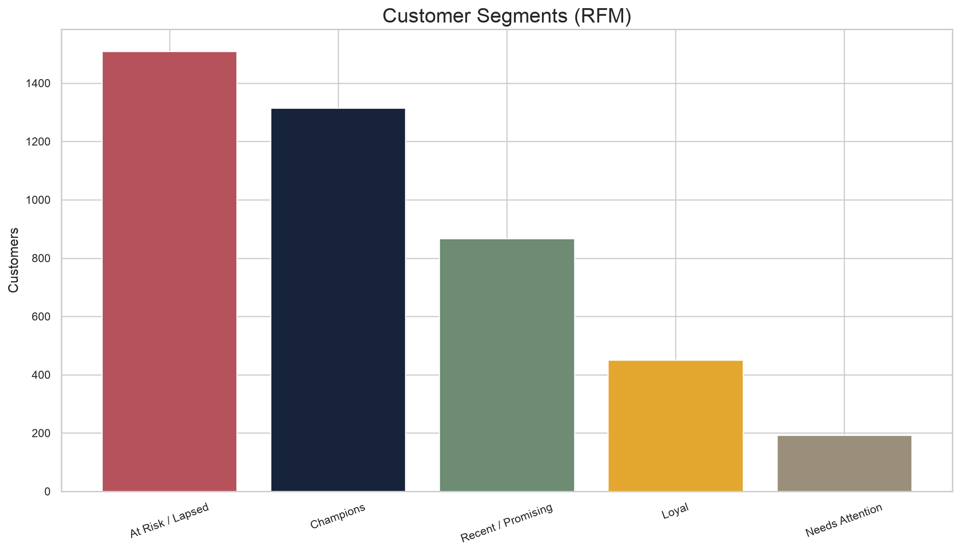
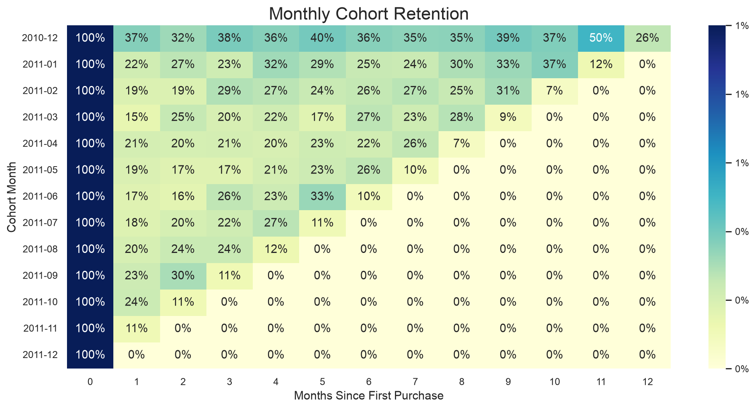
Geographically, the UK contributes the majority of revenue, but international markets such as the Netherlands, EIRE, Germany, and France offer strong expansion efficiency because they already generate meaningful value from relatively few customers.

6. Timing, Returns, and Forecast
Value peaks during business hours, with the strongest hours centered from 10:00 to 15:00 and particularly strong trading on Thursday. Returns and cancellations reduced value by GBP 893,980, equivalent to 8.7% of clean sales.
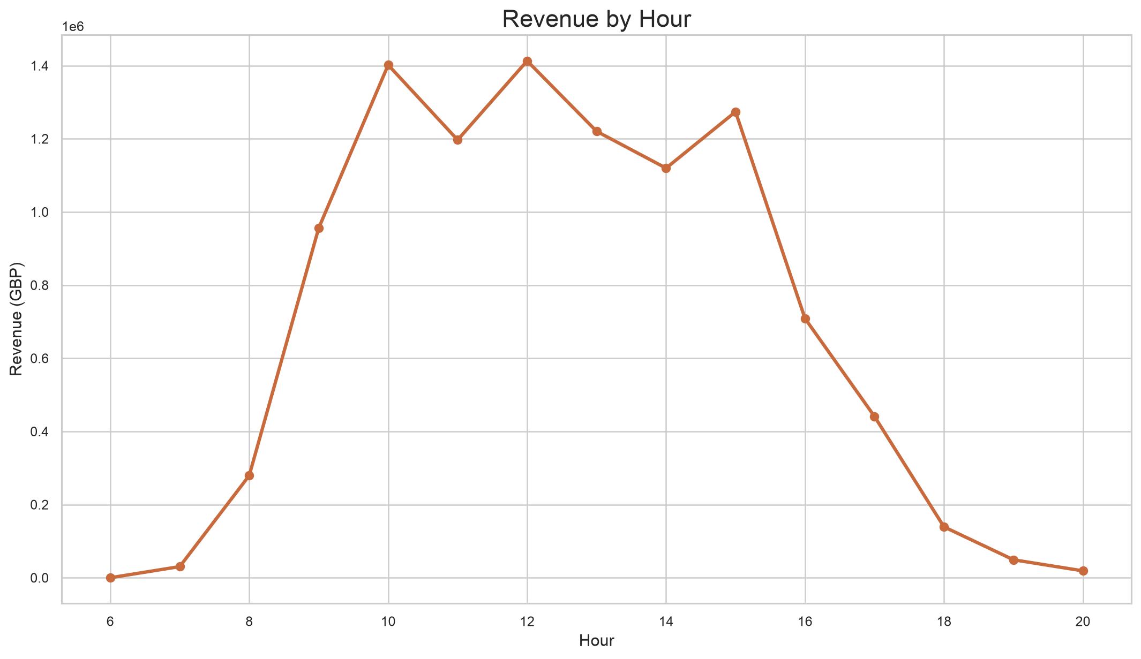
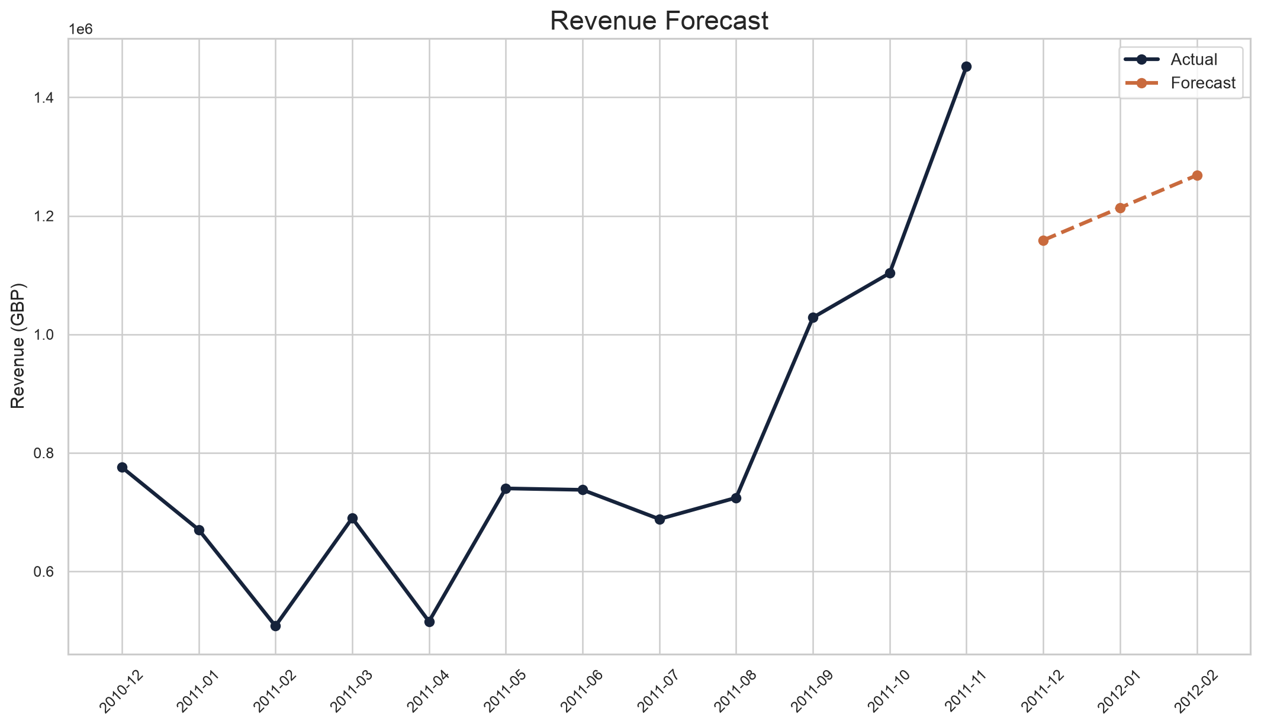
A simple linear-trend baseline suggests continued revenue strength into early 2012, although the model should be treated as directional because it does not yet incorporate holidays, promotions, or inventory constraints.

7. Recommendations
- Defend and scale top giftable SKUs such as REGENCY CAKESTAND 3 TIER, PARTY BUNTING, and JUMBO BAG RED RETROSPOT with priority inventory and featured placement.
- Target high-value repeat buyers with replenishment and seasonal launch campaigns 30-45 days after purchase to lift cohort retention.
- Concentrate promotional sends on Tuesday through Thursday and schedule merchandising pushes between 10:00 and 15:00 when conversion value is strongest.
- Audit the unusually large return lines and manual adjustment codes separately so operational noise does not hide true merchandise returns.
- Prioritize expansion tests in the Netherlands, EIRE, Germany, and France before broader international rollout because they already contribute meaningful revenue at low customer counts.

8. Limitations
- The source data covers only one year, which limits long-run trend estimation.
- The final month is partial because the dataset ends on December 9, 2011.
- Some return rows reflect manual adjustments or operational corrections rather than merchandise dissatisfaction.
- Profitability cannot be estimated directly because product cost data is not available.

