Genetically Evolved Trading Strategies with PonyGE2

Eoin Carroll

16202781
Abstract
Abstract goes here -maybe like half a page-maybe like half a page-maybe like half a page-maybe like half a page-maybe like half a page-maybe like half a page-maybe like half a page-maybe like half a page-maybe like half a page-maybe like half a page-maybe like half a page-maybe like half a page-maybe like half a page-maybe like half a page-maybe like half a page-maybe like half a page-maybe like half a page-maybe like half a page-maybe like half a page-maybe like half a page-maybe like half a page-maybe like half a page-maybe like half a page-

Introduction
The financial markets have been transformed with the use of technology from online trading platforms to comprehensive analytics tools. This paper captures the results of a project involving the application of advances in machine learning to an interesting finance problem. The first few sections of this introduction will bring a computer software student or IT professional who has not researched natural computing up to a base knowledge level where they will understand the project objective and outcome. The introduction section covers natural computing, evolutionary computation, genetic programming (GP), trading strategies, previous application of GP to trading, motivation and objectives. A methodology section describes the approach taken, an experimental section captures the experimentas performed and the paper is completed with a discussion and conclusion. For those initiated in the natural computing area, they may skip forward to section 1.4 Trading Strategies.

Natural Computing
Natural computing is a branch of computer science inspired by nature. One area of natural computing involves utilising materials other than silicone to carry out computational tasks and a great example of this is in biological computing where DNA has been used to successfully store information (Church et al. 2012). Another area of natural computing is in the machine learning domain where algorithms are derived from key characteristics of processes found in nature and are deployed to solve difficult problems (Brabazon & O'Neill, 2009).
Examples of natural computing algorithms include exploration of shortest paths using swarm techniques such as ant colony optimisation or finding optimal points by modelling bird flocking behaviour (Banks et al. 2007). Another popular research area is artificial neural networks where the components and workings of a human brain are mimicked with software to artificially learn the solution to a range of problems such as developing game strategies. The algorithm implemented in this project was inspired by the process of natural evolution and a brief overview is presented in the next few sections.

Evolutionary Computation
The concept of machine learning dates back as far as Turing and has been the subject of many sci-fi works since the beginning of the digital revolution (Turing, 1950). Friedberg (1958) hypothesised that computers could perform new tasks if the computer could create a new program through trial and error. The widely accepted Darwinian evolution theory is the evolution of species through slight variations in each generation where traits that strengthen the species are passed on with a random but probabilistic degree. One means of facilitating a trial and error methodology in computation is through evolutionary programming where an algorithm is designed to generate and test numerous candidate solutions to a problem. This algorithm is a metaphoric implementation of evolution and the trial and error simulation mimics the survival of the fittest aspect of nature (Beyer, 2002).

Genetic Programming
Genetic evolution has been applied to many areas but genetic programming (GP) works by randomly creating an initial population of programs from a defined set of programming features. This random process means we are never guaranteed to converge on an optimal solution however it does introduce the benefit of producing unexpected programs that a human may not have considered as an option. For each generation of population, parent programs pass on traits to children programs stochastically through two main mechanisms (PolR et al. 2008):
- Crossover: Randomly selected traits from two parents are preserved.
- Mutation: A parent is randomly changed.
This process continues until a convergence criteria or iteration limit has been reached. The final output program will be the program producing the best fitness result, where the fitness criteria is defined for that specific problem. An informative graphic showing the information flow in genetic programming is shown in Figure 1 below.
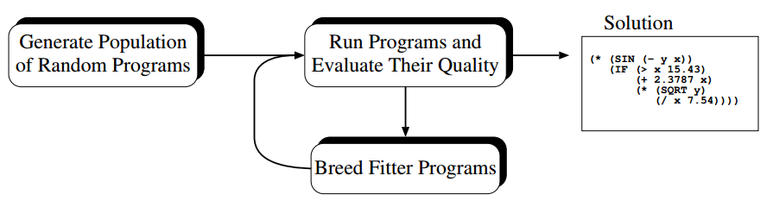
Figure 1 - GP Control Flow (PolR et al. 2008)
As Koza (2009) notes, the usefulness of genetically evolved programs has been proportional to improvements in computing power due to the computation required in this domain. Genetic programming has successfully produced software that rivals that produced by humans in a wide variety of fields such as software creation, game theory where strategies have been developed, electronic design where digital and analog circuits have been designed and mechanical engineering for systems design (Koza, 2009).
Lastly and most importantly for this project, the finance industry has employed genetic programming in many specific problem areas. Some examples of evolutionary computation in finance include asset allocation in pension schemes, strategies for risk-optimal portfolios and stochastic portfolio optimisation (Brabazon & O'Neill, 2009). There are also many examples of notable trading strategies being developed with genetic algorithms. Allen & Karjalainen (1999) used S&P 500 stock price data and a genetic algorithm to generate trading rules which closely matches the aims of this project.

Trading Strategies
In financial markets, a trading strategy is an execution plan of when to invest in or sell an asset. Most strategies aim to maximise return on an initial investment while minimising variation in the expected range of return. Strategies vary greatly depending on the asset class and time frame. Time frame classification can vary but for this project, short time frame is less than three-month period while a long time frame is anything greater than 12 months. A medium-term strategy falls between the two categories and is the focus of this project. Furthermore, the almost limitless asset classes have been restricted to stocks for this project. A key performance metric of a trading strategy is a comparison of the strategies return on investment with that of the return if we have simply bought and held the asset instead.
Financial markets are perceived as non-deterministic and Conrad & Kaul (1998) demonstrated that trading strategies often perform extremely poorly in the real world. This poor performance has been attributed to the noisy, constantly changing arena that is the financial markets, however this environment could be well suited to natural computing (Brabazon & O'Neill, 2009).
The efficient market hypothesis is a theory that states that no trading strategy will return excess profits in a well-developed market as the stocks will always be priced correctly. If this theory holds then no evolutionary algorithm would be able to derive a strategy based on market inefficiency.
One final concept that the reader should be aware of is a moving average crossover. If a stock price rises above or falls below a certain moving average, this signifies a change in trend. This historic indicator is a very simple method of determining the direction a stock price may move and is still used on trading floors today although will not necessarily forecast future prices (Ready, 2002).

Application of Genetic Evolution to Trading
There have been many examples of GE trading strategies published over the years. Most appear to report inconclusive results and recommend further research while very few present definitive successful or unsuccessful strategies. There are countless instances of claimed successful GP trading strategies but we should analyse their results with scepticism. Other related works have been performed with the aim of optimising a portfolio or predicting stock prices however these are outside the scope of this project.
Allen & Karjalainen (1999) implemented a genetic algorithm to find technical trading rules but the authors were quick to point out that numerous papers have shown that technical trading rules are unreliable and will not guarantee profits. They go on to say that it is possible that historic technical rules may not be optimal but that genetic algorithms present an opportunity to derive optimal solutions. The authors applied their genetic algorithm to the S&P 500 composite index and derived some interesting trading rules. While giving informative insights into the data, the rules did not earn additional returns in comparison to buying and holding. This paper also brought together previous work that had not been formally analysed up to this point.
O’Neill et al. (2001) presented promising results by deriving trading rules with Grammatical Evolution which is a method of genetic evolutionary programming. Their work was focused on the UK FTSE 100 stock index in contrast to most other papers concerned with the US stock market.
Further additions to GP strategies are the use of graph and network structure to improve results (Izumi et al. 2006) or the use of Sarsa learning (Chen et al. 2007). Critics of genetic programming induced decision making, Chen & Navet (2007) question the usefulness of genetic programming due to the inconclusive results that seem prominent in publications. They propose a method of testing the market and derived program to help conclude further research and determine if additional research in GP is worthwhile. As we have seen from past works, genetic evolution can derive very interesting and novel strategies due to its random nature but it’s usefulness is questionable.

Motivation and Objective
The objective of this works is to generate a trading strategy using genetic evolution using the PonyGE2 python library to build on previous works and validate their results. Specifically, grammatical evolution like O’Neill et al. (2001) will be implemented on individual US stocks. A positive outcome of the project would be a genetically evolved trading strategy that provides a return on both training and test data that exceeds a return from a simple buy and hold technique. A successful strategy would need to determine technical trading rules such as the moving average crossover but furthermore, that technical trading rule needs to be profitable in the test dataset and this is the fundamental theory behind genetically evolved trading strategies.
Evolutionary algorithms have shown promise in past research and have the benefit of human readable output in comparison to the likes of neural networks. This is attractive for investors who may not trust a hidden trading strategy. The project will use three basic stock indicators, the historic daily open, high and low prices. Since the input data is purely technical in nature, the output strategy will be a set of technical rules. While it is unlikely that a we will uncover ground-breaking indicators from the project, any interesting correlations would be significant in the fields of natural computing and trading strategies.

Methodology
The methodology selected to generate trading strategies is loosly based on O’Neill et al. (2001) with some structural simplifications, a wider search space and different datasets. In this methodology section, an overview of the algorithm in PontGE2 is provided along with simplifications in comparison to O’Neill et al. (2001) and an explanation of the expanded search space. The results of experimentation will be trading rules which can be tested on test data and the outcomes will be benchmarked against a buy and hold strategy.

PonyGE2
PonyGE2 is the second version of PonyGE which was developed as an easy to implement genetic algorithm with the use of grammatical evolution (GE). GE is a concept from molegular biology where grammar is defined to store the possible components of candidate programs in a text file format called Backus-Naur Form (.BNF). A genotype is a randomly generated list containing integer numbers which are mapped to the grammar and each number will select a component from the grammar options. The result of this mapping is referred to as a phenotype which is a candidate solution. In this way, many different grammars can be easily testing using PonyGE2 (Fenton etal. 2017).

Simplifications
In contrast to O’Neill et al. (2001), this project will focus on one share at a time in comparison to an index as the input data. The fitness funtion has been simplified to look purely at profits over the training time period and the data will not be normalised so that the output is relatable to current market prices. The investment strategy will be to invest all or sell all at any point instead of small orders. Additionaly, there is no cost of placing a trade included, we can buy partial shares and we are ommiting dividend returns.

Search Space
O’Neill et al. (2001) note that their project focussed mainly on moving average crossover indicators and while we do not have access to their grammar, it can be assumed that it was strongly typed to promote this as a trading rule. The grammar created for this project is purposfully left quite open to allow for alternative technical rule generation.

Experimentation

Dataset
The dataset for experimenetation was obtained from the Bloomberg suite where the open, high and low stock price for all S&P 500 companies on each trading day for the years 2000 to 2017 was downloaded. This data was then parsed into individual .csv files for analyses. A preprocessing step removed a small number of trading days with missing data points. For the purpose of experimentation, four stocks were selected across a range of industries – Apple (AAPL), Coca Cola (KO), Bank of America (BA) and Boeing (BA).

Grammar
The grammar was created to generate a series of if statements which could be interpreted as trading rules. Firstly, it allows for moving average calculation and single point comparisons across any data points with a bias towards yesterdays prices. Secondly, it allows for a range of combinations of data points and averages to be evaluated which opens the search space for any technical indicator. The grammar will generate a positive or negative number which indicates a recommendation to buy or sell. A sample of the grammar is shown below and the full grammar can be found at the at the Github link in the appendix. The vertical bar indicates a selection which is made by the genome.
<if> ::= if <data> <eval> <data>:{:x = <expr>:}
<data> ::= <moving_average> | <data_point>
<eval> ::= > | <
<expr> ::= <const> | (x + <const>)
<const> ::= 0.1 | 0.2 | 0.3

Fitness Function
The fitness function is a program that executes the phenotype every trading day for a given date range. Specifically, the training fitness is executed from 2000 to 2015 while the test fitness is executed from 2016 to 2017. Note that only the last year of data is passed into the fitness function and so our trading rules will only consider this amount of information. This is important to stop irrelevant historic or unavailable furture data being included. Psuedo code for the fitness function is shown below and the full Python implementation can be found at the at the Github link in the appendix.
cash = $10,000
shares = 0
for i in range(start, end):
data = dataset[start: end]
execute(phenotype)
if recommendation > 0: # Invest all cash in shares
quantity = cash / last_price
shares = shares + quantity
cash = cash - quantity * last_price
else: # Sell all shares
cash = cash + shares * last_price
shares = 0
return cash
The output of this program is cash remaining after executing the candidate program each day over the time period.

PonyGE2 Parameters
The main parameters used during experimentation were a population of 500 candidates for 20 generations and a crossover probability of 75%. A full set of parameters used can be found at the Github link in the appendix.

Experiment Results
A simple buy and hold strategy would return the amounts shown in Table 1.
 | Stock | AAPL | BA | BAC | KO
Train period:  2000/2016 | Investment | $10,000 | $10,000 | $10,000 | $10,000
Train period:  2000/2016 | No. shares | 5754.07 | 164.20 | 363.57 | 421.05
Train period:  2000/2016 | End value | $563,323.55 | $20,788.18 | $52,57.23 | $18,842.11
Test period:  2016/2017 | Investment | $10,000 | $10,000 | $10,000 | $10,000
Test period:  2016/2017 | No. shares | 100.70 | 75.52 | 688.71 | 220.51
Test period:  2016/2017 | End value | $15,488.42 | $14,118.27 | $15,977.96 | $10,006.62
Table 1 - Buy and hold strategy returns
The trading rules were generated by running the genetic algoirthm and the strategy was implemented over both training and test periods, the returns are captured in Table 2.
 | Stock | AAPL | BA | BAC | KO
Train period:  2000/2016 | Investment | $10,000 | $10,000 | $10,000 | $10,000
Train period:  2000/2016 | End value | $ | $ | $ | $
Test period:  2016/2017 | Investment | $10,000 | $10,000 | $10,000 | $10,000
Test period:  2016/2017 | End value | $ | $ | $ | $
Table 2 - Genetic program strategy returns
Since the fitness function output is the cash after each period, we can example the evolution of strategy per generation in context. The plots in figure 2 show the train fitness improve over time. Note that this is not necessarily correlated with the test fitness reults as will be discussed later.
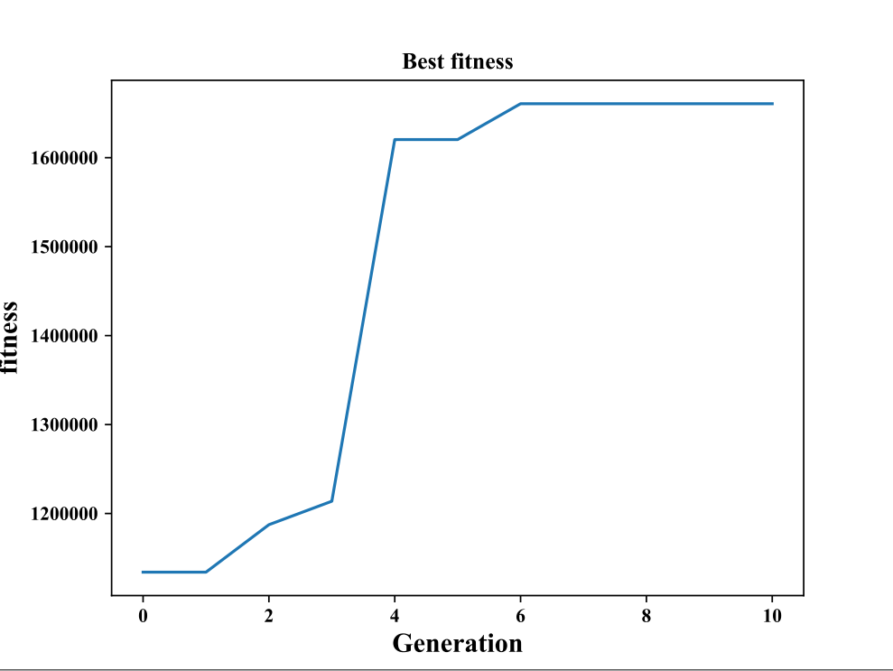
Figure 2 - Fitness results per generation of strategy

Discussion
Analyses of results
Crossover – might totally ruin good parts by combining . . . “Deriving Trading Rules Using Gene Expression Programming” - Overcomes gene crossover issue
Difficult to lose money with AAPL
Debate over speculative trading being detrimental to markets but it props up and keeps commodities constant with futures etc.
efficient market hypothesis
Positives - strategy is in the form of a program string and so can be analysed, Novel strategies that a trader may not have come up with, We can see the output in if statements etc
Limitations/Drawbacks – Overfitting (minimise with train and test), time consuming (reduces with moores law), random so strategy could be completely different every time. Input data could be biased . . . we wouldn’t look at a failing or bust companies data. Limited to technical indicators.
Site run times as a constraint and reasoning for simplifying – would be interesting to increase generations.
Would be nice to see price over time and volatility
Scalable – written so we can add more technical data, went from stock price to open,high,low
Would like to run for more iterations
Compaines that lost money not in S&P . . .

Conclusion
Restate objective
Further research – add other variables, add ability to buy/sell portions not all, add hold option, two objectives – minimise variance, punish complexity
Fitness function should look to give a good return on average and not just max for that dataset
Refer back to objective . . . was it achieved

References
Church, G.M., Gao, Y. & Kosuri, S. 2012, "Next-Generation Digital Information Storage in DNA", Science, vol. 337, no. 6102, pp. 1628.
Brabazon, A. & O'Neill, M. 2009, Natural computing in computational finance, Springer-Verlag Berlin and Heidelberg GmbH & Co. K, Berlin.
Banks, A., Vincent, J. & Anyakoha, C. 2007, "A review of particle swarm optimization. Part I: background and development", Natural Computing, vol. 6, no. 4, pp. 467-484.
Turing, A.M. 1950, "Computing Machinery and Intelligence", Mind, vol. 59, no. 236, pp. 433-460.
Friedberg, R.M., 1958. A learning machine: Part I. IBM Journal of Research and Development, 2(1), pp.2-13.
Beyer, H. & Schwefel, H. 2002, "Evolution strategies – A comprehensive introduction", Natural Computing, vol. 1, no. 1, pp. 3-52.
PolR, Langdon W B, McPhee N F (2008) A Field Guide to Genetic Programming. http://www.gp-field-guide.org.uk
Koza, J.R., 2010. Human-competitive results produced by genetic programming. Genetic Programming and Evolvable Machines, 11(3-4), pp.251-284.
Conrad, J. and Kaul, G., 1998. An anatomy of trading strategies. The Review of Financial Studies, 11(3), pp.489-519.
Ready, M.J. 2002, "Profits from Technical Trading Rules", Financial Management, vol. 31, no. 3, pp. 43-61
O’neill, M., Brabazon, A., Ryan, C. & Collins, J.J. 2001, "Evolving market index trading rules using grammatical evolution", Applications of Evolutionary Computing. EvoWorkshops 2001. Lecture Notes in Computer Science, vol 2037. Springer, Berlin, Heidelberg, pp. 343.
Izumi, Y., Yamaguchi, T., Mabu, S., Hirasawa, K. & Hu, J. 2006, "Trading Rules on the Stock Markets using Genetic Network Programming with Candlestick Chart", IEEE, , pp. 2362.
Allen, F. & Karjalainen, R. 1999, "Using genetic algorithms to find technical trading rules", Journal of Financial Economics, vol. 51, no. 2, pp. 245-271.
Chen, S.H. and Navet, N., 2007. Failure of genetic-programming induced trading strategies: Distinguishing between efficient markets and inefficient algorithms. Computational Intelligence in Economics and Finance, 2, pp.169-182.
Chen, Y., Mabu, S., Hirasawa, K. & Hu, J. 2007, "Enhancement of trading rules on stock markets using genetic network programming with Sarsa learning", IEEE, , pp. 2700.
Fenton, M., McDermott, J., Fagan, D., Forstenlechner, S., O'Neill, M. & Hemberg, E. 2017, "PonyGE2: Grammatical Evolution in Python", .

Appendix
All code can be found at the following Github repository: https://github.com/eoincUCD/NC_GE_Evolved_Trading_Strategy
The PonyGE2 library can be found at the following Github repository: https://github.com/jmmcd/PonyGE2
A fantastic resource for implementing a GE trading strategy: Fabian kostadinov. (2014). Evolving Trading Strategies with Genetic Programming - An Overview. [online] Available at: http://fabian-kostadinov.github.io/2014/09/01/evolving-trading-strategies-with-genetic-programming-an-overview
Special thanks to Michael Fenton for his support with PonyGE2.

