**CS4052 – Computer Graphics**

Final Project

Eoin Fitzsimons – 15324823

Link to video - https://youtu.be/WsFTB__xzU8

For my final project I chose to depict a working windmill. I chose this because I thought it would be a good way to demonstrate object hierarchy as well as the use of multiple textures.

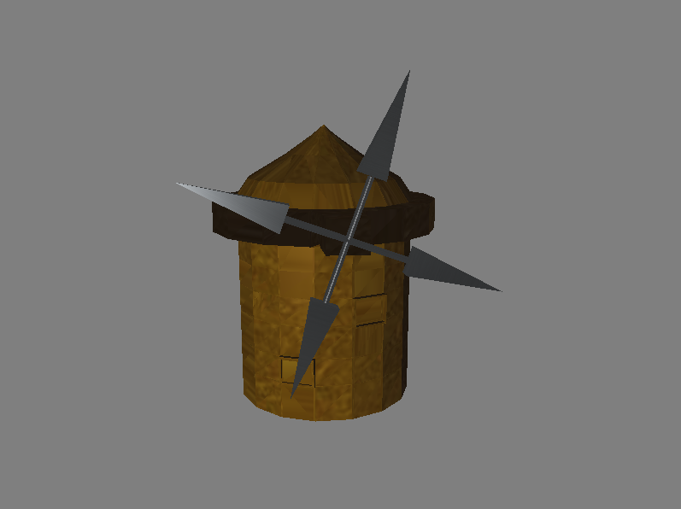

By completing this project I successfully demonstrated:

* Camera control
* Blinn-Phone Illumination
* Hierarchy
* Texturing (using **multiple** textures)
* Modelling using blender
* Simple dynamics of a windmill
* As you can see from my attached video I could successfully manipulate the camera angle around the scene without changing the objects position with respect to the light.
* It is also seen that when rotating the camera the lighting is clearly as the human eye would notice it reflecting off the object
* Originally for the hierarchy I had a one-to-many hierarchy but my demonstrator in the UGPC recommended that I make it one-to-one as it can be interpreted as one-to-many
* Modelling with blender was at first difficult to get used to and I would recommend putting up a little more information about UV Unwrapping in as that had me stuck for a long time but eventually I was able to get the appropriate texture coordinates for my models
* The dynamics I chose to model were simple. When it is windy, the arms of a windmill rotate and so, that is what I did!

**Coding sections of note:**

* One part that I found tricky was successfully implementing simple ideas such as VAO’s in order to solve more advanced problems like bringing in multiple textures to apply to your scene. In order to do this, I had to have an appropriate texture loader that took in a texture number and sampler name so that one texture did not overwrite another
* Another problem that I ran into was using the correct combination of surface reflectance in my fragment shader in order to display the textures as I like. E.g at first, my metal arms were coming up as yellow. A simple if statement in my fragment shader changed this:

if(texture_num == 1){ // if we are loading the metal texture

Kd = vec3 (0.0, 0.0, 0.0); // diffuse surface reflectance

}

* Furthermore, in the fragment shader it is important that you combine your lighting elements with your texel (texture pixel), as I was not doing so and could not figure out why my lighting was no longer working.