Marktübersicht Windows Embedded

Gruppe
Toni Baumann (bauma12@bfh.ch)
Ronny Stauffer (staur3@bfh.ch)
Elmar Vonlanthen (vonle1@bfh.ch)

Aufbau des Kernels, Echtzeitverhalten (tba)
The kernel provides the base OS functionality for any Windows Embedded Compact–based device. This functionality includes process, thread, and memory management. The kernel also provides some file management functionality. Kernel services enable applications to use this core functionality.

Thread priority levels, priority inheritance, interrupt support, and timing and scheduling are all included in the Windows Embedded Compact kernel architecture. Together, they provide real-time application capability for time-critical systems.

In any Windows Embedded Compact–based device, ROM stores the entire OS, in addition to the applications that come with the OS design. Windows Embedded Compact supports a 32-bit (4-GB) address space.

The Windows Embedded Compact kernel uses a paged virtual-memory system to manage and allocate application memory. The virtual-memory system provides contiguous blocks of memory, in 4,096-byte pages along 64-KB regions, so that applications do not have to manage memory allocation. For memory requirements of less than 64 KB, an application can use the local heap provided for all Windows Embedded Compact applications or create separate heaps. The kernel also allocates memory to the stack for each new process or thread.

NK.exe is the OEM application layer (OAL) process. The kernel, Kernel.dll, is loaded during boot by the OAL. Nk.exe is the core of the Windows Embedded Compact OS.

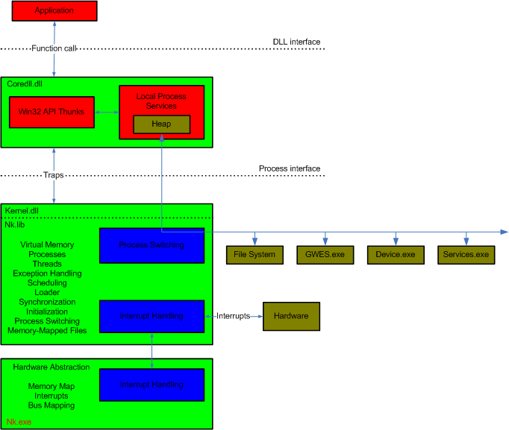

POSIX Unterstützung (tba)
Windows Embedded 7 unterstützt POSIX sowie ANSI nicht.
Auszug aus http://msdn.microsoft.com/en-us/library/ee479345.aspx:
The library does not support American National Standards Institute (ANSI) C or Portable Operating System Interface for Unix (POSIX). For more on ANSI C compatibility, see ANSI C Compatibility.

Core Services (tba)
Core OS services enable low-level tasks, such as process, thread, and memory management. The core OS services consist of features that are common to all Windows Embedded Compact OS designs: debugging on the Windows Embedded Compact powered device, DLL support, errors and exceptions, memory management, network address translation, process and thread management, registry key monitoring, kernel services such as buffer marshaling and synchronization, string and Unicode support, and time APIs. Basic device drivers are also part of the Windows Embedded Compact core OS services.

You can use the State and Notifications Broker to monitor any registry key in the system. The header file snapi.h contains definitions for the registry key, path, value, and bitmask for all the base notifications that are provided by the system

Thread Extensions (tba)
256 levels of thread priority
priority inheritance

Unterstützte Hardware (tba)
Windows Embedded Compact 7 works with key processor architectures
x86
ARM
MIPS

Board Support Packages gibt es für Hardware von Atmel, TI, Freescale und weiteren. Eine aktuelle Suche auf MSDN ergibt 243 BSPs.

Netzwerk und Protokolle (tba)
Updated Networking Stack
Windows Filtering Platform (WFP)
Bluetooth 2.1
Wi-Fi
Cellcore/RIL
Connection Manager
IPSec
MTP is a protocol created by Microsoft to enable the seamless connectivity of portable and mobile devices to Windows desktop operating systems. It also allows optional interconnectivity between various peripheral devices such as a portable device and car infotainment system. Typically MTP is used to synchronize media data (audio, video, or pictures) between the connected devices.
Kerberos 5.0, provides compatibility with Windows
NT LAN Manager v2, provides compatibility with Windows

Grafikbibiliothek und Widget-Bibliotheken (evo)

Entwicklungsumgebung (Debugger, Tracing, Profiling Tools) (evo)

Untersttützte Dateisysteme (evo)

Unterstützte Schnittstellen und Busse (evo)

Sicherheit (evo)

Sourcecode Verfügbarkeit, Memory Footprint (rst)

Referenz Design (rst)

Lizenzgebühren, Royalities (rst)

5. How is Windows Embedded Device Manager 2011 licensed?
Windows Embedded Device Manager 2011 is licensed under the Management Server licensing model in Microsoft Volume Licensing. As with System Center Configuration Manager 2007, customers are able to license SQL Server software separately or in conjunction with Windows Embedded Device Manager 2011. The latter is offered as Windows Embedded Device Manager 2011 with SQL Server Technology and when licensed this way, requires that the underlying System Center Configuration Manager Server software be similarly licensed with SQL Server Technology.

Products | Prices | Features
Windows Embedded Device Manager Server 2011 | $325.00 US* | Server license for full application, server, and client management.
Windows Embedded Device Manager Server 2011 with SQL Server Technology** | $735.00 US* | Note: SQL Server Technology included in this offering is the Microsoft SQL Server 2008 Standard edition and may only be used to support Windows Embedded Device Manager 2011.
Windows Embedded Device Manager 2011 Client Management License (ML)*** | $25.00 US* | Operating system deployment, asset inventory, software update management of Windows Embedded devices. The Client ML may be licensed either per OSE or per user.

Portieren von Applikationen nach Linux mit RT-Extension (rst)

Marktanteile und Produkte (rst)
- OS Chooser
- Compact (formerly CE)
- Standard (formerly Xpe)
- POSReady (formerly WEPOS)
- Device Manager
- Enterprise
- Automotive
- Server
- Embedded SQL Server
- Thin Client
- Handheld

Vor- und Nachteile gegenüber Linux (rst)

Eigene Erfahrungen (evo, tba, rst)
Toni ist Windows-Fan.

Quellenangaben
- http://www.microsoft.com/windowsembedded/en-us/evaluate/windows-embedded-device-manager-how-to-buy.aspx
- http://www.microsoft.com/windowsembedded/en-us/evaluate/windows-embedded-device-manager-faq.aspx
- http://www.theregister.co.uk/2010/01/17/evaluating_embedded/
- http://www.computerworld.com/s/article/9077838/Microsoft_looks_to_avoid_losses_to_Linux_in_embedded_OS_market
- http://blogs.msdn.com/b/mikehall/archive/2009/01/15/is-windows-ce-dead.aspx
- http://www.control.com/thread/1263864902
- http://msdn.microsoft.com/en-us/library/ee483054(v=WinEmbedded.60).aspx

