Digital systems assignment 1
Name: Evan O'Keeffe
Student number: 10324289

Question 1.
A. Y= ¬¬(A)

B. Y=(¬A ¬¬A)

C. Y = ( (AB) + ( B (+) C) )

- Y = ( (¬(AB)) (+) (¬(B+C)) (+) B)

Question 2.
Part A
A | ¬ ¬ A
0 | 0
1 | 1

Part B
A | ¬A | A¬A
0 | 1 | 0
1 | 0 | 0

Part C
A | B | C | AB | B(+)C | (AB)+(B(+)C)
0 | 0 | 0 | 0 | 0 | 0
0 | 0 | 1 | 0 | 1 | 1
0 | 1 | 0 | 0 | 1 | 1
0 | 1 | 1 | 0 | 0 | 0
1 | 0 | 0 | 0 | 0 | 0
1 | 0 | 1 | 0 | 1 | 1
1 | 1 | 0 | 1 | 1 | 1
1 | 1 | 1 | 1 | 0 | 1

Part D
A | B | C | AB | ¬AB | B+C | ¬(B+C) | (¬(AB)(+)(¬(B+C))) | (¬(AB)(+)(¬(B+C)))(+)B
0 | 0 | 0 | 0 | 1 | 0 | 1 | 0 | 0
0 | 0 | 1 | 0 | 1 | 1 | 0 | 1 | 1
0 | 1 | 0 | 0 | 1 | 1 | 0 | 1 | 0
0 | 1 | 1 | 0 | 1 | 1 | 0 | 1 | 0
1 | 0 | 0 | 0 | 1 | 0 | 1 | 0 | 0
1 | 0 | 1 | 0 | 1 | 1 | 0 | 1 | 1
1 | 1 | 0 | 1 | 0 | 1 | 0 | 0 | 1
1 | 1 | 1 | 1 | 0 | 1 | 0 | 0 | 1

¬((¬(AB)(+)(¬(B+C)))(+)B)
1
0
1
1
1
0
0
0

Question 3.
PartA
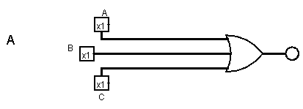
PartB
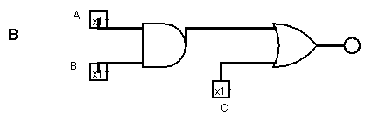
PartC
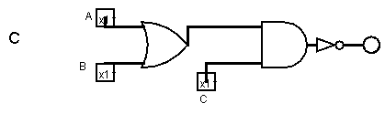
PartD
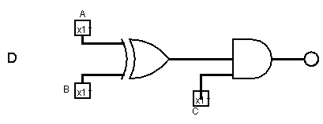

Question 4.
PartA
A | B | C | A+B | (A+B)+C
0 | 0 | 0 | 0 | 0
0 | 0 | 1 | 0 | 1
0 | 1 | 0 | 1 | 1
0 | 1 | 1 | 1 | 1
1 | 0 | 0 | 1 | 1
1 | 0 | 1 | 1 | 1
1 | 1 | 0 | 1 | 1
1 | 1 | 1 | 1 | 1

PartB
A | B | C | AB | (AB)+C
0 | 0 | 0 | 0 | 0
0 | 0 | 1 | 0 | 1
0 | 1 | 0 | 0 | 0
0 | 1 | 1 | 0 | 1
1 | 0 | 0 | 0 | 0
1 | 0 | 1 | 0 | 1
1 | 1 | 0 | 1 | 1
1 | 1 | 1 | 1 | 1

PartC

A | B | C | A+B | (A+B)C | ¬((A+B)C)
0 | 0 | 0 | 0 | 0 | 1
0 | 0 | 1 | 0 | 0 | 1
0 | 1 | 0 | 1 | 0 | 1
0 | 1 | 1 | 1 | 1 | 0
1 | 0 | 0 | 1 | 0 | 1
1 | 0 | 1 | 1 | 1 | 0
1 | 1 | 0 | 1 | 0 | 1
1 | 1 | 1 | 1 | 1 | 0

PartD

A | B | C | A(+)B | (A(+)B)C
0 | 0 | 0 | 0 | 0
0 | 0 | 1 | 0 | 0
0 | 1 | 0 | 1 | 0
0 | 1 | 1 | 1 | 1
1 | 0 | 0 | 1 | 0
1 | 0 | 1 | 1 | 1
1 | 1 | 0 | 0 | 0
1 | 1 | 1 | 0 | 0

Sadly images were made separately but the scale was mixed up in paint
