Assignement 3
Name: Evan O'Keeffe
Student Number: 10324289

Question 1:
Part A:
# | A | B | C | D | Output
0 | 0 | 0 | 0 | 0 | 0
1 | 0 | 0 | 0 | 1 | 0
2 | 0 | 0 | 1 | 0 | 0
3 | 0 | 0 | 1 | 1 | 0
4 | 0 | 1 | 0 | 0 | 1
5 | 0 | 1 | 0 | 1 | 0
6 | 0 | 1 | 1 | 0 | 1
7 | 0 | 1 | 1 | 1 | 1
8 | 1 | 0 | 0 | 0 | 0
9 | 1 | 0 | 0 | 1 | 1
10 | 1 | 0 | 1 | 0 | 1
11 | 1 | 0 | 1 | 1 | 1
12 | 1 | 1 | 0 | 0 | 1
13 | 1 | 1 | 0 | 1 | 0
14 | 1 | 1 | 1 | 0 | 1
15 | 1 | 1 | 1 | 1 | 1

SOP Expression:
(¬AB¬C¬D)+(¬ABC¬D)+(¬ABCD)+(A¬B¬CD)+(A¬BC¬D)+(A¬BCD)

Cd | 00 | 01 | 11 | 10
ab
00 | 0 | 0 | 0 | 0
01 | 1 | 0 | 1 | 1
11 | 1 | 0 | 1 | 1
10 | 0 | 1 | 1 | 1

Group1: (¬ABCD)+(¬ABC¬D)+(ABCD)+(ABC¬D)
= BC

Group2: (¬AB¬C¬D)+(¬ABC¬D)+(AB¬C¬D)+(ABC¬D)
=B¬D

Group3: (ABCD)+(ABC¬D)+(A¬BCD)+(A¬BC¬D)
=AC

Group4: (A¬B¬CD)+(A¬BCD)
=(A¬BD)

Simplified expression from karnaugh map =

AC+BC+B¬D+A¬BD

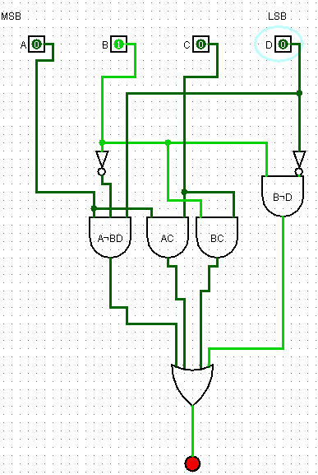

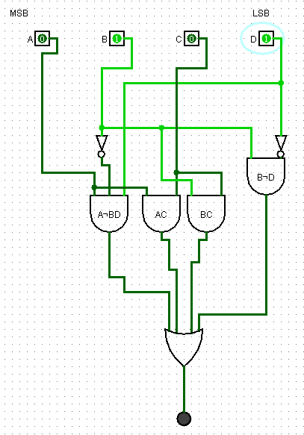

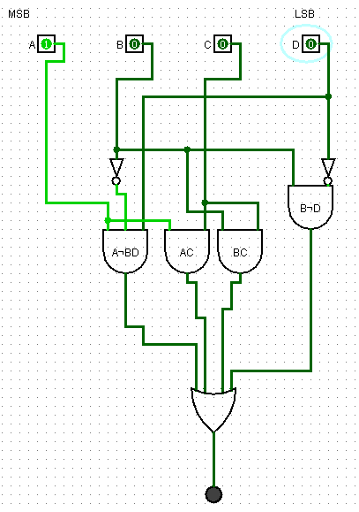

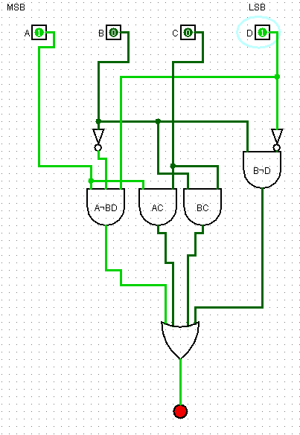
Part H:
Cicuit 1:
AND: 9*3*1.3 = 35.1
OR: 4*1.3=5.2
NOT: 4*0.7=2.8

eq = 43.1 G.E

Circuit 2:
AND: 3+2*1.3= 5.6
OR: 2*1.3 = 2.6
NOT: 2*0.7 = 1.4

eq = 10.6 G.E

(10.6/43.1)*100 = 24.59 % decrease in G.E area

Question 2:

Reminder S# = 10324289 , which means 1 output for (0,1,2,3,4,8,9)
Part A:
# | A | B | C | D | Output
0 | 0 | 0 | 0 | 0 | 1
1 | 0 | 0 | 0 | 1 | 1
2 | 0 | 0 | 1 | 0 | 1
3 | 0 | 0 | 1 | 1 | 1
4 | 0 | 1 | 0 | 0 | 1
5 | 0 | 1 | 0 | 1 | 0
6 | 0 | 1 | 1 | 0 | 0
7 | 0 | 1 | 1 | 1 | 0
8 | 1 | 0 | 0 | 0 | 1
9 | 1 | 0 | 0 | 1 | 1
10 | 1 | 0 | 1 | 0 | 0
11 | 1 | 0 | 1 | 1 | 0
12 | 1 | 1 | 0 | 0 | 0
13 | 1 | 1 | 0 | 1 | 0
14 | 1 | 1 | 1 | 0 | 0
15 | 1 | 1 | 1 | 1 | 0

SOP Expression : (¬a¬b¬c¬d)+(¬a¬b¬cd)+(¬a¬bc¬d)+(¬a¬bcd)+(¬ab¬c¬d)+(a¬b¬c¬d)+(a¬b¬cd)

Cd | 00 | 01 | 11 | 10
ab
00 | 1 | 1 | 1 | 1
01 | 1 | 0 | 0 | 0
11 | 0 | 0 | 0 | 0
10 | 1 | 1 | 0 | 0

Part D:
Simplification by groupings :
row 0: (¬a¬b¬c¬d)+(¬a¬b¬cd)+(¬a¬bc¬d)+(¬a¬bcd)
= (¬A¬B)

col 0 , row 0,1 :(¬A¬B¬C¬D)+(¬AB¬C¬D)
= (¬A¬C¬D)

group 3: (¬a¬b¬c¬d)+(¬a¬b¬cd)+(a¬b¬c¬d)+(a¬b¬cd)
= (¬B¬C)

Part E:

(¬A¬B)+(¬B¬C)+(¬A¬C¬D)

Part F:

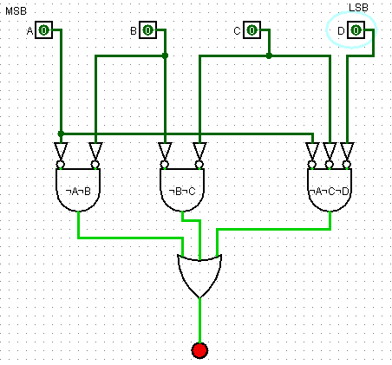

Part G:
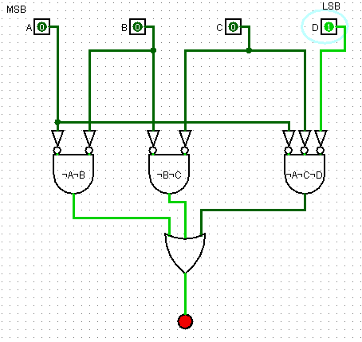

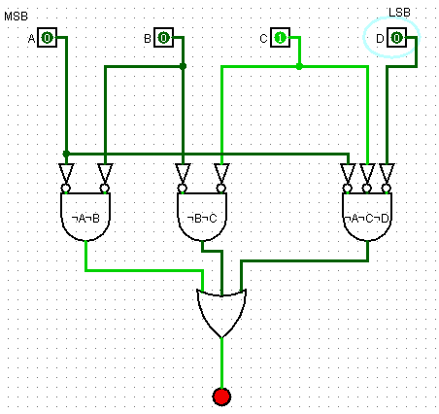

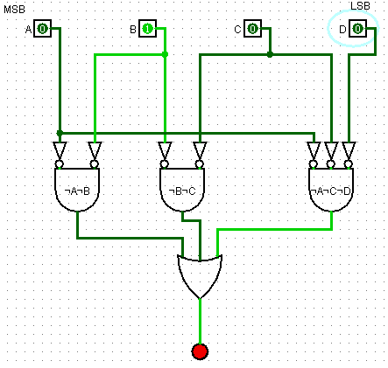

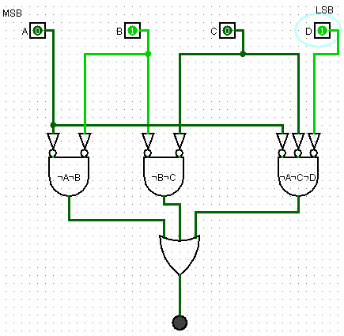

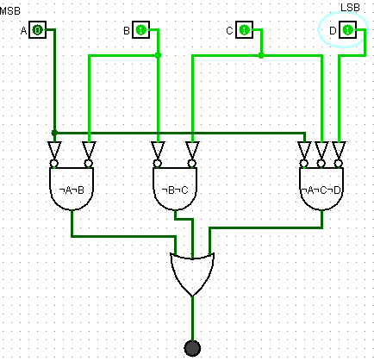

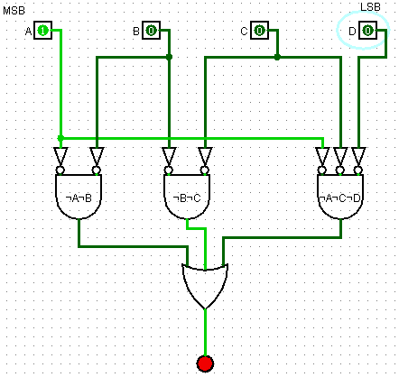

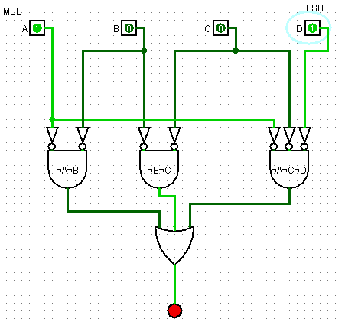

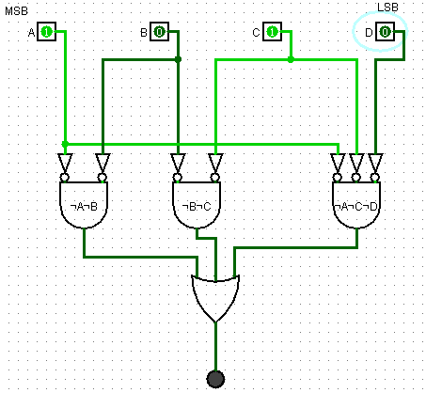

Part H:

First Circuit :

And: 7*(4-1)*1.3 = 27.3
OR: (7-1)*1.3 = 7.8
NOT: 4*0.7 = 2.8

= 37.9 G.E

Simplified circuit:

And : 1+1+2=4*1.3 = 5.2
Or : 2*1.3 = 2.6
NOT : 4*0.7 = 2.8

= 10.6 G.E

(37.9/10.6)*100 = 27.9683377 = approx. 28 G.E decrease

