Assignment 4
Name :Evan O'Keeffe
Student Number: 10324289
Email: evanokeeffe@gmail.com

question1:

The circuit works by using 1 binary half adder and 7 binary full adders. The inputs are put into the circuit and the answer is read on the led in the main circuit shown below. The LEDs are read as left being MSB and right being LSB
The carry is shown by an LED as well.
The half Adder is the full adder only the carry in is attached to the A and B signals
The Full Adder is the carry as a seperate pin.

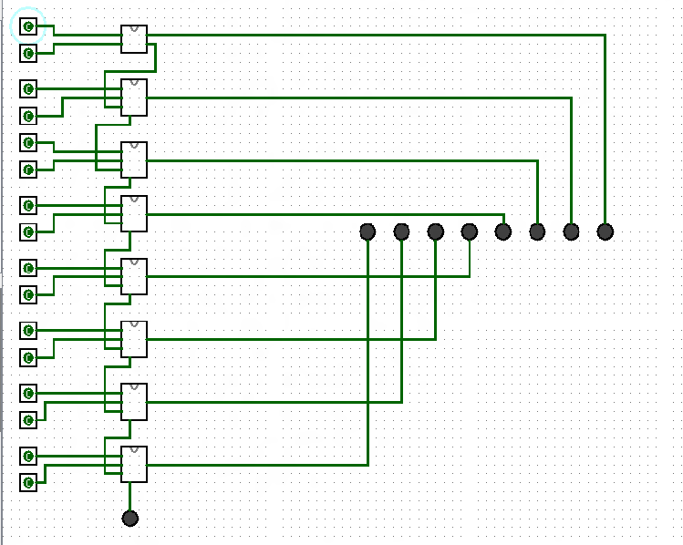

This is the circuit with the equation A=00000001,B=00000000
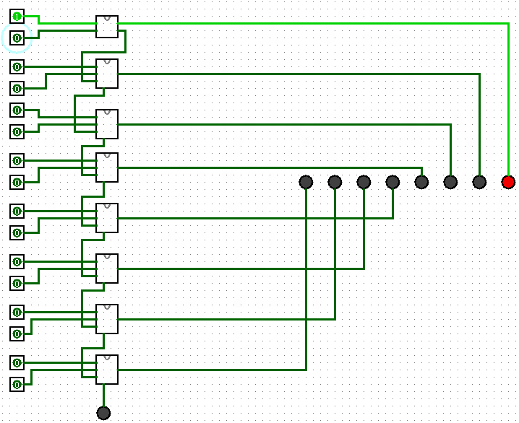

This is equation shows the ripple working by using the equation A = 00000001 and B=00000001

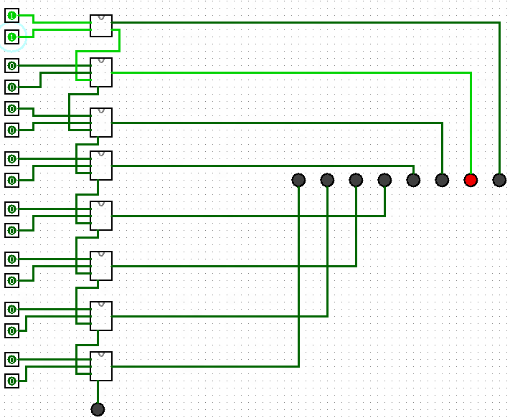

Question 2:

The negation circuit in main shows how the equation A is changed to -A. This works by first negating all values of A and adding 1 to it.
This is shown in the main file with A = 0 , therefore A = 11111111 + 1 = 0 carry out 1.

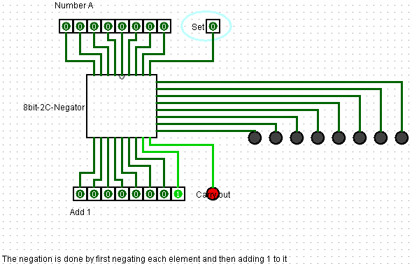

This next circuit shows what happens when one is negated in 2s complement.

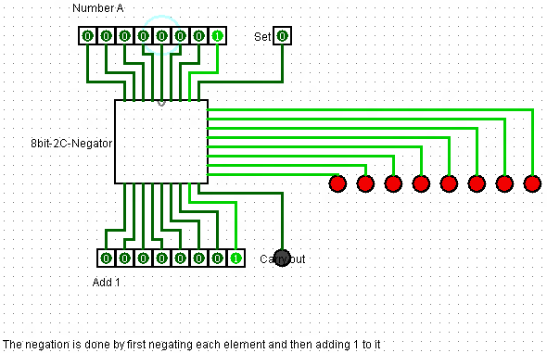
The next circuit shows it works for the rest of the values

A = 9
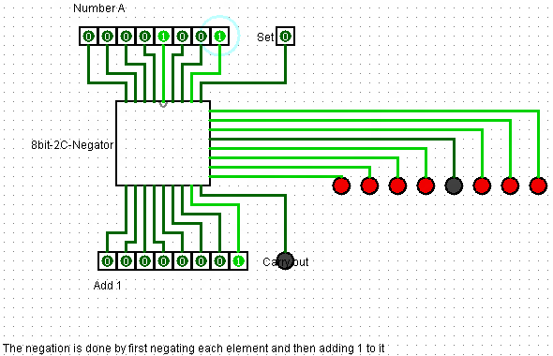

Question 3:

this is done by using the 2s complement adder from the last question .
The set pin is simply set to 1 (which sets b to be a minus number), the carry in is set to what the set pin is for the first carry . Apart from that not much has changed since question 2.

This is the base case , A = 0 , B=0 , therefore carry out 1

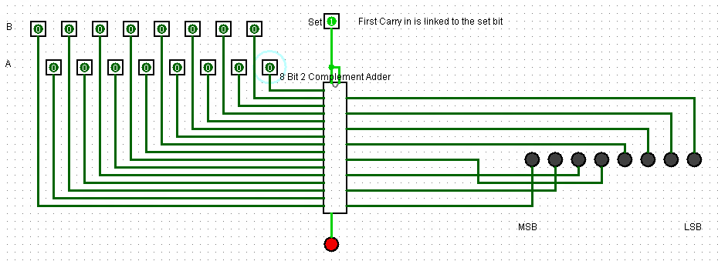
Now for another case . A = 8 or 00001000 , B = -1 , Anser = 7 or 00000111 and carry out the 1
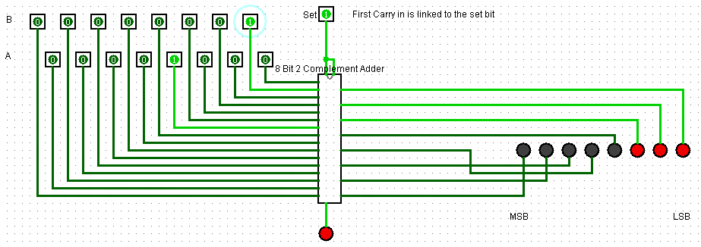

Question 4:

For this question I used the negator from question 2 and the adders from question 3.

The equation 2*a-b which equates to (2(a) – b) ) is done by doing a bit shift of A simply by adding A to itself and then the output of this is added to the negated value of B.

The circuit has 3 input bars of 8 pins and 3 set pins. The set pins have to be zero as only addition is done for al the subcircuits. Add 1 has to have the input (00000001) for the binary negation , A and B are the variable inputs which can hold any value from 0-63.

B will be negated through the sub circuit I made in question 3 and then adder to A in the 8 bit 2s complement adder from question 3.

So here is the zero case

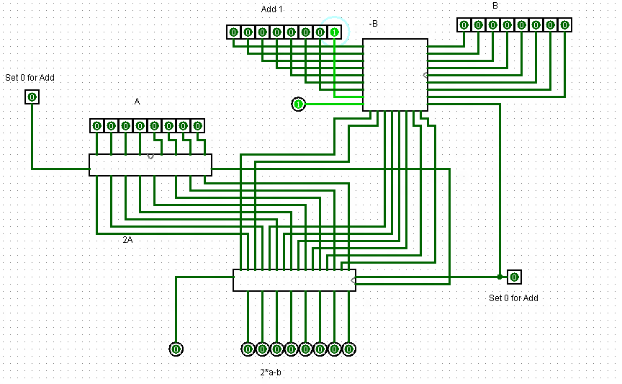

here is the case were A will be multiplied by itself(simply shifts the bit by 1) and B is still minus

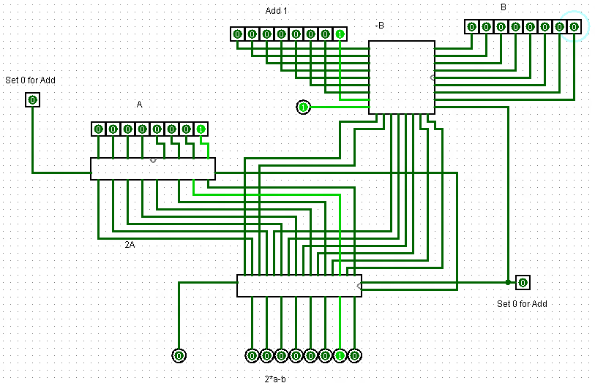
here is the base where A = 1 and B = 1, which should give the output 0010 – 0001 = 0001

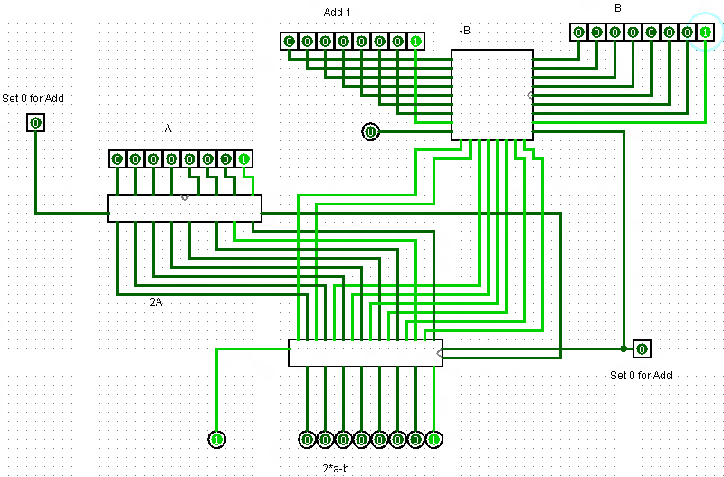
now here is the case where A = 4 and B = 1 , A = 00000100 : b = 00000001 : 2A = 00001000 or 8
Y = 00000111 or 7

